Journal: Cytotechnology
The future is fully defined: recombinant fragment E8 of laminin-511 is a viable xenofree alternative to Matrigel for hiPSC culture and differentiation into neurovascular cell types
Laís A. Ferreira, MSc^{1,2}; Denise Fabiano do Nascimento²; Dr. Ishita Tandon²; Lance Cordes²; Dr. Kartik Balachandran^{1,2*}
¹Cellular & Molecular Biology Graduate Program, University of Arkansas, Fayetteville, Arkansas, United States of America
²Department of Biomedical Engineering, University of Arkansas, Fayetteville, Arkansas, United States of America
*Corresponding author
E-mail: kbalacha@uark.edu (KB)

Supplemental methods

Supplemental Table 1 Reagents used for cell culture and assays.

Product | Vendor | Catalog number
iMatrix-511 | Amsbio | 892 011
Growth Factor Reduced Matrigel | Corning | 47743-718
mTeSR plus | Stemcell Technologies | 100-0276
ReLeSR | Stemcell Technologies | 5872
Rock inhibitor (Y-27632) | R&D systems | 1254/10
DMEM/F-12 | Thermo Fisher Scientific | 11330-032
Trypan blue | Thermo Fisher Scientific | T10282
MTS assay | Abcam | ab197010
StemPro Accutase | Thermo Fisher Scientific | A1110501
Essential 6 Media | Thermo Fisher Scientific | A1516401
Human Endothelial Serum Free Medium | Thermo Fisher Scientific | 11111044
B27 | Thermo Fisher Scientific | 17504044
bFGF/FGF-2 | Preprotech | 100-18B
Retinoic Acid | Sigma-Aldrich | R2625
Collagen IV from Human Placenta | Sigma-Aldrich | C5533
Fibronectin from Bovine Plasma | Sigma-Aldrich | F1141
CHIR99021 | Sigma-Aldrich | SML1046
SB431542 | Tocris | 1614
Dorsomorphin | Tocris | 3093
Heparin Sodium Salt from Porcine Intestinal Mucosa | Sigma-Aldrich | H3149
Bovine Serum Albumin | Millipore Sigma | A9418
Ethylenediaminetetraacetic acid (EDTA) | BioRad | 161-0729
Neural Crest Stem Cell MicroBeads | Miltenyi Biotec | 130-097-127
FcR Blocking Agent | Miltenyi Biotec | 130-059-901
LS Columns | Miltenyi Biotec | 130-042-401
Fetal Bovine Serum | Thermo Fisher Scientific | 26140079
3 kDa Cascade Blue-Dextran | Invitrogen | D7132
Gelatin from cold water fish skin | Sigma-Aldrich | G7041
Normal Goat Serum | Thermo Fisher | PCN5000
Triton X-100 | Millipore-Sigma | T8787
Tween 20 | Amresco | 0777
Paraformaldehyde | Electron Microscopy Sciences | 15710
DAPI (4',6-diamidino-2-phenylindole) | Thermo Fisher | D1306
RIPA Lysis Buffer System | Santa Cruz Biotechnology | sc-24948

Supplemental Table 2 Primary antibodies used for immunoassays.

Marker | Vendor | Host | Application | Dilution | Blocking
OCT-3/4 | Santa Cruz  sc-5279 | Mouse | ICC | 1:50 | +GS/+TR/+TW
SSEA-4 | Abcam  ab16287 | Mouse | ICC | 1:100 | +GS/−TR/−TW
ZO-1 | ThermoFisher  40-2200 | Rabbit | ICC | 1:100 | +GS/+TR/+TW
ZO-1 | ThermoFisher  40-2200 | Rabbit | WB | 1:50 | －
NGFR | Advanced Targeting Systems  AB-N07 | Mouse | ICC | 1:1000 | −GS/−TR/−TW
NG-2 | Millipore-Sigma  MAB2029 | Mouse | ICC | 1:100 | +GS/+TR/+TW
PDGFR-β | Cell Signaling Technology  3169 | Rabbit | ICC | 1:100 | +GS/+TR/+TW
γH2AX | Abcam  Ab11174 | Rabbit | WB | 1:50 | －
NanoG | R&D Systems  AF1997 | Goat | WB | 1:50 | －
Claudin-5 | Thermo Fisher  35-2500 | Mouse | WB | 1:50 | －
GAPDH | Abcam  Ab181602 | Rabbit | WB | 1:1000 | －

GS: normal goat serum; TR: Triton X-100; TW: Tween-20.

Magnetic cell sorting of iPSC-derived neural crest stem cells
Briefly, cells were suspended with accutase and centrifuged at 300g for 5 minutes. The supernatant was then discarded, cells were resuspended in 80 µL of MACS buffer (0.5% bovine serum albumin and 2 mM EDTA in phosphate buffer saline, pH 7.2), 20 µL of anti-Neural Crest Stem Cell MicroBeads (Miltenyi Biotec), and 20 µL of Fc blocking agent (Miltenyi Biotec) and incubated at 4°C for immunolabeling, according to the manufacturer’s instruction. After 15 minutes, 2 mL of MACS buffer were added, and cells were centrifuged. For cell sorting, the pellet was suspended in 500 µL of MACS buffer and passed through a pre-wet positive selection LS column (Miltenyi Biotec). After cell recovery, a sample was collected for counting, and cells were centrifuged to be resuspended in E6-CSFD media containing 10 µM ROCK inhibitor.

Supplemental results
iM-iPSCs maintained pluripotency through 15 passages in culture
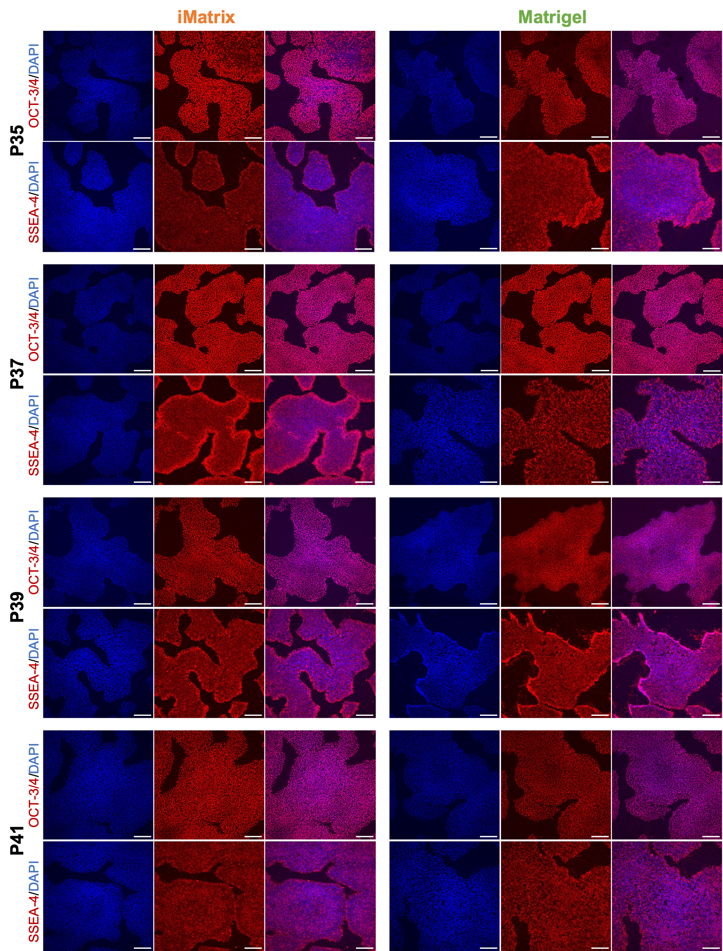

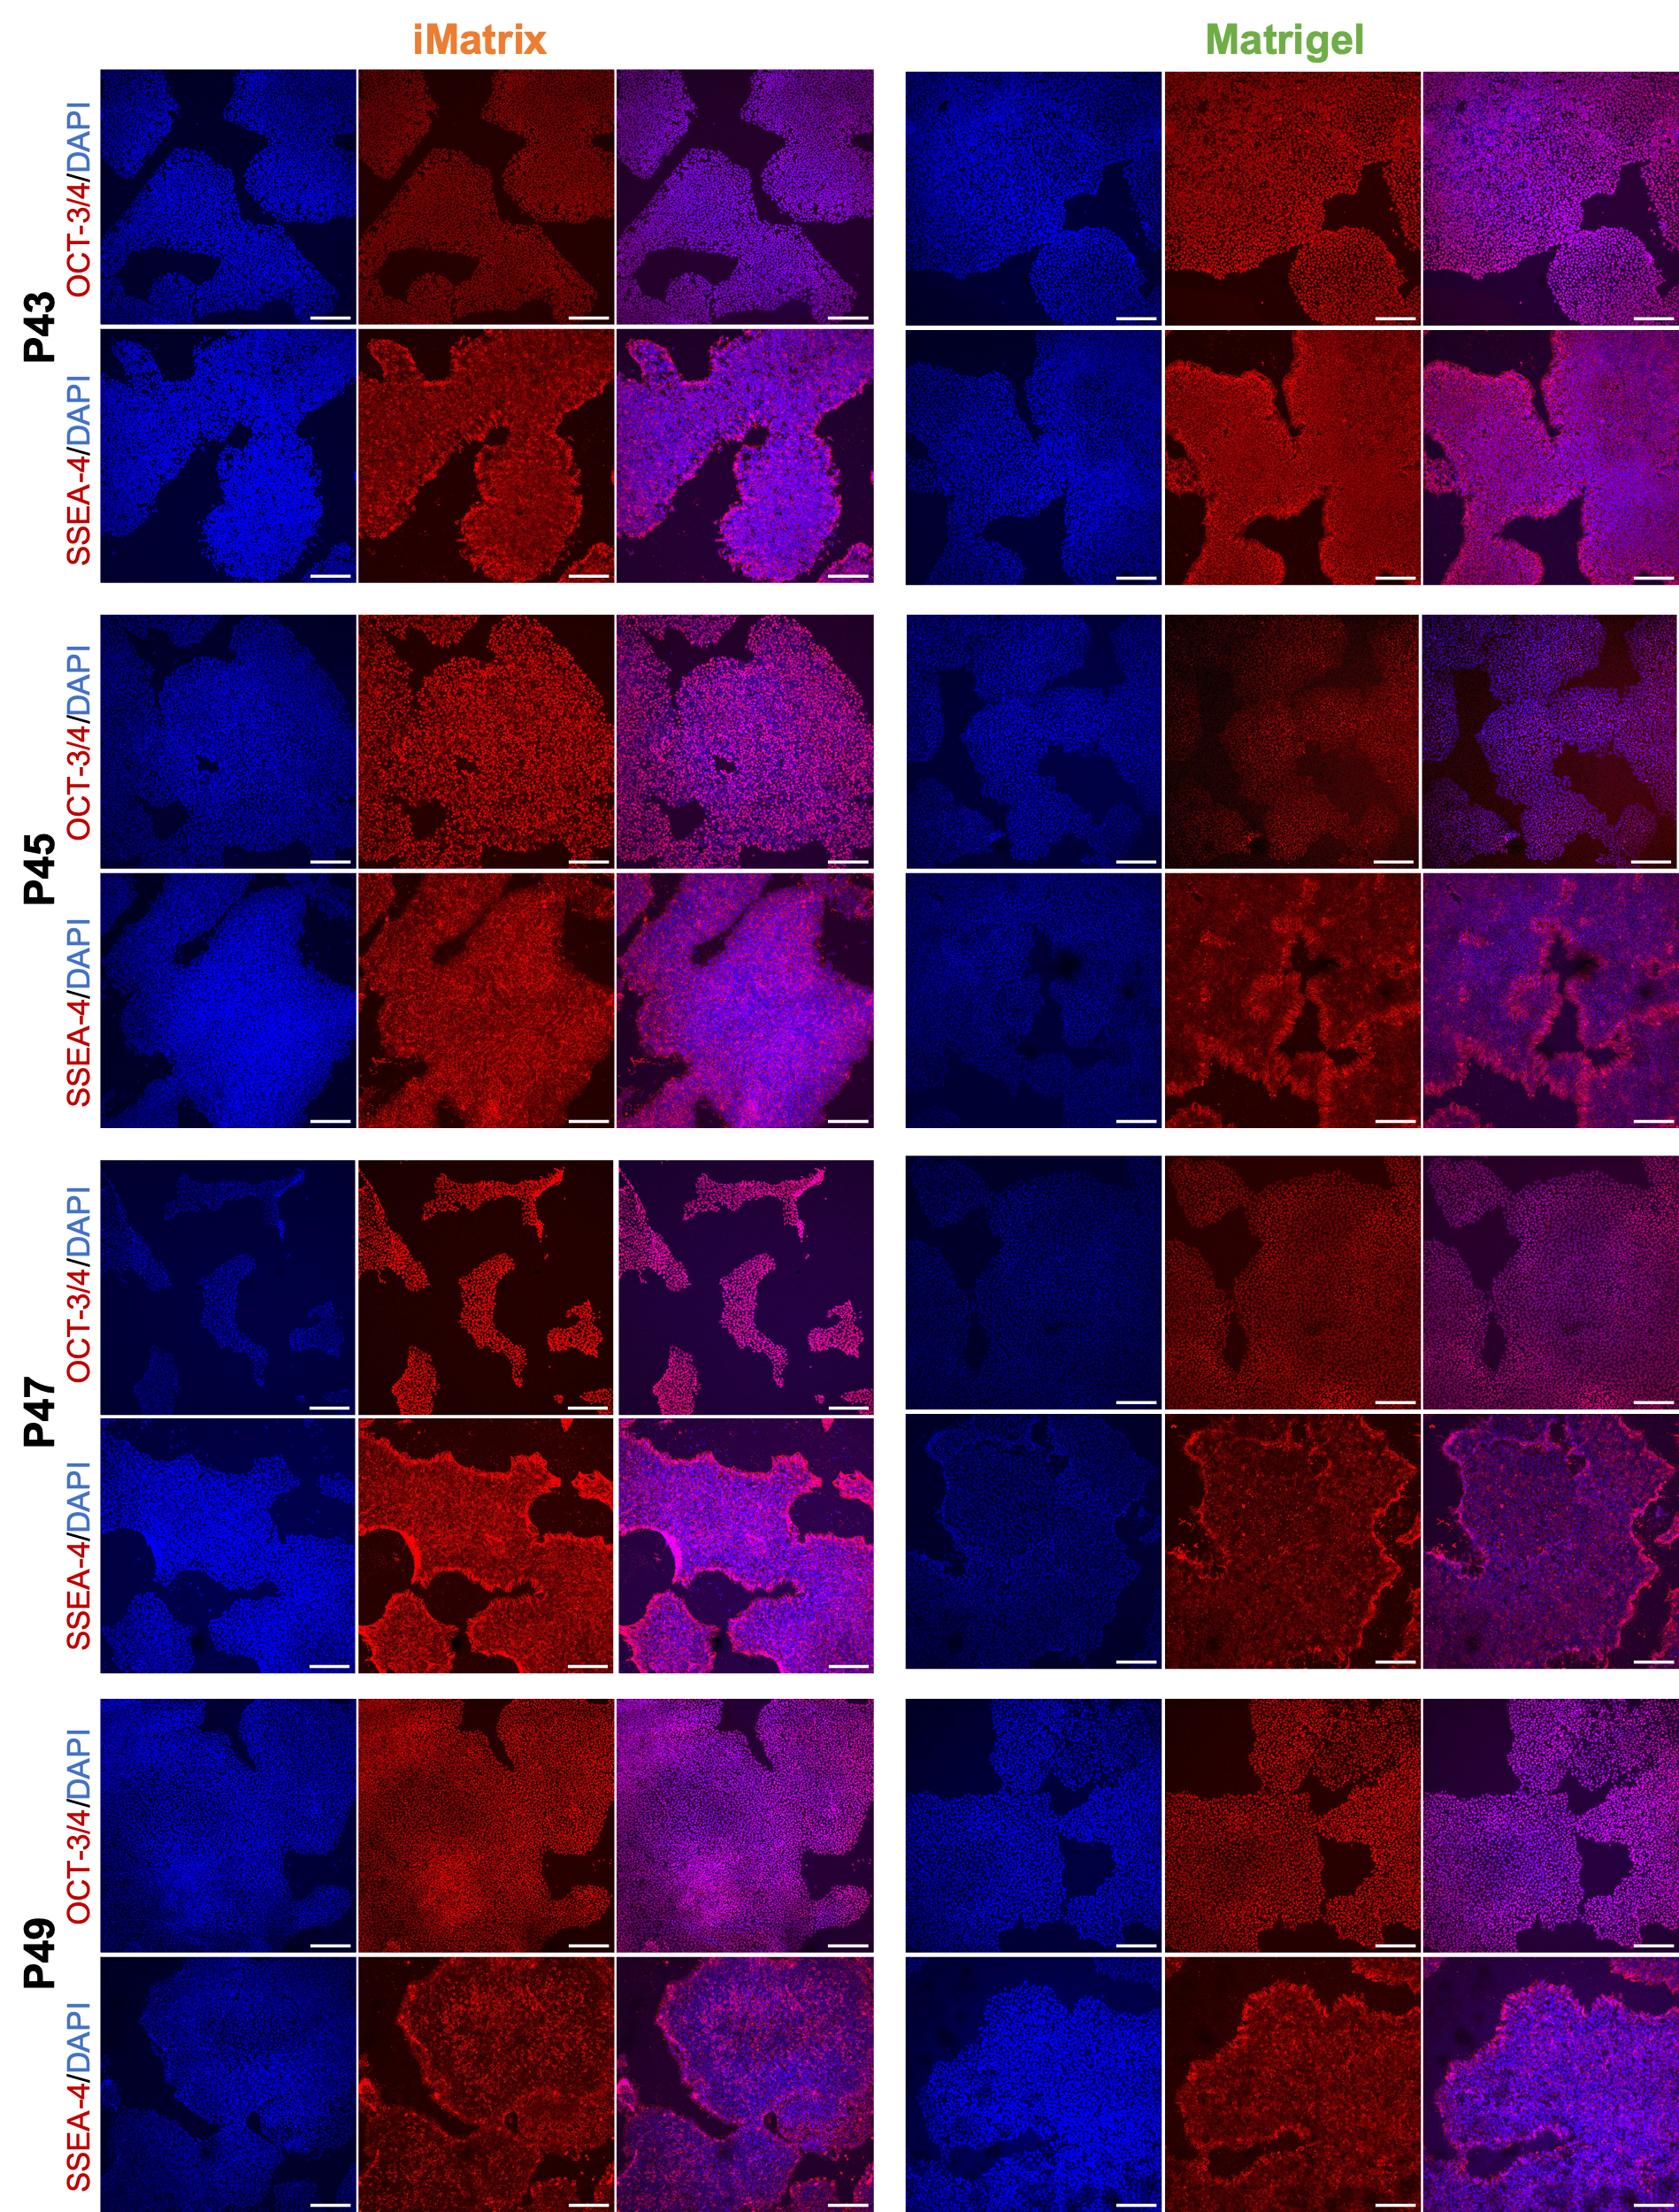

Supplemental Fig. 1 Confocal microscopy images of iPSCs grown from passages 35 to 49 using iMatrix or Matrigel following immunoidentification of pluripotency markers SSEA-4 and OCT-3/4 (red fluorescence) and nuclear staining with DAPI (blue fluorescence). Scale bars: 200 μm. DAPI: 4’,6-diamidino-2-phenylindole; OCT-3/4: octamer binding transcription factor-3/4; P: passage; SSEA-4: stage-specific embryonic antigen-4

Cryopreservation of iPSC-derived brain pericytes

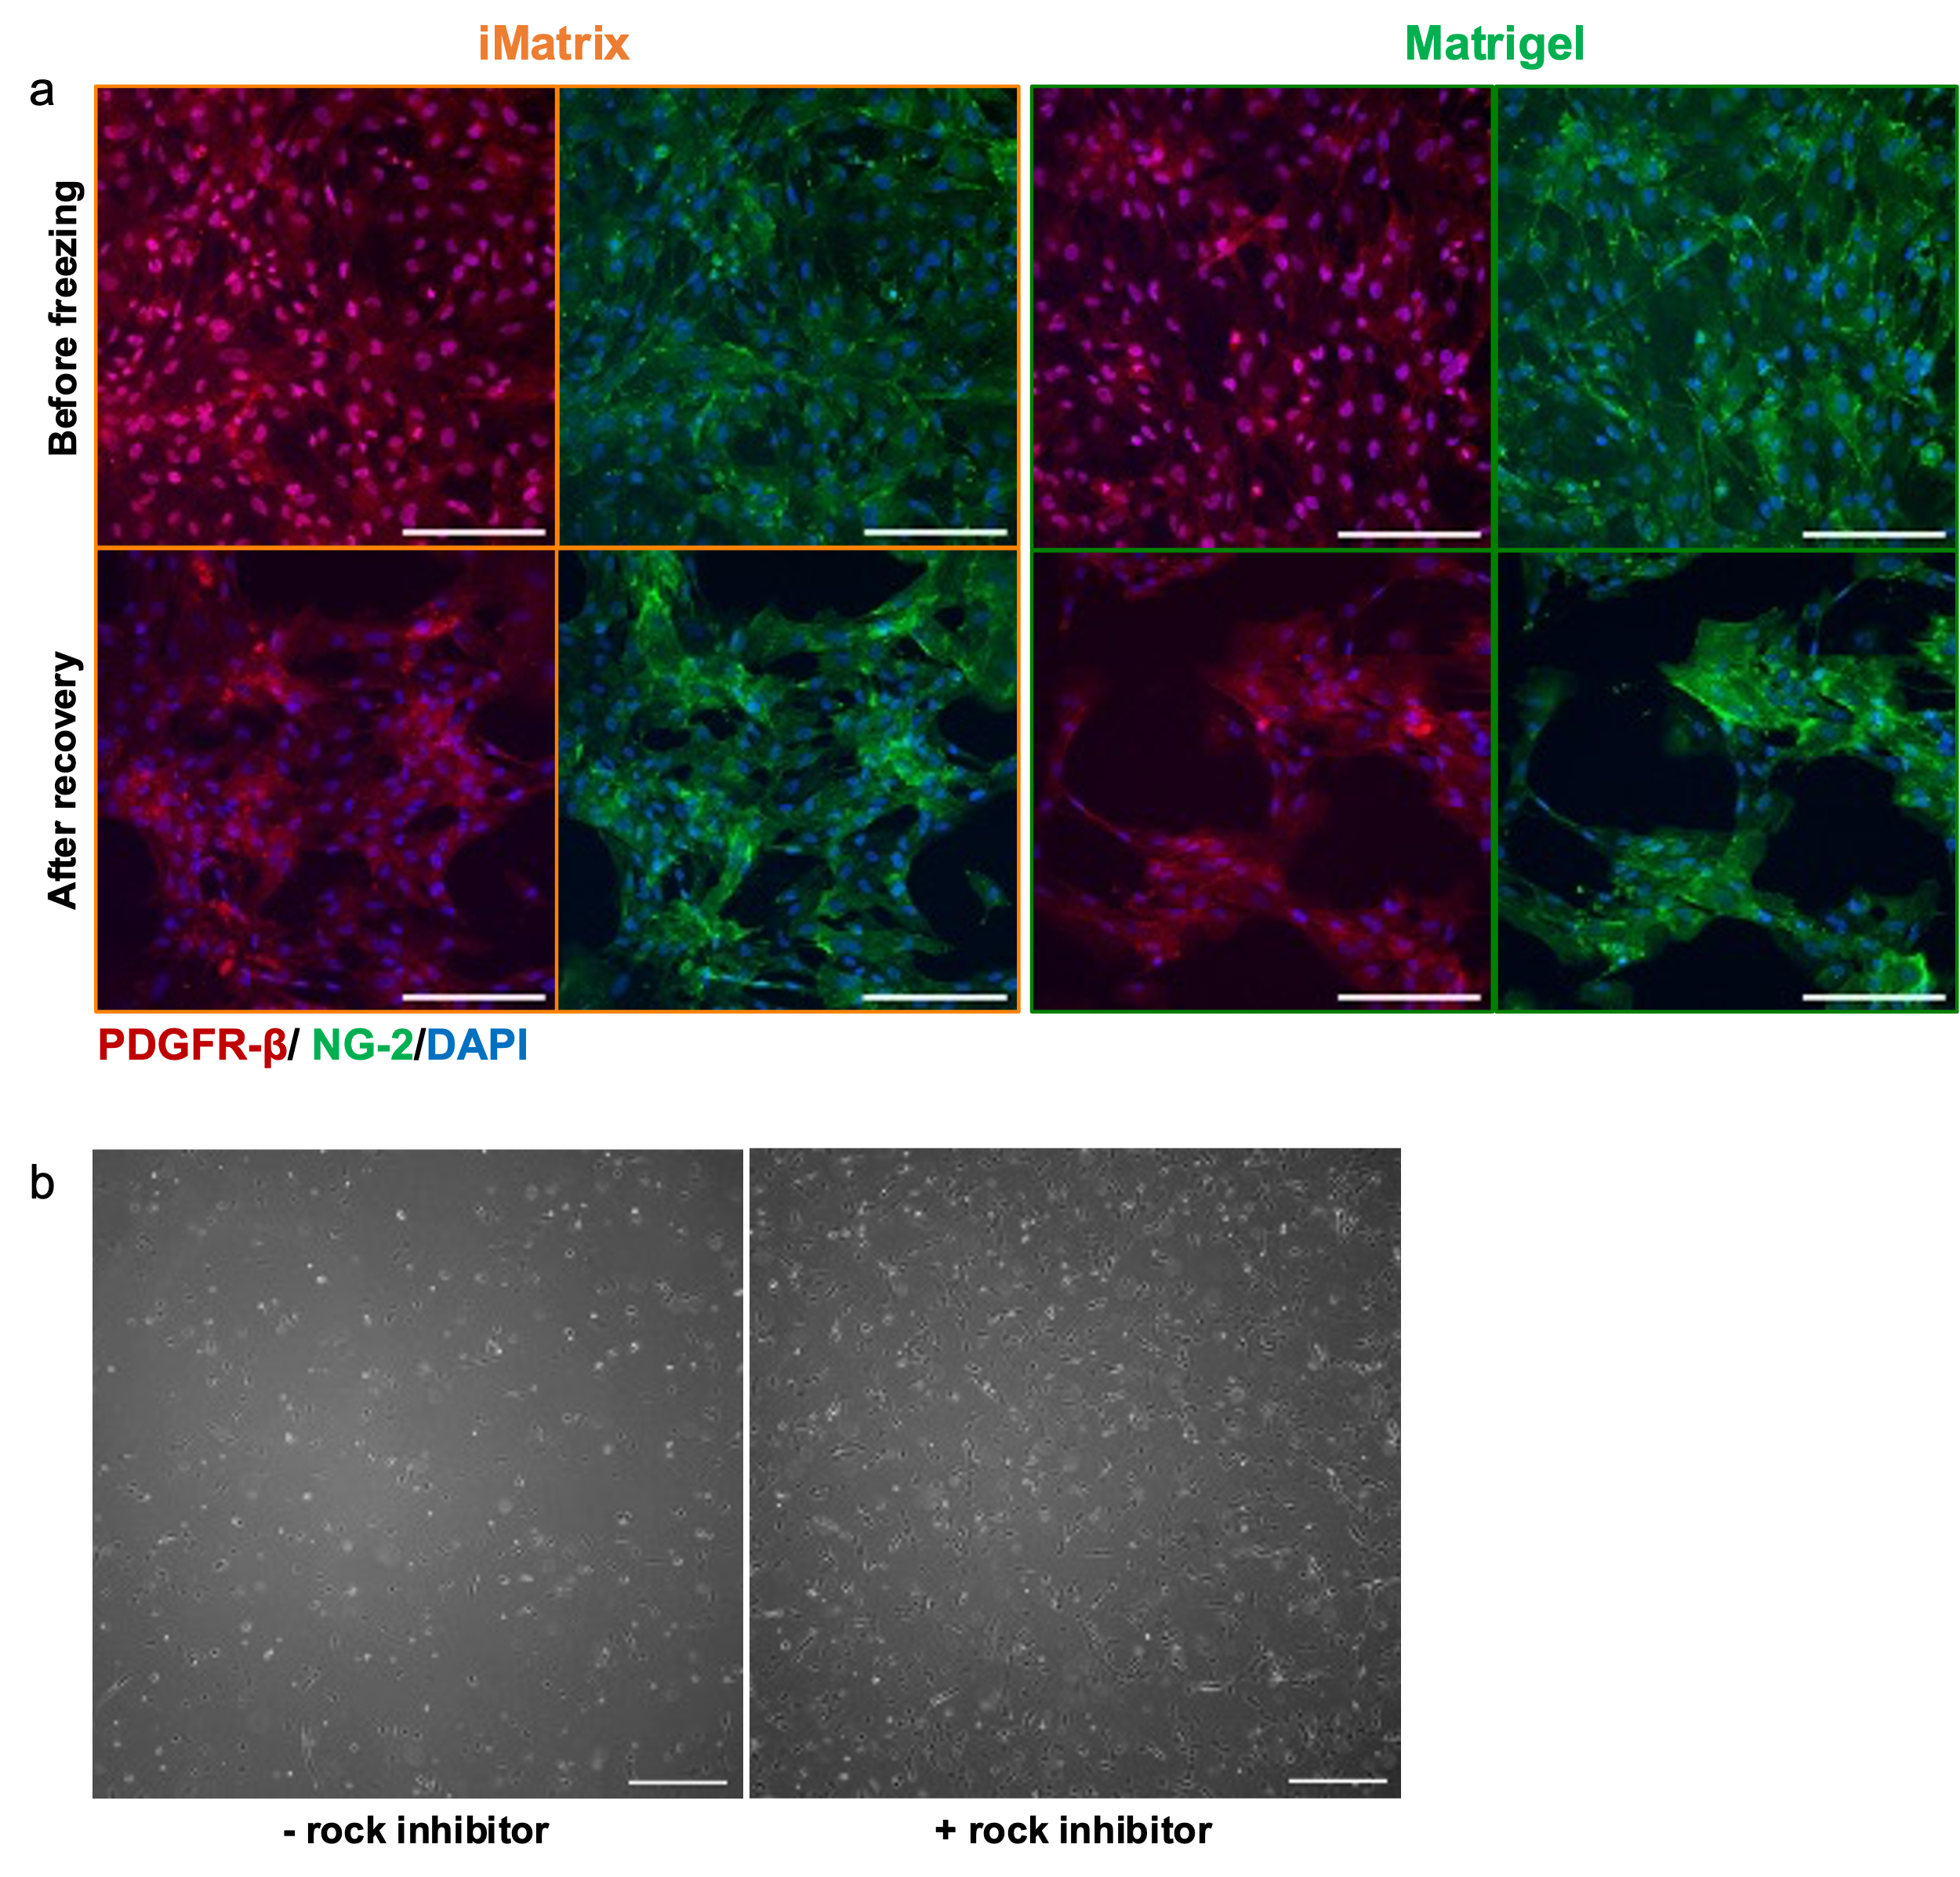

Supplemental Fig. 2 Cryopreservation of iPericytes. (a) Confocal microscopy images of iM-iPericytes and MG-iPericytes before and after cryopreservation following immunolabeling of PDGFR-β (red fluorescence), NG-2 (green fluorescence), and nuclear staining (blue fluorescence). Scale bars: 200 μm. (b) Phase contrast images of iM-iPericytes frozen with or without rock inhibitor in the freezing media 48 hours after thawing. Scale bars: 500 μm. DAPI: 4’,6-diamidino-2-phenylindole; NG-2: neural/glial antigen 2; PDGFR-β: platelet-derived growth factor receptor-β.

