Supporting Information for
Predicting the Impact of Extreme Weather on Agricultural Losses in the Delmarva Peninsula using Multi-Step Machine Learning and Financial Crop Loss Data

Data processing
SHELDUS database contains information on the direct losses caused by the event (property and crop losses, injuries, and fatalities) as well as insured crop losses (indemnity payments by the USDA) in adjusted U.S. dollars. In the uninsured crop damage data, some records with low spatial detail were identified, where losses associated with large-scale statewide events were evenly distributed across affected counties. These records were consequently excluded. For insured crop damage data, multiple loss records for single events within a single county were consolidated into a total value for that county. Additionally, records with missing values in terms of date information were deleted. To mitigate the zero-inflation issue, SHELDUS daily total loss values were aggregated monthly. The insured and uninsured losses were combined to be considered as the total crop damage.
Model training results
The random forest model, implemented with stratified sampling (2-step-strat and 3-step model) during the classification step, yielded highest accuracy and recall overall. This underscores the effectiveness of machine learning approaches compared to traditional statistical methods, such as GLMM, as well as the advantage of adopting stratification technique to deal with data imbalance issue in more accurately capturing crop loss patterns from explanatory variables. Table S1 summarizes the errors obtained from different models.
The estimation step of model training has led to error results shown in Table S2. In both hazard types, the Null Model exhibits highest sMAPE values, indicating limited predictive capability without a structured model, especially in terms of False Negatives highlighted by $w=10$. GLMM demonstrates a notable reduction in sMAPE compared to the Null Model, suggesting improved accuracy with a structured approach. RF generally outperforms both Null and GLMM models, showing lower sMAPE values. However, interestingly, 3-step GLMM has achieved a lower estimation error compared to 3-step RF, highlighting the role of model structure especially designed for inherent data characteristics in estimation capability. SVM also exhibits competitive performance, with lower sMAPE compared to all the algorithms above. 3-step SVM model has the best performance overall. The efficacy of the machine learning approaches in capturing complex patterns in estimation is boosted by the algorithmic configuration. Note that all the models are trained in the estimation step by nonzero observed data, resulting in no false negatives and similar error values for different weights in the error metric.

Table S1. Performance of different models in the training phase
Step | Hazard | Method | WsMAPE | Model Structure
 |  |  |  | 2-step | 2-step-strat | 3-step
Classification | Drought | Null | Accuracy | 0.754
Classification | Drought | GLMM | Accuracy | 0.832 | 0.832 | 0.832
Classification | Drought | RF | Accuracy | 0.872 | 0.872 | 0.872
Classification | Drought | SVM | Accuracy | 0.855 | 0.855 | 0.855
Classification | Drought | Null | Recall | 0.436
Classification | Drought | GLMM | Recall | 0.445 | 0.445 | 0.445
Classification | Drought | RF | Recall | 0.570 | 0.570 | 0.570
Classification | Drought | SVM | Recall | 0.408 | 0.408 | 0.408
Classification | Storm | Null | Accuracy | 0.648
Classification | Storm | GLMM | Accuracy | 0.767 | 0.767 | 0.767
Classification | Storm | RF | Accuracy | 0.836 | 0.836 | 0.836
Classification | Storm | SVM | Accuracy | 0.793 | 0.793 | 0.793
Classification | Storm | Null | Recall | 0.308
Classification | Storm | GLMM | Recall | 0.237 | 0.237 | 0.237
Classification | Storm | RF | Recall | 0.461 | 0.461 | 0.461
Classification | Storm | SVM | Recall | 0.205 | 0.205 | 0.205
Estimation | Drought | Null | $$sMAPE$$ | 30.353
Estimation | Drought | GLMM | $$sMAPE$$ | 11.902 | 11.902 | 8.789
Estimation | Drought | RF | $$sMAPE$$ | 11.362 | 11.355 | 9.056
Estimation | Drought | SVM | $$sMAPE$$ | 9.831 | 9.831 | 7.425
Estimation | Storm | Null | $$sMAPE$$ | 39.682
Estimation | Storm | GLMM | $$sMAPE$$ | 13.079 | 13.079 | 8.972
Estimation | Storm | RF | $$sMAPE$$ | 12.428 | 12.401 | 9.180
Estimation | Storm | SVM | $$sMAPE$$ | 11.151 | 11.151 | 7.650
Figure S1 depicts scatterplots of the observed versus predicted damage values, demonstrating how different methods and structures have learned the relationship between hazard losses and weather variables from the observed data.
(a) | 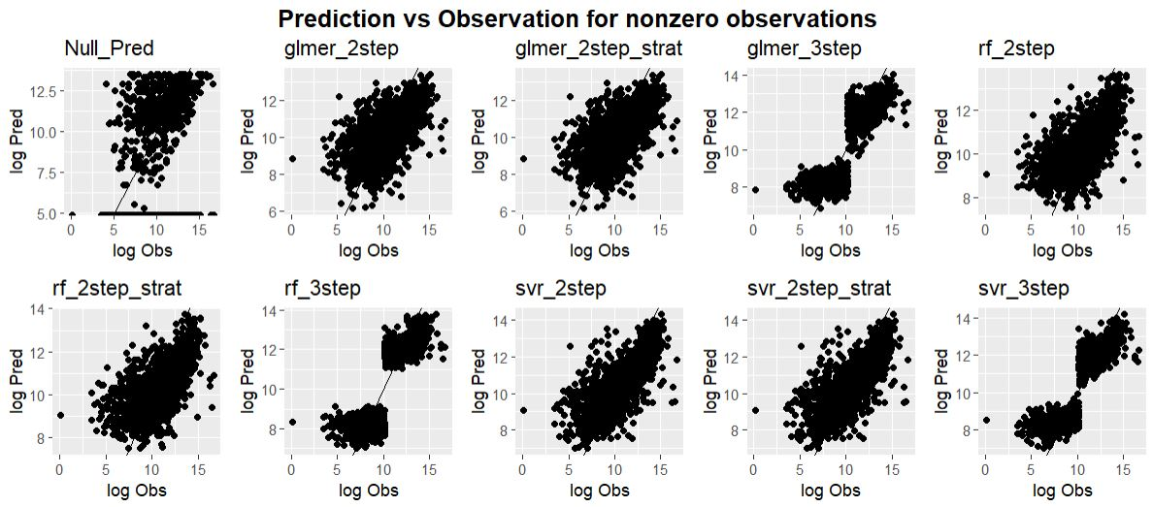
(b) | 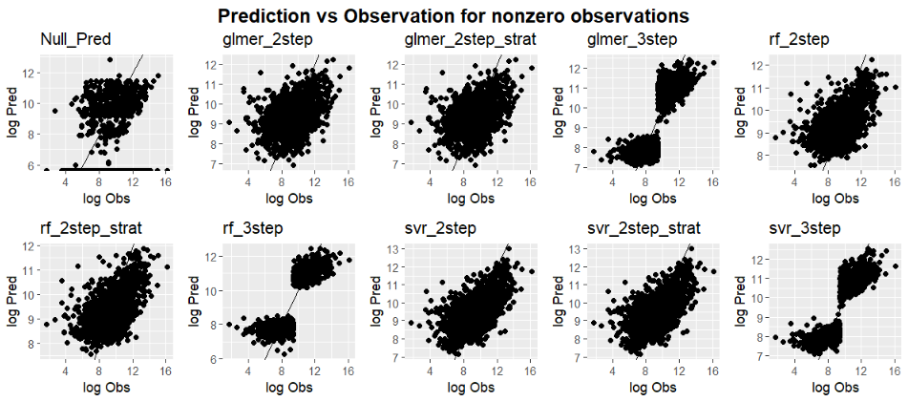
Figure S1. Models’ training performance demonstrated by prediction versus observation scatter plots for nonzero loss observations under (a) drought hazard (b) storm hazard. Values are log-transformed

Importance of discrete variables
Spatial and temporal variations under drought hazard is illustrated in Figure S2. Classification results (panel a) demonstrate that the likelihood of damage is also highest in the three counties of Delaware. The PDPs of the regression model (panel b) demonstrate that the most substantial losses occur during dry summers with rainfall less than the average and high temperatures. This encompasses not only Delaware but also the southern portion of the peninsula.

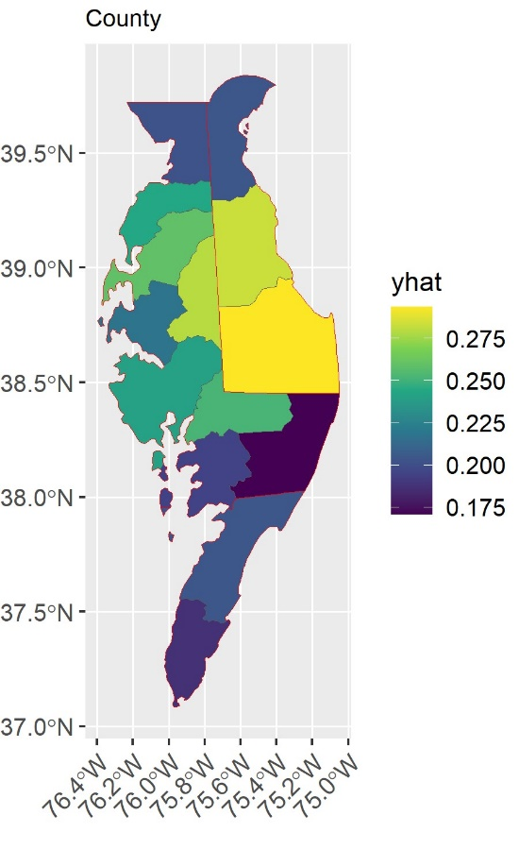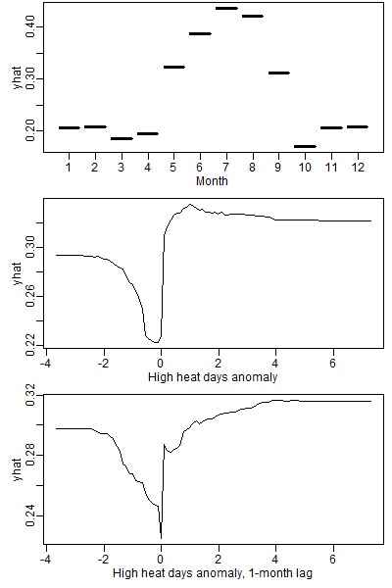 | 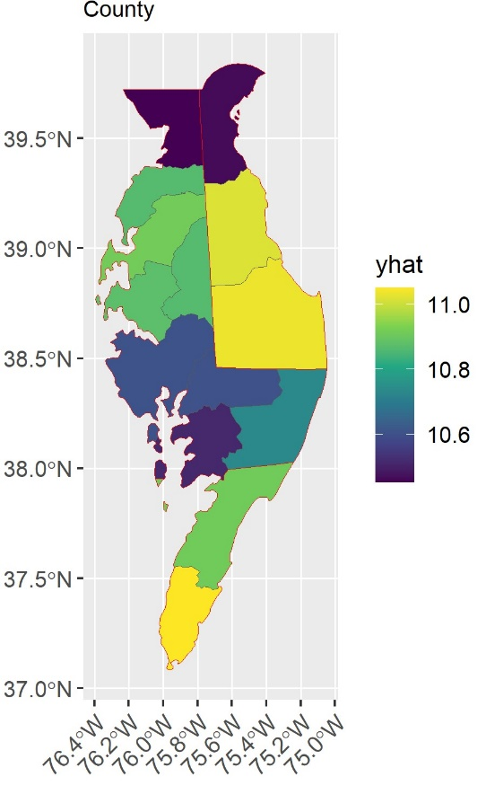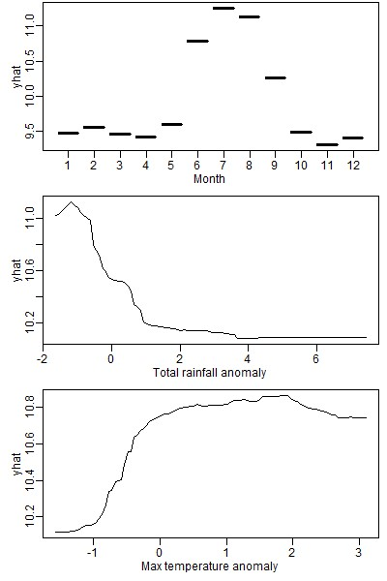
(a) | (b)
Figure S2. Partial dependence of county and month variables in drought hazard assessment (a) classification step (b) regression step.

According to partial dependence plots for storm hazard (Figure S3), storm events leading to significant crop losses are more likely to occur in the summer months. The geographic patterns demonstrate that while these storm-induced losses are infrequent in the Virginia counties, their magnitudes are high when they do occur compared to the rest of the peninsula. High precipitation values, in terms of total precipitation in the current month and one moth prior and greater values of five-day maximum rainfall, are all associated with a higher likelihood and magnitude of damage. A noteworthy threshold effect is observed in the precipitation partial dependence plots (PDPs) of the regression model. This suggests that the vulnerability of agriculture in the peninsula to storm events is not limited to extremely rare and extreme occurrences of storms.
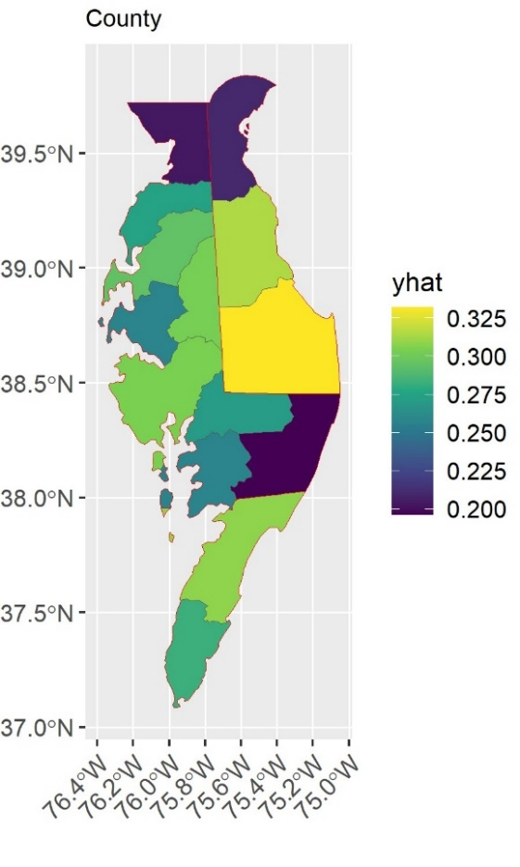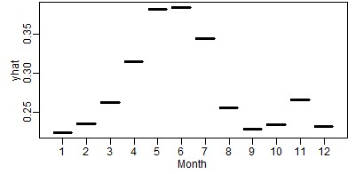 | 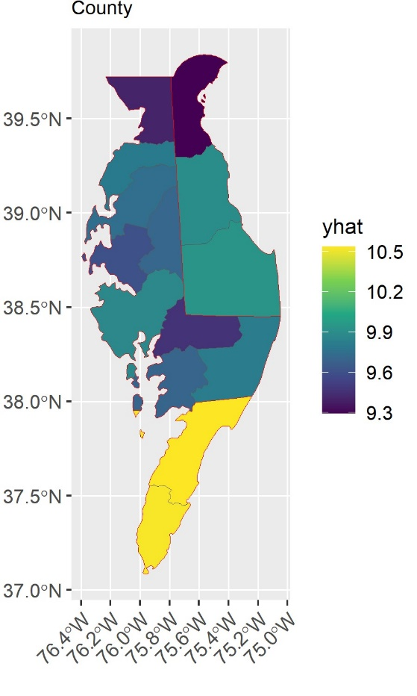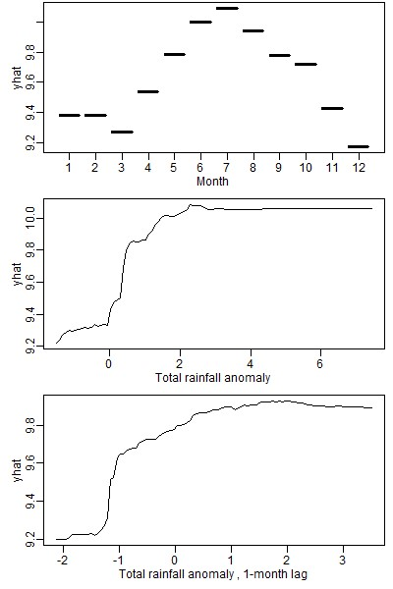
(a) | (b)
Figure S3. Partial dependence of county and month variables in storm hazard assessment (a) classification step (b) regression step

