Supporting Information

Integration of 2D material-based electronic devices on flexible substrates for millimeter wave applications

Eros Reato^{1,2}, Paula Palacios^{3,4}, Burkay Uzlu², Eyyub Baskent³, Ardeshir Esteki¹, Mohamed Saeed⁴, Francisco Pasadas⁵, Lukas Völkel¹, Daniel S. Schneider^{1,2}, Michael Heuken⁶, Daniel Neumaier^{,2,7}, Zhenxing Wang^{1,*}, Renato Negra^{3,*} and Max C. Lemme^{1,2,*}

¹Chair of Electronic Devices, RWTH Aachen University, Otto-Blumenthal-Strasse 25, 52074 Aachen, Germany
²AMO GmbH, Otto-Blumenthal-Strasse 25, 52074 Aachen, Germany
³Chair of High-Frequency Electronics, RWTH-Aachen University, Kopernikusstraße 16, 52074 Aachen, Germany
⁴InCirtT GmbH, Kopernikusstraße 16, 52074 Aachen, Germany
⁵Dep. de Electrónica y Tecnología de Computadores, Campus de Fuentenueva, 18071, Granada, Spain
⁶AIXTRON SE, Dornkaulstrasse 2, 52134 Herzogenrath, Germany
⁷Bergische Universität Wuppertal, Lise-Meitner-Str. 13, 42119 Wuppertal, Germany

*: wang@amo.de; renato.Negra@hfe.rwth-aachen.de; max.lemme@eld.rwth-aachen.de

E. Reato and P. Palacios contributed equally to this work.

Raman data
We conducted material characterization via Raman spectroscopy on Si/SiO₂ substrates. Figure S1 shows the Raman spectra for graphene and MoS₂ following a transfer process on a Si/SiO₂ test substrate. The transfer process we used in this case was identical to that performed on the PI substrate, described in Section II.B. The Raman measurements revealed curves characteristic of both materials, confirming successful growth and transfer on the target substrates [1], [2].
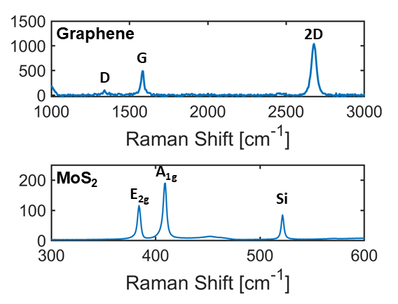
Figure S1: Raman spectra of graphene and MoS₂.

hBN/MoS₂/hBN stack transfer
hBN was purchased from the supplier as a 2 nm thick film on a copper foil growth substrate. We first spin-coated approximately 600 nm thick PMMA onto the hBN on the copper foil. Then, we etched the copper substrate in a solution of HCl, H2O2 and DI water, leaving a free-standing PMMA and hBN layer. We then transferred the hBN layer to OX2 via DI water for adhesion. Finally, we allowed the transferred materials to dry overnight in a laminar airflow and removed the PMMA layer with an acetone bath. We then spin-coated 600 nm PMMA onto the as-grown MoS₂ on sapphire and delaminated the stack of PMMA and MoS₂ by intercalating DI water. For the transfer of MoS₂, only water was used to remove the material from the sapphire growth substrate to avoid further contamination by other chemicals commonly used for this purpose [3], [4], [5], [6]. As in the case of hBN, this resulted in a freestanding stack of PMMA and MoS₂, which was then transferred onto the previously transferred h-BN using DI water. The resulting stack of materials was dried overnight in a laminar flow oven, and the carrier PMMA layer was stripped with acetone. Finally, the last hBN layer was transferred onto the hBN/MoS2 stack via the same procedure as that used for the bottom hBN layer. The process is illustrated in Figure S 2.

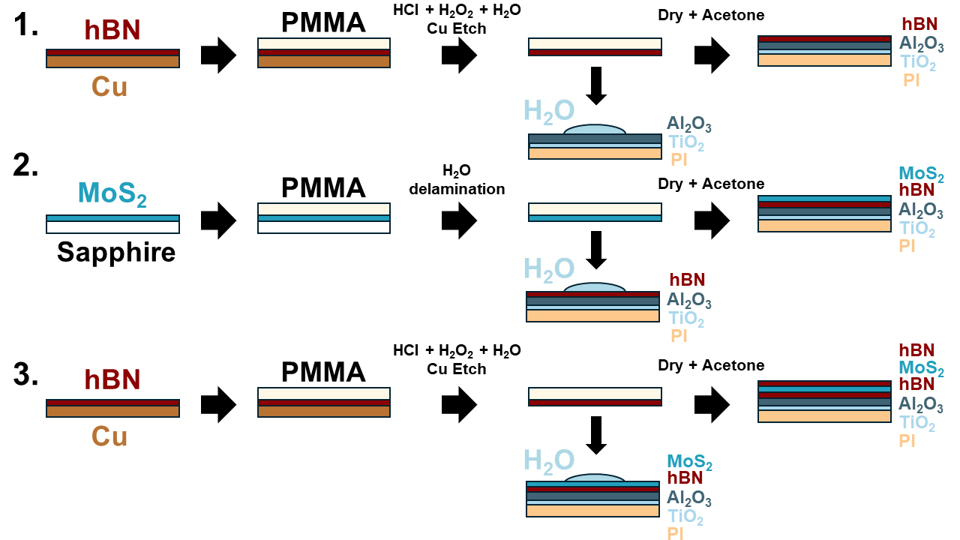
Figure S2. Process for fabricating hBN, MoS2 and hBN stacks on the target substrate.

Bending Tests
We peeled the sample from the carrier substrate after the fabrication ended. To peel the thin polyimide layer from the silicon carrier, we first made small scratches with a scalpel at the four corners of the sample, followed by complete peeling of the PI from the substrate. After this, we prepared a handmade supporting structure made of blue wafer tape that was attached to the edges of the sample and a plastic substrate foil that went underneath and provided support to the structure. This packaging solution makes it possible to handle the sample and to avoid excessive curling of the thin PI edges, which could introduce unwanted stress to the sample while keeping the top surface with the devices accessible to the measurement needles, as shown in Figure 3 in the main text.
References
[1] L. M. Malard, M. A. Pimenta, G. Dresselhaus, and M. S. Dresselhaus, “Raman spectroscopy in graphene,” Phys. Rep., vol. 473, no. 5, pp. 51–87, Apr. 2009, doi: 10.1016/j.physrep.2009.02.003.
[2] H. Li, Q. Zhang, C. C. R. Yap, B. K. Tay, T. H. T. Edwin, A. Olivier, and D. Baillargeat, “From Bulk to Monolayer MoS2: Evolution of Raman Scattering,” Adv. Funct. Mater., vol. 22, no. 7, pp. 1385–1390, 2012, doi: 10.1002/adfm.201102111.
[3] H. Li, J. Wu, X. Huang, Z. Yin, J. Liu, and H. Zhang, “A Universal, Rapid Method for Clean Transfer of Nanostructures onto Various Substrates,” ACS Nano, vol. 8, no. 7, pp. 6563–6570, Jul. 2014, doi: 10.1021/nn501779y.
[4] Z. Lu, L. Sun, G. Xu, J. Zheng, Q. Zhang, J. Wang, and L. Jiao, “Universal Transfer and Stacking of Chemical Vapor Deposition Grown Two-Dimensional Atomic Layers with Water-Soluble Polymer Mediator,” ACS Nano, vol. 10, no. 5, pp. 5237–5242, May 2016, doi: 10.1021/acsnano.6b00961.
[5] H. Yu, M. Liao, W. Zhao, G. Liu, X. J. Zhou, Z. Wei, X. Xu, K. Liu, Z. Hu, K. Deng, S. Zhou, J.-A. Shi, L. Gu, C. Shen, T. Zhang, L. Du, L. Xie, J. Zhu, W. Chen, R. Yang, D. Shi, and G. Zhang, “Wafer-Scale Growth and Transfer of Highly-Oriented Monolayer MoS2 Continuous Films,” ACS Nano, vol. 11, no. 12, pp. 12001–12007, Dec. 2017, doi: 10.1021/acsnano.7b03819.
[6] M. Graf, M. Lihter, M. Thakur, V. Georgiou, J. Topolancik, B. R. Ilic, K. Liu, J. Feng, Y. Astier, and A. Radenovic, “Fabrication and practical applications of molybdenum disulfide nanopores,” Nat. Protoc., vol. 14, no. 4, Art. no. 4, Apr. 2019, doi: 10.1038/s41596-019-0131-0.

