Supplementary Materials
Supplementary A- CRED-NF Checklist Summary
Item No. | Checklist item | Manuscript Details
1a | Pre-register experimental protocol and planned analyses | This study was preregistered with the National Institutes of Health (NIH).  Registration number: NCT02146495. Name of trial registry: Targeted Limbic Self-modulation as a Potential Treatment for Patients Suffering From Fibromyalgia.  https://clinicaltrials.gov/study/NCT02146495
1b | Justify sample size | Sample size: N=14 participants per group.  Sample Size Rationale: The sample size estimate was based on published data from Goldway et al. (2019), which reported long-term clinical effects on various FM-related symptoms, including emotional indices (d = 0.79), sleep indices (d = 1.05) and pain indices (d = 1.1). Our study aims to assess the overall FM disease burden; therefore, the assumed effect size was determined by averaging the effect sizes from all three clinical measurements reported by Goldway et al. (2019), resulting in an average effect size of 0.98. A formal a priori power analysis was conducted using G*Power v3.1.9.2, assuming a power of 0.80 and an alpha of 0.05 in a one-way ANOVA design. The analysis indicated that a sample size of 14 participants in each group would be sufficient to detect a reliable long-term clinical effect.
2a | Employ control group(s) or control condition(s) | //Materials and Methods: //General Procedure:  This study used both within-subjects (pre- and post-intervention) comparisons and between-subjects control groups. The control groups included a placebo (sham NF, NFS) with randomly generated irrelevant EFP signals and a treatment-as-usual (TAU) group, which received no additional training. To balance the weight of the treatment group against the control groups, participants were randomized in a blinded manner with a 2:1:1 allocation, favoring the NF treatment (NFT) group. Blinding was performed using in-house software.  The target was 28 participants in the NFT group and 14 each in the NFS and TAU groups. Fifty-seven patients were randomized: NFT (n=28), NFS (n=15), and TAU (n=14). The dropout rate was 17.5%, leaving 47 patients for final analysis (NFT: n=21; NFS: n=13; TAU: n=13). In the NFT group, four withdrew during the intervention, two withdrew during pre-assessment, and one was excluded due to a false diagnosis. In the NFS group, two withdrew (one during the intervention and one during pre-assessment). One participant withdrew from the TAU group during the second measurement, resulting in 13 participants per control group.
2b | When leveraging experimental designs where a double-blind is possible, use a double-blind | Random allocation was performed using in-house software, and an independent investigator from our lab, not involved in the study, enrolled patients into either the TAU group or the NF groups (NFT and NFS). A double-blind design was used for the NF groups, with group assignments only revealed after the completion of NF data collection. As a result, participants, experimenters, and outcome assessors were all blinded to the treatment assignments.
2c | Blind those who rate the outcomes | Outcome raters were blinded to group assignment for the NF groups (NFT and NFS) but were aware of participants in the TAU group.
 | Blind those who analyse the data | The data analysts remained blinded to group assignments (for the NF groups; NFT and NFS) until group comparisons were required.
2d | Examine to what extent participants and experimenters remain blinded | No measures were taken to examine whether participants and experimenters remained blind.
2e | In clinical efficacy studies, employ a standard-of-care intervention group as a benchmark for improvement. | //Materials and Methods: //General Procedure:  While no specific standard-of-care intervention was provided, patients in the TAU group continued their usual pharmacological and complementary treatments commonly used for F0120. The types of treatments for each study group are detailed in Table 1.
3a | Collect data on psychosocial factors | //Materials and Methods: //Clinical Assessment:  We collected data on trait anxiety using the Trait Anxiety Inventory (STAI-T). The Fibromyalgia Impact Questionnaire (FIQ) also includes references to psychosocial factors, such as anxiety, depression, and social and emotional functioning.
3b | Report whether participants were provided with a strategy | //Materials and Methods: //Amyg-EFP-NF Training Protocol:  In line with our previous work with healthy participants and patients (Keynan et al., 2016; Goldway et al., 2019), trainees were allowed to freely choose any mental strategy.
3c | Report the strategies participants used | //Supplementary C- Methodological Validations: //Mental Strategies Analysis: //Supplementary Figure C.1 and Table C.2:  After each NF run, patients reported the mental strategies they used, which were then categorized into three aspects: psychological attributes, manner characteristics, and emotional attributes. To ensure there were no differences between the NF groups in their preference for specific strategies, we conducted a between-group statistical analysis. For further details, refer to Supplementary C - Methodological Validations: Mental Strategies Analysis.
3d | Report methods used for online-data processing and artifact correction | //Supplementary B- Method// EEG Acquisition and Online Calculation:  EEG Online Data Processing in the Reference Dataset: The Amyg-EFP signal was calculated in real-time from raw EEG data using an automated average artifact subtraction method implemented in BrainVision RecView (BrainProducts). RecView was custom-modified to enable real-time export of corrected EEG data through a TCP/IP socket. The preprocessing algorithm and EFP calculation models were compiled from MATLAB R2009b to Microsoft.NET, allowing execution within the BrainVision RecView EEG Recorder system. The data were then processed through a MATLAB.NET compiled DLL, which calculated the EFP amplitude every 3 seconds. The online-generated EFP data were subsequently used for analysis.
3e | Report condition and group effects for artifacts | //Supplementary C- Methodological Validations: //Supplementary Table C.1- Satisfaction Level Regarding the NF-Intervention:  To avoid an overly rewarding or frustrating experience for the placebo sham group, feedback was provided at an approximate 52% success rate. To determine if the type of feedback (genuine or sham) influenced satisfaction with the NF intervention, participants completed a self-reported questionnaire. The results showed no significant differences in satisfaction levels between the groups, with both groups reporting high satisfaction with the NF training. For further details, refer to Supplementary C - Methodological Validations: Supplementary Table C.1.
4a | Report how the online-feature extraction was defined | //Supplementary B- Method: //EEG Acquisition and Online Calculation:  In the above section, we described the acquisition and calculation of EEG data for the amygdala-electrical fingerprint (Amyg-EFP) prediction model. For a more detailed understanding of the online feature extraction process, we refer readers to the articles on the development of the Amyg-EFP model: Meir-Hasson et al. (2014, 2016) and Keynan et al. (2016).
4b | Report and justify the reinforcement schedule | //Materials and Methods: //Amyg-EFP-NF Training Protocol & //Supplementary B- Method: //Animated Scenario Feedback Generation:  The NF reinforcement schedule utilized a 3D audio-visual interface depicting a hospital waiting room, where character agitation levels were adjusted based on participants' modulation of the Amyg-EFP signal. Feedback was given continuously during the "Regulate" phase, with animated characters and soundtrack agitation reflecting the success of participants' mental strategies. In the "Watch/baseline" phase, participants observed a constant unrest level of 75%, while the "Washout" phase involved distraction tasks to prevent strategy carry-over. Feedback was probabilistically determined, with character movements based on the P value of the targeted signal. To prevent frustration or excessive rewards in the sham group, feedback was derived from a randomized artificial signal, maintaining a success rate of approximately 52%. Each NF session included four runs, each comprising two cycles of Watch, Regulate, and Washout conditions, lasting 7 minutes per run. A final transfer run allowed participants to reapply effective strategies without feedback. This schedule ensured consistent reinforcement, balancing motivation and engagement, and adhered to best practices in NF research.
4c | Report the feedback modality and content | //Materials and Methods: //Amyg-EFP-NF Training Protocol & //Supplementary B- Method: //Animated Scenario Feedback Generation:  The NF modality used in this study was audio-visual. The feedback was provided through a 3D animated virtual scenario depicting a hospital waiting room. Characters within the waiting room exhibited either agitation or relaxation, with their behavior visually reflecting the participant’s ability to modulate the Amyg-EFP signal. The visual feedback consisted of animated characters changing their state (sitting down, standing, protesting), which represented changes in arousal levels. The feedback also included an auditory component—a soundtrack recorded in a real hospital setting—that adjusted in intensity in line with the characters' agitation levels, providing realistic contextual cues.
4d | Collect and report all brain activity variable(s) and/or contrasts used for feedback, as displayed to experimental participants | //Materials and Methods: //Amyg-EFP-NF Training Protocol & //Supplementary B- Method: //Animated Scenario Feedback Generation:  Brain activity variables and time points report: The primary brain activity variable for feedback was the amygdala-electrical fingerprint (Amyg-EFP) signal power, calculated every 3 seconds and transformed into a standardized score (zEFP) during the "Regulate" phase. Feedback was based on this z-score, reflecting Amyg-EFP down-regulation.  The zEFP(t) score was computed as: zEFP(t)=(B(t)- μ(B_Watch ))/σ(B_Watch )  B(t) is the Amyg-EFP amplitude at time t during "Regulate," μ(B_Watch) is the mean during the "Watch" block (local baseline), and σ(B_Watch) is the standard deviation of that block. The goal was for participants to achieve a more negative z-score, indicating successful down-regulation.  For more detailed information, we refer readers to the articles on developing the Amyg-EFP model: Meir-Hasson et al. (2014, 2016) and Keynan et al. (2016).  The time points for collecting brain activity were:  - Pre-training baseline: A 2-minute resting-state EEG at session start.  - Watch phase: Baseline observation with a 75% unrest level.  - Regulate phase: Active modulation with feedback based on Amyg-EFP.  - Washout periods: Distraction tasks.  - Transfer runs: Application of strategies without feedback.
4e | Report the hardware and software used | //Supplementary B- Method: //EEG Acquisition and Online Calculation:  The EEG data were acquired using a V-Amp™ EEG amplifier (Brain Products™, Munich, Germany) and a BrainCap™ electrode cap with sintered Ag/AgCl ring electrodes (Falk Minow Services™, Germany). Electrodes were positioned according to the standard 10/20 system, with the reference electrode placed between Fz and Cz. The raw EEG signal was sampled at 250 Hz and recorded using Brain Vision Recorder™ software (Brain Products).  For online EEG calculation, the RecView™ software was used, with custom modifications to allow real-time data export through a TCP/IP socket. RecView™ removed cardio-ballistic artifacts using an automated average artifact subtraction method. Data preprocessing and Amyg-EFP calculation models were compiled from MATLAB R2013b™ to Microsoft.NET™ and executed within the Brain Vision RecView system. The targeted signal power was computed at 3-second intervals through a MATLAB.NET-compiled Dynamic Link Library (DLL). This system integrated machine learning algorithms and EEG data recorded simultaneously with fMRI to predict amygdala BOLD activity.
5a | Report neurofeedback regulation success based on the feedback signal | //Results: //Self-Neuromodulation Capacity & //Supplementary B- Method: //Evaluation of NF Learning Success:  NF regulation success based on feedback signal: NF regulation success was assessed by comparing "Regulate" (active) to "Watch" (baseline) conditions. The "Watch" phase served as the baseline for each session, and success was measured during both Regulate and transfer runs.  We reported both significant and nonsignificant findings:  Repeated measures ANOVA showed significant Amyg-EFP downregulation in both groups (F(1,32) = 27.10, p = 0.000).  Both NFT and NFS groups showed significant downregulation during the transfer run (NFT: p = 0.001; NFS: p = 0.000).  Nonsignificant Findings:  There was no significant difference between the NFT and NFS groups in regulation ability (Condition x Group: F(1,32) = 0.216, p = 0.645).  There was no significant generalization difference between groups during the transfer run (Session x Group: F(1,32) = 0.607, p = 0.791).
5b | Plot within-session and between-session regulation blocks of feedback variable(s), as well as pre-to-post resting baselines or contrasts | //Results: //Self-Neuromodulation Capacity & //Supplementary B- Method: //Evaluation of NF Learning Success:  We assessed NF success using both within-session and between-session approaches. To evaluate successful downregulation within each group and compare NFT to NFS, a repeated measures ANOVA was used, with Condition ('Watch'/'Regulate') and Session (10 sessions) as within-subject variables and Group (NFT/NFS) as a between-subject variable. Post-hoc Bonferroni comparisons were conducted to evaluate each group's NF sessions individually. Additionally, a "learning slope" was calculated to represent the regression line slope across all NF training sessions, providing an overall measure of performance. Cohen's D, representing the mean effect size, was used as a success parameter for each of the ten measurement points. All metrics were analyzed using a linear mixed model in IBM SPSS 23, with a random intercept and fixed effects of Session, Group, and Group x Session, focusing primarily on the latter.
5c | Statistically compare the experimental condition/group to the control condition(s)/group(s) (not only each group to baseline measures) | //Results: //Self-Neuromodulation Capacity & //Supplementary B- Method: //Evaluation of NF Learning Success:  As outlined in the previous section, we conducted statistical comparisons between the experimental group (NFT) and the sham control group (NFS), rather than solely comparing each group to its baseline measures.
6a | Include measures of clinical or behavioural significance, defined a priori, and describe whether they were reached | //Results: //Amyg-EFP NF Clinical Outcome & //Supplementary B- Method: //Evaluation of Clinical Feasibility:  In this study, clinical significance was assessed through changes in the Symptom Severity Score (SSS), which measured the overall disease burden in patients with fibromyalgia (FM). Other clinical indices, such as the Fibromyalgia Impact Questionnaire (FIQ), the Widespread Pain Index (WPI), Trait Anxiety Inventory (STAI-T), and cognitive symptoms (SSS-Cog sub-score), were also evaluated to capture the comprehensive impact of the neurofeedback intervention on FM symptoms. Clinical and behavioral significance was determined by evaluating the long-term effects of the intervention. Long-term improvements were observed in the NFT group, while the sham control group (NFS) showed limited improvements, specifically for pain reduction, but did not demonstrate a broader impact across other disease measures. The TAU group did not exhibit significant clinical benefits.
6b | Run correlational analyses between regulation success and behavioural outcomes | //Results: //The Association between probe regulation and Long-Term Clinical Improvement:  Correlational analyses were conducted to examine the relationship between NF regulation success (Amyg-EFP downregulation) and long-term clinical improvements. Significant correlations were observed between Amyg-EFP downregulation and improvements in clinical measures, including symptom severity (SSS), cognitive scores (SSS-Cog), and trait anxiety (STAI-T) in the NFT group. These findings suggest that successful self-regulation of the Amyg-EFP signal during training was associated with positive and sustainable changes in clinical outcomes.
7a | Upload all materials, analysis scripts, code, and raw data used for analyses, as well as final values, to an open access data repository, when feasible | The unidentified data (e.g. data spreadsheet) that support the findings of this study are available on request from the corresponding author (A.O.B). The data are not publicly available due to medical confidentiality and since participants did not consent to having their data publicly published.

Supplementary B- Method
The Amyg-EFP Model
The Amyg-EFP model, previously developed in our laboratory, predicts localized amygdala activity using EEG alone (1, 2).
EEG Acquisition and Online Calculation
EEG data were acquired using the V-Amp™ EEG amplifier (Brain Products™, Munich Germany) and the BrainCap™ electrode cap with sintered Ag/AgCI ring electrodes (Falk Minow Services™, Herrsching-Breitburnn, Germany). Electrodes were positioned according to the standard 10/20 system. The reference electrode was between Fz and Cz. The raw EEG signal was sampled at 250 Hz and recorded using the Brain Vision Recorder™ software (Brain Products). Amyg-EFP amplitude was calculated based on data recorded from the Pz channel using an in-house algorithm (1, 2). The RecView software makes it possible to remove cardio-ballistic artifacts from the EEG data in real-time using a built-in automated implementation of the average artifact subtraction method (3, 4). RecView™ was custom modified to enable the export of the corrected EEG data in real-time through a TCP/IP socket. Preprocessing algorithm and Amyg-EFP calculation models were compiled from Matlab R2013b™ to Microsoft.NET™ to be executed within the Brain Vision RecView™ EEG Recorder system. This was done by applying machine learning algorithms to EEG data acquired simultaneously with fMRI. This procedure resulted in a Time-Delay×Frequency×weight coefficient matrix. EEG data recorded from the electrode Pz at a given time-point were multiplied by the coefficient matrix to produce the predicted amygdala fMRI BOLD activity at this point. Subsequently, the data underwent transfer to a MATLAB. NET-compiled Dynamic Link Library (DLL), which computed the value of the targeted signal power at 3-second intervals. Keynan et al. (5) validated the reliability of the Amyg-EFP model in predicting amygdala BOLD activity by conducting further simultaneous EEG–fMRI recordings using a new sample that was not originally used to develop the algorithm (see Supplementary B Figure B.1).

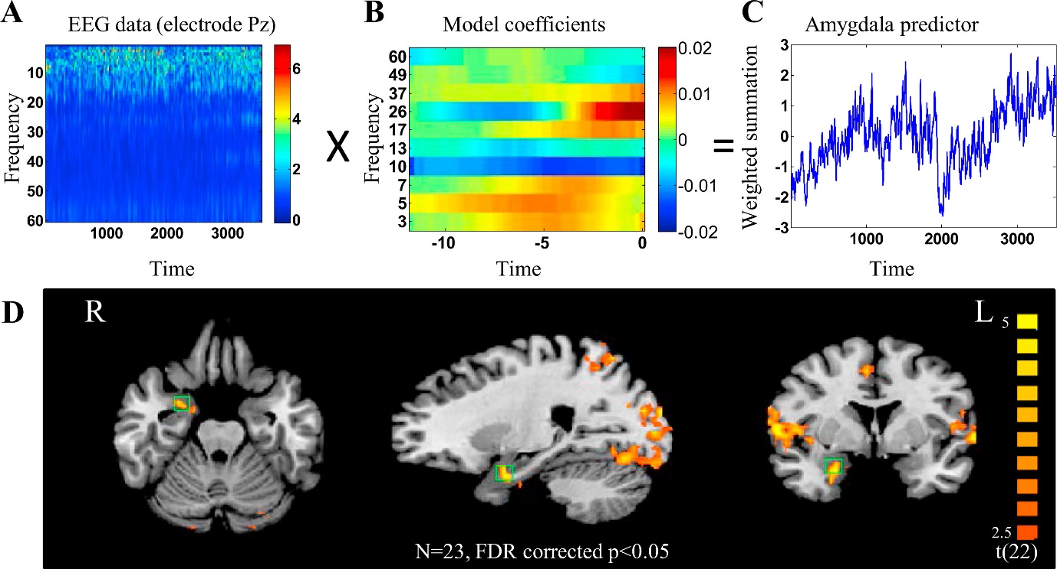
Supplementary Figure B.1 The amygdala-electrical fingerprint (Amyg-EFP) prediction model. Recorded EEG data (A) were multiplied by the common model coefficient matrix (B) to produce the predictor of the right amygdala BOLD activity (C). (A) The EEG data used for the model were a time/frequency matrix recorded from electrode Pz including all frequency bands in a time window of 12 s. (B) The common model coefficients matrix. [CH] × [FQ] × [Delay] × [Time]. FMRI BOLD activity at time T can be predicted by the EEG using the frequency intensity FQ of electrode CH in delay D from T. In our case, CH includes a selected single electrode (Pz). (C) The predicted right amygdala BOLD activity time course. (D) Experiment 1 whole-brain Amyg-EFP correlates. Correlation maps obtained from the whole-brain random-effects general linear model analysis, using the Amyg-EFP during neurofeedback as a predictor, are shown in the axial, sagittal, and coronal views (left to right). The area that was used originally (on a different group) to develop the Amyg-EFP model is marked by a green square. FDR, false discovery rate; L, left; R, right. Adopted from (5).
Animated Scenario Feedback Generation
The NF interface features a virtual hospital waiting room, serving as a metaphor for arousal in a realistic context. Characters in the room exhibit either a resting or agitated state, with the overall agitation level determined by the ratio of these states. This mechanism facilitates seamless visual transitions as individual characters change their states; consequently, the overall ambiance of the room shifts between increased agitation or heightened relaxation (6). The ratio between characters sitting down and protesting at the counter is considered to be a two state Boltzmann distribution (7), whose evolution is driven by a ‘virtual temperature’ when value is derived from the momentary value of the targeted Amyg-EFP signal power. In the scenario, the probability (P value) of a momentary signal during the 'Regulate' phase is sampled based on the preceding 'Watch' distribution. This P value dictates the likelihood of virtual characters moving within the virtual room, and the character distribution is adjusted accordingly. A matching soundtrack, recorded in a real hospital, complements the system output, with agitation levels adjusted based on signal values. During the 'Watch' condition, 75% of the characters congregate at the front desk while expressing their frustration through body and verbal language. The system is implemented using the Unreal Development Kit game engine, overseeing key animations (walking, sitting, standing, and protesting) and managing smooth transitions for individual characters.
In contrast to Goldway et al.'s (8) research, which utilized two interfaces (unimodal auditory and multimodal animated waiting room), our study employed only the 3D audio-visual scenario interface for feedback. This choice was based on evidence demonstrating that the 3D audio-visual interface yields higher NF learning success (6, 8).
Statistical Analyses
Evaluation of Clinical Feasibility
To assess the clinical impact of the intervention on the overall symptomatology of FM, we utilized self-report scales and subscales to evaluate various components: a) Overall disease burden [Symptom Severity Score (SSS)] (9); b) Diverse manifestations of FM [Fibromyalgia Impact Questionnaire (FIQ)] (10); c) Chronic widespread pain [Widespread Pain Index (WPI)] (9); d) Chronic fatigue (FIQ-fatigue sub-score); e) Trait-Anxiety [State-Trait Anxiety Inventory (STAI-T)] (11); f) Cognitive symptoms [Cognitive index core (SSS-Cog)] (9).
We assessed global clinical feasibility across three measurement time points (MTP): pre-intervention, post-intervention, and a follow-up (FU) at 10-12 months (8). To examine our primary hypothesis that Amyg-EFP-NF would yield a greater clinical improvement than each control group, we employed linear mixed-models analysis (LMM; using SPSS version 23), suitable for multiple measurements and incomplete data. The model included a between-subject fixed Group factor (NFT, NFS, and TAU), a covariate for measurement time-point (MTP; pre, post, and FU), and clinical self-report scores as the dependent variable. Missing data were handled using restricted maximum likelihood estimation, and a compound symmetry covariance structure was assumed. Moreover, to ensure a detailed assessment of the clinical effect, we performed planned contrasts that scrutinized the distinctions between the genuine NF group and each control group (i.e., NFT vs. NFS and NFT vs. TAU) at different measurement intervals (i.e., post-pre and FU-pre). Furthermore, to gauge the magnitude of the clinical effect within each group, we employed complementary analyses. For each group, we utilized repeated measures ANOVA with MTP (pre, post, and FU) as a within-subject variable. Subsequent post-hoc comparisons were conducted to assess both immediate clinical effects (post vs. pre) and the enduring clinical impact (FU vs. pre) for each group. All reported P values were two-tailed. An initial comparison of the first measurement point was conducted for all clinical indexes. If a significant difference between the groups was identified, no additional between-group comparisons were conducted. Sphericity assumptions were tested using Box’s test for equality of covariance matrices and Levene’s test for equality of variances. If the sphericity assumption was violated, corrected statistics and P values were used.
Evaluation of NF Learning Success
We determined success in NF by the significant gap between the 'Regulate' and the 'Watch' (the local baseline) conditions. For evaluating successful downregulation within each group and comparing the NFT to the NFS group, repeated measures ANOVA was employed with Condition ('Watch'/'Regulate') and Session (10 sessions) as within-subject variables, and Group (NFT/NFS) as a between-subject variable. Post-hoc comparisons (Bonferroni) were further conducted to assess the success of each group's NF sessions individually. To examine the sustainability of the acquired skill, we assessed patients' ability to volitionally regulate Amyg-EFP in the absence of online feedback during a transfer run. A repeated measures ANOVA was performed, with the Transfer score (regulate vs. baseline) as the dependent variable, Groups (NFT vs. NFS) as the between-subject factor, and Sessions (10 sessions) as the within-subject factor. Furthermore, we calculated a "learning slope" representing the regression line slope over feedback values from all NF training sessions to gauge overall performance across the training procedure. Cohen's D, a mean effect size (12), served as an NF success parameter for each of the ten measurement points. These metrics were analyzed using a linear mixed model in IBM SPSS 23, incorporating a random intercept and fixed effects of Session, Group, and Group x Session, with the latter as the primary focus. Initial comparison of the first measurement point between NF groups revealed no significant difference in success scores (mean effect size) during the first NF session (NFT = -0.400±0.603, NFS = -0.530±0.353, F_{(1,32)} = 0.495, p = 0.4887), and thus met the required model assumptions.

Supplementary C- Methodological Validations
To establish a causal clinical efficacy of the Amy-EFP-NF intervention, we employed a double-controlled design (i.e., TAU and NFS). As previously noted, to prevent an excessively rewarding or frustrating experience, we provided feedback to the sham group with an approximate 52% success rate. However, when administering a placebo NF condition, it is essential to ensure that frustration does not act as a confounding factor (12, 13, 14). Thus, to confirm that the type of feedback (genuine or sham) did not impact satisfaction levels regarding the NF intervention, we administered a self-reported questionnaire:
- Overall satisfaction post-participation in the NF training.
- Comprehension of instructions and explanations regarding the method.
- Evaluation of how well the medical staff addressed pain or other symptoms and aided in coping.
- Likelihood of recommending study participation to others.
- Interest in continuing participation in the NF training.
Patients rated these items on a scale of 1-10, with 10 indicating the highest satisfaction. Subsequently, a t-test was employed to assess between-group differences.
A one-sample t-test indicated significant satisfaction levels with the NF training in both NF groups. No significant differences were found between the groups across all items.

Supplementary Table C.1- Satisfaction Level Regarding the NF-Intervention
 |  | Mean | Std. Deviation | One-Sample T-Test |  | Between-Group T-Test
 |  | Mean | Std. Deviation | t | Sig. (2-tailed) | t | Sig. (2-tailed)
Overall satisfaction | NFT | 7.57 | 2.461 | 14.098 | .000 | 0.310 | 0.759
Overall satisfaction | TFS | 7.31 | 2.323 | 11.341 | .000 | 0.310 | 0.759
Comprehension of instructions and explanations | NFT | 9.14 | 1.153 | 36.350 | .000 | 1.154 | 0.257
Comprehension of instructions and explanations | TFS | 8.62 | 1.502 | 20.679 | .000 | 1.154 | 0.257
Staff response to symptoms | NFT | 8.67 | 2.517 | 15.781 | .000 | -0.332 | 0.742
Staff response to symptoms | TFS | 8.92 | 1.498 | 21.479 | .000 | -0.332 | 0.742
Recommend on the study | NFT | 8.10 | 2.567 | 14.450 | .000 | -0.072 | 0.943
Recommend on the study | TFS | 8.15 | 1.772 | 16.588 | .000 | -0.072 | 0.943
Interest in continuing participation in the NF training | NFT | 6.90 | 2.965 | 10.672 | .000 | -1.265 | 0.215
Interest in continuing participation in the NF training | TFS | 8.08 | 1.935 | 15.051 | .000 | -1.265 | 0.215

Mental Strategies Analysis
We investigated the mental strategy reports to ensure that clinical and brain changes do not solely result from the mental strategy applied during NF (12-13). Our objective was to confirm no discrepancy between the NF groups concerning their inclination to choose a specific mental strategy. The identified mental strategies were subsequently categorized into three aspects:
(A) Psychological attributes: This category encompassed the level of arousal (0=High/1=Low), the valence directionality of the strategy (0=Positive/1=Negative), and the perception of agency while executing the mental strategy (0=No/1=Yes).
(B) Manner characteristics: This category comprised the inclination to switch between multiple strategies (defined as 0) versus adhering to one strategy (defined as 1), the degree of the strategy's engagement with the feedback interface (0=Detached from interface/1=Engaged with interface), and the level of content repeatability (Rhythmic: 0=Low/1=High).
(C) Emotional attributes: Mental strategies were categorized based on the predominant emotion felt by patients during execution, considering ten basic emotions: happiness, love, calmness, sadness, anger, fear, distress, worry, frustration, and tension (0=High/1=Low).
Mann-Whitney test revealed no significant differences between the groups concerning the mental strategies employed during NF training across all three dimensions (see Supplementary Table C.2). Both groups exhibited similar patterns in psychological attributes, demonstrating a preference for strategies characterized by low arousal, positive valence, and a moderate sense of agency during execution. Additionally, the analysis of Manner characteristics revealed a shared tendency in both groups to employ a single predominant strategy rather than switching between multiple strategies. Furthermore, both groups favored strategies that exhibited a more detached interaction with the interface, characterized by a moderate rhythmic repetition of content (see Supplementary Figure C.1 and Table C.2). Lastly, an examination of the emotional attributes associated with the employed mental strategies did not yield significant differences between the groups. Moreover, an ANOVA test underscored a notable inclination within both NF groups towards employing strategies with positive emotions (Mean = 0.197±0.109; the average score of happiness, love, and calmness), as opposed to negative emotions (Mean = 0.029±0.031; the average score of sadness, anger, fear, distress, worry, frustration, and tension) during the execution of mental strategies (see Supplementary Table C.2). This distinction was statistically significant (F_{(1,32)} = 61.39, p = 0.000, ηp² = 0.657), with no observed significant intergroup differences (F_{(1,32)} = 61.39, p = 0.000, ηp² = 0.657).

Supplementary Figure C.1- Exploration of the Mental Strategies
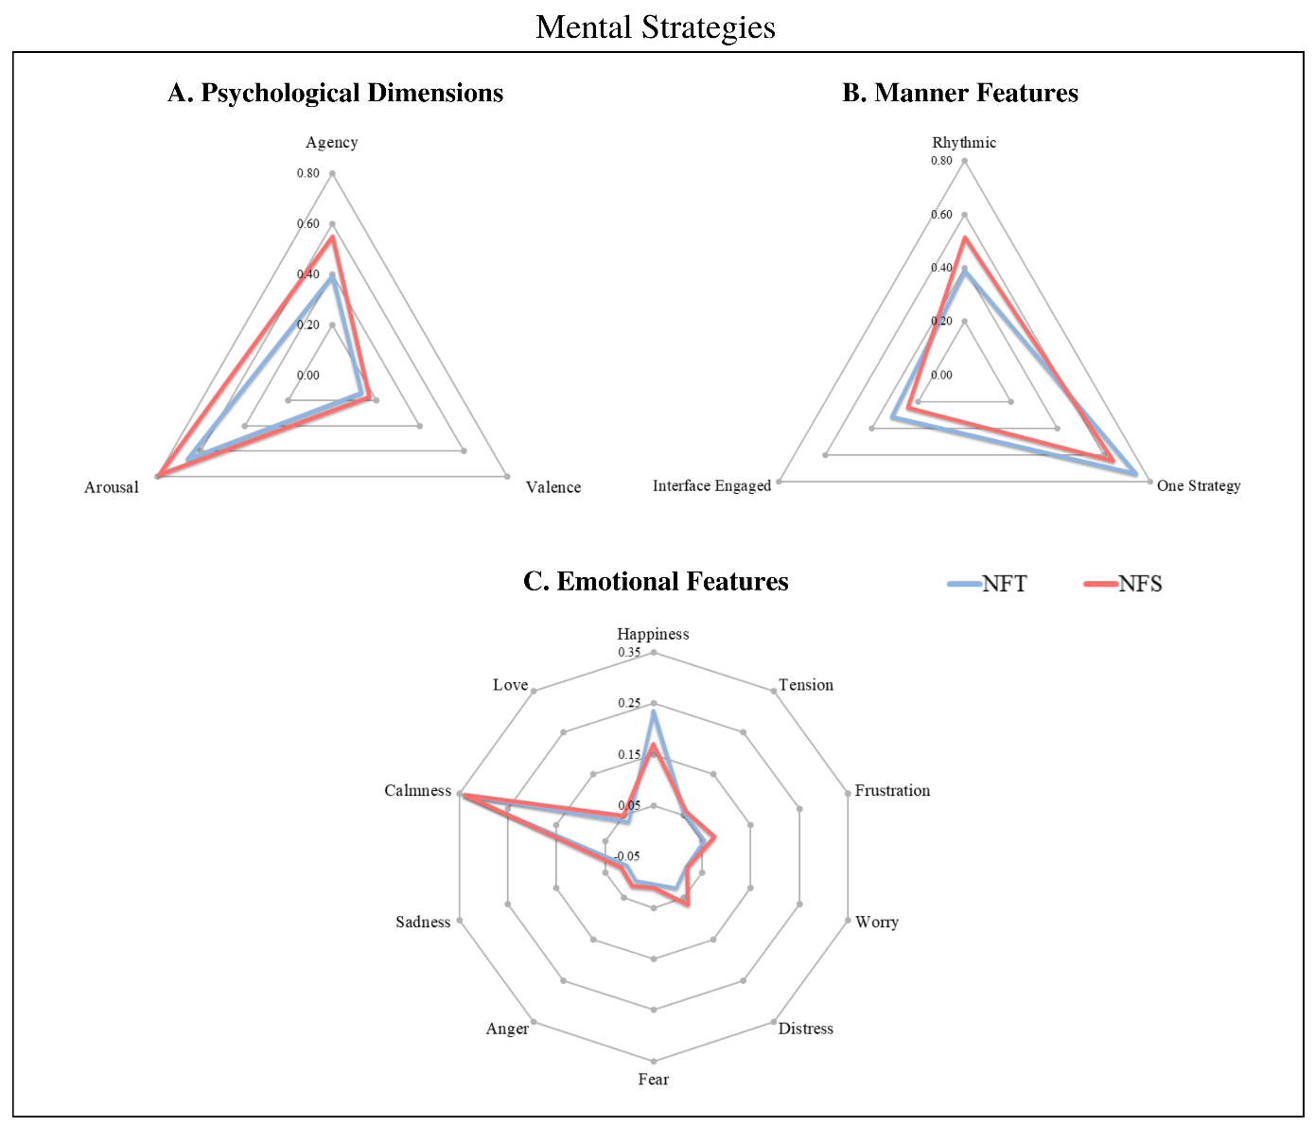

Supplementary Table C.2- Mental Strategies Classification and Examination of Between-Groups Difference.
Psychological attributes
 | Agency | Arousal | Valence
NFT | .396 | .663 | .135
NFS | .551 | .788 | .172
Mann-Whitney U | 101.5 | 121.0 | 130.0
P.V | .218 | .600 | .834

Manner characteristics
 | Rhythmic | Interface Engaged | One Strategy
NFT | .390 | .313 | .739
NFS | .515 | .243 | .643
Mann-Whitney U | 107.0 | 129.0 | 116.0
P.V | 0.309 | 0.807 | 0.484

Emotional attributes
Positive Emotion

 | Happiness | Love | Calmness
NFT | .235 | .034 | .341
NFS | .171 | .050 | .339
Mann-Whitney U | 132.0 | 130.5 | 134.5
P.V | .889 | .834 | .944

Negative Emotion

 | Sadness | Anger | Fear | Distress | Worry | Frustration | Tension
NFT | .005 | .007 | .004 | .026 | .017 | .055 | .054
NFS | .017 | .020 | .010 | .065 | .020 | .075 | .059
Mann-Whitney U | 102.0 | 106.5 | 128.5 | 112.0 | 129.0 | 133.0 | 135.5
P.V | .232 | 0.292 | .780 | .400 | .807 | .917 | .972

The Mann-Whitney test accounts for groups' differences (NFT vs. NFS) regarding all mental strategy features. The Table consists of groups' mean scores, between-group Mann-Whitney U values, and p values.
Effectiveness of Amyg-EFP-NF: Proportion of NF Successful Modulators
We assessed the proportion of good and poor modulators in each NF group to evaluate the effectiveness of Amyg-EFP-NF training using a 3D audio-visual animated scenario interface for feedback. Patients were classified as good modulators if their average EFP amplitude was lower during the 'Regulate' condition compared to the 'Watch' condition across all sessions, indicating successful downregulation. The results demonstrated that a relatively high proportion of participants were successful modulators in both NF groups (NFT: 86%; NFS: 85%; see Supplementary Figure C.2). Furthermore, there was no significant difference in the proportions of responders between the two NF groups (Z = -0.31, p = 0.76), suggesting that successful downregulation was achieved in patients with FM regardless of group affiliation.

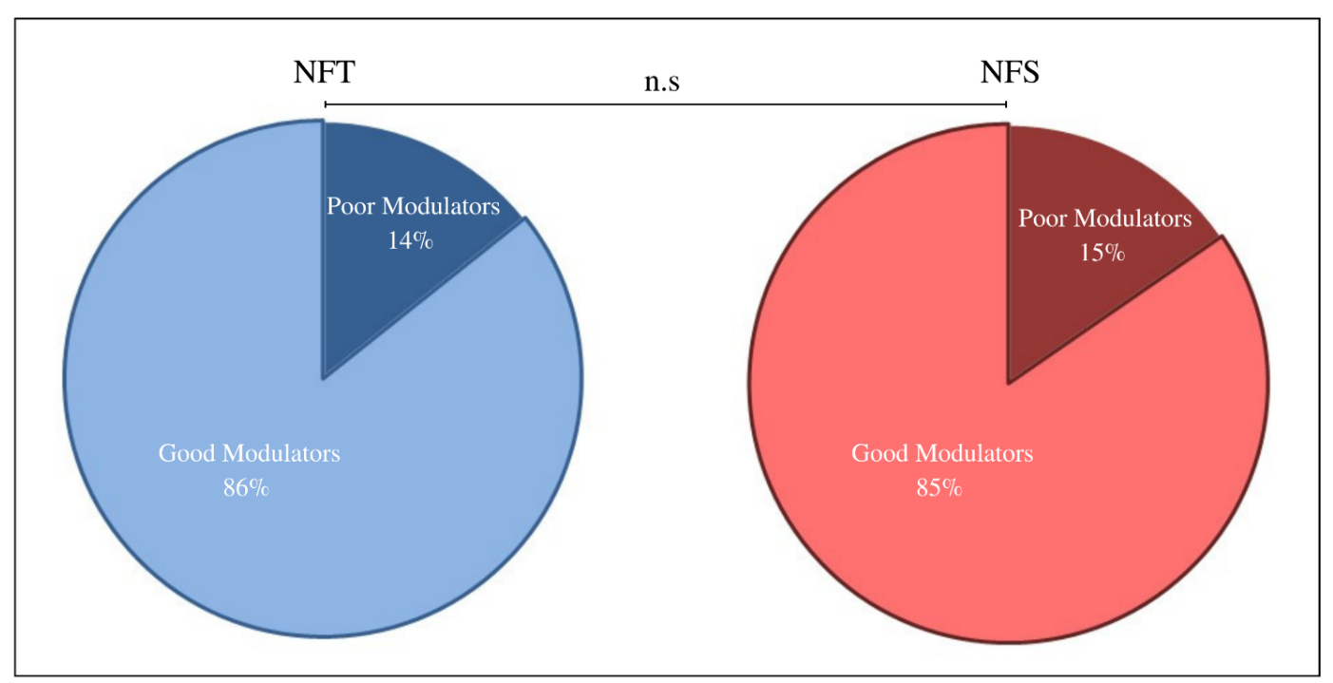
Supplementary Figure C.2- Proportion of Good and Poor Amyg-EFP-NF Modulators

References
1. Meir-Hasson Y, Kinreich S, Podlipsky I, Hendler T, Intrator N. An EEG finger-print of fMRI deep regional activation. Neuroimage. 2014;102:128-141.
2. Meir-Hasson Y, Keynan JN, Kinreich S, et al. One-class FMRI-inspired EEG model for self-regulation training. PLoS One. 2016;11(5):e0154968.
3. Allen PJ, Polizzi G, Krakow K, Fish DR, Lemieux L. Identification of EEG events in the MR scanner: the problem of pulse artifact and a method for its subtraction. Neuroimage. 1998;8(3):229-239.
4. Allen PJ, Josephs O, Turner R. A method for removing imaging artifact from continuous EEG recorded during functional MRI. Neuroimage. 2000;12(2):230-239.
5. Keynan JN, Meir-Hasson Y, Gilam G, et al. Limbic activity modulation guided by functional magnetic resonance imaging–inspired electroencephalography improves implicit emotion regulation. Biological psychiatry. 2016;80(6):490-496.
6. Cohen A, Keynan JN, Jackont G, et al. Multi-modal virtual scenario enhances neurofeedback learning. Frontiers in Robotics and AI. 2016;3:52.
7. Cavazza M, Charles F, Gilroy SW, et al. Integrating virtual agents in BCI neurofeedback systems. 2014:1-8.
8. Goldway N, Ablin J, Lubin O, et al. Volitional limbic neuromodulation exerts a beneficial clinical effect on Fibromyalgia. NeuroImage. 2019;186:758-770.
9. Galvez-Sánchez CM, De la Coba P, Duschek S, Reyes del Paso GA. Reliability, factor structure and predictive validity of the Widespread Pain Index and Symptom Severity scales of the 2010 American College of Rheumatology criteria of fibromyalgia. Journal of Clinical Medicine. 2020;9(8):2460.
10. Burckhardt CS, Clark Sa, Bennett RM. The fibromyalgia impact questionnaire: development and validation. J rheumatol. 1991;18(5):728-33.
11. Spielberger CD, Gonzalez-Reigosa F, Martinez-Urrutia A, Natalicio LF, Natalicio DS. The state-trait anxiety inventory. Revista Interamericana de Psicologia/Interamerican journal of psychology. 1971;5(3 & 4)
12. Paret C, Goldway N, Zich C, et al. Current progress in real-time functional magnetic resonance-based neurofeedback: Methodological challenges and achievements. NeuroImage. 2019;202:116107.
13. Sorger B, Scharnowski F, Linden DE, Hampson M, Young KD. Control freaks: Towards optimal selection of control conditions for fMRI neurofeedback studies. Neuroimage. 2019;186:256-265.
14. Ros T, Enriquez-Geppert S, Zotev V, et al. Consensus on the reporting and experimental design of clinical and cognitive-behavioural neurofeedback studies (CRED-nf checklist). Oxford University Press; 2020.

