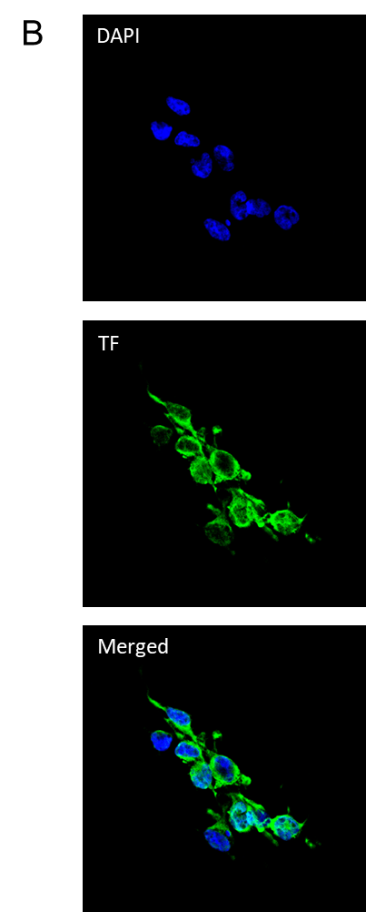
Supplementary Figure 1

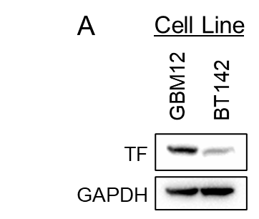

Tissue Factor is highly expressed in GBM12 cultures but exhibits low expression in BT142 cultures. (A) Immunoblot on whole cell lysates derived from GBM12 and BT142 cell cultures showing Tissue Factor and GAPDH expression. (B) Immunocytochemistry of GBM12 cell cultures showing cytoplasmic/membranous staining of Tissue Factor. Images were taken at 40x magnification.

