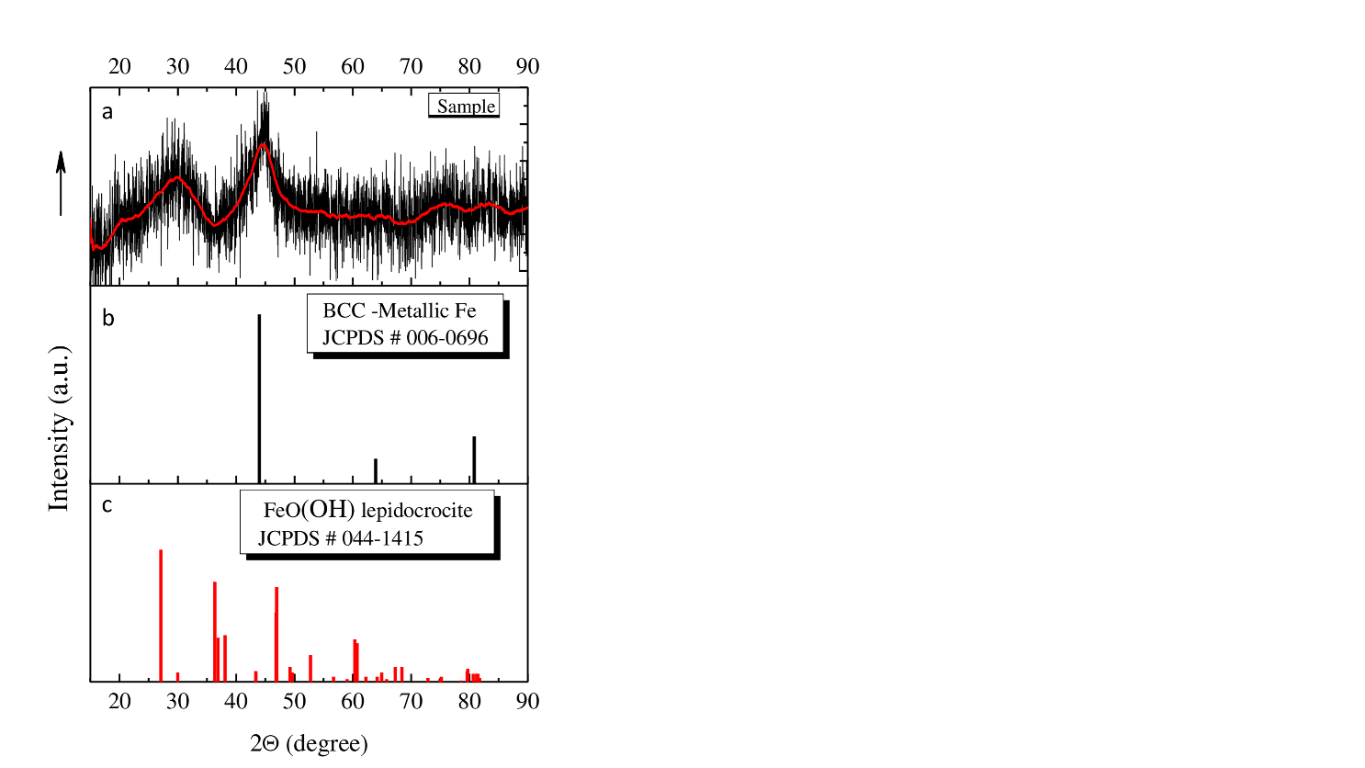
Fig. S1 Characterization by X-ray diffraction (XRD) pattern of iron NPs obtained from borohydride reduction of FeBr₂ 5X10⁻³M in water/isopropanol solution. A. XRD diffraction pattern if iron NPs, B. Crystal structure (BCC)and characterization of metallic iron NPs (JCPDS#00-0696), c. Characterization of oxidizes phase of iron NPs lepidocrocite: FeO (OH) (JCPDS #044-4015)

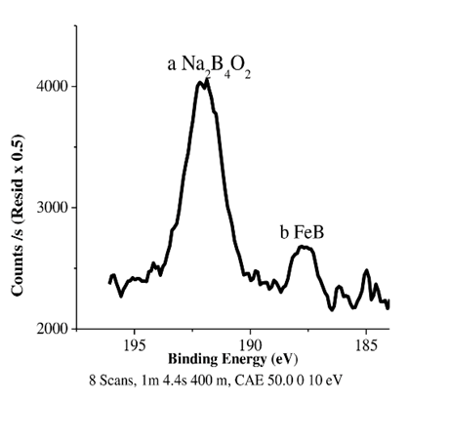

Fig.S2 XPS binding energies of boron by products in iron NPs synthesize by NaBH₄. Reduction in isopropanol/water solution. Peaks are related to boron binding energies a. Na₂B₄O2, b. FeB
TABLE 1 S2: XPS chemical analysis and surface atomic score levels of boron by, oxygen and iron determined In iron NPs
Surface Atomic Score Levels %
WASHING SOLUTIONS | BORON | OXYGEN | IRON
Clorophorm 13 49 19.1
Acetone 11 60 23.06
Hexane 6 72 17.95
Toluene 5 69 17.48
Isopropanol 22 42 14.23
**Isopropanol/water 14 51 13.77
Toluene/methanol 5 38 19.66
Acetone/methanol 5 42 19.75
Clophorm/methanol 23 19.63 14.11
hexane/methanol 2 38 16.56

**solution use in all synthesis process, to dilute FeBr₂, H₂AuCl₄ 3[H₂O] and NaBH₄.

