Supplementary information
Supplementary Figs: 1-23
Supplementary Tables: 1

Supplementary Fig.1: Heatwave days with daily T_{max} > 36.1 °C for > 1 hour over the entire crop season in 2021 and 2022, respectively. Delta temperature is calculated by the average seasonal difference between canopy air temperature inside and outside facilities. Source data used for calcualting heatwave days is available in ref¹.
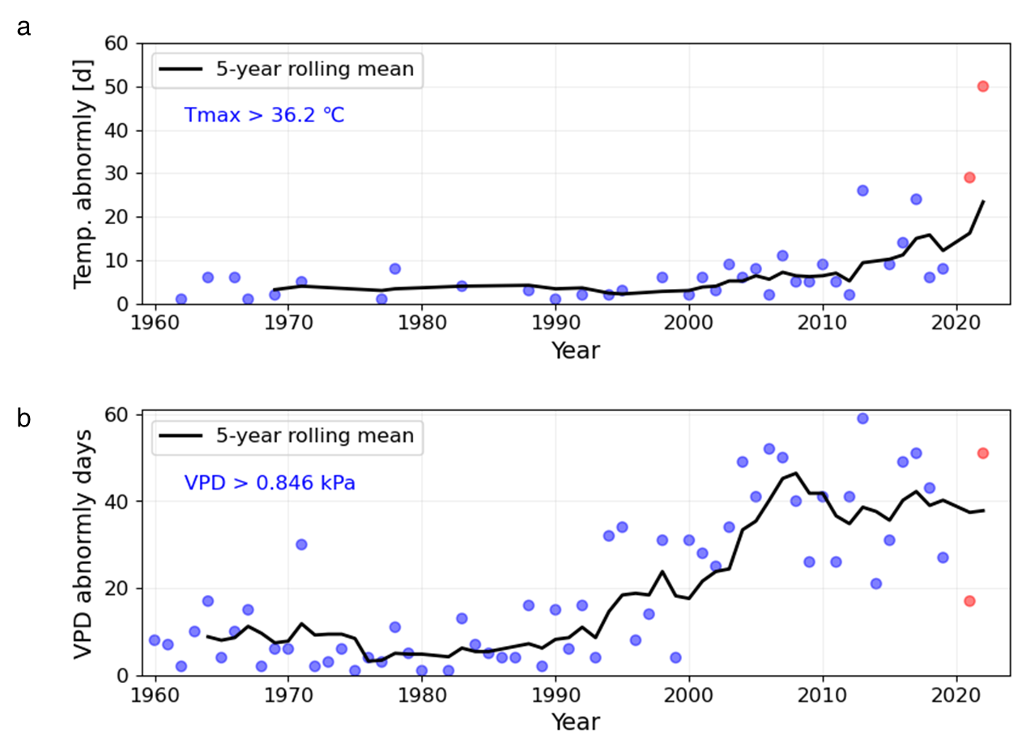
Supplementary Fig. 2: Climate extreme definition and severity of 2021 and 2022 heatwaves (red points, calcaulted from ref¹). a, Trend of extreme frequency in July-August for the period of 1961-2022 that air temperature exceeds 36.2℃ at the experiment site. Heat events is estimated using the mean daily maximum temperature (Tmax, 31.2 ℃) of July-August for the period of 1961-1990 as reference climate. b, Trend of frequency of VPD for the period 1961–2022 (data retrived from ref².), estimated using VPD calculated from air temperature and vapor pressure. The critical VPD (0.846 kPa) is determined by the mean VPD at the heat extreme threshold of 36.2 ± 2.76 ℃ in July-August of 1961-1990.

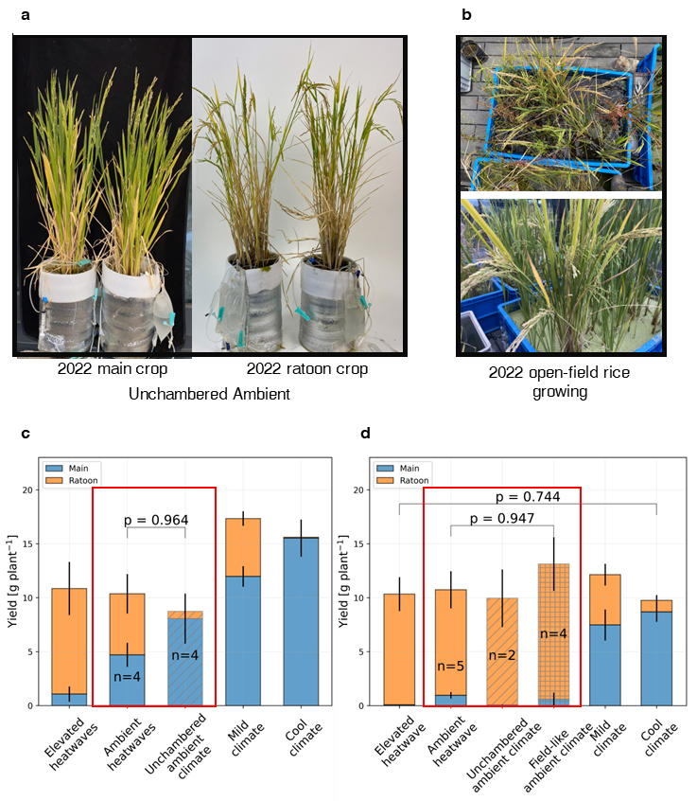
Supplementary Fig. 3: Main and ratoon yield of rice cultivated under true ambient environments outside of AmbControl facilities In both 2021 (c) and 2022 (d).

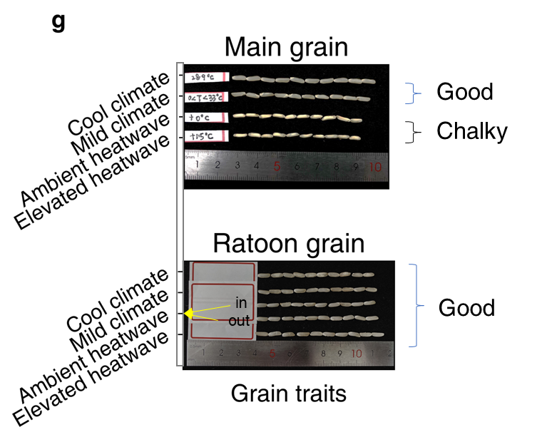
Supplementary Fig. 4: Grain traits (such as chalkiness) of main crop and ratoon crop grains harvested from different climate scenarios in 2022

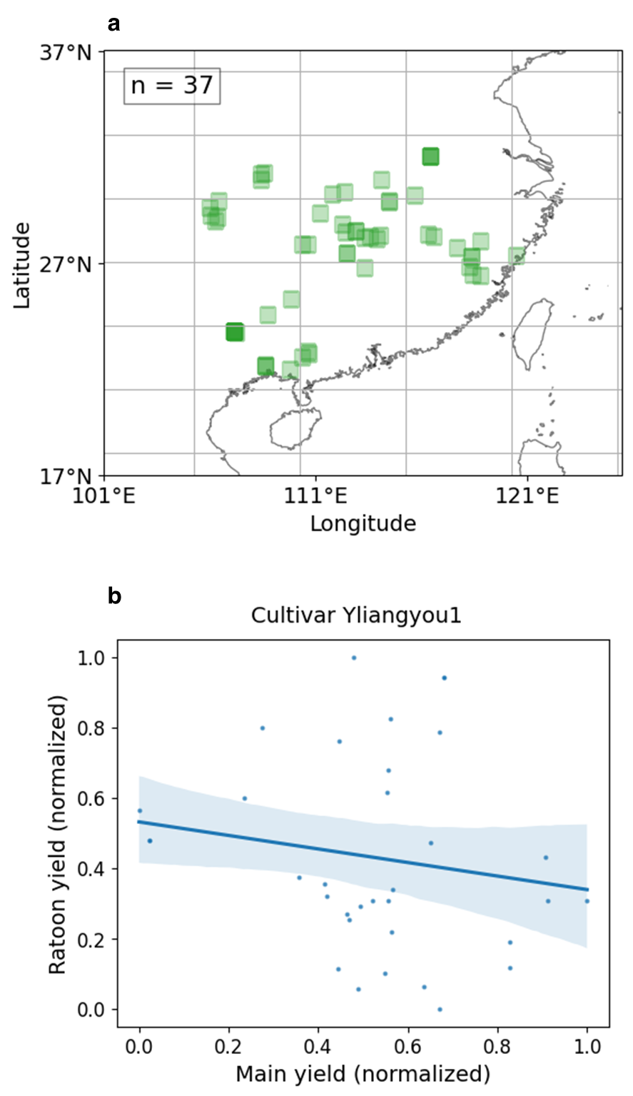
Supplementary Fig. 5: Ratoon records of Yliangyou1 (N = 37 site-year surveys) synthesized from literature (a) and the yield relationship of the main crop and ratoon crop yield of rice cultivar Ylaingyou1.

Supplementary Fig. 6: Geographic distribution of rice yield compensation following heatwaves, floods, droughts, and artificial mowing.

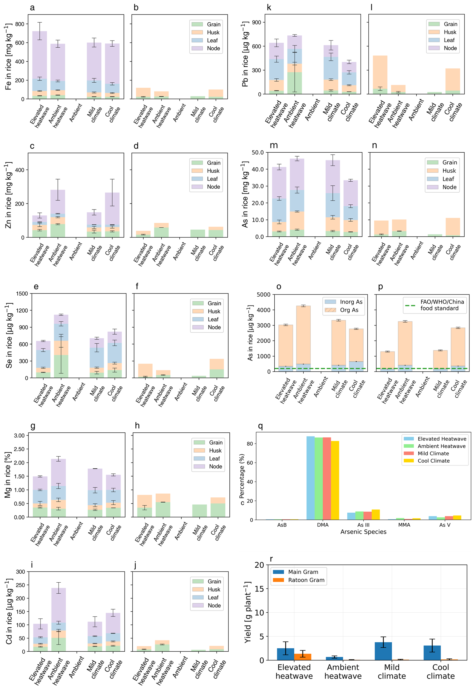
Supplementary Fig. 7: Supplimentary experiment in 2021. a,b, Bar plots showing the levels of oAs and iAs in main crop and ratoon crop rice grain across different climate scenarios for the year 2021. c, The distribution of different As species in the samples. d, Stacked bar chart illustrating tAs concentrations in various parts of rice plants, including grain, husk, leaf and node. e, rice yield of main crop and ratoon crop rice. Error bars denote the se of replicates (N = 4)

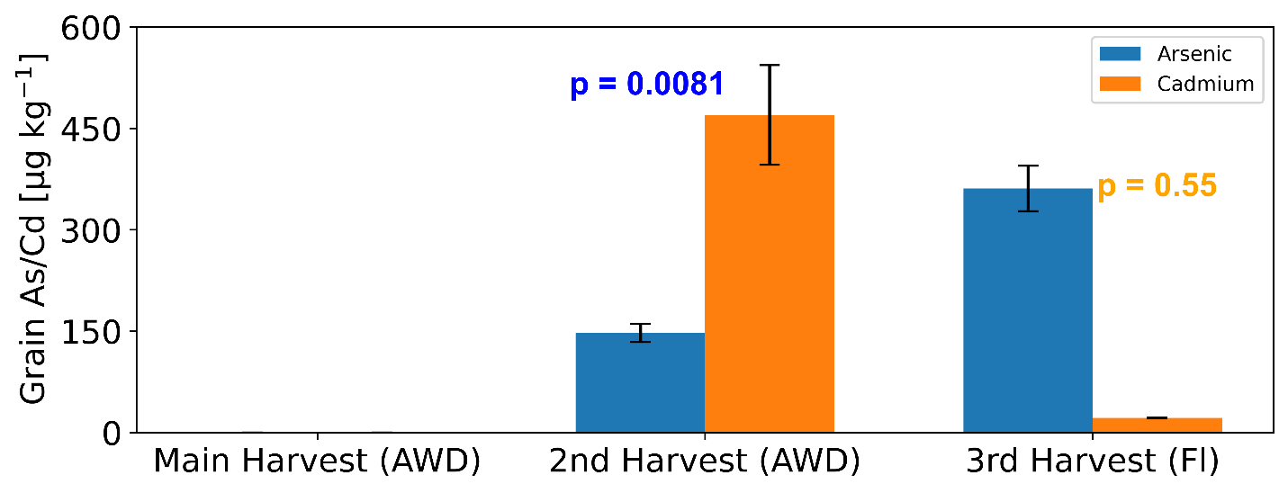
Supplementary Fig. 8: The concentrations of total grain As and Cd harvested from As-elevated soils (tAs 47 mg kg⁻¹) in open field. During the main crop season, soil was under alternate wetting and drying (AWD). Due to zero harvest under 2022 heatwaves, alternate wetting and drying practice was extended to the second ratoon harvests. At later stage, soils were kept flooded to about 5 cm surface water. Bar data are shown as mean ± sd (N = 3).

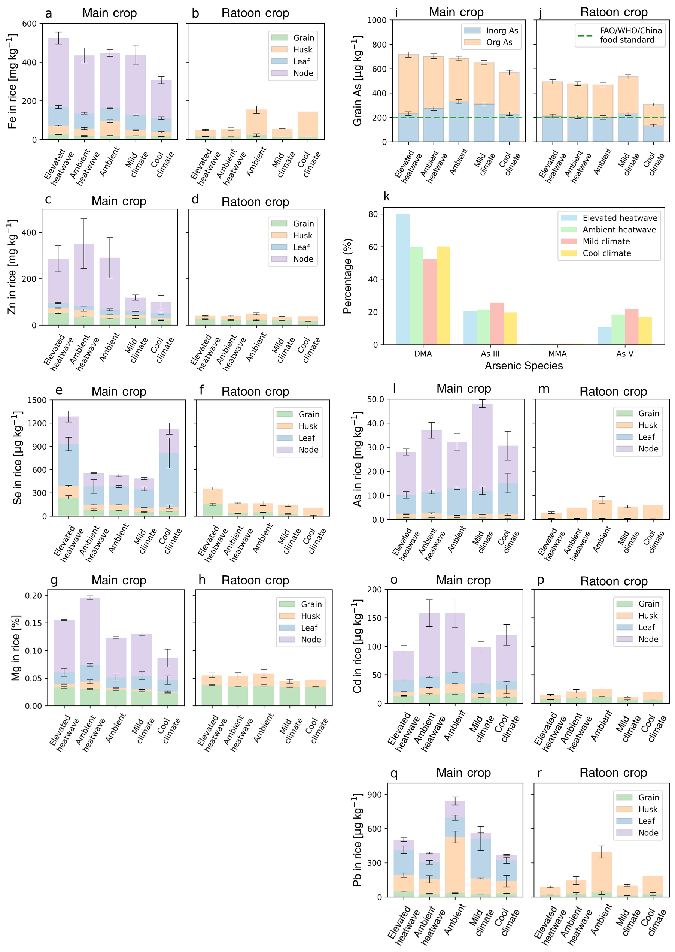
Supplementary Fig. 9：Concentrations of micronutrients i.e., Fe, Zn, Se, macronutrient of Mg, and toxic trace elements of As , Cd and Pb in different portions i.e., node, leaf, husk, and grain of rice plants under different climate scenarios from the 2021 experiments. Error bars indicate the S.E. of the mean (N = 4). For As (i and k), grain As is shown by stacked bar chart using oAs and iAs concentrations while detailed As speciation percentages is also shown accordingly.

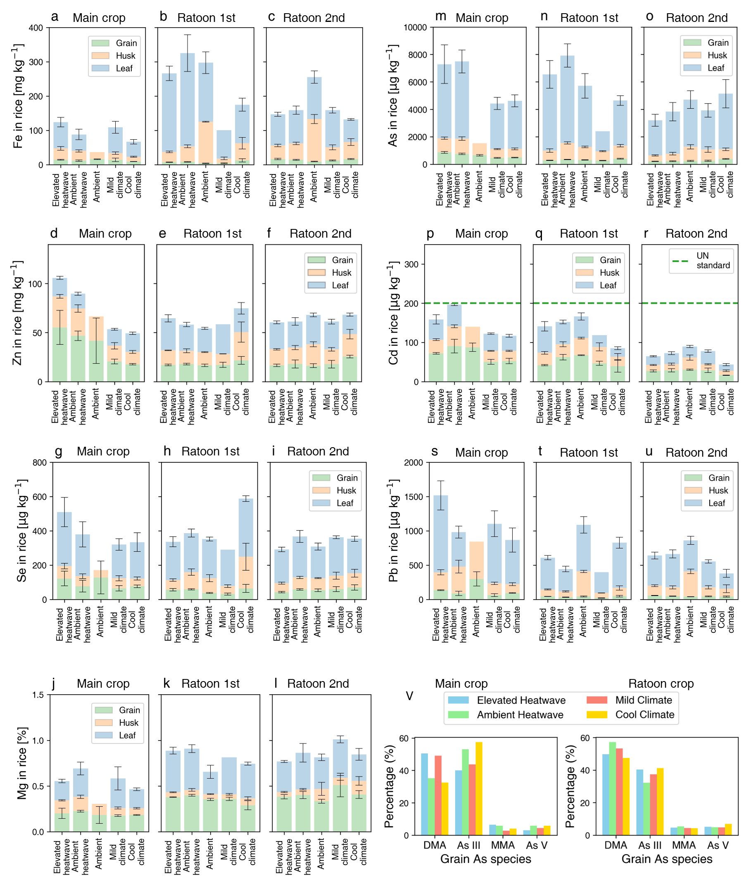
Supplementary Fig. 10: Concentrations of micronutrients i.e., Fe, Zn, Se, macronutrient of Mg, and toxic trace elements of As, Cd and Pb in different portions i.e., node, leaf, husk, and grain of rice plants under different climate scenarios from the 2022 experiments. v, grain As speciation percentages is presented as means from 2-7 measurements. Error bars indicate the S.E. of the mean (N =3-5).

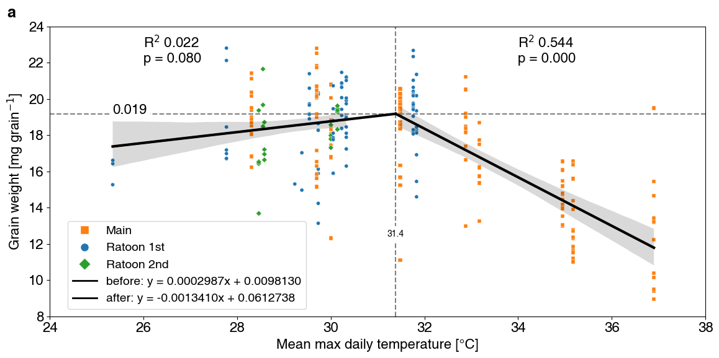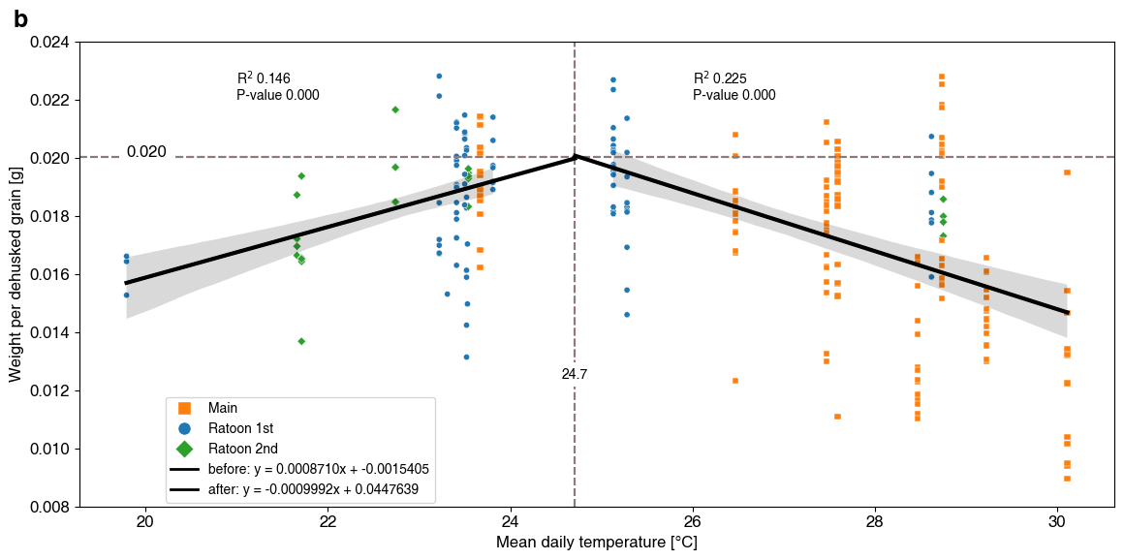
Supplementary Fig. 11: Piecewise linear fit and regression analysis of grain weight versus daily maximum and mean temperatures over corresponded crop seasons. a, Scatter plot showing grain weight versus mean daily maximum temperature (Tmax, °C) and daily mean temperature (T_{mean,} °C), respectively, with data points colored by crop season ('Main', 'Ratoon 1st', 'Ratoon 2nd') before and after the optimized breakpoints (31.4°C and 24.7°C). Vertical and horizontal dashed lines indicate the optimized breakpoint and its corresponding grain weight, respectively. Shade areas denote 95% confidence intervals.

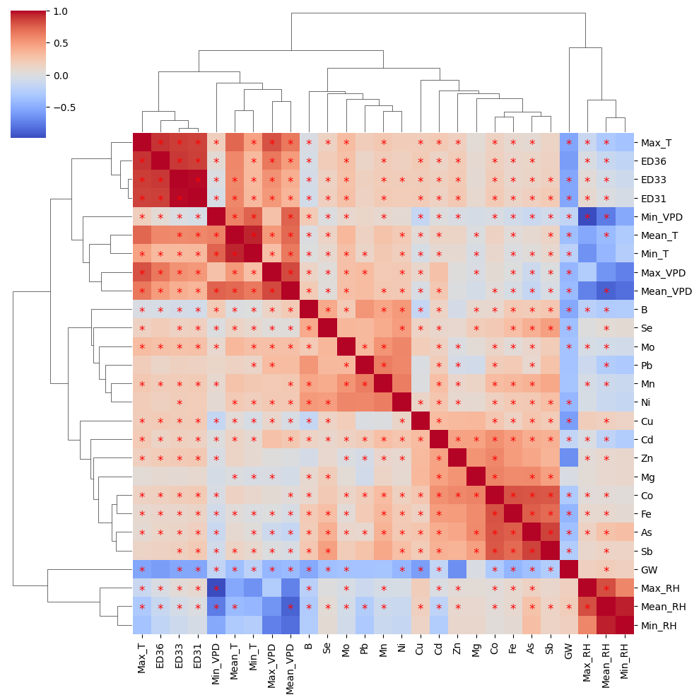
Supplementary Fig. 12: Clustermap of the Pearson correlation matrix for environmental variables and ion concentrations in rice grains harvested from both years of 2021 and 2022. The heatmap shows the strength of correlations between selected features, including temperature, relative humidity (RH), vapor pressure deficit (VPD), and various grain metal(loid)s’ concentrations. The colorbar represents the correlation coefficient, ranging from -1 (negative correlation) to +1 (positive correlation). Stars denote P values < 0.05. For variables such as ED36, ED33 and ED31, they denote extreme days that daily Tmax > 36°C, 33°C, and 31°C, respectively.

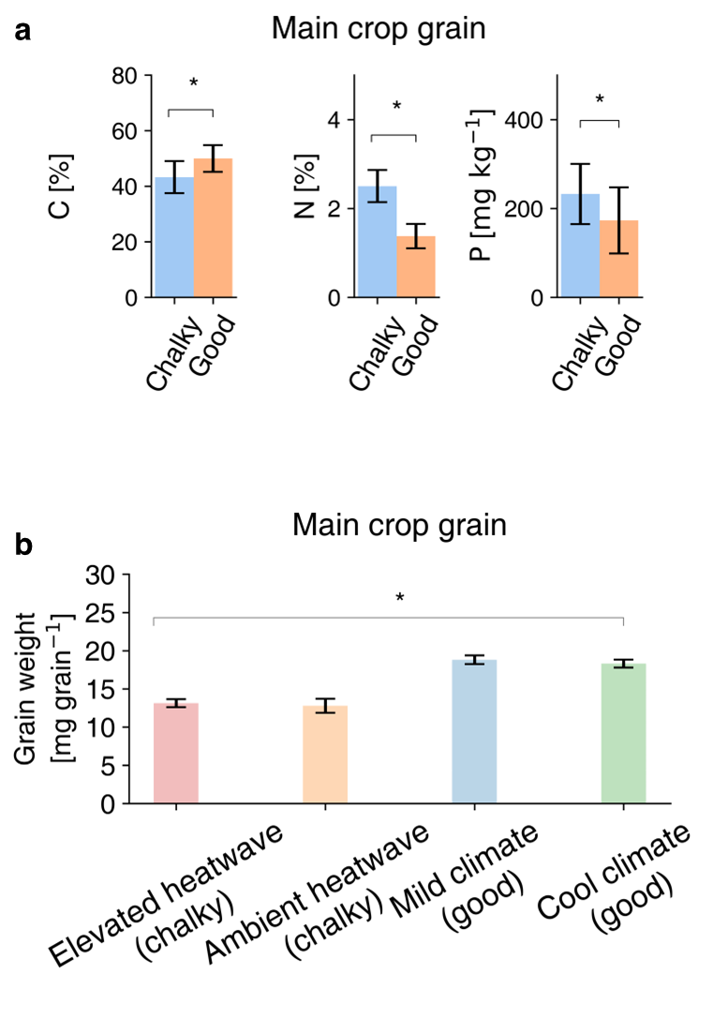
Supplementary Fig. 13: The concentrations of macro elements (a) of C, N, and P and (f) grain weight under different climate conditions. Bar data are shown as mean ± sd (N = 10 – 48). Statistical significance is indicated by stars, with differences assessed at P = 0.05 using t-test for panel (a) and ANOVA for panel b.

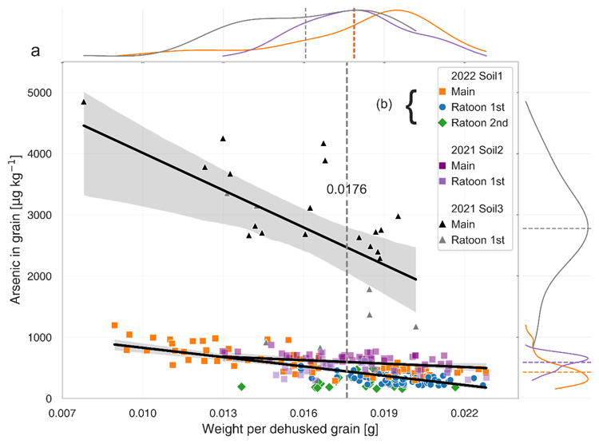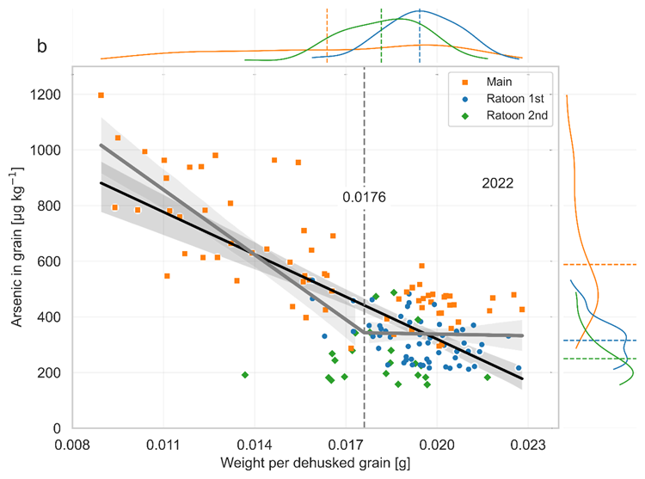
Supplementary Fig. 14: Relationships between grain As concentration and grain weight in both 2021 and 2022 experiments. The data from supplementary experiment using high-As soil in 2021 are also included in figure a. Linear regression (±95% confidence interval) is used for data from different soils. b, linear regression is applied to combined data from two years but excluding the supplementary experiments. A piecewise linear regression is also applied to determine potential turning point at grain weight 0.0176 g.

Supplementary Fig. 15: Porewater concentrations of As at the grain filling stages of main crop and ratoon crop seasons in 2022. Analysis includes porewater from soils with and without plant vegetation. Error bars denote sd from N = 3-5 replicates.

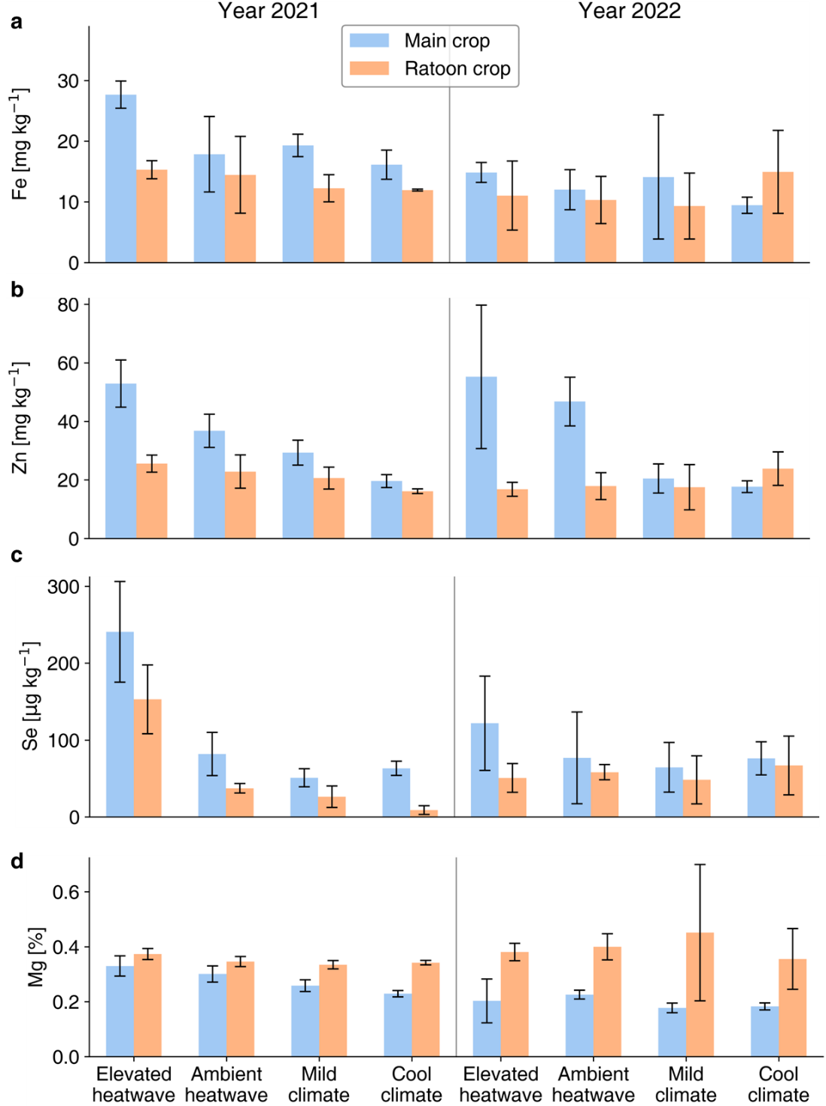
Supplementary Fig. 16: Heatwave effects and ratooning effects on micro- and macronutrients. The concentrations of trace elements (a, b, c) of iron (Fe), zinc (Zn) and selenium (Se), medium element (d) of magnesium (Mg) under different climate conditions, crop seasons and years. Bar data are shown as mean ± sd (N =4 – 5).

Supplementary Fig. 17: Essential elements in main and ratoon rice grains. The two-year combined heatwave effect (a) and ratoon effect (b) were estimated using Fisher's method for combining p-values. Paired t-tests were used to compare the means of two related groups, such as the main and ratoon crop rice. For e, bar data (mean ± S.E.) were aggregated from 2022 heatwave scenarios (elevated and ambient heatwave, N =10 – 13) or non-heatwave scenarios (mild and cool climates, N =32 – 48). Stars denote the P < 0.05.

b
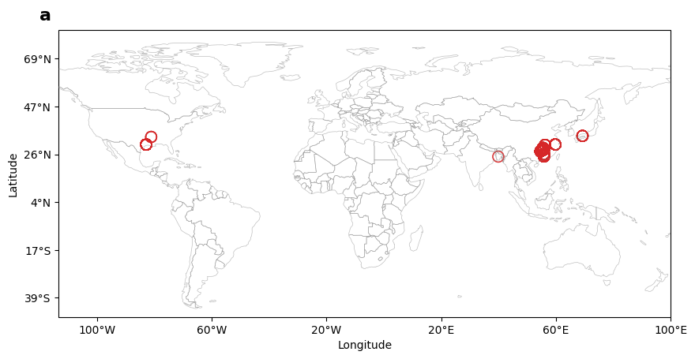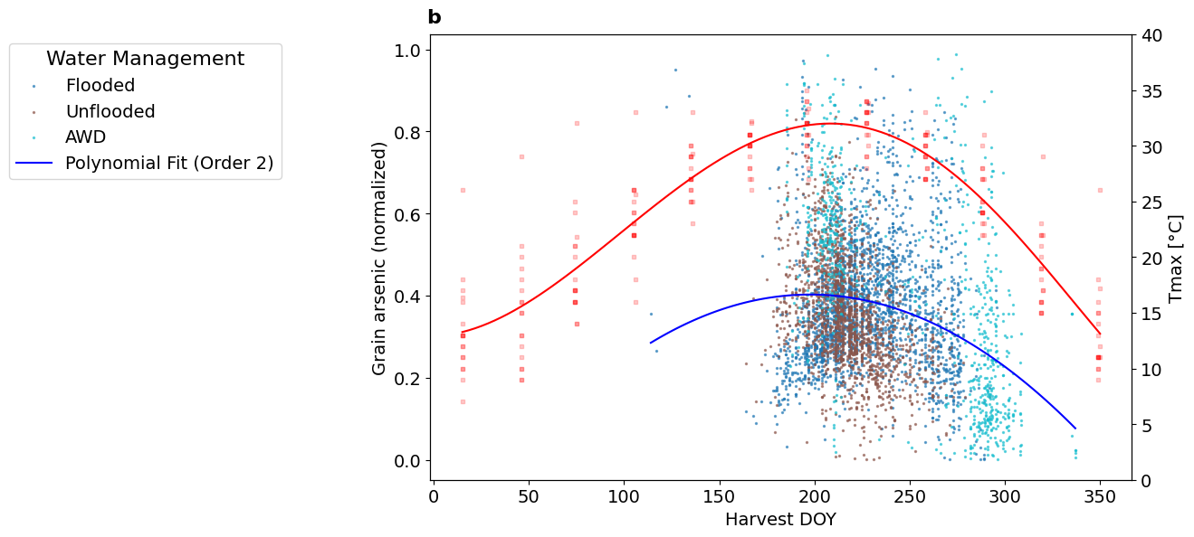
Supplementary Fig. 18: a, Global grain As concentrations (N = 5104) are synthesized from 11 locations. b, Seasonal patterns of air temperature (monthly mean Tmax) and normalized grain As concentrations. This dataset encompasses 5,104 records from major rice-producing countries (e.g., China) that practice ratoon cropping, covering diverse rice production zones (temperate, subtropical, tropical), water management systems (flooded, non-flooded, alternating wetting and drying [AWD]), and rice varieties (N = 2,451). Temperature and grain As data are fitted by Polynomial models.

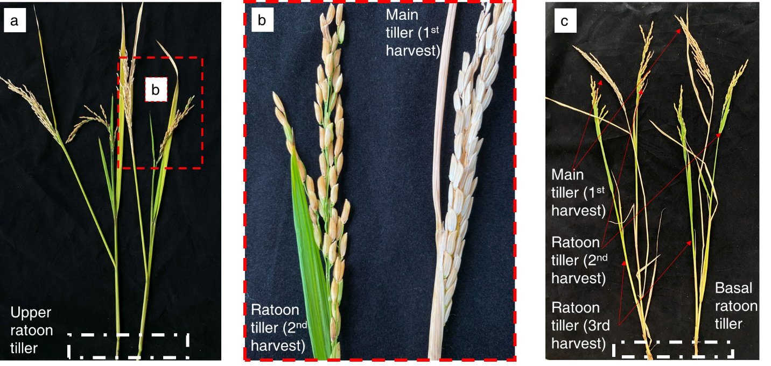
Supplementary Fig.19. Under heatwaves, the main crop panicles were unfilled (b), with ratoon tillers rapidly emerging from upper nodes and maturing earlier than lower tillers. Under mild climate conditions, the ratooning phenotype of rice occurred after the harvest of the main crop. No upper tillers were developed; instead, basal tillers grew slowly and matured later and an additional two months to reach the grain filling stage.

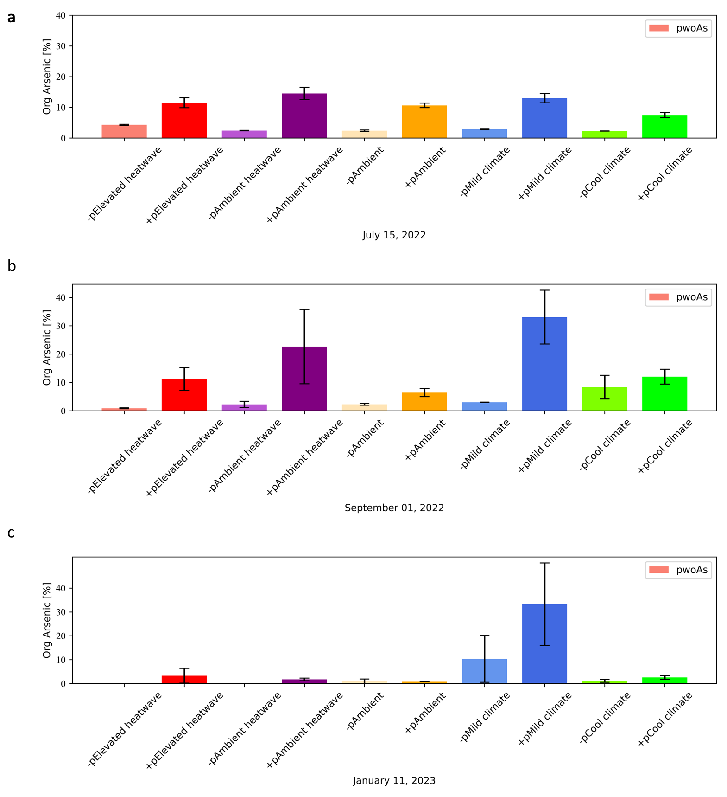
Supplementary Fig. 20: The percentages of organic species of porewater As (oAs) at the grain filling stages of main, 1st ratoon and 2nd ratoon crops in 2022. +p (N = 5) and -p (N = 2) denote the porewater samples are sampled from root zones of rice and control pots without plant growth.

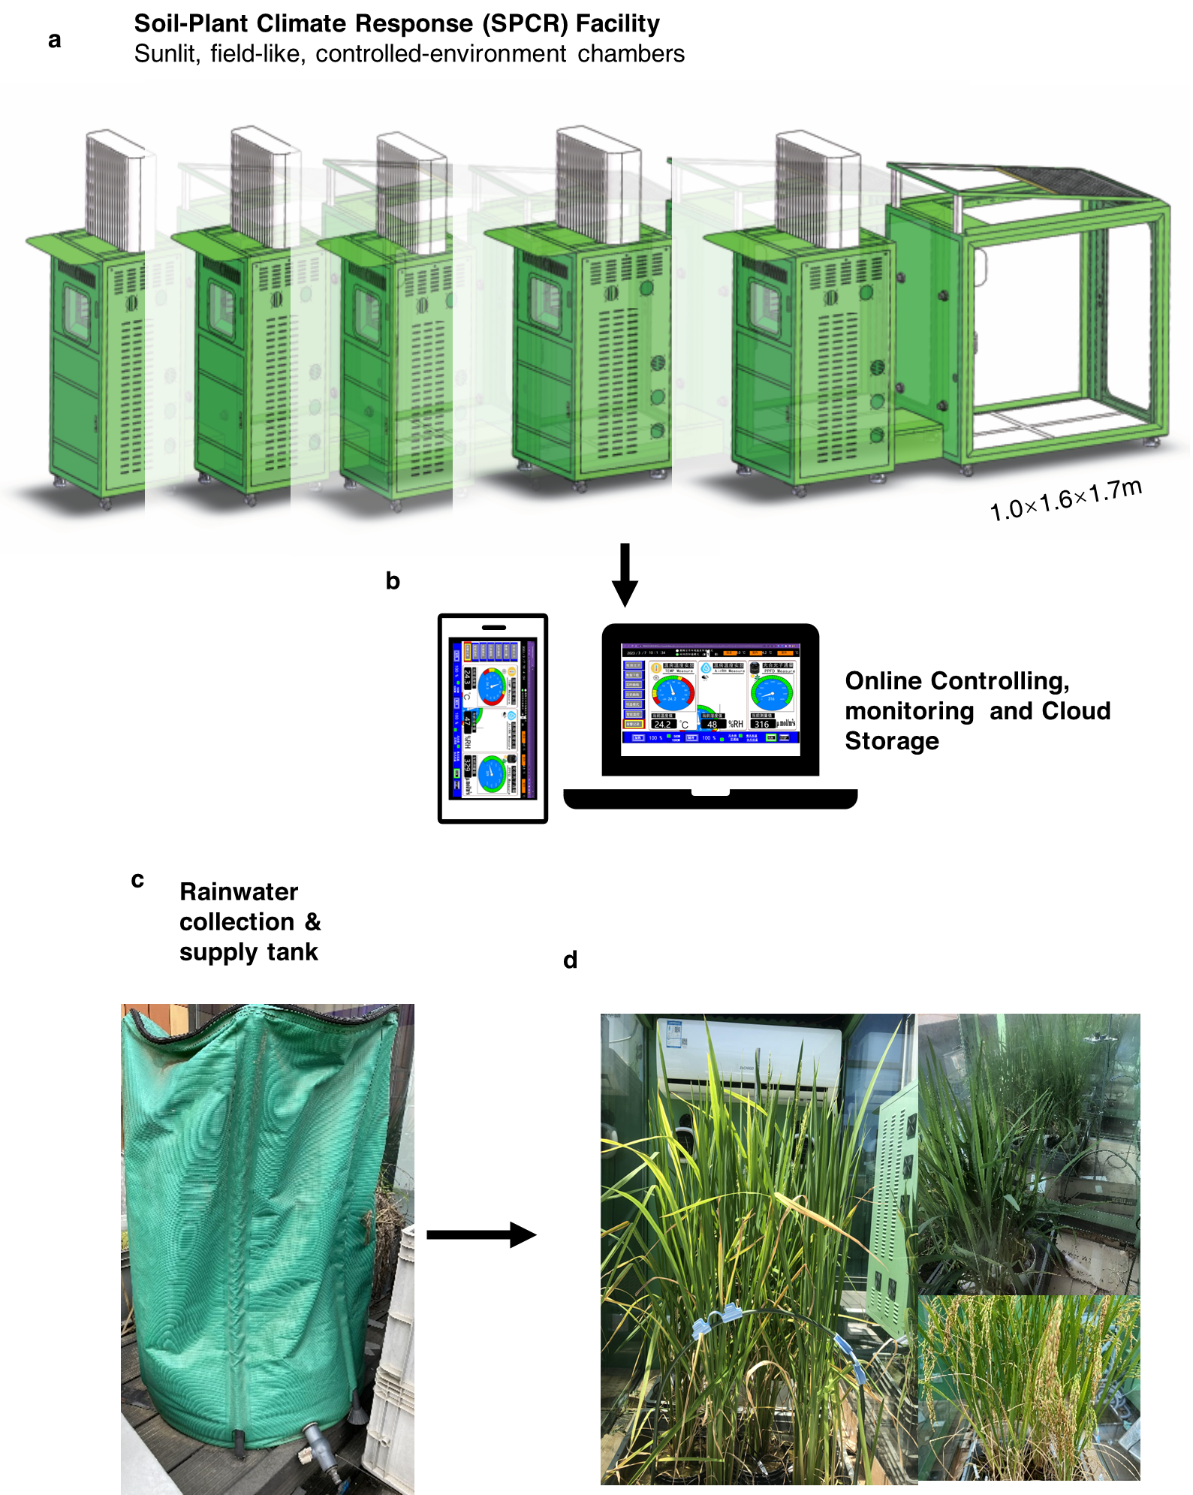
Supplementary Fig. 21: Experimental setup of the AmbControl facilities used for heatwave manipulation. Six sunlit chambers, each with 1.6 m² growing space, were equipped with an autonomous system for precise temperature control (±5%) above crop canopies. Chambers are mounted on wheels for randomization and consist of double-layered glass for optimal light transmission. Real-time monitoring and adjustment of temperature, humidity, and photosynthetic photon flux density (PPFD, 300–2000 μmol m⁻² s⁻¹) were managed via SCADA software, with data auto-logged every minute. The system featured remote access through a Web API for continuous environmental regulation and data collection.

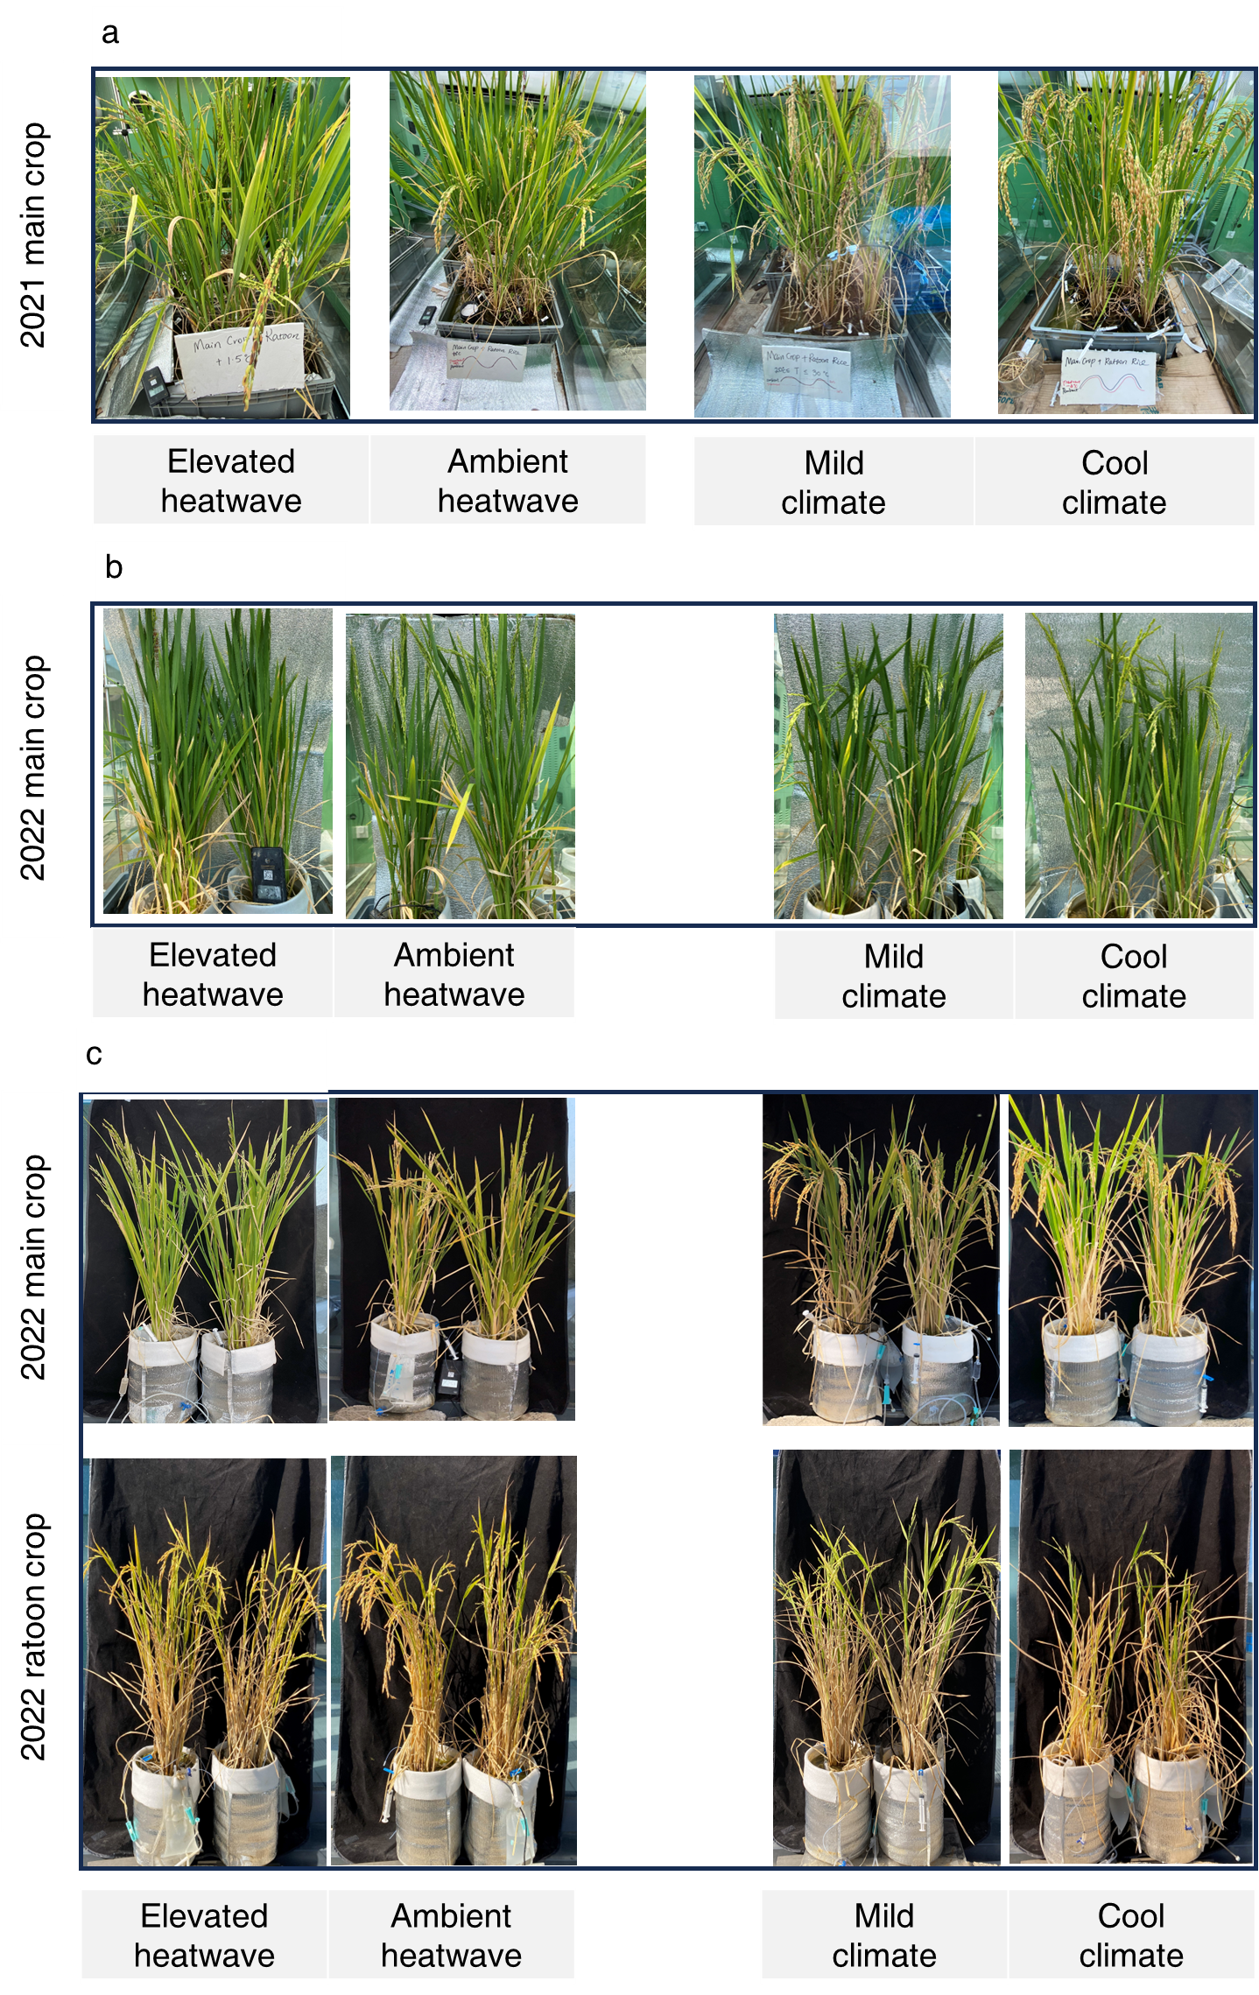
Supplementary Fig. 22: Rice growth to maturity inside AmbControl facilities in 2021 and 2022. To alleviate sidewall heating effects, plant growth pots are bathed in sands in 2021 (a) and covered insulated materials in 2022 (b).

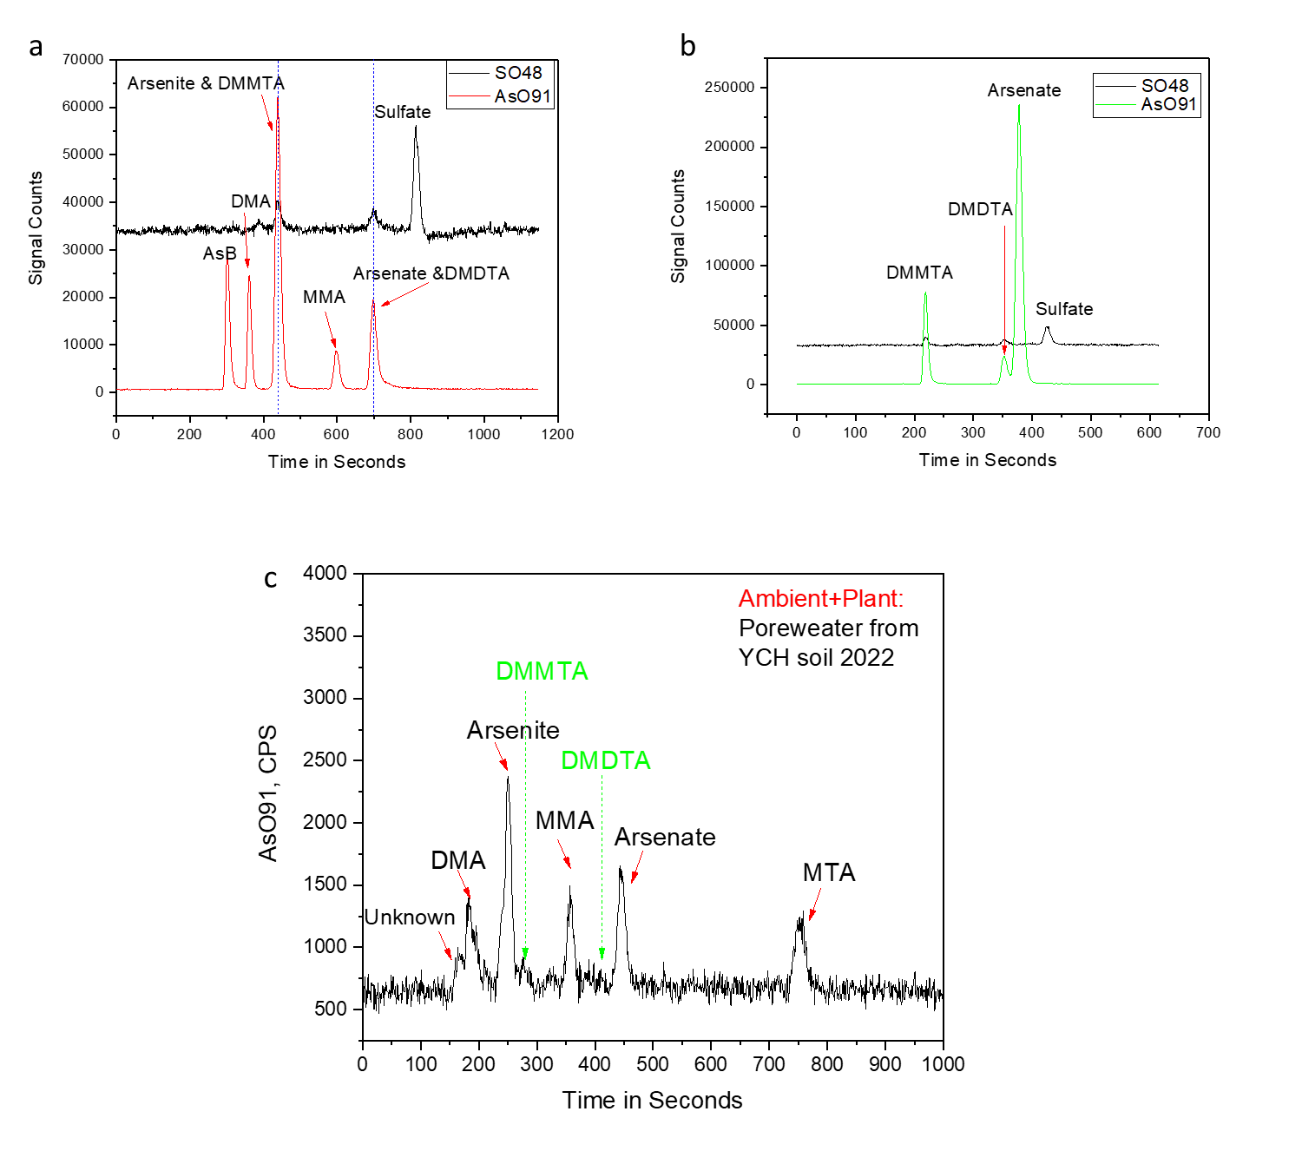
Supplementary Fig. 23: a,ICP-MS counts of mixed standard of As at varying retention times. b, current method cannot effectively separating DMMTA and As (III), and DMDTA and As(V), respectively. c, An example of porewater As species during the grain filling stages of 2022 experiments.

Supplementary Table 1 Soil information
Soil | Test year | Lat, Lon | Organic matter content | Soil paste pH | Arsenic concentration
 |  |  | g kg⁻¹ |  | mg kg⁻¹
SY | 2021/2022 | 30°0' 8.03"N, 120°47'58.14"E | 27 | 5.24 | 47
XC | 2021 | 31°29′49.095″N,120°32′49.927″E | 22 | 6 | 13
YCH | 2022 | 31°28′25.52″N,120°46′18.88″E | 26 | 5 | 6.4

