Extended Data Fig.1. Study design and patient disposition

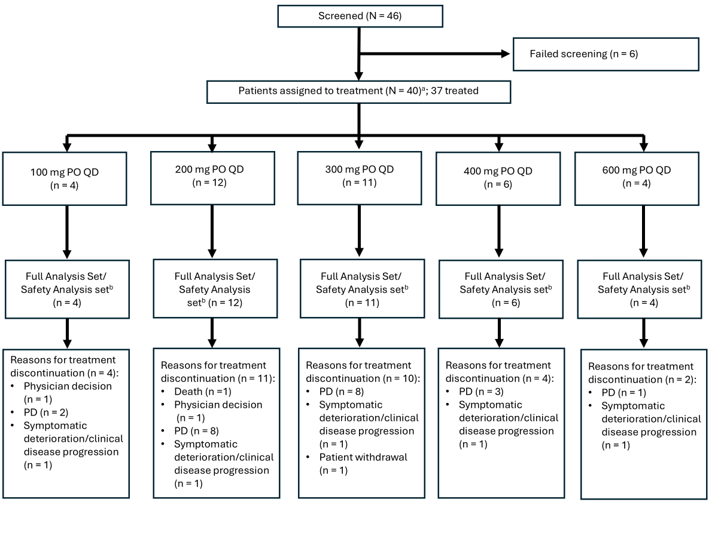
ªIncludes three patients who were in the process of screening at the cutoff date.
^{b}Defined as all patients who had received at least one dose of study treatment. Patients continued on treatment until disease progression, start of new anti-cancer therapy, intercurrent illness that interferes with the patient’s ability to follow study requirements, patient withdraws consent, study participation is terminated by the investigator, or the patient is lost to follow up.
PO, orally; QD, once a day.

Extended Data Fig. 2. Post-treatment response as demonstrated by changes in circulating tumor cells at Cycle 2, Day 1 and Cycle 4, Day 1 compared to baseline (Cycle 1, Day 1) in (A) all evaluable patients (n = 23); and (B) patients with ESR1 mutations (n = 10)
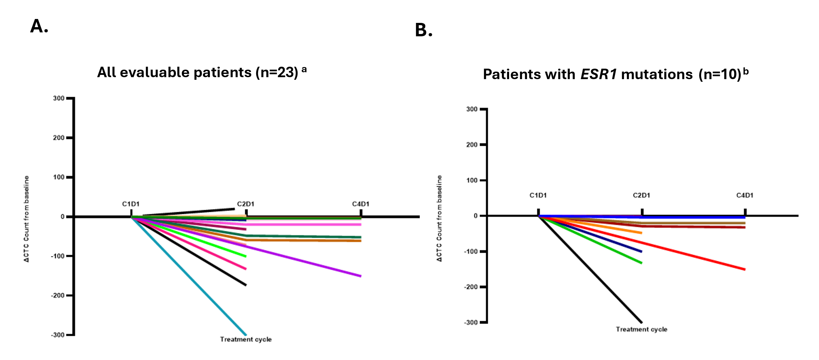

ªAll patients (n=23) who had a C1D1 baseline CTC above 0 and C2D1 and/or C4D1 CTC.
^{b}Panel B shows all patients with ESR1 mutations (n-10).
C, cycle; D, day; CTC, circulating tumor cell; ESR, estrogen receptor; mut, mutated.

Extended Data Table 1. Estrogen receptor mutation status at baseline
ER mutation status | Sample | ER status | Cohort
Mutant | C1D1 | E380Q (5.73%), Y537S (1.96%) | 100 mg
Mutant | C1D1 | D538G (18.72%), Y537S (0.72%), Y537N (0.03%) | 100 mg
WT (cutoff <1%) | C1D1 | D538G (0.1%) | 100 mg
WT | C1D1 | WT | 100 mg
WT (cutoff <1%) | C1D1 | D538G (0.06%) | 200 mg
WT (germline non-hot spot mutation) | C1D1 | K299R germ | 200 mg
Mutant | C1D1 | Y537S (2.14%) | 200 mg
Mutant | C1D1 | D538G (49.8%) | 200 mg
Mutant | C1D1 | D538G (8.81%), F404L (3.71%) | 300 mg
WT (cutoff <1%) | C1D1 | Y537S (0.2%) | 300 mg
Mutant | C1D1 | Y537S (5.81%), F404L (0.26%), E353G (2.7%) | 300 mg
Mutant | C1D1 | D538G (3.43%) | 200 mg
WT | C1D1 | WT | 300 mg
WT | C1D1 | WT | 300 mg
WT | C1D1 | WT | 200 mg
WT | C1D1 | WT | 200 mg
WT | C1D1 | WT | 200 mg
WT | C1D1 | WT | 300 mg
WT (cutoff <1%) | C1D1 | Y537S (0.77%) | 300 mg
WT | C1D1 | WT | 300 mg
WT | C1D1 | WT | 200 mg
Mutant | C1D1 | Y537S (7.57%), V422del (5.73%) | 200 mg
WT (cutoff <1%) | C1D1 | D538G (0.61%) | 200 mg
Mutant | C1D1 | Y537S (24.09%), D538G (2%), Y537N (1.57%), L536P (1.17%), L536H (0.12%), G415-C417del (0.08%), L541del (0.04%) | 200 mg
Mutant | C1D1 | D538G (65.77%), L549P (14.77%), D426E (9.42%) | 300 mg
WT | C1D1 | WT | 300 mg
WT (cutoff <1%) | C1D1 | E380Q (0.36%), Y537C (0.17%) | 300 mg
WT (cutoff <1%) | C1D1 | V422del (0.5%), D538G (0.2%) | 400 mg
WT | C1D1 | WT | 400 mg
Mutant | C1D1 | Y537N (2.54%), Y537S (0.65%), L536P (0.42%) | 400 mg
WT | C1D1 | WT | 400 mg
Mutant | C1D1 | D538G (32.98%), F404V (15.34%), F404I (1.46%), F404L (1.37%), L536R (0.66%), E380V (0.11%) | 600 mg
WT | C1D1 | WT | 600 mg
WT (cutoff <1%) | C1D1 | C530_K531del (0.4%) | 600 mg
WT (cutoff <1%) | C1D1 | D538G (0.34%), H524L (0.14%) | 600 mg
WT (cutoff <1%) | C1D1 | D538G (0.07) | 400 mg
Pending | C1D1 | Pending | 400 mg
C, cycle; D, day; WT, wild type, ER, estrogen receptor.

Extended Data Table 2. Most frequent TRAEs by preferred term in ≥10% of patients in any treatment group
Preferred term | All CTCAE grades | CTCAE Grade ≥3
Patients with any TRAE | 15 (40.5) | 0
Nausea | 5 (13.5) | 0
Hot flush | 5 (13.5) | 0
Neutrophil count decreased | 4 (10.8) | 0
CTCAE, Common Terminology Criteria for Adverse Events; TRAE, treatment-related adverse event.

Supplemental information
Dose-limiting toxicities (DLTs) were defined as any Grade 5 toxicity; a hematologic DLT was defined as Grade 4 neutropenia lasting more than 7 days or febrile neutropenia (absolute neutrophil count [ANC] <1000/mm³ with a single temperature of >38.3°C [101°F] or a sustained temperature of ≥38°C [100.4°F] for more than 1 hour), Grade 4 thrombocytopenia or Grade 3 thrombocytopenia associated with clinically significant bleeding, including any bleeding that warrants a platelet transfusion, or Grade 4 anemia (life-threatening consequences requiring urgent interventions). A non-hematologic DLT was defined as a Grade 3 or 4 non-hematologic toxicity with the exceptions of alopecia, Grade 3 nausea, vomiting, or diarrhea if well controlled by supportive care within 72 hours, Grade 3 skin rash that improves within 7 days with or without supportive care, Grade 3 fatigue that improves in within 7 days with or without supportive care, Grade 3 endocrinopathies that only require treatment with hormone replacement therapy, and Grade 3 non-hematologic laboratory abnormalities other than liver function tests unless associated with clinical manifestations leading to medical intervention and/or hospitalization. Non-hematologic DLTs were also defined as potential drug-induced liver injury consistent with Hy’s Law, defined as aspartate transferase (AST) and/or alanine transaminase (ALT) >3 × upper limit of normal [ULN] with concurrent total bilirubin >2 × ULN without findings of cholestasis (alkaline phosphatase [ALP] <2 × ULN) and Grade 3 or higher electrolyte abnormality that lasts >72 hours unless the patient has clinical symptoms, in which case all Grade 3 or higher electrolyte abnormalities regardless of duration should count as a DLT.

