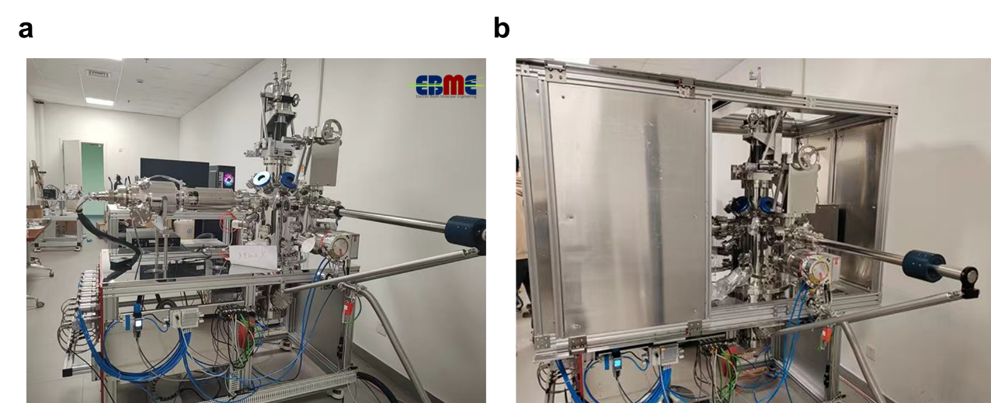
Extended Data Fig. 1ǀ Electron beam molecular engineering system. a. The home-made electron beam molecular engineering system (EBME) equipped with 0-100 keV electron gun, sample transfer holder, RGA mass spectrum, CCD camera and vacuum system, without (a) and with (b) X ray protective cover.

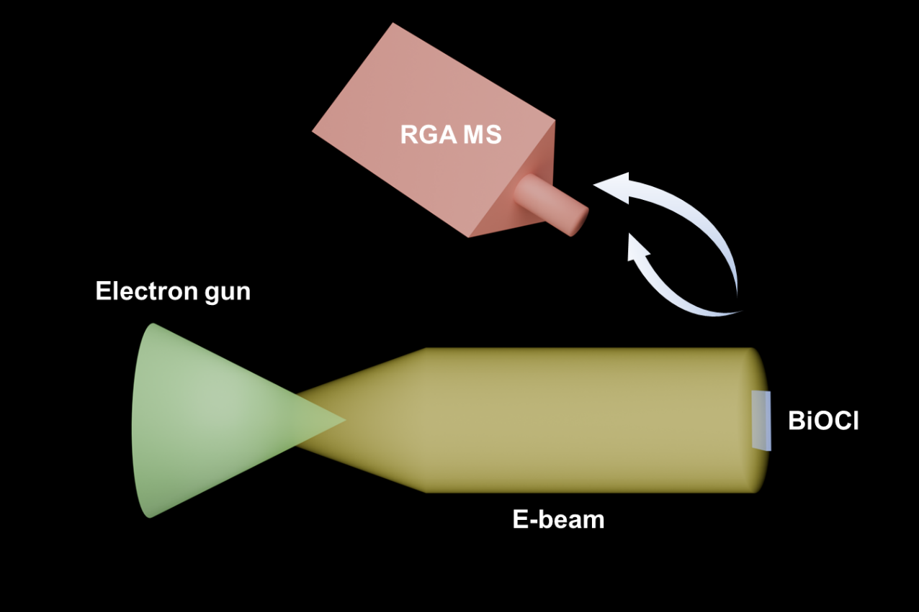
Extended Data Fig. 2ǀ Scheme of the in situ electron beam irradiation experiment. The BiOCl sample was irradiated by the electron beam. The dissociated and escaped component were generated into the RGA mass spectrometer.

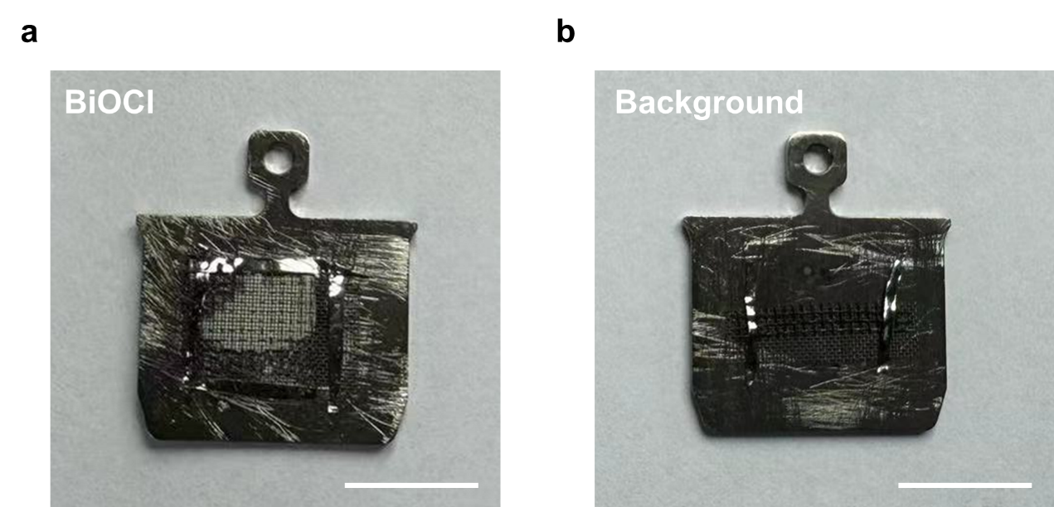
Extended Data Fig. 3ǀ The sample holder for in situ electron beam irradiation experiment in EBME. a, BiOCl powder on holder (white). b, The empty holder for control experiment. The BiOCl powder sample was pressed on a 100-mesh molybdenum net by a tablet press. An empty sample holder was set as a control experiment to determine the background gas products.
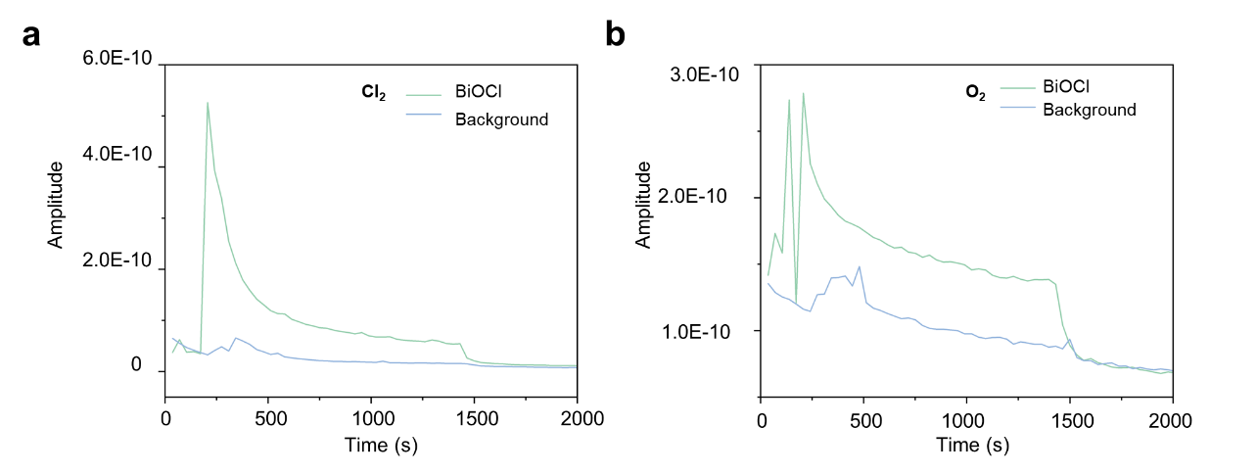
Extended Data Fig. 4ǀ In situ mass spectrum of the BiOCl sample for the electron beam irradiation experiment. a, Comparison of the sum of 69 to 74 m/z between BiOCl substrate and background, which including the possible products of Cl₂. b, Comparison of the 32 m/z between BiOCl substrate and background, which is them O₂ from the dissociation of BiOCl.

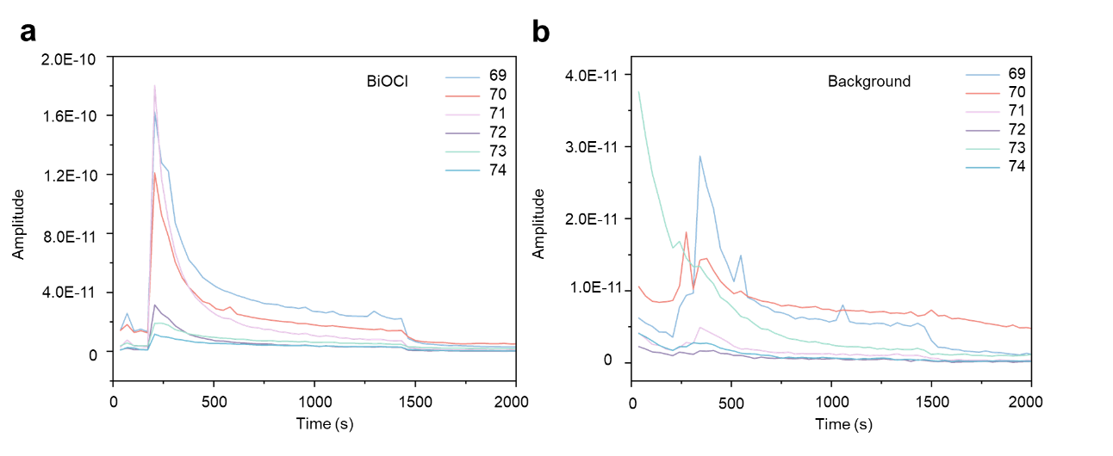 Extended Data Fig. 5ǀ In situ mass spectrum of the BiOCl sample for the electron beam irradiation experiment focusing on the m/z from 69 to74. a, The comparison of the 69 to 74 m/z of the BiOCl substrate under electron beam irradiation. b, The comparison of the 69 to 74 m/z of the BiOCl substrate under electron beam irradiation. We classify the products of Cl₂ into 69-74 by the pairwise combination of different isotopes of Cl, Cl³⁵ and Cl³⁷. By integrating the production of molecular fragments with mass numbers 69-74 under electron beam irradiation in a, we obtained that the content of Cl³⁵ is 74.67% and the content of Cl³⁷ is 25.33% in the total Cl₂ production, which was consistent with the content of Cl³⁵ (75.76%) and Cl³⁷ (24.23%) in nature.

