Supplementary Information
Surface effects on heterogeneous nucleation of metal at the atomic scale
Pu Yan¹, Kaijun Sun¹, Yan Mi², Jing Feng², Wendi Zhang¹, Yue Yang¹, Dong Zhang¹, Yadong Li¹, Yifei Dang¹, Dongyu Li¹, Yuan Hu^{1,} *, Kecheng Cao^{1,} *
Affiliations:
¹School of Physical Science and Technology & Shanghai Key Laboratory of High-resolution Electron Microscopy, ShanghaiTech University, Shanghai 201210, China
²Key Laboratory of Chemistry and Engineering of Forest Products, State Ethnic Affairs Commission, Guangxi Minzu University, Nanning 530006, China
*Correspondence to: caokch@shanghaitech.edu.cn (K.C.); huyuan@shanghaitech.edu.cn (Y.H.)

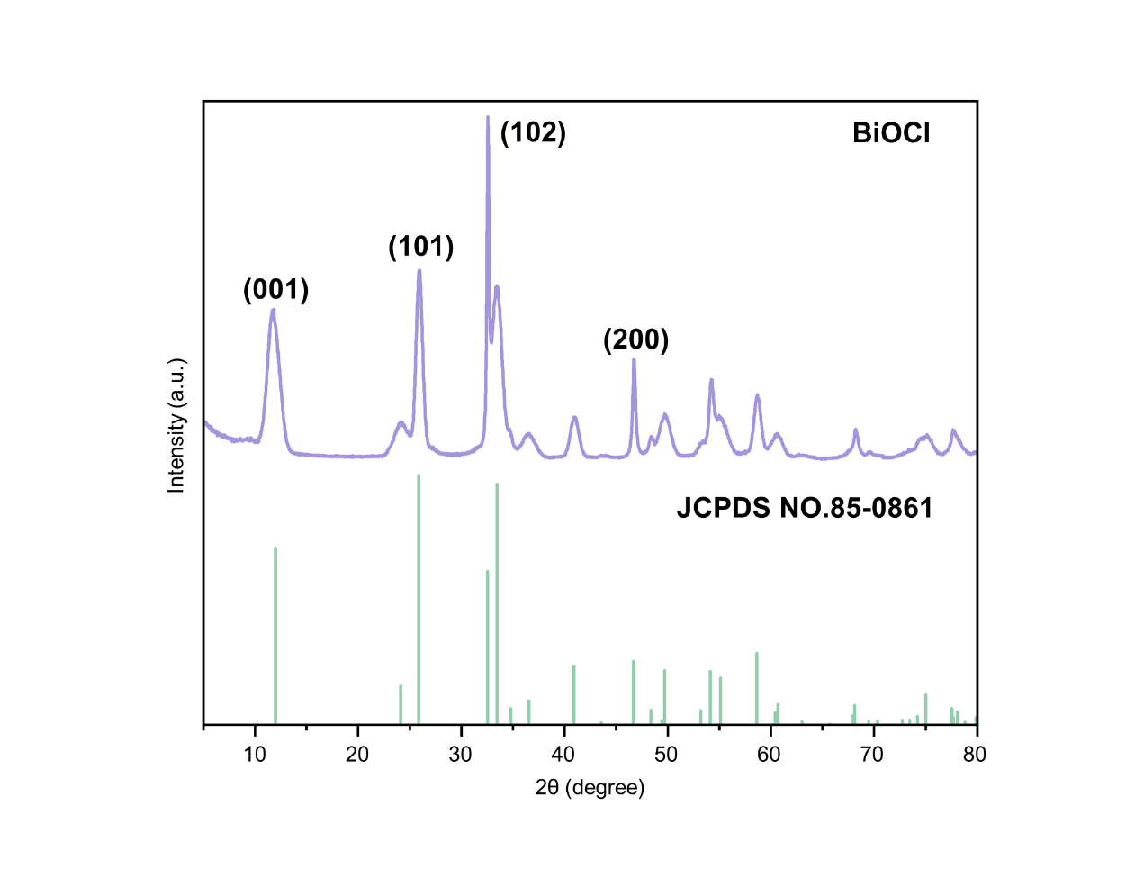
Supplementary Fig. 1. XRD pattern of the synthesized BiOCl with standard card number.

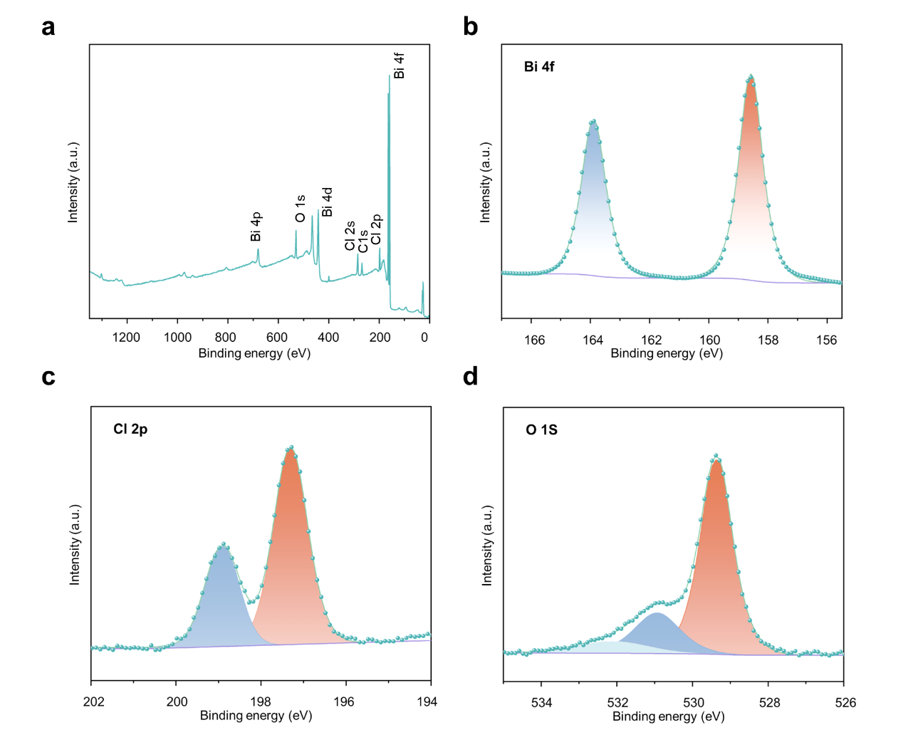
Supplementary Fig. 2. XPS spectra of the BiOCl sample. a, Full survey spectrum of the BiOCl. High-resolution XPS of Bi 4f (b), Cl 2p (c) and O 1s (d).
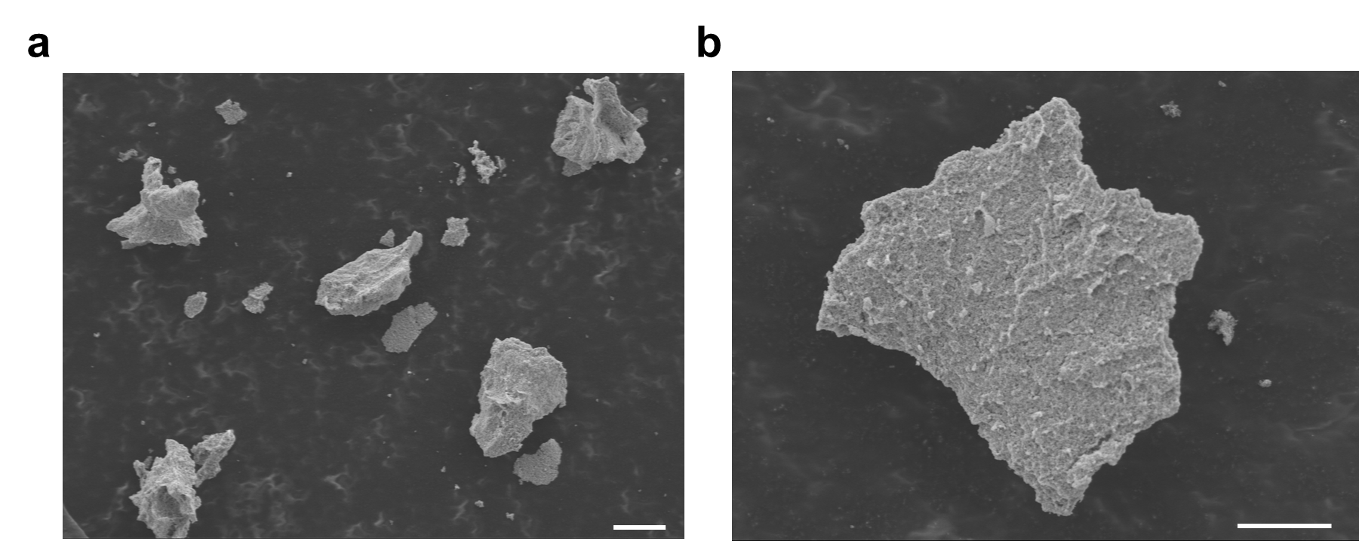 Supplementary Fig. 3. SEM images of BiOCl. The scale bar in a and b is 10 μm. Our experimental mainly focuses on the edge of the sample.

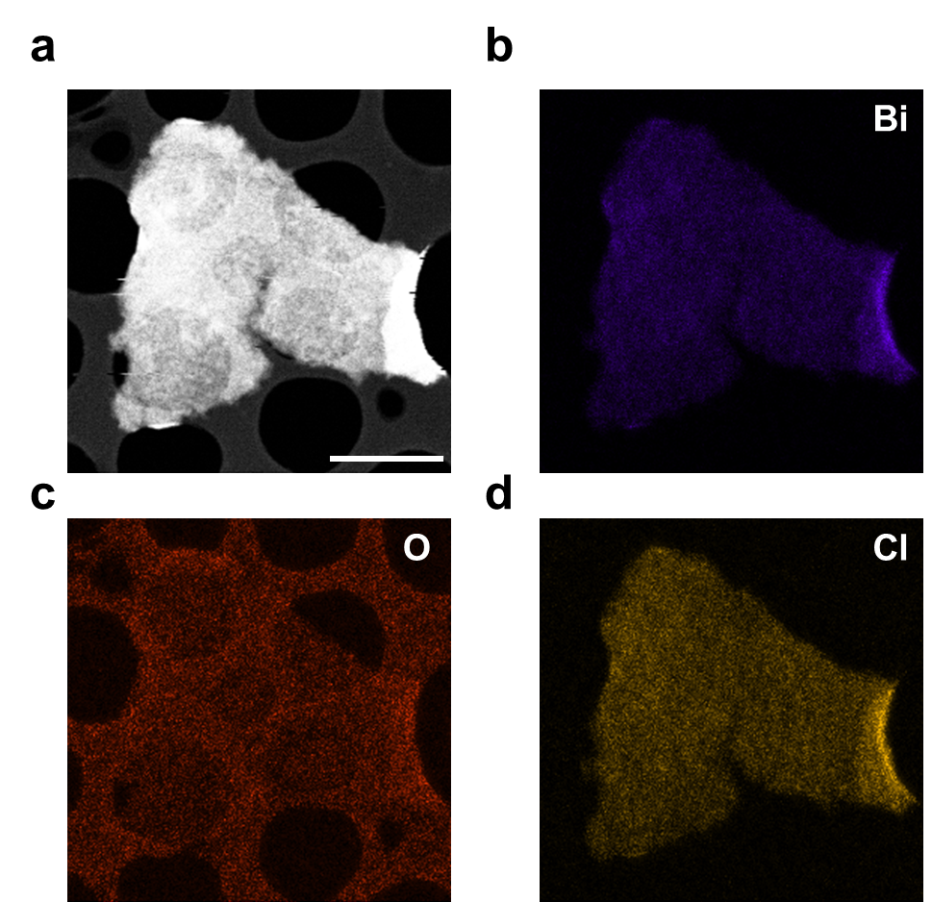 Supplementary Fig. 4. EDS mapping of BiOCl substrate. a, HAADF-STEM image of the BiOCl. b, Bi element distribution in BiOCl. c, O element distribution in BiOCl. d, Cl element distribution in BiOCl. EDS mapping shows the uniformity of the elements distribution. The scale bar in a is 10 μm.
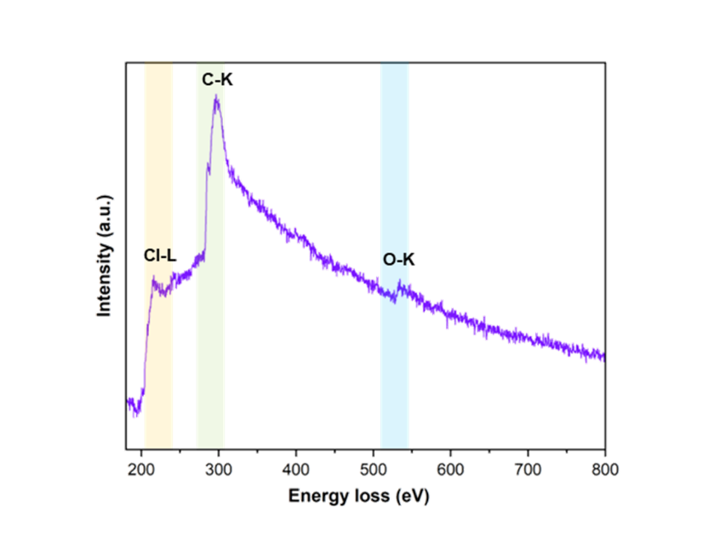 Supplementary Fig. 5. EELS of BiOCl. EELS were acquired by the direct electron camera K2, and the peaks of Cl-L and O-K are demonstrated.

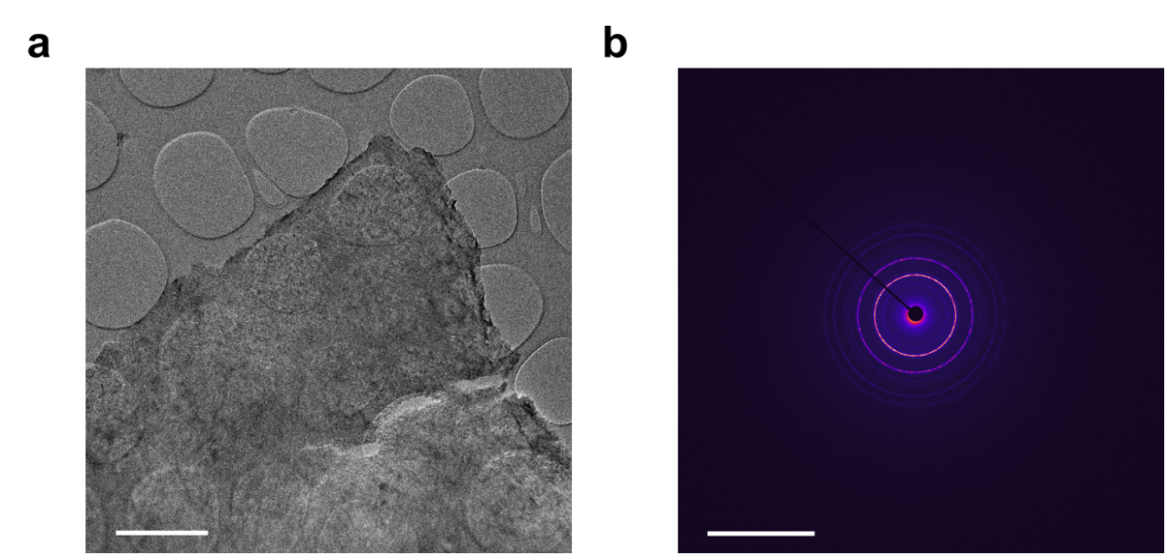 Supplementary Fig. 6. SAED pattern of BiOCl. a, The low mag image of BiOCl, the scale bar is 2 μm. b, The ccorresponding SAED image of a, the scale bar is 10 nm⁻¹.
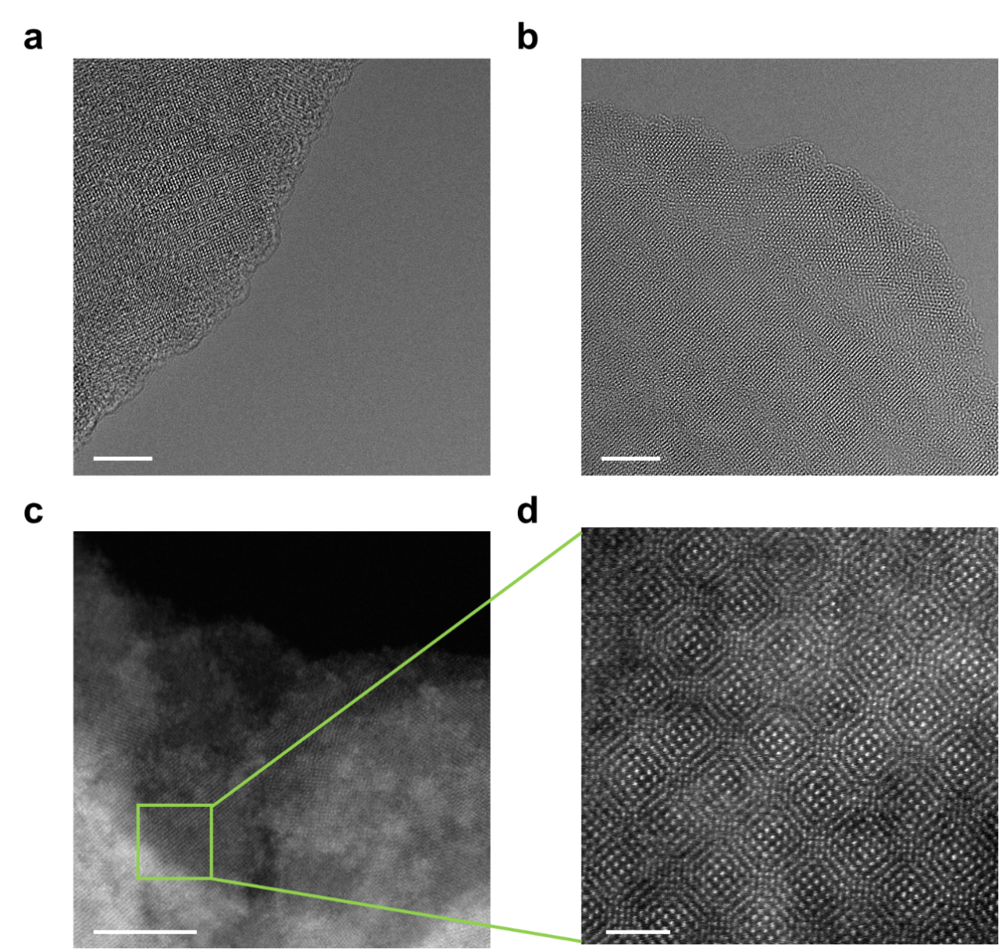
Supplementary Fig. 7. High resolution images of BiOCl. a,b, AC-HRTEM images of BiOCl, the scale bar is 5 nm. c,d, HAADF-STEM images of BiOCl,the scale bar in c is 10 nm and the scale bar in d is 2 nm. We can see the moire patterns in a and d, which shows that the BiOCl nanosheets are stacked in different twist angles. And the edges of BiOCl have the single crystal structure.
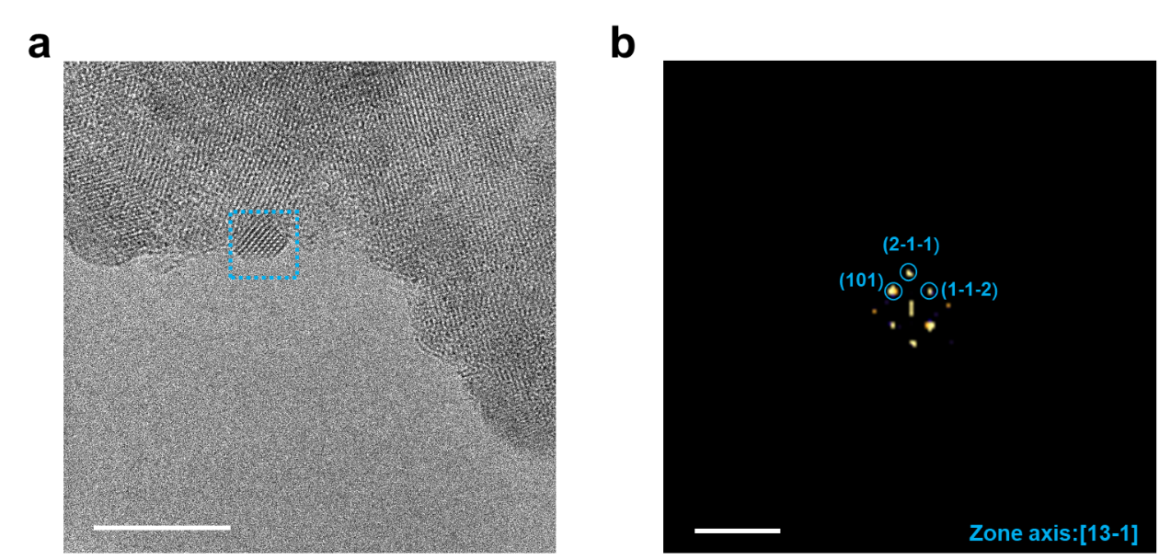
Supplementary Fig. 8. FFT pattern of the nucleated Bi nanoparticle in Fig. 1a in maintext. a, The AC-HRTEM image in Fig. 1a of maintext shows that the Bi nanocrystal had nucleated on the BiOCl surface at 245,680 ms in Supplementary Movie 4. Scale bar in a is 10 nm. b, FFT pattern of the blue dash box in a to vertify the nucleated nanocrystal on the BiOCl surface is a pure Bi nanocrystal. Scale bar in b is 10 nm⁻¹.

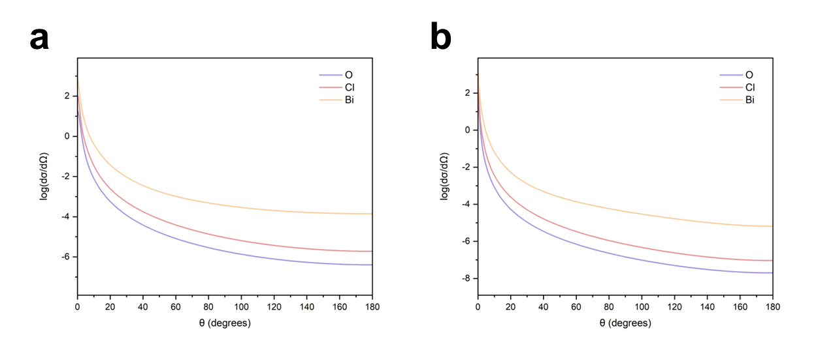Supplementary Fig. 9. Elastic scattering cross-section of the O, Cl and Bi at different voltage. a, The relation curves between differential cross section and the outgoing electron angle for the incident electron energy of 80 keV. b, The relation curves between differential cross section and the outgoing electron angle for the incident electron energy of 300 keV. The eleatic scattering cross sections of the O, Cl and Bi element at 80 keV and 300 keV were calculated from the NIST Electron Elastic-Scattering Cross-Section Database, SRD 64, dσ/dθ (a₀²/sr, a₀²=2.8×10⁻²¹m²).

Supplementary Table 1. Relativistic BEB Cross Sections¹ of the Bi, O and Cl.
 | Bi | O | Cl
80 keV | 0.04113 Å² | 0.01340 Å² | 0.02032 Å²
300 keV | 0.01244 Å² | 0.00403 Å² | 0.00611 Å²
Supplementary Table 2. Ionization Potentials of Bi, O and Cl.
 | Bi | O | Cl
Experimental result | 7.29 eV | 13.62 eV | 12.97 eV
Theoretical result(alpha) | 7.46 eV | 15.59 eV | 13.56 eV
Theoretical result(beta) | 7.06 eV | 13.63 eV | 12.93 eV
The Ionization Potentials were obtained at EPT(OVGF)²/aug-cc-pVQZ³ level for O, Cl, and EPT(P3)/cc-pVQZ-DK⁴ with DKH2⁵ relativistic correction for Bi. Kinetic energies were obtained at CCSD (T)⁶ /aug-cc-pVQZ level for O, Cl and CCSD(T)/cc-pVQZ-DK with DKH2 for Bi. All calculations were performed with Gaussian 09 software⁷. Kinetic energies were obtained by Multiwfn⁸.
Supplementary Table 3. Maximum transferred kinetic energy at different voltage via elastic scattering. The incident electron energy and the atomic weight determine the maximum transferred kinetic energy via elastic scattering. The energy transfer from incident electron to target atom led to the dissociation of the BiOCl substrate and provide the energy for the atomic movement.
 | Bi | O | Cl
80 keV | 0.9036 eV | 11.8 eV | 5.326 eV
300 keV | 4.064 eV | 53.07 eV | 23.95 eV

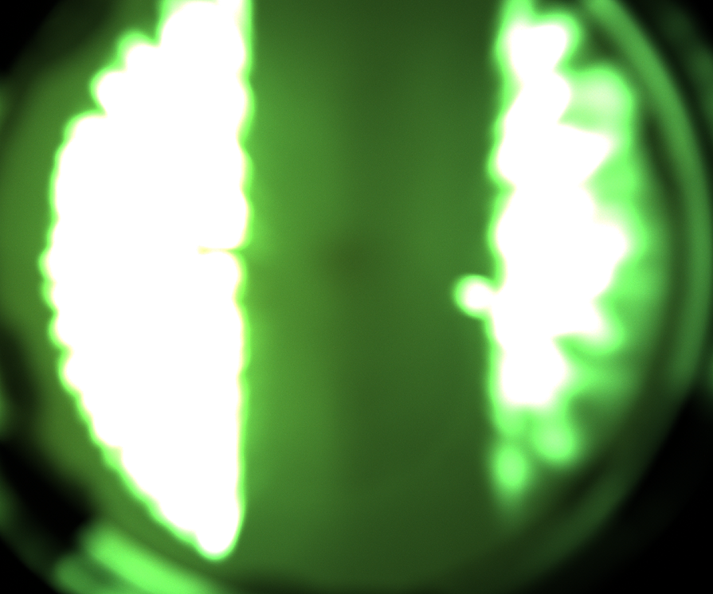
Supplementary Fig. 10. Real time irradiation photo captured by CCD camera. The position of the irradiated sample confirmed by monitoring the projection of sample on fluorescent screen.
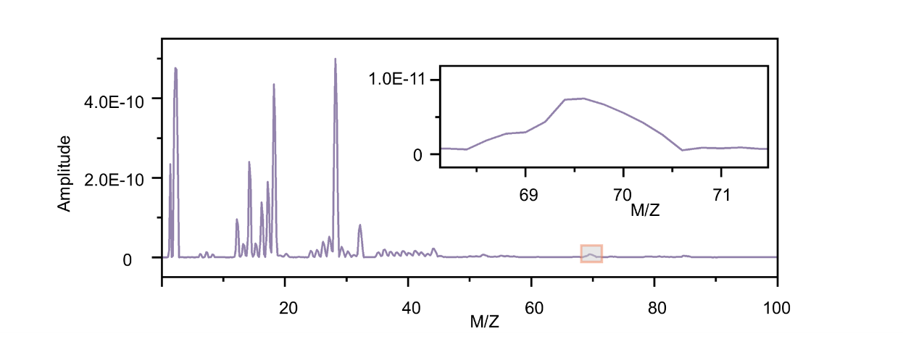
Supplementary Fig. 11. Mass spectrum of the BiOCl sample under 80 keV electron beam irradiation. The dissociation of BiOCl samples under electron beam irradiation was determined by comparing the output and type of gas during the irradiation process.
Supplementary Table 4. The electron beam irradiation parameters setup.
 | E-beam irradiation parameter
Energy (keV) | 80
Source (V) | 1.110
Emission (μA) | 4.934
Grid (V) | 0.1
Anode (V) | 3099

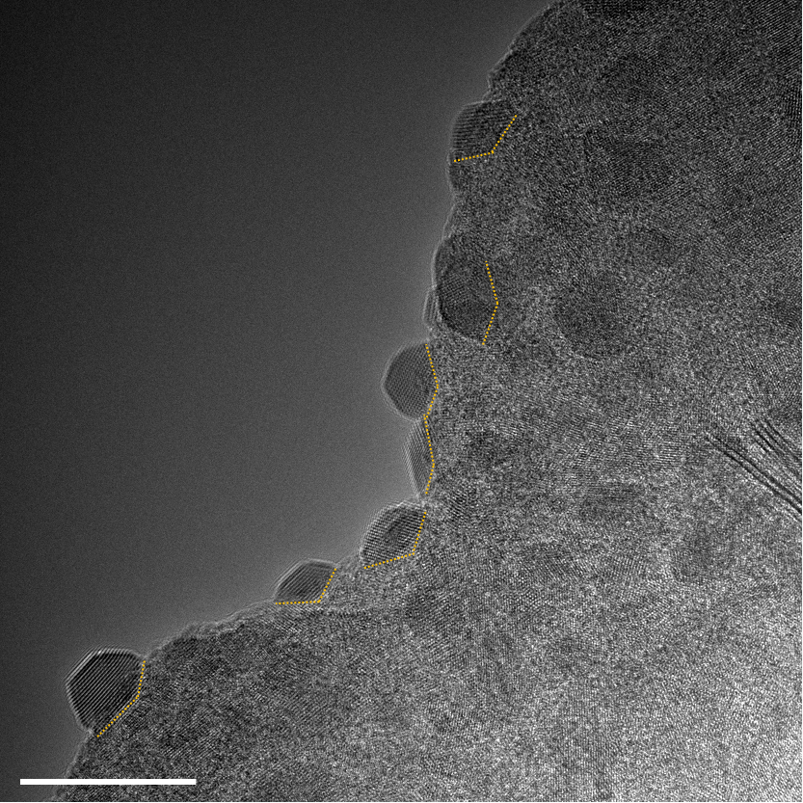
Supplementary Fig. 12. The typical AC-HRTEM image showing Bi nanocrystals nucleated at the concave sites of the surface on surface of BiOCl under electron beam irradiation. During the TEM observation process, the BiOCl dissolved under electron beam irradiation ganerating discrete Bi atoms. These Bi atoms diffused along the surface and nucleated at the convex site.And we studied the interactions of the Bi atoms at the convex sites and the dynamics of the nucleations. Scale bar in image is 20 nm.

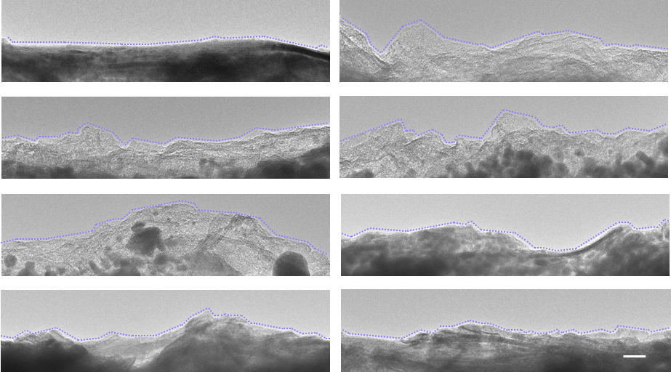
Supplementary Fig. 13. The typical AC-HRTEM image of the surface of the BiOCl substrate. The scale bar is 50 nm. As shown in Fig. 2 in maintext, the BiOCl surface rarely has convex site with angle less than 90 degrees, which is due to the release of surface energy during sample synthesis.

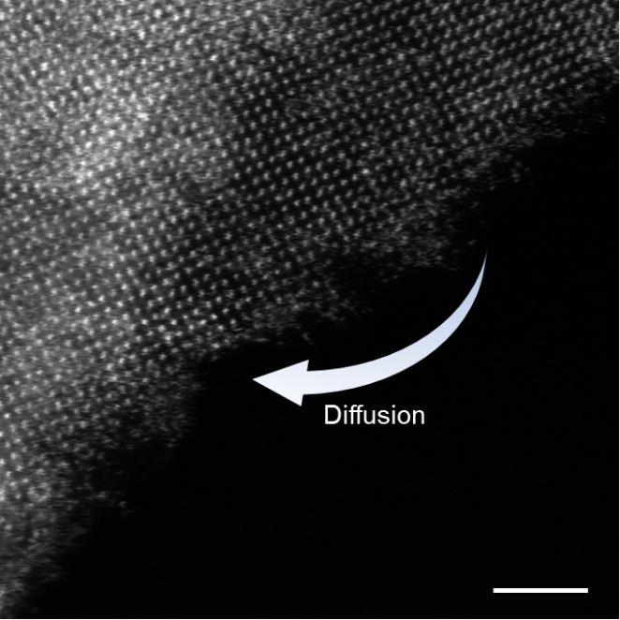
Supplementary Fig. 14. Typical HAADF-STEM image for the BiOCl during one frame capture time under electron beam irradiation. Under the irradiation of the electron, the Bi atoms were dissolved to discrete atoms which diffused along the BiOCl surface. During the whole capture time (33.5 s, 8 μs/pixel) of a single HAADF-STEM image, the blurry atom path on the surface provided valid evidence of the atomic diffusion. Scale bar is 2 nm.
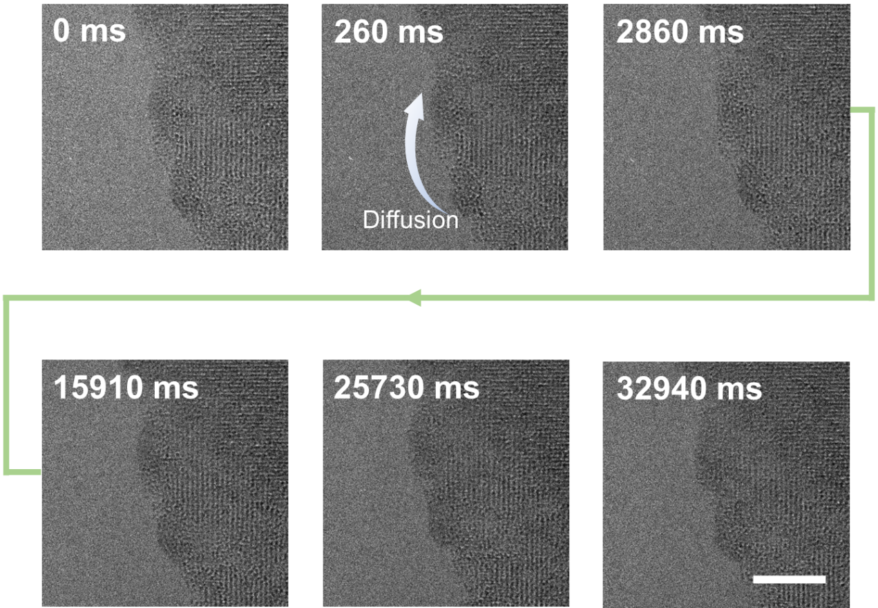 Supplementary Fig. 15. The Bi atoms diffusing on flat surface at 80 keV. The discrete Bi atoms diffused along the surface but cannot nucleate on flat surface, like the phenomenon shown in Fig. 3a of maintext. Scale bar is 5 nm.

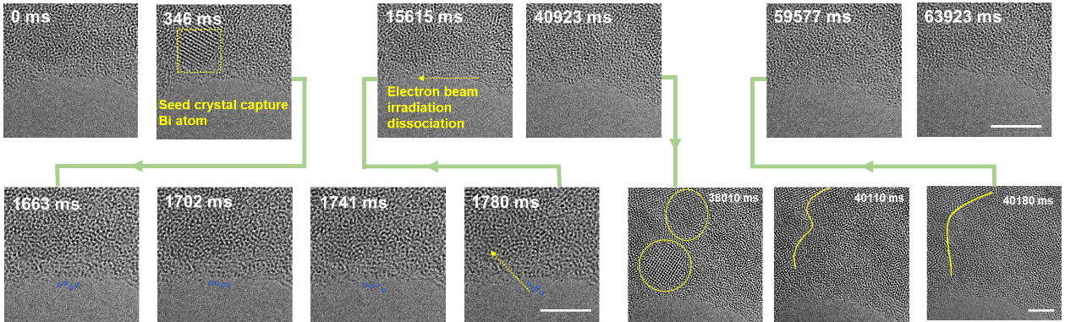 Supplementary Fig. 16. The Bi atoms diffusing on flat surface at 300 keV. On flat surface, the discrete Bi atoms diffuse along the surface but cannot nucleate on flat surface, like the phenomenon shown in Fig. 3c in maintext. At 38,010 ms, two Bi nanocrystals coalesced into one large Bi nanocrystal. Scale bar is 5 nm.

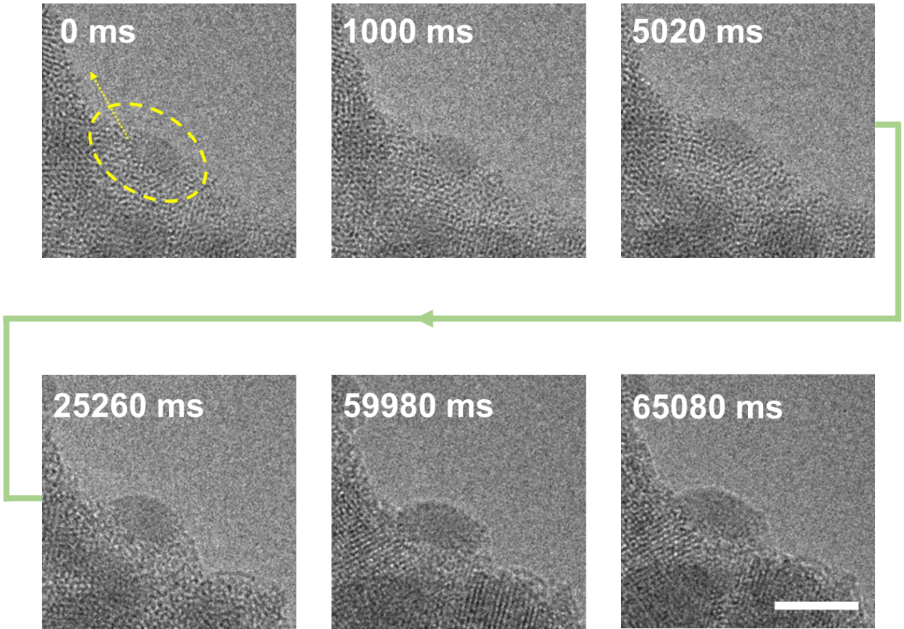Supplementary Fig. 17. The growth of the metastable Bi cluster and the migration of nucleation site. Near the convex site on the BiOCl surface, there is a metastable Bi cluster. During the observation process in TEM, the size of the metastable Bi cluster extended as it captured more discrete Bi atoms. The Bi cluster gradually migrated to the convex site that could help it release its free energy and stablize its structure. Scale bar is 5 nm.
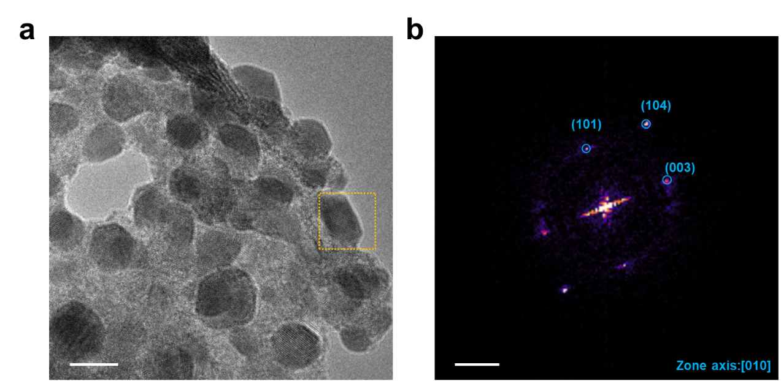
Supplementary Fig. 18. FFT pattern of the Bi nanoparticle in Fig. 4a in maintext. a, The AC-HRTEM image showing nucleated Bi nanocrystals on the BiOCl substrate in Fig. 4a in maintext. Scale bar in a is 10 nm. b, FFT pattern of the Bi nanocrystal in orange dash box in a. Scale bar in b is 2 nm⁻¹.

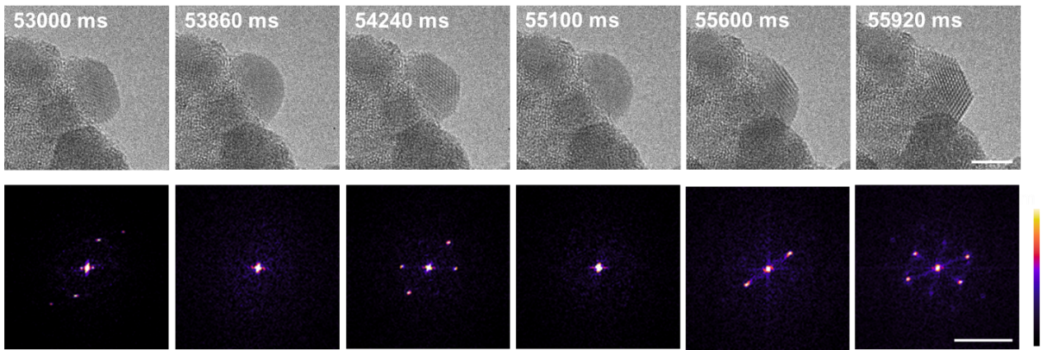
Supplementary Fig. 19. Bi nanoparticle increasing crystallinity and stability by contacting boundaries. Time series raw AC-HRTEM images and corresponding FFT patterns acquired from Supplementary movie 8 showing a Bi nanoparticle with A-C changing state was stabilized by contacting with boundaries. This set of images as well as Supplementary movie 8 are the “stabilization process” of a A-C changing state Bi nanoparticle during electron beam irradiation experiments lasting 78 s. The scale bar in TEM images is 5 nm, scale bar in FFT pattern is 5 nm⁻¹.
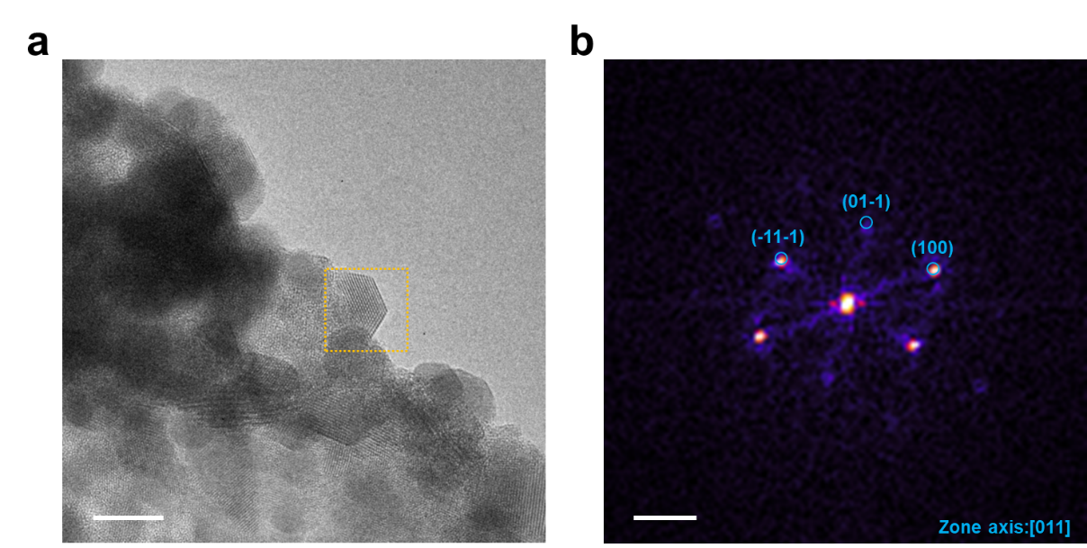
Supplementary Fig. 20. FFT pattern of the Bi nanoparticle in Supplementary Fig. 19. a, The AC-HRTEM image in Supplementary Fig. 19 that have Bi nanocrystal contact with the boundary of the BiOCl substrate. Scale bar in a is 10 nm. b, FFT pattern of the Bi nanocrystal in orange dash box. Scale bar in b is 2 nm⁻¹.

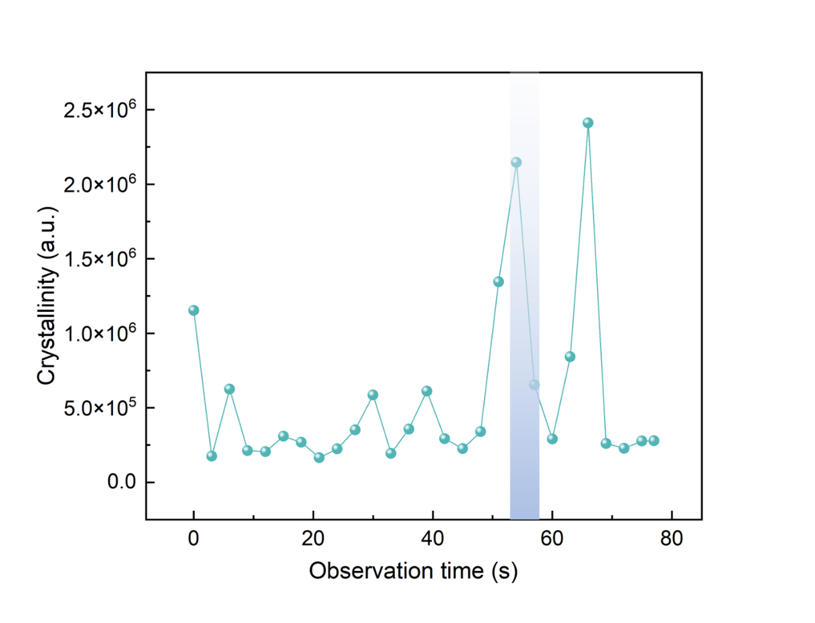

Supplementary Fig. 21. Quantification of the crystallinity by comparing the intensities of the reflection spots in the FFT patterns of Bi nanoparticle in Supplementary Fig. 19. The whole observation that a A-C changing state Bi nanoparticle stabilized its structure by contacting with the boundary lasted 78 s during our observation. Here we presented the crystallinity change of the whole process, and highlighted the “stabilization process” presented in Supplementary Fig. 19.

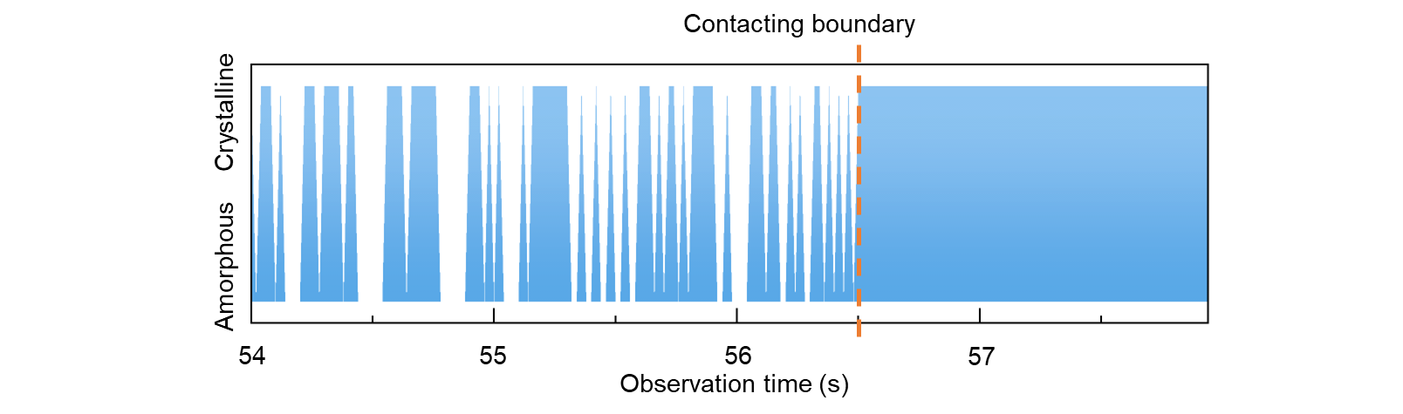
Supplementary Fig. 22. Trajectories of state transitions between amorphous and crystalline states during the 4 s from 54 s to 58 s in Supplementary Fig. 19 and Supplementary movie 8. The trajectories illustrated the A-C changing state before the Bi nanocrystal contacted with the boundary. When the Bi nanocrystal contacted with boundary, the Bi nanocrystal released its free energy and became a stable crystalline state.

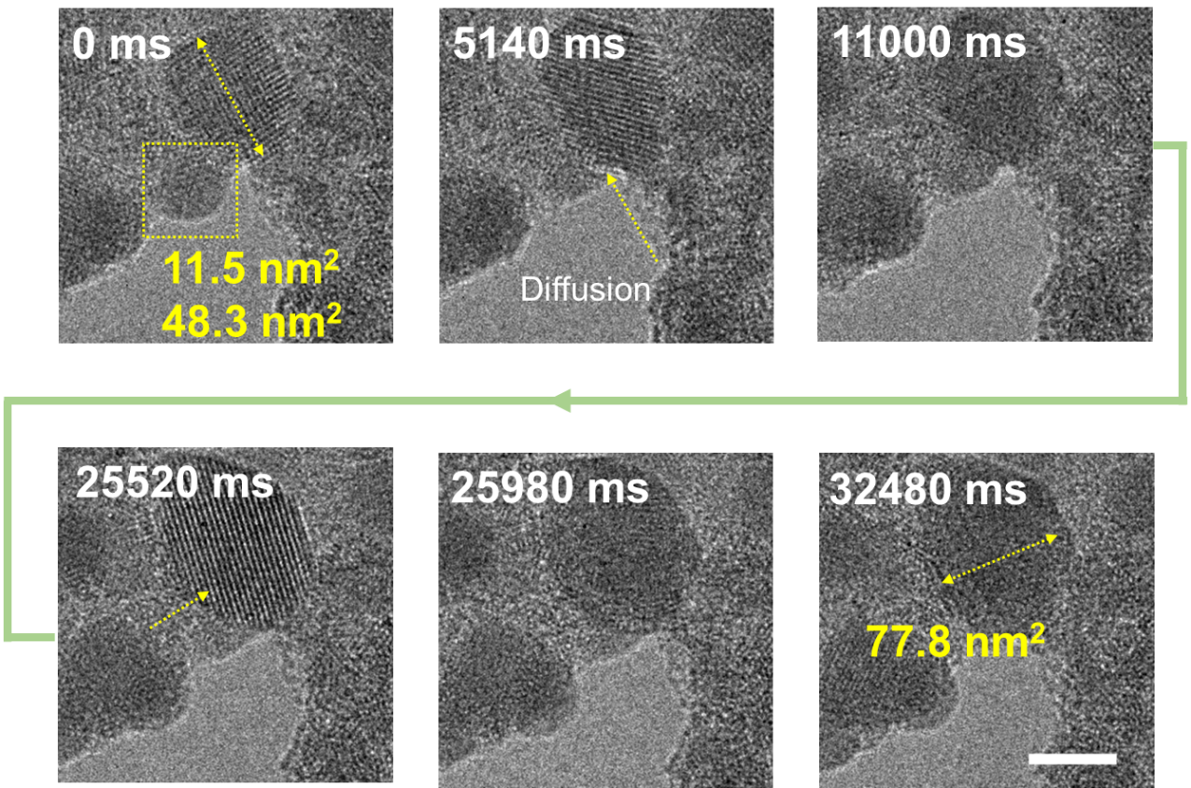
Supplementary Fig. 23. The ripening of the nucleated Bi nanocrystals. At the initial state of the observation, there were a metastable Bi cluster (11.5nm²) and a large-sized Bi nanocrystal (48.3nm²) on the BiOCl surface. The metastable Bi cluster gradually dissolved into discrete Bi atoms under the electron beam irradiation which were captured by the large one. At 32,480 ms, the metastable cluster was entirly decomposed while the large one captured the Bi atmo. Scale bar is 5 nm.

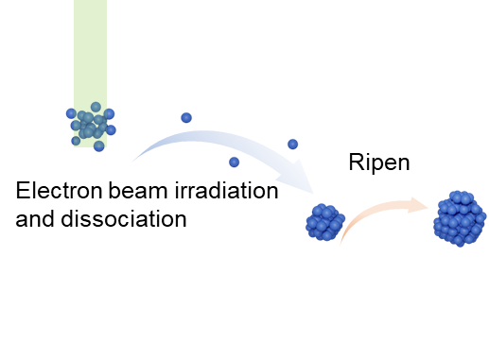
Supplementary Fig. 24. Schematic for the ripening of the Bi nanocrystal.

Supplementary movies 1-8. The different behaviors of Bi atom on BiOCl surface under the electron beam irradiation. The scale bars in all supplementary movies are 2 nm.
Supplementary movie 1: Electron beam irradiation induced dissociation.
Supplementary movie 2: Pre-nucleation via atom relaxing.
Supplementary movie 3: Nuclei growth.
Supplementary movie 4: Reversible amorphous-crystalline changing state.
Note Supplementary movies 1-4 are continuous movie of one event but are divided into four parts to reduce the size of each movie.
Supplementary movie 5: Atom diffusion at 80 keV.
Supplementary movie 6: Atom diffusion at 300 keV.
Supplementary movie 7: Structural stabilization via boundary contacting Ⅰ. This movie shows the key “stabilization part” (18 s -21 s) from the whole observation lasting 23 s.
Supplementary movie 8: Structural stabilization via boundary contacting Ⅱ. This movie shows the key “stabilization part” (54 s -56 s) from the whole observation lasting 78 s.

Reference:
1 Kim, Y.-K., Santos, J. P. & Parente, F. Extension of the binary-encounter-dipole model to relativistic incident electrons. Phys. Rev. A 62, 052710 (2000).
2 Zakrzewski, V. G. & von Niessen, W. Vectorizable algorithm for green function and many‐body perturbation methods. J. Comput. Chem. 14, 13-18 (1993).
3 Kendall, R. A., Dunning, T. H. & Harrison, R. J. Electron affinities of the first‐row atoms revisited. Systematic basis sets and wave functions. The Journal of chemical physics 96, 6796-6806 (1992).
4 Bross, D. H. & Peterson, K. A. Correlation consistent, Douglas–Kroll–Hess relativistic basis sets for the 5 p and 6 p elements. Thom H. Dunning, Jr. A Festschrift from Theoretical Chemistry Accounts, 19-30 (2015).
5 Douglas, M. & Kroll, N. M. Quantum electrodynamical corrections to the fine structure of helium. Annals of Physics 82, 89-155 (1974).
6 Pople, J. A., Head‐Gordon, M. & Raghavachari, K. Quadratic configuration interaction. A general technique for determining electron correlation energies. The Journal of chemical physics 87, 5968-5975 (1987).
7 Frisch, M.J., et al., Gaussian∼09 {R}evision {E}.01.
8 Lu, T. & Chen, F. Multiwfn: A multifunctional wavefunction analyzer. J. Comput. Chem. 33, 580-592 (2012).

