Supplementary Information for “Topological Dirac-vortex modes in a three-dimensional photonic topological insulator”

Bei Yan^{1,2,#}, Yingfeng Qi^{1,#}, Ziyao Wang^{1,#}, Yan Meng³, Linyun Yang⁴, Zhen-Xiao Zhu¹, Jing-Ming Chen¹, Yuxin Zhong¹, Min-Qi Cheng¹, Xiang Xi^{3,*}, Zhen Gao^{1,§}

¹State Key Laboratory of Optical Fiber and Cable Manufacturing Technology, Department of Electronic and Electrical Engineering, Guangdong Key Laboratory of Integrated Optoelectronics Intellisense, Southern University of Science and Technology, Shenzhen 518055, China
²Hubei Province Key Laboratory of Systems Science in Metallurgical Process, and College of Science, Wuhan University of Science and Technology, Wuhan 430081, China
³School of Electrical Engineering and Intelligentization, Dongguan University of Technology, Dongguan, 523808, China
⁴College of Aerospace Engineering, Chongqing University, Chongqing, 400030, China
#These authors contributed equally to this work.
*§Corresponding author. Email: xix@dgut.edu.cn (X.X.); gaoz@sustech.edu.cn (Z.G.)

- The Hamiltonian of the 3D Kekulé-distorted tight-binding model
As conceptually depicted in Fig. S1a, the unit cell of the 3D Kekulé-distorted honeycomb lattice consists of two layers of identical honeycomb lattices with intralayer couplings t_{a} (green rods), t_{b} (cyan rods), and t_{c} (orange rods) in the x-y plane and the corresponding Hamiltonian is denoted as $H_{xy}$. The two layers of the honeycomb lattices are vertically coupled with interlayer couplings t_{z} (grey rods) and the corresponding Hamiltonian for the vertical couplings is termed as $H_{z}$. Hence, the Hamiltonian of the full 3D Kekulé-distorted tight-binding model can be written as
$$\begin{aligned}{H=I_{N}⨂H}_{xy}+H_{z}⨂I_{6}\#\left(S1\right)\end{aligned}$$
where the basis is chosen to be $ψ=\left[ψ_{1},ψ_{2},ψ_{3},ψ_{4},ψ_{5},ψ_{6},ψ_{1^{'}},ψ_{2^{'}},ψ_{3^{'}},ψ_{4^{'}},ψ_{5^{'}},ψ_{6^{'}}\right]$, and $I_{N}$ is the N-by-N identity matrix for N=2, 6.
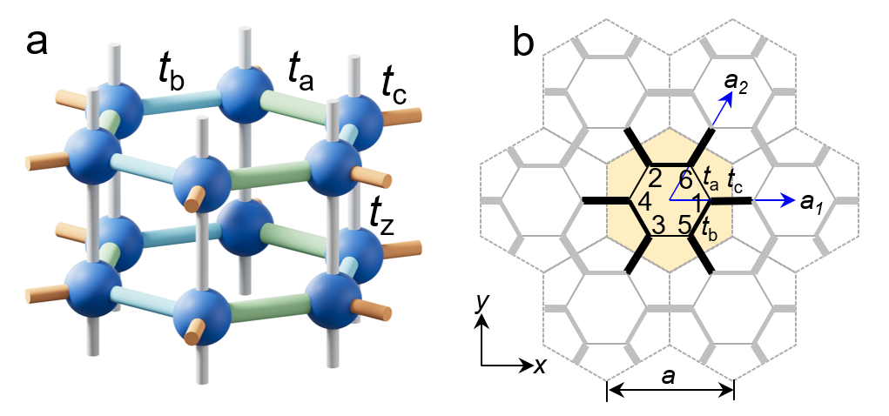
Fig. S1 | a Unit cell of a 3D Kekulé-distorted honeycomb lattice. b Top view of the Kekulé-distorted honeycomb lattice.
As shown in Fig. S1b, we can rewrite the explicit form of the Hamiltonians as follows
$$\begin{aligned}H_{xy}=\left[\begin{matrix}0 & Q \\ Q^{†} & 0\end{matrix}\right]\#\left(S2a\right)\end{aligned}$$
$$\begin{aligned}H_{z}=\left[\begin{matrix}0 & ρ \\ ρ^{*} & 0\end{matrix}\right]\#\left(S2b\right)\end{aligned}$$
where $ρ=t_{z}+t_{z} exp(-ik_{z})$, and $Q$ is a 3-by-3 matrix
$$\begin{aligned}Q=\left[\begin{matrix}t_{c} exp\left(i\overline{k}∙a_{1}\right) & t_{b} & t_{a} \\ t_{a} & t_{c} exp\left(i\overline{k}∙\left(a_{2}-a_{1}\right)\right) & t_{b} \\ t_{b} & t_{a} & t_{c} exp\left(-i\overline{k}∙a_{2}\right)\end{matrix}\right]\#\left(S3\right)\end{aligned}$$
with $\overline{k}=\left(k_{x},k_{y}\right)$ represents the 2D projection of the wave vector $k$ in the 3D momentum space, and the lattice vectors are $a_{1}=a\left(0, 1\right)$and $a_{2}=a\left(1/2,{\sqrt{3}}/2\right).$ The intralayer coupling strengths between neighboring sublattices are $t_{a}=t_{0}-δt cos(φ+4π/3)$, $t_{b}=t_{0}-δt cos(φ+2π/3)$, and $t_{c}=t_{0}-δt cos(φ)$, where t₀ represents the initial coupling strength, and δt and φ represent the amlitude and phase of the Dirac mass, respectively.
- Wilson loop of the 3D Kekulé-distorted honeycomb lattice
We have also calculated the Wilson loop of the 3D Kekulé-distorted honeycomb lattice at k_{z} = 0 based on the discretization of the first Brillouin zone (BZ), as shown in Fig. S2a. The Wilson loop eigenvalues of the 3D Kekulé-distorted honeycomb lattice for φ = 0 are localized at 0, as shown in Fig. S2b, indicating that the system is an 3D ordinary insulator and the Chern number is 0. The Wilson-loop eigenvalues of the 3D Kekulé-distorted honeycomb lattice for φ = π cannot vary continuously with k changes from −π to π, and they are distributed around 0, −π, and π. This is due to the trivial bands mix with the bands under the gap making the Wilson loop generate a bandgap, which indicates that the system has fragile topological properties and corresponds to a nontrivial 3D topological insulator. Besides, the Wilson loop of the 3D Kekulé-distorted honeycomb lattice will not change with varying k_{z}.
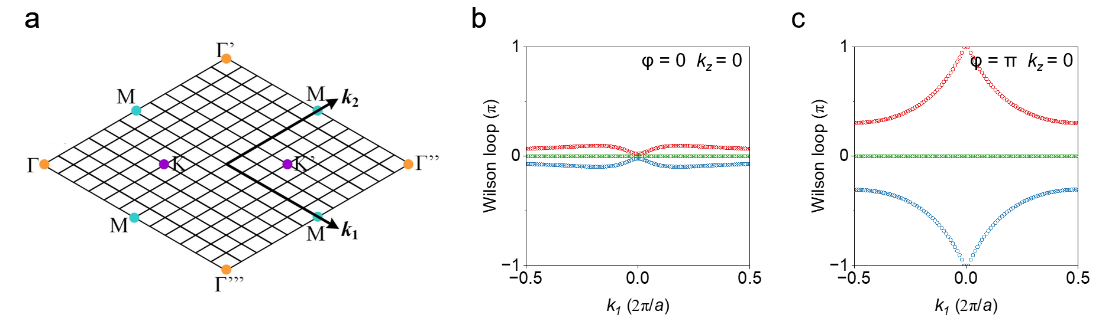
Fig. S2 | a Discretization of the first BZ. b,c Wilson loop of the 3D Kekulé-distorted honeycomb lattice at k_{z} = 0 for φ = 0 (b) and φ = π (c), respectively.
- 3D topological insulator based on a three-dimensional Kekulé-distorted honeycomb lattice
The 3D Kekulé-distorted honeycomb lattice with φ = π can be used to construct a 3D topological insulator. To demonstrate this point, we calculate the eigenstate spectrum of a hexagonal supercell consisting of a finite 3D Kekulé-distorted honeycomb lattice for φ = π, as shown in Fig. S3a. The 3D Kekulé-distorted honeycomb lattice exhibits a Wannier-type 3D higher-order topological insulator with complete 3D bandgap and coexisting topological bulk (grey dots), surface (purple dots), and hinge (blue dots) states, whose eigenmodes energy distributions are shown in Figs. S3b-3d.
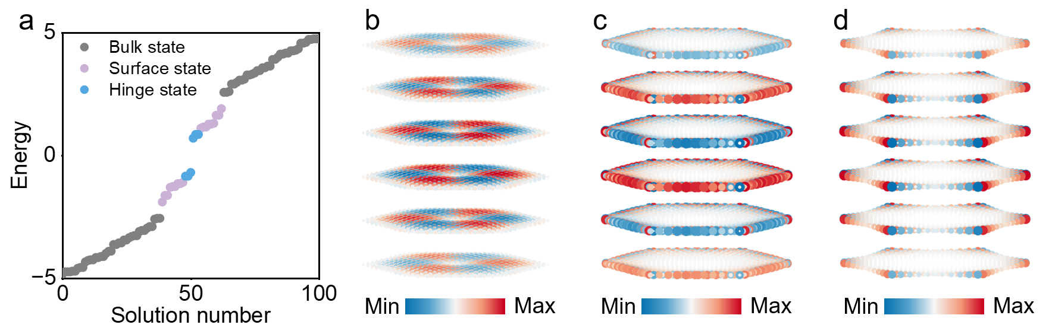
Fig. S3 | a Calculated eigenstate spectrum of a hexagonal supercell of a finite 3D Kekulé-distorted honeycomb lattice for φ = π with open boundary condition in the x-y plane and fixed $k_{z}=0$. b, c, d Calculated energy distributions of the topological bulk states (b), surface states (c), and hinge states (d) of a finite 3D Kekulé-distorted honeycomb lattice.
- Simulated bulk band structures of the 3D tight-binding-like photonic crystal
Figs. S4a-4b show the simulated bulk band structures of the 3D tight-binding-like photonic crystals undergo Kekulé modulation with the Dirac mass phase φ = 0 (Fig. S4a) and φ = π (Fig. S4b), respectively. According to the frequency order of the dipole-like (p) and quadruple-like (d) modes, as shown in Fig. S4c-4d, there exists a band inversion for the 3D tight-binding-like photonic crystals with φ = 0 and φ = π, which correspond to a 3D photonic trivial insulator and a 3D photonic topological insulator, respectively. Note that the 3D photonic topological insulator is a weak topological insulator constructed by stacking 2D quantum spin Hall insulators with interlayer couplings [1-3].
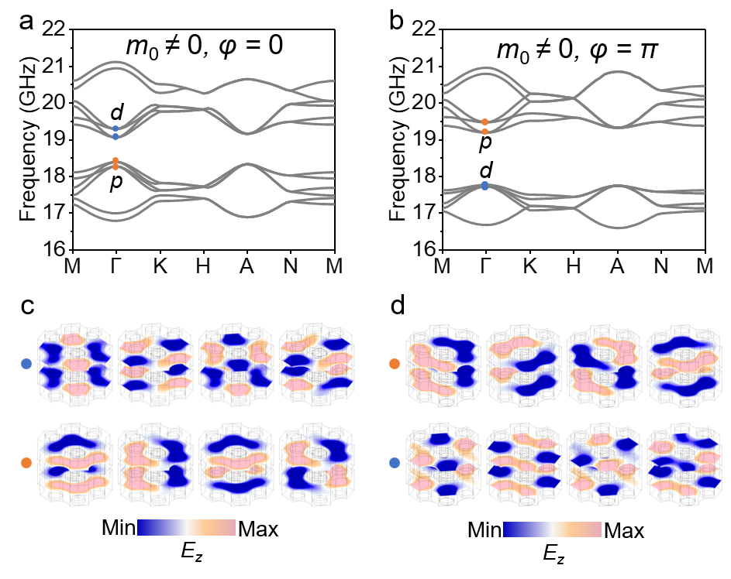
Fig. S4 | a, b Simulated bulk band structures of the 3D tight-binding-like photonic crystals with Kekulé distortion m₀ ≠0, φ = 0 (a) and m₀ ≠0, φ = π (b). c, d Simulated electric field distributions at the Γ point for φ = 0 (c) and φ = π (d).
- Multiple degenerate photonic topological Dirac-vortex modes with larger wind numbers
The number of topological Dirac-vortex modes is determined by the winding number w of the Dirac vortices. As shown in Fig. 5a (Fig. 6a), when we increase the winding number of the Dirac mass to w = 2 (w = 3), two (three) degenerate topological Dirac-vortex modes can exist simultaneously in the simulated dispersion relations, as shown in Fig. S5b (Fig. S6b). Figs. S5c-5d (Figs. S6c-6e) presents the simulated electric field distributions of the two (three) degenerate topological Dirac vortex modes.
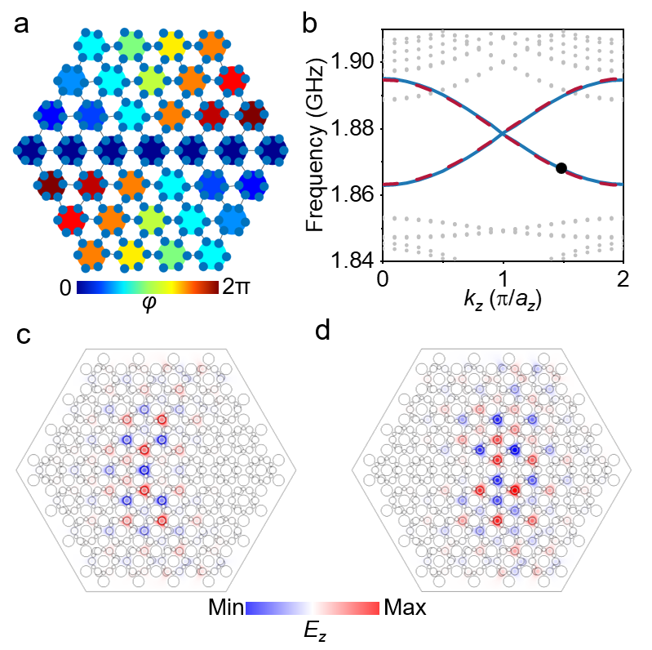
Fig. S5 | a Schematic of the modulation angle φ of the Kekulé distortion which has a winding number of w = 2. b Simulated dispersion of the topological Dirac-vortex modes (red and blue lines) along k_{z}. c, d Simulated electric field distributions of the two degenerate topological Dirac-vortex eigenmodes at k_{z} = 1.5π/a_{z} marked by the black dot in b.

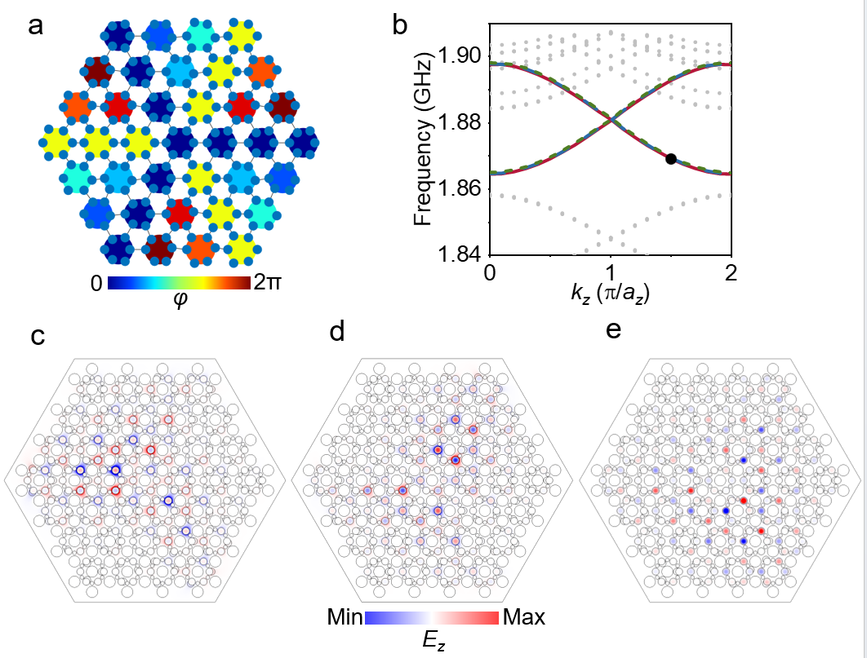
Fig. S6 | a Schematic of the modulation angle φ of the Kekulé distortion which has a winding number of w = 3. b Simulated dispersion of the topological Dirac-vortex modes (red, blue, and green lines) along k_{z}. c-e Simulated electric field distributions of the three degenerate topological Dirac-vortex eigenmodes at k_{z} = 1.5π/a_{z} marked by the black dot in b.
References
- L. Fu, C. L. Kane, and E. J. Mele, Topological insulators in three dimensions. Phys. Rev. Lett. 98, 106803 (2007).
- R. S. Mong, J. H. Bardarson, and J. E. Moore, Quantum transport and two-parameter scaling at the surface of a weak topological insulator. Phys. Rev. Lett. 108, 076804 (2012).
- Z. Ringel, Y. E. Kraus, and A. Stern, Strong side of weak topological insulators. Phys. Rev. B 86, 045102 (2012).

