SUPPLEMENTARY FIGURES

A
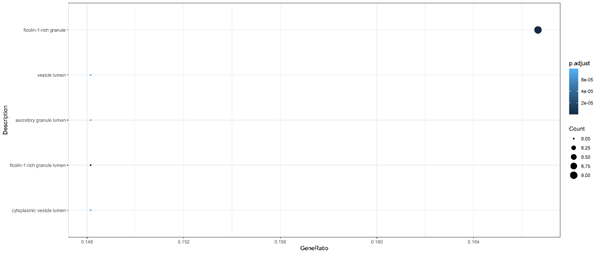

B

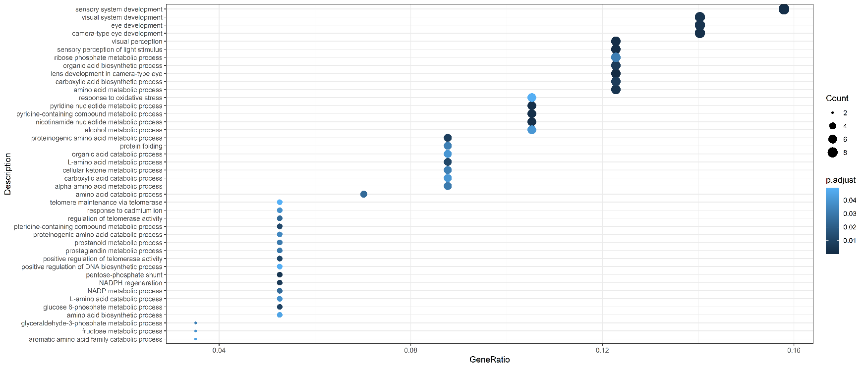
Supplementary Figure 1. (A) Cellular Component (CC); (B) Biological Processes (BP) charts found enriched in proteins upregulated or exclusive of Ctrl VH. GeneRatio was calculated and data filtered for p≤0.05.

A

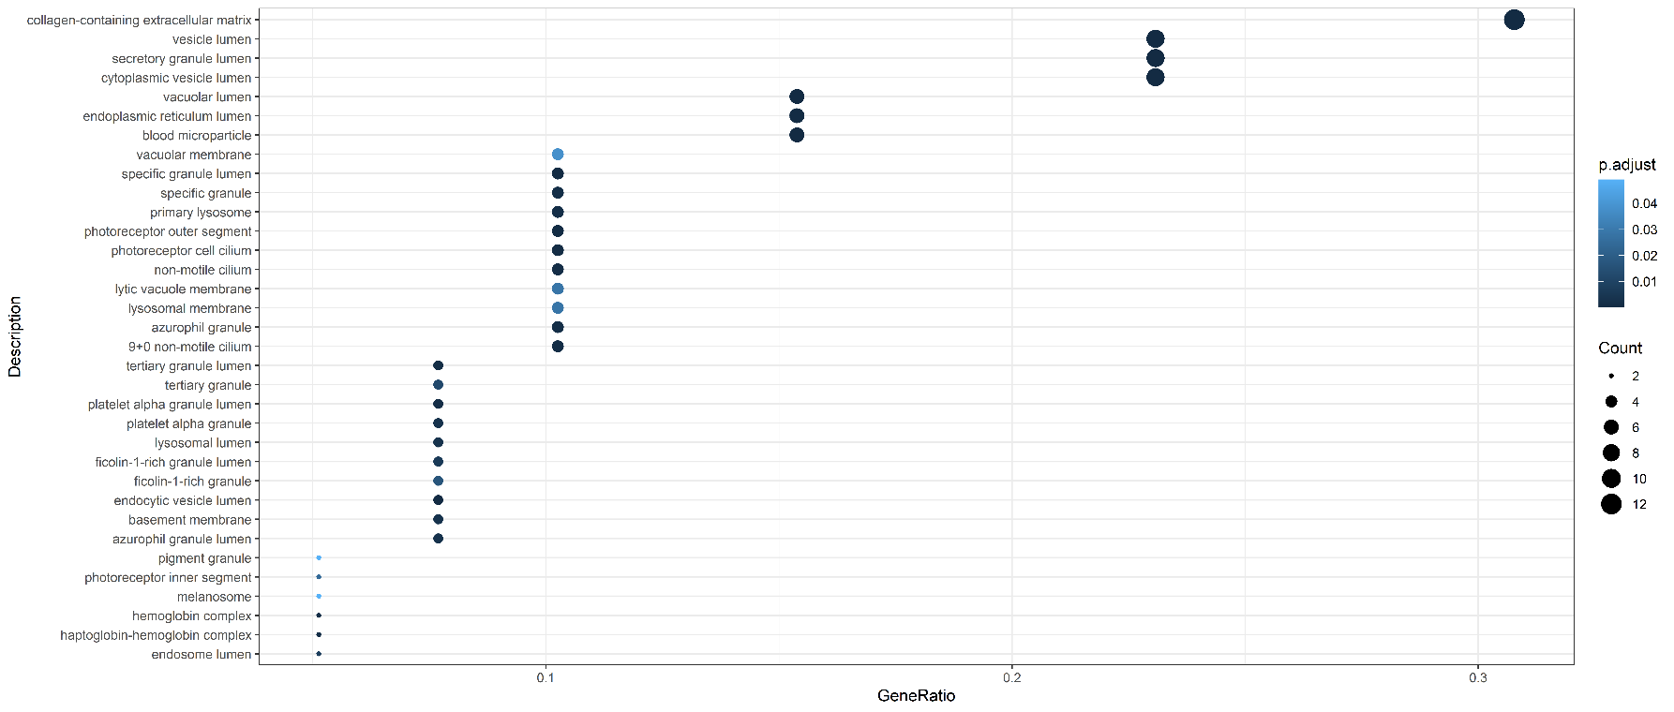

B
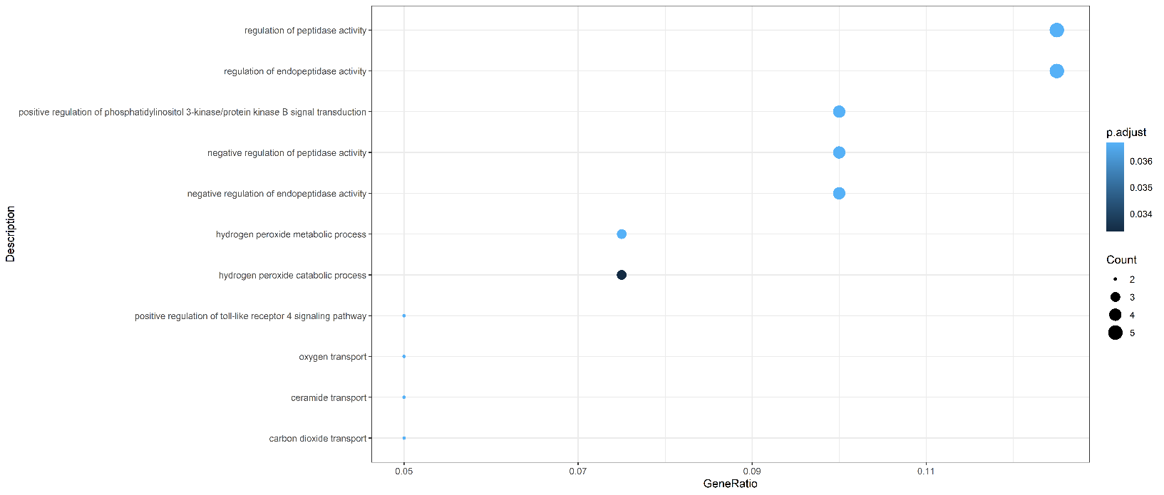

Supplementary Figure 2. (A) Cellular Component (CC); (B) Biological Processes (BP) charts found enriched in proteins upregulated or exclusive of Ctrl VH. GeneRatio was calculated and data filtered for p≤0.05.

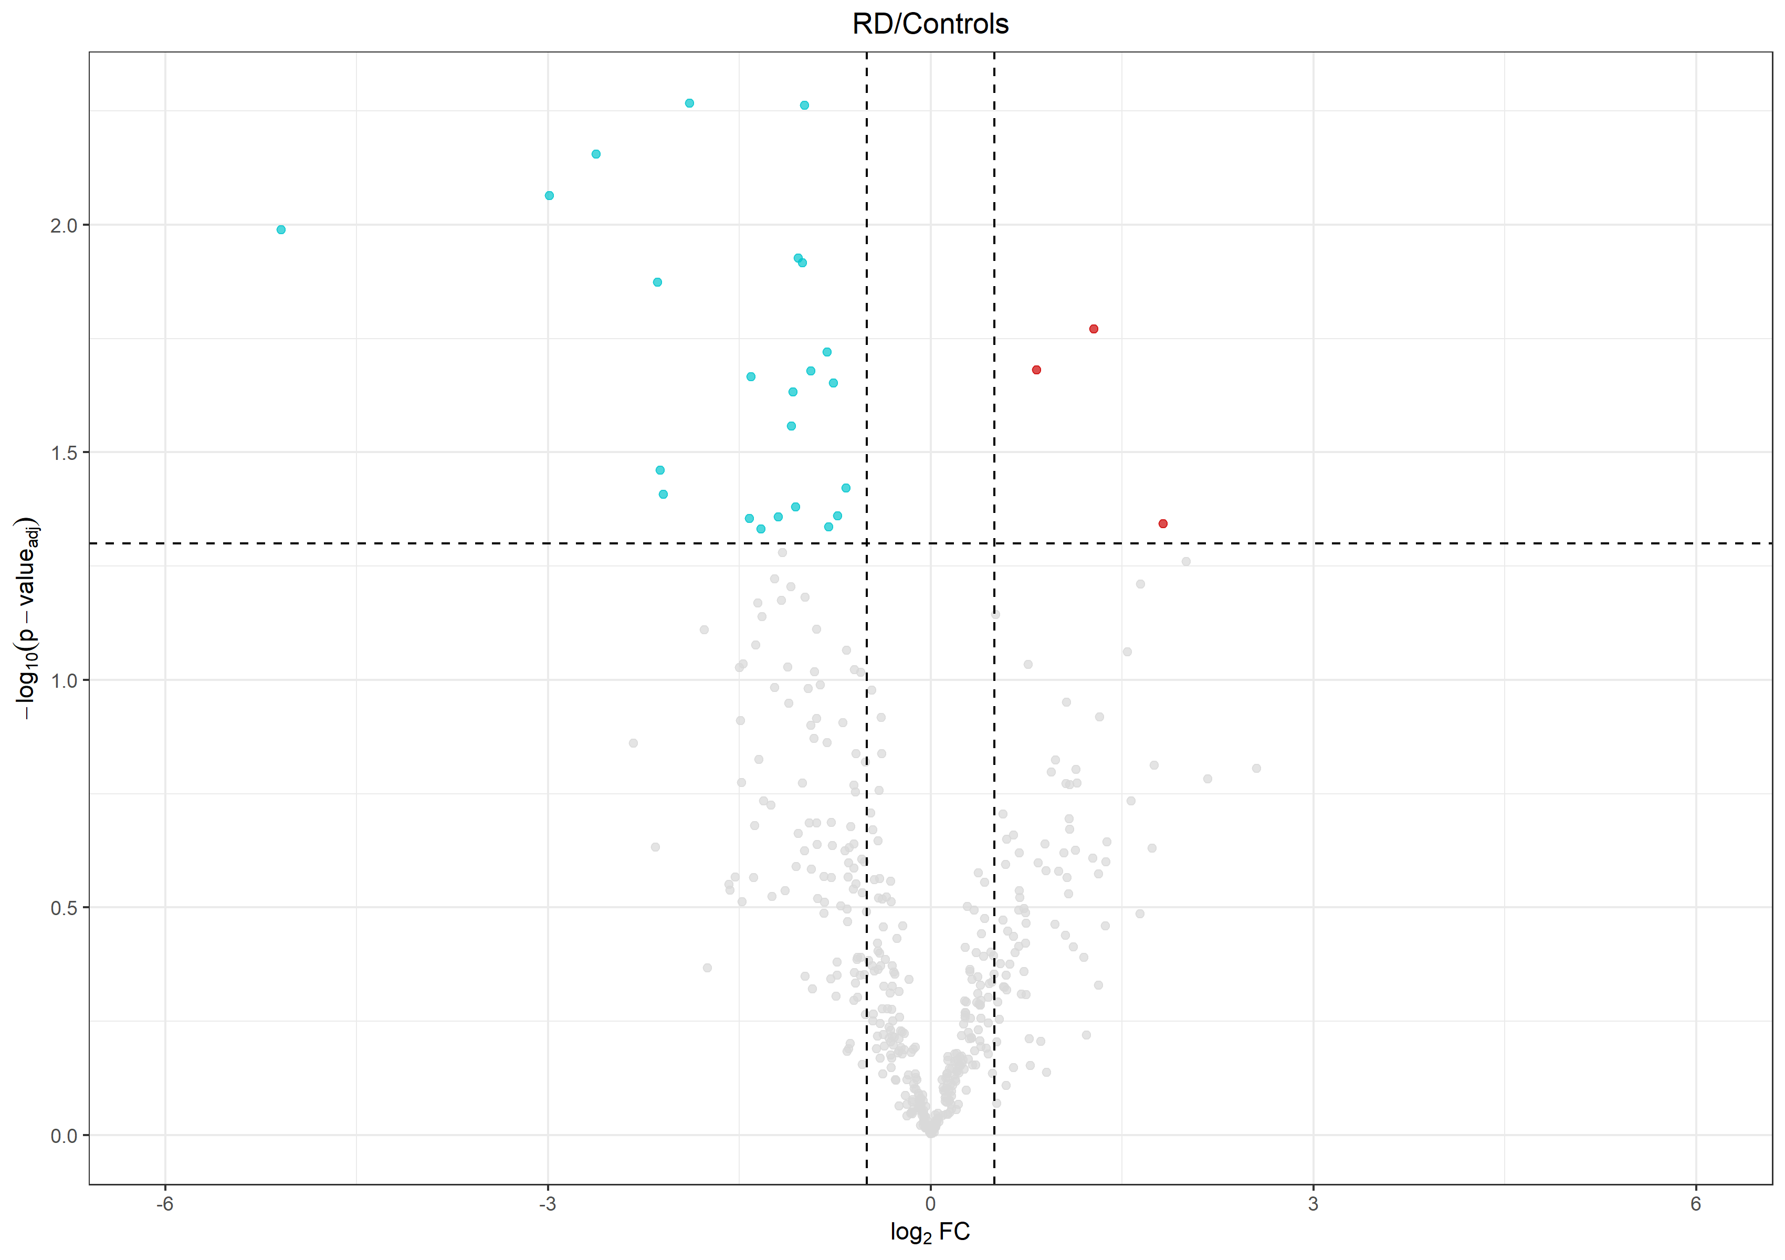

Supplementary Figure 3. Volcano plot showing differentially expressed N-termini. X-axis reports the fold change expressed as log2 fold-change (Log2FC); Y-axis reported the -log10 p-value adjusted by Benjamini-Hochberg correction [-log₁₀(p-value_{adj})]. Statistical significance was set for p.ord≤0.05. Dashed lines highlighted the cut-off set for log2FC and log₁₀ of p-value significance, namely: ±0.57 and 1.3, respectively. N-termini upregulated and downregulated in DR vs Ctrl VH are represented in red and turquoise, respectively.

