Tables
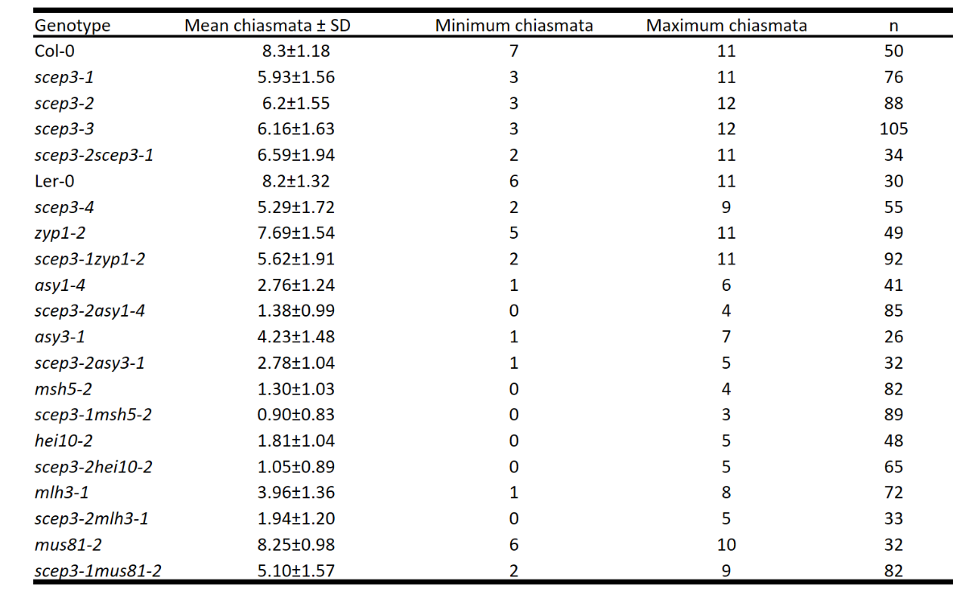
Table 1: Chiasma numbers for genotypes in this study. Minimum chiasma numbers (MCN) in scep3 are significantly (two-sided Student’s t-test) decreased (scep3-1, P = 1.02 x 10⁻¹⁶; scep3-2, P = 5.43 x 10⁻¹⁵; scep3-3, P = 5.88 x 10⁻¹⁶ and scep3-4, P = 5.05 x 10⁻¹²) when compared with the respective WT. No difference was found in scep3-1scep3-2 when compared with single mutants (P = 0.2776; one-way ANOVA). No significant difference is found between scep3-1zyp1-2 and scep3-1 (P = 0.251, two-sided Student’s t-test). Significant differences (two-sided Student’s t-test) were found in scep3-2asy1-4 vs. asy1-4 (P = 5.21 x 10⁻¹⁰), scep3-2asy3-1 vs. asy3-1 (P = 5.3 x 10⁻⁵), scep3-1msh5-2 vs. msh5-2 (P = 5.21 x 10⁻³), scep3-2hei10-2 vs. hei10-2 (P = 1.03 x 10⁻⁵), scep3-2mlh3-1 vs. mlh3-1 (P = 5.34 x 10⁻¹¹), scep3-2mus81-2 vs. scep3-1 (P = 9.86 x 10⁻⁴).

