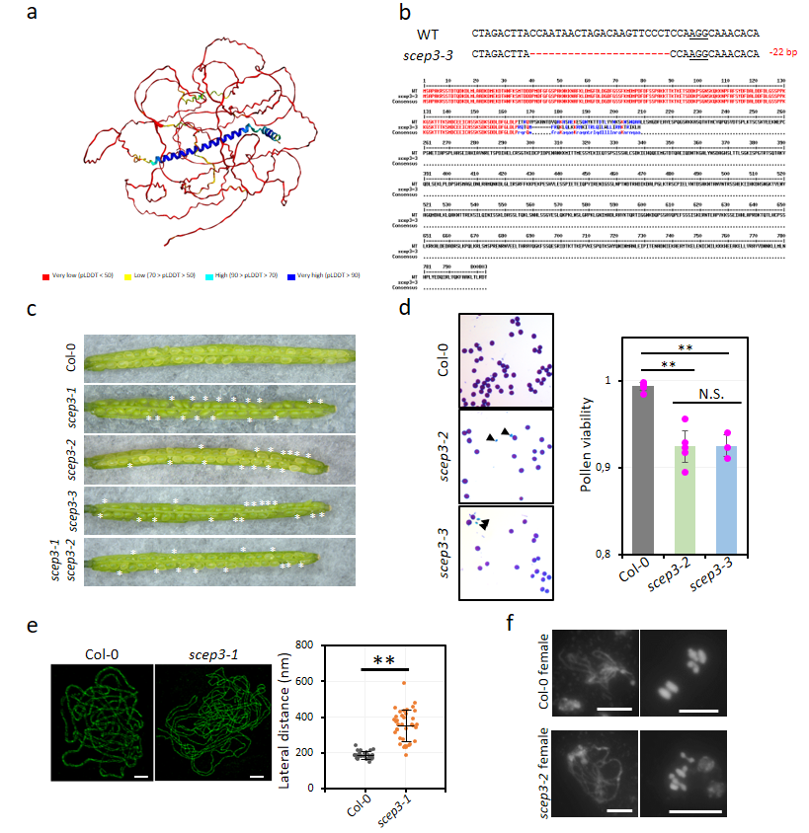
Fig. S1: Isolation of scep3-3 and phenotypic analysis of scep3 alleles.
a, SCEP3 full-length protein structure prediction by AlphaFold2. b, Isolation of scep3-3. Top: CRISPR/Cas9-mediated 22 bp deletion in exon 5 resulting in a predicted truncated protein of 201 AA; PAM sequence underlined and deleted bases as red dashes. Below: Alignment of SCEP3 WT and SCEP3-3 proteins. c, Seed abortion (indicated by asterisks) in the WT, scep3 alleles and allelic cross. d, Alexander staining of pollen grains (arrowheads indicate non-viable ones in blue) and quantification of pollen viability (data as mean ± standard error of the mean (s.e.m.)) in Col-0 and scep3. e, Left: 3D-SIM analysis of REC8 immunolocalization in Col-0 and scep3-1. Along synapsed chromosomes the two parallel LEs show an average distance of 188 ± 21.6 nm (range 148-243 nm) in the WT, while in scep3-1 in regions of alignment the average distance increased to 352 ± 87.5 nm with larger variation (189-592 nm). Single-slice images were used for measuring the distances between two aligned axes. Scale bar, 2 μm. Right: Quantification of aligned axes distances in both Col-0 and scep3-1. f, Female meiotic chromosome spreads of Col-0 and scep3-3. DAPI-stained DNA in gray. Scale bar, 10 μm.

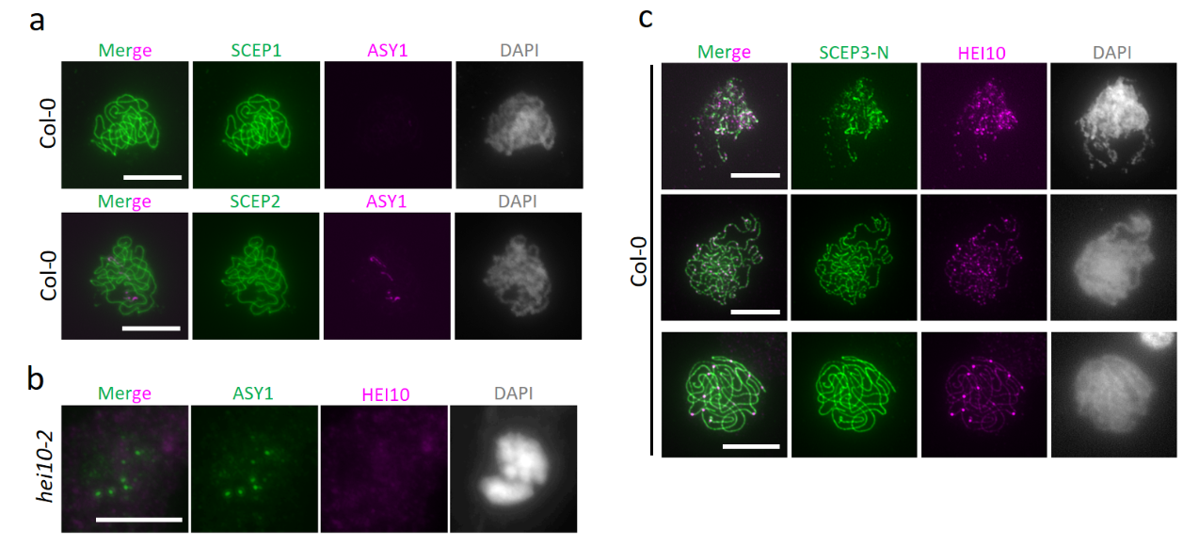
Fig. S2: SCEP1, SCEP2 and SCEP3 localization during pachytene in the WT and absence of HEI10 in hei10-2 (specificity of HEI10 antibody).
Immunolocalization of a, SCEP1 or SCEP2 and ASY1 in Col-0, of b, HEI10 and ASY1 in hei10-2 and of c, SCEP3-N and HEI10 in Col-0. DNA counterstained with DAPI in gray. Scale bar, 10 μm.

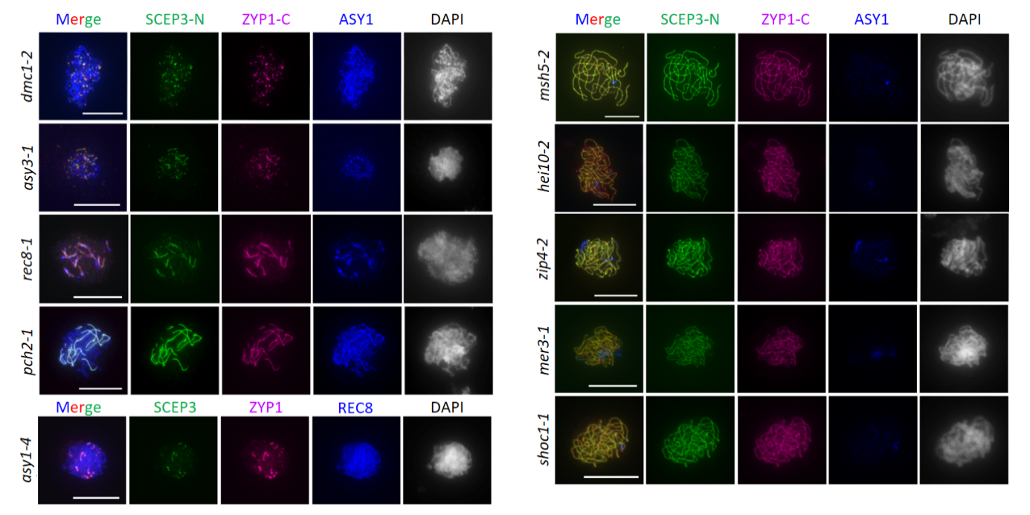
Fig. S3: Co-localization of SCEP3 and ZYP1 in various meiotic mutants.
Immunolocalization of SCEP3-N (green), ZYP1-C (purple) and ASY1 or REC8 (blue) in dmc1-2, asy3-1, rec8-1, pch2-1, asy1-4, msh5-2, hei10-2, zip4-2, mer3-1 and shoc1-1 during meiotic prophase I. DNA stained with DAPI in gray. Scale bar, 10 μm.

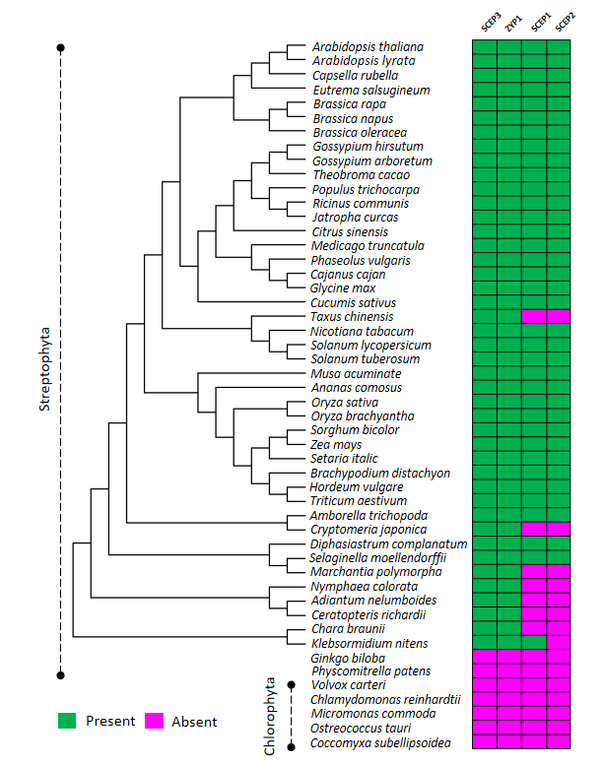
Fig. S4: Evolutionary analysis of SCEP3 and other CR components.
The evolutionary tree is constructed based on SCEP3 homologous sequences (PSI blast results using Arabidopsis SCEP3 as seed sequence) from Streptophyta species. Accessions used: A. thaliana (NP_001328810.1), A. lyrata (XP_020875481.1), Capsella rubella (XP_023635313.1), Eutrema salsugineum (XP_024005618.1), Brassica rapa (XP_009136934.2), B. napus (XP_013737233.2), B. oleracea (XP_013594171.1), Gossypium hirsutum (XP_040935483.1), G. arboretum (KAK5792206.1), Theobroma cacao (XP_017978471.1), Citrus sinensis (XP_024950445.1), Phaseolus vulgaris (XP_007153704.1), Cajanus cajan (XP_029124714.1), Medicago truncatula (XP_039689560.1), Glycine max (XP_040873294.1), Ricinus communis (XP_048229528.1), Jatropha curcas (XP_020541047.2), Populus trichocarpa (KAI5570781.1), Cucumis sativus (XP_011658243.1), Solanum lycopersicum (XP_019067843.1), S. tuberosum (KAH0717859.1), Sorghum bicolor (XP_021312987.1), Zea mays (XP_008673176.1), Setaria italic (XP_004969993.2), Oryza sativa (KAF2952333.1), O. brachyantha (XP_040380573.1), Brachypodium distachyon (KQK09796.1), Ananas comosus (XP_020098929.1), H. vulgare (XP_044977082.1), Nicotiana tabacum (XP_016437386.1), Triticum aestivum (KAF7023752.1), Musa acuminate (XP_018686223.1), Amborella trichopoda (XP_020527858.1), Taxus chinensis (KAH9309445.1), Selaginella moellendorffii (XP_024528147.1), Nymphaea colorata (XP_049931681.1), Cryptomeria japonica (XP_059065081.1), Adiantum nelumboides (MCO5557227.1), Ceratopteris richardii (KAH7301291.1), Diphasiastrum complanatum (KAJ7553908.1), Marchantia polymorpha (PTQ45356.1), Chara braunii (GBG74560.1), Klebsormidium nitens (GAQ79536.1). Some Streptophyta and Chlorophyta species without SCEP3 homolog identified are also listed. The color-coded table includes SCEP3, ZYP1, SCEP1 and SCEP2 and shows the presence (green) or absence (purple) of respective homologs in different species.

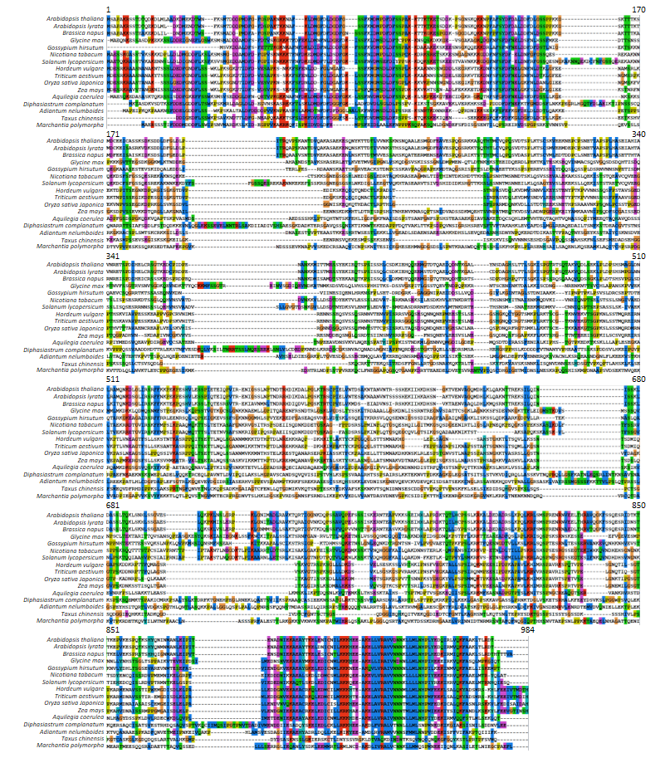
Fig. S5: Multiple protein sequence alignment of plant SCEP3 homologs.
Accessions used: A. thaliana, NP_193584.3; A. lyrata, XP_020875478.1; B. napus, XP_013737233.1; G. max, XP_006583844.1; G. hirsutum, KAG4178256.1; N. tabacum, XP_016437384.1; S. lycopersicum, XP_019067843.1; H. vulgare, XP_044977082.1; T. aestivum, KAF7030755.1; O. sativa Japonica, XP_015621851.1; Z. mays, NP_001348911.1; Aquilegia coerulea, IA41840.1; D. complanatum, KAJ7553908.1; A. nelumboides, MCO5557227.1; T. chinensis, KAH9309445.1; M. polymorpha, PTQ45357.1.

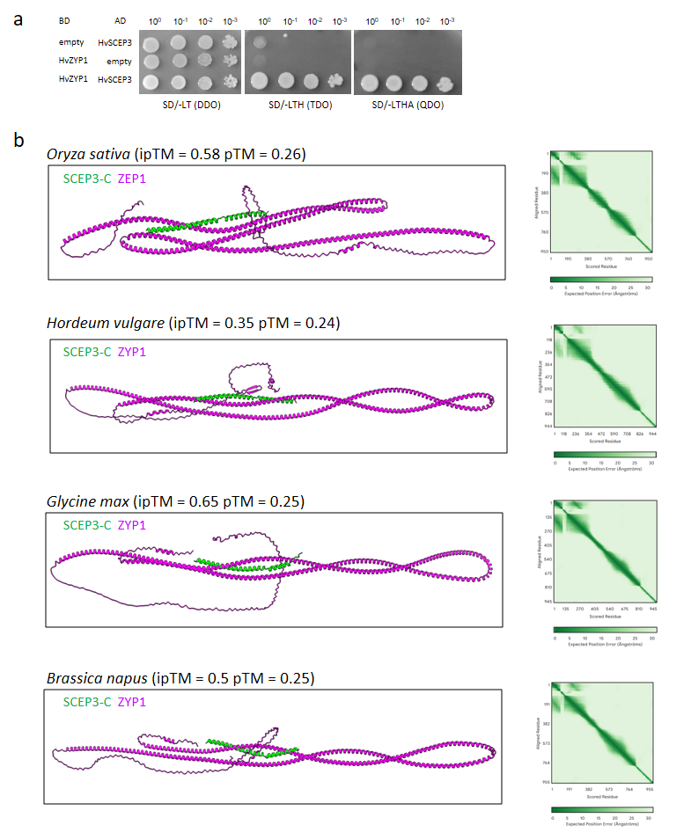
Fig. S6: Conservation of the SCEP3 and ZYP1 interaction in plants.
a, Y2H interaction of H. vulgare ZYP1 and SCEP3 (full-length proteins). Note, TDO (SD/-LTH) is lower and QDO (SD/-LTHA) is higher stringent medium for selection. b, AlphaFold3 interaction prediction using the C-terminus (α-helical domain) of SCEP3 and full-length ZYP1 (ZEP1 is the rice ZYP1 homolog) from O. sativa, H. vulgare, G. max or B. napus. PAE values are shown on the right; ipTM and pTM values indicated in parentheses.
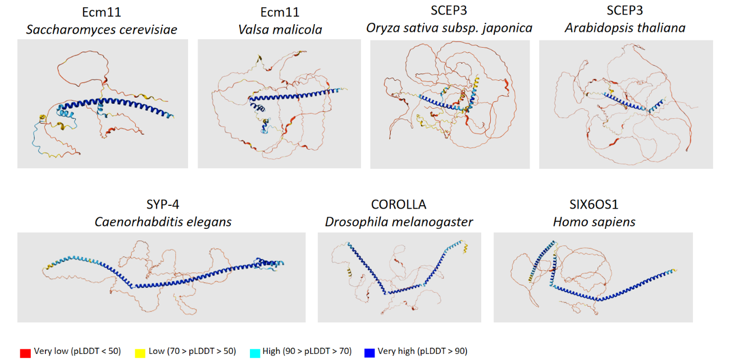
Fig. S7: SC proteins from non-plant species: possible structural SCEP3 orthologues.
Known SC proteins as potential non-plant SCEP3 structural orthologues isolated from the AlphaFold protein structure database ^{59, 60}.

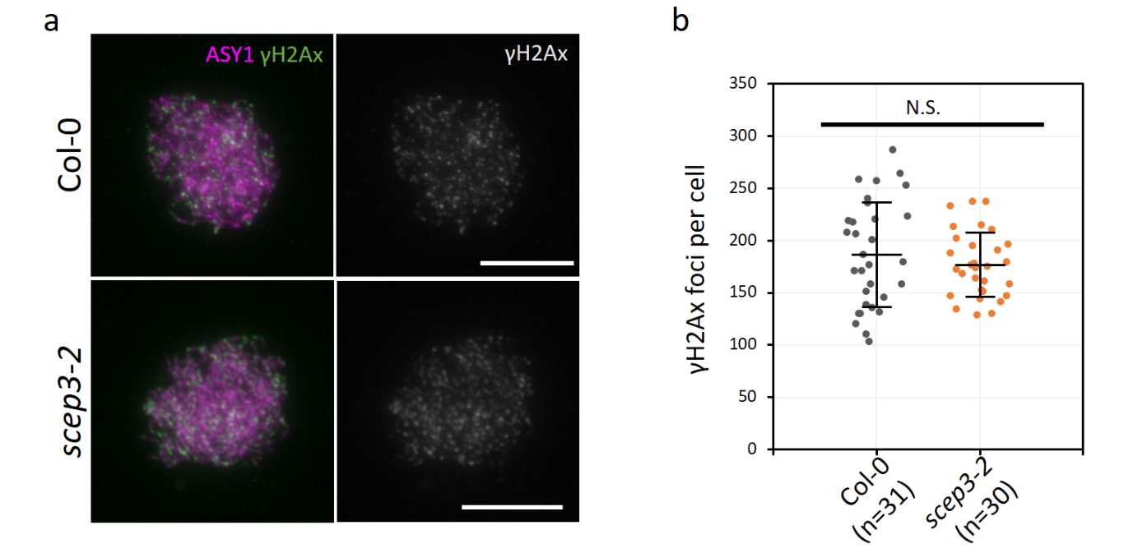
Fig. S8: Similar γH2Ax foci numbers in scep3 when compared with the WT.
a, Immunolocalization of ASY1 (magenta) and γH2Ax (green) in Col-0 and scep3-2 meiocytes. γH2Ax signal channel are depicted on the right (gray). Scale bar, 10 μm. b, Quantification of γH2Ax foci numbers in Col-0 (187 ± 51) and scep3-2 (177 ± 31) meiocytes (late leptotene/early zygotene). No significant difference was found between Col-0 and scep3-2 (P = 0.355, two-sided Student’s t-test).

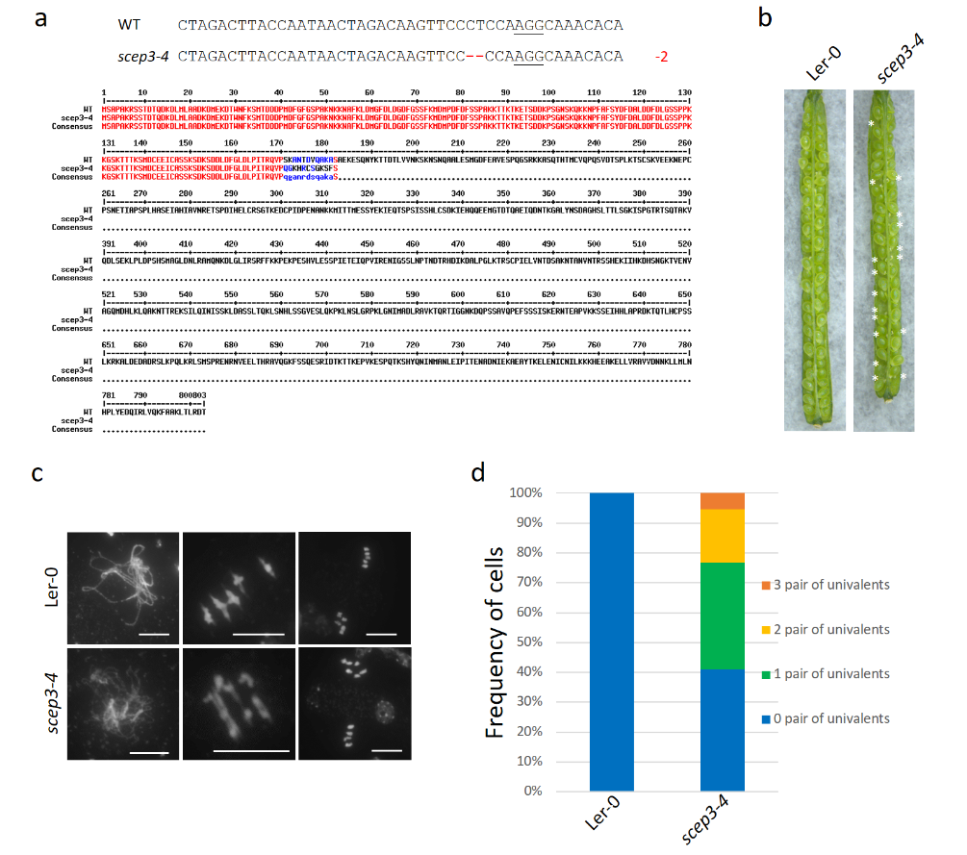
Fig. S9: Isolation and phenotype of scep3-4 in Ler-0 and scep3-3scep3-4.
a, Details on the CRISPR/Cas9-mediated allele scep3-4: 2 bp deletion within exon five resulting in a predicted truncated protein of 182 AA. PAM sequence underlined and deleted bases as red dashes. Below: alignment of SCEP3 wildtype and truncated SCEP3-4 protein. b, Seed setting in siliques of Ler-0 and scep3-4. Seed abortion indicated by asterisks. c, Male meiotic chromosome spreads and d, quantification of univalent frequency in Ler-0 and scep3-4.

