Exploring genetic variants of lncRNA associated with splicing regulation and their impact on ovarian cancer development
Lingxiao Zou¹, Meng Zhang¹, Shan He¹, Minhui Zhuang¹, Yulan Wang¹, Xiaofeng Song^{1,*}, Jian Zhao^{1,*}

¹ Department of Biomedical Engineering, Nanjing University of Aeronautics and Astronautics, Nanjing 211106, China

* To whom correspondence should be addressed: Xiaofeng Song, Department of Biomedical Engineering, Nanjing University of Aeronautics and Astronautics, Nanjing 211106, China. Email: xfsong@nuaa.edu.cn; Jian Zhao, Department of Biomedical Engineering, Nanjing University of Aeronautics and Astronautics, Nanjing 211106, China. Email: zhaojian@nuaa.edu.cn;

Supplementary material
Figure S1. Reducing the batch effect of data originating from different projects.
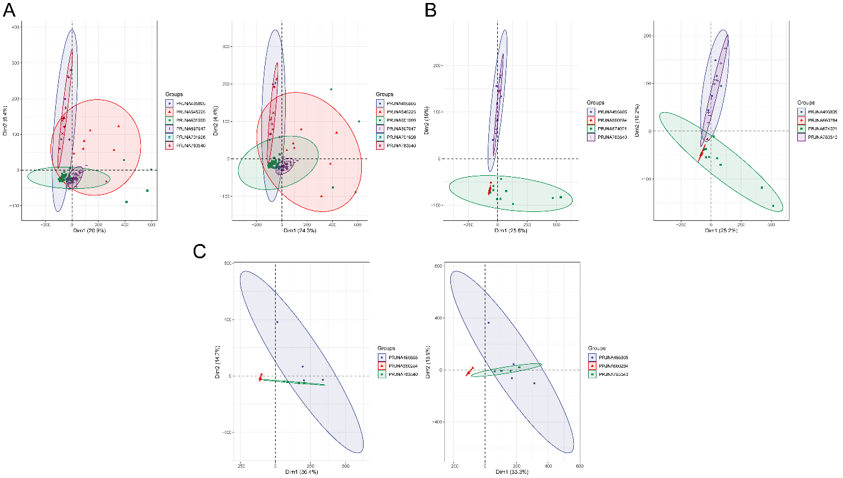

Figure S2. COLOC PP3 values between the lncRNA sQTL and lncRNA eQTL signals.

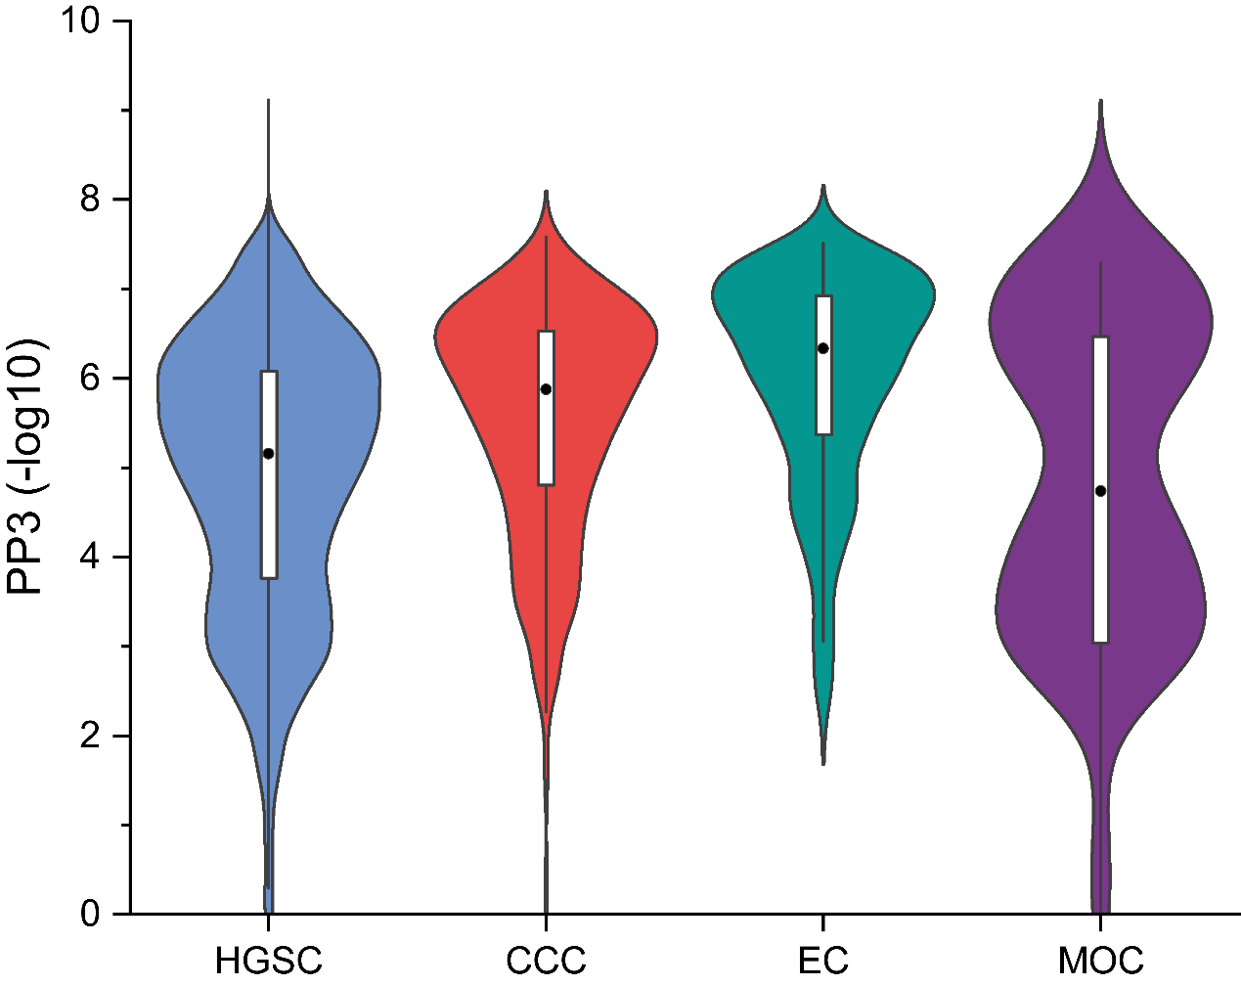

Figure S3. LncRNAs significantly associated with overall survival in ovarian cancer patients.
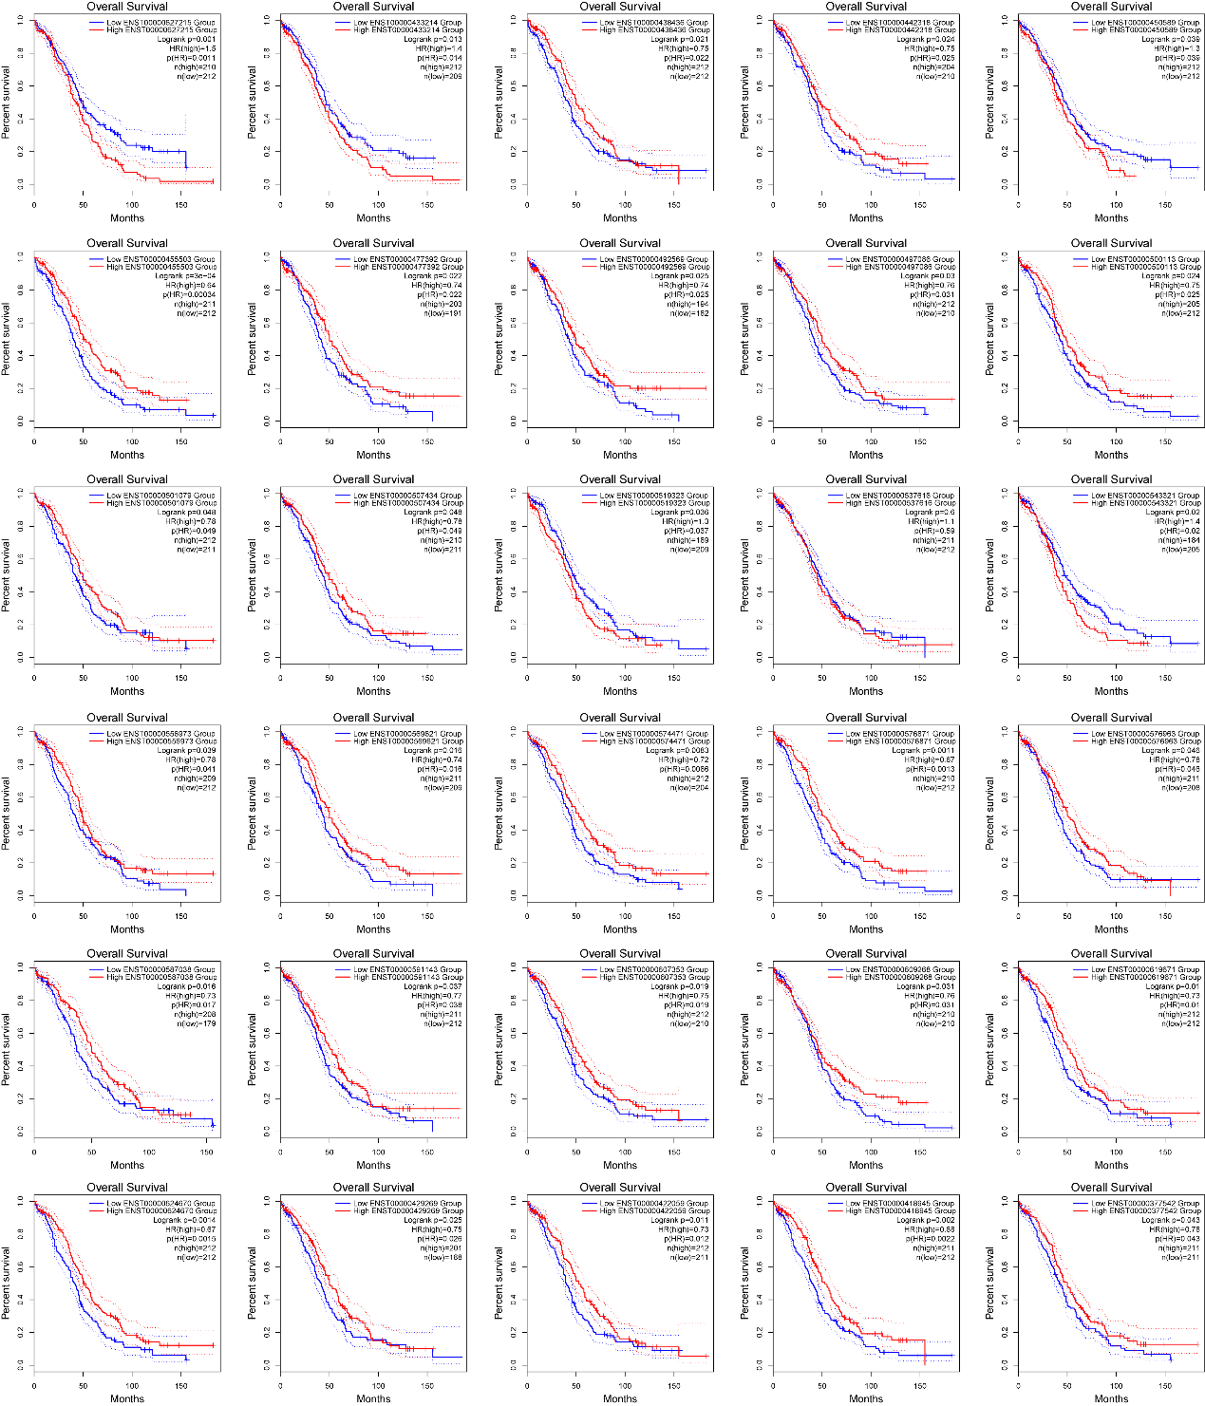

Figure S4. mRNAs significantly associated with overall survival in ovarian cancer patients.
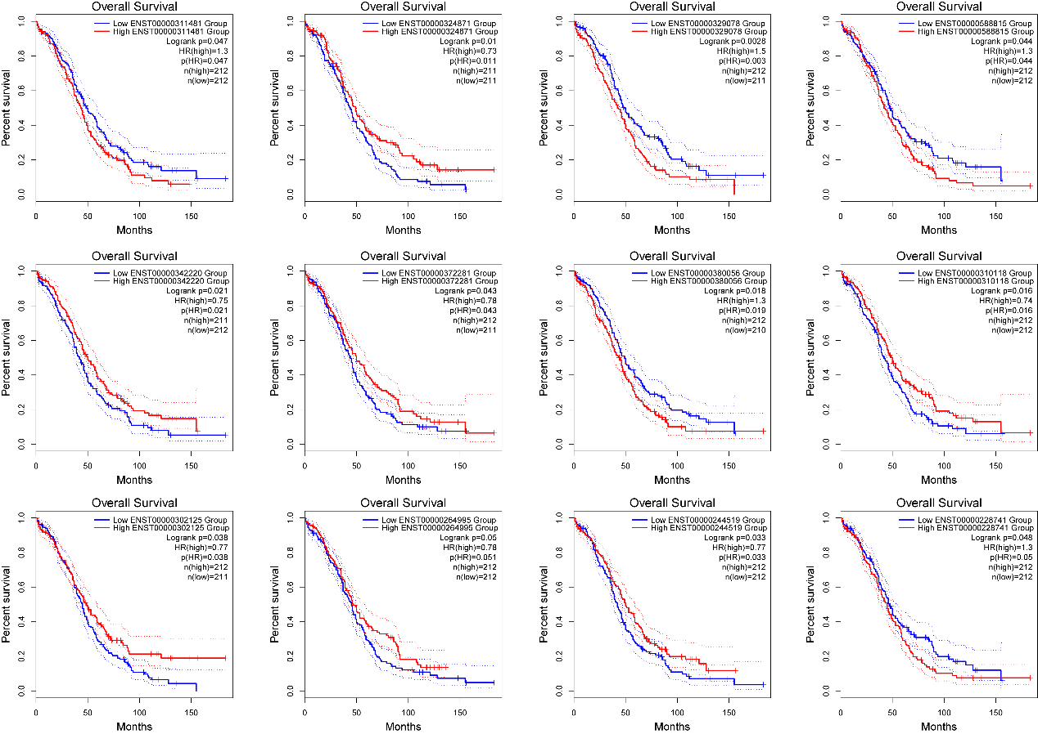

Figure S5. Excision rates of introns involving clu_34361_+ under rs1549334 different genotype conditions.
