Title
Radiomic-based models are able to predict the pathologic response to different neoadjuvant chemotherapy regimens in patients with gastric and gastroesophageal cancer: a cohort study
Authors
Annamaria Agnes^{1,2}; Luca Boldrini³; Federica Perillo¹; Huong Elena Tran³; Maria Gabriella Brizi^{1,3}; Riccardo Ricci^{1,4}; Jacopo Lenkowicz³; Claudio Votta³; Alberto Biondi^{1,2}; Riccardo Manfredi^{1,3};Vincenzo Valentini^{1,3}; Domenico M D’Ugo^{1,2}; Roberto Persiani^{1,2}.

Affiliations
¹ Università Cattolica del Sacro Cuore, Largo F. Vito n.1, 00168, Rome, Italy
² Dipartimento di Scienze Mediche e Chirurgiche, Fondazione Policlinico Universitario Agostino Gemelli IRCCS, Largo A. Gemelli n. 8, 00168, Rome, Italy
3 Dipartimento di Diagnostica per Immagini, Radioterapia Oncologica ed Ematologia, Fondazione Policlinico Universitario "A. Gemelli" IRCCS, Largo A. Gemelli n. 8, 00168, Rome, Italy
⁴ Dipartimento di Scienze della salute della donna, del bambino e di sanità pubblica, Fondazione Policlinico Universitario Agostino Gemelli IRCCS, Largo A. Gemelli n. 8, 00168, Rome, Italy

Corresponding author. Alberto Biondi, General Surgery Unit, Fondazione Policlinico Universitario
Agostino Gemelli, Catholic University, Largo Francesco Vito 1, 00168 Rome, Italy, email
alberto.biondi@policlinicogemelli.it ; phone number: +39-0630154974; fax +39-0630158015

Supplementary Materials - Index

Type - Supplementary Figures and Tables
Figures | pag. 3
Tables | pag.

Supplementary Figures and Tables

Figures

Fig. 1s Flowchart of the patients’ selection
2.1 Model for the prediction of non-responders (TRG 3-5) to all chemotherapy regimens (CF + ECF/EOX + FOLFOX + FLOT)
Results for this model are presented in Table 3 and in detail in the Supplementary Materials. In this model, the feature selected by the Boruta algorithm was: “F_stat.energy”, a statistical feature. Among the clinicopathological variables, none had a significant association with the outcome of NR. The radiomic model resulting from logistic regression analysis (Supplementary Table 2) had a Hosmer-Lemeshow p of 0.519. The ROC AUC of the model was 0.725 (CI 95% 0.610-0.839). The calibration linear equation of the model was y= (-)0.130 + 1.275*x. After bootstrap resampling, the mean AUCs under the ROC curve (CI 95%) was 0.723 (0.602-0.837), and the calibration belt did not show a significant deviation from the ideal calibration.

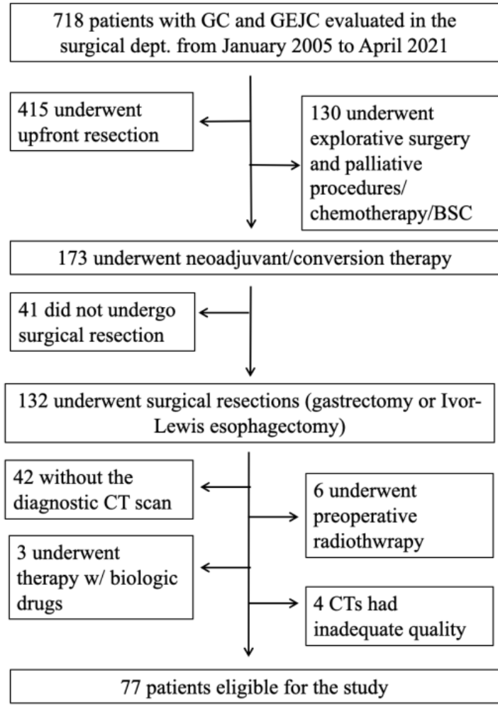

Figure 2s: Performance of the predictive model for non-responders (TRG 4-5) to all types of chemotherapy. Panel A (top left): ROC curve; Panel B (right): probability of being non-responders (TRG 4-5) predicted by the model for each patient – colors represent the true outcome, the dotted line represents the cut-off, patients with predicted probability above cut-off are model-positives and those with predicted probability below the line model-negative; panel C (bottom left): calibration belt.
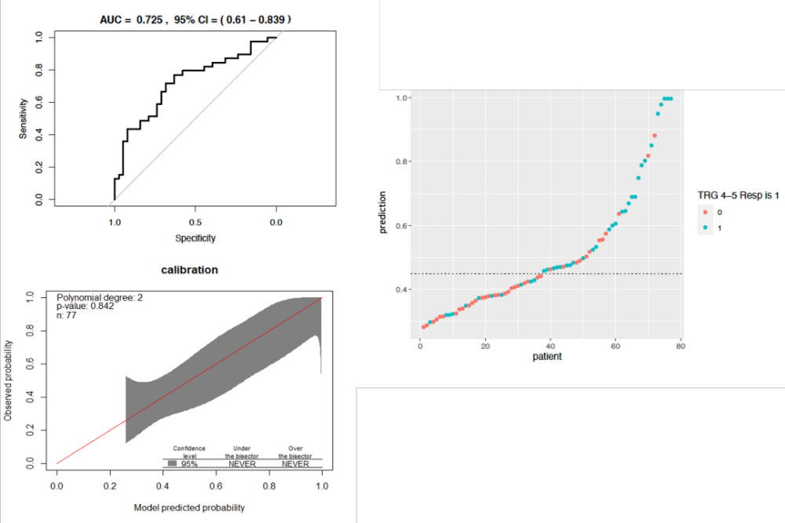

Tables

Table 1s: Multivariable logistic regression conducted on 73 patients to construct a radiomic – clinicopathologic model to predict major response in all patients undergoing chemotherapy
 | Estimate | Std. Error | z value | p value
(Intercept) | -1.23 | 0.39 | -3.129 | 0.002
F_stat.10thpercentile | -0.97 | 0.39 | -2.521 | 0.012
SRC | -3.20 | 1.52 | -2.104 | 0.035

Table 2s: Logistic regression conducted on 77 patients to predict non-response in patients undergoing all types of chemotherapy
 | Estimate | Std. Error | z value | p value
(Intercept) | 0.23 | 0.28 | 0.809 | 0.418
F_stat.energy | 1.41 | 0.56 | 2.541 | 0.011

Table 3s: Logistic regression conducted on 61 patients to predict non-response in patients undergoing standard of care chemotherapy
 | Estimate | Std. Error | z value | p value
(Intercept) | 0.43 | 0.38 | 1.122 | 0.262
F_stat.energy | 2.05 | 0.86 | 2.384 | 0.017

Table 4s: Multivariable logistic regression conducted on 53 patients to predict non-response in patients undergoing oxaliplatin-based chemotherapy
 | Estimate | Std. Error | z value | p value
(Intercept) | 0.14 | 0.37 | 0.387 | 0.699
F_morph.volume | 1.51 | 0.60 | 2.501 | 0.012
F_szm.hgze | -1.56 | 0.68 | -2.299 | 0.021

Table 5s: Multivariable logistic regression conducted on 40 patients to predict non-response in patients undergoing FLOT chemotherapy
 | Estimate | Std. Error | z value | p value
(Intercept) | 0.26 | 0.64 | 0.401 | 0.688
F_morph.volume | 3.06 | 1.31 | 2.339 | 0.019
F_szm_2.5D.szhge | -4.47 | 1.70 | -2.630 | 0.009

