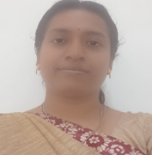 Dr.D. Sathiya is working as an Associate Professor in the department of Computer Science and Engineering at KSR College of Engineering (Autonomous), Tiruchengode, Namakkal, Tamilnadu.She obtained her Ph.D. degree from Anna University, Chennai in 2019, M. E from VMKVEC in 2010, and B. E from Bharathidasan University, Trichy in 2003.She is having 22 years of teaching experience in the field of Computer Science Engineering. She has published more than 12 research papers in reputed international journals and conferences with high impact factors. She is an active member of various professional bodies. She has authored 6 Indian
patents. Her areas of interest are Wireless network, Manet, Data Science, Artificial
Intelligence, Machine Learning.

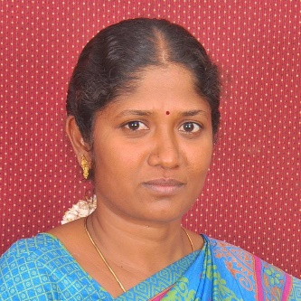 Dr.V. Sharmila is working as an Associate Professor in the department of Computer Science and Engineering at KSR College of Engineering (Autonomous), Tiruchengode, Namakkal, Tamilnadu.She obtained her Ph.D. degree from Anna University, Chennai in 2018, M. E from KSRCT in 2008, and B. E from KSRCT, in 2002.She is having 20 years of teaching experience in the field of Computer Science Engineering. She has published more than 48 research papers in reputed international journals and conferences with high impact factors. She is an active member of various professional bodies. She has authored 6 Indian patents. Her areas of interest are Wireless network, Manet, Data Science, Artificial Intelligence, Machine Learning.

