Surporting Information
Manipulating molecular conformation of charge-transfer cocrystal for NIR-II absorption and light/thermal-responsive imaging
Yun Rong^{1,2,3}, Si-Qi Chen^{1,2}, Yu-Dong Zhao³, Sheng Zhuo³, Yuan-Yuan Li^{1,2,3}, Jin-Zhuo Liu^{1,2,3}, Yi-Yi Ju¹, Yue-Min Xie³, Liang-Sheng Liao³, Ming-Peng Zhuo^{1,2}*, Ke-Qin Zhang^{1,2}*

¹College of Textile and Clothing Engineering, National Engineering Laboratory for Modern Silk, Soochow University, Suzhou, Jiangsu 215123, China
²Jiangsu Provincial International Cooperation Joint Laboratory for Sustainable Textile Materials and Engineering in Universities, Suzhou 215021, China
³Institute of Functional Nano and Soft Materials (FUNSOM), Soochow University, Suzhou 215123, China
These authors contributed equally: Y. Rong, S. -Q. Chen. Correspondence and requests for materials should be addressed to M.-P. Zhuo (mpzhuo@suda.edu.cn), or K.-Q. Zhang (kqzhang@suda.edu.cn).

Experimental details
- Materials
4,4',4'',4'''-([2,2'-Bi(1,3-dithiolylidene)]-4,4',5,5'-tetrayl)tetrabenzaldehyde (TFTB, CAS: 1639134-02-3) and 2,3,5,6-Tetrafluoro-7,7',8,8'-Tetracyanoquino-dimethane (F₄TCNQ, CAS: 29261-33-4) were purchased from (Alpha) Zhengzhou Alpha Chemical Co., LTD and TCI, respectively. The dichloromethane (DCM, analysis grade), ethanol (analysis grade), N,N-dimethylformamide (DMF, analysis grade) solvents were purchased from Beijing Chemical Ltd. China. The thermoplastic polyurethane (TPU) was purchased from Dongguan Haosheng New Materials Co., Ltd. Reversible thermochromic microcapsules were purchased from Shenzhen Fantasy Color Changing New Materials Co., Ltd.
- Synthesis of Organic Microwires
The organic 4,4',4'',4'''-([2,2'-Bi(1,3-dithiolylidene)]-4,4',5,5'-tetrayl)tetrabenzaldehyde (TFTB) and 2,3,5,6-Tetrafluoro-7,7',8,8'-Tetracyanoquino-dimethane (F₄TCNQ) microwires were obtained via the primary self-assembly process by a solution-evaporation method.^{[1]} Typically, 0.01 mmol TFTB and 0.01 mmol F₄TCNQ were dissolved into 2 mL DCM at room temperature. Secondly, the TFTB-F₄TCNQ (TFQ) stock solution was added to 2 mL acetonitrile. The mixture was then dropped onto a quartz substrate. The formation of TFQ microwires were observed after the solvents completely evaporated.
- Synthesis of the TFQ-RTCMs Nanofiber Membrane
The fabrication of TFQ-RTCMs nanofiber membrane was conducted by electrostatic spinning.^{[2]} Typically, add TFQ nanowires into DCM (4.02 g) and DMF (2.68 g) mixed solution and sonicate for a few minutes to completely dissolve them. Then, TPU particles were blended and stirred magnetically for 12 hours. Finally, add RTCMs and continue stirring magnetically for 20 minutes to obtain the electrospinning reserve solution. Among them, TFQ, TPU, and RTCMs account for 2, 10, and 10 wt % respectively. During the electrospinning process, control the following parameters to ensure the successful preparation of TFQ-RTCMs nanofiber membranes. Wherein, the flow rate of spinning solution is 0.5 ml/h, drum speed 200 r/min, the distance from the needle to the drum 15 cm, and a high voltage 20 kV.
- Calculation of photothermal conversation properties
The TFQ cocrystals were irradiated by NIR laser (808 nm) with a power density of 1.57 W/cm² (Zhuhai TengXing Photoelectric Technology Co., Ltd. China) for 150 s. Then, the system cools naturally and the temperature change is recorded by IR thermal camera (Fotric 225).
The photothermal conversion efficiency (PCE, η) of TFQ cocrystal was calculated according the previous methods.^{[3]} Details were as follows:
Equations:
$$\sum_{i}{m_{i}C_{p,i}}\frac{dT}{dt}=Q_{s}-Q_{loss}$$
where 𝑚_{𝑖} (2.1896 g) and 𝐶_{𝑝𝑖} (0.8 J/(g.°C)) are the mass and heat capacity of system components (TFQ cocrystals and quartz glass), respectively. The mass of TFQ cocrystals is negligible compared with that of quartz glass, the heat capacity of quartz glass is therefore used for photothermal conversion efficiency calculation of TFQ cocrystals. Q_{s} is the photothermal heat energy input by irradiating NIR laser to CF cocrystals, and Q_{loss} is thermal energy lost to the surroundings. When the temperature rises to maximum, the system reaches balanced.
𝑄_{𝑠} = 𝑄_{𝑙𝑜𝑠𝑠} = ℎ𝑆𝛥𝑇_{𝑚𝑎𝑥}
h represents heat transfer coefficient, S represents the surface area of container, and ΔT_{max} is the maximum temperature change. The photothermal conversion efficiency (PCE) 𝜂 is calculated from the following equation:
$$η=\frac{hS{∆T}_{max}}{I(1-{10}^{{-A}_{808}})}$$
𝐼 represents the power density of laser (1.57 W/cm²) and 𝐴₈₀₈ represents the absorbance of the TFQ cocrystals at the wavelength of 808 nm (1.357).
In order to get the hS, a dimensionless driving force temperature, θ is introduced as follows:
$$θ=\frac{T-T_{surr}}{T_{max}-T_{surr}}$$
T is the temperature of TFQ cocrystals, T_{max} is the maximum temperature (50.1 °C), and T_{surr} is the initial surrounding temperature (26.2 °C).
The system time constant 𝜏_{s}
$$τ_{s}=\frac{\sum_{i}{m_{i}C_{p,i}}}{hS}$$
Therefore $\frac{dθ}{dt}=\frac{1}{τ_{s}}\frac{Q_{s}}{hS{∆T}_{max}}-\frac{θ}{τ_{s}}$
when the laser is off, Q_{s}=0, so
$$\frac{dθ}{dt}=-\frac{θ}{τ_{s}}$$
$$t=-τ_{s}\ln{θ}$$
So hS could be calculated from the slope of cooling time versus $\ln{θ}$ (Figure S8b). Therefore, the PCE of TFQ cocrystals is 81.7 %.
TFQ-TPU nanofiber membrane was irradiated by NIR laser with a power density of 0.37 W/cm² for 90 s. m (2.14 g) and ΔTmax (30.4 ℃) is mass and maximum temperature change of system. A808 is the absorbance of the TFQ-TPU membrane at the wavelength of 808 nm (0.04688). C is the specific heat capacity (quartz glass: 0.8 J/(g.°C)). Therefore, the photothermal 𝜏𝑠 conversion efficiency η (62.8 %) of TFQ-TPU nanofiber membrane is calculated via the same method.

- Characterizations
The morphology and size of the organic micro/nanostructures were examined by field emission scanning electron microscopy (FESEM, Carl Zeiss, Supra 55, Germany) dropping on an indium tin oxide (ITO) coated glass. TEM images were obtained by a transmission electron microscopy (TEM, FEI company, Tecnai G2 F20, United States). A drop of the solution was dropped on a carbon-coated copper grid, and evaporated. TEM measurement was performed at room temperature at an accelerating voltage of 100 kV. The X-ray diffraction (XRD) patterns were measured by a D/max 2400 X-ray diffractometer with Cu Kα radiation (λ = 1.54050 Å) operated in the 2θ range from 5° to 40°, by using the samples on the quartz. Fluorescence images were recorded using a fluorescence optical microscope (Leica, DM4000M, Germany) with a spot-enhanced charge couple device (Diagnostic Instrument, Inc.). The excitation source is a mercury lamp equipped with a band-pass filter (330-380 nm for UV-light). The samples were prepared by placing a drop of solution onto a cleaned quartz, and then evaporated at room temperature.
Micro-area photoluminescence (μ-PL) spectra were collected on a homemade optical microscopy. To measure the PL spectra of individual nanowire, the wire was excited locally with a 375 nm laser focused down to the diffraction limit. The excitation laser was filtered with a 375 nm notch filter. The light was subsequently coupled to a grating spectrometer (Princeton Instrument, ARC-SP-2356) and recorded by a thermal-electrically cooled CCD (Princeton Instruments, PIX-256E).
The electron spin resonance (ESR) experiments were carried out on a JES-X320 spectrometer. The ESR detection was conducted at a microwave frequency of 9.155 GHz and a microwave power of 1.0 mW at room temperature. The absorption spectra were analysed with a Lambda 950 (varian, USA). IR spectra were performed on an IR-408 (Shimadzu, Japan).

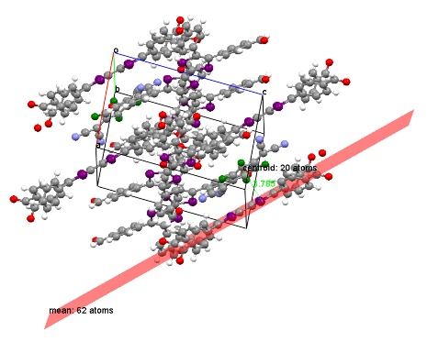
Figure S1. The distance between TFTB and F₄TCNQ molecules.

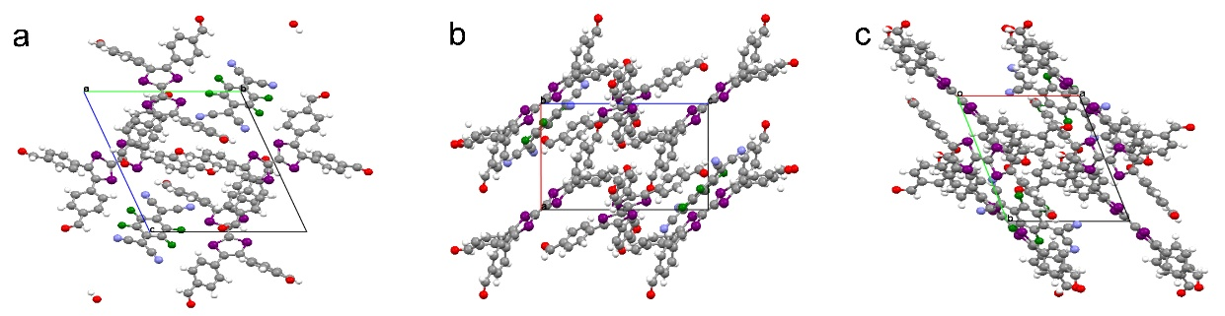
Figure S2. The molecular packing mode of TFQ cocrystal in (a) bc, (b) ac, and (c) ab plane.

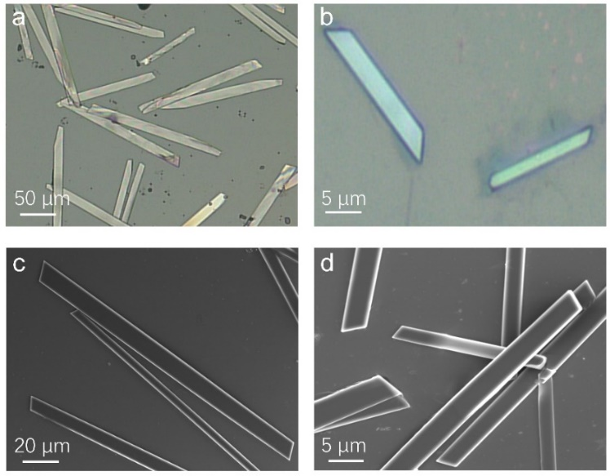
Figure S3. The FM patterns of (a) TFTB microcrystal and (b) F₄TCNQ microcrystal with the scale bar of 50 µm and 5 µm respectively. The SEM images of (c) TFTB microcrystal and (d) F₄TCNQ microcrystal with the scale bar of 20 µm and 5 µm respectively.

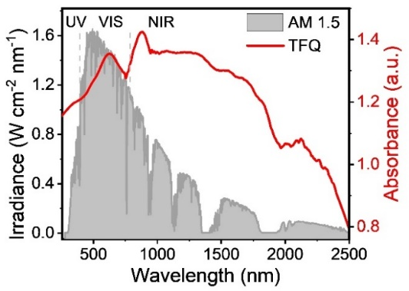
Figure S4. Absorption of TFQ cocrystal and the solar spectral irradiance (gray, AM 1.5 G).

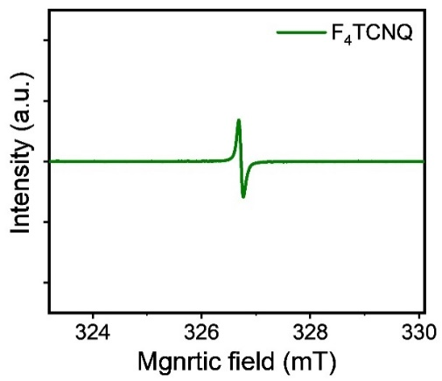
Figure S5. ESR spectra of F₄TCNQ.

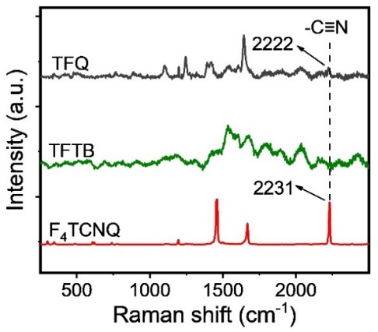
Figure S6. The Roman spectra of TFQ microwires (black line), TFTB (green line), and F₄TCNQ (red line).

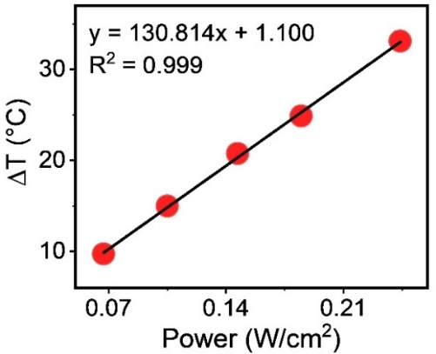
Figure S7. Fitting curve between ΔT and the varied power densities.

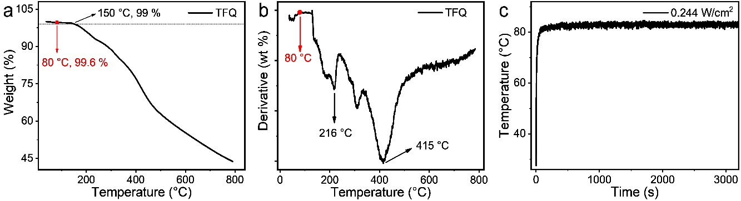
Figure S8. (a) TG, and (b) DTG images of TFQ cocrystal. (c) Temperature variations of the TFQ cocrystals with a power density of 0.244 W/cm² under continuous irradiation for 3600 seconds.

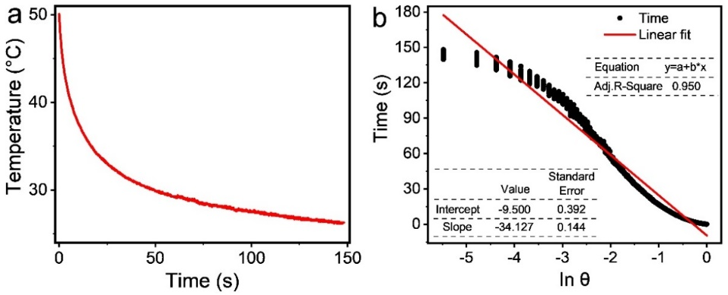
Figure S9. (a) The cooling curve of TFQ cocrystals after the irradiation of 808 nm laser (1.57 W/cm²) and (b) its corresponding time-$\ln{θ}$ linear curve.

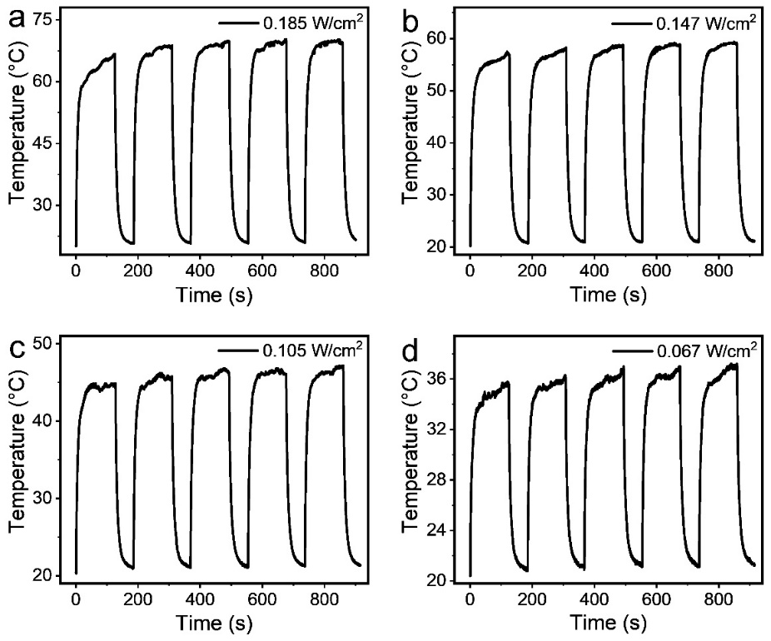
Figure S10. 5 cyclic tests of TFQ cocrystals under 808 nm laser irradiation at (a) 0.185, (b) 0.147, (c) 0.105, and (d) 0.067 W/cm² power density.

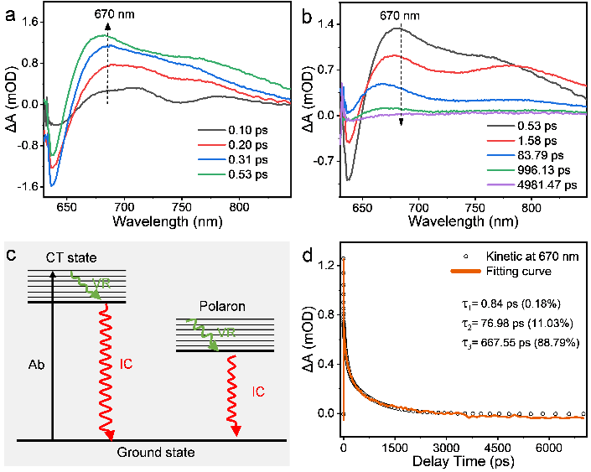
Figure S11: (a, b) Fs-TA spectra of TFQ cocrystals. (c) Jablonski diagram of TFQ cocrystal. (d) Kinetic fitting results of the TFQ cocrystals at 670 nm.

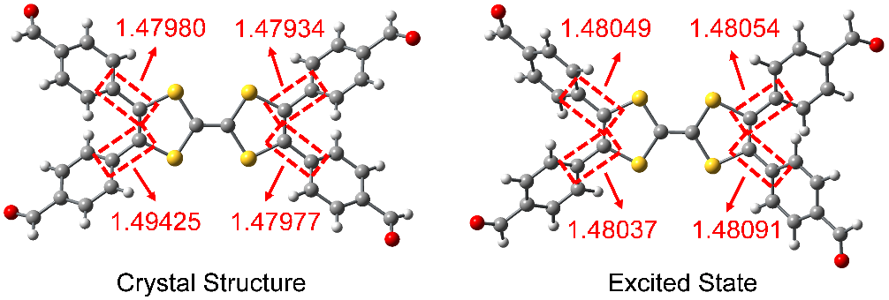
Figure S12. Crystal structure and DFT calculations of the excited state of the bond lengths of TFTB.

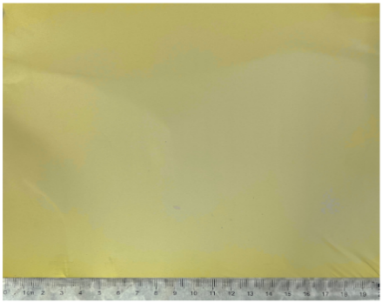
Figure S13. Optical image of TFQ-TPU photothermal nanofiber membrane.

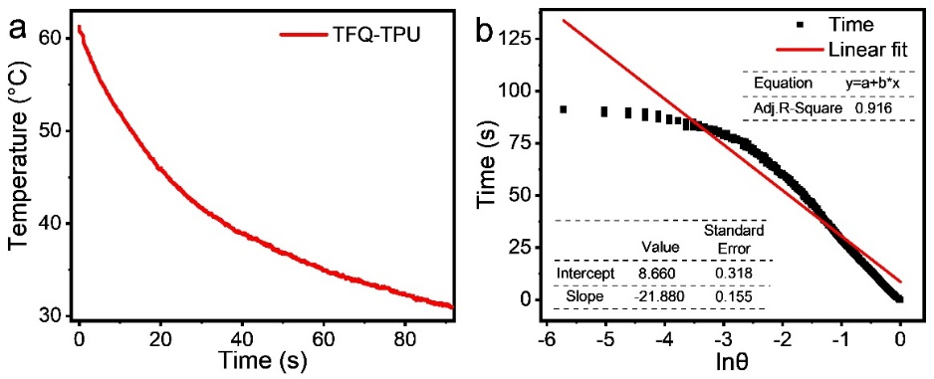
Figure S14. (a) The cooling curve of TFQ-TPU nanofiber membrane after the irradiation of 808 nm laser (0.37 W/cm²) and (b) its corresponding time-$\ln{θ}$ linear curve.

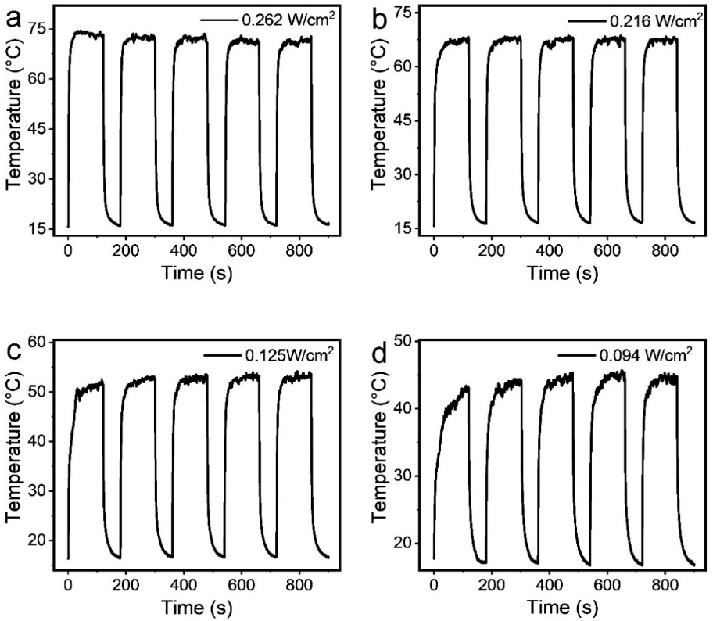
Figure S15. 5 cyclic tests of TFQ-TPU nanofiber membrane under 808 nm laser irradiation at (a) 0.262, (b) 0.216, (c) 0.125 and (d) 0.094 W/cm² power density.

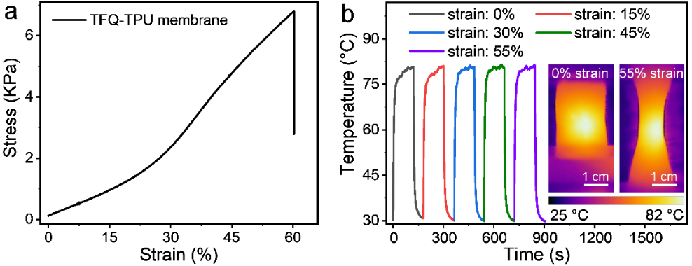
Figure S16. (a) Mechanical properties of TFQ-TPU membrane. (b) Under the irradiation of 808 laser, the photothermal performance of TFQ-TPU membrane stretched to the strain of 0 % (black line), 15 % (red line), 30 % (black line), 45 % (green line), and 55 % (purple line) at a power density of 0.332 W/cm². Insert of Figure R4b is the IR image of TFQ-TPU photothermal membrane with 0 % and 55 % tensile deformation.

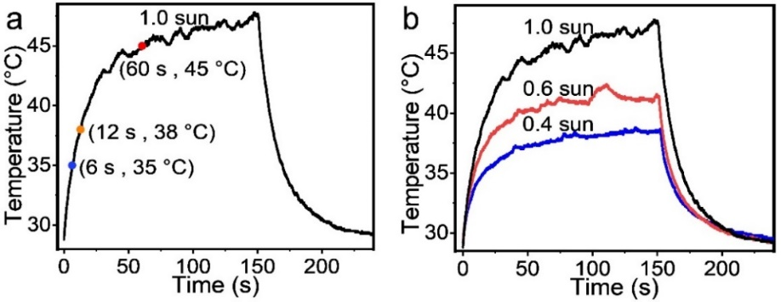
Figure S17. (a) The corresponding temperature and time data of TFQ-TPU based temperature warning strip under the irradiation of xenon lamp with a light power of 1.0 sun. (b) The temperature-time curves of TFQ-TPU based temperature warning strip under the irradiation of xenon lamp with the light power of 1.0 (black line), 0.6 (red line) and 0.4 (blue line) sun.

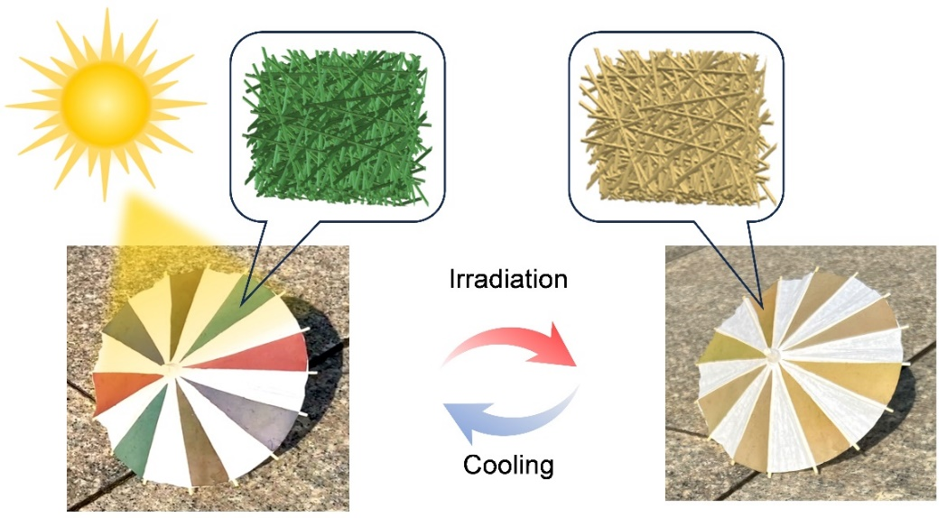
Figure S18. The discoloration of TFQ-RTCMs nanofiber membranes with various colors under sunlight irradiation.

Table S1. Photothermal performance of reported charge-transfer cocrystals.
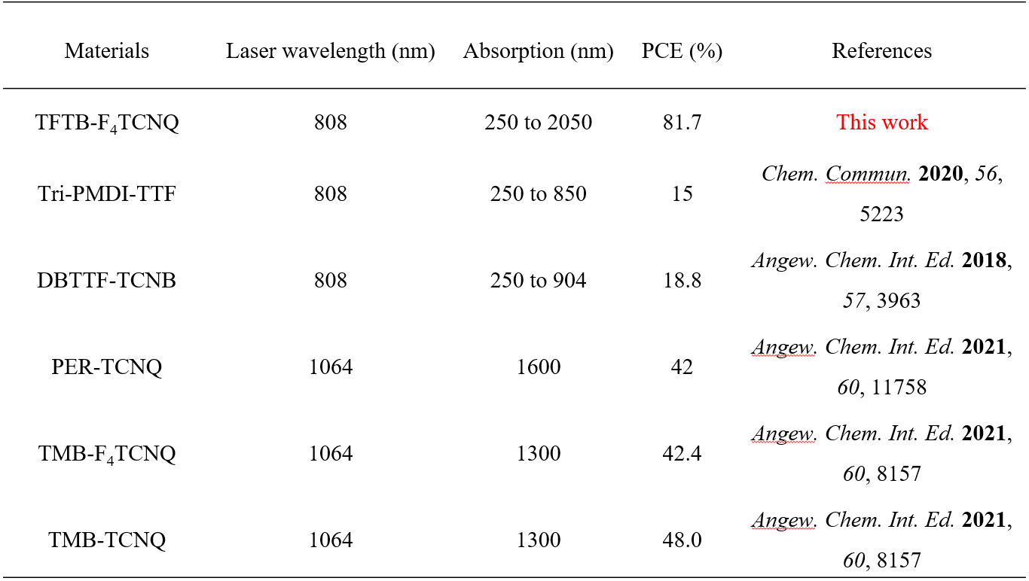

Table S2. Crystal data and structure refinement for TFTB-F₄TCNQ.
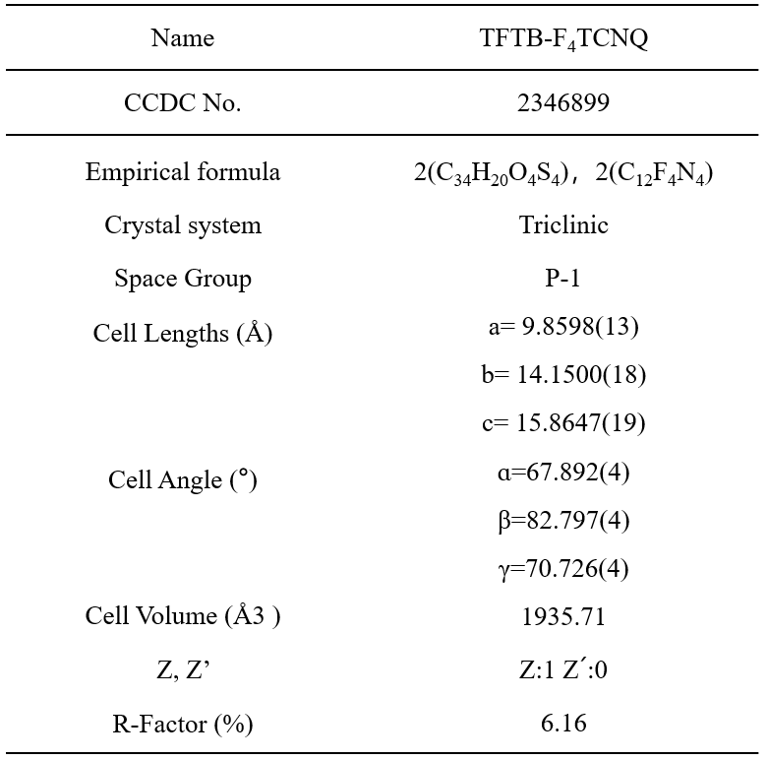

Table S3. The Attach Eattach {hkl} data of each crystal surface {hkl} of TFTB-F₄TCNQ cocrystal was calculated by Material Studio software.
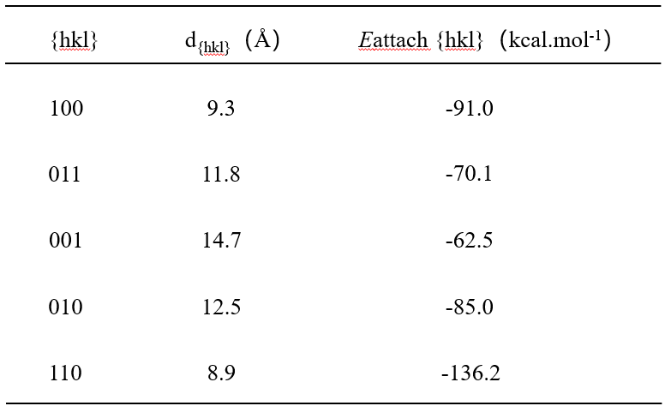

Table S4: ν₀, ν_{CT}, and ν₁ and calculated charge transfer degree values of TFQ at room temperature.
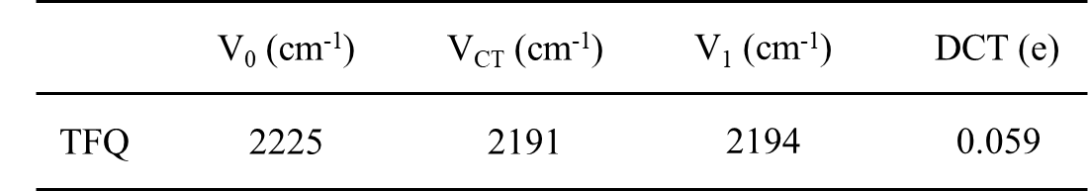

Movie S1: (a) Video of different colored membranes fading under sunlight, and (b) recovering color in a cool place.
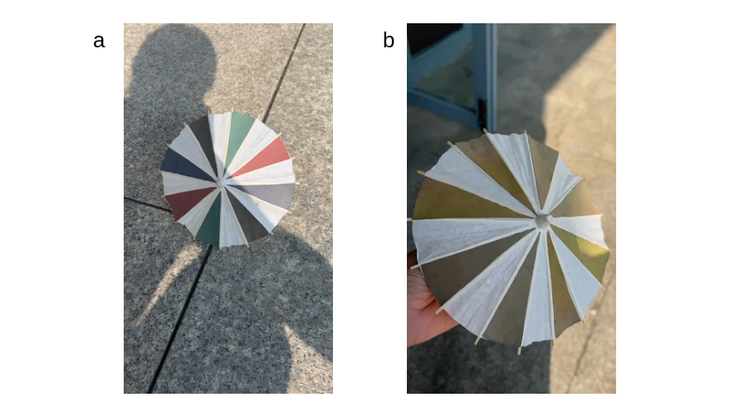

Reference
[1] M. P. Zhuo, Y. Yuan, Y. Su, S. Chen, Y. T. Chen, Z. Q. Feng, Y. K. Qu, M. D. Li, Y. Li, B. W. Hu, X. D. Wang, L. S. Liao, Adv. Mater. 2022, 34, 2107169.
[2] Y. D. Zhao, J. Han, Y. Chen, Y. Su, Y. M. Cao, B. Wu, S. M. Yu, M. D. Li, Z. Wang, M. Zheng, M. P. Zhuo, L. S. Liao, ACS Nano 2022, 16, 15000.
[3] J. Xu, Q. Chen, S. Li, J. Shen, P. Keoingthong, L. Zhang, Z. Yin, X. Cai, Z. Chen, W. Tan, Angew. Chem. Int. Ed. 2022, 61, e202202571.

