Appendix A
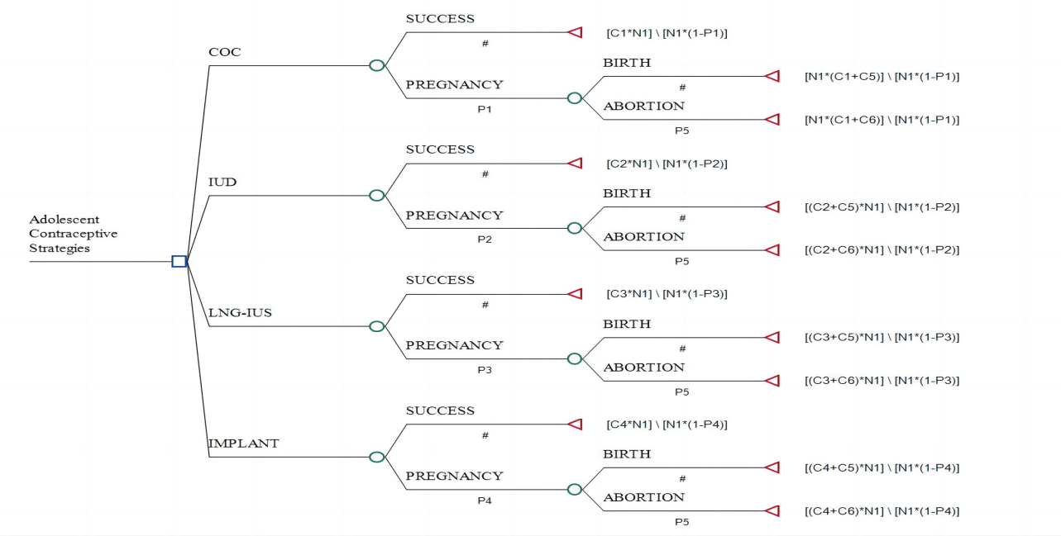
Figure A1 Decision tree model of multiple contraceptive strategies for adolescents
COC, combined oral contraception; IUD, intrauterine device; LNG-IUS, levonorgestrel intrauterine system; IMPLANT, sudemal implant; P1, probility of COC contraceptive failure; P2, probility of IUD contraceptive failure; P3, probility of LNG-IUS contraceptive failure; P4, probility of IMPLANT contraceptive failure; P5, probility of abortion; N1, the number of adolescents with contraceptive needs； C1, costs of COC contraceptive strategy; C2, costs of IUD contraceptive strategy; C3, costs of LNG-IUS contraceptive strategy; C4, costs of IMPLANT contraceptive strategy; C5, costs of birth; C6, costs of abortion.

Appendix B
Table B1 Cost parameters (RMB)
 | JiangSu | JiangXi | ShanXi | JiLin
Medical appointment | 30 | 30 | 30 | 30
Sugary costs
Intrauterine device insertion | 180 | 60 | 48 | 74
Intrauterine device removal | 180 | 60 | 48 | 74
Subdermal implant insertion | 130 | 60 | 57 | 105
Subdermal implant removal | 130 | 60 | 57 | 105
Examination costs
B-mode ultrasound | 30 | 28 | 28.3 | 26
complete blood count | 10 | 15 | 14.7 | 22
blood biochemistry | 195 | 195 | 195 | 195
coagulation monitoring | 49 | 72 | 60 | 76.5
vaginal discharge examination | 7 | 5 | 5 | 5
gynecological examination | 13 | 15 | 20.3 | 21
electrocardiogram | 36 | 22 | 20.3 | 21
Hepatitis B testing | 73.5 | 63 | 63.5 | 112.5
Hepatitis C testing | 25 | 15 | 48 | 14
HIV testing | 35 | 57 | 28 | 36
Syphilis testing | 30 | 60 | 40 | 52.5
Beds and caring | 50 | 50 | 50 | 50
Sugery | 320 | 183 | 117.7 | 126
Anaesthesia | 633.5 | 900 | 733.3 | 946

Appendix C
Table C1 LARC clinical and costs difference and their ICER
Outcome | Clinical difference | Cost difference | ICER
LNG-IUS versus IUD | 14880 | 18242038500.00 | 1225943.45
Subdermal implant versus IUD | 104160 | 23757766800.00 | 228089.16
Subdermal implant versus LNG-IUS | 89280 | 5515728300.00 | 61780.11
LARC, long-acting reversible contraceptive; COC, combined oral contraception; ICER, incremental cost-effectiveness rate; IUD, intrauterine device; LNG-IUS, levonorgestrel intrauterine system.

Appendix D
Figure D1 The tornado diagrams by one-way sensitivity analysis
COC, combined oral contraception; IUD, intrauterine device; LNG-IUS, levonorgestrel intrauterine system; IMPLANT, sudemal implant.

Figure D2 The scatterplots of COC and LARC methods simulated by model Monte Carol
COC, combined oral contraception; IUD, intrauterine device; LNG-IUS, levonorgestrel intrauterine system; IMPLANT, sudemal implant; ICE, incremental cost-effectiveness

