Supporting Information

In-situ engineering carboxyl in donor-acceptor polymers via photothermal synergetic system towards highly efficient H₂O₂ synthesis
Yuanjie Peng¹†, Jiahong Lin¹†, Jiacheng Gong²†, Mengxiang Zhu¹, Chenyu Bao³, Shuxun Chen³, Xincheng Xie⁴, Wenjie Yu⁴, Peng Zhang¹, Jiahua Cui⁵, Jinrong Yang²*, Kan Li³*, Dongting Yue¹*

¹School of Environmental and Chemical Engineering, Shanghai University, No.99 Shangda Road, Baoshan District, Shanghai 200444, P. R. China.
²Shanghai Engineering Research Center of Molecular Therapeutics and New Drug Development, Shanghai Frontiers Science Center of Molecule Intelligent Syntheses, School of Chemistry and Molecular Engineering, East China Normal University, Shanghai, 200062, P. R. China.
³School of Environmental Science and Engineering, Shanghai Jiao Tong University, No. 800, Dongchuan Road, Shanghai 200240, P. R. China. Shanghai Institute of Pollution Control and Ecological Security, Shanghai 200092, P. R. China.
⁴National Facility for Protein Science in Shanghai, Shanghai Advanced Research Institute, Chinese Academy of Sciences, No. 99, Haike Road, Zhangjiang Hi-Tech Park, Pudong Shanghai, 201210, P.R. China.
⁵School of Chemistry and Chemical Engineering, Shanghai Jiao Tong University, No. 800, Dongchuan Road, Shanghai 200240, P. R. China. Shanghai Institute of Pollution Control and Ecological Security, Shanghai 200092, P. R. China.
*Correspondence to: yuedongting@shu.edu.cn (D.Y.); jryang@chem.ecnu.edu.cn (J.Y.); likan@sjtu.edu.cn (K.L.)
†These authors contributed equally to this work.

Table of Contents
Figures S1-S27
Tables S1-S5
References S1-S41

Supplementary Figures

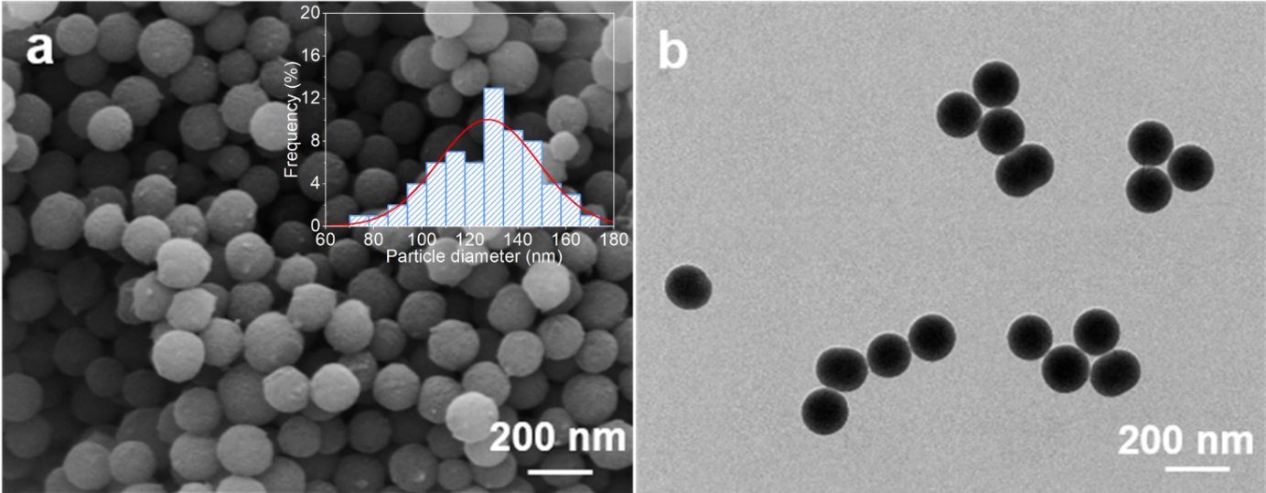
Figure S1. (a) SEM and size-distribution histograms of APF resin (insert in Figure S1a). (b) TEM (b) of APF resin.
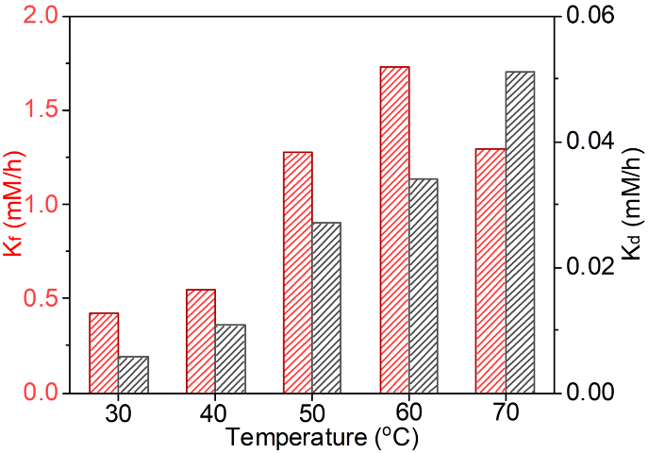
Figure S2. Comparison between H₂O₂ formation rate constant (k_{f}) and H₂O₂ decomposition rate constant (k_{d}) for APF resins at different temperature. Conditions: catalyst (5 mg), water (50 ml), O₂ bubbling, and AM1.5G simulated sunlight.

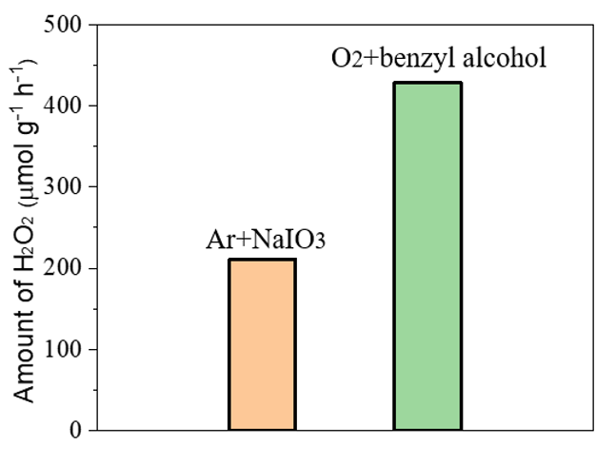
Figure S3. H₂O₂ production of the APF with electron sacrificial agent (NaIO₃) and Ar bubbling or hole sacrificial agent (benzyl alcohol) with O₂ bubbling. Conditions: water (50 ml), catalyst (10 mg), NaIO₃ (10 mM), benzyl alcohol (10 mM), AM1.5G simulated sunlight irradiation.

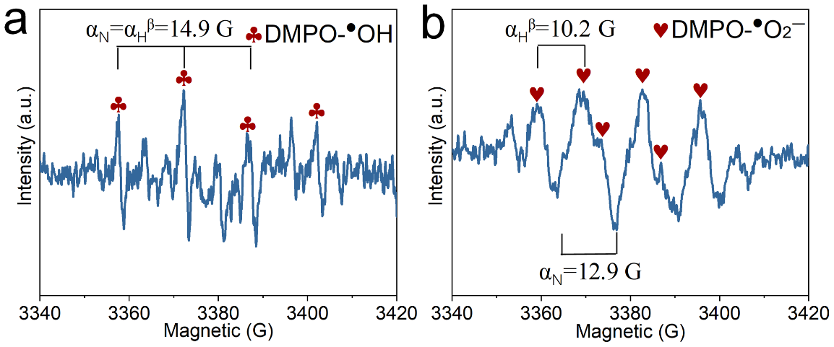
Figure S4. (a) EPR spectra of APF after 5 min irradiation in (a) water and (b) methanol with 5,5-dimethyl-pyrroline N-oxide (DMPO) as a free-radical spin trapping agent without the photocatalyst.

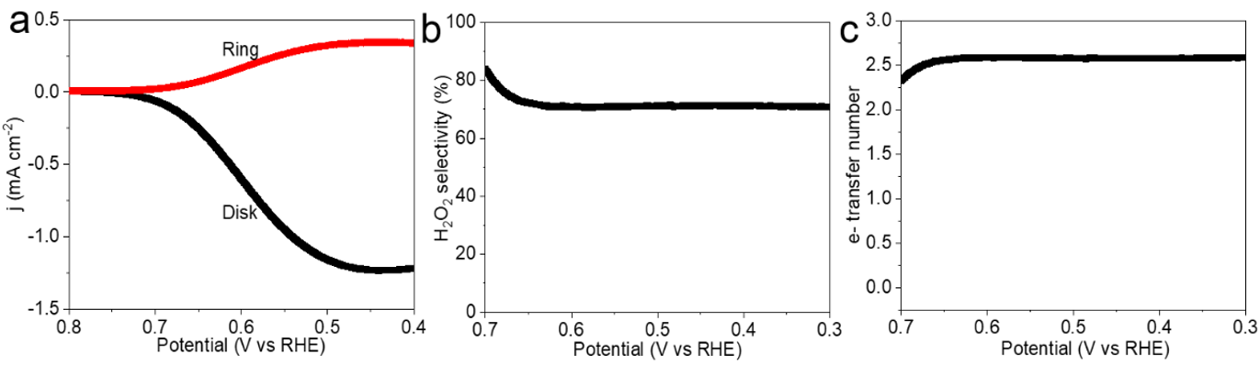
Figure S5. LSV and corresponding H₂O₂ selectivity comparison on APF.

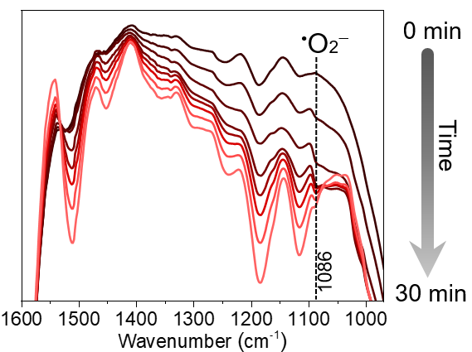
Figure S6. In-situ-ATR-FTIR spectra of APF processed by photothermal treatment for 30 min.

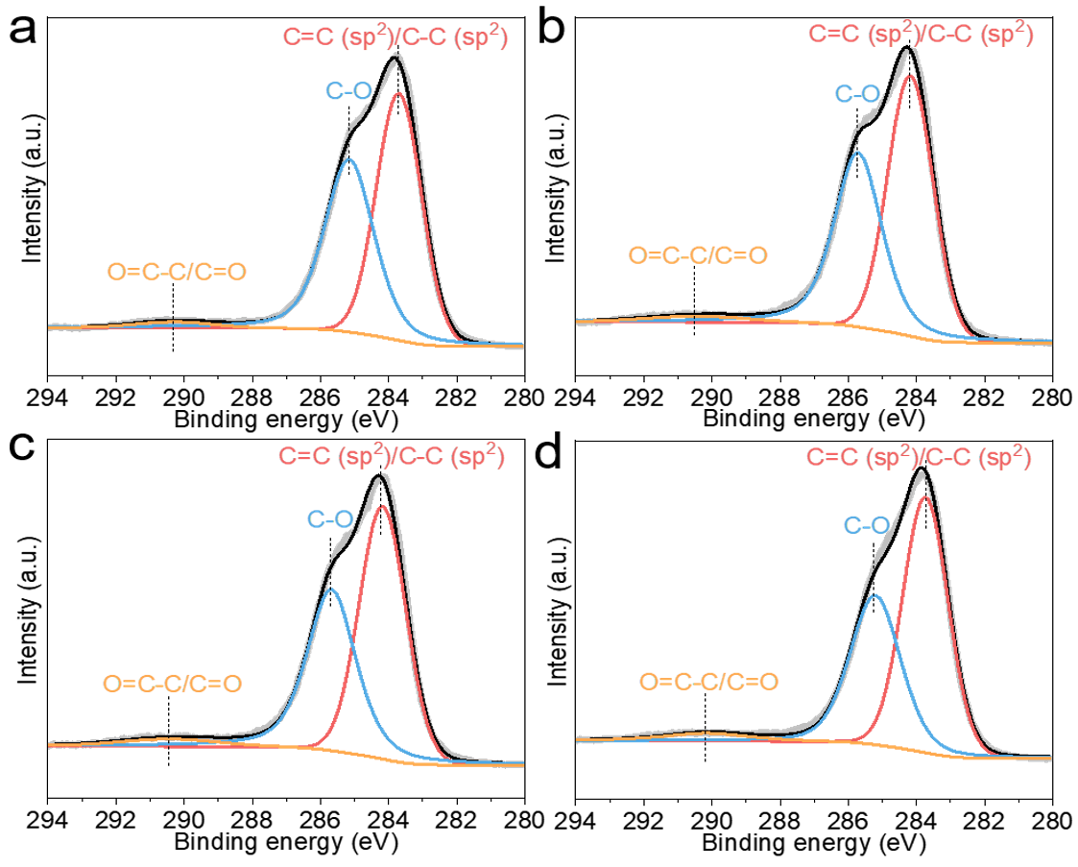
Figure S7. XPS charts of the C 1s level for (a) APF resin, (b), APF resin after sunlight treatment, (c) APF resin after thermal treatment, and (d) APF resin after photothermal treatment.

Figure S8. XPS charts of the O 1s level for (a) APF resin, (b), APF resin after sunlight treatment, (c) APF resin after thermal treatment, and (d) APF resin after photothermal treatment.

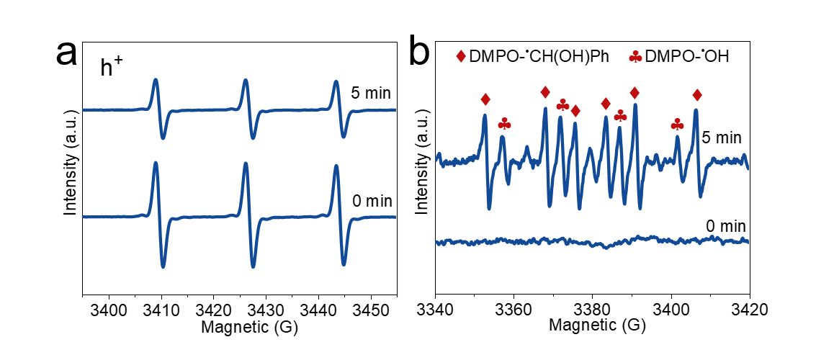
Figure S9. (a) EPR spectra of APF after 5 min irradiation in water using TEMPO as a free-radical spin trapping agent without the photocatalyst, (b) EPR spectra of APF after 5 min irradiation in water using DMPO as a free-radical spin trapping agent with the photocatalyst.

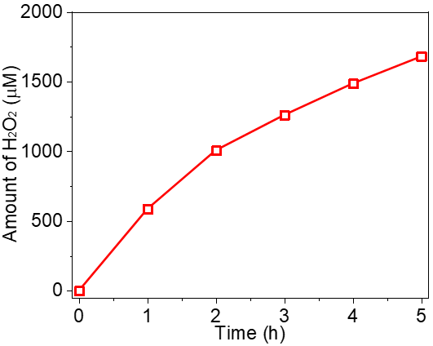
Figure S10. H₂O₂ generation of the APF resin during the initial stage of the photothermal reaction process (<5 h). Conditions: catalyst (500 mg), water (100 ml), O₂ bubbling, AM1.5G simulated sunlight irradiation, temperature (333 K).

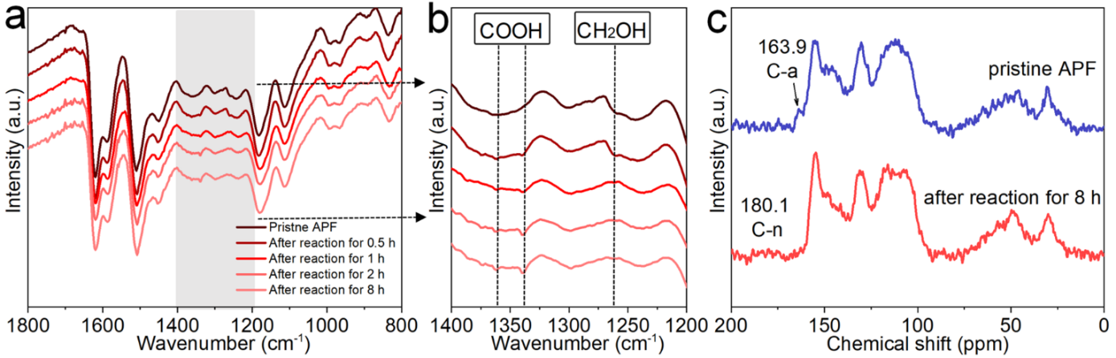
Figure S11. (a, b) FTIR spectra and (c) ¹³C CP-MAS NMR of APF after long-term photothermal process.

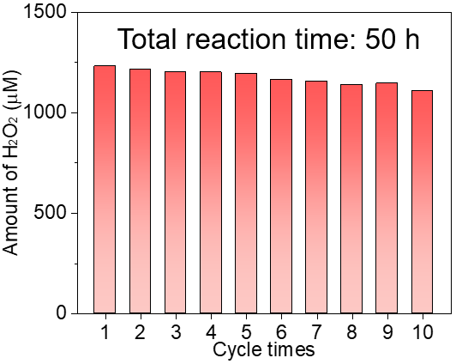
Figure S12. Ten sequential 5 h H₂O₂ production runs of the APF resin with O═C─OH groups in the thermally assisted photocatalytic system. Conditions: catalyst (500 mg), water (100 ml), O₂ bubbling, AM1.5G simulated sunlight irradiation, temperature (333 K).

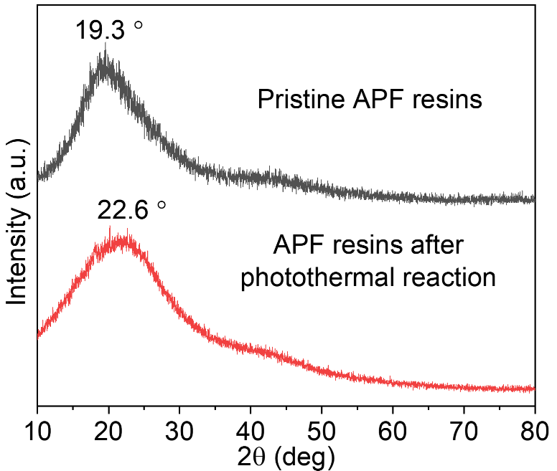
Figure S13. XRD patterns of APF before and after photothermal treatment.

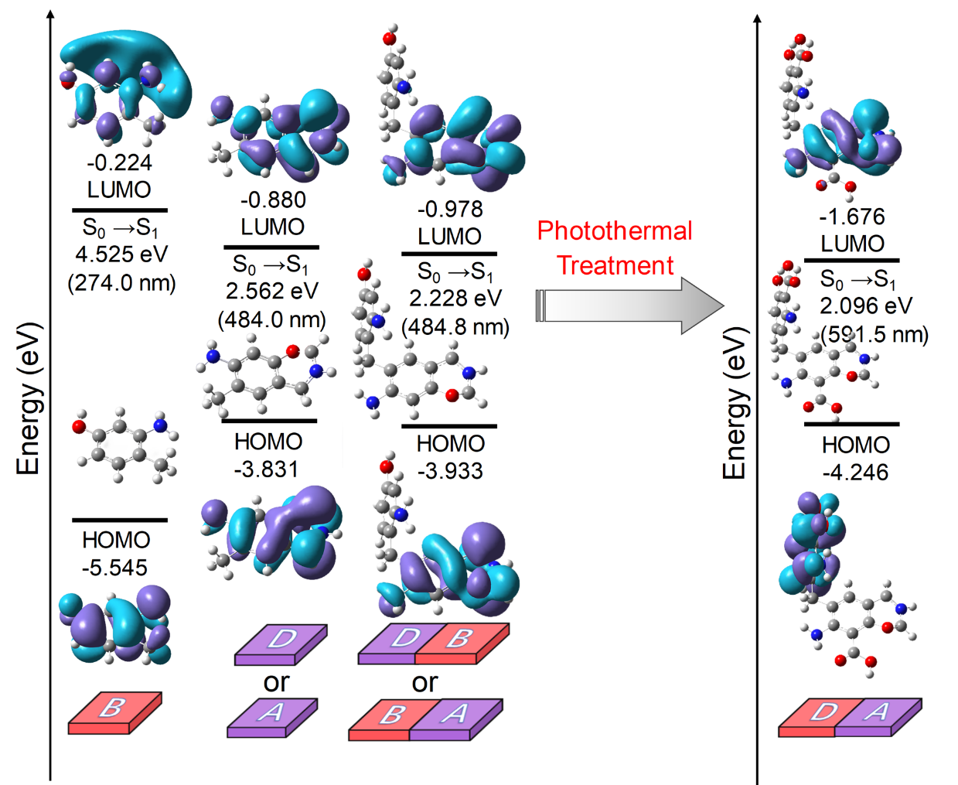

Figure S14. Energy diagrams and interfacial plots of the main molecular orbitals for calculated models of the benzoxazine-aminophenol units without O═C─OH groups compared to those with O═C─OH groups introduced via the photothermal treatment. The HOMO and LUMO wave function isosurfaces were plotted with the same isovalue, and the light blue and cyan areas denote (±) signs.

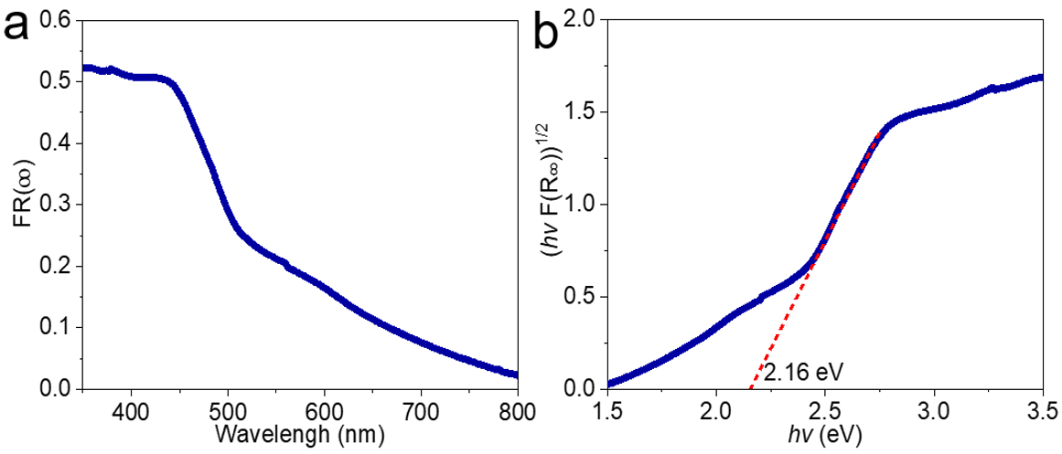
Figure S15. (a) Diffuse reflectance (DR) UV–vis spectra of the APF resin, where F(R∞) is the Kubelka–Munk function. (b) Tauc plots of the APF resin.

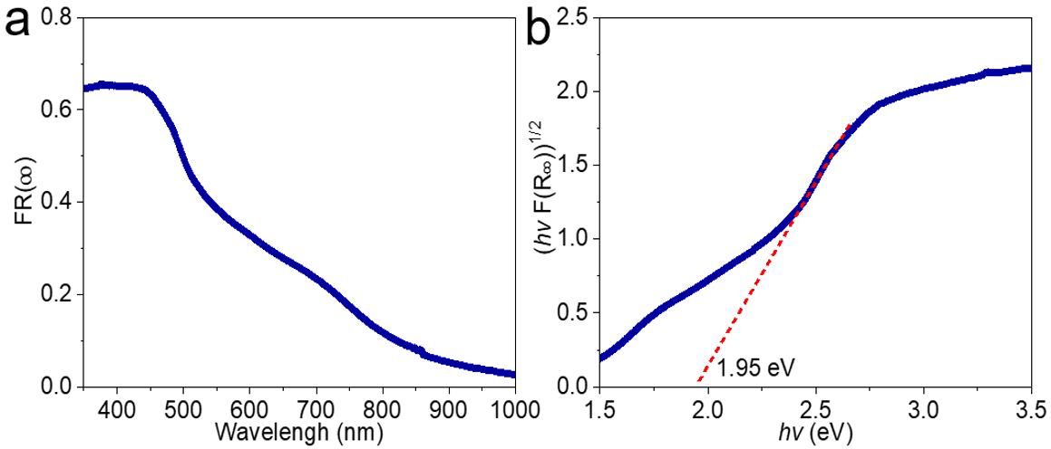
Figure S16. (a) Diffuse reflectance (DR) UV–vis spectra of the APF resin after photothermal treatment, where F(R∞) is the Kubelka–Munk function. (b) Tauc plots of the APF resin after photothermal treatment.

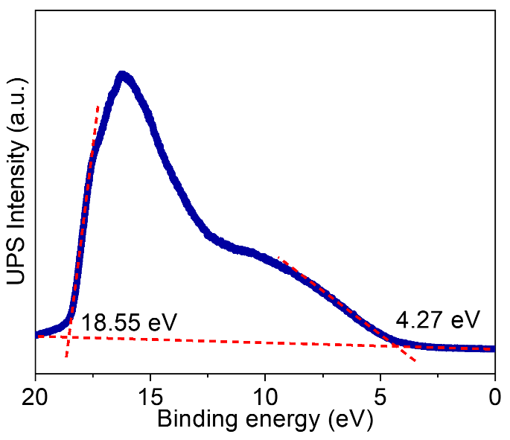
Figure S17. UPS spectra of APF resin (dark blue curve). The dashed red lines mark the baseline and the tangents of the curve. The intersections of the tangents with the baseline give the edges of the UPS spectra from which the UPS width is determined.

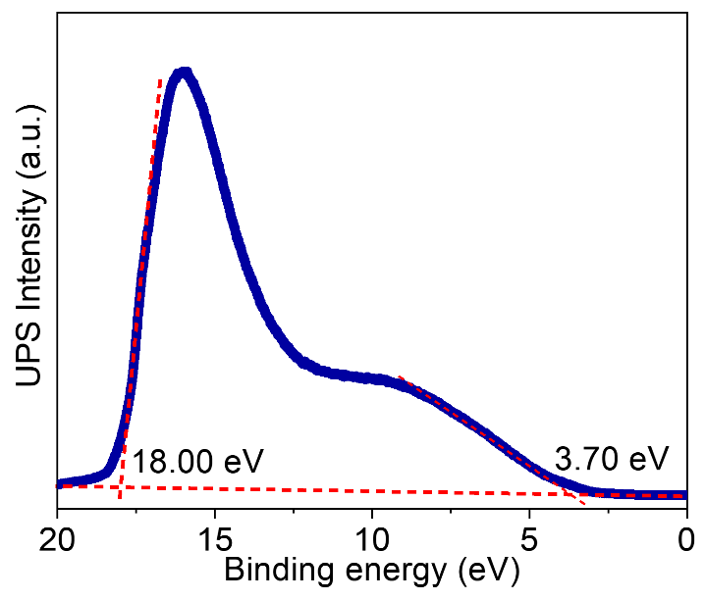
Figure S18. UPS spectra of photothermally treated APF resin (dark blue curve). The dashed red lines mark the baseline and the tangents of the curve. The intersections of the tangents with the baseline give the edges of the UPS spectra from which the UPS width is determined.

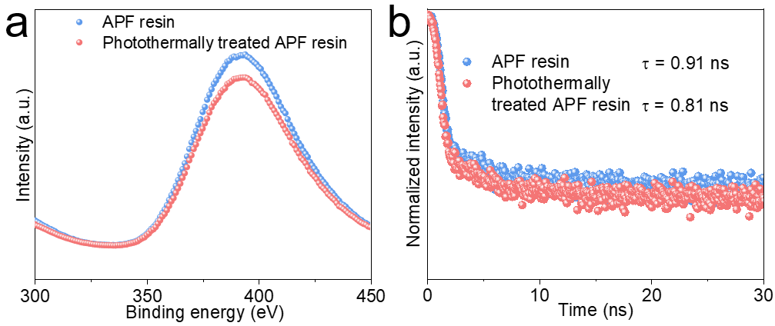
Figure S19. (a) Steady-state PL spectra of APF resin and photothermally treated APF resin with the excitation wavelength of 265 nm and (b) Time-resolved PL spectra of APF resin and photothermally treated APF resin.

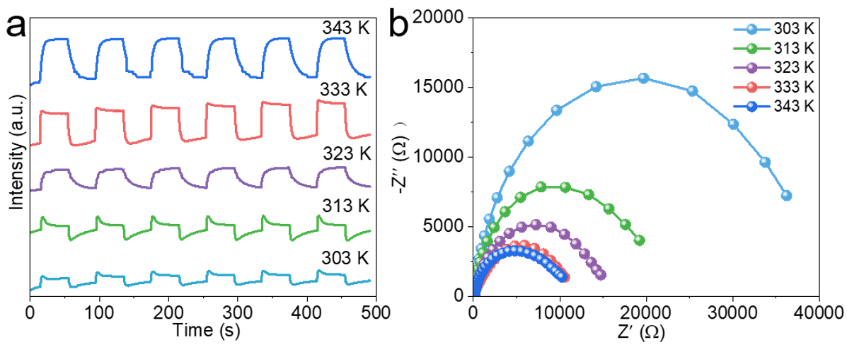
Figure S20. (a) Photocurrent and (b) EIS spectra of APF resin at different temperature.

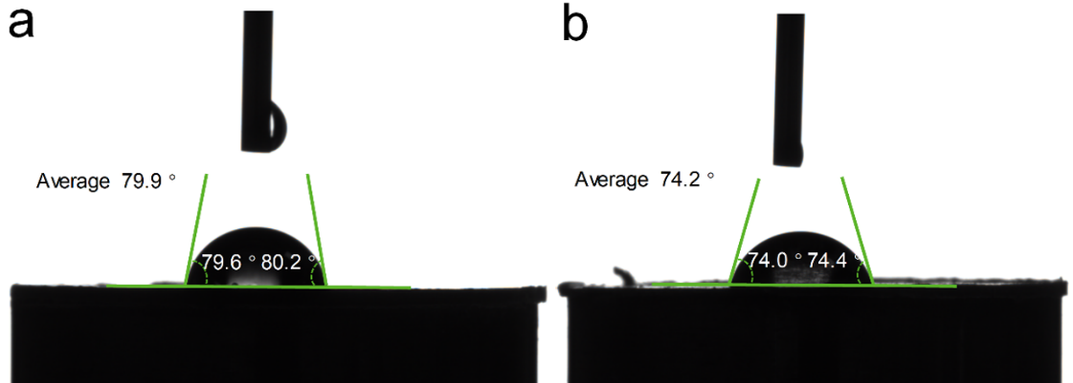
Figure S21. Hydrophilicity of APF resin before (a) and after (b) photothermal treatment.

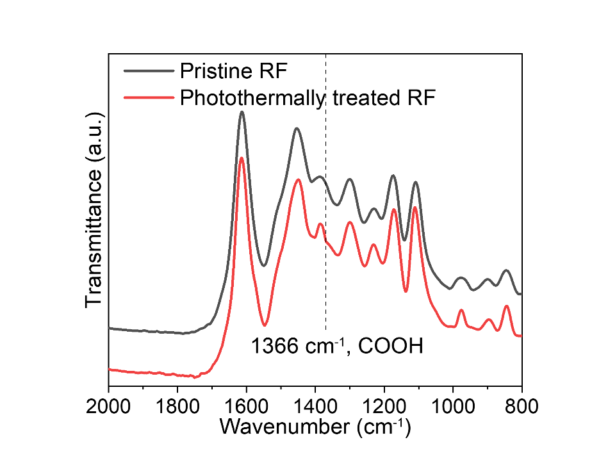
Figure S22. FTIR of pristine RF resin and photothermally treated RF resin.

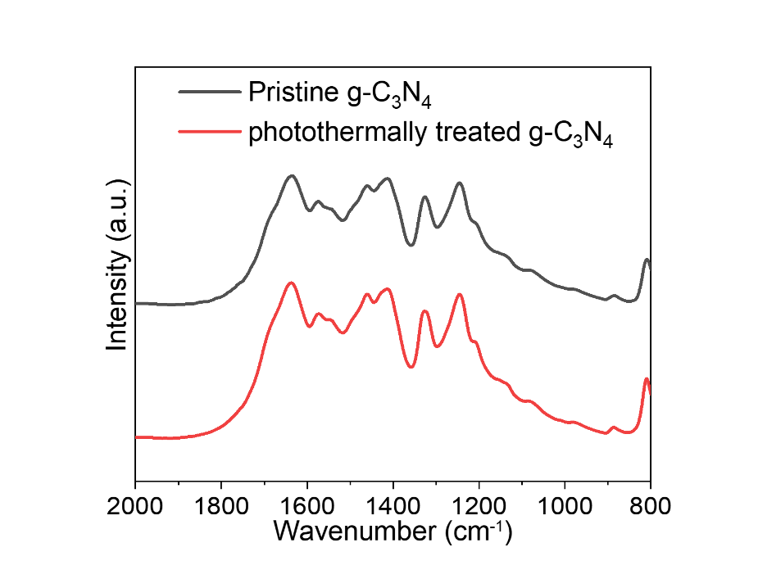
Figure S23. FTIR of pristine g-C₃N₄ and photothermally treated g-C₃N₄.

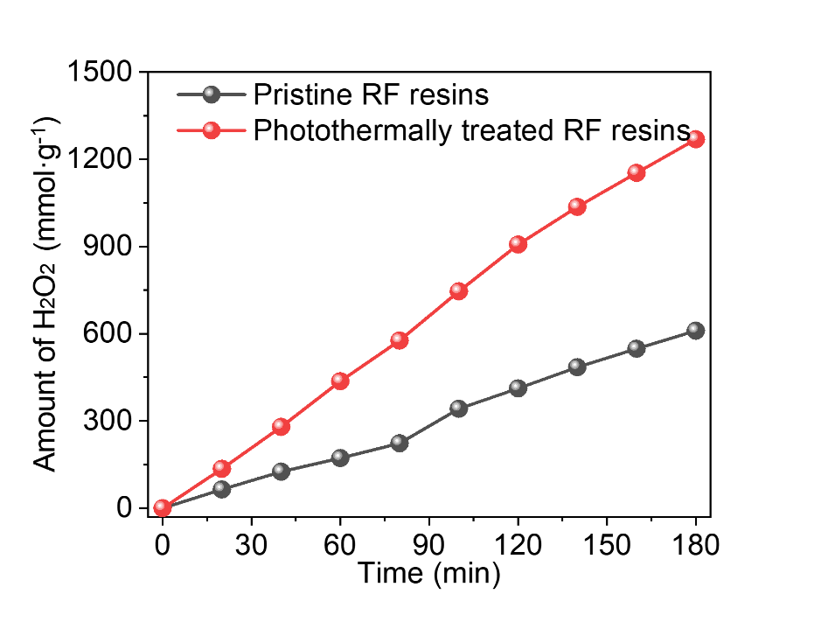
Figure S24. The photosynthetic H₂O₂ efficiency of the RF resin pristine RF resin and photothermally treated RF resin. Conditions: catalyst (5 mg), water (50 ml), O₂ bubbling, AM1.5G simulated sunlight irradiation, reaction temperature (303 K).

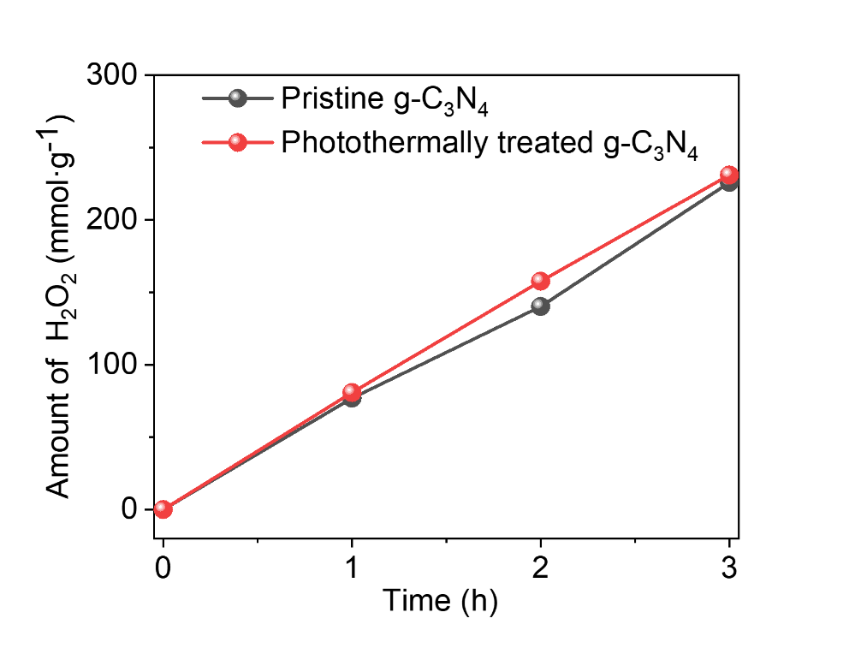
Figure S25. The photosynthetic H₂O₂ efficiency of the pristine g-C₃N₄ and photothermally treated g-C₃N₄. Conditions: catalyst (5 mg), water (5 ml), O₂ bubbling, AM1.5G simulated sunlight irradiation, reaction temperature (303 K).

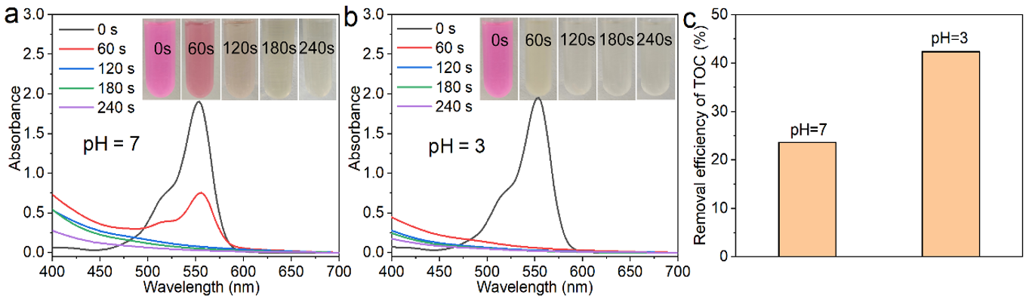
Figure S26. UV absorption spectra of RhB degradation in the constructed Fenton system with pH at 7 and 3. (c) TOC removal efficiency in pH 3 and 7, respectively.

Figure S27. (a) FTIR spectroscopy, (b) XRD patterns, and (c) photosynthetic H₂O₂ efficiencies of pristine APF and APF after immersing APF resins in harsh water environments for 2 h. Conditions: catalyst (5 mg), water (50 ml), O₂ bubbling, and AM1.5G simulated sunlight.

Supplementary Tables

Table S1 The SCC efficiency of reported photocatalysts for H₂O₂ production at elevated temperatures.
Catalyst | Atmosphere | Temperature | Light Source | SCC efficiency  (%) |  | Ref.
TPT-alkynyl-AQ | O₂ | 333K | AM 1.5G solar simulator |  | 0.35 |  | ¹
COF-TfpBpy | air | 333K | AM 1.5G solar simulator |  | 1.08 |  | ²
SA-TCPP | O₂ | 328K | AM 1.5G solar simulator |  | 1.2 |  | ³
RF/P3HT-1.0 | O₂ | 333K | AM 1.5G solar simulator |  | 1.0 |  | ⁴
RF-DHAQ-2 | O₂ | 323K | AM 1.5G solar simulator |  | 1.2 |  | ⁵
RF523 | O₂ | 333K | AM 1.5G solar simulator |  | 0.8 |  | ⁶
RF-(COOH)₂-523 | O₂ | 333K | AM 1.5G solar simulator |  | 0.7 |  | ⁷
RF-CQDs | O₂ | 323K | AM 1.5G solar simulator |  | 1.1 |  | ⁸
rGO@MRF | O₂ | 323K | AM 1.5G solar simulator |  | 1.23 |  | ⁹
APFac | O₂ | 323K | AM 1.5G solar simulator |  | 0.54 |  | ¹⁰

Table S2 The comparison of activity and SCC efficiencies between APF resin photothermal system and other reported photocatalysts for H₂O₂ production.
Catalyst | Atmosphere | Temperature | Light Source | Amount of H₂O₂  ( μmol·g⁻¹·h⁻¹) |  |  | SCC efficiency  (%) | Ref.
TPE-AQ | air | Room Temperature | AM 1.5G solar simulator |  | 909 | 0.26 |  | ¹¹
COF-TfpBpy | air | 298K | 300W Xe lamp  (λ≥420nm) |  | 695 | 1.08 |  | ²
RF523 | O₂ | 298K | AM 1.5G solar simulator |  | 97.6 | 0.5 |  | ¹²
RF/P3HT | O₂ | 298K | AM 1.5G solar simulator |  | 392.2 | 1.0 |  | ⁴
SA-TCPP | O₂ | 328K | 300W Xe lamp  (λ≥420nm) |  | 1150 | 1.2 |  | ³
ZIF-8/C₃N₄ | O₂ | 298K | 300W Xe lamp  (λ≥420nm) |  | 2641 | 0.58 |  | ¹³
Bpt-CTF | O₂ | 298K | 300W Xe lamp  (λ≥420nm) |  | 3268.1 | --- |  | ¹⁴
Sb-SAPC | O₂ | 298K | 300W Xe lamp  (λ≥420nm) |  | 588 | 0.361 |  | ¹⁵
TC/pCN-2 | O₂ | 298K | 300W Xe lamp  (λ≥420nm) |  | 137.71 | --- |  | ¹⁶
Ni-CAT-CN₆₀ | O₂ | 298K | 300W Xe lamp  (λ≥420nm) |  | 1801 | 0.1 |  | ¹⁷
RF-CQDs | O₂ | 323K | 300W Xe lamp  (λ≥420nm) |  | 2450 | 1.1 |  | ⁸
CTF-BDDBN | O₂ | Room Temperature | 300W Xe lamp  (λ≥420nm) |  | 97.2 | 0.14 |  | ¹⁸
PM-CDs-30 | O₂ | Room Temperature | AM 1.5G solar simulator |  | 1776 | 0.21 |  | ¹⁹
ACNN | O₂ | 298K | 300W Xe lamp  (λ≥420nm) |  | 10200 | --- |  | ²⁰
Al-MIL-101-NH₂ | O₂ | 298K | 500W Xe lamp  (λ≥420nm) |  | 649 | --- |  | ²¹
FS-COFs | O₂ | Room Temperature | LED lamp (λ≥420nm) |  | 3904.2 | 6.21 |  | ²²
PDI/CNA | O₂ | 298K | AM 1.5G solar simulator |  | 1605.32 | --- |  | ²³
g-C₃N₄-CoWO | O₂ | 298K | 300W Xe lamp  (λ≥420nm) |  | 187 | --- |  | ²⁴
TZ-COF | O₂ | Room Temperature | AM 1.5G solar simulator |  | 268 | 0.036 |  | ²⁵
Nv–C≡N–CN | O2 | 298K | λ≥420nm，40 mW cm⁻² |  | 3093 | 0.23 |  | ²⁶
OWS* | O₂ | Room Temperature | AM 1.5G solar simulator |  | 4690 | 1.1 |  | ²⁷
CoPc-BTM-COF | O₂ | Room Temperature | visible-light irradiation (λ >400nm) |  | 2096 | --- |  | ²⁸
PCN-NaCA-2* | O₂ | Room Temperature | AM 1.5G solar simulator |  | 18700 | --- |  | ²⁹
COF-N32 | O₂ | 298K | 300W Xe lamp  (λ≥420nm) |  | 605 | 0.31 |  | ³⁰
C₃N₅ | O₂ | 298K | 300W Xe lamp  (λ≥420nm) |  | 3809.5 | --- |  | ³¹
Py-Da-COF | O₂ | 298K | 300W Xe lamp  (λ≥420nm) |  | 461 | 0.09 |  | ³²
APF resin | O₂ | 333 K | AM 1.5G solar simulator |  | 3216 | 4.03 |  | This work
* heterogeneous reaction

Table S3 Carbon compositions of the ARF resin, sunlight treated APF resin, thermally treated APF resin, and photothermally treated APF resin.
Samples | C═C(sp2)/C─C(sp2) | C─O/C─O─C | C=O─O/C═O
Pristine APF resin | 51.3% | 46.7% | 2.0%
Sunlight treated APF resin | 52.6% | 44.7% | 2.7%
Thermally treated APF resin | 53.0% | 43.2% | 3.8%
Photothermally treated APF resin | 55.2% | 40.1% | 4.7%

Table S4 Oxygen compositions of the ARF resin, sunlight treated APF resin, thermally treated APF resins, and photothermally treated APF resin.
Samples | C─O | C═O
Pristine APF resin | 76.0% | 24.0%
Sunlight treated APF resin | 75.2% | 24.7%
Thermally treated APF resin | 74.5% | 25.5%
Photothermally treated APF resin | 71.3% | 28.7%

Table S5 The comparison of activity between APF resin photothermal system and other reported photocatalysts for H₂O₂ production from seawater.
Catalyst | Atmosphere | Light Source | Amount of H₂O₂ (μmolg⁻¹h⁻¹) | Ref.
TD-COF | Air | a white LED (400–700 nm, 100 mWcm⁻²) | 3364 | ³³
Au@Ni₅P₄ | O₂ | Xenon lamp  ( λ > 420 nm, 40 mW cm⁻²) | 218.3 | ³⁴
Co–CN@G | O₂ | AM 1.5G solar simulator | 829 | ³⁵
Co₉S₈-CoZnIn₂S₄* | O₂ | A 300 W Xenon lamp (AM 1.5 G, 100 mW cm⁻², 𝜆>420 nm) | 32750 | ³⁶
PMCR-1* | O₂ | 300W Xe lamp  (λ≥420nm) | 10429.8 | ³⁷
LBOB | O₂ | Kessil LED lamp (λ = 427 nm) | 499.3 | ³⁸
CDs | O₂ | λ ≥ 420 nm; 34.8 mW c⁻² | 1776.6 | ³⁹
K-doped g-C₃N₄ | O₂ | A 300 W Xenon lamp (AM 1.5 G) | 1622 | ⁴⁰
TiCOF-spn | O₂ | 300 W Xe lamp (420 nm ≤ λ ≤ 780 nm) | 309.98 | ⁴¹
APF resin | O₂ | AM 1.5G solar simulator | 1834.4 | This work
APF resin | air | AM 1.5G solar simulator | 1592.4 | This work
APF resin | air | natural solar light | 1727.7 | This work
* heterogeneous reaction
1 Yan, H. et al. Spontaneous exciton dissociation in organic photocatalyst under ambient conditions for highly efficient synthesis of hydrogen peroxide. Proc. Natl. Acad. Sci. 119, e2202913119 (2022).
2 Kou, M. et al. Molecularly Engineered Covalent Organic Frameworks for Hydrogen Peroxide Photosynthesis. Angew. Chem. Inter. Ed. 61, e202200413 (2022).
3 Zhang, Y. et al. H₂O₂ generation from O₂ and H₂O on a near-infrared absorbing porphyrin supramolecular photocatalyst. Nat. Energy 8, 361-371 (2023).
4 Shiraishi, Y., Matsumoto, M., Ichikawa, S., Tanaka, S. & Hirai, T. Polythiophene-Doped Resorcinol–Formaldehyde Resin Photocatalysts for Solar-to-Hydrogen Peroxide Energy Conversion. J. Am. Chem. Soc. 143, 12590-12599 (2021).
5 Zhao, C. et al. Molecular Level Modulation of Anthraquinone‐containing Resorcinol‐formaldehyde Resin Photocatalysts for H₂O₂ Production with Exceeding 1.2 % Efficiency. Angew. Chem. Int. Ed. 13, e202218318 (2023).
6 Shiraishi, Y. et al. Resorcinol–formaldehyde resins as metal-free semiconductor photocatalysts for solar-to-hydrogen peroxide energy conversion. Nat. Mater. 18, 985-993 (2019).
7 Shiraishi, Y. et al. Solar-to-hydrogen peroxide energy conversion on resorcinol–formaldehyde resin photocatalysts prepared by acid-catalysed polycondensation. Commun. Chem. 3, 1-9 (2020).
8 Zhao, C., Wang, X., Ye, S. & Liu, J. Graphene Quantum Dots-Modified Resorcinol-Formaldehyde Resin for Efficient Hydrogen Peroxide Production. Solar Rrl. 6, 2200427 (2022).
9 Tian, Q. et al. Exceptional Photocatalytic Hydrogen Peroxide Production from Sandwich‐Structured Graphene Interlayered Phenolic Resins Nanosheets with Mesoporous Channels. Adv. Funct. Mater. 33, 2213173 (2023).
10 Wang, X. et al. Ambient Preparation of Benzoxazine-based Phenolic Resins Enables Long-term Sustainable Photosynthesis of Hydrogen Peroxide. Angew. Chem. Int. Ed. 62, e202302829 (2023).
11 Ye, Y.-X. et al. A solar-to-chemical conversion efficiency up to 0.26% achieved in ambient conditions. Proc. Natl. Acad. Sci. 118, e2115666118 (2021).
12 Shiraishi, Y. et al. Resorcinol–formaldehyde resins as metal-free semiconductor photocatalysts for solar-to-hydrogen peroxide energy conversion. Nat. Mater. 18, 985-993 (2019).
13 Zhao, Y. et al. Efficient production of H₂O₂ via two-channel pathway over ZIF-8/C₃N₄ composite photocatalyst without any sacrificial agent. Appl. Catal. B: Environ.278, 119289 (2020).
14 Wu, C. et al. Polarization Engineering of Covalent Triazine Frameworks for Highly Efficient Photosynthesis of Hydrogen Peroxide from Molecular Oxygen and Water. Adv. Mater. 34, 2110266 (2022).
15 Teng, Z. et al. Atomically dispersed antimony on carbon nitride for the artificial photosynthesis of hydrogen peroxide. Nat. Catal. 4, 374-384 (2021).
16 Yang, Y. et al. Ti₃C₂ Mxene/porous g-C₃N₄ interfacial Schottky junction for boosting spatial charge separation in photocatalytic H2O2 production. Appl. Catal. B: Environ. 258, 117956 (2019).
17 Zhao, Y. et al. Carbon nitride assisted 2D conductive metal-organic frameworks composite photocatalyst for efficient visible light-driven H₂O₂ production. Appl. Catal. B: Environmental 289, 120035 (2021).
18 Chen, L. et al. Acetylene and Diacetylene Functionalized Covalent Triazine Frameworks as Metal‐Free Photocatalysts for Hydrogen Peroxide Production: A New Two‐Electron Water Oxidation Pathway. Adv. Mater. 32, 1904433 (2020).
19 Wu, Q. et al. A metal-free photocatalyst for highly efficient hydrogen peroxide photoproduction in real seawater. Nat. Commun. 12, 483 (2021).
20 Wu, S., Yu, H., Chen, S. & Quan, X. Enhanced Photocatalytic H₂O₂ Production over Carbon Nitride by Doping and Defect Engineering. ACS Catal.10, 14380-14389 (2020).
21 Kondo, Y. et al. Lewis acid-triggered photocatalytic hydrogen peroxide production in an aluminum-based metal-organic framework. Chem. commun. 58, 12345-12348 (2022).
22 Luo, Y. et al. Sulfone-Modified Covalent Organic Frameworks Enabling Efficient Photocatalytic Hydrogen Peroxide Generation via One-Step Two-Electron O₂ Reduction. Angew. Chem. Int. Ed. 62, e202305355 (2023).
23 Hu, J. et al. Tailoring well-ordered, highly crystalline carbon nitride nanoarrays via molecular engineering for efficient photosynthesis of H₂O₂. Appl. Catal. B: Environ. 317, 121723 (2022).
24 Zhao, S. & Zhao, X. Insights into the role of singlet oxygen in the photocatalytic hydrogen peroxide production over polyoxometalates-derived metal oxides incorporated into graphitic carbon nitride framework. Appl. Catal. B: Environ.250, 408-418 (2019).
25 Mou, Y. et al. Linkage Microenvironment of Azoles-Related Covalent Organic Frameworks Precisely Regulates Photocatalytic Generation of Hydrogen Peroxide. Angew. Chem. Int. Ed. Engl. 62, e202309480 (2023).
26 Zhang, X. et al. Unraveling the dual defect sites in graphite carbon nitride for ultra-high photocatalytic H₂O₂ evolution. Energy Environ. Sci. 15, 830-842 (2022).
27 Moon, B. C., Bayarkhuu, B., Zhang, K. A. I., Lee, D. K. & Byun, J. Solar-driven H₂O₂ production via cooperative auto- and photocatalytic oxidation in fine-tuned reaction media. Energy Environ. Sci. 15, 5082-5092 (2022).
28 Zhi, Q. et al. Piperazine-Linked Metalphthalocyanine Frameworks for Highly Efficient Visible-Light-Driven H₂O₂ Photosynthesis. J. Am. Chem. Soc. 144, 21328-21336 (2022).
29 Zhao, Y. et al. Mechanistic analysis of multiple processes controlling solar-driven H2O2 synthesis using engineered polymeric carbon nitride. Nat. Commun.12, 3701 (2021).
30 Liu, F. et al. Covalent organic frameworks for direct photosynthesis of hydrogen peroxide from water, air and sunlight. Nat. Commun. 14, 4344 (2023).
31 Li, Z. et al. Dipole field in nitrogen-enriched carbon nitride with external forces to boost the artificial photosynthesis of hydrogen peroxide. Nat. Commun. 14, 5742 (2023).
32 Sun, J. et al. Pyrene-Based Covalent Organic Frameworks for Photocatalytic Hydrogen Peroxide Production. Angew. Chem. Int. Ed. Engl. 62, e202216719 (2023).
33 Yue, J.-Y. et al. Thiophene-Containing Covalent Organic Frameworks for Overall Photocatalytic H₂O₂ Synthesis in Water and Seawater. Angew. Chem. Int. Ed. 62, e202309624 (2023).
34 Wang, W. et al. Gold–nickel phosphide heterostructures for efficient photocatalytic hydrogen peroxide production from real seawater. Inorg. Chem. Front. 10, 1907-1918 (2023).
35 Wang, W. et al. Photothermal-enabled single-atom catalysts for high-efficiency hydrogen peroxide photosynthesis from natural seawater. Nat. Commun. 14, 2493 (2023).
36 Li, L. et al. Solar-Driven Production Of Hydrogen Peroxide And Benzaldehyde In Two-Phase System By An Interface-Engineered Co₉S₈-CoZnIn₂S₄ Heterostructure. Small 19, 2301865 (2023).
37 Das, P., Roeser, J. & Thomas, A. Solar Light Driven H₂O₂ Production and Selective Oxidations Using a Covalent Organic Framework Photocatalyst Prepared by a Multicomponent Reaction. Angew. Chem. Int. Ed. 62, e202304349 (2023).
38 Gopakumar, A. et al. Lignin-Supported Heterogeneous Photocatalyst for the Direct Generation of H₂O₂ from Seawater. J. Am. Chem. Soc. 144, 2603-2613 (2022).
39 Wu, Q., Cao, J., Wang, X. et al. A metal-free photocatalyst for highly efficient hydrogen peroxide photoproduction in real seawater. Nat. Commun. 12, 483 (2021).
40 Luo, P. P., Li, X. Z., Qu, B. B., Xue, H. Y. & Yang, Y.-H. Solar-driven seawater production H₂O₂ catalyzed by hydroxyl functionalized crystalline K-doped g-C₃N₄ under ambient conditions. Appl. Org. Chem. 11, e7264 (2023).
41 Han, W. K. et al. Targeted construction of a three-dimensional metal covalent organic framework with spn topology for photocatalytic hydrogen peroxide production. Chem. Eng. J. 449, 137802 (2022).

