Supplementary Information
Optical Wigner crystal lattices enabled by Kekulé metasurfaces
Authors: Jinguo Liu^{1, †}, Yufan Luo^{1, †}, Airong Zhao^{3, †}, Pin Lyu^{1,2}, Ying Liu^{1,2}, Wenhui Sun¹, Xiaofan Wang^{1,2}, Chaoling Du^{1,4}, Mingming Jiang^{1,4,5}, Caixia Kan^{1,4,5}, Shuiyan Cao^{1,4,5}*, Yanpeng Liu^{1,2,5}*
*Corresponding author. Email: shuiyancao@nuaa.edu.cn (S.C.); chmliuyp@nuaa.edu.cn (Y.P.L.)

Table of Contents
S1. Calculation of transverse SPP field generated by a single nanoslit S2
S2. Parameters optimization of Kekulé metasurfaces S3
S3. Calculation of SPP field generated by Kekulé metasurface S4
S4. Electric field distributions with different topological charges S5
S5. Normalized electric vector field of outer-wing-shaped metasurface S6
S6. Comparison with other shaped metasurfaces S7
S7. Extra wing-shaped nanoslits coupled with TC=1 metasurface S8
S8. Design scheme of optical paths S9
S9. Position-dependent real-plane light field intensity distribution S10
S10. Experimental setup for detecting scattering light S11
S11. The optical field intensity distribution S12
S12. Flexible Kekulé metasurfaces and light-emitting arrays S13
S13. The scattering field of Kekulé metasurfaces under white light S14
S14. The least significant bit of a cover image S15
References S16

S1. Calculation of transverse SPP field generated by a single nanoslit
A nanoslit etched in gold-SiO₂ film can be regarded as an electric dipole with two orthogonal dipole moments along its horizontal and vertical axes for SPP generation^{[S1,S2]}. The dipole moment can be described by the following matrix:
$P_{0}=\left[\begin{matrix}P_{x} & 0 \\ 0 & P_{y}\end{matrix}\right]$ (1)
where P_{x} and P_{y} are the complex amplitudes excited by x and y polarized incidences, respectively. By rotating the nanoslit with an angle α, the matrix can be written as:
$P=R\left(α\right)P_{0}R\left(-α\right)=\left[\begin{matrix}\frac{P_{x}+P_{y}}{2}+\frac{P_{x}-P_{y}}{2}\cos{2α} & \frac{P_{x}-P_{y}}{2}\sin{2α} \\ \frac{P_{x}-P_{y}}{2}\sin{2α} & \frac{P_{x}+P_{y}}{2}-\frac{P_{x}-P_{y}}{2}\cos{2α}\end{matrix}\right]$ (2)
where R(α) is the rotation matrix.
When illuminated by the circularly polarized light $\left|\left.σ\right\rangle \right.$, where$\left|\left.σ\right\rangle \right.=\frac{1}{\sqrt{2}}{\left(\begin{matrix}1 & iσ\end{matrix}\right)}^{T}$, represents left circularly polarized light (σ=1, LCP) and right circularly polarized light (σ=-1, RCP) in linear polarization basis, respectively. Thus, the effective dipole moment of single nanoslit unit cell can be expressed as follows:
$P=\frac{P_{x}+P_{y}}{2}\left|\left.+σ\right\rangle \right.+\frac{P_{x}-P_{y}}{2}e^{-i2σα}\left|\left.-σ\right\rangle \right.$ (3)
Therefore, the in-plane SPP field generated by a single nanoslit can be calculated as:
$E_{||}∝\left(η_{σ}\left|\left.+σ\right\rangle \right.+η_{-σ}e^{-i2σθ}\left|\left.-σ\right\rangle \right.\right)e^{-ik_{spp}d}$ (4)
where k_{spp} is the wave vector of SPPs; d represents the effective propagation distance of SPPs excited by the nanoslit; $η_{σ}=\frac{P_{x}+P_{y}}{2}$, $η_{-σ}=\frac{P_{x}-P_{y}}{2}$ represents the generation efficiency of co-polarized and cross-polarized SPP beam by the nanoslit under circular polarizations, respectively.
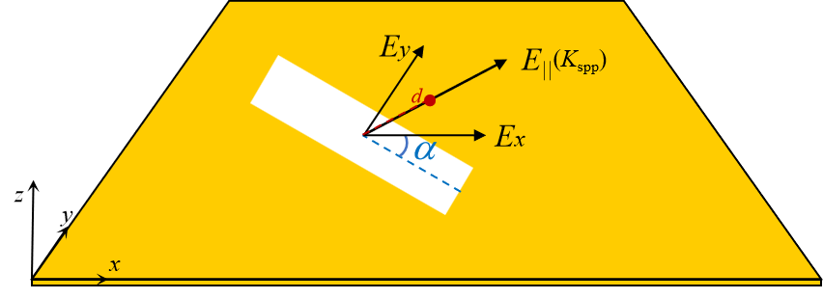
Fig. S1 | Schematic illustration of SPP generation by a single nanoslit.

S2. Parameters optimization of Kekulé metasurfaces
In order to avoid the uniform distribution of the WC lattice caused by the decay of the bound SPP mode with distance (L_{SPP} ≈ 7.0 μm for gold/SiO₂ interface)^{[S3]}, the radius of Kekulé metasurface is optimized to be 2.5 μm. Meanwhile, we set the number of nanoslits in each side of the Kekulé metasurface equals to 7 and the spacing between two nanoslit is near half of incident wavelength, guaranteeing constructively interference of SPPs.
In addition, the polarization conversion efficiency (PCE) of a single nanoslit to generate SPPs and the finite-difference time-domain (FDTD) method were used to optimize the nanoslit parameters. Specifically, for an incident light with RCP or LCP state, the PCE is defined as^{[S4]}:
$PCE=\frac{T_{cross}}{\left(T_{co}+T_{cross}\right)}$ (5)
where $T_{cross}=\frac{1}{4}{\left|\left(P_{x}-P_{y}\right)\right|}^{2}, T_{co}=\frac{1}{4}{\left|\left(P_{x}+P_{y}\right)\right|}^{2}$.
The PCE (Fig. S2a) is obtained as a function of nano-antennas' length L and width W with a sweeping step of 2 nm under illumination by a constant-wavelength laser (wavelength of 633 nm)^{[S5]}. Here, the optimized dimension of single unit cell is set to be 230 nm for length and 118 nm for width (indicated by the black dot). Based on this, we obtain that the PCE equals to ~0.5 and the utilization of both LCP and RCP excitation are ensured. Besides, departing from this dimension of the nanoslit, the averaged PCEs across the entire visible range was also calculated (Fig. S2b) and it is seen that the PCE value remains large over 200 nm range centered at 650 nm. This broadband characteristic will be further discussed in later experimental parts.
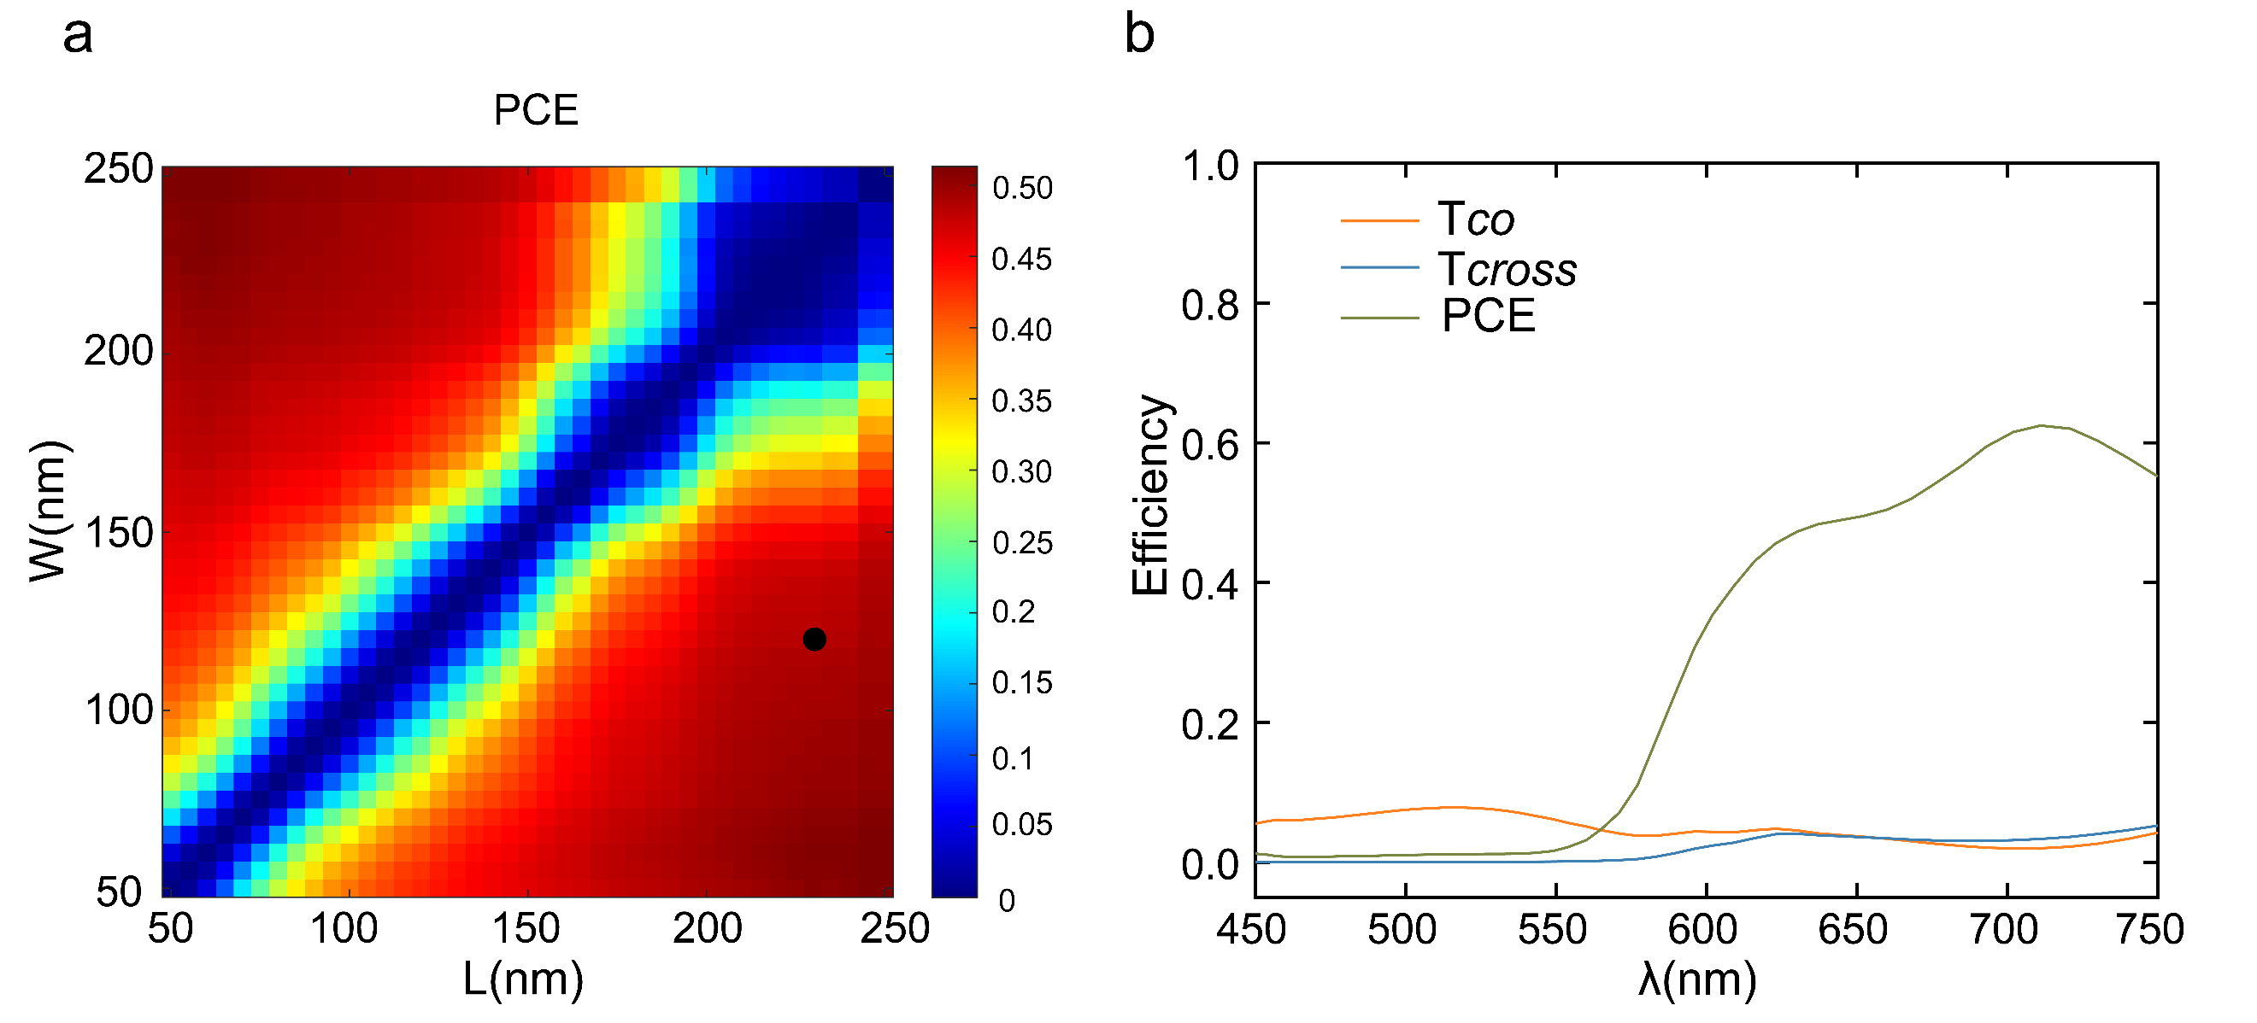
Fig. S2 | a, PCE Simulation of nanoslits as a function of length L and width W excited by a laser with a wavelength of 633 nm. b, Simulated distributions of PCEs efficiency of nanoslits (the dimension of L = 230 nm and W = 118 nm) under excitation wavelengths ranging from 450 nm to 750 nm.

S3. Calculation of SPP field generated by Kekulé metasurface
The electric vector is normally expressed by the transverse field in x, y direction (E||) and axial direction in z (E_{z}). For the Kekulé metasurface, its SPPs in transverse field is the superposition of the SPPs in six directions. According to equation S4, the following expression is obtained:
$E_{||}=\left[\begin{matrix}E_{x} \\ E_{y}\end{matrix}\right]=\sum_{n=1}^{6}{\left[\begin{matrix}\cos\left(α_{n}\right) \\ \sin\left(α_{n}\right)\end{matrix}\right]e^{-iσα_{n}}e^{-ik_{spp}\left[x\cos{θ_{n}}+y\sin{θ_{n}}\right]}}e^{-ik_{z}z}$ (6)
Where α_{n}, θ_{n}, σ and k_{spp} is the same definition as in the maintext. k_{z} is axial wave vector.
Based on Maxwell’s equations, the relationship between the transverse and axial electric field components are as follows ^{[S6]}:
$E_{x}=\frac{1}{k_{spp}^{2}}\frac{d^{2}E_{z}}{dxdz}$, $E_{y}=\frac{1}{k_{spp}^{2}}\frac{d^{2}E_{z}}{dydz}$, (7)
Therefore,
$\vec{E}=\left[\begin{aligned}\begin{matrix}E_{x} \\ E_{y}\end{matrix} \\ E_{z}\end{aligned}\right]=e^{-izk_{z}}\sum_{n=1}^{6}{\left[\begin{aligned}\begin{matrix}\cos\left(α_{n}\right) \\ \sin\left(α_{n}\right)\end{matrix} \\ \frac{k_{spp}}{2k_{z}}\frac{\sin\left(α_{n}+θ_{n}\right)}{\sin{2θ_{n}}}\end{aligned}\right]e^{-iσα_{n}}e^{-ik_{spp}\left[x\cos{θ_{n}}+y\sin{θ_{n}}\right]}}$ (8)

The normalized three-dimensional physical field can be defined by using the real part of the local unit vector of the electric field $\vec{e}=\left(\begin{matrix}e_{x}, & e_{y}, & e_{z}\end{matrix}\right)=\frac{Re\left\{\left(E_{x},E_{y},E_{z}\right)\right\}}{\sqrt{{\left|E_{x}\right|}^{2}+{\left|E_{y}\right|}^{2}+{\left|E_{z}\right|}^{2}}}$.
Fig. S3 present the calculated normalized electrical distributions of TC =0 Kekulé metasurface in transverse e|| (a) and axial e_{z} (b).
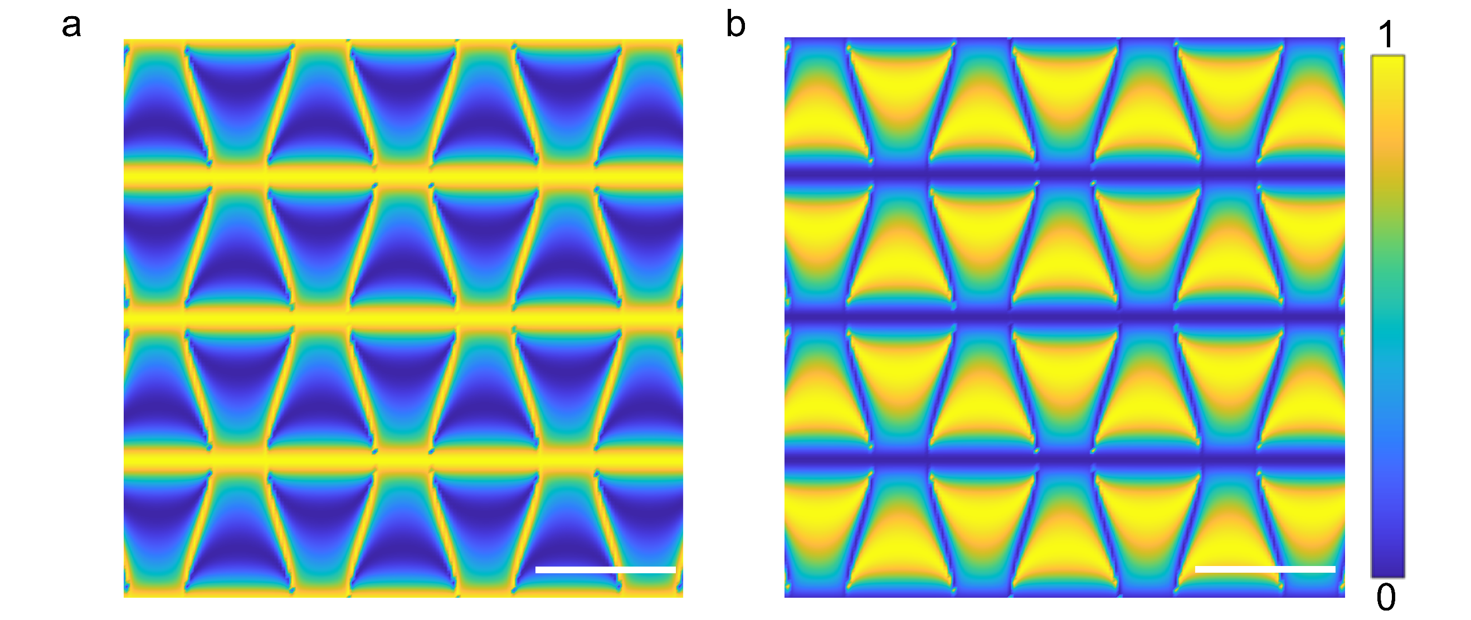
Fig. S3 | Calculated real parts of the local unit vector of the electric field generated by Kekulé metasurface in e|| (a) and e_{z} (b). Scale bar: 0.5 μm. The electric field intensity is normalized between 0 and 1.

S4. Electric field distributions with different topological charges
According to the PB phase theory, under circle polarization incident, a Kekulé metasurface can support four different lattice topological charges TC=0, 1, 2 and 3 in the cross-polarization, with TC=0 in co-polarization state. Therefore, gradient of the metasurface structure is calculated for different lattice TC, sketched in Fig. S4a-S4d. Based on the in-plane electric field equation:
$E_{||}∝\sum_{n=1}^{6}{\left(η_{σ}\left|\left.E_{σ}\right\rangle \right.+η_{-σ}e^{-i2σα_{n}}\left|\left.E_{-σ}\right\rangle \right.\right)}e^{-ik_{spp}\left[x\cos{θ_{n}}+y\sin{θ_{n}}\right]}$ (9)
The calculated electric field under RCP state incident without analyzer are plotted in Fig. S4a-S4d (middle panels). Moreover, derived from equation (9), we can see that since the co-polarization (RCR analyzer) state $η_{σ}$ is not related to the rotation angle, the intensity distributions for four metasurfaces remain the same (Fig. S4a-S4d, bottom panels).
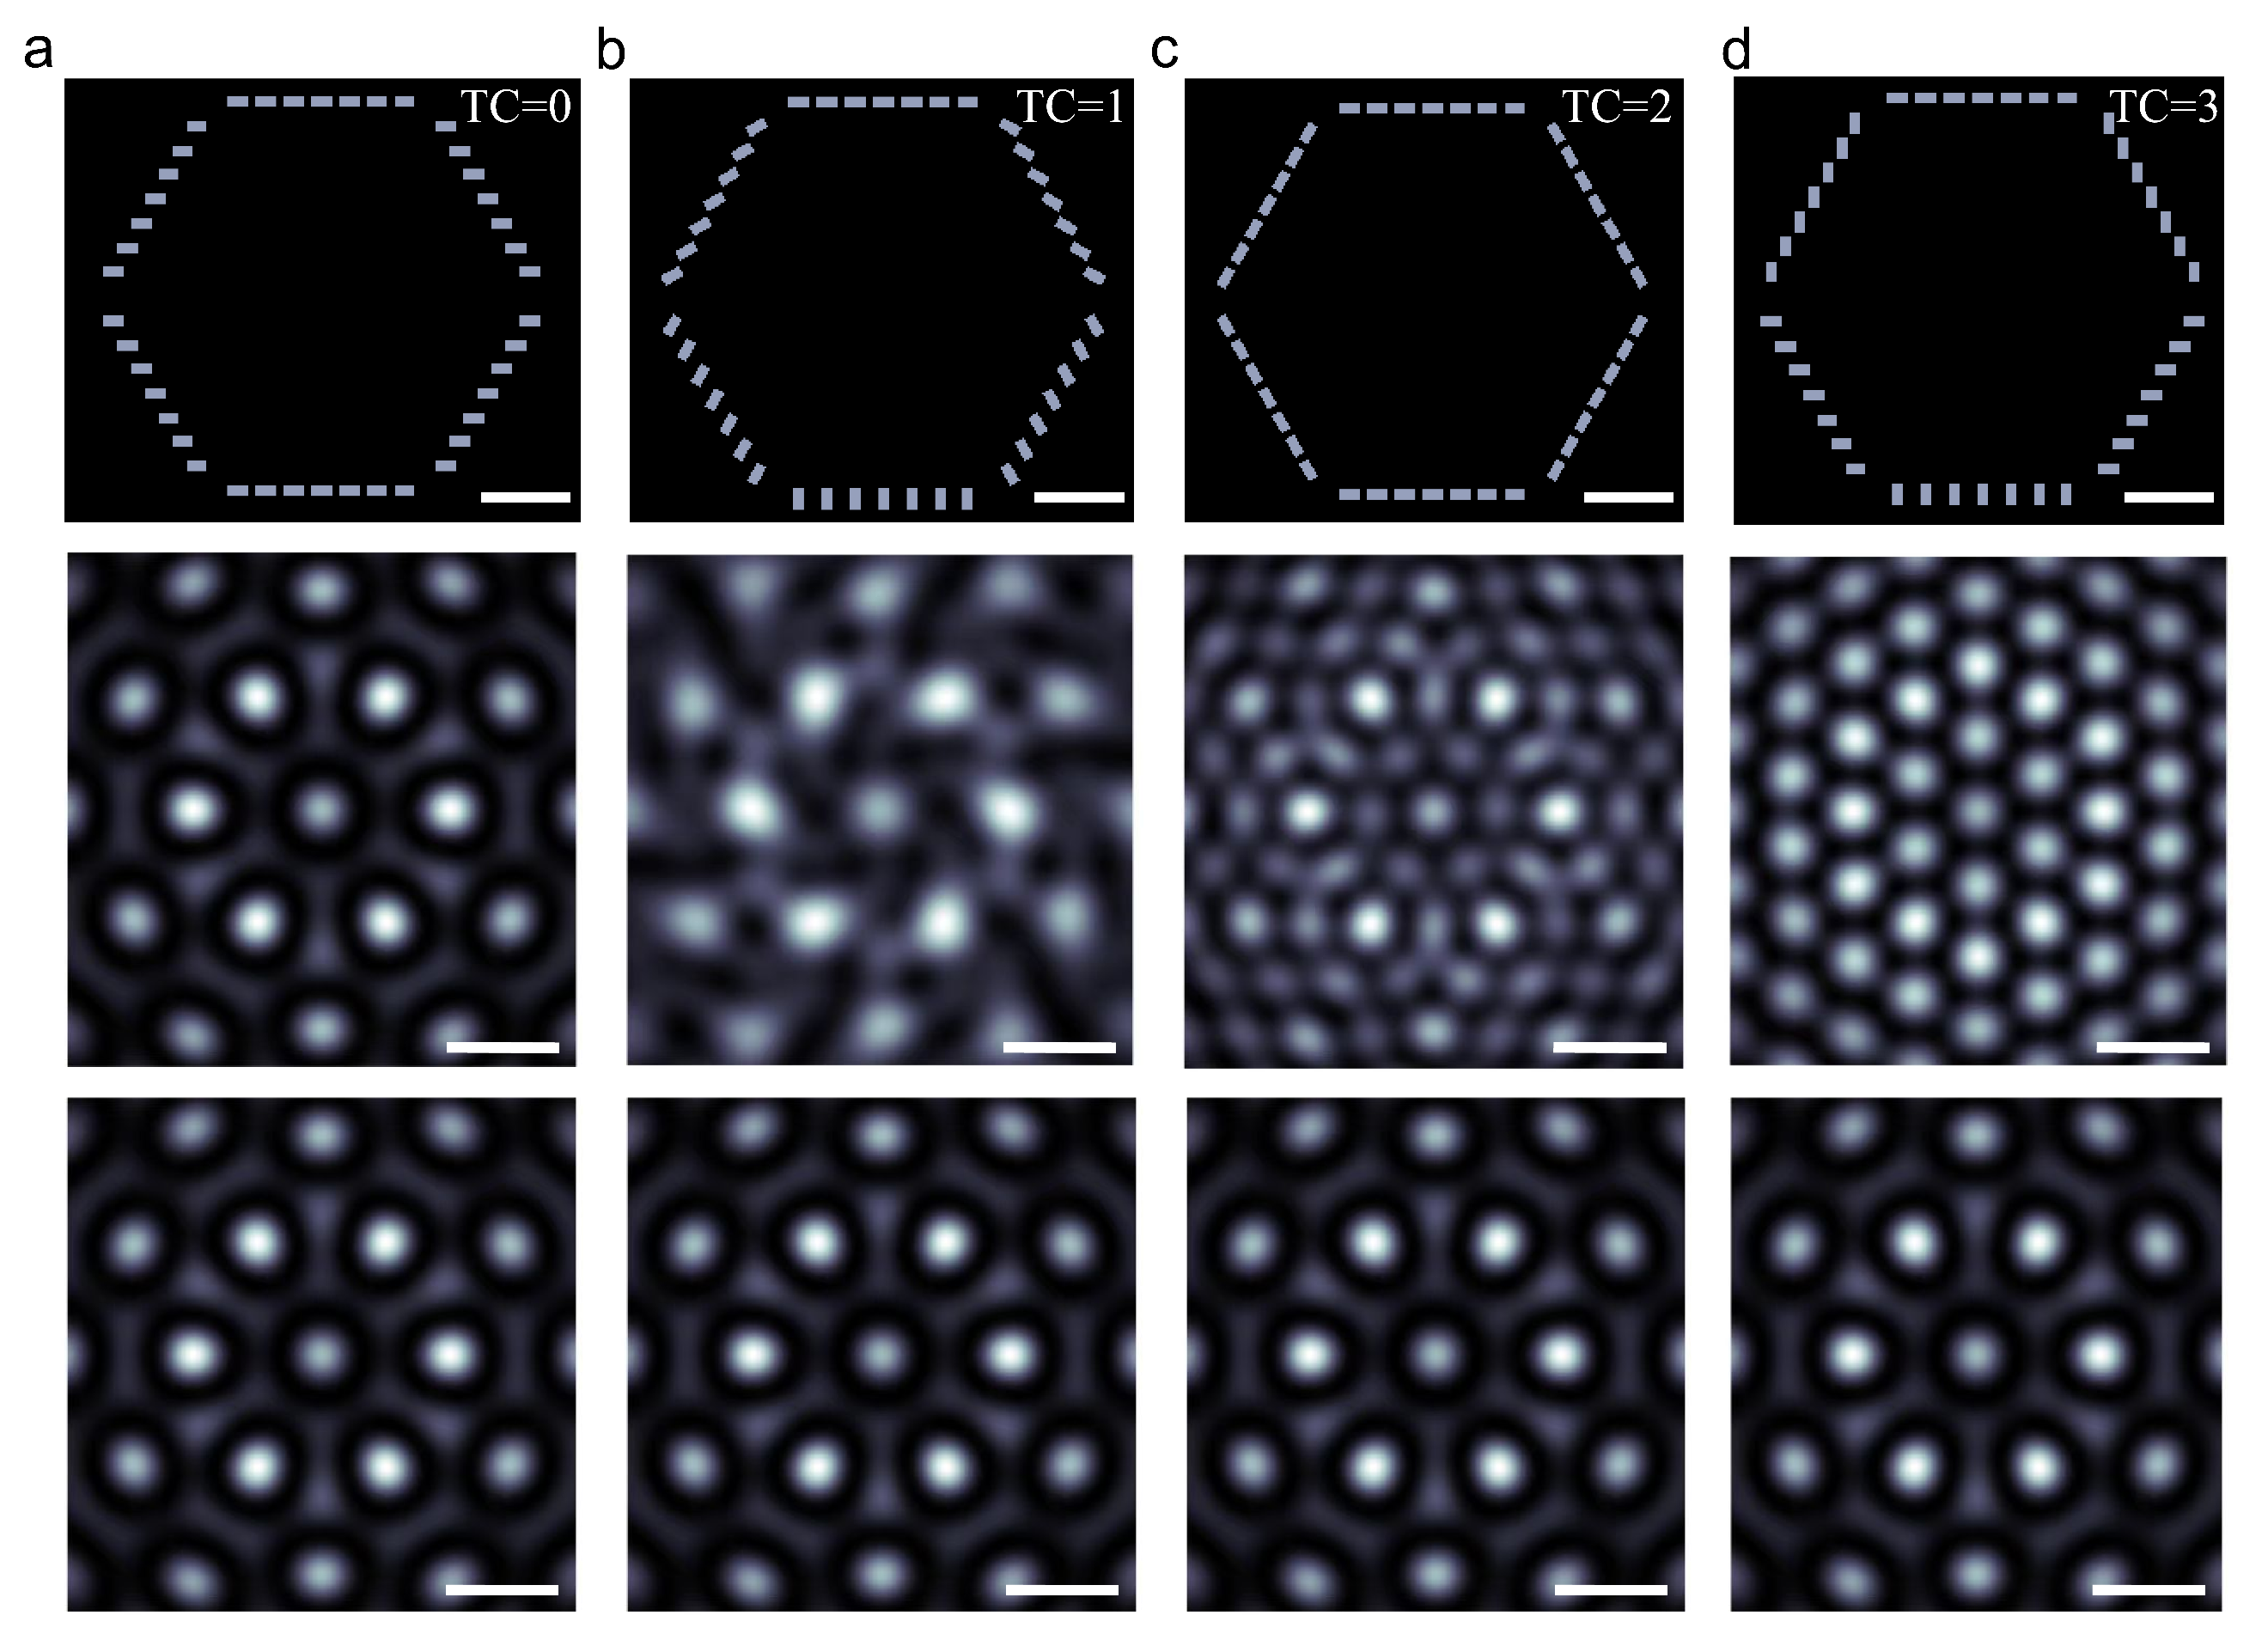
Fig. S4 | a-d, Metasurface structures for TC= 0, TC= 1, TC= 2, and TC= 3, respectively. Scale bar: 1 μm. The total intensity distributions of the electric field without polarization analyzer are plotted in middle panels. The spatial amplitudes of the electric field in RCP polarization state are plotted in bottom panels. Scale bar: 0.6 μm.

S5. Normalized electric vector field of outer-wing-shaped metasurface
The FDTD simulation was performed on TC=0 Kekulé metasurface equipped with extra wing-shaped nanoslits of M=4. A RCP incident beam illuminated on the metasurface and PML boundary condition was employed in all directions. The in-plane electric field under LCP analyzer and the out-plane electric field are, respectively, extracted and showed in Fig. S5a and S5b. By combining these, the normalized electric vector field could be constructed (Fig. S5c) and exhibit fantastic meron-antimeron (MAM) like lattice pattern^{[S7]}.
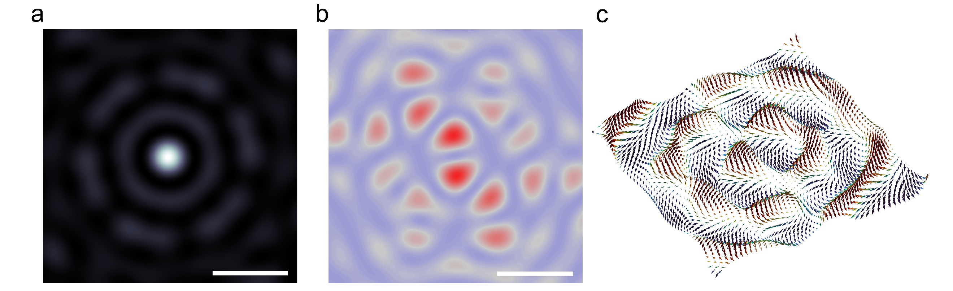
Fig. S5 | FDTD simulation of electricity field of Kekulé metasurface of TC =0 equipped with extra wing-shaped nanoslits of M=4. a, The in-plane electric field. Scale bar: 0.6 μm. b, The out-plane electric field. Scale bar: 0.6 μm. c, The 3D normalized electric vector field.

S6. Comparison with other shaped metasurfaces
One advantage of our Kekulé metasurface lies in its plentiful DOFs for manifesting optical WC lattices, for instance, compared with M=0 structure (Fig. S6a), on-demand intensity enhancement at specified lattice sites could be realized with M=4 (Fig. S6c). While, without extra wing-shaped set (M=0), periodic rings structure (period equals to a wavelength of λ_{spp}) presents indiscriminate intensity enhancement of lattice sites (Fig. S6b). In addition, extra sets of periodic Kekulé metasurface are coupled with the Kekulé metasurface with M=4, as illustrated in Fig. S6d-S6e. The corresponding cross-polarization intensity distributions (bottom panels, Fig. S6d-S6e) exhibits indiscriminate intensity enhancement of WC lattices. The intensity difference between lattice site A and lattice site B gradually decrease with the increment of extra periodic Kekulé structures. In theory, however, this intensity difference could be monotonically enlarged by increasing M. Hence, our Kekulé metasurface is powerful in controlling optical WC lattices.
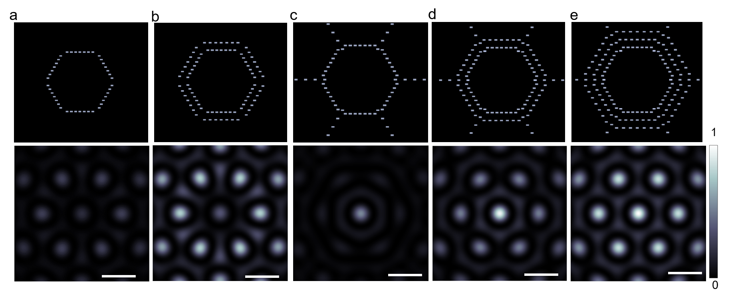
Fig. S6 | Comparisons with other shaped metasurfaces. a-e (upper panel), Structures of different periodic Kekulé metasurfaces. a-e (bottom panel), The cross-polarization of in-plane SPP field corresponds to each structure. The full scale bar here is normalized to be from 0 to 1 and the Scale bar: 0.6 μm.

S7. Extra wing-shaped nanoslits coupled with TC=1 metasurface
The wing-shaped nanoslit design is suitable for all the mentioned Kekulé metasurfaces. Take TC=1 as an example, Fig. S7a-S7e shows the designs with several sets (M = 0, 1, 2, 3 and 4) of extra wing-shaped nanoslits having Δα=0 and separating of λ_{spp}. The corresponding intensity in LCP state distribution under RCP incident beam is numerically calculated and are shown in Fig. S7f-S7j. It can be seen that the peripheral lattices of the generated hexagonal vortex lattice gradually melt, while the intensity of central lattice site A increases linearly along with M increment. This is consistent with the tonality of WC lattice in TC = 0, which re-confirms the feasibility and superiority of our Kekulé metasurface design interplayed with extra wing-shaped nanoslit set.
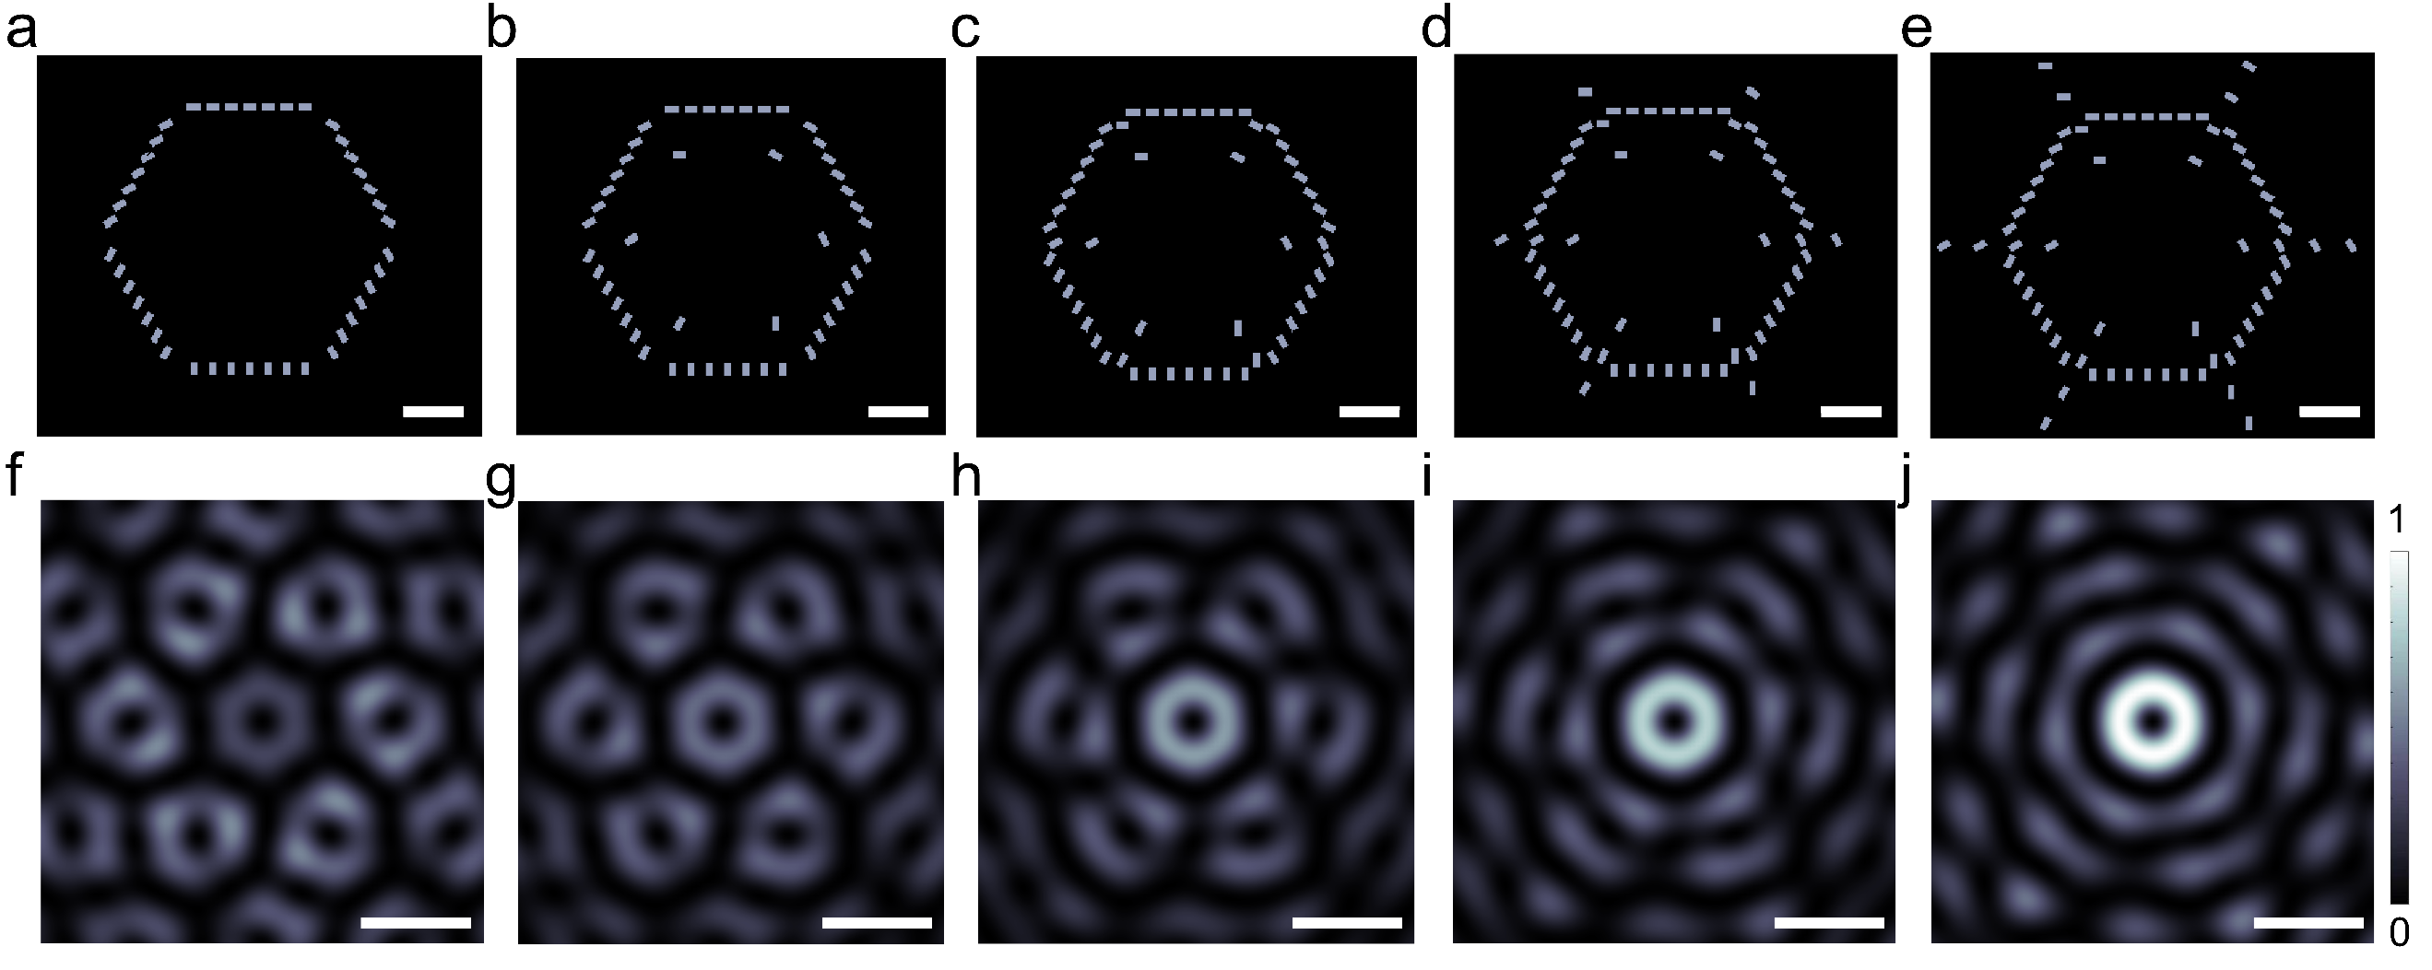
Fig. S7 | Theoretical calculation of SPP lattice with TC=1 metasurface by various nanoslits numbers M (M=0, 1, 2, 3 and 4). a-e, The designed metasurface with different number of nanoslits set. Scale bar, 1 μm. f-j, The corresponding intensity distributions of (a-e). Scale bar: 0.6 μm.

S8. Design scheme of optical paths
As shown in Fig. S8a, a monochromatic laser with a wavelength of 633 nm is emitted and converted into RCP beam after passing through a linear polarizer and a quarter-wave plate. Then RCP beam is focused onto the sample surface with the assistance of a 40× objective lens. The polarized incident light couples with the Kekulé structure and excites SPPs, which interfere with each other to form a regular field distribution. A home-made leakage radiation microscopy platform is used to collect signals, which enables the quantitative analysis of in-plane SPP signals in a far-field manner. The emitted light through beneath quartz substrate was collected using a 100× oil immersion objective with a numerical aperture of NA equals to 1.3 (a filter is also used to filter out the 633 nm laser component). The light then passes through a quarter-wave plate and a linear polarizer for orthogonal polarization analysis, filtering out the RCP polarization component of emitted light while retaining the LCP component converted by the metasurface. After being focused by a tube lens and Lens 1 in Fig. S8a, a mask can be placed at the Fourier plane focus to remove any small-angle emitted light. The light is then refocused by Lens 2 and Lens 3 to obtain the Fourier plane SPP field intensity distribution, which is captured by a CCD camera^{[S8]}.
To obtain the real plane light field distribution, Lens 3 can be removed from the setup (Fig. S8b), allowing the CCD camera to capture the real plane intensity distribution. Since SPPs are electromagnetic waves that propagate along the interface and are confined within the plane, the corresponding Fourier plane for SPPs generated by isotropic excitation sources typically appears as a narrow and uniform bright ring^{[S9]}. This SPPs nature is also evidenced (Fig. S8c) in our Kekulé metasurface. The more complicated angular distribution for SPPs may stem from possible wave interference altering both the original propagation direction and magnitude of the SPP's leaking radiation.
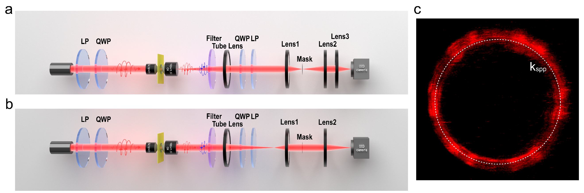
Fig. S8 | Experimental optical setup diagram. a, Fourier plane collection experimental optical setup. b, In-plane collection experimental optical setup. c, Experimental Fourier-plane intensity distribution image of the SPP field (M=3), obtained after filter and mask processing.

S9. Position-dependent real-plane light field intensity distribution
There is a strong correlation between the positions of extra wing-shaped nanoslits and the WC lattice field intensity distribution. Taking central lattice site A as the enhancement target, several devices with varied distance (r) from the nanoslit position to the center are fabricated and the corresponding SEM images are shown in Fig. S9 a-f, where r= Rsin(60°) + λ_{spp} (n-2)/2, (n equals to 1, 2, 3, 4, 5 and 6 respectively). Fig. S9g-S9l show the corresponding in-plane field distributions and it can be seen that the lattice site A intensity varies with the position variation of extra wing-shaped nanoslit with a period of λ_{spp}. Fig. S9m also illustrates the oscillatory decay relationship between the position of extra wing-shaped nanoslit and the WC lattice field intensity distribution, with (a)-(f) corresponding to the data collected from different metasurfaces (a-f). Based on this regularity, the positions of extra wing-shaped nanoslit in Kekulé structure could be optimized.
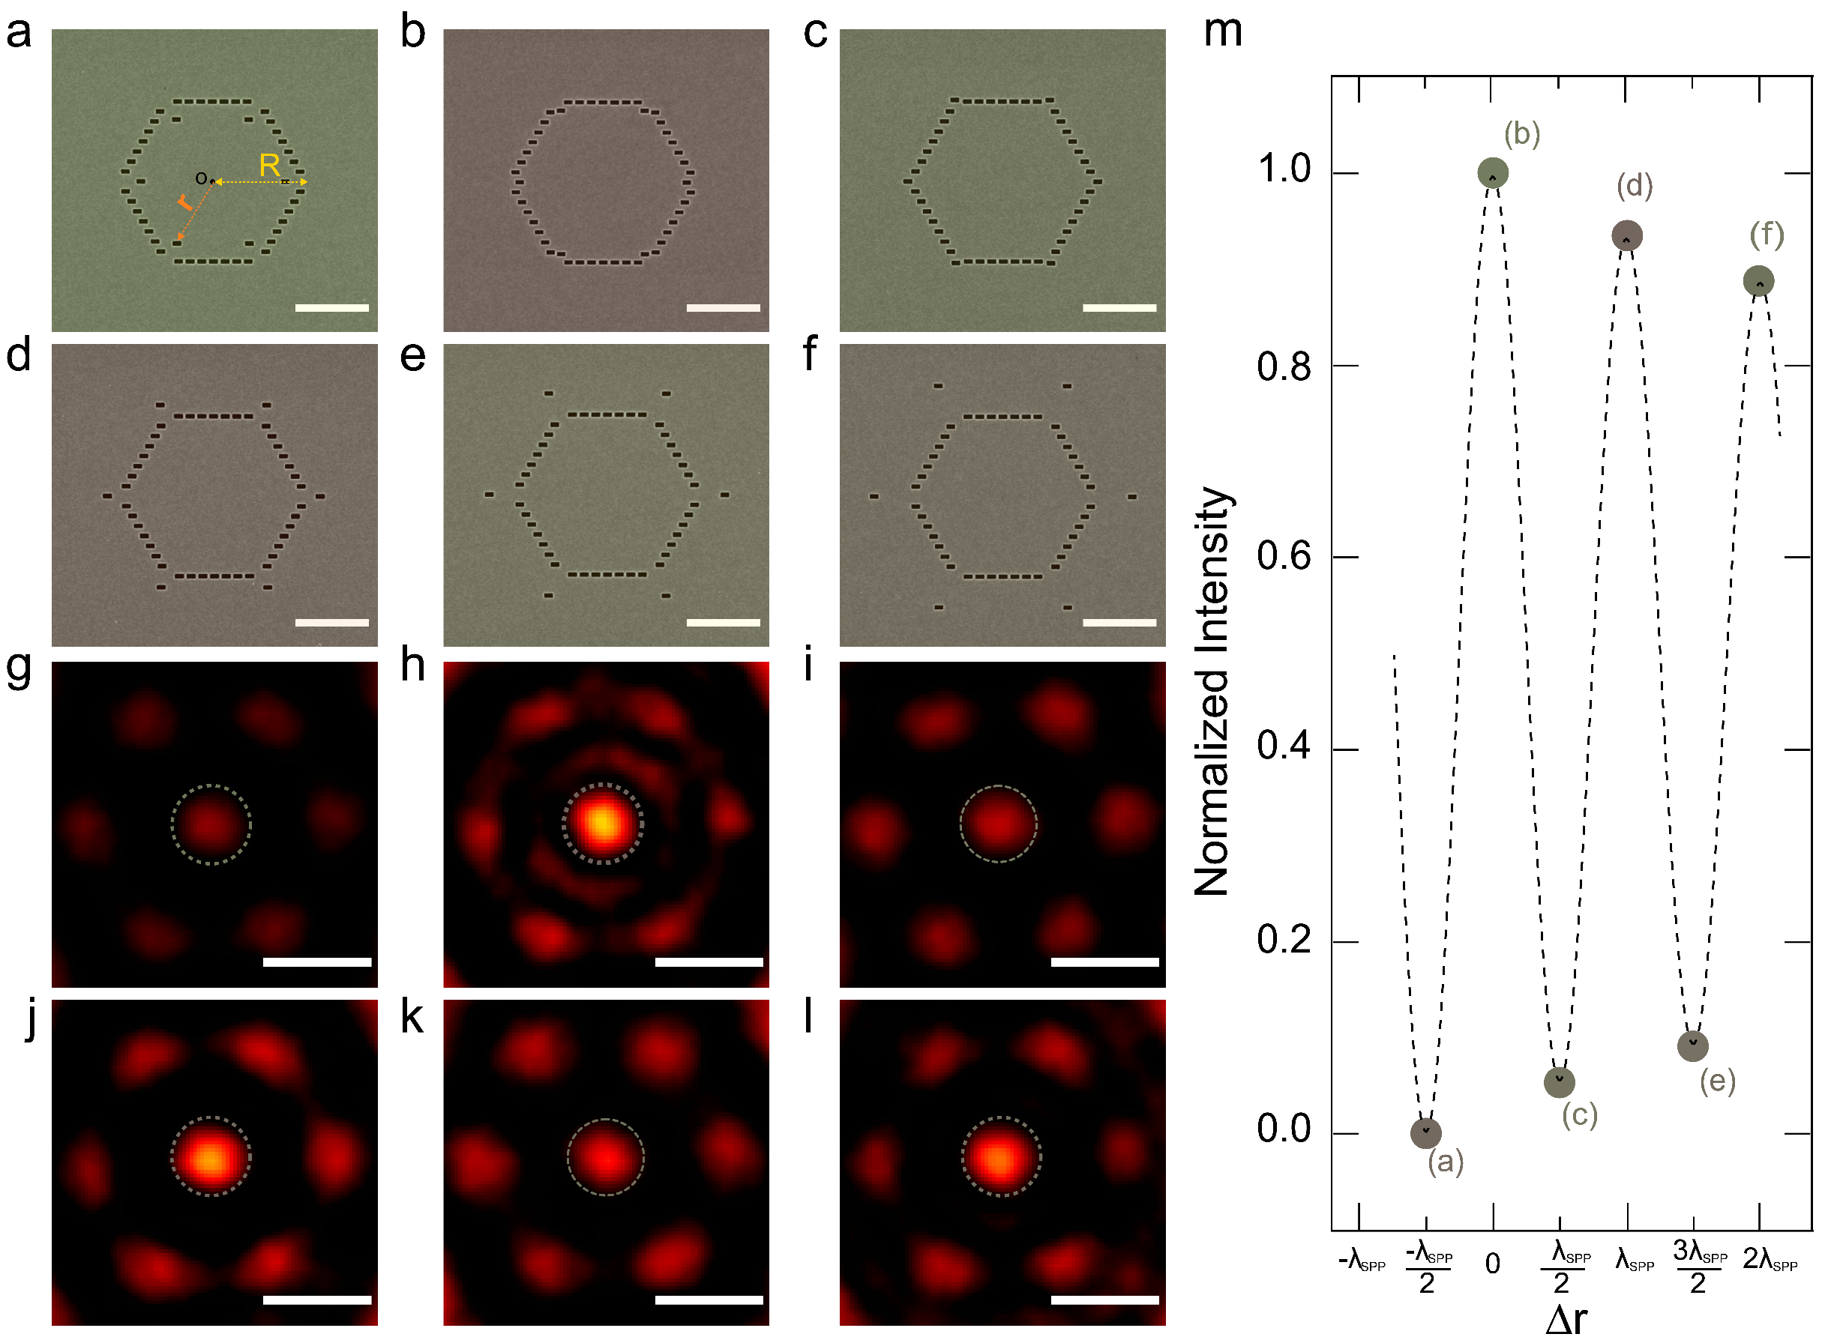
Fig. S9 | Real-plane light field intensity distribution of the Kekulé structures with different nanoslit positions. a-f, The SEM images of Kekulé structures with M=1 nanoslit positioned at different locations. Scale bar: 2 μm. g-l, The corresponding real-plane optical field distributions of metasurface structures (a-f), respectively. Scale bar: 0.6 μm. m, The plots of central lattice site A intensity as function of nanoslit positions. The symbols (a)-(f) correspond to the Kekulé structures in Fig. S9a-S9f and Δr= r- Rsin(60°).

S10. Experimental setup for detecting scattering light
As illustrated in Figure S10, a normally incident laser beam is weakly focused onto the sample via a microscopy objective of 40× with the numerical aperture (NA) of 0.75. The scattering light is collected via an objective of 100× with of 0.85, instead of the oil objective (used in leakage radiation microscopy). The input and output polarization states are controlled via two sets of linear polarizers (LP) and quarter-wave plates (QWP).
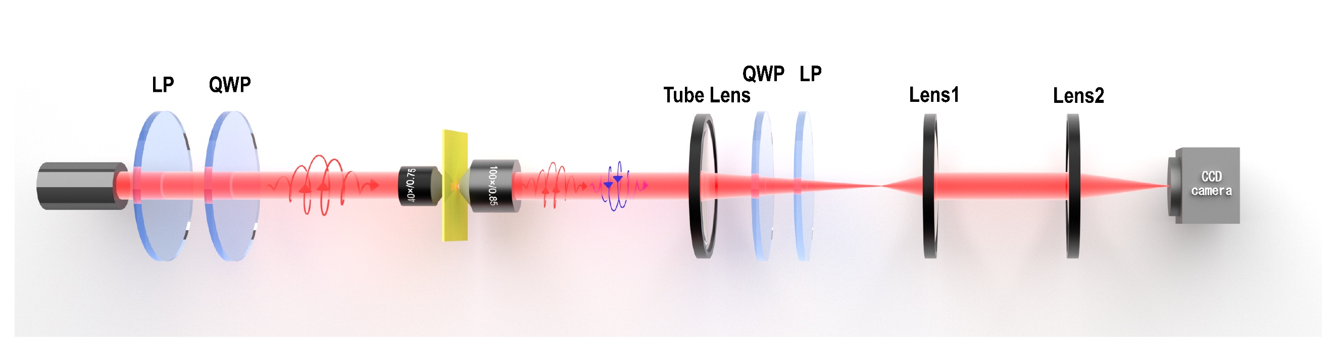
Fig. S10 | Schematic of real space imaging of scattering light.

S11. The optical field intensity distribution
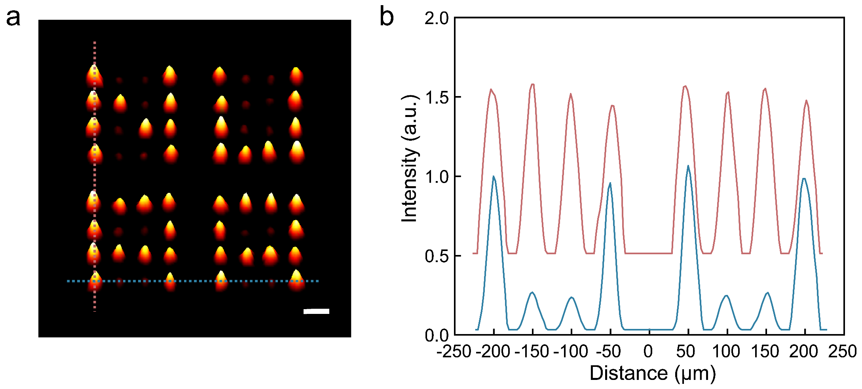
Fig. 11 | The 3D normalized optical field intensity distribution. a, Spontaneous light-emitting patterns of 'N-U-A-A' shaped Kekulé metasurface arrays (The normalized baseline level is 0.12). Each bright spot represents the in-plane central sublattice A intensity. Scale bar: 10μm. b, The distance-intensity profiles corresponding to the dashed lines (Fig. S11a).

S12. Flexible Kekulé metasurfaces and light-emitting arrays
On a 5 cm × 1.5 cm PET flexible substrate (Fig. S12a), we sequentially vapor-deposited 5 nm of Ti and 200 nm of Au, and etched the metal film into four Kekulé metasurface arrays. The M=4 Kekulé structures were arranged into the letters of 'N-U-A-A', while the rest ones were occupied by M=0 Kekulé structures. The SEM image in Figure S12b shows the flexible arrays with uniform geometric parameters. Under 633 nm laser illumination, the Kekulé array (Fig. S12c) emits shows 'N-U-A-A' patterned light, potential for on-chip planar device application and integration^{[S10]}.
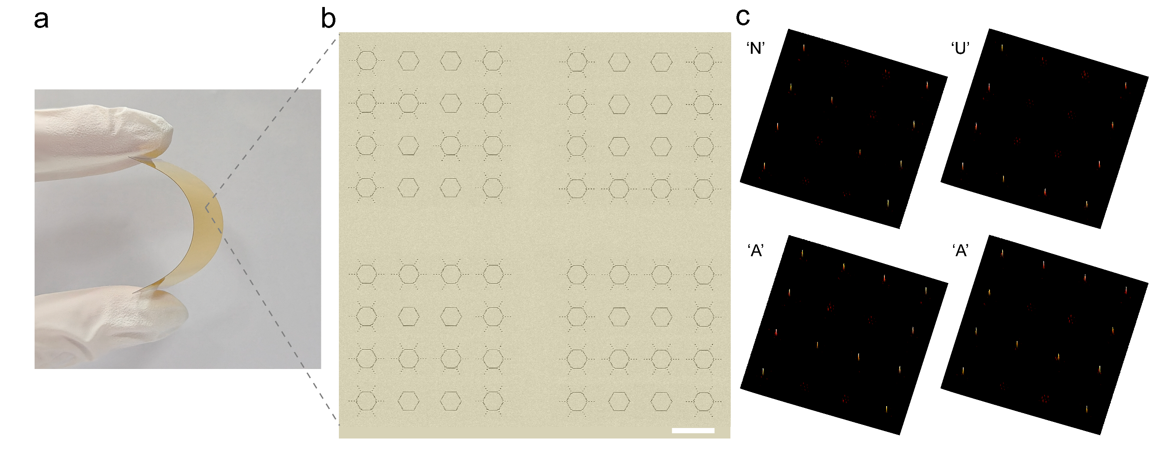
Fig. S12 | Flexible Kekulé structure arrays. a, a representative image of 5 nm Ti and 50 nm Au film on PET substrate. The Kekulé structure arrays is sample-wide and highly feasible. b, The SEM image of the Kekulé structure arrays. Scale bar: 10 μm. c, The 3D emission patterns of Kekulé arrays under 633 nm laser illumination.

S13. The scattering field of Kekulé metasurfaces under white light
Due to the PB phase principle, the light-Kekulé metasurface interaction is expected to be broadband-basis and may work in the whole visible light. We performed experiment by using LED as the source to illuminate the Kekulé array shown in the maintext (Fig. 4), and set RCP and LCP states for the incident and emergent beams, respectively. Figure S13a and 13b show the achieved WC lattice intensities of M=0 (a) and M=4 (b) Kekulé structures. The intensities of lattice site A from two structures are measured to be ultra-stable, and the intensity collected from M=4 Kekulé metasurface is about four times than that of M = 0 one, which clearly exhibit a 'N-U-A-A' pattern after laser scanning over the whole array. These features are consistent with the evolution of WC lattice distribution under 633 nm monochromatic laser incidence, suggesting the potential of our Kekulé metasurface as broadband lighting sources.
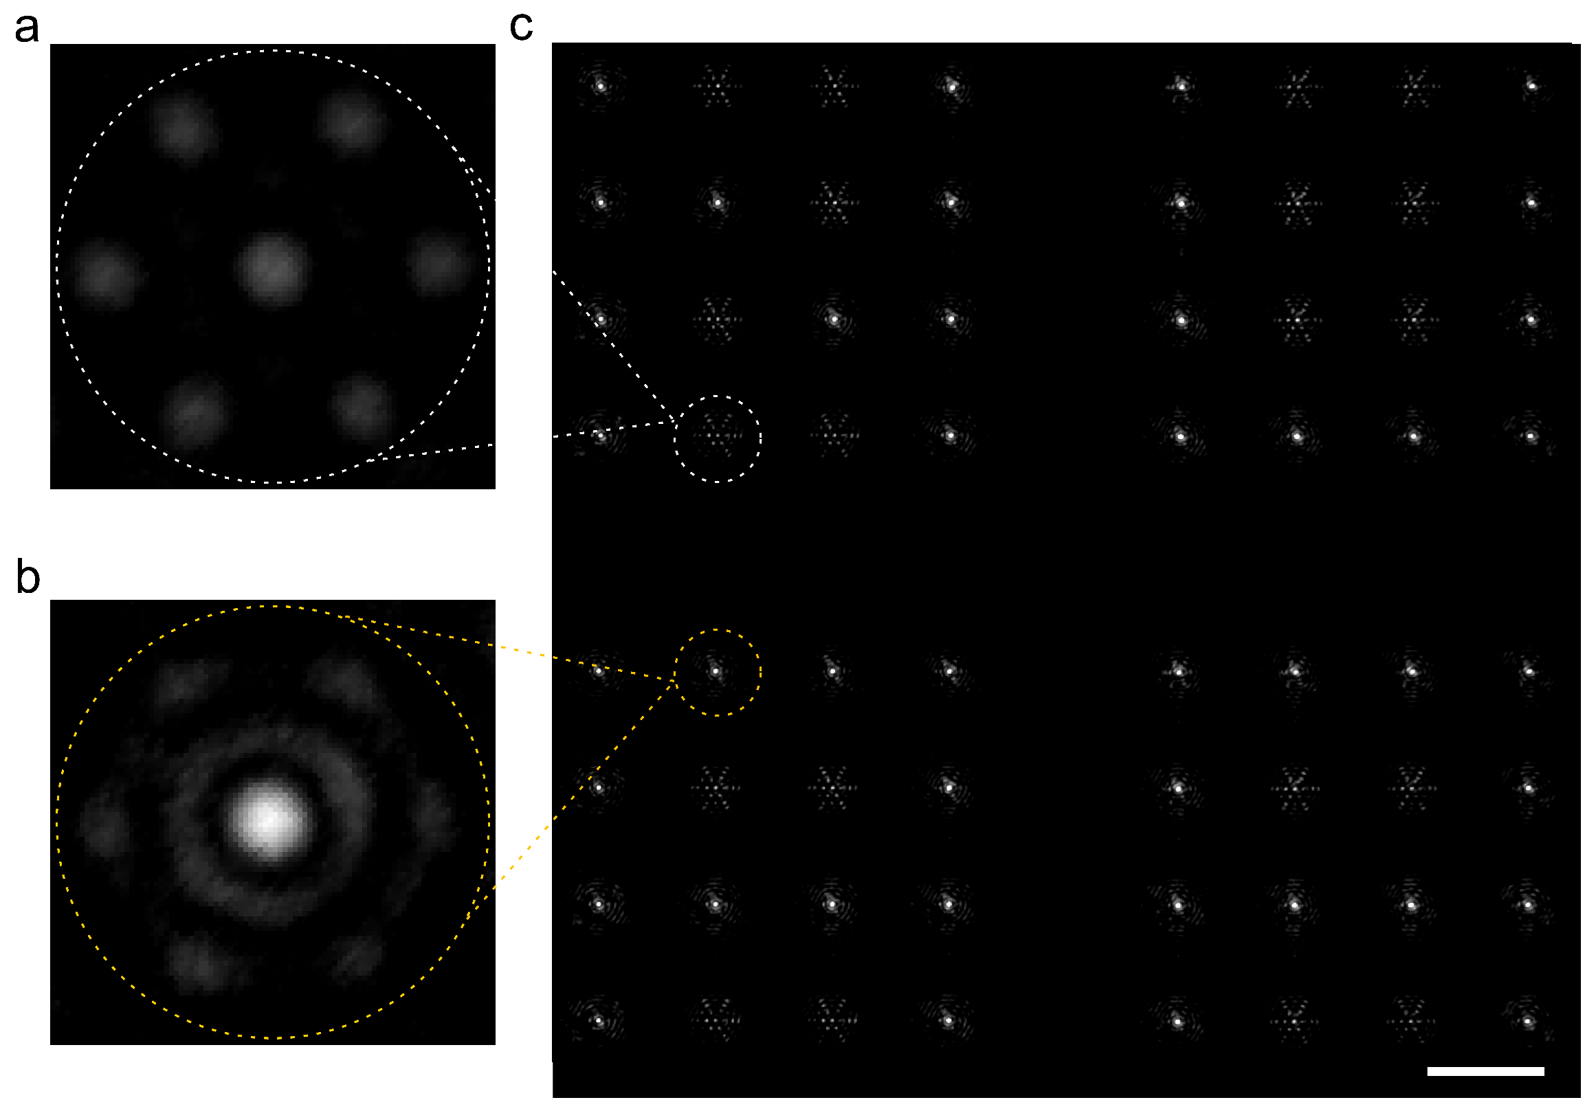
Fig. S13 | Scattering field of Kekulé structure array under white light incidence. a, Scattering field distribution of M=0 Kekulé structure. b, Scattering field distribution of M=4 Kekulé structure. c, The emission pattern of the on-chip planar Kekulé array under broad white light illumination. Scale bar:10 μm.

S14. The least significant bit of a cover image
The conversion from Lenna image to the least significant bit (LSB) of the cover image is shown in Figure S14. The Lenna image is a gray image ranging from 0 to 255. Through conversion between decimal and binary, the gray image can be converted into the binary image, meanwhile, we replaced the information of the least and the second least significant bit with the information in our Cipher image 1 and Cipher image 2 to complete a cipher cover image.
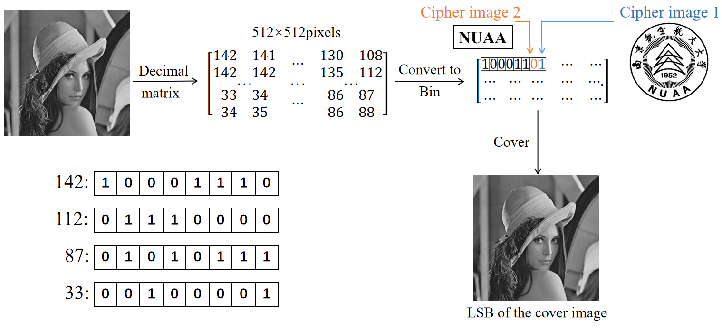
Fig. S14 | Conversion diagram from Lenna image to LSB cipher image.

References
- S. Xiao, F. Zhong, H. Liu et al., Flexible coherent control of plasmonic spin-Hall effect. Nat. Commun. 6, 8360 (2015).
- D. Wang, F. Liu, T. Liu et al., Efficient generation of complex vectorial optical fields with metasurfaces. Light Sci. Appl. 10, 67 (2021).
- L. Novotny, and B. Hecht, Principles of Nano-Optics. Cambridge University Press: Cambridge, UK, (2012).
- Y. Yang, W. Wang, P. Moitra et al., Dielectric meta-reflectarray for broadband linear polarization conversion and optical vortex generation. Nano Lett. 14, 1394-1399 (2014).
- F. Ding, R. Deshpande, and S. I. Bozhevolnyi, Bifunctional gap-plasmon metasurfaces for visible light: polarization-controlled unidirectional surface plasmon excitation and beam steering at normal incident. Light Sci. Appl. 7, 17178 (2018)
- S. Tsesses, E. Ostrovsky, K. Cohen et al., Optical skyrmion lattice in evanescent electromagnetic fields. Science 361, 993-996 (2018).
- Y. Shen, Q. Zhang, P. Shi, L. Du et al., Optical skyrmions and other topological quasiparticles of light. Nat. Photonics 18, 15-25 (2024).
- Q. Jiang, A. Pham, M. Berthel et al., Directional and singular surface plasmon generation in chiral and achiral nanostructures demonstrated by leakage radiation microscopy. ACS Photonics 3, 1116-1124 (2016).
- H.-Z. Chen, J.-Q. Hu, S. Wang et al., Imaging the dark emission of spasers. Sci. Adv. 3, e1601962 (2017).
- H. Y. Luan, Y. H. Ouyang, Z. W. Zhao et al., Reconfigurable moiré nanolaser arrays with phase synchronization. Nature 624, 282-288 (2023).

