Supplementary material, Figure S1. Measurements on Micro-CT.
(a) Condylar length; (b) Condylar width. The orange region indicates the measurement range of subchondral bone.

Supplementary material, Figure S2. Fibrillation extends vertically in the posterior regions of condyles with loss of chondrocytes in the ADD-EG (A), CL-EG (B), and CG (C).
Small vessels were observed in the fibrous layer (blue arrows).

Supplementary material, Figure S3. The intraoperative examination during the second surgery in the pilot study.
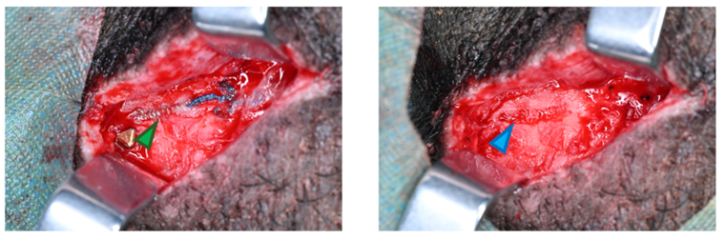
The coil spring did not recover from the elastic deformation (green arrow), osseointegration occurred between the nickel-titanium coil spring and zygomatic arch. (blue arrow).

