Supplementary Material

Smart Health Kit:

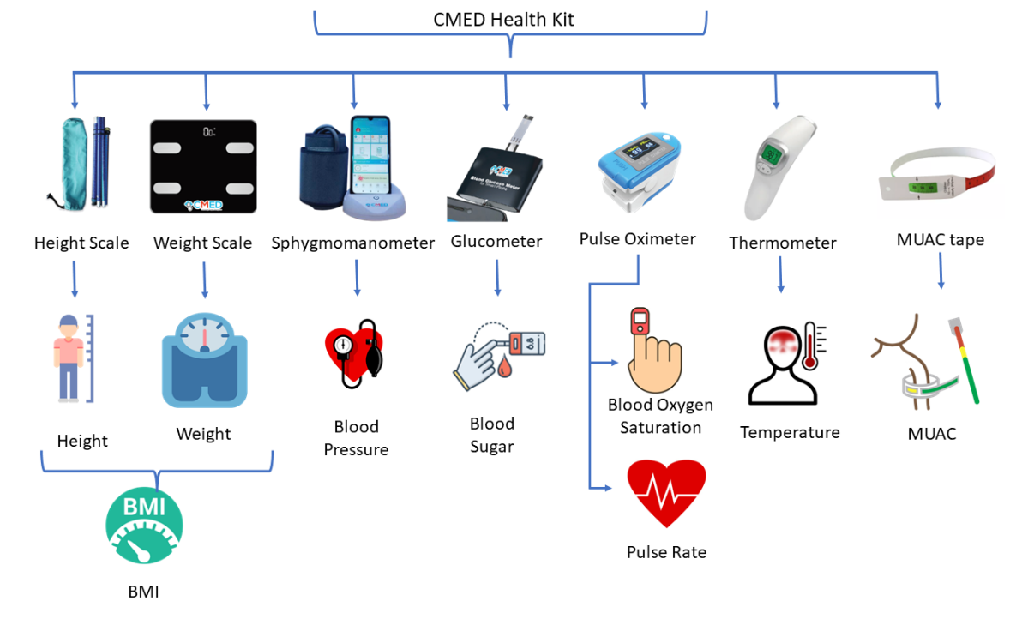
Figure 1 CMED smart health kit

