Supplementary Fig 2 - The cumulative incidence of IVR. IVR = intravesical recurrence; RNU = radical nephroureterectomy.
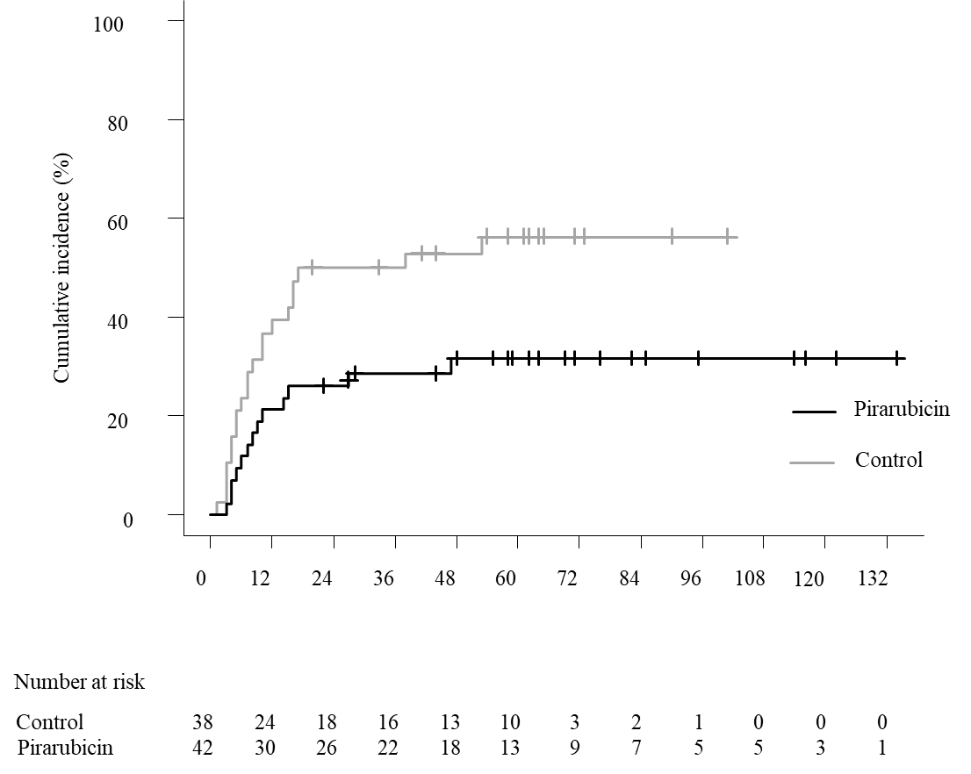

Supplementary Fig 3 - Kaplan-Meier curves showing overall survival in all patients. RNU = radical nephroureterectomy.
