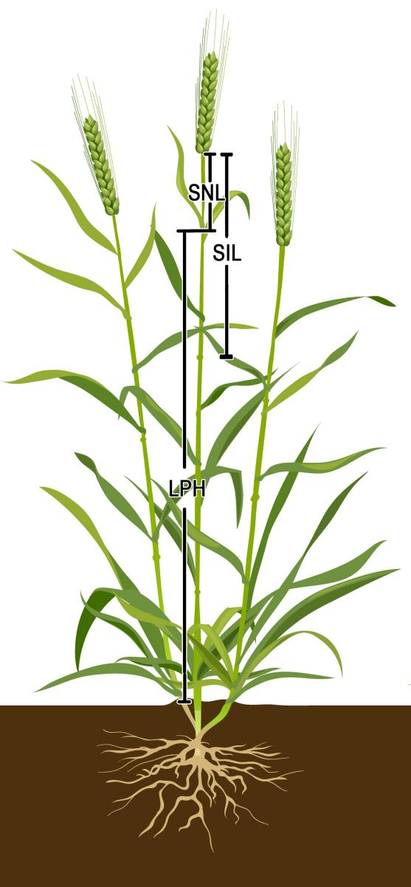
Fig S1. Plant height related traits measurement diagram. LPH, leaf pillow height; SIL, subspike internode length; SNL, spike neck length.
Fig. S2. Heat maps of tissue expression patterns of candidate genes in the Qph/lph.ahau-7A and Qngps/sps.ahau-1A regions. A Transcriptome data of candidate genes underlying Qph/lph.ahau-7A from “Chinese Spring Development (single)”. B Transcriptome data of candidate genes underlying Qph/lph.ahau-7A from “Chinese Spring Development (pair)” at different stem developmental stages. C Transcriptome data of candidate genes underlying Qngps/sps.ahau-1A from “Chinese Spring Development (single)”. D Transcriptome data of candidate genes underlying Qngps/sps.ahau-1A from “Chinese Spring Development (pair)” at different spike developmental stages. Stem_Z30, _Z32, and _Z65, stems at 1 cm spike, two-node and anthesis stages, respectively. Spike_Z32, _Z39, and _Z65, spikes at two-node, flag leaf and anthesis stages, respectively.
Fig. S3. Detection of the two markers TaF-box-Q-744 and TaF-box-C+304 for TaF-box-7A in Yangmai 158 (YM158, carrying T and T, respectively), Jimai 22 (JM22, carrying C and T, respectively) and Henong 825 (HN825, carrying C and G, respectively) using 2.0% agarose gel electrophoresis.

Fig. S4. Detection of the two markers TaBSK2-Q-937 and TaBSK2-Q-1421 for TaBSK2-1A in Yangmai 158 (YM158, carrying T and G, respectively), Jimai 22 (JM22, carrying C and A, respectively) and Henong 825 (HN825, carrying C and A, respectively) using 2.0% agarose gel electrophoresis.
Fig. S5. Manhattan and quantile–quantile (Q–Q) plots of BLUP values of PH-related traits based on the MLM model. PH, plant height; LPH, leaf pillow height; SIL, subspike internode length; SNL, spike neck length.
Fig. S6. Manhattan and quantile–quantile (Q–Q) plots of BLUP values of grain-related traits based on the MLM model. GL, grain length; GW, grain width; TGW, thousand grain weight.
Fig. S7. Manhattan and quantile–quantile (Q–Q) plots of BLUP values of spike-related traits based on the MLM model. GWPS, grain weight per spike; NGPS, number of grains per spike; SD, spike density; SL, spike length; SPS, number of spikelets per spike; SSP, spikelet set percentage.

