Supporting information

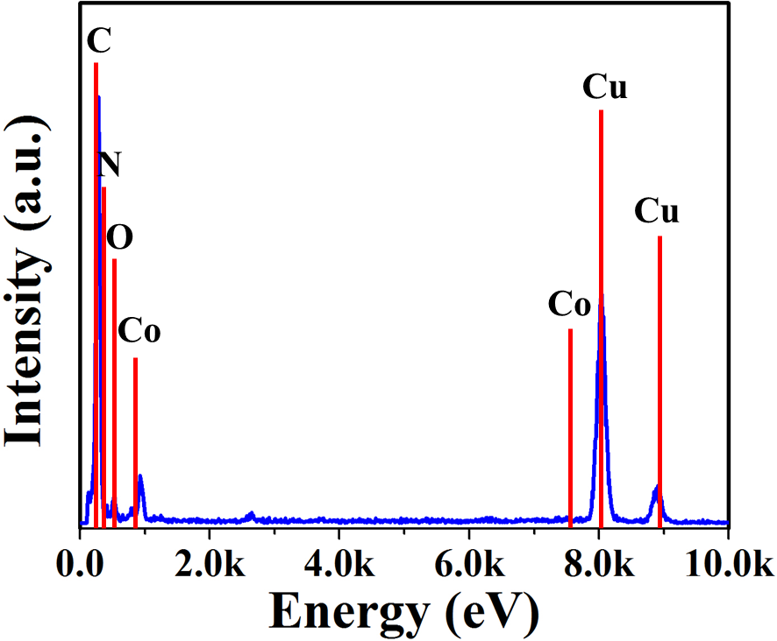
Fig. S1 EDX spectrum of Co@NC-800 catalyst.

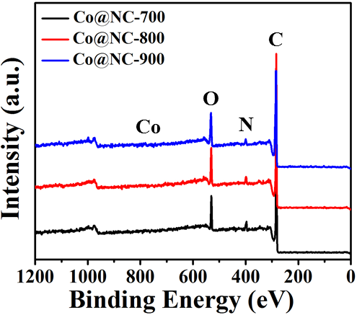
Fig. S2. The wide-range XPS spectrum of Co@NC-T samples.

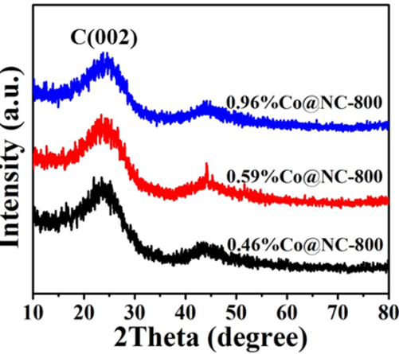
Fig. S3. XRD spectra of different cobalt content of Co@NC-800 catalysts

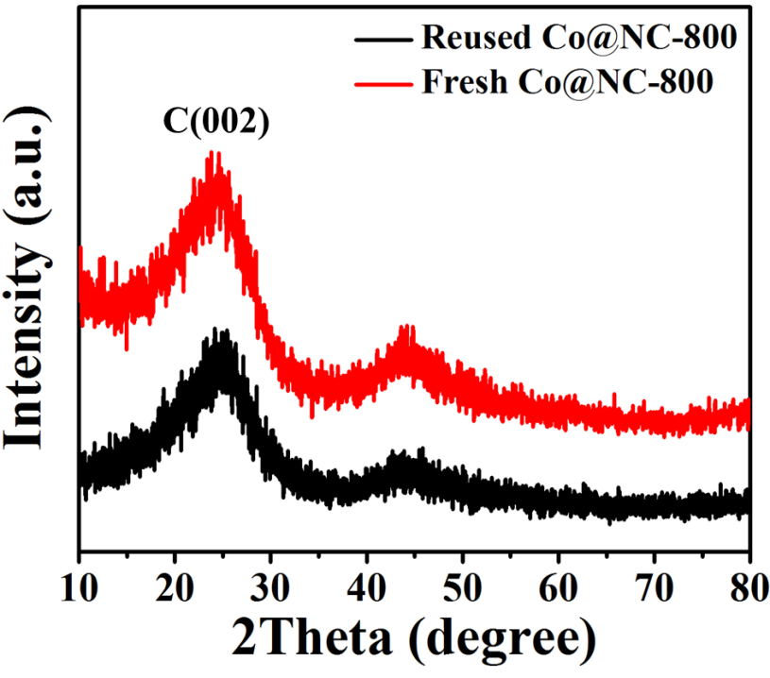
Fig. S4. XRD spectra of fresh and reused Co@NC-800 catalyst.

Table S1
Elemental analysis results of catalyst under different pyrolysis temperature.
Sample | N  (wt. %) | C  (wt. %) | H  (wt. %)
Co@NC-700 | 9.15 | 81.30 | 1.04
Co@NC-800 | 8.19 | 82.34 | 1.74
Co@NC-900 | 7.17 | 85.00 | 0.55

Table S2
The Co content of Co@NC-T catalysts.
Sample | Co
Co@NC-700 | 0.69
Co@NC-800 | 0.96
Co@NC-900 | 0.54
¹Co@NC-800 | 0.46
²Co@NC-800 | 0.59

Table S3
Structure parameters of Co@NC-T catalysts.
Catalyst | Surface area | Pore size | Pore volume
Co@NC | 209.06 | 1.96 | 0.10
Co@NC-800 | 268.19 | 1.78 | 0.12

