Supplementary material for the paper:

“Simultaneous removal of soluble metal species and nitrate from acidic and saline industrial wastewater in a pilot scale biofilm reactor”

Authors: Panagiota Mendrinou, Artin Hatzikioseyian, Pavlina Kousi, Paschalis Oustadakis, Petros Tsakiridis, Emmanouella Remoundaki

S1. Reactor layout

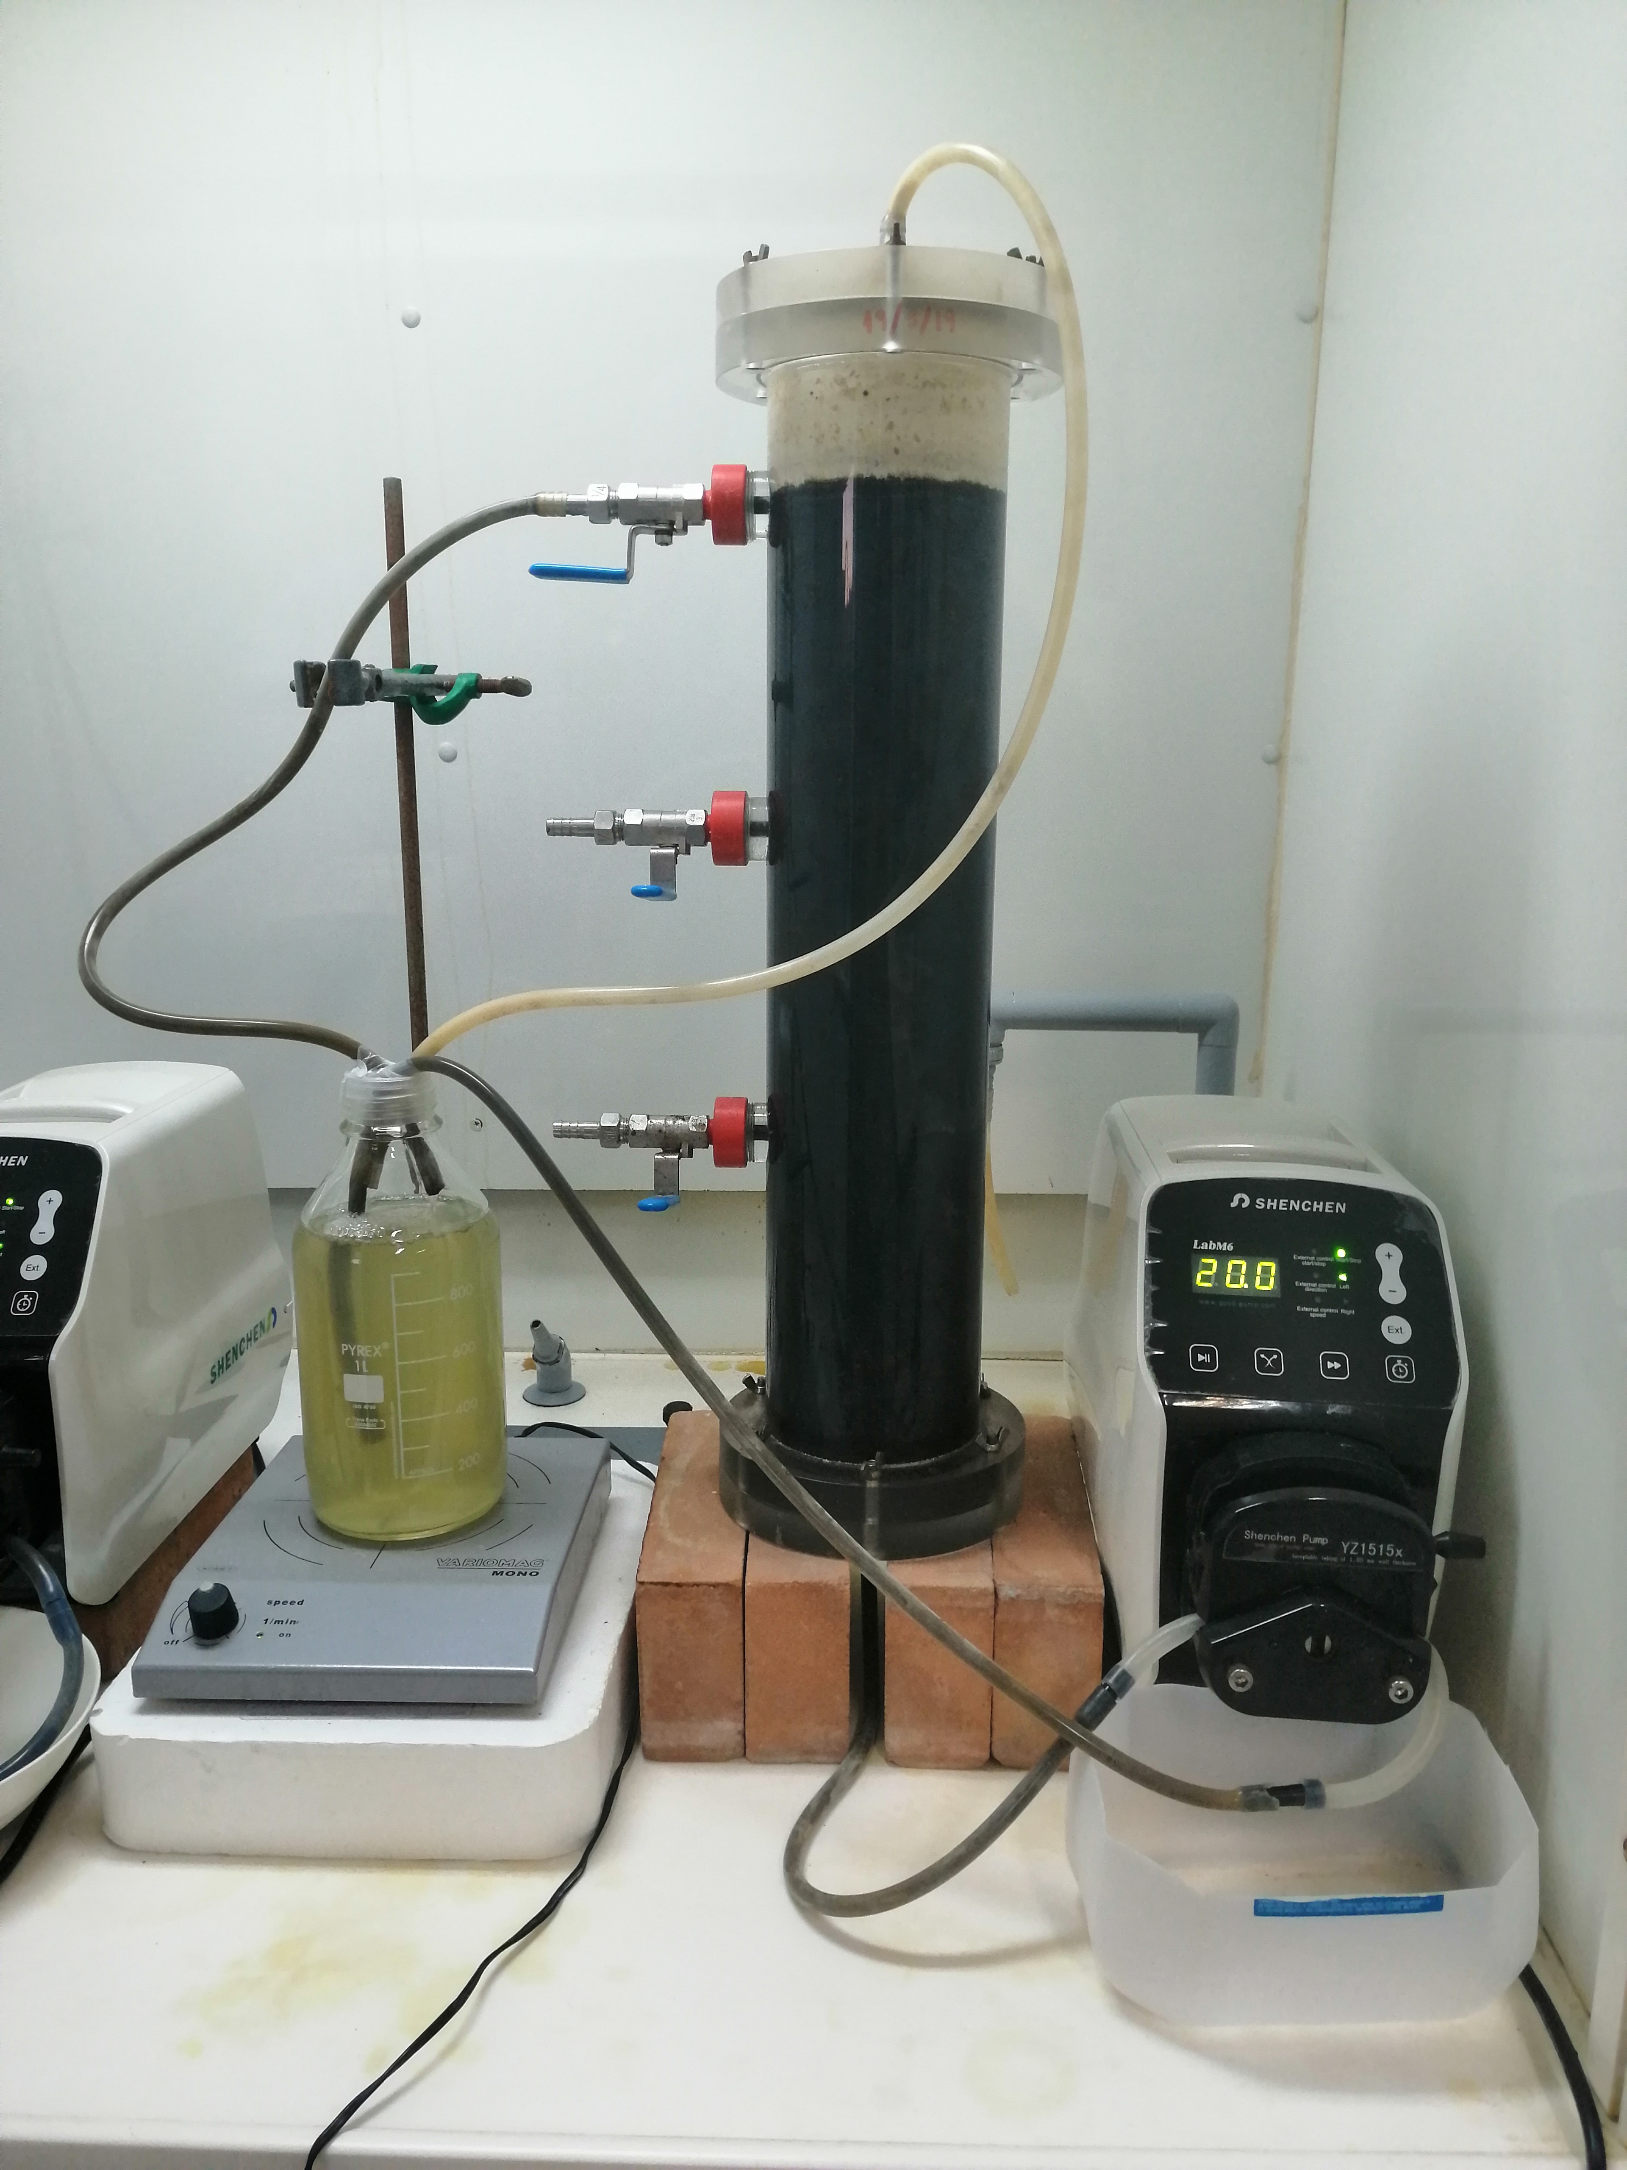

Figure S1. Picture of the pilot scale biofilm reactor as described in the paper.

S2. Mixture of Zn, Cu, Fe and Ni

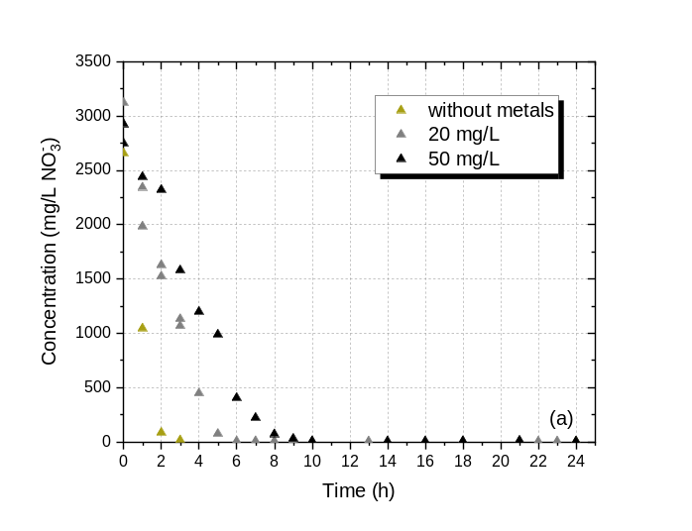 | 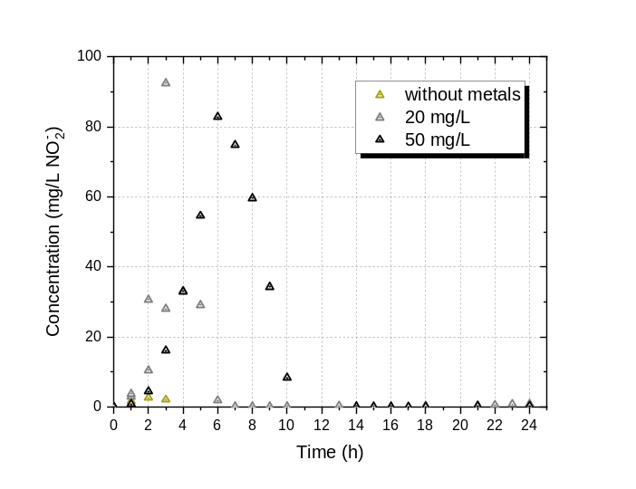
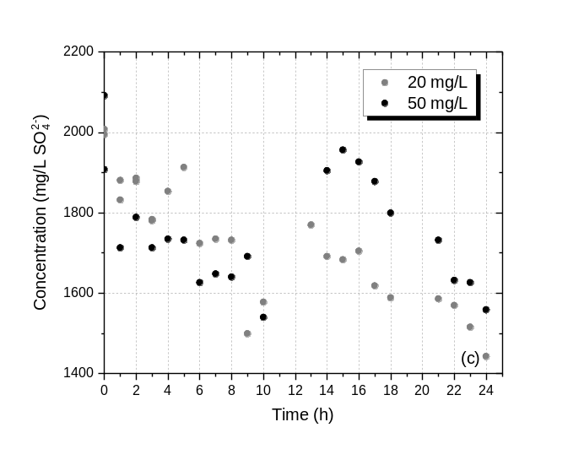 | 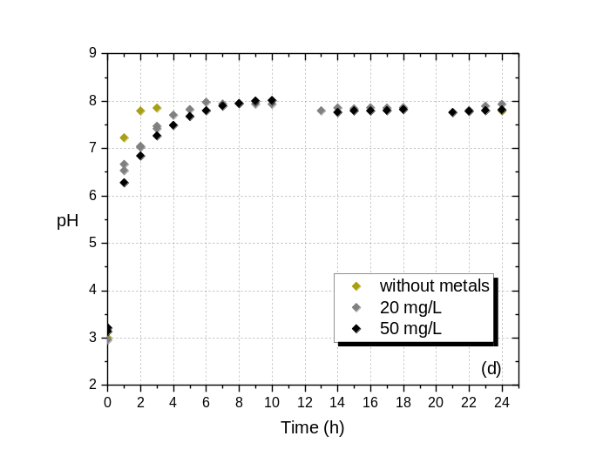
Figure S2.1. Profiles of: (a) nitrate, (b) nitrite, (c) sulfate , and (d) pH, during denitrification for metal concentrations 20 mg/L and 50 mg/L from each of Zn, Cu, Fe and Ni (initial nitrate concentration: 2750 - 3250 mg/L, initial pH 3, salinity 5% w/v).

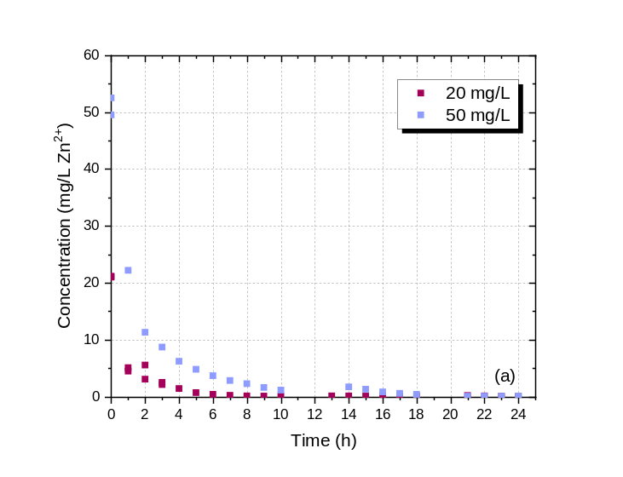 | 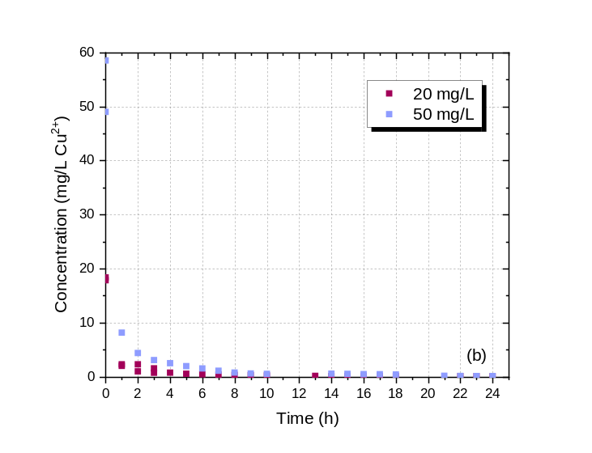
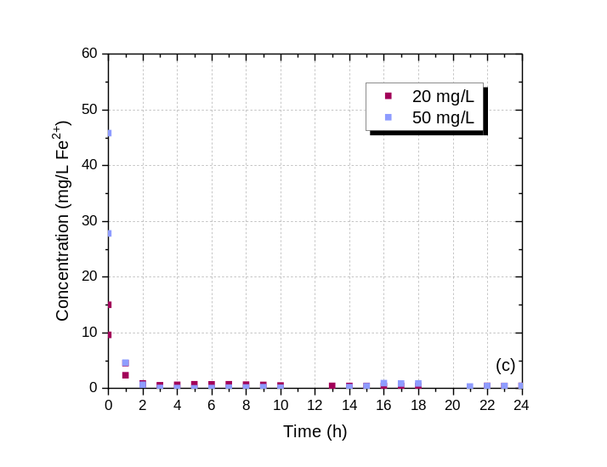 | 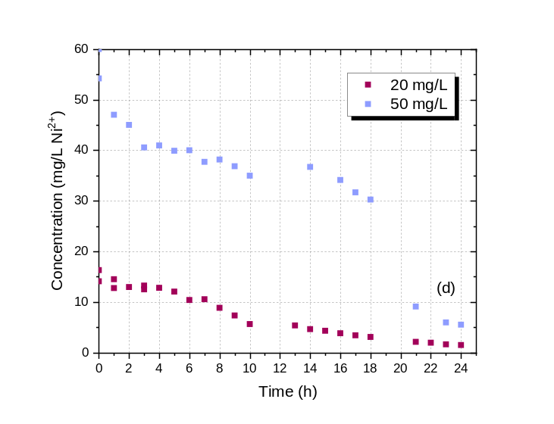
Figure S2.2. Concentration of soluble (a) zinc, (b) copper, (c) iron, and (d) nickel, during denitrification for metal concentrations 20 mg/L and 50 mg/L from each of Zn, Cu, Fe and Ni (influent nitrate concentration: 2750 - 3250 mg/L, influent pH 3, salinity 5% w/v).

S3. SEM images and the corresponding EDS spectra of metal precipitates.

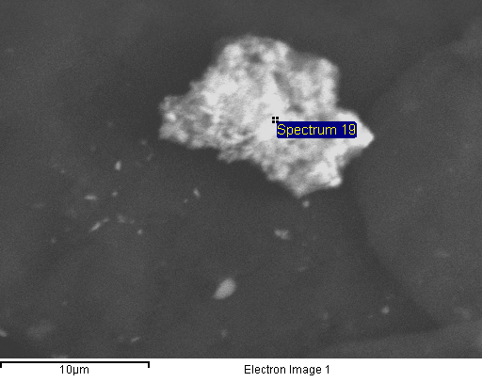 |  | 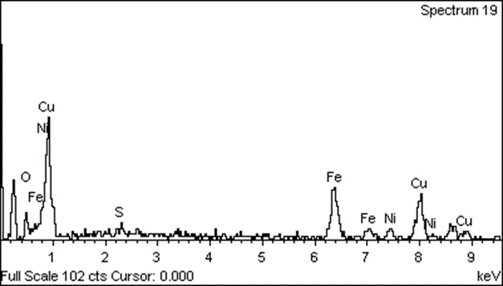
(a)
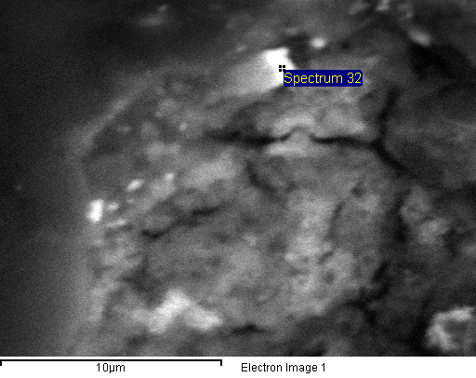 |  | 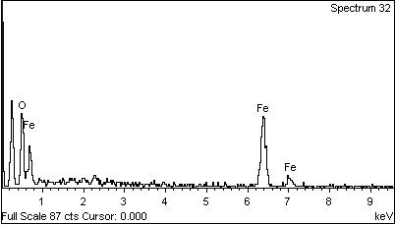
(b)
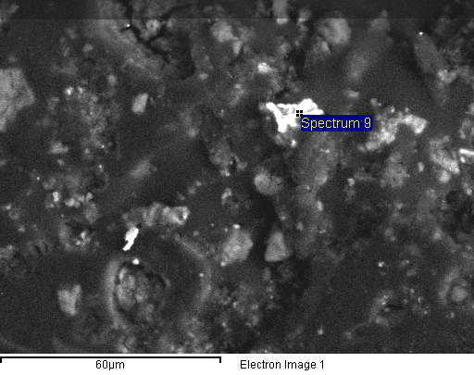 |  | 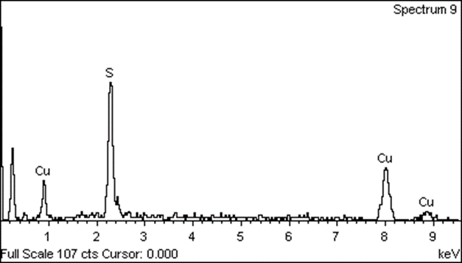
(c)

Figure S3. SEM images (left) and the corresponding EDS spectra (right) at selected spots of the metal precipitates identifying: (a) mix metal oxides (hydroxides) (b) iron oxides (hydroxides) and (c) copper sulfides.

S4. Solubility curves of Ni

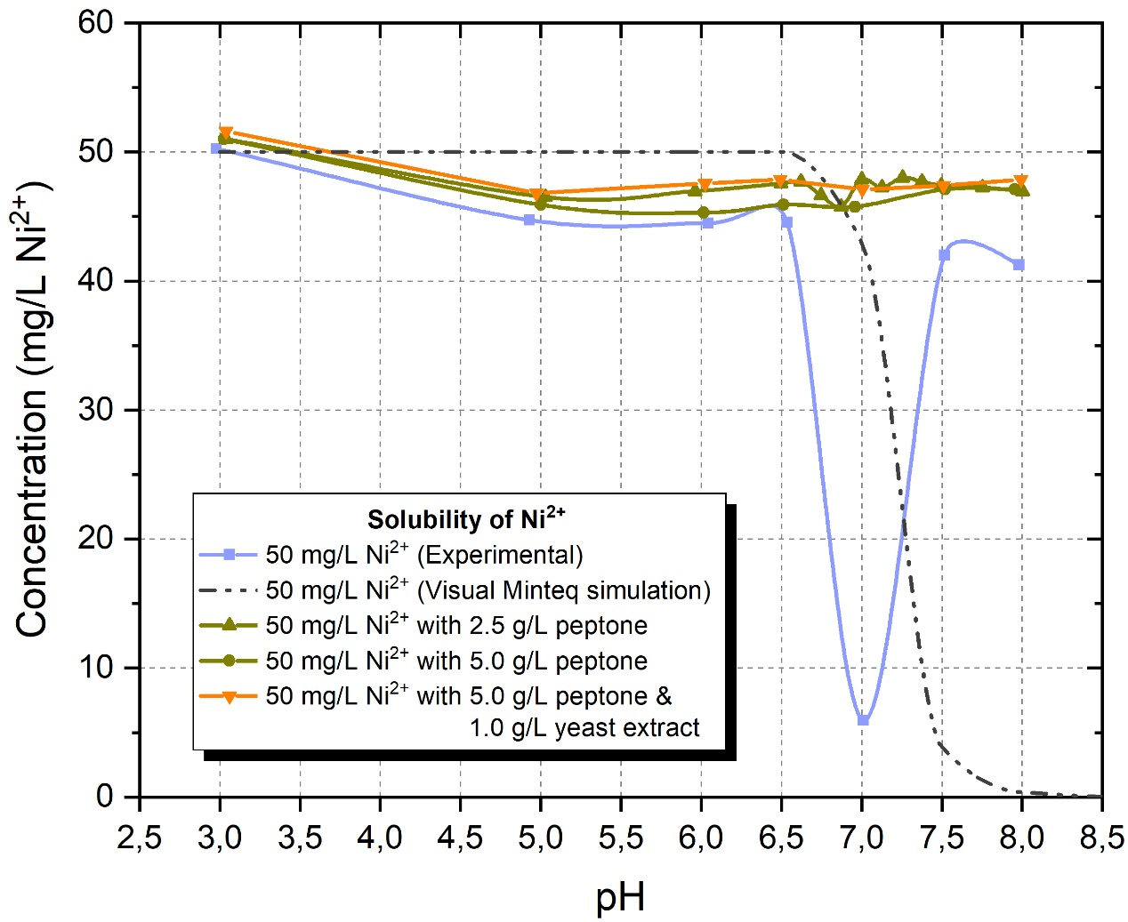
Figure S4. Solubility curves of Ni vs. pH with and without the presence of organic nutrients.
Nickel remains almost completely soluble up to pH 6.5 while its solubility is abruptly reduced at pH 7. However, by further increasing the pH of the solution above 7.5 the formation of charged nickel poly hydroxyl species increases Ni solubility. Comparing the experimentally determined and theoretically simulated Ni solubility curves a displacement of about 0.5 pH units is observed. This difference can be predominantly attributed to the slow creeping hydrolysis reactions that take place in the solutions that cannot be modeled by the software and to the laboratory test conditions that are not strictly standard (i.e., temperature different than 25°C and non-controlled ionic strength of the solutions).

