Supporting Information

Table S1: State of the art of OECTs fabricated by electrodeposition
Material | Polymerization mode | Configuration | Transconductance | References
Polypyrrole | Potentiostatic | planer | - | ¹
Polyaniline | Potentiostatic | planar | - | ²
P3MT^{a)} | Potentiodynamic | planar | - | ^{3,4}
PETE-S^{b)} | Potentiostatic deposition | planar | 5.2 mS | ⁵⁻⁷
P(EDOT-ran-EDOTOH):ClO₄ | Potentiostatic deposition | planar | 2.36 mS | ⁸
PEDOT with azide (-N₃) or ethynyl (-E):PF₆/ClO₄ | Potentiodynamic | planar | 2~55 mS | ⁹⁻¹¹
PEDOT:PF₆ | AC | planar | - | ¹²
PEDOT:PSS | AC bipolar | planar | ≤ 2.5 μS | ^{13,14}
PEDOT:PSS | AC bipolar | Planar array | 0.77 ± 0.01 mS | ¹⁵
PEDOT:PSS | Potentiostatic | planar | ≤ 1 mS | ¹⁶
Poly (EDOT-COOH-co-EDOT-PC)/PEDOT:PSS | Potentiodynamic | planar | 4 mS | ¹⁷
PEDOT:PF₆ | Galvanostatic | vertical | 68 mS | ¹⁸
PEDOT:ClO₄,  PEDOT:pTS  PEDOT:PSS | Galvanostatic | planar | 27~46 mS | ¹⁹
Note: ^{a)} Poly(3-methylthiophene)
^{b)} Poly[4-(2-(2,5-bis(2,3-dihydrothieno[3,4-b][1,4]dioxin-5-yl) thiophen-3-yl)ethoxy)butane-1-sulfonate]

Table S2. Composition of the electrolyte solutions used for electrodeposition.
PEDOT film | Dopant | Dopant concentration (mM) | Solvent
PEDOT:ClO₄ | LiClO₄ | 100, 5 and 1 | acetonitrile
PEDOT:BF₄ | LiBF₄ | 100 and 5 | acetonitrile
PEDOT:BF₄ | TEABF₄ | 100 and 5 | acetonitrile
PEDOT:PSS | NaPSS | 100 | acetonitrile/water (4/1 vol)

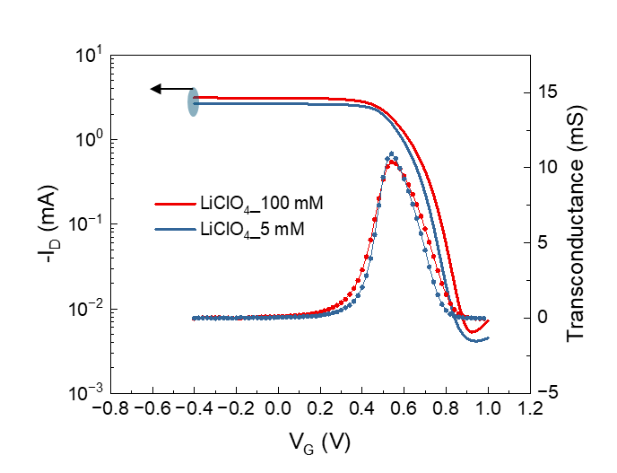
Figure S1. Transfer characteristics of PEDOT:ClO₄ OECTs deposited under different dopant concentrations of 100mM and 5 mM.
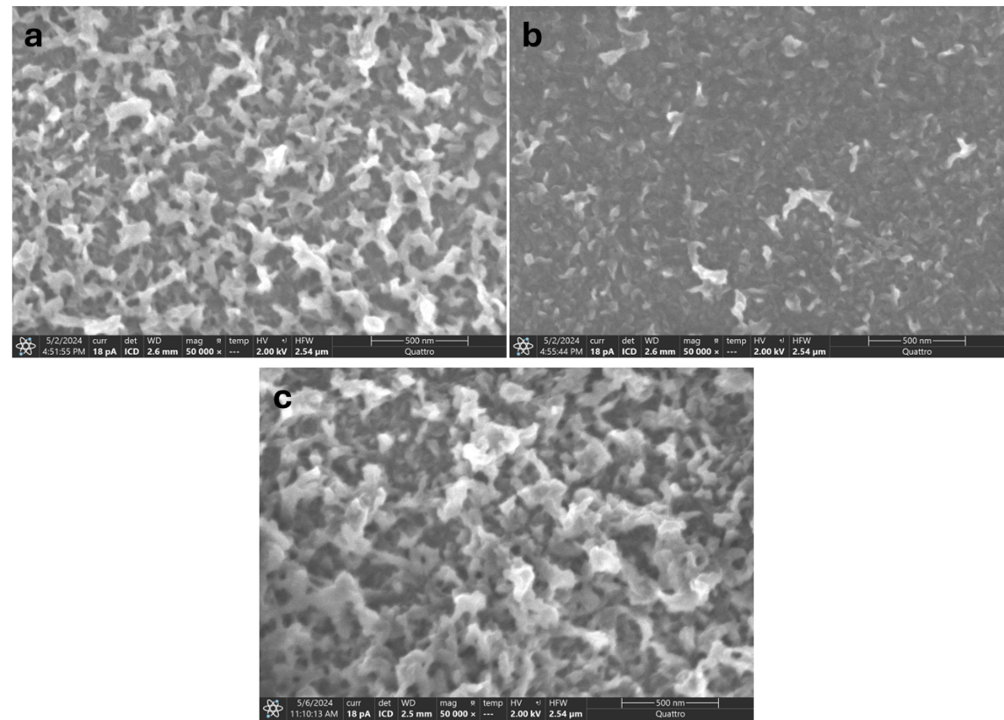
Figure S2. SEM images of PEDOT:ClO₄ films electropolymerized at charge densities of 30 mC/cm² a on gold electrode and b in channel area; c electropolymerized at charge densities of 60 mC/cm².
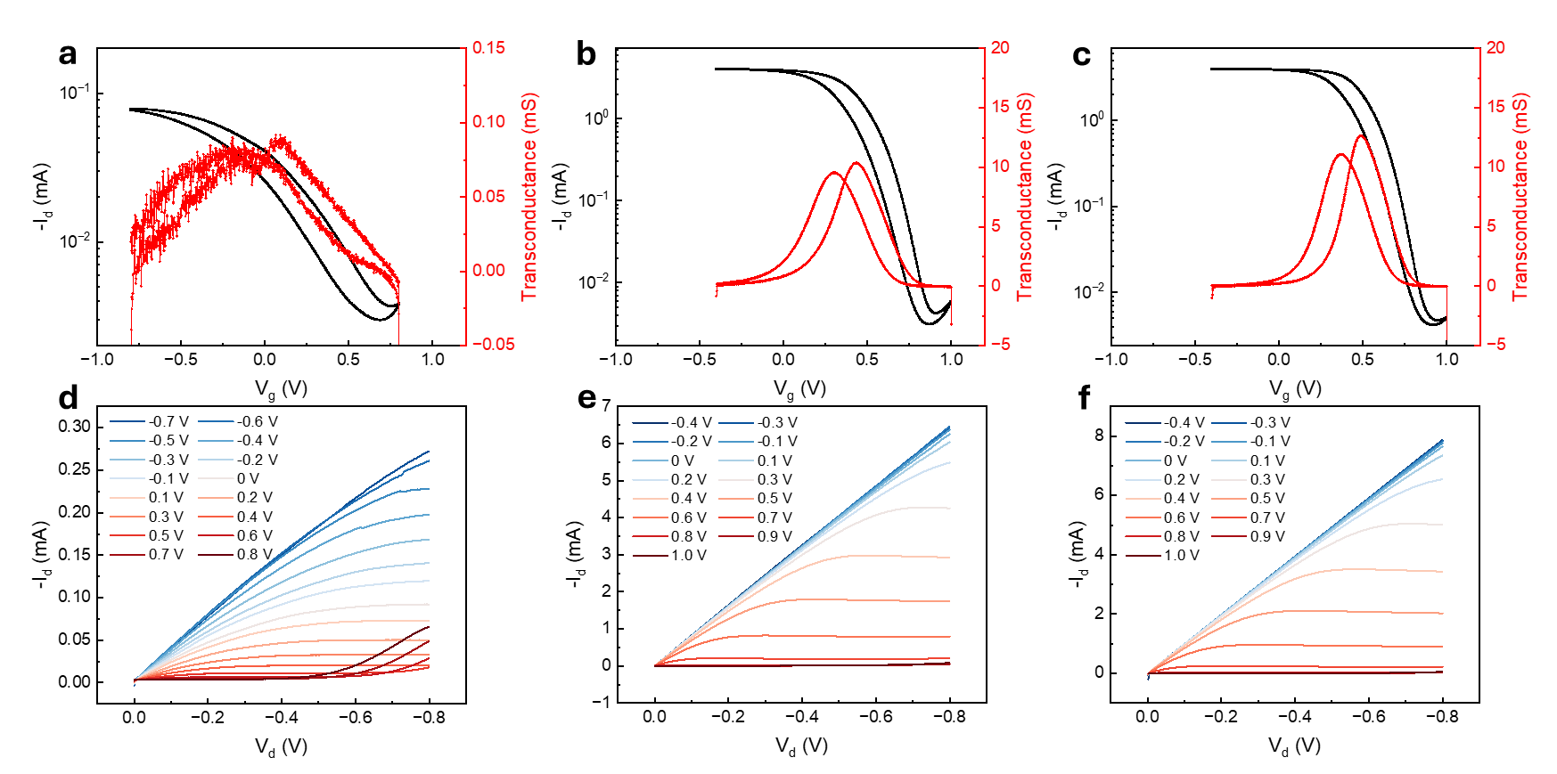
Figure S3. Transfer (I_{D}-V_{G}) characteristics and output (I_{D}-V_{D}) characteristics for electropolymerized PEDOT:ClO₄ OECTs under the deposition of charge density: a, d 15 mC/cm²; b, e 30 mC/cm²; c, f 60 mC/cm².

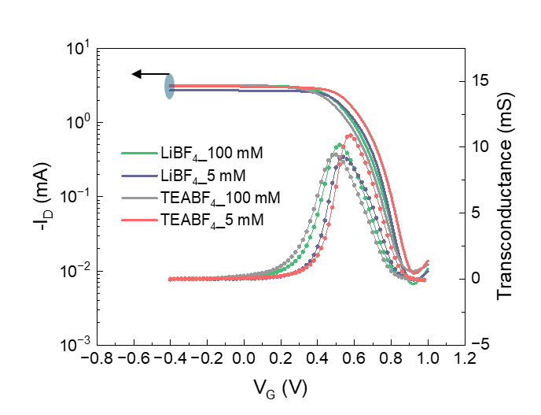
Figure S4. Transfer characteristics (I_{D}-V_{G}) of PEDOT:BF₄-based OECTs deposited using LiBF₄ and TEABF₄ as dopants under different dopant concentrations of 100mM and 5 mM.

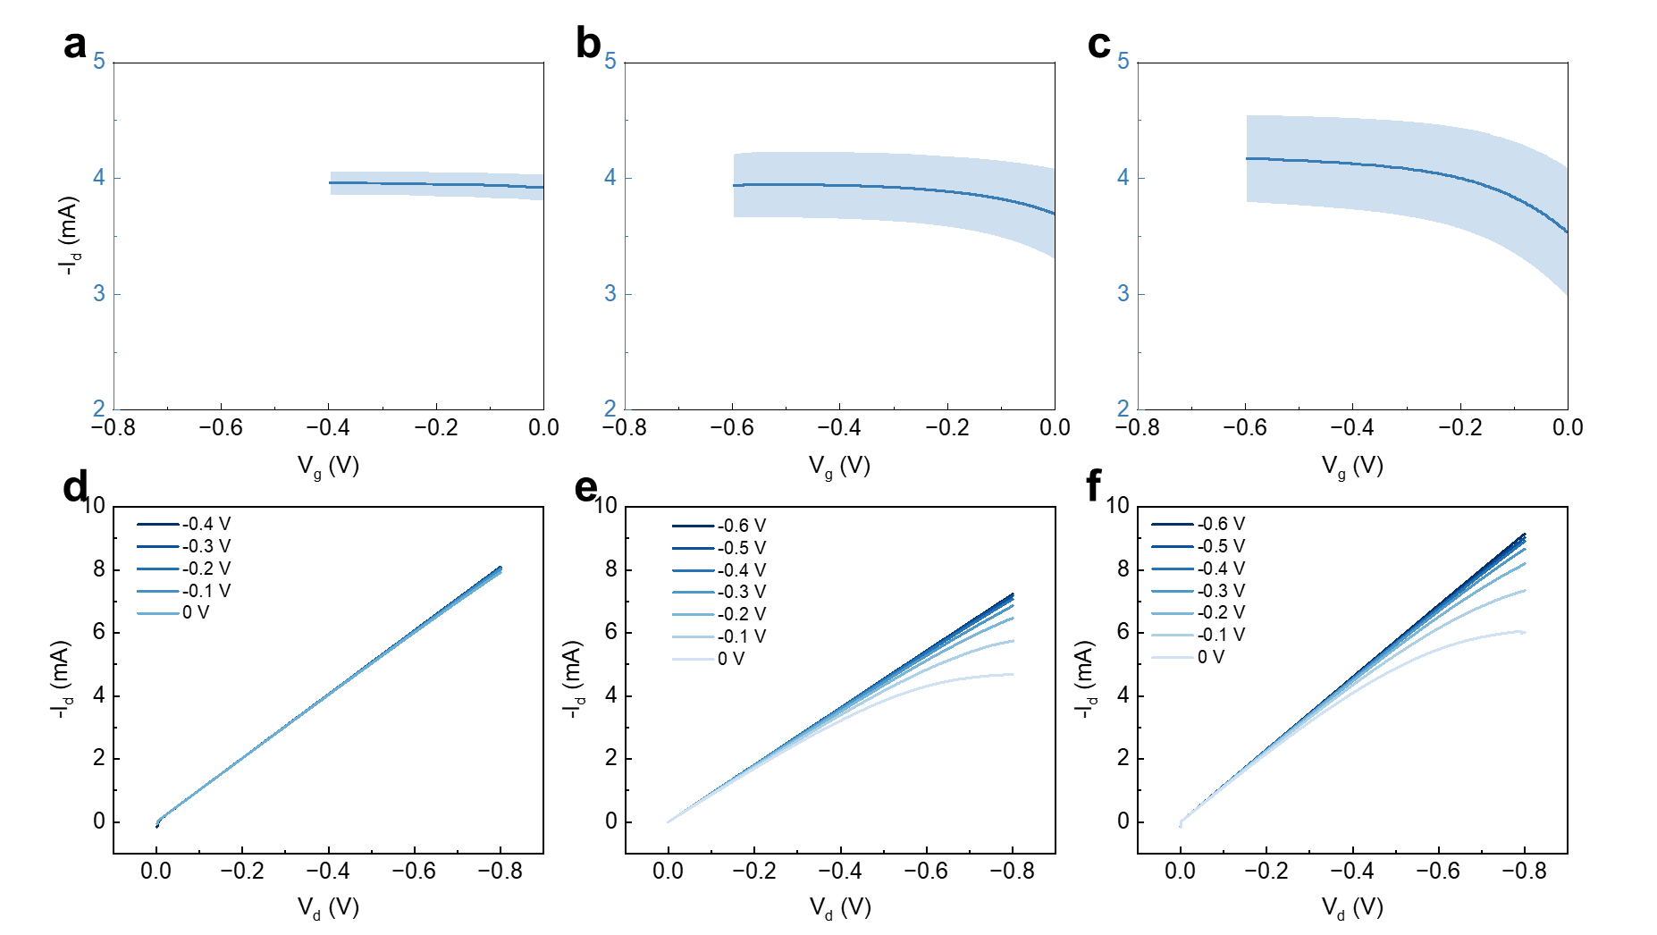
Figure S5. Transfer (I_{D}-V_{G}) characteristics and output (I_{D}-V_{D}) characteristics plotted within a V_{G} range below 0 V for OECTs based on: a, d electropolymerized PEDOT:ClO₄ with deposition charge density of 60 mC/cm²; b, e electropolymerized PEDOT:PSS with deposition charge density of 300 mC/cm²; c, f ink-jet printed PEDOT:PSS.
Figure S6. Spectroelectrochemical measurements of PEDOT:ClO₄ films electrodeposited from a 5mM dopant solution. Real time spectra during the a dedoping and b redoping processes between +0.4 V to -1.0 V presented with 0.1 V increments. c top layer: voltage sweep, lower layer: temporal behaviour of three wavelengths chosen as representative of neutral chains (621 nm), polarons (801 nm), and polarons + bipolarons (1000 nm).
Figure S7. Cyclic voltammetry curve for PEDOT:PSS under degassing condition.

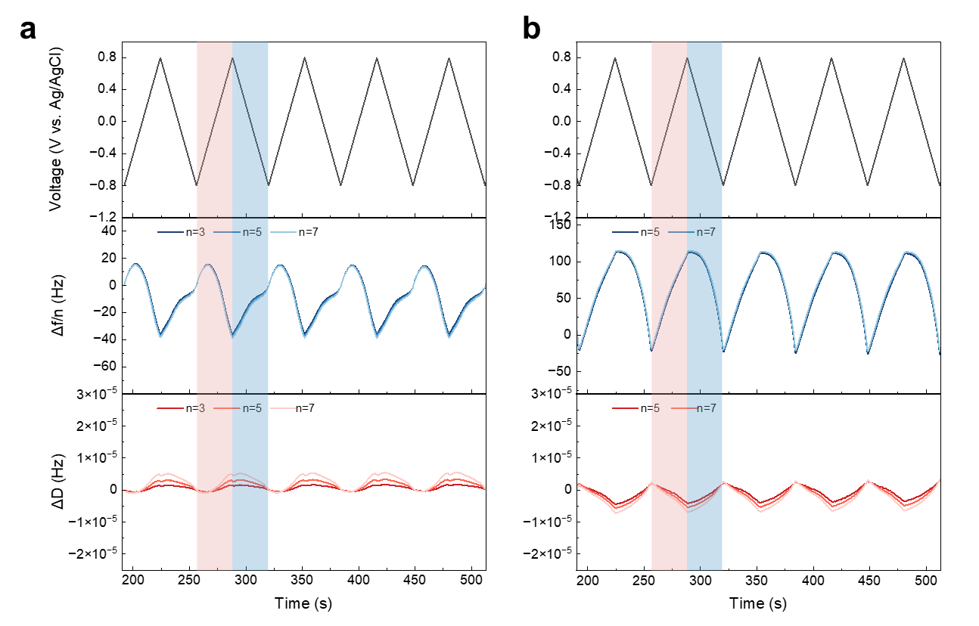
Figure S8. EQCM-D measurements for PEDOT:ClO₄ and PEDOT:PSS films. Frequency (Δf/n) and Dissipation (ΔD) responses of the third, fifth and seventh overtones under cycled linear potential sweep for a 30 s coated PEDOT:ClO₄ and b 30 s coated PEDOT:PSS. The potential is applied between -0.8 V to 0.8 V at a scan rate of 50 mV/s.
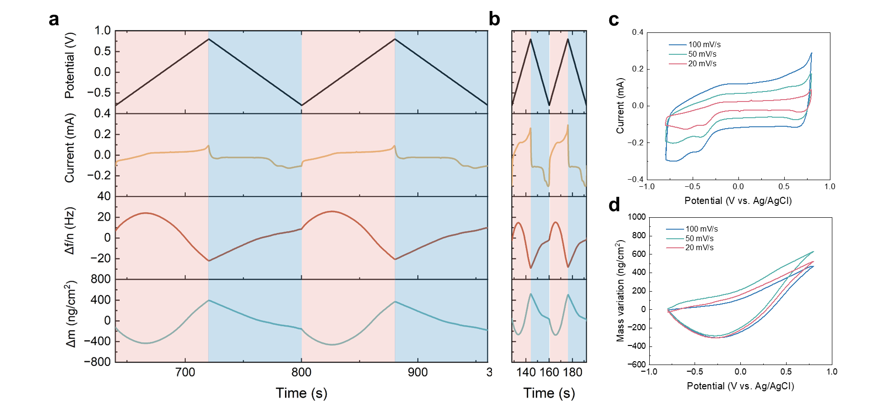
Figure S9. EQCM-D results for 30 s coated PEDOT:ClO₄ film at different scan rates. Current (I), Frequency (Δf/n) response and calculated mass shift (Δm) of the third overtone under cycled linear potential sweep at the scan rate of a 20 mV/s and b 100 mV/s. c CV curves and d mass variation vs. voltage at different scan rates.
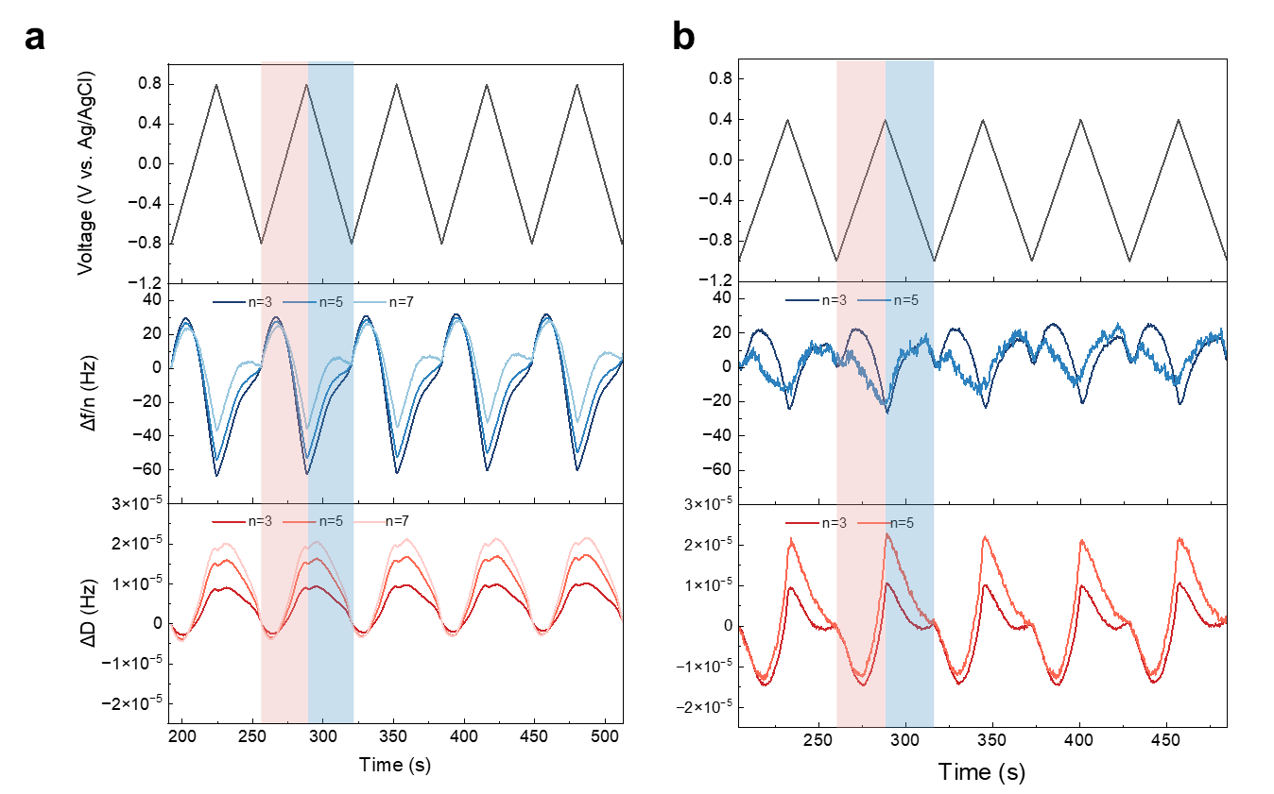
Figure S10. EQCM-D measurements for PEDOT:ClO₄ films. Frequency (Δf/n) and Dissipation (ΔD) responses of the third, fifth and seventh overtones under cycled linear potential sweep for a 60 s coated PEDOT:ClO₄ and b 120 s coated PEDOT:ClO₄. The potential is applied between -0.8 V to 0.8 V at a scan rate of 50 mV/s.

References:

1 White, H. S., Kittlesen, G. P. & Wrighton, M. S. Chemical derivatization of an array of three gold microelectrodes with polypyrrole: fabrication of a molecule-based transistor. Journal of the American Chemical Society 106, 5375-5377 (1984).
2 Paul, E. W., Ricco, A. J. & Wrighton, M. S. Resistance of polyaniline films as a function of electrochemical potential and the fabrication of polyaniline-based microelectronic devices. The Journal of Physical Chemistry 89, 1441-1447 (1985).
3 Thackeray, J. W., White, H. S. & Wrighton, M. S. Poly (3-methylthiophene)-coated electrodes: optical and electrical properties as a function of redox potential and amplification of electrical and chemical signals using poly (3-methylthiophene)-based microelectrochemical transistors. The Journal of Physical Chemistry 89, 5133-5140 (1985).
4 Thackeray, J. W. & Wrighton, M. S. Chemically responsive microelectrochemical devices based on platinized poly (3-methylthiophene): variation in conductivity with variation in hydrogen, oxygen, or pH in aqueous solution. The Journal of Physical Chemistry 90, 6674-6679 (1986).
5 Gerasimov, J. Y. et al. An Evolvable Organic Electrochemical Transistor for Neuromorphic Applications. Advanced Science 6, 1801339 (2019). https://doi.org:10.1002/advs.201801339
6 Gerasimov, J. Y. et al. A Biomimetic Evolvable Organic Electrochemical Transistor. Advanced Electronic Materials 7 (2021). https://doi.org:10.1002/aelm.202001126
7 Harikesh, P. C. et al. Organic electrochemical neurons and synapses with ion mediated spiking. Nature Communications 13, 901 (2022). https://doi.org:10.1038/s41467-022-28483-6
8 Wustoni, S. et al. In Situ Electrochemical Synthesis of a Conducting Polymer Composite for Multimetabolite Sensing. Advanced Materials Technologies 5 (2019). https://doi.org:10.1002/admt.201900943
9 Fenoy, G. E. et al. "Clickable" Organic Electrochemical Transistors. Journal of the American Chemical Society 2, 2778-2790 (2022). https://doi.org:10.1021/jacsau.2c00515
10 Fenoy, G. E. et al. Interface Engineering of "Clickable" Organic Electrochemical Transistors toward Biosensing Devices. ACS Applied Materials & Interfaces 15, 10885-10896 (2023). https://doi.org:10.1021/acsami.2c21493
11 Fenoy, G. E. et al. A Poly(3,4-ethylenedioxythiophene) Derivative Incorporating Ethynyl Moieties for Click Chemistry-Based Bioelectronics. Chemistry of Materials 36, 7207-7221 (2024). https://doi.org:10.1021/acs.chemmater.4c00989
12 Cucchi, M. et al. Directed Growth of Dendritic Polymer Networks for Organic Electrochemical Transistors and Artificial Synapses. Advanced Electronic Materials 7 (2021). https://doi.org:10.1002/aelm.202100586
13 Janzakova, K. et al. Dendritic Organic Electrochemical Transistors Grown by Electropolymerization for 3D Neuromorphic Engineering. Advanced Science 8, e2102973 (2021). https://doi.org:10.1002/advs.202102973
14 Janzakova, K. et al. Analog programing of conducting-polymer dendritic interconnections and control of their morphology. Nature Communications 12, 6898 (2021). https://doi.org:10.1038/s41467-021-27274-9
15 Ji, J. et al. Bipolar electrodeposition of organic electrochemical transistor arrays. Journal of Materials Chemistry C 8, 11499-11507 (2020). https://doi.org:10.1039/d0tc00436g
16 Ghazal, M. et al. Bio‐Inspired Adaptive Sensing through Electropolymerization of Organic Electrochemical Transistors. Advanced Electronic Materials 8 (2021). https://doi.org:10.1002/aelm.202100891
17 Zhang, S. et al. Intrinsically Antifouling, soft and conformal bioelectronic from scalable fabrication of Thin-Film OECT arrays by zwitterionic polymers. Chemical Engineering Journal 483 (2024). https://doi.org:10.1016/j.cej.2024.148980
18 Brodsky, J. et al. Downsizing the Channel Length of Vertical Organic Electrochemical Transistors. ACS Applied Materials & Interfaces 15, 27002-27009 (2023). https://doi.org:10.1021/acsami.3c02049
19 Lee, J. et al. Electrochemical Fabrication and Characterization of Organic Electrochemical Transistors Using poly(3,4-ethylenedioxythiophene) with Various Counterions. ACS Applied Materials & Interfaces 14, 42289-42297 (2022). https://doi.org:10.1021/acsami.2c10149

