Supplementary Figures
Supplementary Figure 1. Characterization of LAM-EV & Normal-EV. (A) Relative percentage of particles in various size classes based upon the intensity of scattered light size distribution by DLS (LAM-EV n=6, Normal-EV n=4). (B). EV Surface CD9 by FACS. Each Peak is normalized to its mode (n=2).
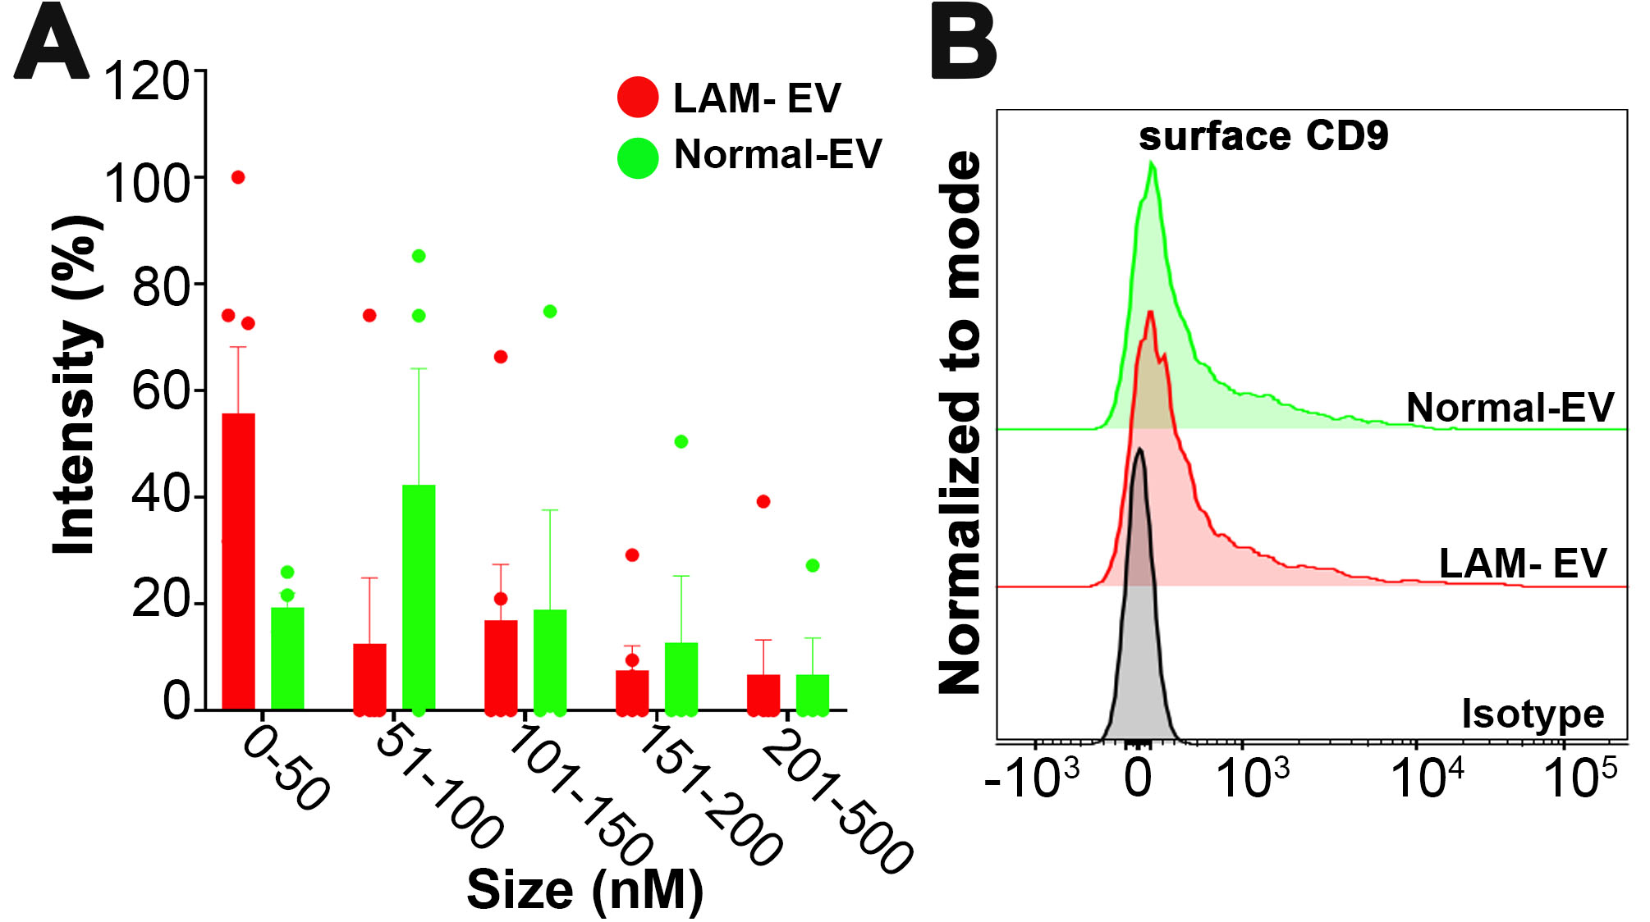

Supplementary Figure 2. Loss of TSC1/2 alters biochemical and physical characteristics of EV. (A) Representative immunoblot of TSC2 expression in TSC-null and TSC2 addback cell (n=16). (B) NTA analysis of EV derived from TSC-null and TSC2 addback cells (n=2). (B-i) particle concentration. (B-ii) size distribution. (C) Relative percentage of particles in various size classes based upon the intensity of scattered light size distribution by DLS (n=2). (D) EV surface expression of CD63 and CD9 by FACS. Each Peak is normalized to its mode (CD63 n=2, CD9 n=1). (E) Morphology of EV by transmission electron microscopy (TEM) (n=1).
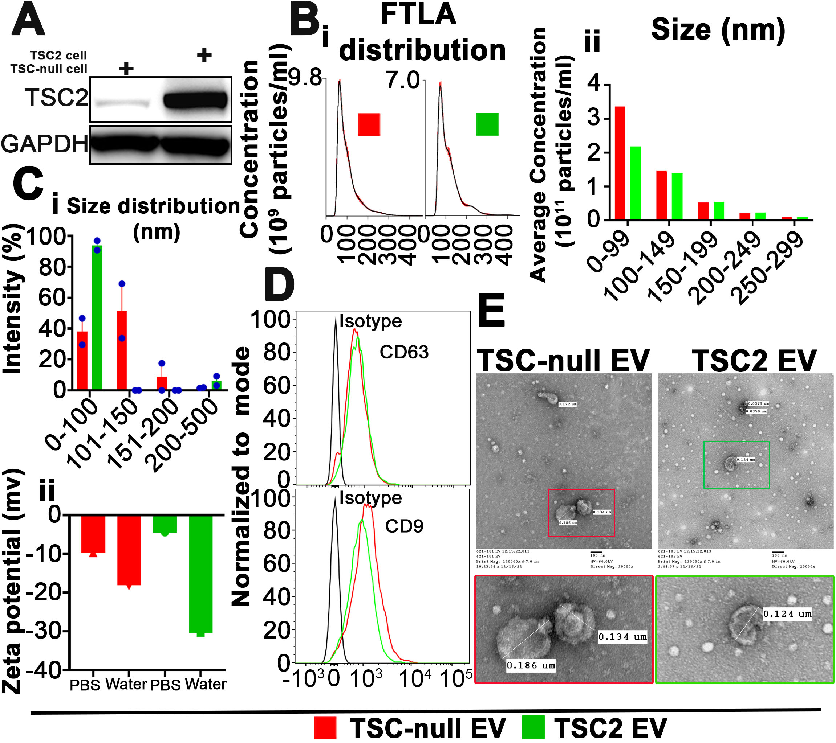

Supplementary Figure 3. The blockade of TSC-null EV biogenesis inhibit 621-101 sphere size and sphere cell migration. (A-C) 621-101 spheres were treated with vehicle or inhibitor of EV biogenesis, Tipifarnib (0.1 µM). (A) Isolated EV were quantified by FACS. Histogram shows decrease in surface EV CD63 and CD9 fluorescence upon Tipifarnib treatment (n=2). (B) Primary 621-101 spheres treated with vehicle or Tipifarnib (n=3). (B-i) Representative bright field images and (B-ii) quantification of sphere sizes (Two-tailed unpaired t-test, t=6.122, df=16). (C) Migration of 621-101 spheres treated with vehicle or Tipifarnib (n=3). (C-i) Representative bright field images and (C-ii) quantification of migrated sphere cell distance (Two-tailed unpaired t-test, t=13.34, df=203). (D) Phospho-c-Src and phospho-FAK immunoblot of 621-101 spheres treated with vehicle or c-Src inhibitor (Bosutinib,1 µM) (n=2). (E) Migration of 621-101 spheres treated with vehicle or c-Src inhibitor (Bosutinib, 1 µM) in the presence or absence of TSC-null EV. (E-i) Representative bright field images and (E-ii) quantification of migrated sphere cells distance (n=3) (one-way ANOVA, F=235, df=2). Data represent as Mean ± SEM. ****P < 0.0001.
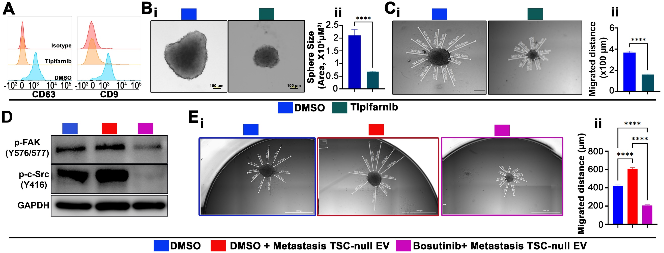

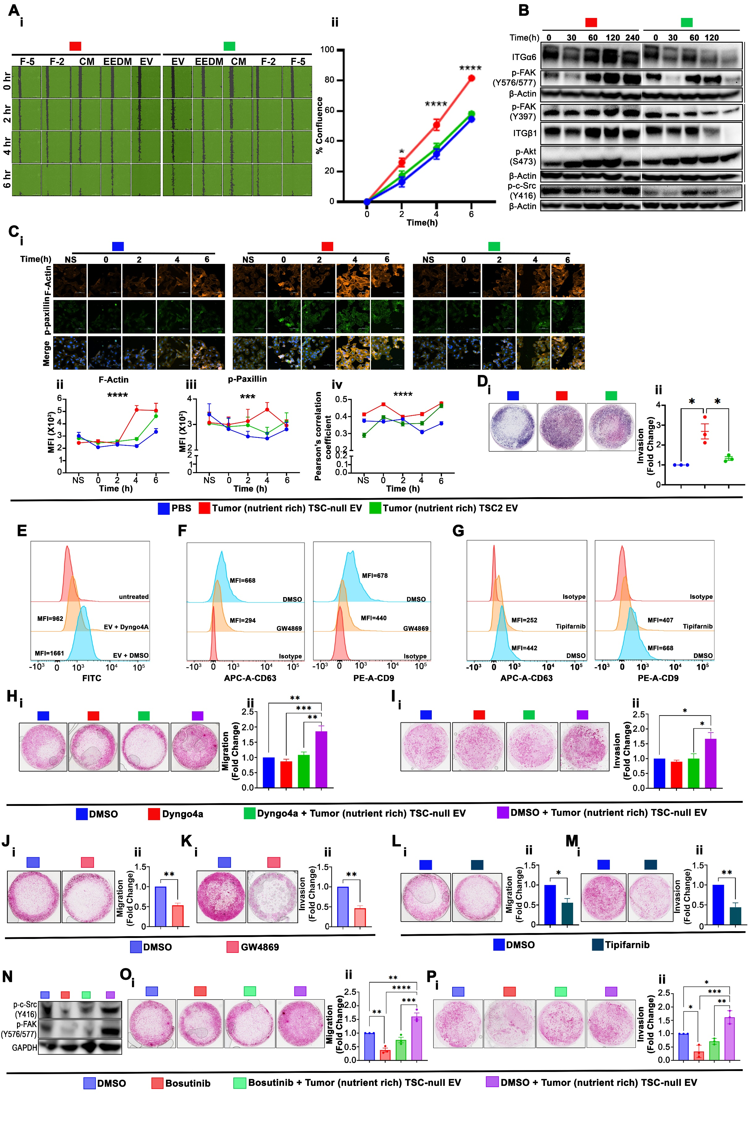
Supplementary Figure 4. Tumor TSC-null EV enhance migration and invasion of adherent TSC-null cells. (A) 621-101 cells were exposed to EV or JEV controls and when approximately 95% confluent scratched. (A-i) Representative mark-up images of migrated cells. (A-ii) Quantification of wound closure at indicated timepoint with respect to the wound area at time 0 (n=4) (Two-way ANOVA, F=9.733, df=8). (B) Expression of ITG-α6/β1, phospho-FAK, phospho-c-Src, and phospho-Akt in migrated 621-101 cells exposed to tumor TSC-null EV or TSC2 EV by immunoblot (n=3). β-actin was used as a loading control. (C) Immunofluorescence of (C-i) F-Actin and p-paxillin in migrated 621-101 cells exposed to tumor TSC-null EV or TSC2 EV. (C-ii) quantification of F-Actin (Two-way ANOVA, F=10.96, df=8). and (C-iii) phospho-paxillin (Two-way ANOVA, F=4.079, df=8), (C-iv) co-localization of F-Actin and phospho-paxillin (n=3) (Two-way ANOVA, F=26.78, df=8). (D) Transwell invasion assay of adherent 621-101 cells exposed to tumor TSC-null EV or TSC2 EV (n=3) (One-way ANOVA, F=14, df=2, P= 0.0157). (D-i) Representative images and (D-ii) quantification of D-i as a fold change in number of cells relative to PBS. (E) 621-101 cells were treated with vehicle or EV uptake inhibitor, Dyngo4a, prior exposure to labelled TSC-null EV. The EV uptake was measured by FACS. Each Peak is normalized to its mode. (F-G) 621-101 cells were treated with vehicle or inhibitor of EV biogenesis, (F) GW4869 or (G) Tipifarnib, and isolated EV were quantified by FACS. Each Peak is normalized to its mode. Histogram shows decrease in surface EV CD63 and CD9 fluorescence upon (F) GW4869 or (G) Tipifarnib treatment (n=2). (H-I) Adherent 621-101 cells treated with vehicle or inhibitor of EV uptake in the presence or absence of tumor TSC-null EV (n=3). (J-M) Adherent 621-101 cells treated with vehicle or inhibitor of EV biogenesis (n=3), or (N-P) vehicle or inhibitor of c-Src in the presence or absence of tumor TSC-null EV. (H, J, L, O,) Transwell migration assay (n=3). (H-i, J-i, L-i, O-i) Representative images and (H-ii, J-ii, L-ii, O-ii) quantification of H-i, J-i, L-i, O-i as a fold change in number of cells relative to DMSO. (H-ii) One-way ANOVA, F=16.5, df=3. (J-ii) Two-tailed unpaired t-test, t=8.019, df=4. (L-ii) Two-tailed unpaired t-test, t=4.232, df=4. (O-ii) One-way ANOVA, F=33.1, df=3. (I, K, M, P) Transwell invasion assay (n=3). (I-i, K-i, M-i, P-i) Representative images and (I-ii, K-ii, M-ii, P-ii) quantification of I-i, K-i, M-i, P-i as a fold change in number of cells relative to DMSO. (I-ii) One-way ANOVA, F=7.991, df=3. (K-ii) Two-tailed unpaired t-test, t=8.529, df=4. (M-ii) Two-tailed unpaired t-test, t=5.113, df=4. (P-ii) One-way ANOVA, F=7.991, df=3. (N) Immunoblot of phospho-c-Src and phopsho-FAK in 621-101 cells treated with Bosutinib (n=1). Bar show Mean ± SEM. Graphs plotted show Mean ± SEM. *P<0.01; **P<0.001; ***P<0.0001; ****P<0.0001.

Supplementary Figure 5. (A) The expression of hamartin and phospho-S6 in Tsc1-null or wild type E15.5 mouse embryo neuronal progenitors’ cells by immunoblot (n=3). (B) validation of qPCR rat DNA assay. Amplicons from assay were chromatograph on agarose gel containing Sybr Green Safe DNA gel stain and visualized using UV fluorescence to confirm amplicon size for each primer pair (n=3). (C-D) Characterization of EV isolated from cells described in (A) by (C) FACS indicating surface expression of CD9 (n=1) and (D) immunoblot (n=7). (E-F) Characterization of plasma EV isolated from mice injected with 621-L9 or TSC2 addback cells by (E) FACS for surface expression of CD63 and CD9 (n=2), and (F) immunoblot (n=2). (G) Lung MMP activity using IVISSense MMP 750 FAST fluorescent probe from mice treated with tumor EV i.v. injection 24 hours prior to probe injection. (G-i) Representative fluorescent images at 6, 24, and 48 hours post-MMP probe injection, and (G-ii) quantification of fluorescence photon flux in the chest region (TSC-null EV n= 4, TSC2 EV n=4).
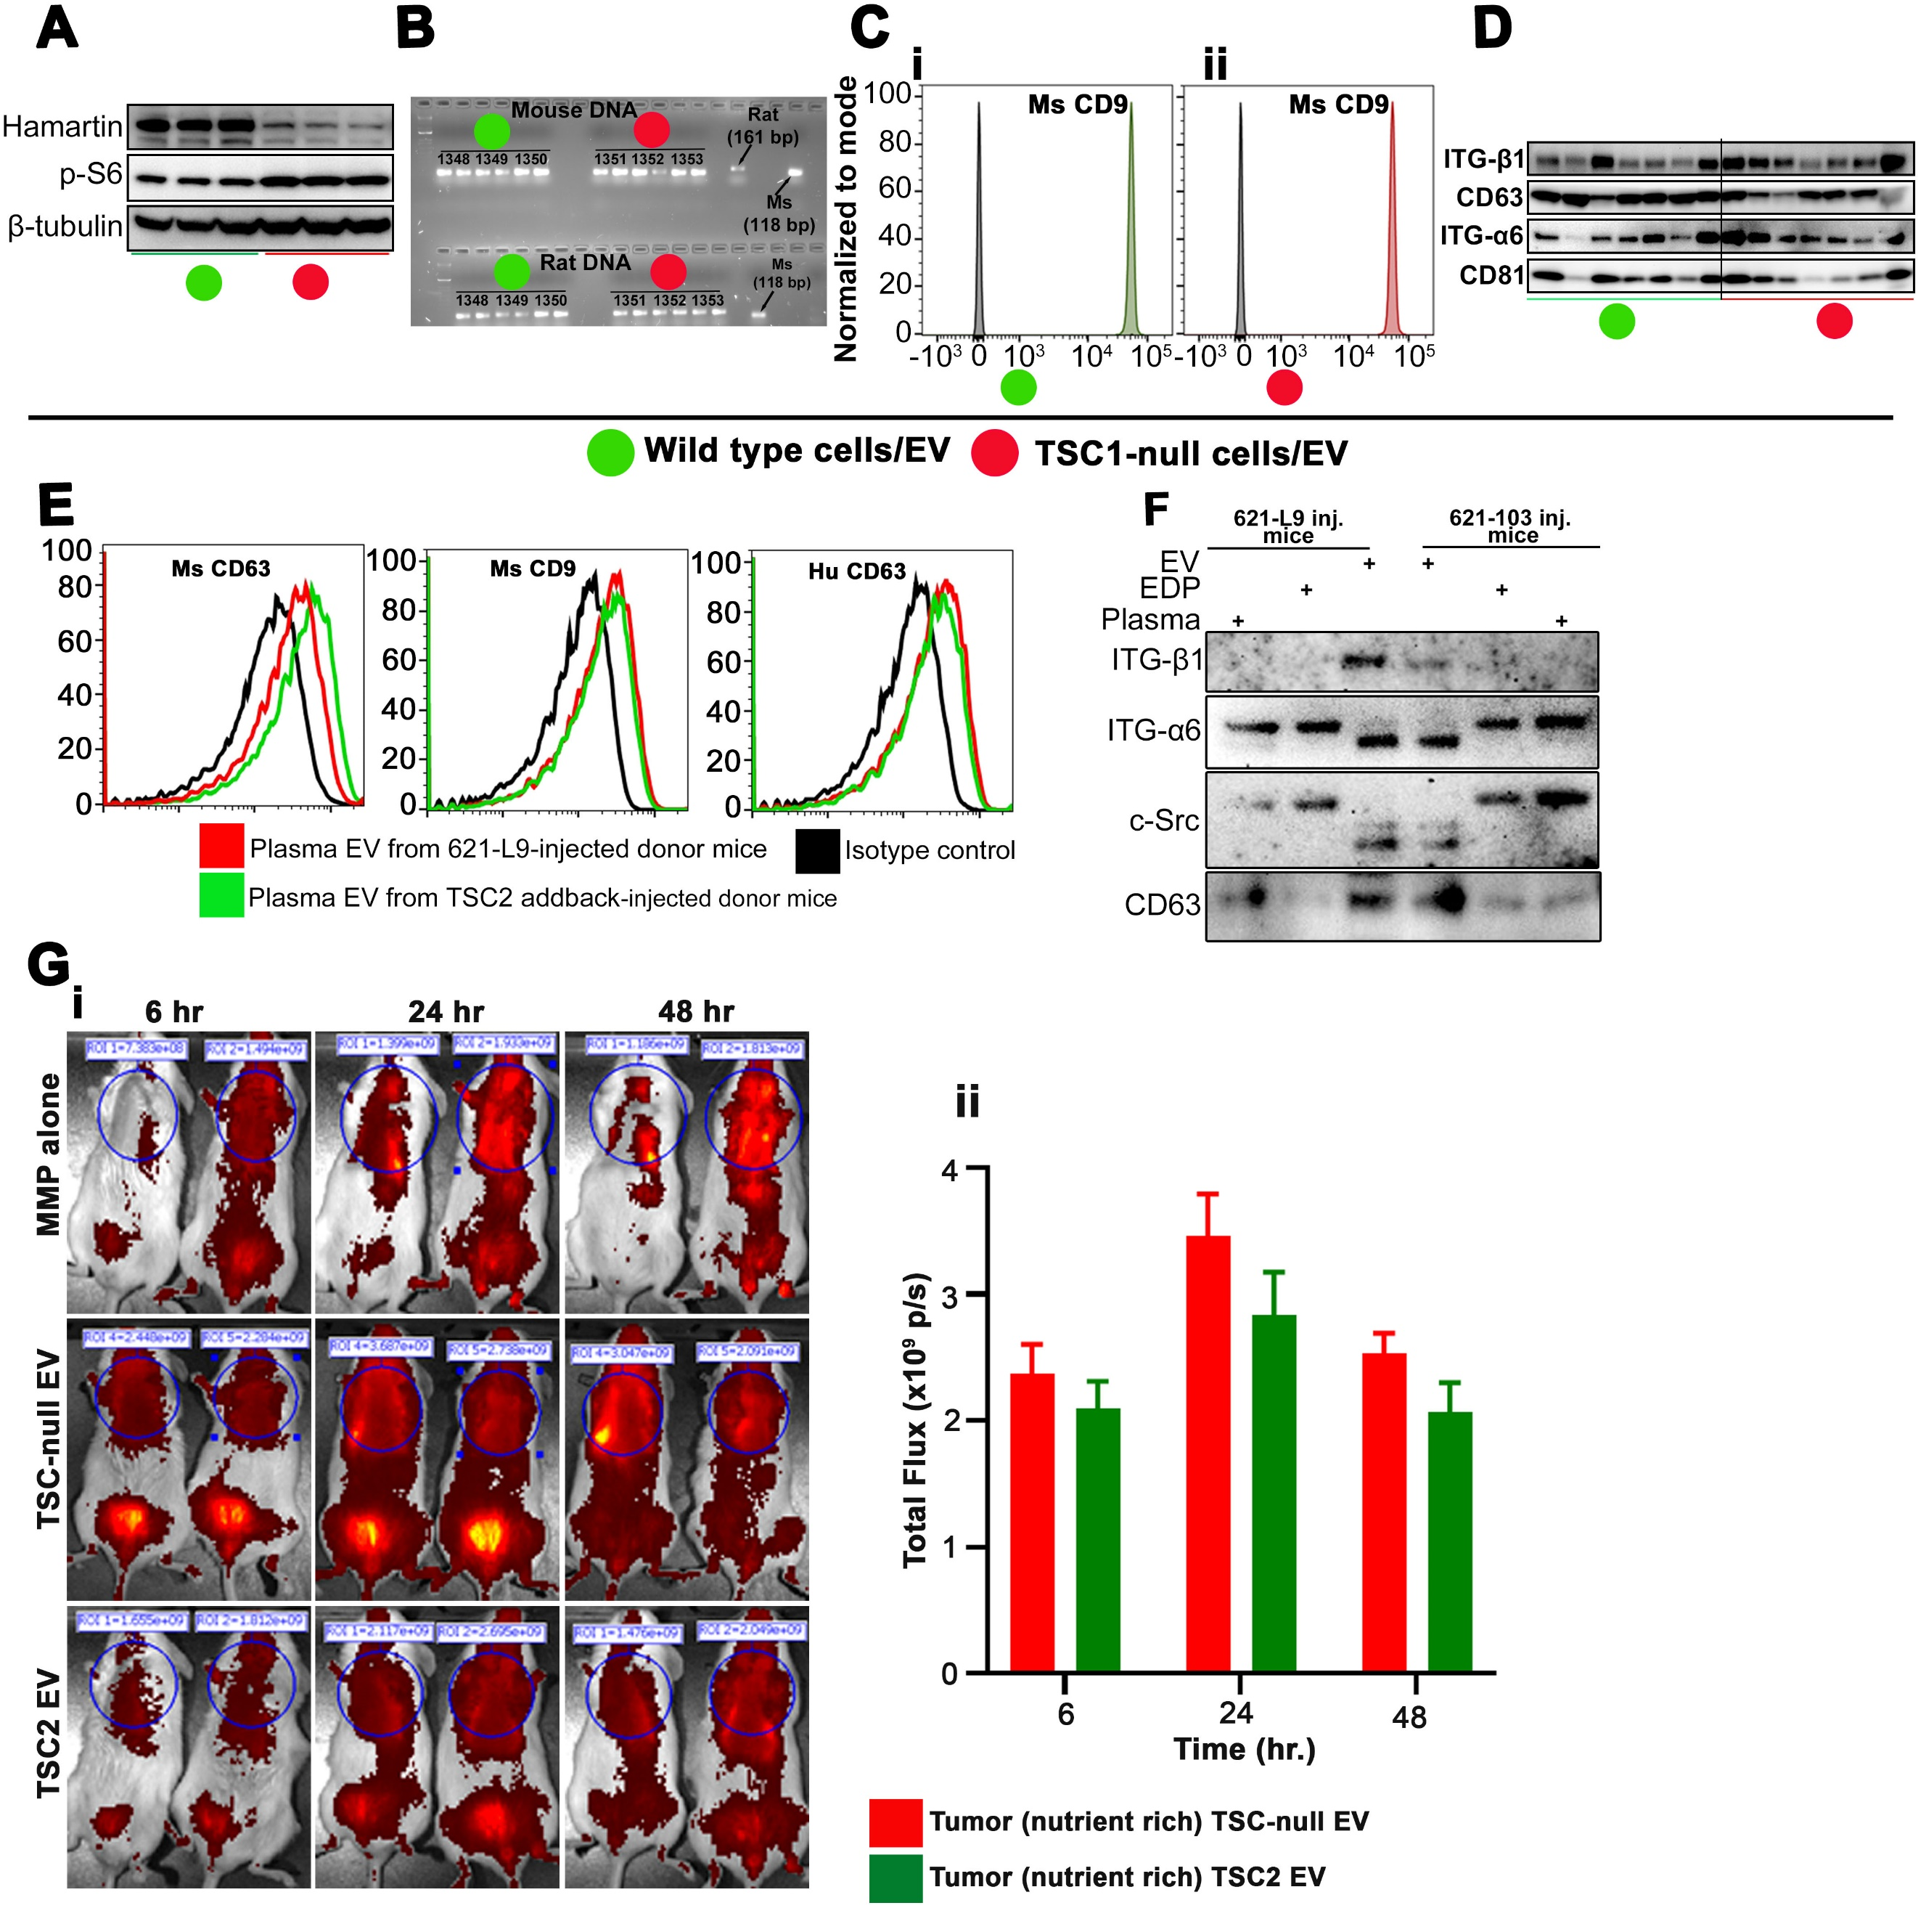

Supplementary Table 1. List of Antibodies.
Antibodies | Source | Identifier | Application
ALIX | Cell Signaling Technology | 92880S | WB (1:1000)
RAB27B | Cell Signaling Technology | 17572S | WB (1:1000)
RAB27A | Cell Signaling Technology | 69295S | WB (1:1000)
CD63 | SBI | EXOAB-CD63A-1 | WB (1:1000)
CD81 | Santa Cruz | sc-166029 | WB (1:500)
FLOTILLIN-1 | BD biosciences | 610820 | WB (1:1000)
FLOTILLIN-2 | Cell Signaling Technology | 3436S | WB (1:1000)
ANNEXIN-V | Cell Signaling Technology | 8555S | WB (1:1000)
TFAM | Cell Signaling Technology | 8076S | WB (1:1000)
CALNEXIN | Cell Signaling Technology | 2679S | WB (1:1000)
EpCAM | Cell Signaling Technology | 42515S | WB (1:1000)
GRP94 | Enzo | ADI-SPA-8500 | WB (1:1000)
ALBUMIN | Cell Signaling Technology | 4929S | WB (1:1000)
ITGβ1 | Cell Signaling Technology | 9699S | WB (1:1000)
ITGα6 | Cell Signaling Technology | 3750S | WB (1:1000)
CD44 | Cell Signaling Technology | 37259S | WB (1:1000)
c-SRC | Cell Signaling Technology | 2109S | WB (1:1000)
FAK | Cell Signaling Technology | 3285S | WB (1:1000)
MMP9 | Cell Signaling Technology | 2270S | WB (1:1000)
MMP3 | Cell Signaling Technology | 14351S | WB (1:1000)
CD9 | Cell Signaling Technology | 13174S | WB (1:1000)
NRF2 | Cell Signaling Technology | 12721S | WB (1:1000)
SOD2 | Santa Cruz | sc-133134 | WB (1:500)
P70 S6 kinase T389 | Cell Signaling Technology | 97596S | WB (1:1000)
S100A4 | Cell Signaling Technology | 13018S | IHC (1:800)
ATP SYNTHASE C | EMD Millipore | MABS1304 | WB (1:2000)
SOX10 | Cell Signaling Technology | 69661S | WB (1:1000)
VINCULIN | Proteintech | 66305-1-1g | WB (1:3000)
TALIN | Santa Cruz | sc-365875 | WB (1:500)
ILK-1 | Cell Signaling Technology | 3856S | WB (1:1000)
PAXILLIN | Cell Signaling Technology | 50195S | WB (1:1000)
p-FAK (Y397) | Cell Signaling Technology | 8556S | WB (1:1000)
p-FAK (Y576/577) | Cell Signaling Technology | 3281S | WB (1:1000)
p-cSRC (Y416) | Cell Signaling Technology | 59548S | WB (1:1000)
p-AKT (s473) | Cell Signaling Technology | 4058S | WB (1:1000)
p-Paxillin (Y118) | Cell Signaling Technology | 2541S | IF (1:50)
p-AMPK (T172) | Cell Signaling Technology | 2535S | WB (1:1000)
MMP14 | Cell Signaling Technology | 26424S | WB (1:1000)
MMP2 | Cell Signaling Technology | 87809S | WB (1:1000)
TSC2 | Cell Signaling Technology | 3990S | WB (1:1000)
TSC1 | Cell Signaling Technology | 6935S | WB (1:1000)
GAPDH | Santa Cruz | sc-365062 | WB (1:1000)
B-tubulin | Cell Signaling Technology | 86298S | WB (1:1000)
FAP | Invitrogen | PA5-99313 | WB (1:1000)
p-Erk p44/42 MAPK | Cell Signaling Technology | 9102S | WB (1:1000)

Supplementary Table 2. List of primers used in this study.
Gene | Forward | Reverse
Col1a1 | GCTCCTCTTAGGGGCCACT | CCACGTCTCACCATTGGGG
Mmp14 | CAGTATGGCTACCTACCTCCAG | GCCTTGCCTGTCACTTGTAAA
Cxcl5 | GTTCCATCGCCATTCATGC | GCGGCTATGACTGAGGAAGG
Mmp2 | CAAGGATGGACTCCTGGCACAT | TACTCGCCATCAGCGTTCCCAT
S100a4 | TCCACAAATACTCAGGCAAAGAG | GCAGCTCCCTGGTCAGTAG
Itgb1 | ATGCCAAATCTTGCGGAGAAT | TTTGCTGCGATTGGTGACATT
Col11a1 | AGGTGGAAAACGAAACGGTG | GGAAGAGAAAAGTCAAGGCGA
Mapk13 | ATGAGCCTCACTCGGAAAAGG | GCATGTGCTTCAAGAGCAGAA
Ctsk | GAAGAAGACTCACCAGAAGCAG | TCCAGGTTATGGGCAGAGATT
Abca3 | TCAGTAAAGCCAACATAGCAGC | GAGGAGCCACGAAAAAGTAGG
Lrrc23 | AGATGATGTGGATGACGTTGATG | CAGAGTAATGAGAGCCCTTCCT
Gapdh | AGGTCGGTGTGAACGGATTTG | TGTAGACCATGTAGTTGAGGTCA
NDUFB4 | AAACGAGAGTACCTGCTTCAGT | AGTGAGTTTTTAGGAGTGGGTCT
NDUFB5 | AGCTGGAAGTGCGAAAATTGA | ATACCAGGGTCCATCTCCTCT
COQ3 | CCTGGCTCACAAATGGTGG | TTGTCCCTAATAAATGGCACCC
MRPL22 | TGAAACGCATCCGCTACCAT | CCCTTCCACCAACTTCACAAAAT
MRPL46 | AGAATGACCGAACATCCCTGA | TGGGGCAGTATCCAAACATCC
TNC | AGGGCAAGTGCGTAAATGGAG | TGGGCAGATTTCACGGCTG
MMP3 | CTGGACTCCGACACTCTGGA | CAGGAAAGGTTCTGAAGTGACC
FN1 | AGGAAGCCGAGGTTTTAACTG | AGGACGCTCATAAGTGTCACC
HIST1H3I | ATGGCACGAACAAAGCAAACA | GCGATCTCCCGTACCAAGC
ABI3BP | CAAATGCAACATGCTCTCCAGT | TTGGCCTTTTACCTTTTGGCA
GAPDH | CTGGGCTACACTGAGCACC | AAGTGGTCGTTGAGGGCAATG
MS DNA | AGATGGCTCAGTGGGTAAAGG | GTGGAGGTCAGAGGCAAACTT
Rat DNA | CAAGACGGATGATCAAAATGTG | ATTGGGTGGCTGTATATGTATGG

