Appendix A

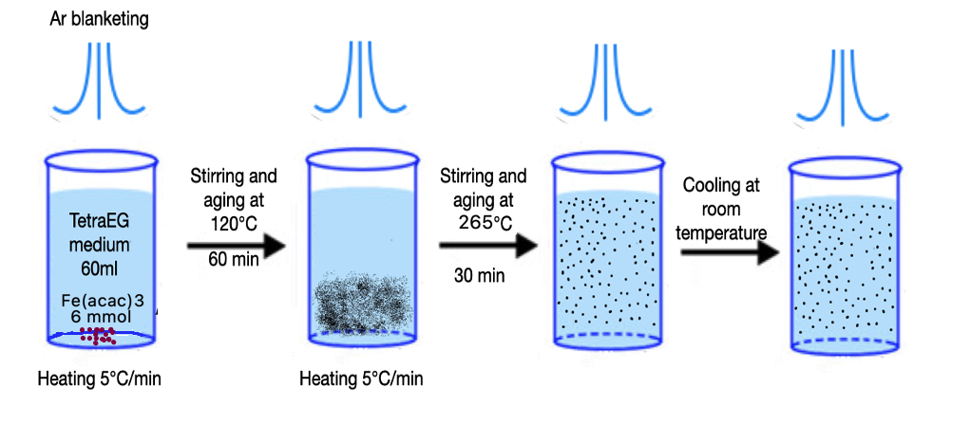
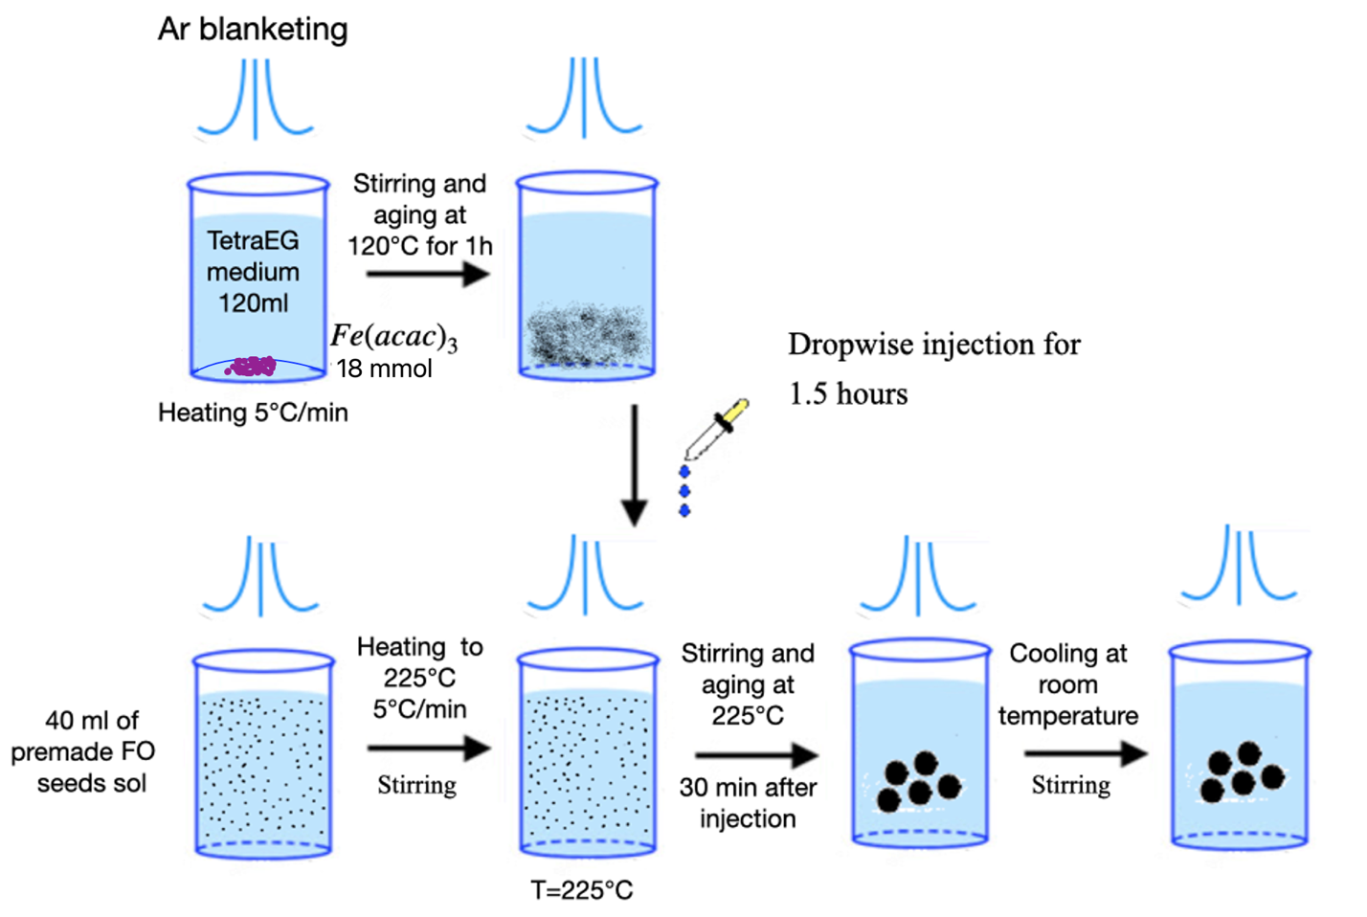
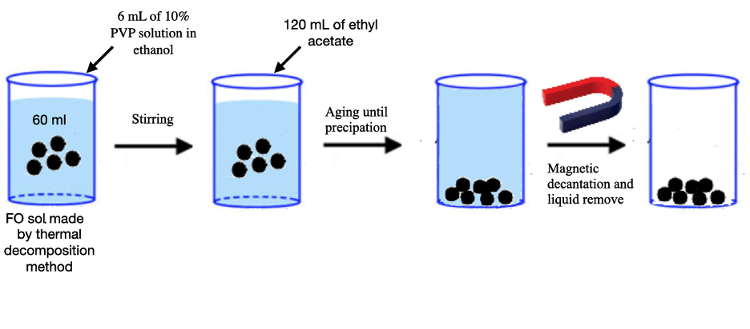
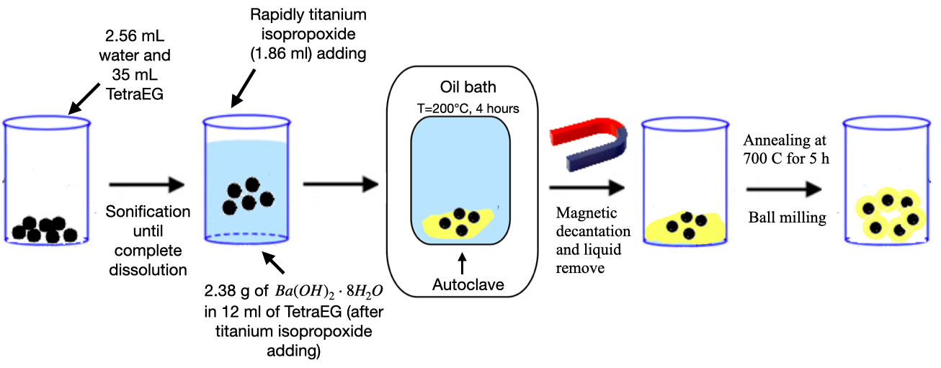
There are various methods for synthesizing FO@BTO particles. In our work, the synthesis was conducted according to the protocol described in [22, 23]. In the reviewed studies [20, 22-32], the first stage of synthesis involves the production of FO MNPs. The main methods for synthesizing such nanoparticles include chemical co-precipitation [24-26, 26], thermal decomposition [22], and hydrothermal methods [20, 23, 27]. We selected the thermal decomposition method due to its ability to controllably and reproducibly produce nanoparticles with a narrow size distribution, despite the complexity of this method compared to chemical co-precipitation. The synthesis of FO nanoparticles occurred in two stages [33]. The first stage involved the synthesis of the “seeds” of the future particles. Fig. 12 schematically shows the synthesis of the FO MNPs seeds. Initially, to fully dissolve Fe(acac)₃ in TEG, the solution was heated to 120°C and held at that temperature for an hour. Upon further heating to the required temperature, a new phase of FO nanoparticle seeds was formed. The sizes and size distribution of the resulting seeds largely depend on the heating rate of the synthesis medium. Upon reaching a temperature of 265°C (overcoming the potential barrier for the formation of a new phase), particles should form simultaneously throughout the solution, ensuring a “good” particle size distribution. For the continued growth of FO MNPs, it is crucial that the seed suspension remains colloidally stable (i.e., the particles do not precipitate). Fig. 13 shows a schematic representation of the second stage of FO MNP synthesis. Particle growth occurs according to the LaMer-Dinegar mechanism, without the fusion and aggregation of disordered clusters. A solution of Fe(acac)₃ in TEG was added dropwise to the seed solution. When heated to 225°C, solvent complexes detach from the surface of the FO seeds, allowing the particles to grow. At this temperature, particle growth is energetically more favorable than the formation of a new phase (seeds). Increasing the concentration of iron ions, the solution temperature, or the solution addition rate can lead to the formation of new seeds rather than the growth of MNPs. The final size of FO nanoparticles primarily depends on the amount of solution added to the seeds. This allows the production of particles of the desired size at the end of the reaction. By repeating the protocol described above one, two, and three times, we obtained MNPs with diameters of D=12.7±1.6 nm, D=25.9±3.4 nm, D=47.7±4.3 nm, respectively (Fig. 1, 2).The next stage of FO@BTO particle synthesis Involves forming a BTO shell around the MNPs. Several approaches are discussed in the literature [20, 22-28, 33]: solvothermal [23, 27], mechanochemical [25], and sol-gel [20, 22, 26, 28] methods. We selected the solvothermal method. First, 6 ml of an alcoholic solution of polyvinylpyrrolidone (PVP, Sigma-Aldrich, USA) and 120 ml of ethyl acetate were added to 60 ml of the prepared MNPs solution, after which the particles were extracted by magnetic decantation (Fig. 14) and dissolved in 35 ml of TEG and 2.56 ml of deionized water. Then, while stirring intensively, 1.86 ml of titanium isopropoxide (97%, Sigma-Aldrich, USA) was quickly added to the particles, followed by a solution of 2.38 grams of barium hydroxide (Ba(OH)₂·8H₂O, Sigma-Aldrich, USA) in 12 ml of TEG. The reaction proceeded at 200°C for 4 hours in an autoclave in an oil bath, after which the sample was allowed to cool to room temperature. The resulting particles were washed three times with ethyl acetate and dried in an oven. Some of the particles were immediately used for measurements, while others were annealed in a muffle furnace for 5 hours at 700°C. Some particles were milled in a Retsch MM301 ball mill for 12 hours in 25 ml tungsten carbide jars using one 1.5 cm ball and twenty 1 mm balls. During milling, octadecene and oleic acid were added to stabilize the particles (Fig. 15).
Fig. 12. Schematic representation of the synthesis of FO MNPs seeds.

Fig. 13. Schematic representation of the process of FO MNPs growth.

Fig. 14. Schematic representation of the stages of FO@BTO nanoparticle synthesis.

Fig. 15. Schematic representation of the stages of FO@BTO nanocomposite synthesis.

Appendix B
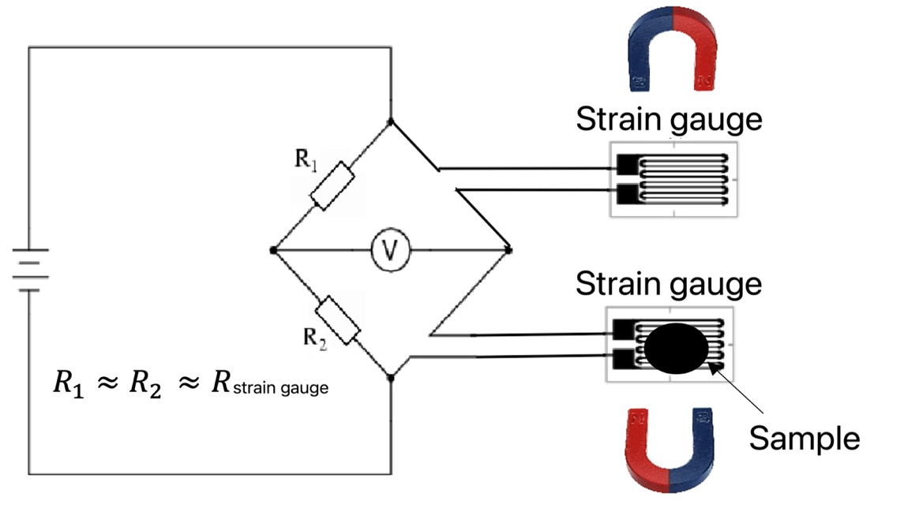
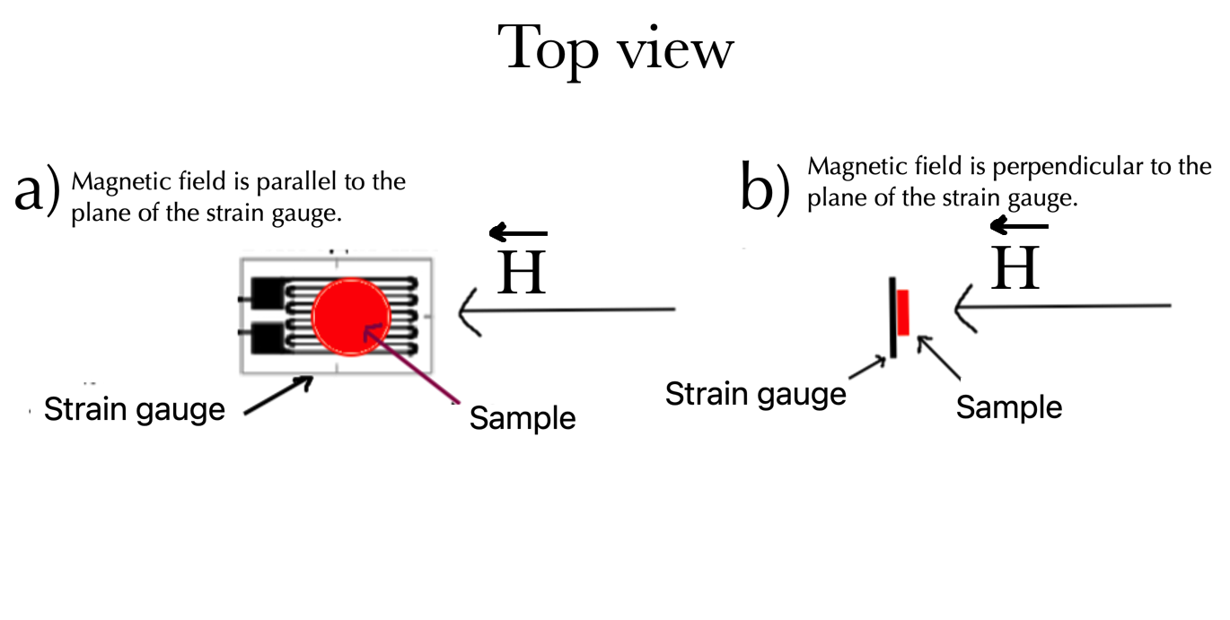
The following method was chosen as the magnetostriction coefficients measurement method: a pellet is pressed from nanoparticles (in our work, 30 mg of a sample was used to press 5 mm in diameter tablets), which was attached with polymer glue to a strain gauge (Vishay EA-05-125BZ-350). Next, a magnetic field is applied to the sample, causing the magnetostrictive sample to deform. As a result, the load cell deforms, which alters its resistance. By calculating the change in the resistance of the load cell through a change in the potential difference on the branches of the bridge circuit (Fig. 16), it is possible to calculate the magnetostriction coefficient of the sample. A magnetic field is also applied to the load cell without a sample in order to eliminate the influence of magnetoresistance. Magnetostriction measurements were carried out in a constant magnetic field created by magnetic field source based on Halbach array assembly. The magnetic field was applied perpendicular and parallel to the plane of the load cell (Fig. 17 ). In the first case (Fig. 17 a), the field uniformity area is 10mm * 10mm, that is, the sample falls entirely into this area, the value of the applied field is H = 20 kOe, in the second case (Fig. 17 b), the field heterogeneity within the sample does not exceed 3%, and the applied field is H = 10 kOe. Demagnetization of the sample was not additionally carried out. However, the good reproducibility of the experimental results suggests that the sufficiently small residual magnetization of the samples does not significantly contribute to the experimental results.
Fig. 16. Schematic representation of the setup for magnetostriction measurements.
Fig. 17. Configuration of the strain gauge with the sample and magnetic field during magnetostriction measurements.

