Lichen colonization and associated biodeterioration processes on ancient bricks of the Gonbad-e Qābus tower, UNESCO World Heritage Site, Iran

Mehdi Zabihiª, Mohammad Sohrabiª *, Sergio E. Favero-Longo^{b}, Abdolmajid Nortaghani^{c}

ª Iranian Research Organization for Science and Technology (IROST), Tehran, Iran
^{b} Department of Life Sciences and Systems Biology, University of Turin, Viale Mattioli 25, 10125, Turin, Italy
^{c} Department of Architecture, Faculty of Engineering, Golestan University, Golestan Province, Iran

* Correspondence: sohrabi@irost.org Tel: 021-57416606; Fax: 021-57416803

Supplementary Figures

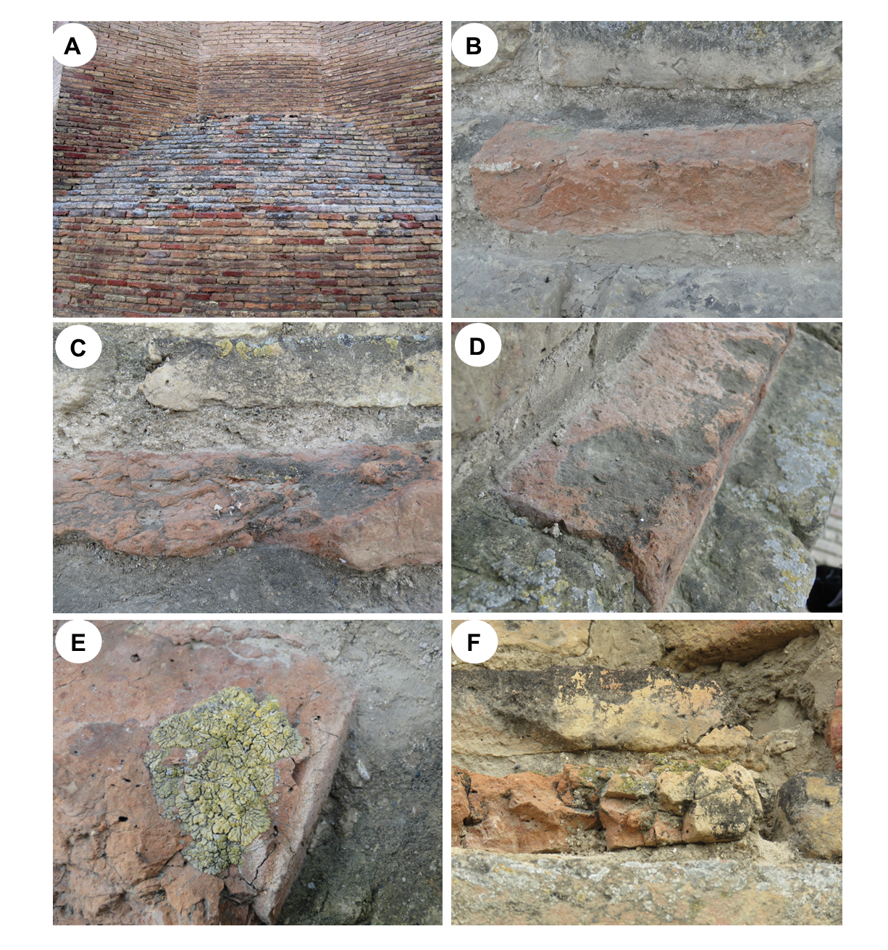

Supplementary Figure 1. (A-B). Variation of lichen and (C-D-E-F) its relationship with biodeterioration of the Gonbad-e Qābus tower bricks.
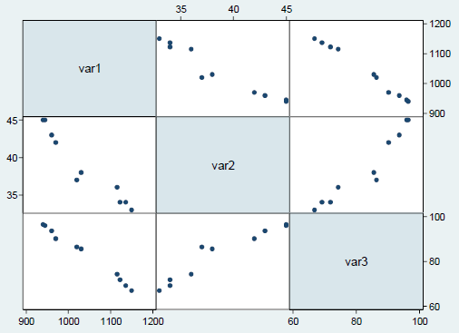
Supplementary Figure 2. Correlation graph between variables. Var 1 (intensity of solar radiation, W/M²), var 2 (brick surface moisture, %), and var 3 (distribution of lichens, % of colonized sides).

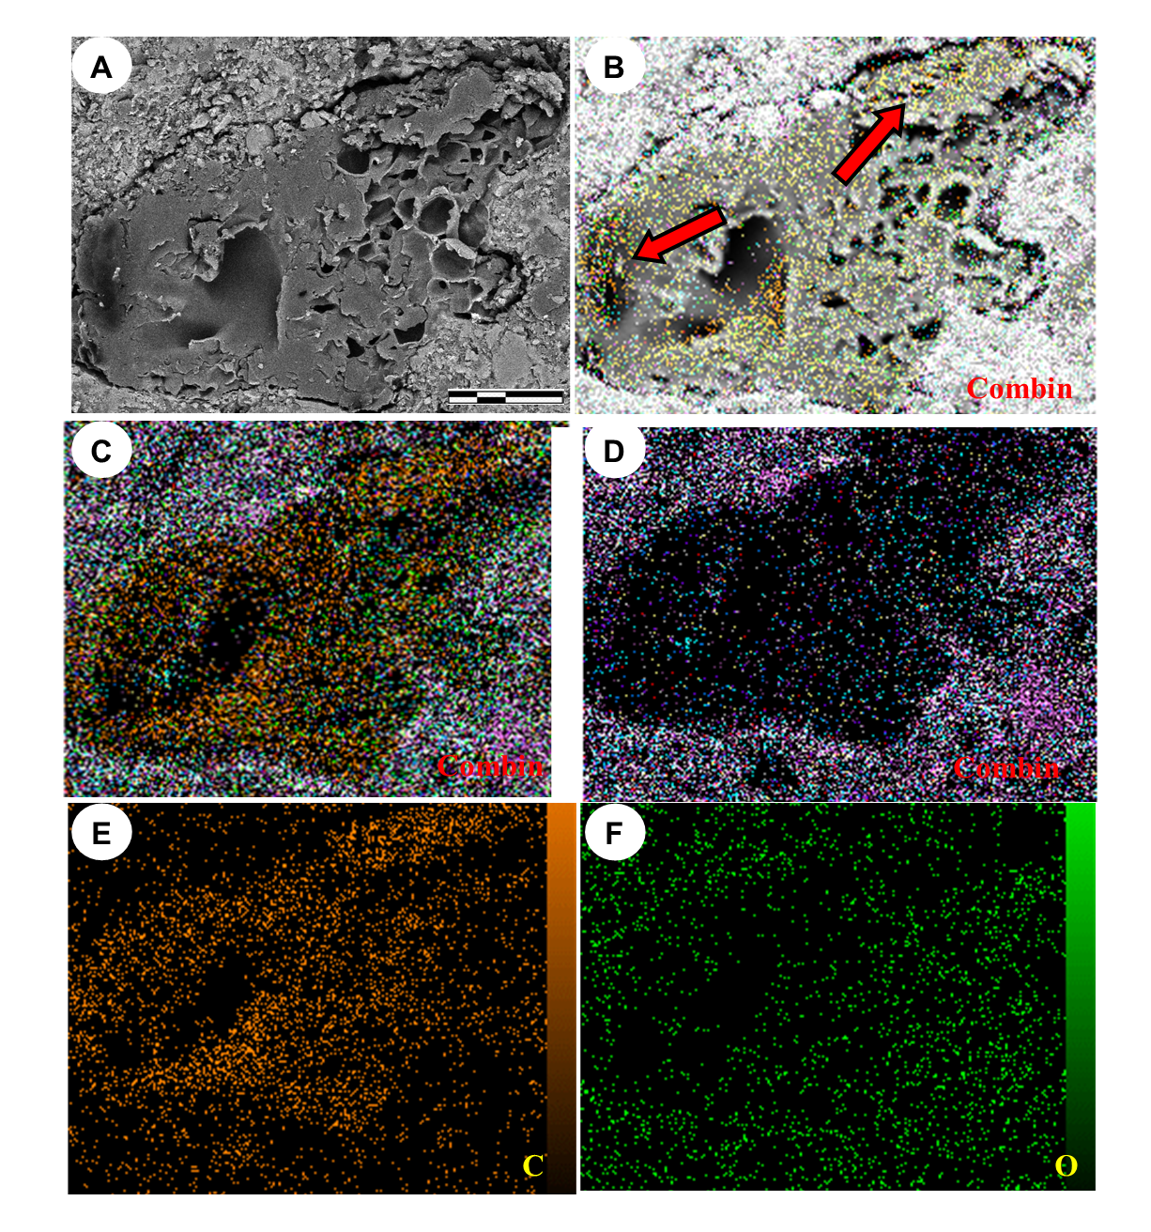
Supplementary Figure 3. SEM–BSE (A) and energy dispersive X-ray spectroscopy (EDS) elemental distribution maps (B-F) of a brick volume colonized by Cyanolichen. Images B and C show the overall map of the elements. Image D show the accumulation of all elements except carbon and oxygen in penetrating hyphal structures. Image E accumulation of carbon element and F accumulation of oxygen. Scale bars: 10 μm (A).
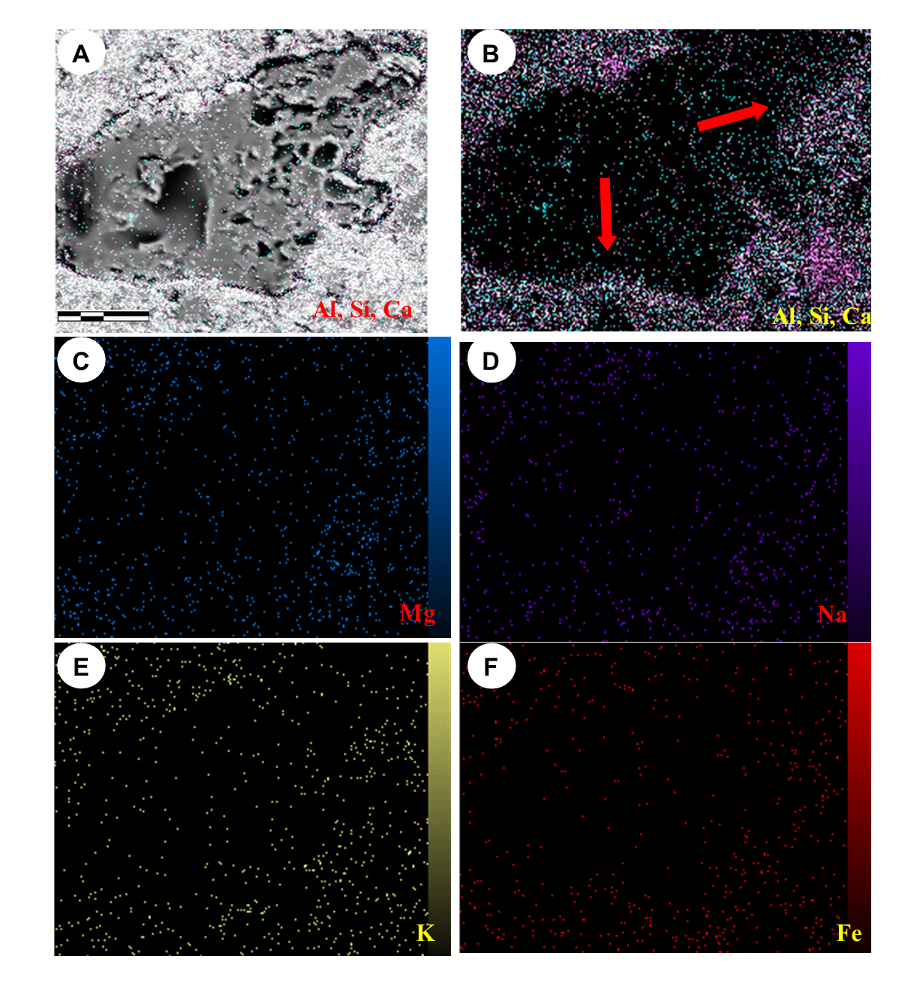
Supplementary Figure 4. SEM–BSE (A) and energy dispersive X-ray spectroscopy (EDS) elemental distribution maps (B-F) of a brick volume colonized by Cyanolichen. Images A and B show the accumulation of aluminum, silica and calcium within the penetrating hyphal structures at the thallus-brick interface (red arrow). Images C, D, E and F show the map of magnesium, sodium, potassium and iron elements in the thallus-brick interface. Scale bars: 10 μm (A).

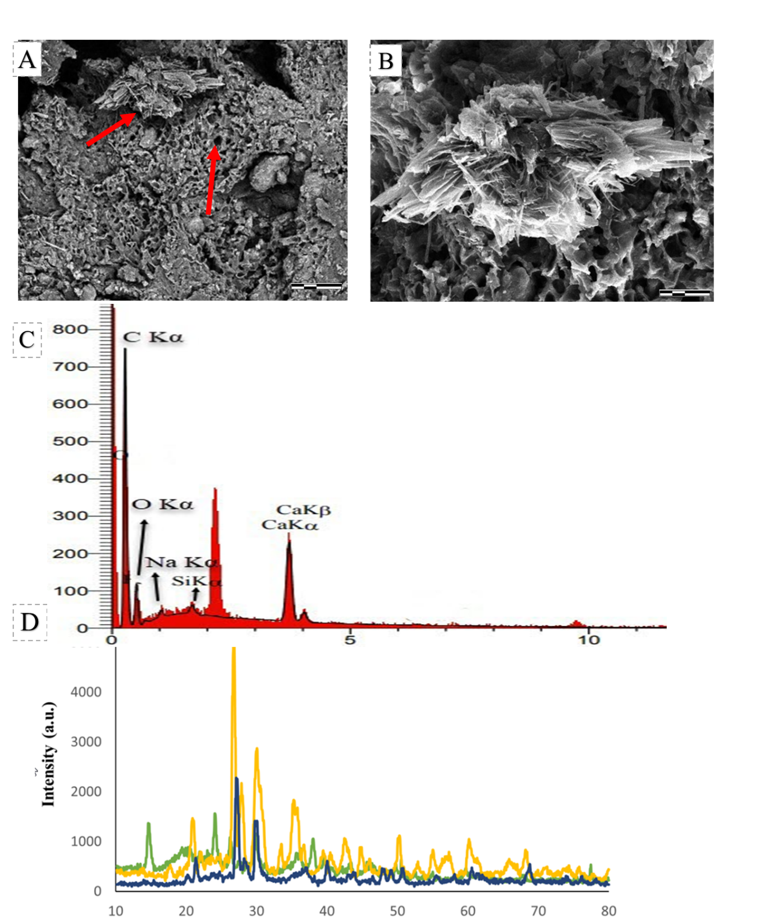
Supplementary Figure 5. Interface between the brick substrate and a thallus of Kuettlingeria teicholyta (A). Electron microscope image of a neo-formed crystal (B) and its EDX spectrum (C). XRD pattern for identification of whewellite (green color), mineralogical composition of thallus-brick interface (blue color) and brick (yellow color) (D). Scale bars: 50 µm (A), 5 μm (B).

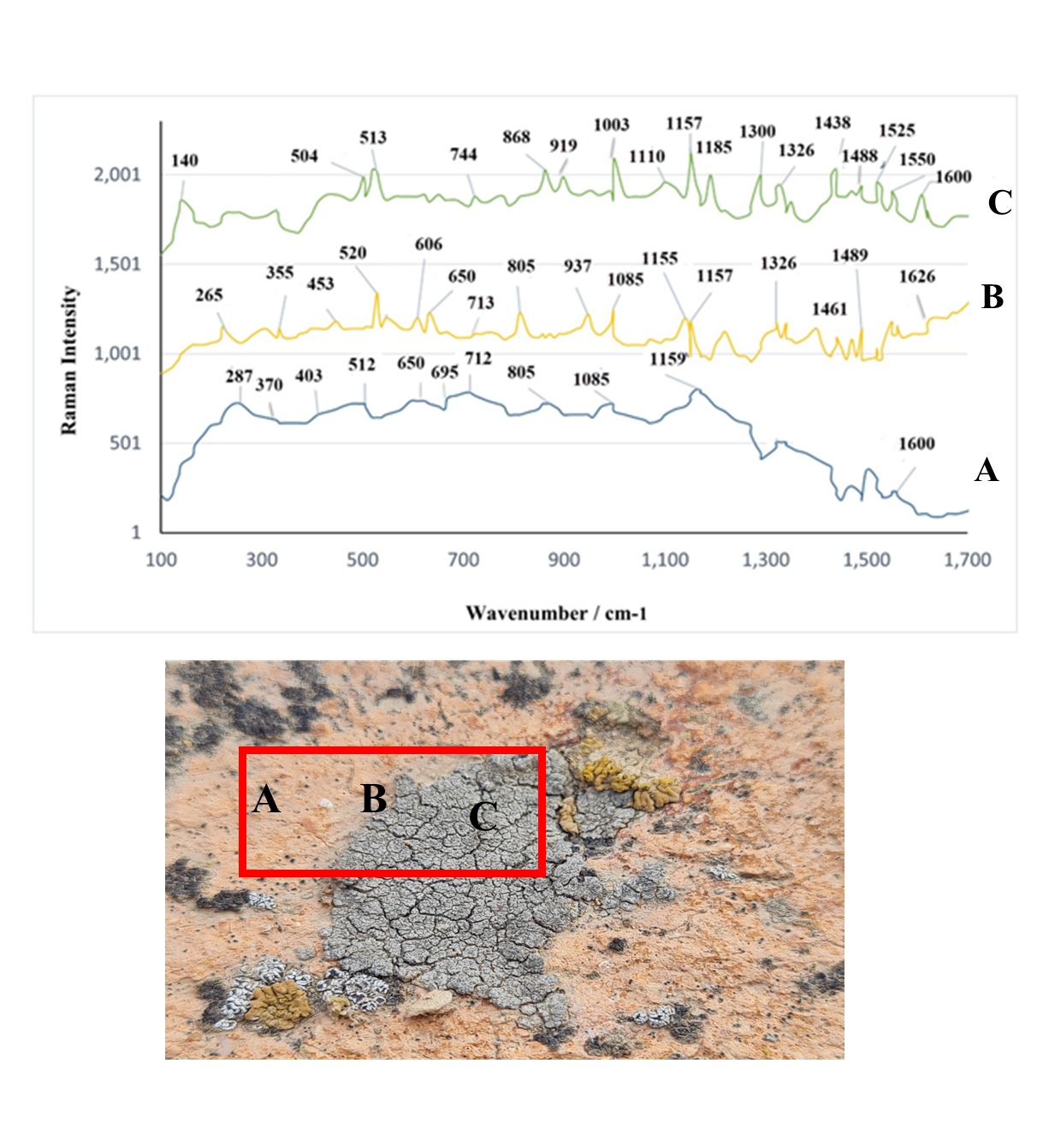
Supplementary Figure 6. Raman spectrum obtained in lichen samples on brick substrate. On the brick substrate (blue peak A) between lichen and brick (orange spectrum B) and the inner part of lichen (green spectrum C).

Supplementary Tables

Supplementary Table 1- Environmental factors affecting the growth and distribution of lichens in the Gonbad-e Qābus World Heritage October 2018 to October 2020.

wind-driven rain (WDR) | The angle of the sun's rays | Wind speed | Temperature | Rainfall data
West and Northwest  tracks(sides)  4, 5, 6, 7 | East and Southeast  tracks(sides) 9, 10, 1, 2 | 8.3 km / h | 10 °C in Winter and  30 °C in summer | 120 mm rainfall yr−1

Supplementary Table 2- Correlation of lichen distribution with the amount of brick surface moisture on the brick surfaces and the intensity of sunlight. Var 1 (intensity of solar radiation, W/m²), var 2 (brick surface moisture, %) and, var 3 (distribution of lichens, % of colonized sides).
Variable | Normality |  |  |  |  | Relationship between variables
 | Obs | W | V | Z | Prob >Z | Var1 | Var2 | Var3
Var1 | 10 | 0.865 | 2.071 | 1.348 | 0.08883 | 1.0000
Var2 | 10 | 0.888 | 1.722 | 0.986 | 0.16217 | ρ - 0.9642  p 0.0000 | 1.0000
Var3 | 10 | 0.953 | 0.722 | - 0.542 | 0.70605 | ρ - 0.9952  p 0.0000 | ρ 0.9570  p 0.0000 | 1.0000

Supplementary Table 3 – Mineralogical composition of thallus-brick interface and inside bricks by XRD method.

Number | Sample type | XRD results
1 | inside brick | Major phases: Quartz (SiO₂)  Minor phases: Feldspar (CaAl₂ Si₂O₈)  Clay minerals, Hematite (Fe₂O₃), Carbonates (Mg_{0.06} Ca_{0.94}) (CO₃)  Calcite (CaCO₃), Pyroxene Ca (Mg, Al, Fe) Si₂O₆
2 | thallus-brick interface | Major phases: Quartz (SiO₂)  Minor phases: Feldspar (Ca Al₂ Si₂O₈)  Clay minerals, Hematite (Fe₂O₃), Carbonates (Mg_{0.06} Ca_{0.94}) (CO₃)  Calcite (CaCO₃).  Calcium oxalate monohydrate (whewellite) (CaC₂O₄.H₂O)

Supplementary Table 4 - Elementary composition (av. wt % of the detectable elements) of thallus-brick interface of Gonbad-e Qābus tower, assessed by XRF method.
 | SiO₂ | Al₂O₃ | Fe₂O₃ | CaO | Na₂O | K₂O | MgO | TiO₂ | MnO | P₂O₅ | n
 | % | % | % | % | % | % | % | % | % | % | %
inside brick | 50.238 | 9.644 | 3.925 | 15.234 | 1.331 | 2.113 | 4.433 | 0.522 | 0.092 | 0.256 | 11.800
thallus-brick interface | 47.010 | 8.492 | 3.594 | 14.306 | 0.836 | 1.986 | 3.141 | 0.593 | 0.061 | 0.159 | 17.990

