Additional File 2: Supplemental Figures

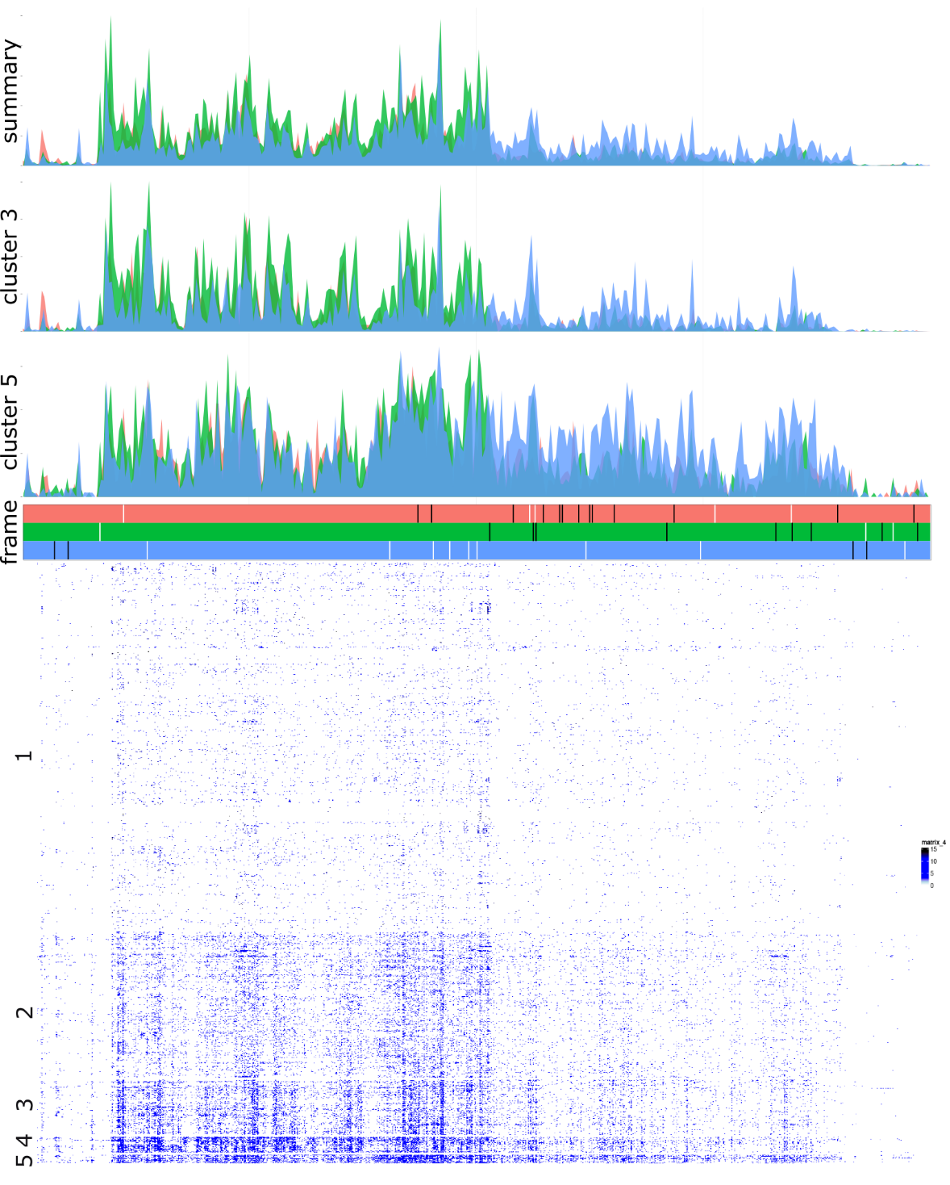
Figure S1. Analysis of aggregated Ribo-seq data identifies distinct clusters with differential ORF translation. Bottom: coverage heatmap of 2783 Ribo-seq libraries, grouped into 5 clusters with k-means algorithm. Top: sub-codon coverage plots for clusters 3, 5 and all samples combined showing differential ORF translation between clusters.

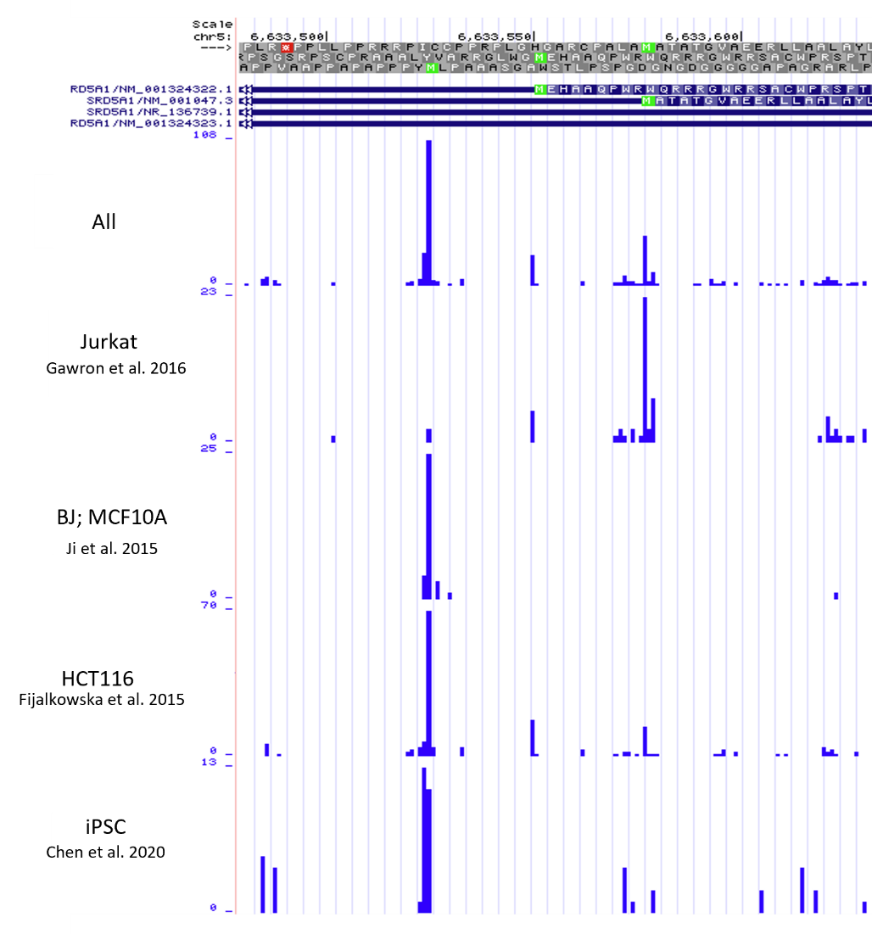
Figure S2. Ribosome footprints derived from Ribo-seq experiments that preferably select for initiating ribosomes. The frame plot shows the amino acid sequence in the three frames. The Met residues corresponding the three AUG codons are highlighted in green. Below are the RefSeq transcript annotations. Shown are data from all studies combined (upper row) and that from 4 individual studies, in Jurkat, BJ and MCF10A, HCT116, and iPSC. The first author and the year of study publication are indicated.
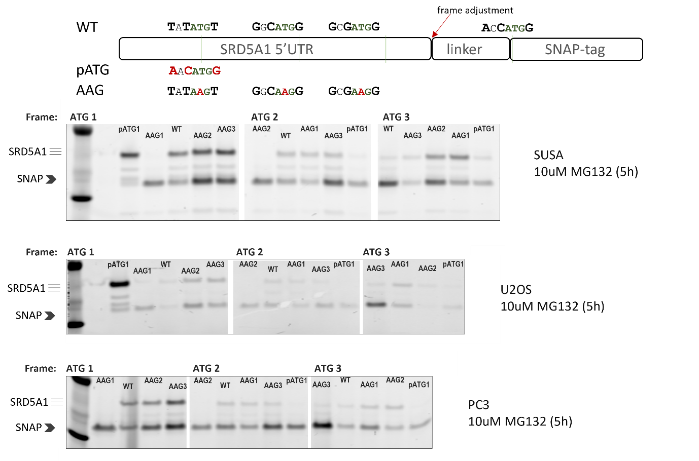
Figure S3. Reporter assay validation of translation initiation at three AUG codons in the SRD5A1 5' leader in different cell lines. a Schematic of the construct with SNAP-tag encoding sequence downstream to the SRD5A1 5’ leader. b Imaging of SNAP-tag labelled proteins from SUSA, U2OS and PC3 cell lines. Treatment with the proteasome inhibitor MG132 was used to stabilise the protein products.

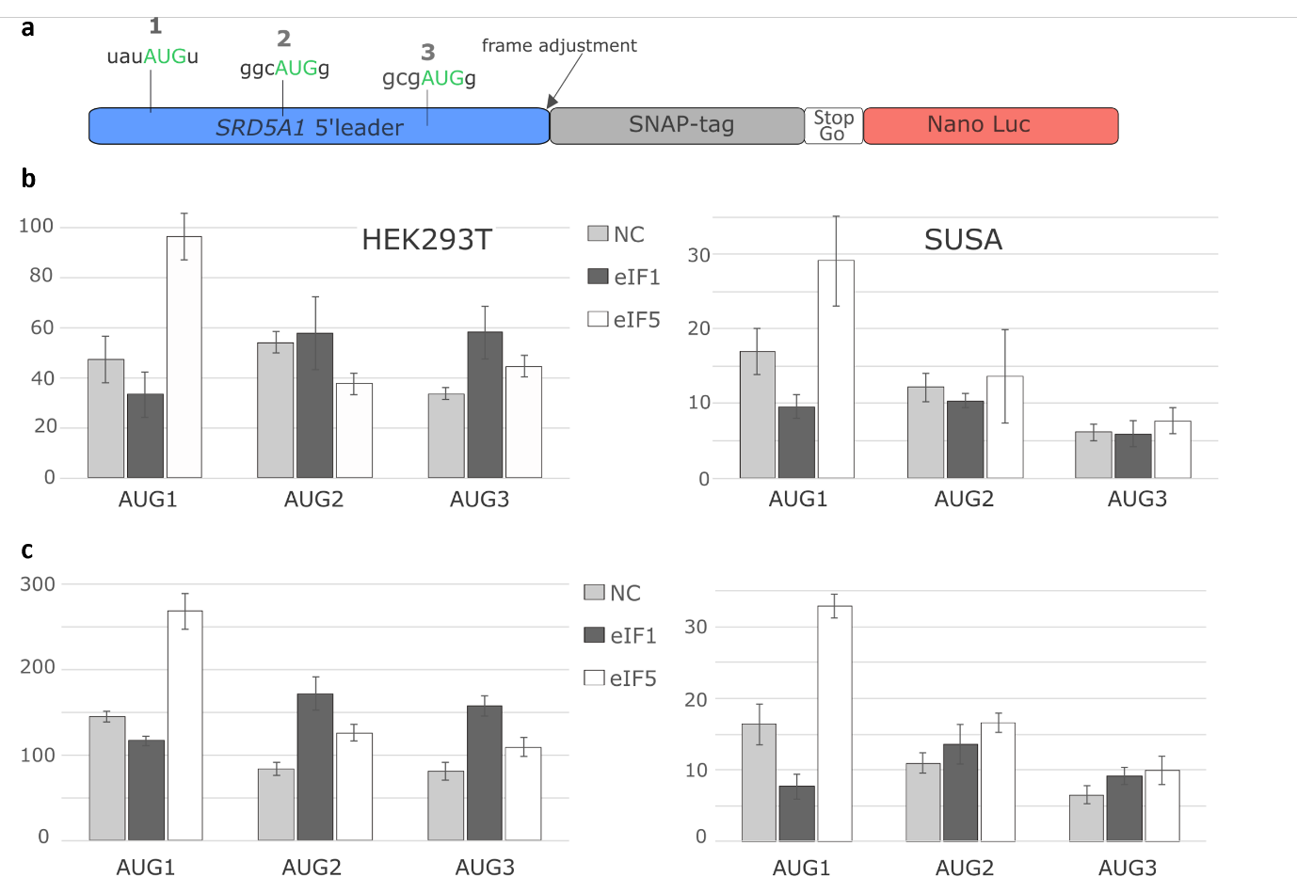
Figure S4. eIF1/eIF5 effects on start codon selection in SRD5A1 5’ leader. a Schematic of the construct used in luciferase assays where NanoLuc activity reports on each of the frame’s expression. b, c eIF1/eIF5 overexpression to assess the stringency effect on start codon selection in SRD5A1 5’ leader in HEK293A and SUSA cell lines; normalised NanoLuc activities are shown for two independent transfection experiments.

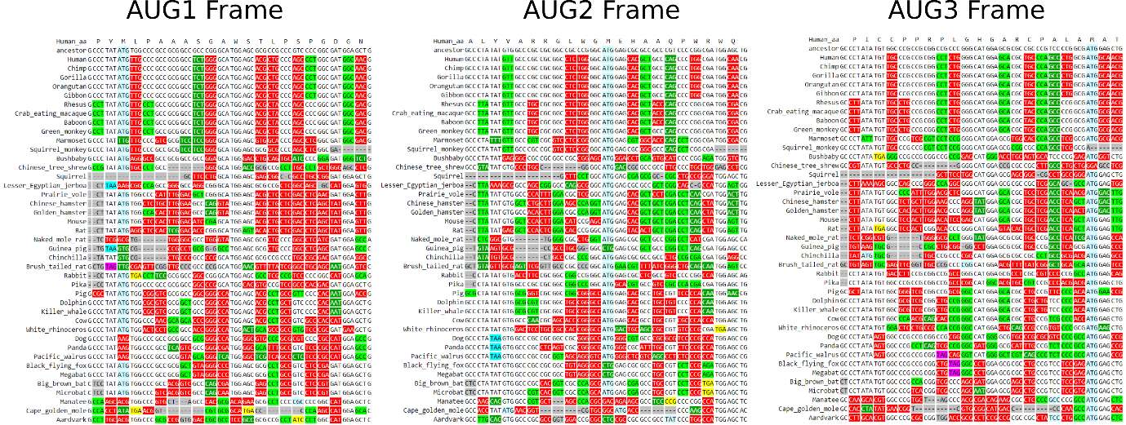
Figure S5. CodAlignView visualisation of 100-way vertebrate genomic alignment in the vicinity of SRD5A1 AUG codons. Each panel corresponds to the reading frame matching one of the three AUG codons with AUG codons highlighted in blue, radical codon substitutions in red and synonymous or similar codon substitutions in light or dark green respectively. The first row shows the ancestral sequence predicted with CodAlignView.

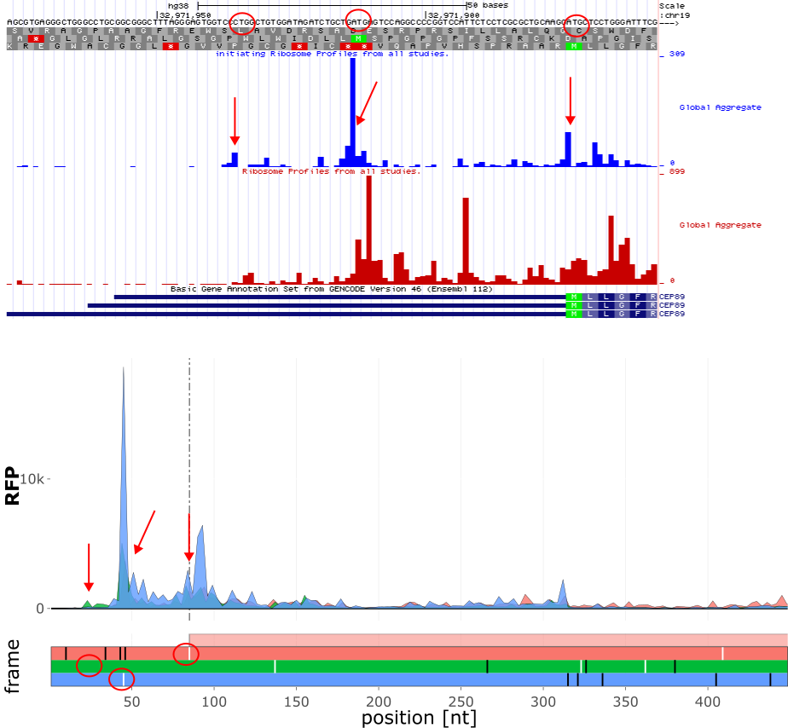
Figure S6. Ribosome profiling evidence of triple decoding in CEP89 locus. Top is GWIPS-viz screenshot showing aggregated footprints of elongating ribosomes (red) and of ribosomes enriched at initiation sites (blue) for 5’ part of the first exon of CEP89. Bottom is a RiboCrypt screenshot for a similar region. The locations of inferred translation initiation are indicated with red arrows in the plots showing footprint densities and as circles in the sequence and ORF plots.

