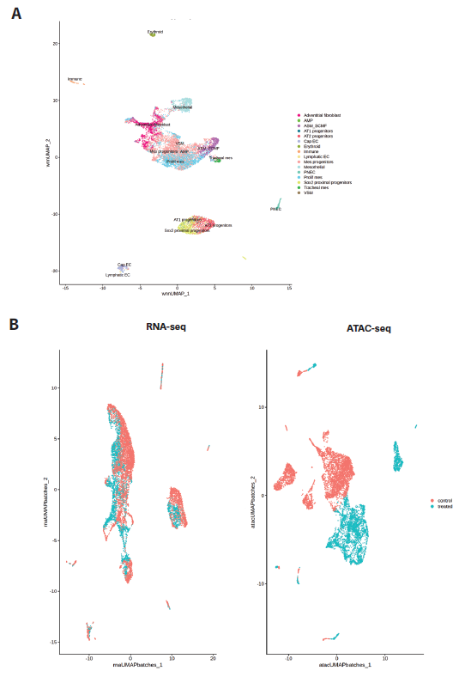
Supplementary Figure S1. Overview of cell clusters in UMAP embeddings including (A) annotation by CellCards mapping against a published mouse E12.5 embryonic lung scRNA-seq dataset [1, 2] and (B) distributions of cell clusters using scRNA-seq and scATAC-seq data, color coded by cells from control (peach) and Cd and As exposed (teal) lungs.

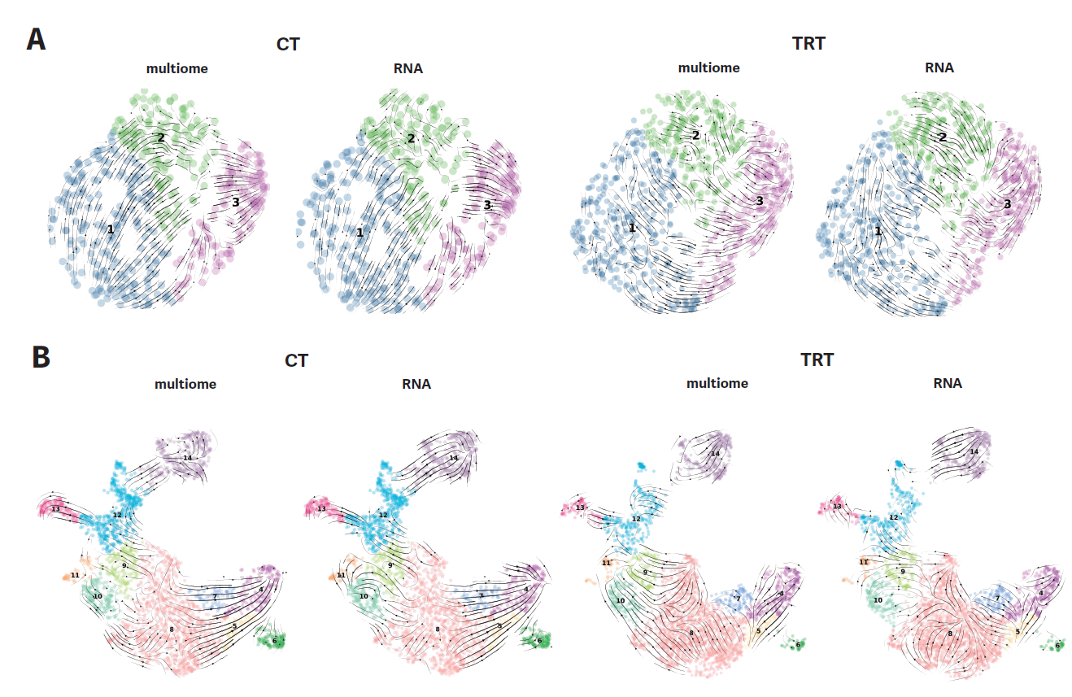
Supplementary Figure S2. Comparison of velocity analyses using scRNA-seq + scATAC-seq (multiome) data and scRNA-seq only (RNA) data for epithelial cells (A) and mesenchymal cells (B).

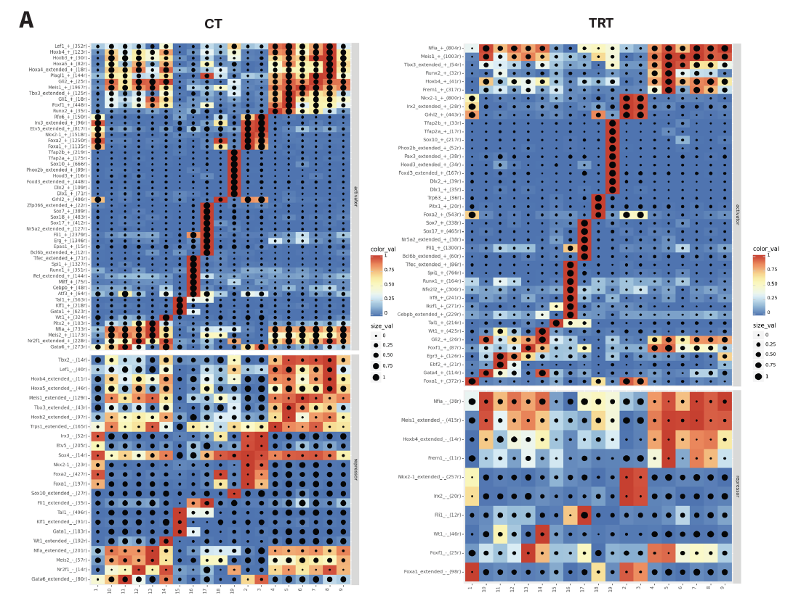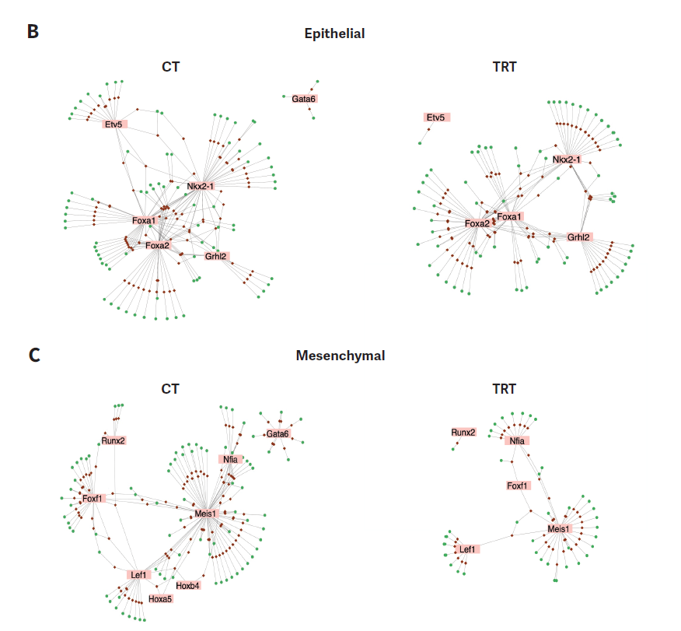
Supplemental Figure S3. Details of gene regulatory network (GRN) analyses. CT – control; TRT – Cd and As exposed. (A) The heatmap showing the complete list of eRegulons calculated by SCIENIC+. Top and bottom grids correspond to activator and repressor, respectively. The color intensity and dot size indicates the level of expression and activity of each TF, respectively. (B) GRN of the top affected TF and top 1000 genes that vary most across epithelial clusters. (C) GRN of the top affected TF and top 1000 genes that vary most across mesenchymal clusters.

Supplemental Table S1: Annotation of cell clusters identified by UMAP embedding of single cell multiome data on mouse E12 embryonic lungs. Annotation 1 is generated by the CellRef algorithm [1] referencing against a mouse E12.5 scRNA-seq dataset ([2], see Supplemental Figure S1A for UMAP projection) and Annotation 2 is by manual comparison of hallmark identifier genes [3]. Putative annotation is based on the combination of the two aforementioned approaches with additional information on other published markers [4]. Abbreviations: AT – alveolar type; ASM – airway smooth muscle; SCMF – secondary crest myofibroblast; Prolif – proliferating; mes – mesenchymal; Cap – capillary; EC – endothelial cells; PNEC – pulmonary neuroendocrine cells.
Cluster | Annotation 1 | Annotation 2 | Putative annotation
1 | Sox2 proximal progenitors | N/A | Sox2 proximal progenitors
2 | AT1 progenitors/  Sox2 proximal progenitors/  AT2 progenitors | Early epithelium | AT1 progenitors/  Sox2 proximal progenitors/  AT2 progenitors
3 | AT2 progenitors | Early epithelium | AT2 progenitors
4 | ASM_SCMF | Smooth muscle/myofibroblast | ASM_SCMF
5 | Prolif mes | Prolif Myofibrobloast | Prolif mes
6 | Tracheal mes | N/A | Tracheal mes
7 | Mes progenitor/  Prolif mes | N/A | Prolif mes
8 | Mes progenitor/  Prolif mes/  VSM | Wnt2+ fibroblast | Mes progenitor
9 | Mes progenitor/  Prolif mes | Adventitial fibroblast | Prolif mes
10 | Mes progenitor/  Prolif mes | Adventitial fibroblast | Prolif mes
11 | Adventitial fibroblast | Adventitial fibroblast | Adventitial fibroblast
12 | Adventitial fibroblast/  Mes progenitors | Adventitial fibroblast | Adventitial fibroblast
13 | Adventitial fibroblast/  Mes progenitors/  Prolif mes | Adventitial fibroblast | Adventitial fibroblast
14 | Mesothelial | Mesothelial | Mesothelial
15 | Erythroid | N/A | Erythroid
16 | Immune | N/A | Immune
17 | Cap EC/Lymphatic EC | Cap | Cap EC/Lymphatic EC
18 | N/A | N/A | Esophageal
19 | PNEC | N/A | PNEC

Reference
1. Guo, M., et al., Guided construction of single cell reference for human and mouse lung. Nature Communications, 2023. 14(1): p. 4566.
2. Zepp, J.A., et al., Genomic, epigenomic, and biophysical cues controlling the emergence of the lung alveolus. Science, 2021. 371(6534): p. eabc3172.
3. Negretti, N.M., et al., A single-cell atlas of mouse lung development. Development, 2021. 148(24).
4. Kuwahara, A., et al., Delineating the early transcriptional specification of the mammalian trachea and esophagus. Elife, 2020. 9.

