Supplementary Information

Composition and Function of the Nuchal Hump of Male Xiphophorus multilineatus

Keith Tompkins¹, Will Boswell², Kang Du², Zhao Lai^{3,4}, Yuan Lu² and Molly R Morris¹

¹Department of Biological Sciences, Ohio University Athens OH 45701
² Institute for Molecular Life Sciences, Texas State University, San Marcos, TX 78666
³ Department of Molecular Medicine, University of Texas Health San Antonio, San Antonio, TX 78229
⁴ Genome Sequencing Facility, Greehey Children’s Cancer Research Institute (GCCRI), University of Texas Health San Antonio, San Antonio, TX 78229

Activity Levels

Methods
To test the hypothesis that activity may influence the size of the nuchal hump, we tested the activity levels of 15 males reared in the cold environment and 8 males reared in the warm environment. A test tank was placed in each of the environmental chambers, consisting of a 37.85 liter aquarium with gravel on the bottom, marked on the outside with lines dividing it into 12 boxes (Fig. S1). After transferring a male to a test tank, they were given 5 minutes to acclimate. We then measured the number of times an individual crossed into another section of the aquarium over a period of 5 minutes (Fig. S1).

Fig. S1
Activity level test tank. The lines on the outside of the tank were used to score activity (e.g. number of times crossing into a different square)

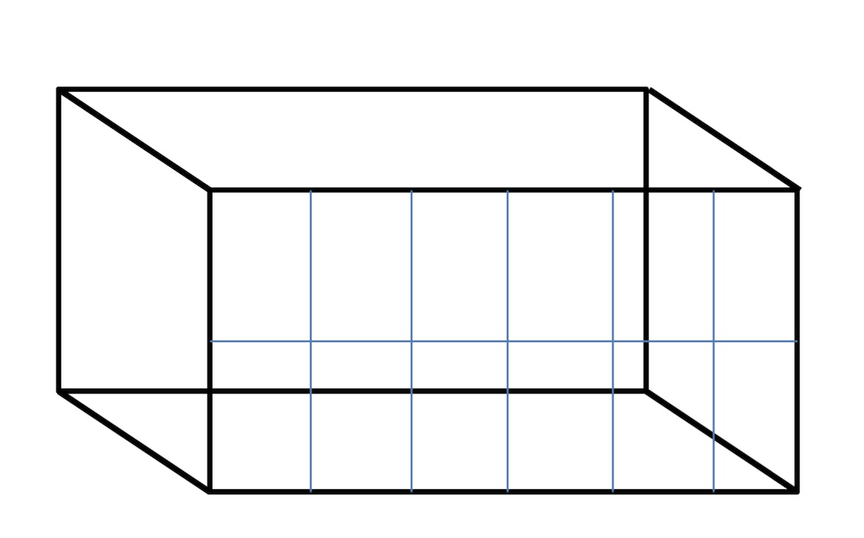

Analysis
We used a generalized least squares model with dam as a random effect to examine variation in nuchal hump size, considering the factors of temperature treatment, activity level and their interaction.

Results
Variation in the nuchal hump size was best explained by temperature treatment (χ² = 47.5, df = 1, P < 0.001) and activity levels (χ²= 5.6, df = 1, P = 0.018). The best model did not include the interaction of these factors (Fig. S2).

Fig. S2
The relationship between nuchal hump size and activity levels by treatment. An inverse relationship was detected in males from the warm (red) and cold (blue) environments

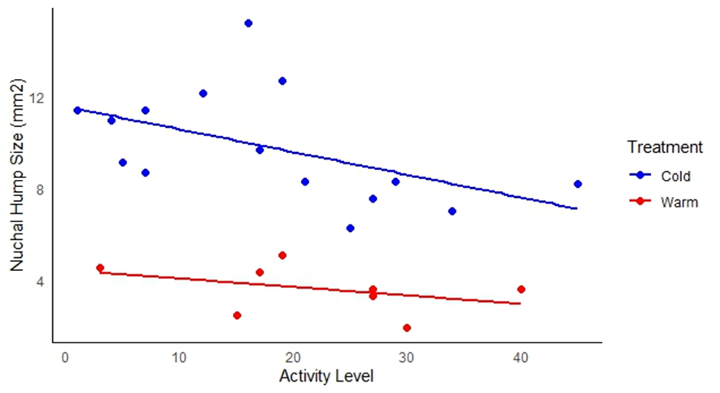

Discussion

The significant influence of activity levels on the relative size of the nuchal hump at 330 days, controlling of rearing temperature, suggests that being active may use energy stored in the nuchal hump. The activity tests were not conducted at the same age as the measures of the nuchal hump size (between 538 - 765 days as compared to 330 days). And yet, activity was still significantly associated with nuchal hump size. These results suggests that activity may be a trait that is relatively stable over long timescales. Boldness, a trait that also involves activity, was found to be stable over a period of 56 days in the swordtail X. birchmanni (Boulton et al. 2014). It will be important to examine the stability of activity levels over time in addition to the influence of variation in this factor on fat deposition in future studies of this species.

References
Boulton K, Grimmer AJ, Rosenthal GG, Walling CA, Wilson AJ (2014) How stable are personalities? A multivariate view of behavioural variation over long and short timescales in the sheepshead swordtail, Xiphophorus birchmanni. Behavioral Ecology and Sociobiology, 68, 791-803

