Supporting Information
Cellulose Nanocrystals Prepared by Different Methods as Toughening Agents in Sodium Alginate/Polyacrylamide Hydrogels for Flexible Sensors
Wenrong Che a, Ziyang He a, Yuhang Chi a, Baohui Li a, Jianwei Zheng a, Xianhai Zeng b, *, Miao Zuo a, *

- College of Forestry, Hebei Agriculture University, Baoding, 071101, PR China.
- College of Energy, Xiamen University, Xiamen, 361102, PR China.
E-mail: zuomiao@hebau.edu.cn; xianhai.zeng@xmu.edu.cn
Tel/Fax: +86 0592 2880701
This supplementary information file includes:
Supplementary Videos 1-1
Supplementary Figures 1-7
Supplementary Tables 1-7
Supplementary References 1-8
S1 Supplementary Videos
Video S1 (.mp4 format). Demonstration of the strong self-adhesive properties of DES-CNC/SA/PAAM hydrogel by using forceful hand manipulation.
Video S2 (.mp4 format). Resistance under 300 consecutive stretch-release processes at 50% tensile strain change
Video S3 (.mp4 format). Demonstration of the self-healing properties of DES-CNC/SA/PAAM hydrogel.
S2 Supplementary Figures
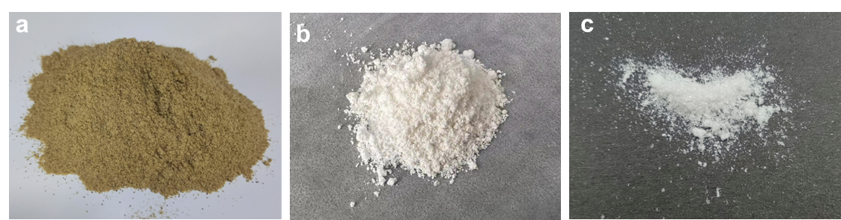 Fig. S1 Optical photographs of the Gleditsia sinensis peel, S-CNC, and DES-CNC.
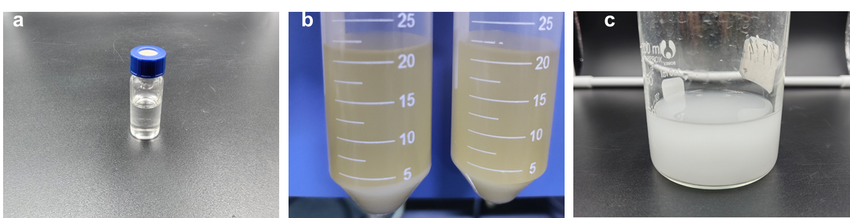
Fig. S2 (a) Choline chloride Citric acid and aqueous DES solution. (b-c) Optical photographs of the centrifuged DES-pretreated microcrystalline cellulose and the corresponding DES-CNC suspensions.

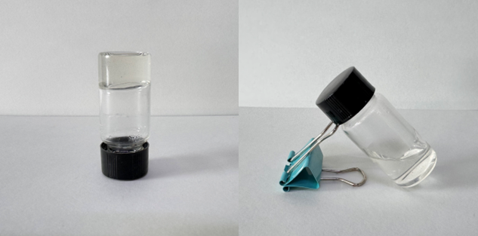
Fig. S3 Images showing the gelation process of CNC/SA/PAAM.
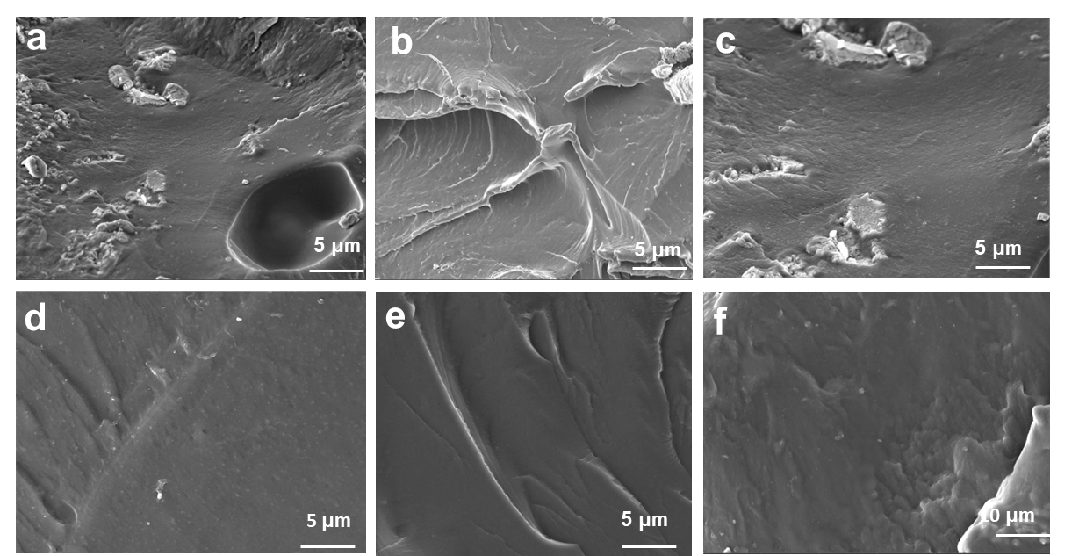
Fig. S4 SEM spectrum of CNC/SA/PAAM hydrogel surface.
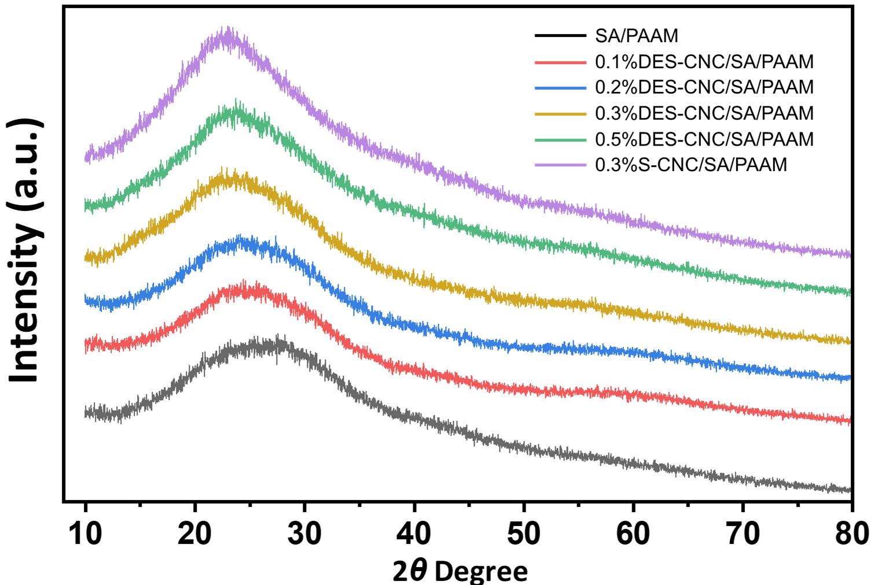
Fig. S5 XRD pattern of CNC/SA/PAAM hydrogel.
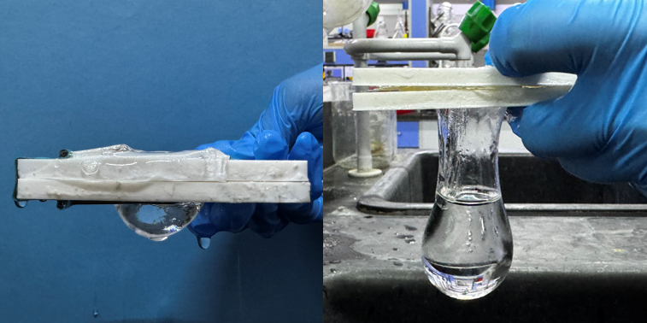
Fig. S6 Photograph of hydrogel forming a water balloon.
Fig. S7 Mass changes in 0.3%DES-CNC/SA/PAAM hydrogels.
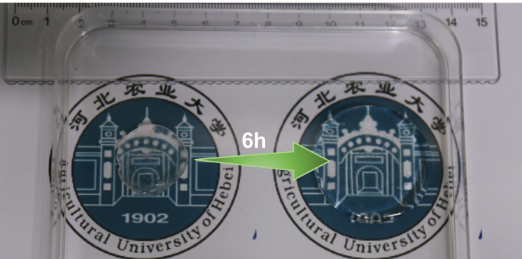
Fig S8 Photograph of DES-CNC/SA/PAAM hydrogel after 6 h of swelling.
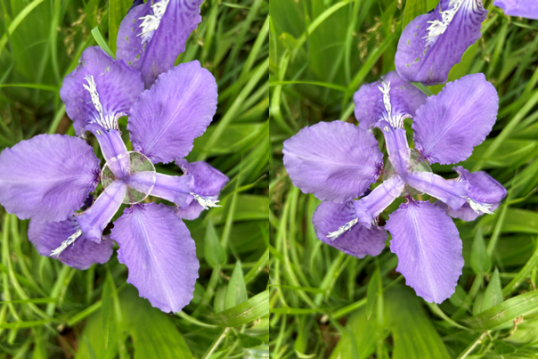
Fig S9 Transmittance photos of 0% DES-CNC/SA/PAAM (left) and 0.3% DES-CNC/SA/PAAM (right).
Fig S10 Electrical conductivity of hydrogels with different DES-CNC contents.

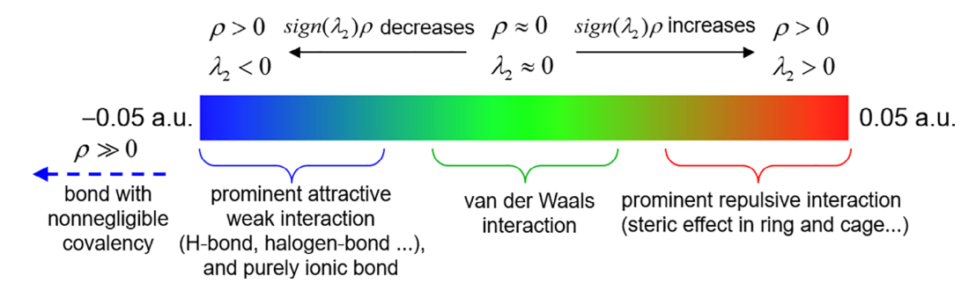
Fig. S11 Schematic classification of weak intermolecular interaction forces.
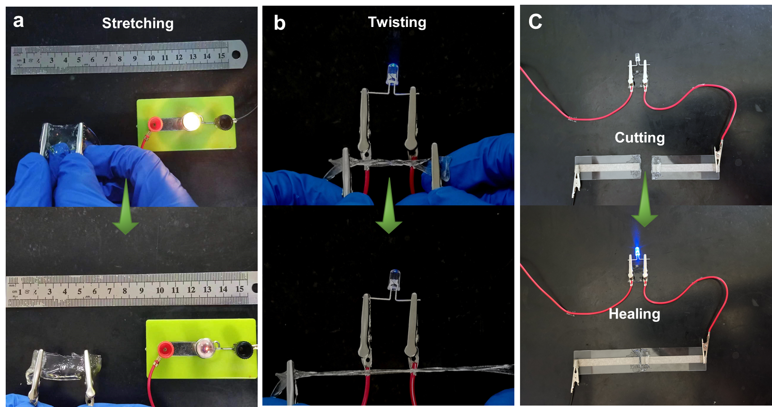
Fig. S12 DES-CNC/SA/PAAM hydrogel undergoes stretching and twisting of light bulb and diode brightness, change in light bulb brightness after hydrogel self-healing.
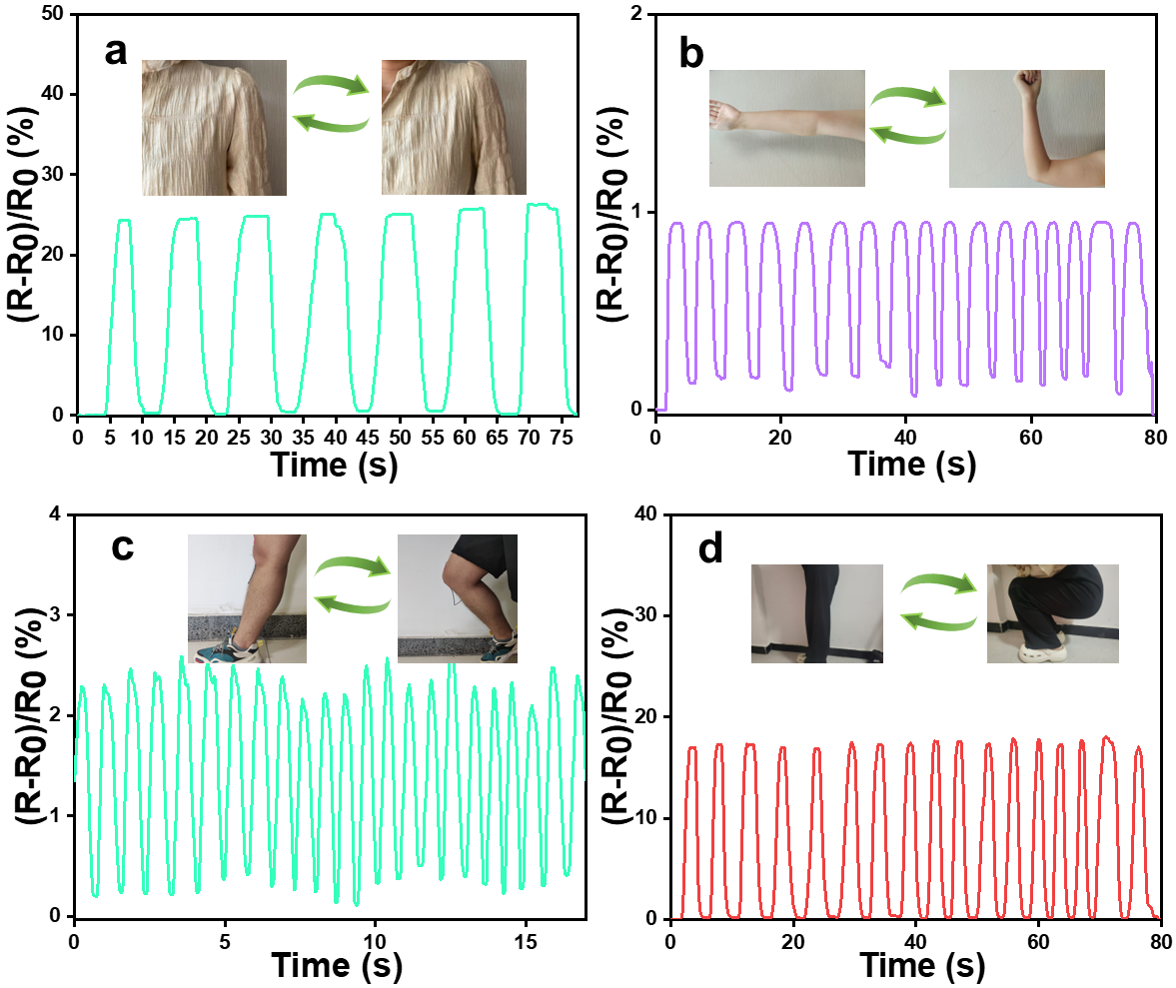
Fig. S13 Corresponding over-the-shoulder, elbow joints, running, and squatting signals.
S4 Supplementary Tables
Table S1 Numerical mechanical properties of DES-CNC/SA/PAAM hydrogels with different DES-CNC contents
Samples | Stress  (Kpa) |  | Strain (%) | modulus of elasticity (MPa) | Toughness  (kj m⁻³)
DES-CNC/SA/PAAM |  | 28.58 | 1349.58 | 0.08 | 131.54
0.1%DES-CNC/SA/PAAM |  | 36.54 | 2534.51 | 0.14 | 305.36
0.3%DES-CNC/SA/PAAM  0.5%DES-CNC/SA/PAAM |  | 50.58  46.69 | 1824.94  1669.48 | 0.14  0.19 | 261.73  254.35
Table S2 Kinetic parameters of swelling of hydrogel samples in distilled water.
Samples | Q_{eq} (g/g) | Q_{w} (g/g) | Ks (g/min.g) | n | Kw
DES-CNC/SA/PAAM | 6.70 | 7.68 | 0.006428 | 0.47993 | 0.00866
0.1%DESCNC/SA/PAAM | 8.56 | 9.75 | 0.007105 | 0.45368 | 0.01017
0.3%DES-CNC/SA/PAAM | 6.09 | 8.10 | 0.002042 | 0.64588 | 0.00600
0.5%DES-CNC/SA/PAAM | 6.96 | 9.12 | 0.002457 | 0.65486 | 0.00666
0.3%S-CNC/SA/PAAM | 6.55 | 14.50 | 0.000280 | 0.79631 | 0.00307

