Supplementary information
Methyl acrylate Functionalized Hyper-Crosslinked Polymers and Their Efficient Adsorptive Removal of Aromatic Small Molecule Compounds from Water
Xiaobei Huang ^{a, b}, Xiaolin Wang ^{a, b}, Shibao Zhu ^{c}, Qingyuan Zhang ^{c}, Yutong Wang ^{c}, Yuli Fu ^{c}, Zisheng Xiao ª (corresponding author), Mangcai Xu ª (corresponding author), Shihua Zhong ª (corresponding author)
ª College of Chemistry and Chemical Engineering, Open Foundation of National & Local Joint Engineering Laboratory for New Petro-chemical Materials and Fine Utilization of Resources, Key Laboratory of the Assembly and Application of Organic Functional Molecules of Hunan Province, Hunan Normal University, Changsha 410081, China
^{b} Changsha Institute for Food and Drug Control，National Liquor Product QuaLity Supervision and Inspection Center, Changsha 410081, China
^{c} School of Materials Science and Engineering, Tianjin University of Technology, Tianjin 300384, China
__________
Corresponding Author. *Zisheng Xiao, E-mail: zishengxiao@hunnu.edu.cn;
*Mancai Xu, E-mail: romann@hunnu.edu.cn;
*Shihua Zhong, E-mail: zhongshihua@hunnu.edu.cn.

1. Experimental section
1.1 Materials.
Styrene (St), divinylbenzene (DVB), methyl acrylate (MA), 2,2'-Azobis(2-methylpropionitrile) (AIBN), 4-Methyl-2-pentanol (MIBC), Dichloromethane (DCM), anhydrous aluminum (III) trichloride (AlCl₃), aniline, phenol, salicylic acid were purchased from Energy-Chemical. These agents were analytical reagents and used without further purification.
1.2 Synthesis of methyl acrylate functionalized hyper-crosslinked polymers.
Aqueous phase: Dissolve 5% gelatin in 210 mL of water and add 10% sodium chloride (to prevent polar monomers from polymerizing in water) into a 500 mL three necked flask, then stir and heat to 323 K.
Oil phase: Styrene, 8% of the content of divinylbenzene and different content (20%, 15%, 10%, 5%) of methyl acrylate were mixed, AIBN (1% of the monomer) as initiator and MIBC as porogen (60% of the monomer).
The mixed oil phase was added to the three-necked flask containing the water phase, stirring and heating to 323 K. Thereafter, the temperature was gradually raised to 363 K and maintained for 12 h. Then, these samples were collected, washed and extracted in a Soxhlet apparatus with ethanol. The synthesized polymer was designated as SDM.
DCM was selected as the solvent and AlCl3 as the catalyst, followed by high crosslinking reaction. The reaction temperature was set to 313 K and the reaction time is 24 h. The highly crosslinked product was named HSDM.
1.3 Characterization.
The Fourier transform infrared spectroscopy (FT-IR) of polymers was subjected to measurement by KBr disk method using Nicolet 510P Fourier transform infrared spectroscopy (Thermo Nicolet Corporation, USA) in the range of 500-4000 cm⁻¹. Its resolution is 1.0 cm⁻¹. The pore structure of the polymer was determined by a nitrogen adsorption-desorption isotherm (77 K) using a Micromeritics ASAP 2020 Surface Area and Porosity Analyzer (Micromeritics Instrument Corporation, USA). Prior to measurement, a degassing process was carried out for 300 min at a nitrogen purge and degassing pretreatment temperature of 363 K. The BET surface area (S_{BET}) was calculated by the BET model including P/P₀=0.05-0.30, and the total pore volume was calculated (V_{total}) at P/P₀=0.99. The micropore area (S_{micro}) and micropore volume (V_{micro}) were determined by the Barrett-Joyner-Halenda (BJH) model, while the pore size distribution (PSD) was calculated by the non-local density functional theory (NLDFT) model. The X-ray photoelectron spectroscopy (XPS) of the samples was investigated on a Thermo ESCALAB 250Xi (ThermoFisher-VG Scientific, China) spectrometer with an Al K-alpha source. The chlorine content of the polymers was measured according to the Volhard method. The concentration of phenol in aqueous solution was determined using a UV-2450 spectrophotometer.
1.4 Adsorption isotherm and adsorption kinetics.
0.2 g wet polymers after absorbing the surface moisture with filter paper and put it into a dry 50 mL erlenmeyer flask with 25 mL adsorbate aniline solution with its initial concentration at 100, 200, 300, 400, and 500 mg/L, respectively. Placed these flasks in a constant temperature oscillator at a certain temperature (288, 298, and 308 K), and shaken at 120 r/min for 24 h. The equilibrium concentration of aniline solution was measured at the maximum adsorption wavelength (aniline: λ_{max} = 280 nm), then calculated the equilibrium adsorption capacity of the polymer on the adsorbate q_{e} (mg/g) according to the equation q_{e} = (C₀-C_{e})V/(W(1-x)). (Eq.1)
Where q_{e} is the equilibrium capacity (mg/g), C_{e} and C₀ are the equilibrium and initial concentration (mg/L), V is the solution volume (L), W and x (%) were the mass of wet polymer (g) and water content of the polymers, respectively. The adsorption isotherms of aniline for each polymer at a certain temperature were plotted with C_{e} as the abscissa and q_{e} as the ordinate. Determine the adsorption isotherms of phenol (λ_{max} = 269 nm) and salicylic acid (λ_{max} = 296 nm) using the same method.
The operation of kinetic adsorption was as follows. 0.8 g wet polymers were accurately weighed and added to a 250 mL erlenmeyer flask and pipette 100 mL of adsorbate aniline solutions with its initial concentration at 500 mg/L. Placed these flasks in a constant temperature oscillator at a 288 K, and shaken at 120 r/min. Collected the solution at different time intervals, and measured the absorbance after diluting. Recorded the concentration and time (t) of sampling, and stopped sampling when the concentration does not change. Recorded the time when the adsorption reached equilibrium, then calculated the q_{t} (mg/g).
1.5 Effect of initial pH on the adsorption capacity.
About 0.2 g wet polymers was introduced into a sequence of 50 mL of erlenmeyer flasks with 25 mL a certain concentration of aqueous solutions, respectively. Then the erlenmeyer flasks were settled and shaken in a thermostatic oscillator at a certain temperature for 2 h and 120 r/min speed sampling. The effects of initial pH values of the aqueous solutions on the adsorption performance for the polymers were conducted with 500 mg/L of aniline in the aqueous solution at 288 K, and the initial pH was set to be 5.0, 6.0, 7.0, 8.0, 9.0 10.0 11.0 and 12.0, respectively. The effects of initial pH values of the aqueous solutions on the adsorption performance for the polymers were conducted with 500 mg/L of phenol in the aqueous solution at 288 K, and the initial pH was set to be 3.0, 4.0, 5.0, 6.0, 7.0 8.0 9.0 and 10.0, respectively. The effects of initial pH values of the aqueous solutions on the adsorption performance for the polymers were conducted with 500 mg/L of salicylic acid in the aqueous solution at 288 K, and the initial pH was set to be 3.0, 4.0, 5.0, 6.0, 7.0 8.0 9.0 and 10.0, respectively. The initial pH of the solutions was adjusted by NaOH or HCl aqueous solutions.
1.6 Repeated adsorption and desorption experiments.
About 0.2 g wet polymers was added into a 50 mL conical flask, 25 mL aniline (or phenol or salicylic acid) solution with an initial concentration of 100 mg/L was added. Placed the flask in a constant temperature oscillator at 298 K, and shaken at 120 r/min for 2 h. The equilibrium concentration of solution were measured at the maximum adsorption wavelength, and calculate the adsorption amount according to the formula Eq.1. After the HSDM@aniline was desorbed with 0.01 mol/L (w/v) of HCl and 60% (v/v) of ethanol, the HSDM@phenol and HSDM@SA were desorbed with 70% (v/v) of ethanol, washed with water and filtered. The above adsorption operation was repeated five times.
1.7 Dynamic adsorption and desorption experiments.
Accurately measure 10.0 mL of wet polymers tightly packed into monolith with glass sand core column (16 mm). The concentration of the upper column aniline solution was 537.7 mg/L. At room temperature, the upper column solution was passed through the column at a flow rate of 1.5 BV/h. Collected the effluent, while the volume of the effluent and the corresponding effluent concentration were determined. The leakage point and the saturation point were defined when the effluent concentration was 5% and 95% of the upper column concentration, respectively. Desorption process: (i) Rinse the column with 1 BV deionized water; (ii) Add the mixed solution of 0.01 mol/L (w/v) of HCl and 60% (v/v) of ethanol as desorbent, then pass through the column at a flow rate of 1.0 BV /h. Collected the effluent, and record the effluent volume and concentration.

2. Supplementary Figure.
Figure S1 N₂ adsorption-desorption isotherms.

Figure S2 Equilibrium isotherms of phenol adsorption on the HSDMs at 288 K.
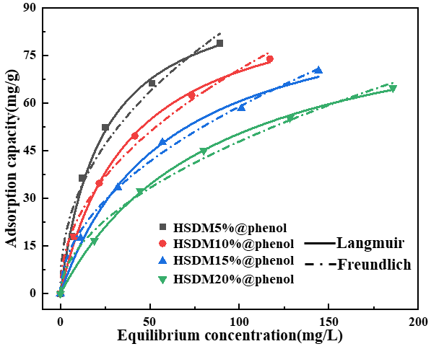

Figure S3 Equilibrium isotherms of SA adsorption on the HSDMs at 288 K.
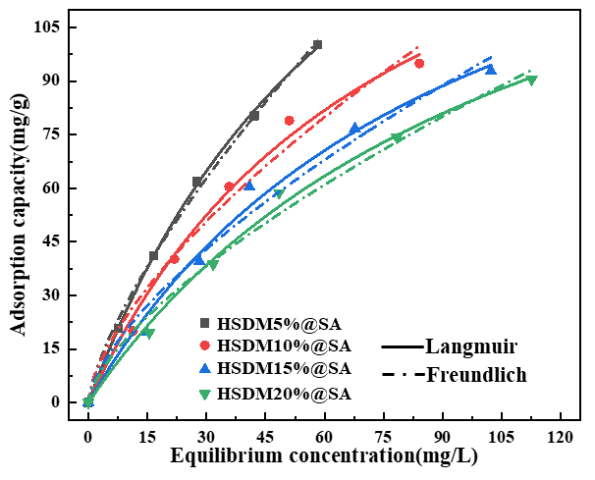

Figure S4 Equilibrium isotherms of phenol adsorption on the HSDM-5 at 288, 298 and 308 K.
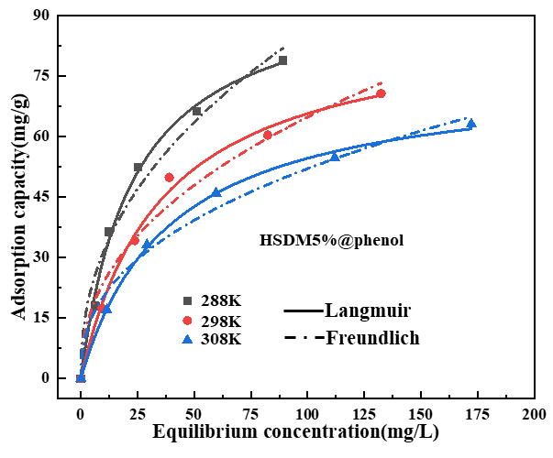

Figure S5 Equilibrium isotherms of SA adsorption on the HSDM-5 at 288, 298 and 308 K.
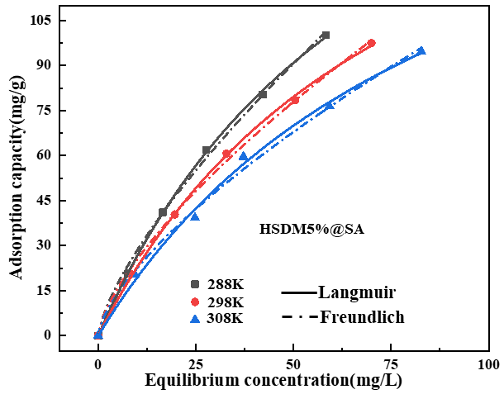

Figure S6 Vant-Hoff plotting of lnc_{e} versus 1/T*10^3 (HSDM-5@phenol)
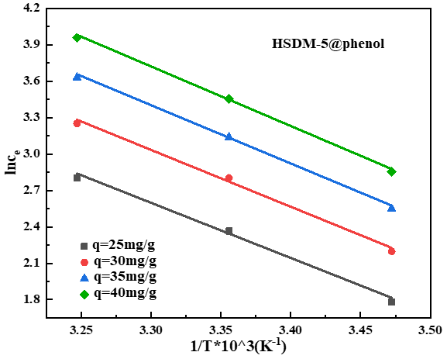

Figure S7 Vant-Hoff plotting of lnc_{e} versus 1/T*10^3 (HSDM-5@SA)
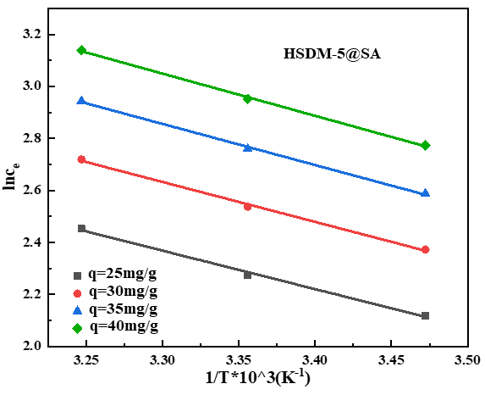

Figure S8 Weber-Morris model of HSDM-5 adsorption aniline, phenol and SA.

Figure S9 FT-IR spectra of HSDM before and after aniline, phenol and SA adsorption.
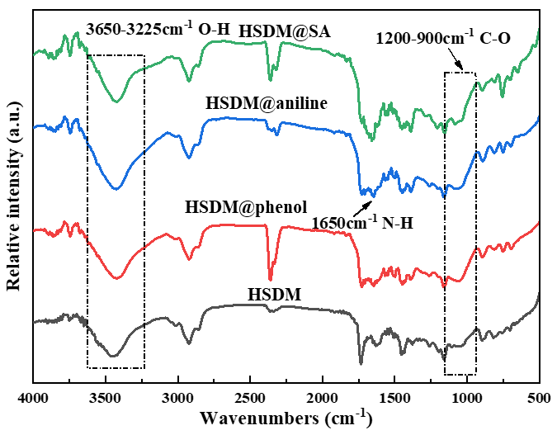

Table S1 Correlated parameters of the equilibrium data for the adsorption of aniline on the polymers at 288 K according to the Langmuir and Freundlich model
Sample | Langmuir model |  |  | Freundlich model
Sample | K_{L} (L/mg) | q_{m} (mg/g) | R² | K_{F} (mg/g)((L/mg)^{1/n}) | n | R²
HSDM-5 | 3.01×10⁻² | 103.79 | 0.9968 | 9.49 | 0.465 | 0.9710
HSDM-10 | 2.29×10⁻² | 97.45 | 0.9934 | 7.83 | 0.466 | 0.9592
HSDM-15 | 1.88×10⁻² | 90.21 | 0.9958 | 6.29 | 0.478 | 0.9869
HSDM-20 | 1.42×10⁻² | 83.34 | 0.9940 | 5.09 | 0.479 | 0.9889

Table S2 Correlated parameters of the equilibrium data for the adsorption of phenol on the polymers at 288 K according to the Langmuir and Freundlich model
Sample | Langmuir model |  |  | Freundlich model
Sample | K_{L} (L/mg) | q_{m} (mg/g) | R² | K_{F} (mg/g)((L/mg)^{1/n}) | n | R²
HSDM-5 | 4.30×10⁻² | 98.75 | 0.9942 | 11.45 | 0.438 | 0.9698
HSDM-10 | 2.58×10⁻² | 97.10 | 0.9985 | 8.09 | 0.471 | 0.9913
HSDM-15 | 1.71×10⁻² | 95.95 | 0.9949 | 5.87 | 0.501 | 0.9941
HSDM-20 | 1.14×10⁻² | 94.54 | 0.9994 | 4.24 | 0.527 | 0.9912

Table S3 Correlated parameters of the equilibrium data for the adsorption of SA on the polymers at 288 K according to the Langmuir and Freundlich model
Sample | Langmuir model |  |  | Freundlich model
Sample | K_{L} (L/mg) | q_{m} (mg/g) | R² | K_{F} (mg/g)((L/mg)^{1/n}) | n | R²
HSDM-5 | 1.31×10⁻² | 229.98 | 0.9994 | 5.45 | 0.629 | 0.9972
HSDM-10 | 1.31×10⁻² | 185.87 | 0.9914 | 5.45 | 0.656 | 0.9745
HSDM-15 | 1.05×10⁻² | 181.96 | 0.9874 | 4.54 | 0.661 | 0.9720
HSDM-20 | 0.90×10⁻³ | 180.98 | 0.9950 | 3.90 | 0.671 | 0.9851

Table S4 The thermodynamic parameters of HSDM-5 adsorption aniline
q  (mg/g) | ΔH  (kJ/mol) | ΔG (kJ/mol) |  |  | ΔS (J/(mol·K))
q  (mg/g) | ΔH  (kJ/mol) | 288K | 298K | 308K | 288K | 298K | 308K
25 | -25.59 | -5.15 | -5.72 | -6.53 | -70.97 | -66.66 | -61.88
30 | -27.73 | -5.15 | -5.72 | -6.53 | -78.42 | -73.86 | -68.84
35 | -29.54 | -5.15 | -5.72 | -6.53 | -84.71 | -79.94 | -74.73
40 | -31.12 | -5.15 | -5.72 | -6.53 | -90.16 | -85.21 | -79.83

Table S5 The thermodynamic parameters of HSDM-5 adsorption phenol
q  (mg/g) | ΔH  (kJ/mol) | ΔG (kJ/mol) |  |  | ΔS (J/(mol·K))
q  (mg/g) | ΔH  (kJ/mol) | 288K | 298K | 308K | 288K | 298K | 308K
25 | -37.76 | -5.46 | -5.70 | -6.50 | -112.13 | -107.58 | -101.50
30 | -38.92 | -5.46 | -5.70 | -6.50 | -116.18 | -111.50 | -105.29
35 | -39.91 | -5.46 | -5.70 | -6.50 | -119.61 | -114.81 | -108.49
40 | -40.77 | -5.46 | -5.70 | -6.50 | -122.58 | -117.68 | -111.26

Table S6 The thermodynamic parameters of HSDM-5 adsorption SA
q  (mg/g) | ΔH  (kJ/mol) | ΔG (kJ/mol) |  |  | ΔS (J/(mol·K))
q  (mg/g) | ΔH  (kJ/mol) | 288K | 298K | 308K | 288K | 298K | 308K
25 | -12.28 | -3.33 | -3.57 | -3.86 | -31.06 | -29.23 | -27.33
30 | -12.74 | -3.33 | -3.57 | -3.86 | -32.68 | -30.80 | -28.84
35 | -13.14 | -3.33 | -3.57 | -3.86 | -34.05 | -32.12 | -30.12
40 | -13.48 | -3.33 | -3.57 | -3.86 | -35.23 | -33.26 | -31.23

Table S7 Fitted parameters for the kinetics adsorption data of aniline, phenol and SA on the HSDM-5 by pseudo-first-order rate and pseudo-second-order rate equations at 288 K
Adsorbate | Pseudo-first-order |  |  | Pseudo-second-order
Adsorbate | k₁  (min⁻¹) | q_{m}  (mg/g) | R² | k₂  (g/(mg·min)) | q_{cal}  (mg/g) | R²
aniline | 0.0436 | 69.69 | 0.9215 | 8.34×10⁻⁴ | 76.41 | 0.9575
phenol | 0.0490 | 68.68 | 0.8990 | 1.01×10⁻³ | 74.07 | 0.9519
SA | 0.0378 | 89.35 | 0.9802 | 5.00×10⁻⁴ | 98.40 | 0.9944

Table S8 Morris-Weber model constants and values of HSDM-5 adsorption aniline, phenol and SA.
adsorbate | aniline | phenol | SA
k¹_{ip} | 6.16 | 6.16 | 11.04
k ²_{ip} | 4.42 | 1.93 | 3.30
k ³_{ip} | 0.18 | 0.17 | 0.38
C¹ | 11.04 | 12.82 | 2.27
C² | 24.96 | 46.65 | 46.75
C³ | 68.76 | 68.52 | 85.39
R₁² | 0.9550 | 0.9867 | 0.9809
R₂² | 0.9211 | 0.9712 | 0.9884
R₃² | 0.9797 | 0.9122 | 0.9466

References
[1] Mekonnen M, Hoekstra A (2018) Global Anthropogenic Phosphorus Loads to Freshwater and Associated Grey Water Footprints and Water Pollution Levels: A High-Resolution Global Study. Water Resources Research 54: 345-358
[2] Fu Y, Liang J, Xiao J, Su S, Xu M, Lei T, Zhong S (2024) Preparation of phenolic hydroxyl-modified hyper-crosslinked polymers and their adsorption performance towards small molecular aromatic amines. Separation and Purification Technology 332: 125733
[3] Fu Y, Gong H, Su S, Lei T, Zhong S (2023) Fabrication of O-enriched Macroporous Polymer for the efficient adsorption organic acid from aqueous solution. Journal of Polymer Research 30: 441
[4] Li F, Chen B, Han Y, Cao Y, Hong X, Xu M (2021) Enhanced adsorption of caprolactam on phenols-modified Amberlite XAD16. Reactive and Functional Polymers 161: 104850
[5] Suliman S, Othman N, Noah N, Kahar I (2023) Separation of phenolic compounds from fruit processing wastewater using liquid membrane technology: A short review. Biochemical Engineering Journal 200: 109096
[6] Wu D, Hui C, Dong H, Pietrasik J, Ryu H, Li Z, Zhong M, He H, Kim E, Jaroniec M, Kowalewski T, Matyjaszewski K (2011) Nanoporous Polystyrene and Carbon Materials with Core-Shell Nanosphere-Interconnected Network Structure. Macromolecules 44: 5846-5849
[7] Huang J, Turner S (2018) Hypercrosslinked Polymers: A Review. Polymer Reviews 58: 1-41
[8] Schwab M, Lennert A, Pahnke J, Jonschker G, Koch M, Senkovska I, Rehahn M, Kaskel S (2011) Nanoporous copolymer networks through multiple Friedel-Crafts-alkylation-studies on hydrogen and methane storage. Journal Of Materials Chemistry,. 21: 2131-2135
[9] Veverka P, Jerabek K (1999) Mechanism of hypercrosslinking of chloromethylated styrene-divinylbenzene copolymers. Reactive and Functional Polymers 41: 21-25

