Appendix
Option Characteristic Curves for each item used to estimate a type of child abuse can be found below. P1 to P5 represent the response curve for a specific option from the item. Specifically, P1 represents a response of “Never”, P2 represents “1-2 times”, P3 represents “3-5 times”, P4 represents “6-10 times”, and P5 represents “10+ times”. Theta (θ) provides an estimate of the severity of maltreatment, where higher values indicate a higher frequency of abuse is required for selecting the response option, and P(θ) represents the probability of selecting the response option based on a given theta value.
Figure A1. Option Characteristic Curve for Physical Abuse Item 1
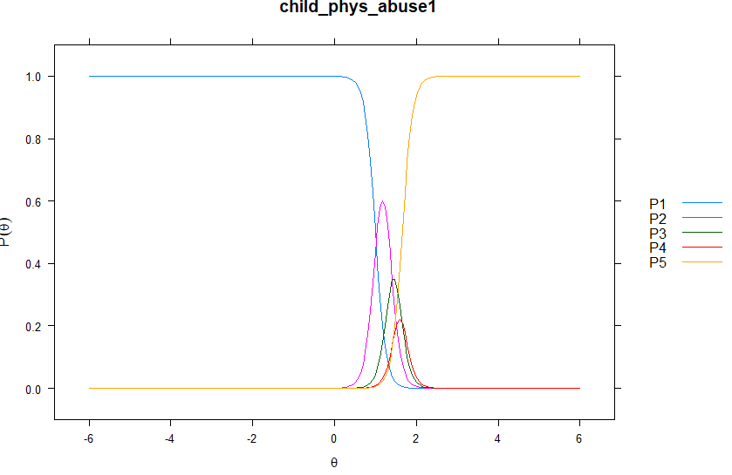

Figure A2. Option Characteristic Curve for Physical Abuse Item 2
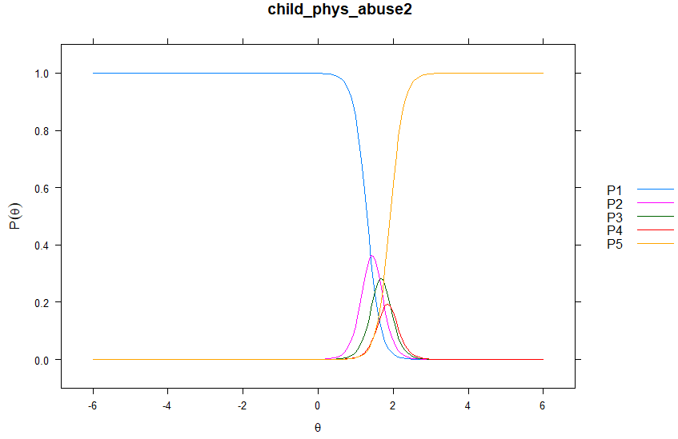

Figure A3. Option Characteristic Curve for Physical Abuse Item 3
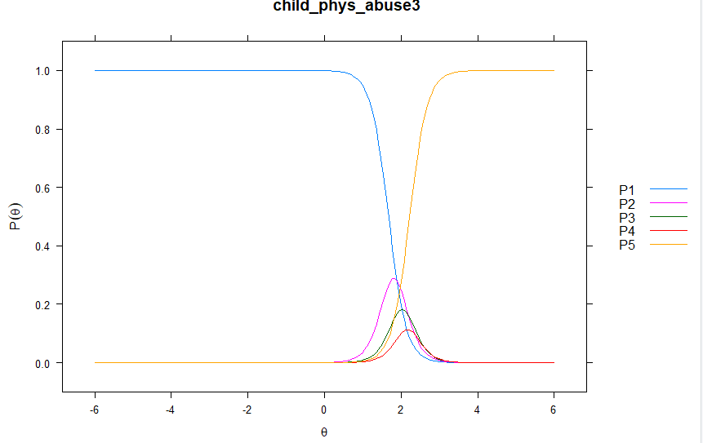
Figure A4. Option Characteristic Curve for Sexual Abuse Item 1
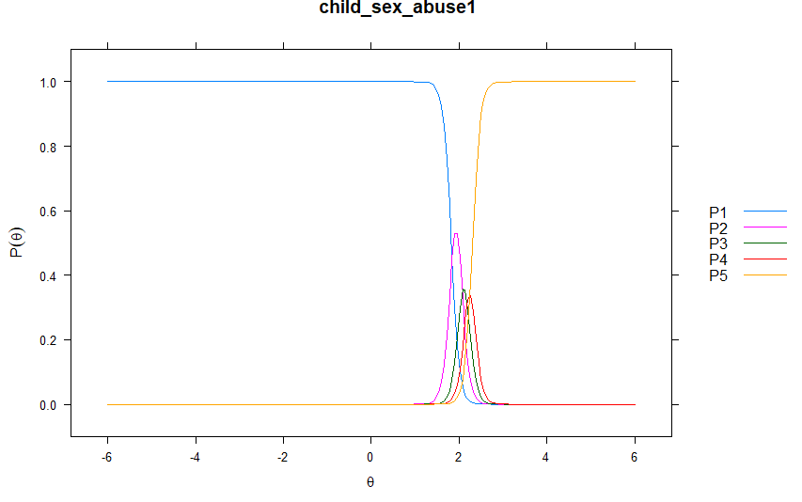

Figure A5. Option Characteristic Curve for Sexual Abuse Item 2
