Table 1- The most frequent collocations with Cantonese(粤语) in news headlines
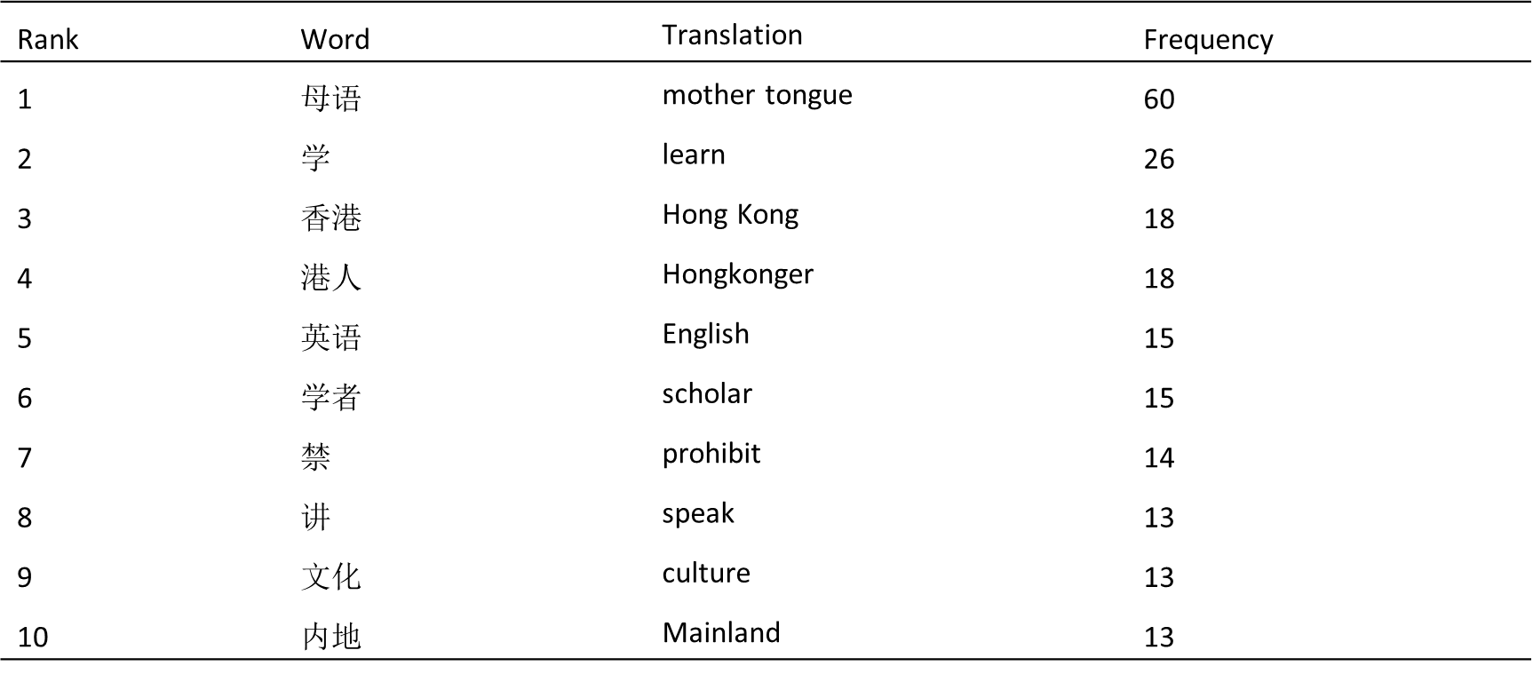

Table 2- The most frequent collocations with TC (繁体字 or 正体字) in the news headlines
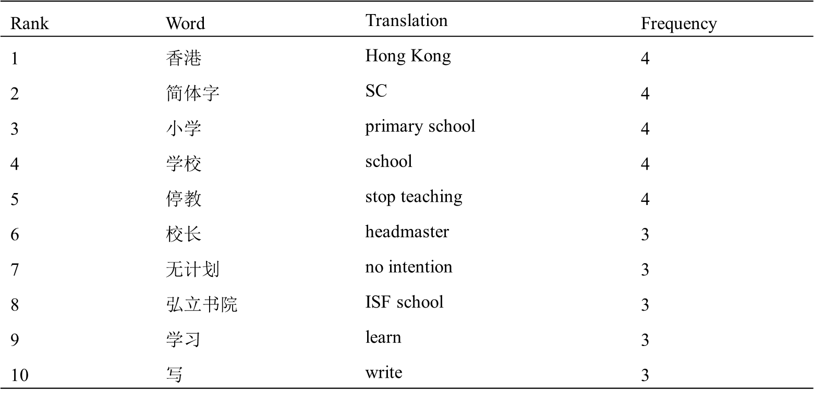

Table 3- The most frequent collocations with putonghua (普通话) in news headlines
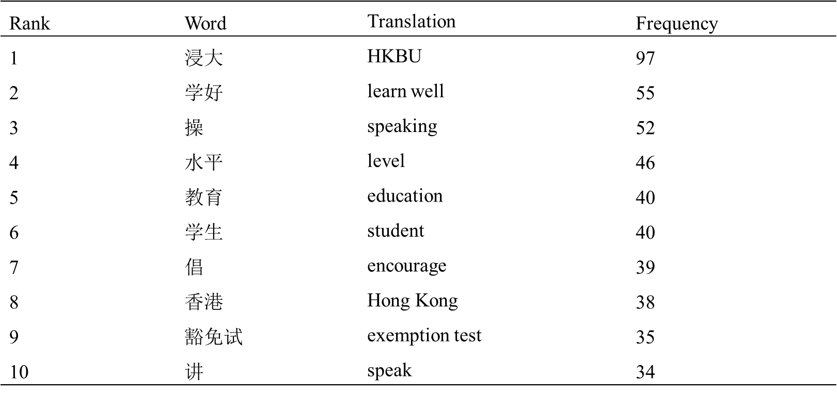

Table 4- The most frequent collocations with SC (简体字) in news headlines
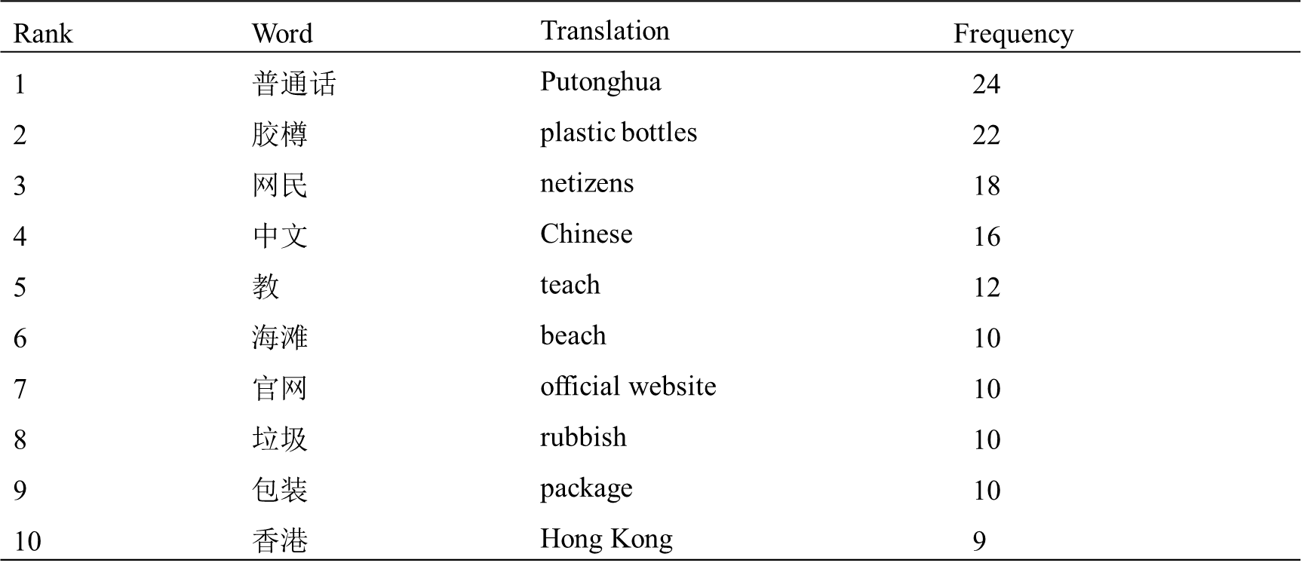

Table 5 - Number of articles containing the terms related to national identity as collocation of Putonghua in news headlines
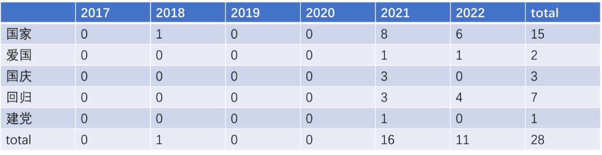

Table 6- Four modality of language-in-identity construction in HK media discourse
