Supporting Information

Phase Transition and Anisotropic Transport of MoS₂/Chlorophyll Van der waal Heterostructure Formed via Biomimetic Photo-electron Donation

Debmallya Das^{1†}, Jhimli Sarkar Manna^{2*†}, Tarun Kanti Bhattacharyya²

supporting information 1:
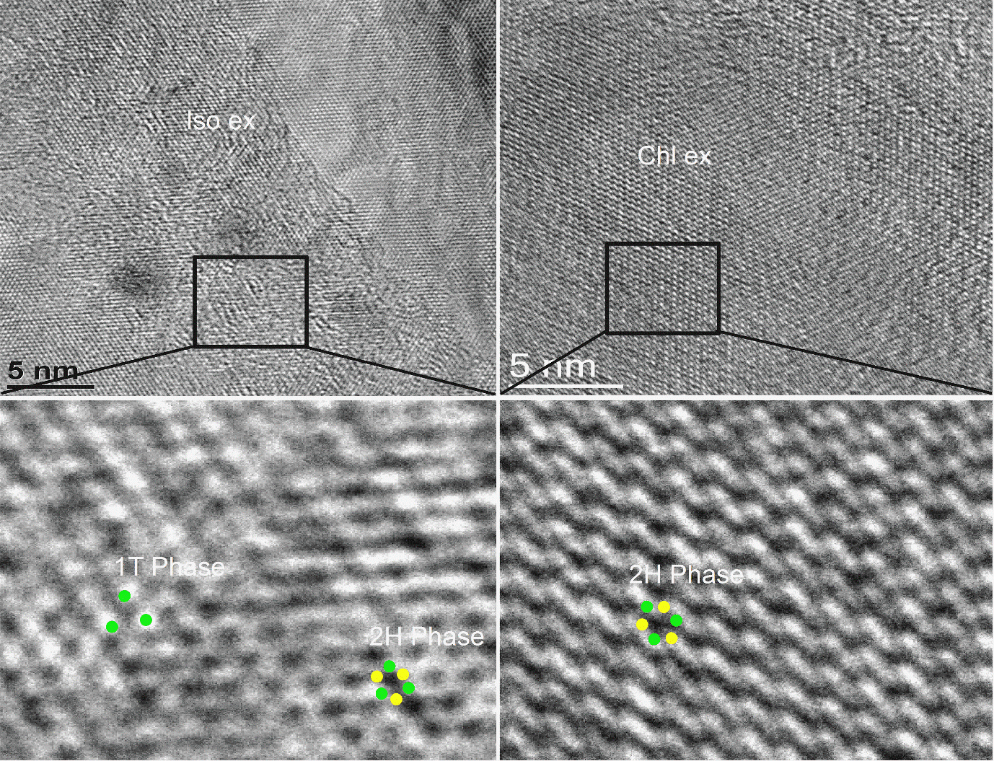
Figure 2 S.Figurecaption :iso: exfoliated without chlorophyll, CHLex: exfoliated with chlorophyll
MoS₂ prepared via sonication-assisted exfoliation without CHL-a consists of different structural domains [supporting information 3]. Honeycomb lattice of 2H-MoS₂ single layers along with the 1T signature of the hexagonal lattice was observed in various regions of the samples and can be readily explained by the effect of thermal vibrations and the presence of surface contaminations.
supporting information 2:
$$γi=\frac{1}{g_{i}}πN(ϵ_{f})λ_{i}ω_{bi}^{2}$$
where (ε_{f}) is the electronic density of states at the Fermi level per eV per spin per unit cell, g_{i} is the mode degeneracy and ω_{bi}is the bare frequency in the absence of electron-phonon interaction. In our Raman spectra, the A_{1g} mode at 112.4 cm⁻¹ shows the largest asymmetry line shape, which is relevant in the context of conventional superconductivity. Since the peak position of this mode varies only slightly with temperature, we take the bare frequency ω_{bi}as 112.4 cm⁻¹. With g_{i}= 1 for a A_{1g}mode, γ_{i}= 9.4 cm⁻¹ as deduced from Fig. 1(d), and N(ε_{f})= 2.8178 states/eV/spin/unit cell from our band structure calculations, we get λ_{i}= 0.68, a value close to λ = 0.85 estimated from calculations.
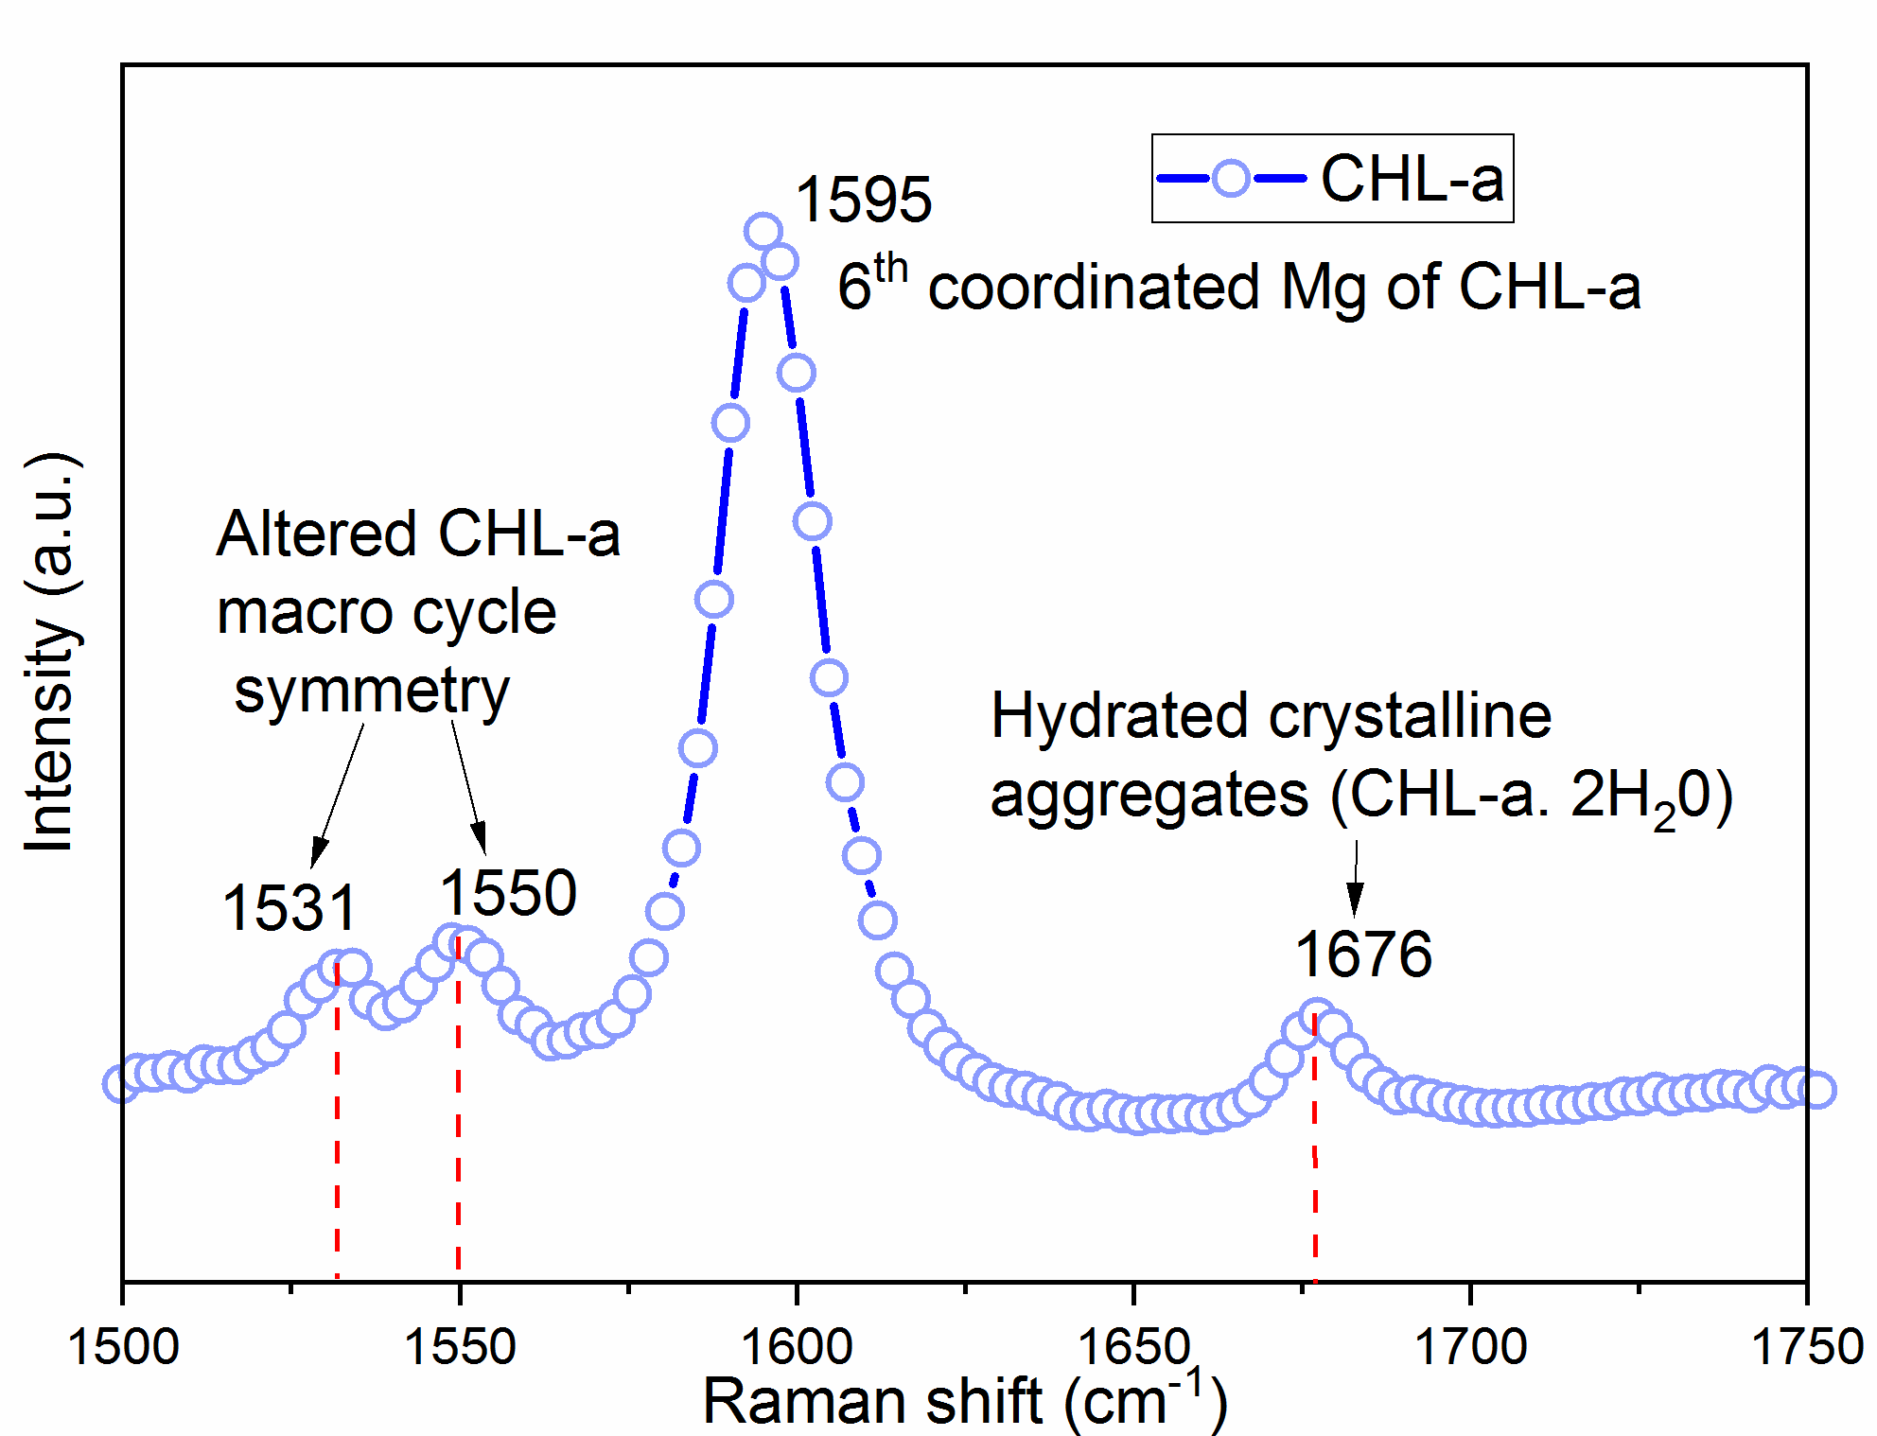
Figure 2S. Raman shift in chlorophyll zone of 2H MoS₂ chlorophyll heterostructure
supporting information 3:
Photo-Emission data:
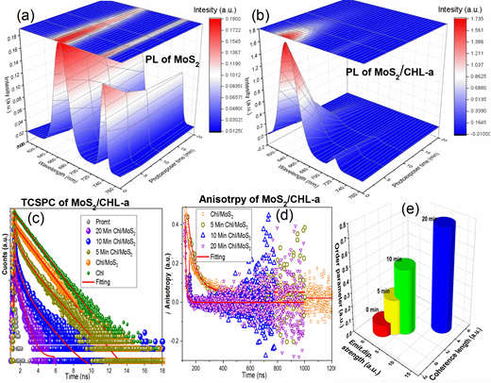
Figure 3S.Time dependent photoluminescence spectra of as exfoliated MoS₂(a) and CHL-a/MoS₂.(b) showing that CHL-a exfoliated samples undergo phase-conversion with light exposure (c), (d)& (e)TCSPC, fluorescence anisotropy and the relationship of the order parameter, emission dipolar strength with coherence length data respectively of all the samples.

Emission portfolio suggests that with increased photo-exposure CHL-a/MoS₂ convert to 1T phase as no 675 nm peak corresponding to CHL-a emission is present in Fig. 2 (a). With photo-exposure both the 720 nm and 675 nm PL emission peak rapidly quenches in CHL-a exfoliated counterpart as a result of electron transfer from CHL-a to MoS₂ converting it to 1T phase. On the other hand, the 740nm peak remains almost the same in bare counterpart where no CHL-a molecules were present, [providing evidence that this peak originates from the staked MoS₂] with a slight decrease in 675 nm with photo-exposure in bare counterpart reveals that 1T phase evolved with photo-exposure in CHL-a intercalated MoS₂.
- TCSPC table:

Sample | τ₁(ns) | a₁ | τ₂(ns) | a₂ | <τ>(ns) | χ2
CHL-a | 0.88907 | 0.113 | 4.68 | 0.887 | 4.59042 | 1.2
5 min | 0.54616 | 0.8906 | 4.51 | 0.1094 | 2.54221 | 1.23
10 min | 0.34068 | 0.928 | 2.96 | 0.072 | 1.39539 | 1.18
20 min | 0.41023 | 0.9533 | 1.3 | 0.0467 | 0.5298 | 1.32
Table 1 S. Decay Time Components of All Samples (Excitation at 405 nm; Emission at 633nm)

MoS₂/CHL-a nanohybrids with 5 min, 10 min, and 20 min photo exposer respectively.χ2=Curve fitting residual parameter.
Table 2 S. Fluorescence Quantum Yields, Radiative Rates, Non-Radiative Rates & Coherence Length Together with the Relative Dipole Strengths of all samples
Samples | Quantum  yield  (±3%) | Rad. rate  k_{rad}  (ns⁻¹)  (±6%) | Non-  Rad. rate  k_{nrad}  (ns⁻¹)  (±6%) | k_{rad}/  k_{nrad} | Refractive  index n | Emit. dip.  strength  (|μ|2)  (±6%) | Coherence  Length(pk_{rad}  /mk_{rad})
CHL-a | 0.30a | 0.049 | 0.155 | 0.31 | 1.36 | 1.00 | ----
5 min | 0.18 | 0.0708 | 0.32255 | 0.21951 | 1.33 | 2.73 | 1.08347
10 min | 0.17 | 0.12183 | 0.59481 | 0.20482 | 1.33 | 4.71 | 1.86426
20 min | 0.16 | 0.302 | 1.58552 | 0.19048 | 1.33 | 11.67 | 4.62131

- Radiative decay rate (k_{rad}):
The radiative decay rate (k_{rad}) can be calculated using the following relation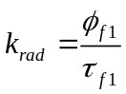 from the quantum yield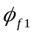 and the fluorescence lifetime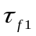.
Radiative decay rate (k_{rad}):
The radiative decay rate (k_{rad}) can be calculated using the following relation from the quantum yield and the fluorescence lifetime.
Sample | τ_{f}(ns) | a₁ | τ_{s}(ns) | a₂ | S
0 min | 0.5422 | 0.99172 | 0.092 | 0.0082 | 0.091
5 min | 0.4852 | 0.92871 | 0.162 | 0.0712 | 0.267
10 min | 0.44067 | 0.75892 | 0.2135 | 0.2410 | 0.491
20 min | 0.08140 | 0.3822 | 0.38 | 0.6177 | 0.786
c) Table3 S. Fluorescence anisotropy of all samples and order parameter of all samples

order parameter or S parameter obtained from Debye equation: S=a _{slow}^{0.5};
wherea_{slow}=contribution of the slow component of fluorescence anisotropy.
Probable Stabilization phenomenon and anisotropic structure formation:
Unlike the semiconducting 2H-MoS₂, the 1T-MoS₂ monolayer is metallic 34 and the electronic states around the Fermi level are mainly composed of the Mo 4d and S 3p states which are only partially filled 35. These states provide room for the unpaired electrons to pair up with the chemical groups, leading to a strong interaction. Upon excitation, the Mg atom of CHL-a becomes a strong oxidizing agent and if the charge transfer state lives long enough, should surrender this electron to any reasonable acceptor here MoS₂ 35. The electron transfer is also prominent from a deep electronic pocket in band dispersion near Γ symmetry point, along with the lifting in the density of state degeneracy of Mo 4d orbital creating an asymmetric pseudogap in DFT analysis[Fig. 3 (f)].
The radiative decay rate can subsequently be related to the dipole strength of the emitting state using the formula of the Einstein coefficient for spontaneous emission.

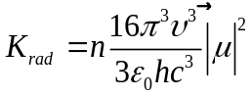 (2)
From eq (2), the refractive index n is of the solvent, is the emission wavelength in cm-1, and the vacuum dielectric constant is of the direct surroundings. Using the radiative lifetime from 30 we calculate the dipole strength from eq.2,[supporting information 3, table 1S & 2S].
Very interesting observation found in bi exponentially fitted TCSPC curve. The relative amplitude of a shorter lifetime gradually increases and the longer lifetime component corresponding to more planar conformer gets decreased implying that more amounts of species participating in decay channel and support the conformational heterogeneity of the chlorophyll population. Which is obvious as more amount of CHL-a participates in electron donation reaction with longer photo exposure time, and after electron donation their conformation change to non-planarity. As a result, positively charged CHL-a+ having nonplanar macrocycle evolved 31. The conformational heterogeneity may have occurred via static and dynamic disorder of the porphyrin introduced via strong electron-phonon 31 coupling with electron donation as evident from Raman spectroscopy. As the photo exposure time progressed, the evolution of the 1T phase via superlattice formation is evident from TEM. The distorted lattice behaves differently with CHL-a in terms of Van der waal interaction or π-stacking which might give the favorable surface for CHL-a macrocycle to come into contact and donate electrons. The structural fluctuation introduced this way results in coupling difference which is evident in the enhanced nonradiative lifetime, coherence length, and dipolar strength with gradual photo exposure, [supporting information 3, table 2S] implying that strong localized electronically coupled structures are formed with increasing photo-exposure time which participates in electron transfer. Since electronic coupling causes molecules to behave coherently, the coherence can be reduced by static and dynamic disorder, which leads to localization. A short and spectrally broad excitation pulse creates a coherent superposition of several exciton states, i.e., an excitonic wave packet. Because of interference, the wave packet may have a major part of its amplitude in a very much localized region of the aggregate. The greater coherence length also supports the significance of faster decay component with time where excitonic delocalization faces lesser disorder with gradual photo exposure.
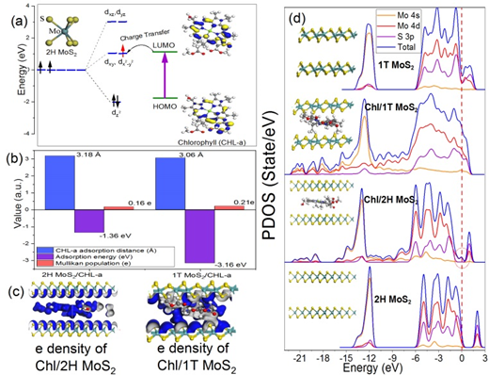
Figure 4S. (a) The occupation of electrons in Mo 4d orbitals under the crystal fields of 2H phase showing photoexcited electron transfer mechanism from CHL-a LUMO derived from DFT calculation. (b) Comparison of adsorption energy, adsorption distance, and Mulliken population of 2H MoS₂ CHL-a and 1T MoS2 CHL-a, (c) Isosurface data depicts that the CHL-a molecule is almost parallel over the MoS₂ plane with no significant bending in any of the structure. The charge rearrangements are prominent between the electron cloud of the 1T MoS₂ and the electronic states of the CHL-a. (d) Partial density of state from DFT calculation shows band renormalization through hybridization in both the MoS₂ CHL-a heterostructures.

Looking at the band alignment of CHL-a and 2H-MoS₂ [Fig.4S (a)] we can assume that heterostructure provides an opportunity towards the formation of charge-transfer complex by donating photo-excited electron from CHL-a to MoS₂. We also found the prominent charge transfer transition probability centered at around 720nm in PL emission spectra, providing insight that 1T phase can be formed and stabilized36.
The stabilization phenomenon has also been substantiated by DFT calculation where we found that relative stability of positively charged CHL-a and 1T MoS2heterostruture increases as the adsorption energy decreases from -1.36 eV [2H MoS₂/CHL-a] to -3.16 eV [1T MoS₂/CHL-a; Fig. 4S (d)]. It can be explained from PDOS where modulation of electronic structure mainly happens in Mo 4d and 4s orbital state. In the monolayer 1T-MoS₂, the Mo atom is located at the center of the anti layer, prism crystal field, and the state of 4d orbital electrons is split into dx2-y2/dz2, dyz/dxz/dxy, where dyz, dxz, and dxy compose triple degenerate state for the ground state37. According to the reference37, the dxy/dyz/dxz degenerate ground energy level is partially filled, whereas the dx2-y2/dz2 degenerate energy level is higher than the Fermi level and is not filled. PDOS shows the modulation of Mo 4d orbital which creates the pseudogap-like structure by lifting the degeneracy of DOS with 3S in 1T MoS₂. This might lead to subsequent stabilization. From the optimized geometries (Fig. 4 (d)), it is evident that, the CHL-a molecule is almost parallel over the 2H MoS₂ plane at room temperature Fig. 4S (c) and the band gap of the 2H MoS₂ reduces to 0.61 eV from 1.9 eV as the conduction band shifted towards low energy after the CHL-a intercalation.
The Van der waal interaction regime between the CHL-a molecule and the 2H MoS₂ is 3.18 Å, excluding the possibility of chemical bond formation. This is stabilized with high negative adsorption energies [-1.36 eV] with massively amplified Pauli pushback Figure 4S (d). The reason for that is, here one enters the regime of Fermi-level pinning, the “weak-coupling regime” with only negligible charge transfer between molecular states and the 2H MoS₂, as is usually observed for physisorption. The “pushed-back” electrons are accumulated directly above the 2H MoS₂surface. After the photoexcitation, CHL-a donates its excited electrons to MoS₂ by interacting with the 4d orbital of Mo, as CHL-a LUMO is closely situated 2H MoS₂ dx2-y2/dz2 orbital [Fig. 4S (a)]. The excess electrons alter the symmetry of the 2H MoS₂, [Fig. 1 (g)] hence the situation of iso-surface changes qualitatively in the 1T MoS2/CHL-a regime [Fig.4S (c)]. The distance is reduced to 3.06 Å and adsorption energy is reduced to -3.16 ev, with enhanced charge transfer evident from Mulliken population analysis. [Fig. 4S (b), supporting information 4, table 3S].
supporting information 4:
DFT Computational details:
Density functional theory (DFT) calculations lend further insight into CHL-a interactions with MoS2 and the accompanying electronic effects. The DFT computations were performed by using the Quantum Expresso 6.1 package. Electron exchange-correlation is represented by the functional of Perdew, Burke, and Ernzerhof (PBE) of generalized gradient approximation (GGA).45 A cutoff energy of 570 eV was used for the plane-wave basis set. The convergence threshold for structural optimization was set to be 0.02 eV/Å in force. A reasonable mesh cut-off of 320Ry is used for the grid integration to represent the charge density. We have sampled the Brillouin zone by 4 × 4 × 1 k-points using the Monkhorst-Pack scheme for electronic property calculations. Periodic boundary conditions and the supercell approximation are taken in such a way so that the distance between an adsorbate CHL-a molecule and its periodic image is more than 10 Å to avoid any unintentional interactions between them. We have considered the 2H MoS₂ supercell as it is a thermodynamically stable phase [18]. The MoS₂ supercell is 8 × 8 in size (it contains 64 Mo atoms and 128 s atoms and one S layer, followed by one Mo and another S layer). To mimic our experimental scenario the CHL-a molecule is intercalated in between the two 2H and 1T MoS₂ sheets which are separated 10 Å along the z-axis from each other. For simplicity, we have ignored the phytyl chain of the CHL-a molecule and only consider the porphyrin ring.
From the optimized geometries (figure 2 (f)), it is evident that the CHL-a molecule is almost parallel over the 2H MoS₂ plane and there is no significant bending in any of the structures and the distance between the molecule and the 2H MoS₂ layer is ⩾3 Å is observed. Therefore, there is no possibility of chemical bond formation between the CHL-a and the MoS₂ layer. The van der waal interaction regime between the CHL-a molecule and the 2H MoS₂ is 3.18 Å, which is stabilized with high negative adsorption energies [ -1.36 eV] opens up a new peak in PDOS near the Fermi level [as evident from MD simulation, Fig: 2 (f)] resulting massively amplified Pauli pushback. The reason for that is, here one enters the regime of Fermi-level pinning, the “weak-coupling regime” with only negligible charge transfer between molecular states and the MoS₂, as is usually observed for physisorption. The “pushed-back” electrons are accumulated directly above the MoS₂ surface. After the photoexcitation CHL-a donates its excited electrons to MoS₂ by interacting with the 4d orbital of Mo, the excess electrons alter the symmetry of the 2H MoS₂,[Fig 2 (g)] hence the situation of iso-surface changes qualitatively in the 1T MoS₂ CHL-a regime [Fig 2 (g)].
We have performed the Mülliken population analysis of the systems to calculate the amount of charge (electron) transfer from the CHL-a molecule to the MoS₂ plane and found that the charge transfer increases to a small amount from 2H MoS₂ to 1T MoS₂ due to the enhancement of adsorption energy from −1.36 to −3.16 eV (table 1). The bandgap of the 2H MoS₂ reduces to 0.61 eV from 1.9 eV as the conduction energy states shifted towards low energy after the CHL-a intercalation. The massive broadening of all molecule-derived features in the PDOS [fig 2 (f)] is indicative of a particularly strong hybridization.
Table 4S
Sample name | E_{adsorption} (eV) | Distance (Å) | Charge transfer (e) | Band Gap (eV) | HOMO-LUMO gap of the CHL-a (eV)
CHL-a | -- | -- | -- | -- | -2.8
2H MoS2 | -- | -- | -- | 1.9 | --
2H MoS2/CHL-a | -1.36 | 3.18 | 0.16 | 0.61 | --
1T MoS2/CHL-a | -3.16 | 3.06 | 0.21 | 0 | --

We calculated the electronic structure of the pristine 2H MoS₂ and found that our calculated band-gap (1.9 eV) of MoS₂ compares well with experimental findings. Table 2S displays the adsorption energies, charge transfer, and bandgap for CHL-a intercalated 2H and 1T MoS₂. The large (negative) adsorption energy indicates favorable and strong CHL-a interactions with the MoS2 basal plane, even in the absence of surface defects. The calculated LUMO energy level (+1.1) of the CHL-a is closer to the valence band (VB) of the 2H MoS₂. Thus, electrons from the LUMO energy level of the excited CHL-a can be transferred easily to the 2H MoS₂, as observed in PL and TCSPC spectra from the experimental section.

Molecular dynamics Computational details:
Molecular dynamics (MD) simulation performed on Forcite module of Quantum Expresso 6.1. Molecular mechanics and the MD method were used to determine the dynamic behavior of CHL-a molecule on the 1T MoS₂ surface at a constant temperature ranging from 263K to 323K. The universal force field was used to describe the 1T MoS₂ surface and CHL-a molecule. For the non-bonding interactions, the Ewald method was adopted to calculate the electrostatic interaction in the adsorption system. The van der Waals energy was calculated by the atom-based method with a cut-off of 12.5 Å. The initial distance between the 1T MoS₂ surface and the porphyrin plane of the CHL-a molecule was set as 18 Å. All the calculations were performed using the Discover module.
supporting information 5:
Device fabrication:
We inserted chlorophyll molecules into the MoS₂ through exfoliation in water-alcohol media, similar to the process we opted earlier for graphene exfoliation. The water content of 10 mL of MoS₂ [1 mg/mL] in ethanol (SigmaAldrich, ACS reagent, >99.5%) solution, gradually increased along with low power sonication (120 W), so that the amphiphilic CHL-a molecules [conc 10⁻⁷mol], present in alcohol, enter into MoS₂ by finding their way to the gaps opening up at the edges through sonication to minimize hydrophobic interaction causing a substantial volume expansion of the MoS₂ crystal, where interlayer spacing increases from the original 3.16 Å to 3.2 Å. The dimension of molecules may be used to tailor the structure (such as interlayer spacing and molecule packing density) and properties (electron-doping level) of intercalated compounds. The resultant nanosheets were washed repeatedly through centrifugation, 2,000 r.p.m. for 3 min to remove the excess chlorophyll and large aggregates, and then dispersed in DI water to formulate a stable and easy-to-handle MoS₂ solution. The slightly greenish-yellow colour [figure 5S (b)] of the dispersion is indicative of the formation of relatively thin, semiconducting nanosheets.
An n-type Si wafer was used as a substrate. Si wafer was thermally oxidized to achieve a 200 nm SiO₂ layer which is necessary for device fabrication. In order to improve the adhesion of gold on SiO₂, a 10 nm Cr interlayer was used. Gold layer (thickness 200 nm) was deposited on the Cr layer by DC sputtering. The gold layer was patterned lithographically to design the source and drain electrodes. The width and gap of the electrodes are 220 μm and 45 μm respectively.
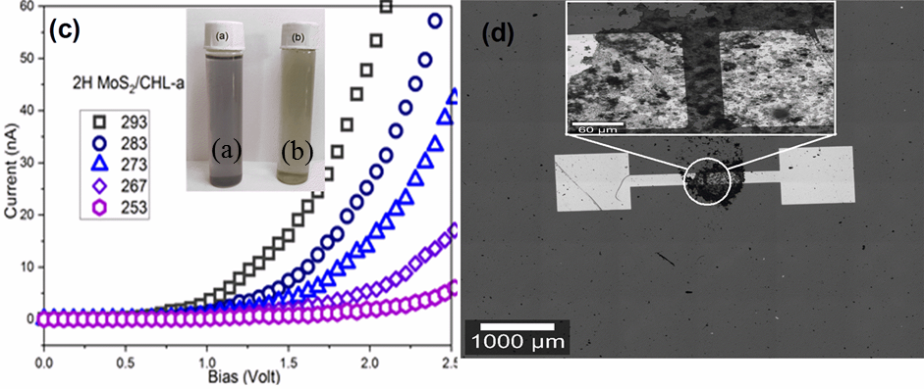
Figure 5S. a) Bulk MoS₂ suspended in water, (b) CHL-a exfoliated 2H MoS₂ suspended in water. (c) Temperature dependent 2H MoS₂ /CHL-a current/voltage characteristics. (d) two port device images after drop casting MoS₂ /CHL-a on Au electrode.

Effective mass calculation:
The effective mass was calculated along the various crystallographic directions by fitting the band structure DFT data for bare 1T MoS₂ and 1T MoS₂ /CHL-a using following equation:
$${E\left(k\right)=\frac{-1±\sqrt{1+4α\frac{ħ^{2}k^{2}}{2m}}}{2 α}+Ec}^{0}$$
Where E(k) is the energy of the band at reciprocal space point k, α is a fitting parameter that quantifies the non-parabolicity of the band, m is the effective mass, and ${Ec}^{0}$ is the band extrema.
Supporting information 6:
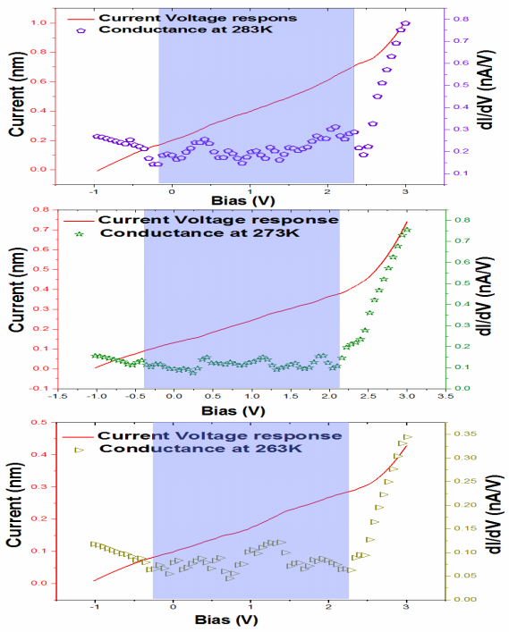
Figure 6S.Temperature-dependent conductance of 1T MoS₂/CHL-a heterostructure below 293K

