Epidemiological features of the infertility, 1990–2021 and 15-year projection: An analysis of the global burden of disease study 2021
Jiale Feng^{1†} ,Qingguo Wu^{1†},Yangbing Liang¹,Yiwen Liang¹ and Bin Qin^{1*}

¹Department of Urology, Guigang People’s Hospital, The Eighth Affiliated of
Guangxi Medical University, Guigang 537100, Guangxi Zhuang Autonomous Region, China
† Jiale Feng and Qingguo Wu contributed equally to this work.
Jiale Feng Email: 961049790@qq.com
Qingguo Wu Email: wuqingguowu@163.com
Yangbing Liang Email: 2676836857@qq.com
Yiwen Liang Email:67351174@qq.com

*Correspondence: Bin Qin, Department of Urology, Guigang People’s Hospital, The Eighth Affiliated of Guangxi Medical University, Guigang 537100, Guangxi Zhuang Autonomous Region, China. Email: qbin081@126.com

Acknowledgements
We sincerely thank collaborators who contributed to the GBD 2021.

Author contributions
Jiale Feng conceived, designed the manuscript. Qingguo Wu and Yangbing Liang did a literature search and download the data. Jiale Feng and Yiwen Liang analysis and interpretation, compiled tables and figures, Jiale Feng ,Qingguo Wu and Bin Qin drafted the manuscript, proofed and interpreted the report. Bin Qin are the corresponding authors. All authors participated in data analysis, interpretation, discussion and writing of the manuscript, and all authors read and approved the final version of the paper.

Funding
Not applicable.

Consent for publication
Not applicable.

Competing interests
All authors have no conflicts of interest to declare.

Table S1 The number of prevalence cases and ASPR (per 100,000 population) of Male infertility and Female infertility in 2021, and percentage change of ASPR were analyzed across 204 countries and territories
Countries and territories | Male infertility |  |  | Female infertility
 | Num_2021 | ASPR_2021  per 100,000 | EAPC_CI  1990-2021 | Num_2021 | ASPR_2021  per 100,000 | EAPC_CI  1990-2021
Afghanistan | 82555 (60010-109613) | 585.09  (432.08-764.44) | -1.39%  (-1.65--1.13) | 103774 (65690-142851) | 787.89  (505.09-1083.29) | -2.5%  (-2.93--2.07)
Albania | 9223 (6726-12695) | 669.86  (491.43-917.98) | -1.18%  (-1.86--0.49) | 12163 (8866-15886) | 975.38  (708.81-1270.08) | -1.48%  (-2.56--0.39)
Algeria | 241720 (135725-390349) | 1013.95 (565.16-1647.28) | 1.78%  (1.55-2.02) | 411463 (180229-736498) | 1710.6  (738.66-3052.16) | 2.87%  (2.53-3.21)
American Samoa | 252 (142-400) | 1085.2 (612.04-1747.87) | -0.03%  (-0.04--0.02) | 450 (190-851) | 2013.9  (832.55-3735.02) | -0.12%  (-0.15--0.09)
Andorra | 374 (201-611) | 824.6  (435.71-1363.3) | -0.04%  (-0.07--0.02) | 495 (139-1018) | 1060.44  (276.89-2236.9) | -0.23%  (-0.29--0.16)
Angola | 227759 (126022-367404) | 1800.68 (1017.65-2952.35) | 0.01%  (-0.02-0.04) | 533943 (287662-941956) | 3816.96  (2002.37-6678.34) | 0.24%  (0.22-0.27)
Antigua and Barbuda | 711 (405-1152) | 1505.75 (851.09-2451.31) | -0.01%  (-0.02-0) | 1447 (740-2618) | 2887.06  (1477.76-5235.94) | 0.05%  (0.03-0.07)
Argentina | 244880 (139991-414873) | 1022.31 (583.47-1729.93) | -0.03%  (-0.1-0.05) | 261639 (63094-579074) | 1053.24  (254.95-2334.95) | -0.29%  (-0.37--0.2)
Armenia | 6683 (4701-9212) | 431.14  (302.62-600.38) | -1.93%  (-2.24--1.61) | 7690 (4384-11654) | 495.95  (283-733.71) | -2.7%  (-3.29--2.1)
Australia | 71316 (40257-123061) | 566.75  (318.15-969.69) | -0.06%  (-0.11--0.01) | 16214 (4511-69965) | 123.31  (34.12-515.39) | -0.19%  (-0.36--0.02)
Austria | 71318 (39049-118115) | 1622.47  (907.62-2710.6) | 0.75%  (0.47-1.03) | 126855 (56158-232867) | 2908.71  (1312.34-5314.31) | 1.06%  (0.74-1.38)
Azerbaijan | 77867 (42953-131396) | 1271.84 (709.26-2129.58) | -0.39%  (-1.21-0.43) | 135501 (56369-276168) | 2234.32  (957.83-4399.13) | -0.39%  (-1.64-0.87)
Bahamas | 3086 (1761-5125) | 1526.59  (873.9-2552.71) | -0.04%  (-0.05--0.03) | 6013 (3031-11082) | 2776.93  (1395.96-5143.25) | 0.06%  (0.05-0.08)
Bahrain | 15149 (8766-24343) | 1104.98 (635.05-1815.74) | 0.01%  (0-0.01) | 12863 (5953-22979) | 1875.6  (873.87-3329.38) | 0.06%  (0.03-0.09)
Bangladesh | 640268 (476969-849628) | 741.06  (554.73-981.89) | 0.85%  (0.53-1.16) | 1506087 (1190413-1810954) | 1550.85  (1224.08-1863.47) | 2.96%  (2.56-3.36)
Barbados | 2060 (1172-3366) | 1502.12 (851.23-2491.66) | 0%  (-0.02-0.01) | 4146 (2113-7506) | 2851.21  (1450.79-5186.28) | 0.02%  (0-0.04)
Belarus | 64003 (35736-111882) | 1426.76 (798.91-2445.33) | -0.01%  (-0.02--0.01) | 115515 (50429-227190) | 2565.89  (1176.63-4823.43) | 0.26%  (0.22-0.3)
Belgium | 76409 (42082-124951) | 1443.21  (797.5-2320.8) | 1.54%  (1.12-1.97) | 135219 (58389-247336) | 2498.25  (1108.32-4533.2) | 2.42%  (1.89-2.95)
Belize | 2159 (1204-3578) | 942.42 (534.24-1544.25) | 0.99%  (0.72-1.27) | 3321 (1311-6349) | 1403.46  (538.91-2718.62) | 1.65%  (1.21-2.09)
Benin | 62215 (46183-82438) | 1115.31 (826.91-1471.57) | -1.27%  (-1.33--1.2) | 43774 (17721-70639) | 691.43  (262.8-1155.35) | -1.88%  (-2.15--1.6)
Bermuda | 408 (229-682) | 1503.38 (851.36-2490.79) | 0%  (-0.01-0.01) | 824 (404-1502) | 2864.06  (1465.61-5206.64) | 0.07%  (0.05-0.08)
Bhutan | 3411 (1975-5572) | 699.68 (409.08-1141.15) | -0.1%  (-0.12--0.09) | 6049 (2539-11297) | 1382.93  (581.38-2585.81) | -0.02%  (-0.04-0)
Bolivia (Plurinational State of) | 39123 (21842-65206) | 617.82  (343.9-1046.34) | 1.39%  (0.71-2.07) | 24344 (2796-79116) | 387.39  (44.56-1262.32) | 6.7%  (3.89-9.57)
Bosnia and Herzegovina | 15762 (8386-28127) | 1028.5 (535.53-1769.41) | -0.05%  (-0.06--0.04) | 28239 (11725-59026) | 1912.52  (796.38-3897.24) | 0.16%  (0.13-0.2)
Botswana | 11385 (5882-21210) | 793.34 (411.81-1460.55) | 0.48%  (0.15-0.81) | 32629 (12794-67450) | 2248.96  (894.14-4619.26) | 0.77%  (0.26-1.29)
Brazil | 1335417 (751579-2223673) | 1106.42 (626.91-1857.81) | 1.84%  (1.41-2.28) | 2125447 (887052-4170154) | 1677.47  (709.28-3278.73) | 1.7%  (1.09-2.32)
Brunei Darussalam | 2103 (1153-3659) | 658.79 (359.22-1143.25) | -0.09%  (-0.18-0) | 952 (109-3398) | 347.96  (40.59-1240.4) | -0.46%  (-0.73--0.19)
Bulgaria | 32135 (16713-58437) | 1050.82 (550.05-1830.74) | -0.01%  (-0.02-0) | 56192 (22571-120187) | 1933.64  (797.8-3846.96) | 0.03%  (0.01-0.06)
Burkina Faso | 146018 (86240-236973) | 1637.74  (951.28-2682.6) | -0.73%  (-1.24--0.22) | 151357 (46038-322972) | 1478.92  (429.12-3252.34) | 2.15%  (1.3-3.01)
Burundi | 17048 (12392-22593) | 286.34  (210.07-378.98) | -2.34%  (-2.78--1.9) | 20729 (11395-31123) | 344  (191.58-521.41) | -4.49%  (-5.63--3.33)
Cabo Verde | 7445 (4310-12108) | 2173.28 (1263.58-3422.38) | -0.03%  (-0.04--0.02) | 8535 (3439-16585) | 2767.17  (1159.23-5283.78) | 0.46%  (0.41-0.51)
Cambodia | 89476 (49834-156018) | 969.59 (544.24-1676.42) | -1.75%  (-2.42--1.07) | 220334 (102200-415498) | 2352.48  (1097.29-4398.01) | -2.47%  (-3.42--1.52)
Cameroon | 476601 (273224-762810) | 3280.58 (1939.56-5141.3) | -0.46%  (-1.27-0.35) | 549482 (278289-975463) | 3666.38  (1820.04-6492.82) | 0.32%  (-0.87-1.53)
Canada | 110319 (59785-183430) | 633.56 (344.26-1052.91) | -0.03%  (-0.05-0) | 81972 (8231-216141) | 472.43  (45.82-1256.53) | -0.19%  (-0.24--0.15)
Central African Republic | 66253 (38820-100975) | 2803.4 (1618.38-4341.94) | 0.72%  (0.52-0.92) | 148169 (90817-237833) | 5751.56  (3585.62-9238.57) | 0.7%  (0.47-0.93)
Chad | 129917 (74587-210510) | 2129.96 (1188.81-3548.28) | -2.63%  (-3.31--1.94) | 143985 (52871-287190) | 2112.24  (754.78-4255.64) | -4.22%  (-5.49--2.93)
Chile | 99916 (55869-170472) | 997.51  (555.17-1695.3) | -0.1%  (-0.17--0.03) | 106501 (24098-238349) | 1072.61  (244.32-2385.43) | -0.17%  (-0.29--0.04)
China | 11845804 (6488726-20756171) | 1591.79 (886.51-2708.22) | 0.01%  (-0.05-0.06) | 29317000 (14569167-52098692) | 4144.55  (2149.99-7228.3) | 0.01%  (-0.03-0.05)
Colombia | 107619 (80964-144248) | 397.86  (299.24-531.64) | 0.29%  (0.12-0.47) | 58268 (13249-111088) | 213.19  (48.78-408.02) | 1.23%  (0.59-1.87)
Comoros | 6765 (3756-11000) | 1736.17  (970.5-2811.95) | 0.89%  (0.39-1.39) | 17948 (10106-28707) | 4663.64  (2603.13-7443.88) | 1.02%  (0.46-1.58)
Congo | 37161 (20611-62133) | 1387.03 (773.98-2332.26) | -0.63%  (-1.15--0.11) | 87057 (41048-161490) | 3105.42  (1461.38-5756.32) | -0.52%  (-1.27-0.25)
Cook Islands | 76 (44-121) | 1035.22 (597.82-1686.39) | 0%  (-0.02-0.02) | 178 (79-327) | 2103.25  (936.96-3898.08) | -0.14%  (-0.16--0.12)
Costa Rica | 26724 (14978-45397) | 1055.45 (590.51-1782.78) | -0.04%  (-0.05--0.04) | 49838 (20850-100255) | 1791.2  (758.88-3586.31) | -0.06%  (-0.08--0.04)
C么te d'Ivoire | 360979 (215464-572863) | 2643.52 (1568.36-4217.07) | 0.81%  (0.38-1.23) | 405916 (192551-762142) | 3130.79  (1464.67-5887.37) | 2.59%  (1.87-3.33)
Croatia | 20164 (10641-36518) | 1055.15 (552.84-1818.32) | -0.01%  (-0.02--0.01) | 35645 (14306-77357) | 1940.49  (779.27-4005.15) | -0.15%  (-0.24--0.06)
Cuba | 77789 (44843-130879) | 1498.58 (851.33-2494.68) | 0.01%  (0-0.03) | 144318 (74438-263135) | 2894.76  (1502.44-5266.97) | -0.07%  (-0.14-0.01)
Cyprus | 6600 (3461-11333) | 829.66 (440.59-1407.67) | -0.08%  (-0.11--0.06) | 9763 (2994-20762) | 1104.12  (334.94-2355.03) | -0.49%  (-0.66--0.31)
Czechia | 66984 (35828-117081) | 1409.93 (749.96-2463.73) | 1.11%  (0.69-1.52) | 128037 (58522-245085) | 2818.05  (1319.6-5200.36) | 1.44%  (0.91-1.98)
Democratic People's Republic of Korea | 178265 (97829-315800) | 1160.2  (643.73-2041.9) | 0.04%  (0.01-0.06) | 410661 (201844-776717) | 3035.53  (1493.44-5740.63) | -0.05%  (-0.08--0.02)
Democratic Republic of the Congo | 479436 (267987-769452) | 1189.35 (661.73-1932.69) | -0.76%  (-1.59-0.09) | 862739 (409645-1644018) | 2239.74  (1020.35-4305.76) | -0.8%  (-2.35-0.78)
Denmark | 11994 (6025-21259) | 450.55  (224.47-795.74) | 1.48%  (1.03-1.92) | 8206 (718-22725) | 317.37  (27.29-889.46) | 3.66%  (2.53-4.81)
Djibouti | 13338 (7675-21473) | 1777.91 (1027.08-2864.62) | 0.28%  (-0.18-0.75) | 36059 (20121-58772) | 5304.56  (3029.58-8632.08) | 0.39%  (-0.18-0.95)
Dominica | 528 (302-876) | 1519.64  (869.2-2519.88) | 0.01%  (0-0.02) | 929 (474-1730) | 2804.27  (1437.75-5220.3) | 0.02%  (0.01-0.03)
Dominican Republic | 77529 (44175-132196) | 1280.27 (731.51-2179.92) | 1.34%  (0.61-2.07) | 139681 (63324-270113) | 2384.15  (1080.53-4596.73) | 1.98%  (0.76-3.22)
Ecuador | 59499 (32938-99141) | 632.06  (351.73-1065.9) | 2.18%  (1.64-2.73) | 34628 (4370-118287) | 364.79  (46.01-1240.19) | 9.33%  (7.27-11.42)
Egypt | 463785 (260526-751492) | 833.05  (466.77-1349.87) | 0.92%  (0.58-1.26) | 989412 (442270-1672172) | 1882.51  (847.29-3177.21) | 1.36%  (0.73-2)
El Salvador | 17663 (9688-30302) | 586.9  (321.39-1022.6) | 1.95%  (1.17-2.74) | 26372 (4332-64834) | 749.7  (121.74-1866.44) | 5.16%  (2.94-7.42)
Equatorial Guinea | 14032 (7925-22764) | 1752.89 (995.23-2833.08) | -0.16%  (-0.18--0.15) | 26891 (14679-47461) | 3910.76  (2082.03-7019.98) | 0.27%  (0.22-0.33)
Eritrea | 53372 (30039-87700) | 1530.45 (858.31-2498.82) | 1.64%  (1.45-1.83) | 142798 (79663-237797) | 4420.25  (2431.49-7558.71) | 2.27%  (2.02-2.52)
Estonia | 8784 (4880-15497) | 1434.74  (783.6-2474.49) | 0.01%  (0-0.02) | 15140 (6954-28747) | 2614.71  (1215.59-4726.04) | 0.34%  (0.29-0.38)
Eswatini | 3358 (1766-5957) | 569.24 (299.16-1007.21) | -0.39%  (-1.12-0.34) | 8002 (2446-17221) | 1247.95  (377.37-2664.4) | -0.64%  (-2.39-1.13)
Ethiopia | 409621 (229972-665447) | 808.78 (451.22-1324.26) | -1.07%  (-1.27--0.88) | 992154 (476708-1804689) | 1900.9  (902.06-3501.64) | -0.56%  (-0.89--0.24)
Fiji | 7359 (4276-11587) | 1505.91 (877.88-2366.25) | 0.02%  (0.01-0.04) | 15293 (8060-26195) | 3271.06  (1733.88-5607.08) | -0.06%  (-0.08--0.04)
Finland | 13778 (7204-23567) | 536.25  (274.41-906.12) | 1.05%  (0.58-1.51) | 21050 (5178-45662) | 831.16  (201.13-1839.28) | 1.3%  (0.52-2.09)
France | 335291 (184957-570129) | 1182.59 (639.37-2003.82) | 1.57%  (1.11-2.03) | 625853 (259355-1114550) | 2096.62  (860.26-3736.66) | 2.05%  (1.46-2.64)
Gabon | 18135 (10518-28533) | 2151.79 (1242.99-3432.98) | 0.14%  (-0.25-0.52) | 46817 (26562-77282) | 5072.46  (2842.85-8423.78) | 0.28%  (-0.2-0.76)
Gambia | 23548 (13978-37413) | 2223.41 (1321.41-3469.27) | -0.52%  (-0.82--0.21) | 28494 (11775-55242) | 2487.04  (961.97-4995.8) | -0.57%  (-1.01--0.13)
Georgia | 17589 (9869-31477) | 1039.13 (573.63-1803.86) | -0.03%  (-0.04--0.02) | 26627 (9016-57764) | 1613.95  (616.59-3294.8) | -0.34%  (-0.43--0.25)
Germany | 214861 (113143-378600) | 533.61  (280.06-944.23) | 1.59%  (1.14-2.04) | 220847 (38085-558906) | 563.52  (95.39-1435.02) | 4.7%  (3.32-6.09)
Ghana | 365821 (213465-601594) | 2264.66 (1305.25-3685.48) | -0.16%  (-0.64-0.32) | 377924 (137289-822057) | 2103.66  (749.23-4600.61) | 0.4%  (-0.48-1.29)
Greece | 38226 (19901-64124) | 828.79  (433.8-1420.68) | -0.04%  (-0.07--0.01) | 51813 (11610-113114) | 1024.36  (241.8-2277.84) | -0.39%  (-0.51--0.26)
Greenland | 188 (100-313) | 638.6 (343.03-1056.92) | -0.09%  (-0.13--0.06) | 132 (13-356) | 476.15  (46.9-1269.26) | -0.15%  (-0.19--0.1)
Grenada | 845 (473-1399) | 1546.13 (869.85-2566.14) | 0.01%  (-0.01-0.03) | 1439 (743-2680) | 2869.61  (1469.17-5286.55) | 0.03%  (0.01-0.05)
Guam | 827 (476-1331) | 1080.05  (616.2-1738.58) | 0.05%  (0.04-0.07) | 1400 (539-2632) | 1973.44  (761.4-3710.92) | -0.28%  (-0.32--0.25)
Guatemala | 72757 (39985-121592) | 947.41 (516.05-1619.18) | -0.47%  (-1.13-0.2) | 133608 (51054-283637) | 1589.75  (605.02-3413.33) | -1.27%  (-2.44--0.08)
Guinea | 107894 (80108-142051) | 2048.65 (1516.62-2683.14) | -0.79%  (-0.9--0.69) | 136365 (87441-189499) | 2069.83  (1311.82-2938.9) | -0.2%  (-0.51-0.11)
Guinea-Bissau | 20131 (11833-31704) | 2273.99  (1302.62-3689.93) | -0.01%  (-0.02-0) | 21954 (8174-42574) | 2165.53  (774-4168.98) | 1.01%  (0.9-1.12)
Guyana | 7795 (4423-12410) | 2014.24 (1156.2-3260.91) | -0.35%  (-1.06-0.36) | 15888 (8842-27705) | 3971.96  (2171.02-7008.92) | -0.43%  (-1.46-0.62)
Haiti | 67852 (49964-88138) | 1016.85  (752.44-1324.3) | -0.41%  (-0.57--0.25) | 113714 (84161-142353) | 1559.03  (1151.86-1952.69) | -0.19%  (-0.4-0.02)
Honduras | 47706 (26010-82791) | 967.91 (525.44-1646.92) | 0.3%  (-0.71-1.32) | 95108 (38407-188330) | 1728.59  (682.8-3452.58) | 0.56%  (-1.54-2.71)
Hungary | 44970 (23697-80372) | 1044.86  (542.26-1825.88) | 0.01%  (-0.01-0.02) | 80012 (33659-166650) | 1919.84  (802.68-3982.19) | 0.01%  (-0.02-0.05)
Iceland | 1503 (796-2533) | 834.57 (438.59-1399.57) | -0.03%  (-0.06--0.01) | 1956 (557-4219) | 1147.73  (323.91-2469.44) | -0.12%  (-0.24-0.01)
India | 12352775 (7079212-20281847) | 1516.62 (872.42-2491.07) | 2.03%  (1.54-2.53) | 29075289 (16070794-49483699) | 3768.2  (2080.6-6423.08) | 2.53%  (1.85-3.2)
Indonesia | 3096051 (1794084-5069623) | 1939.83 (1128.75-3179.61) | 1.43%  (0.98-1.88) | 6251542 (3293414-11133561) | 4022.14  (2093-7179.39) | 1.67%  (1.09-2.25)
Iran (Islamic Republic of) | 629495 (349767-1059011) | 1267.29 (668.74-2212.22) | -0.14%  (-0.64-0.35) | 815742 (367319-1472829) | 1642.98  (723.46-3057.68) | -0.77%  (-1.64-0.11)
Iraq | 255679 (143726-421404) | 1112.42 (634.49-1802.09) | 0%  (-0.01-0.02) | 385454 (183787-661420) | 1885.95  (908.16-3257.92) | 0.12%  (0.1-0.14)
Ireland | 19521 (10196-33175) | 818.9 (434.66-1391.97) | -0.06%  (-0.1--0.03) | 30327 (9074-64436) | 1131.66  (320.05-2431.56) | -0.05%  (-0.14-0.04)
Israel | 55542 (29795-93816) | 1217.99 (648.36-2068.65) | 0.07%  (-0.03-0.16) | 39816 (9916-90331) | 870.09  (211.07-1972.42) | 0.28%  (0.07-0.5)
Italy | 336010 (183301-573362) | 1325.59 (731.69-2306.54) | 1.39%  (1.11-1.66) | 281020 (34316-762230) | 1085.93  (140.65-3057.65) | 2.78%  (2.34-3.23)
Jamaica | 27346 (15710-44148) | 1767.87 (1021.65-2865.6) | 0.02%  (0-0.03) | 54434 (29719-95285) | 3408.47  (1856.4-5920.5) | 0.03%  (0.01-0.06)
Japan | 580359 (314229-992733) | 1040.13 (565.18-1732.58) | -0.11%  (-0.2--0.02) | 424422 (37954-1273566) | 720.15  (71.71-2225.72) | -0.36%  (-0.65--0.06)
Jordan | 71049 (51651-97108) | 944.05 (691.26-1287.07) | 1.13%  (0.9-1.37) | 99625 (74090-127976) | 1657.33  (1233.93-2111.54) | 2.33%  (1.94-2.73)
Kazakhstan | 99020 (54670-173589) | 1022.13 (566.92-1753.78) | 1.79%  (1.38-2.21) | 175036 (68958-370779) | 1739.32  (715.42-3543.33) | 3.27%  (2.55-3.99)
Kenya | 231805 (131188-392200) | 957.26 (537.89-1633.13) | -2.59%  (-3.73--1.42) | 617522 (314620-1122348) | 2457.26  (1216.07-4516.83) | -3.88%  (-5.58--2.14)
Kiribati | 637 (362-1037) | 1064.75 (607.78-1723.37) | -0.02%  (-0.03--0.01) | 1388 (632-2564) | 2166.8  (985.98-4031.19) | -0.05%  (-0.08--0.02)
Kuwait | 39121 (22284-64162) | 1119.75 (633.65-1808.15) | 0.02%  (0.02-0.03) | 62231 (27749-113601) | 1809.5  (837.2-3230.73) | -0.04%  (-0.08--0.01)
Kyrgyzstan | 44537 (24858-76492) | 1251.82 (709.87-2121.36) | 0.3%  (-0.11-0.72) | 85510 (40458-163876) | 2376.02  (1128.85-4490.12) | 0.63%  (0.02-1.25)
Lao People's Democratic Republic | 36276 (20152-62014) | 885.62 (496.59-1488.89) | 0.01%  (-0.01-0.03) | 78106 (34643-147647) | 1965.78  (889.7-3746.2) | -0.19%  (-0.21--0.17)
Latvia | 11991 (6569-21227) | 1458.48  (794.22-2510.5) | 1.79%  (1.44-2.13) | 21562 (9796-41262) | 2677.86  (1282.01-5050.99) | 2.72%  (2.23-3.21)
Lebanon | 44170 (25517-72503) | 1379.03 (808.81-2210.39) | 1.35%  (0.88-1.82) | 86054 (42323-153793) | 2690.64  (1381.6-4718.52) | 1.94%  (1.32-2.57)
Lesotho | 10000 (5527-16731) | 1025.55  (566.9-1750.15) | -2.24%  (-3.27--1.2) | 28597 (13669-52989) | 2903.78  (1367.28-5463.55) | -3.85%  (-5.52--2.15)
Liberia | 75567 (44328-118651) | 2804.1 (1612.32-4491.78) | -0.66%  (-1.14--0.17) | 87235 (40516-163086) | 3279.87  (1503.51-6204.2) | 0.07%  (-0.52-0.66)
Libya | 45094 (25379-72492) | 1022.64  (571.4-1625.81) | 1.48%  (1.2-1.77) | 69077 (30788-125656) | 1659.59  (739.84-3042.8) | 2.41%  (1.95-2.87)
Lithuania | 17650 (9684-31176) | 1461.14 (805.31-2563.38) | 1.73%  (1.4-2.06) | 32232 (15148-62109) | 2748.21  (1318.16-5247.49) | 2.37%  (1.93-2.82)
Luxembourg | 2935 (1574-5064) | 830.98 (442.67-1394.71) | -0.08%  (-0.11--0.05) | 3592 (905-8029) | 998.68  (241.54-2204.31) | -0.04%  (-0.22-0.15)
Madagascar | 136438 (76999-217070) | 1042.23 (596.05-1699.28) | 0.76%  (0.14-1.37) | 355631 (185469-597454) | 2586.92  (1289.44-4409.9) | 1.27%  (0.41-2.14)
Malawi | 26259 (18466-35965) | 297.57  (209.93-401.32) | -4.22%  (-4.55--3.9) | 41567 (25927-57043) | 391.45  (241.46-540.38) | -6.2%  (-6.65--5.75)
Malaysia | 164290 (90291-286851) | 829.28  (461.2-1436.99) | 0.2%  (0.13-0.27) | 407011 (162381-812003) | 2325.36  (933.35-4620.9) | -0.27%  (-0.3--0.24)
Maldives | 8044 (6116-10486) | 1459.44 (1109.85-1890.73) | -1.14%  (-1.58--0.69) | 9189 (7308-11222) | 3476.5  (2747.9-4253.32) | -1.68%  (-2.23--1.13)
Mali | 141754 (105273-187908) | 1476.27 (1112.9-1937.96) | -1.33%  (-1.67--0.99) | 109179 (60461-158688) | 932.19  (504.72-1380.79) | 0.69%  (-0.33-1.73)
Malta | 1852 (969-3115) | 833.3 (438.53-1394.59) | -0.05%  (-0.08--0.02) | 2516 (762-5322) | 1146.15  (333.53-2427.94) | -0.23%  (-0.45--0.01)
Marshall Islands | 342 (198-556) | 1085.85 (624.85-1753.29) | 0%  (-0.01-0.01) | 634 (294-1154) | 2151.06  (1006.16-3896.22) | -0.12%  (-0.14--0.1)
Mauritania | 49696 (29190-80746) | 2707.04 (1625.71-4341.97) | 1.66%  (1.47-1.85) | 58064 (26277-107048) | 2889.64  (1229.34-5615.82) | 4.36%  (3.86-4.86)
Mauritius | 5735 (3156-9638) | 858.68  (472.23-1450.6) | -0.05%  (-0.06--0.04) | 12586 (4867-24531) | 1911.4  (728.19-3753.42) | -0.25%  (-0.27--0.22)
Mexico | 925251 (526665-1564207) | 1384.45 (784.55-2354.71) | 0.69%  (0.29-1.1) | 1614547 (684946-3192541) | 2269.08  (968.71-4496.99) | 1.49%  (0.83-2.15)
Micronesia (Federated States of) | 572 (332-920) | 1085.67 (634.42-1736.56) | -0.05%  (-0.06--0.04) | 1040 (480-1889) | 2131.27  (990.54-3912.83) | -0.01%  (-0.03-0.01)
Monaco | 116 (63-198) | 823.83 (440.46-1389.29) | -0.07%  (-0.1--0.05) | 172 (50-351) | 1070.87  (288.67-2229.92) | -0.12%  (-0.17--0.06)
Mongolia | 18533 (10420-32374) | 1039.15 (585.92-1779.07) | 0.27%  (0.2-0.34) | 31156 (12719-62694) | 1731.64  (727.23-3392.88) | 0.34%  (0.29-0.4)
Montenegro | 3105 (1654-5465) | 1035.01  (546.97-1762.6) | -0.02%  (-0.03--0.01) | 5381 (2228-11408) | 1851.44  (772.99-3869.42) | -0.01%  (-0.02-0.01)
Morocco | 261111 (146773-422280) | 1322.62 (743.02-2155.35) | 2.79%  (1.97-3.61) | 430242 (216983-739243) | 2169.24  (1080.58-3696.51) | 3.88%  (2.68-5.09)
Mozambique | 180570 (102126-295557) | 1473.73 (830.14-2404.03) | -1.19%  (-1.8--0.58) | 574163 (323719-930604) | 4159.35  (2301.08-6981.69) | -1.13%  (-1.91--0.35)
Myanmar | 158643 (118583-208422) | 564.13  (421.63-743.11) | -2.29%  (-2.7--1.87) | 296755 (201457-389740) | 998.72  (680.99-1305.84) | -3.51%  (-4.11--2.91)
Namibia | 7575 (4117-13324) | 612 (327.93-1101.72) | -0.91%  (-1.97-0.16) | 19808 (6571-42758) | 1501.89  (485.5-3295.1) | -1.95%  (-4.36-0.51)
Nauru | 59 (33-96) | 1056.65 (592.65-1720.19) | -0.02%  (-0.03--0.01) | 119 (54-220) | 2168.05  (968.26-4036.3) | -0.12%  (-0.14--0.09)
Nepal | 73946 (53891-98753) | 475.37  (350.54-629.31) | -0.83%  (-1.48--0.17) | 150430 (109902-194827) | 760.61  (553.04-985.18) | -0.47%  (-1.81-0.89)
Netherlands | 62800 (33223-105631) | 821.89 (429.87-1394.52) | -0.01%  (-0.04-0.02) | 88185 (25914-189032) | 1152.19  (334.13-2467.77) | 0.03%  (-0.02-0.08)
New Zealand | 23083 (12824-39575) | 897.58 (497.25-1540.71) | 1.47%  (1.22-1.73) | 7732 (1326-29990) | 308.22  (52.6-1186.52) | 4.31%  (3.49-5.14)
Nicaragua | 23350 (12756-39783) | 646.76 (352.63-1114.98) | 1.47%  (0.8-2.14) | 32873 (8145-74925) | 889.79  (222.47-2023.12) | 3.92%  (1.97-5.91)
Niger | 191421 (110870-302638) | 2153.52 (1270.9-3422.11) | -1.1%  (-1.62--0.57) | 231243 (98432-427363) | 2516.34  (1021.62-4808.68) | -0.42%  (-1.13-0.3)
Nigeria | 1423329 (813990-2299821) | 1550.97  (890.03-2503.5) | -0.96%  (-1.29--0.63) | 1892833 (719710-3940193) | 1813.15  (643.78-3910.41) | -1.14%  (-1.55--0.73)
Niue | 8 (4-13) | 1039.48  (583-1684.54) | 0%  (-0.02-0.02) | 16 (7-30) | 2137.52  (911.7-3918.44) | -0.15%  (-0.17--0.14)
North Macedonia | 12347 (6579-21911) | 1028.77 (535.62-1776.31) | -0.01%  (-0.02-0.01) | 21438 (8983-45206) | 1905.55  (809.03-3898.59) | 0.07%  (0.05-0.09)
Northern Mariana Islands | 272 (152-433) | 1064.5 (607.57-1707.35) | -0.03%  (-0.04--0.02) | 433 (192-835) | 2098.88  (939.52-4015.36) | -0.05%  (-0.08--0.02)
Norway | 35280 (19315-59320) | 1319.64 (719.51-2260.11) | -0.06%  (-0.09--0.03) | 46117 (14503-93940) | 1803.04  (565.22-3639.91) | -0.13%  (-0.27-0.01)
Oman | 49144 (28475-80117) | 1101.38 (634.23-1768.64) | 0.02%  (0.01-0.03) | 43442 (19846-76751) | 1935.46  (896.75-3348.43) | -0.19%  (-0.22--0.17)
Pakistan | 2152785 (718884-4603396) | 1735.86 (602.15-3629.48) | -3.46%  (-6.37--0.46) | 4817403 (1352930-10740041) | 3877.12  (1093.75-8389.93) | -5.6%  (-10.05--0.92)
Palau | 117 (65-188) | 1037.84  (576.22-1660.38) | 0.01%  (0-0.02) | 161 (66-305) | 2126.49  (908.22-3976.21) | -0.1%  (-0.12--0.07)
Palestine | 29382 (16678-48394) | 1106.37  (639.04-1763.44) | -0.02%  (-0.03--0.01) | 48573 (23815-84700) | 1956.53  (971.75-3352.1) | 0.07%  (0.05-0.09)
Panama | 25289 (14097-43403) | 1155.84 (644.44-1996.73) | -0.06%  (-0.07--0.06) | 45747 (19728-90415) | 2140.89  (909.81-4237.6) | -0.06%  (-0.09--0.04)
Papua New Guinea | 31126 (22472-42814) | 572.11  (415.45-779.24) | -1.12%  (-1.43--0.81) | 37489 (20998-55295) | 685.44  (383.36-1029.27) | -1.96%  (-2.49--1.43)
Paraguay | 49188 (27658-79438) | 1243.9  (692.19-1989.8) | 1.54%  (1.12-1.97) | 90276 (48834-157990) | 2371.86  (1280.85-4138.73) | 1.95%  (1.43-2.46)
Peru | 133745 (72437-238820) | 679.27 (368.53-1223.92) | 2.33%  (1.89-2.77) | 121873 (10651-372425) | 607.6  (53.27-1845.49) | 7.12%  (5.52-8.74)
Philippines | 1214217 (494659-2295376) | 1968.48 (817.08-3700.04) | 5.33%  (3.27-7.44) | 2499071 (851174-4963466) | 4277.68  (1477.29-8456.9) | 6.57%  (3.8-9.41)
Poland | 365295 (205782-629519) | 1921.05 (1065.25-3372.64) | 0.97%  (0.7-1.24) | 657230 (324241-1192629) | 3493.73  (1745.33-6263.72) | 1.39%  (0.98-1.8)
Portugal | 36656 (19446-60639) | 779.16 (410.03-1327.82) | -0.06%  (-0.09--0.04) | 55230 (15934-118061) | 1045.25  (290.93-2239.9) | -0.24%  (-0.31--0.18)
Puerto Rico | 21371 (12086-34576) | 1503.71  (852.69-2473.6) | 0.01%  (-0.01-0.02) | 42735 (21025-78105) | 2803.15  (1362.47-5060.97) | -0.05%  (-0.06--0.03)
Qatar | 42210 (23899-69306) | 1102.31 (619.03-1776.68) | 0.01%  (-0.01-0.02) | 24658 (10605-45057) | 1889.98  (819.06-3328.85) | 0.09%  (0.07-0.12)
Republic of Korea | 189238 (100372-329317) | 657.2  (355.47-1134.32) | -0.18%  (-0.28--0.08) | 112151 (10787-388446) | 392.25  (40.69-1357.69) | -0.14%  (-0.33-0.05)
Republic of Moldova | 30679 (16924-53007) | 1589.69  (889.67-2663.4) | 0.86%  (0.14-1.58) | 52438 (24238-98104) | 2749.66  (1337.88-4934.14) | 1.43%  (0.35-2.52)
Romania | 88777 (46659-159439) | 1063.13 (552.33-1886.81) | -0.04%  (-0.06--0.02) | 150446 (61535-319646) | 1890.42  (782.1-3878.42) | 0.25%  (0.14-0.35)
Russian Federation | 1495203 (820471-2534415) | 2155.7 (1178.35-3631.64) | -0.02%  (-0.03--0.01) | 2715415 (1370335-5019099) | 3819.34  (1945.65-6906.25) | 0.26%  (0.25-0.28)
Rwanda | 52212 (29380-88025) | 801.84  (458.06-1355.73) | -1.34%  (-1.85--0.82) | 46497 (11842-108671) | 668.32  (159.19-1579.44) | -0.61%  (-1.92-0.72)
Saint Kitts and Nevis | 498 (278-838) | 1519.1 (845.47-2533.08) | 0.01%  (-0.01-0.02) | 945 (482-1695) | 2905.37  (1502.43-5248.84) | 0.04%  (0.01-0.06)
Saint Lucia | 1468 (828-2421) | 1537.07 (857.59-2549.45) | -0.01%  (-0.02-0.01) | 2726 (1358-5025) | 2887.65  (1454.91-5328.51) | 0.11%  (0.09-0.13)
Saint Vincent and the Grenadines | 879 (496-1440) | 1543.06 (862.78-2550.31) | 0%  (-0.02-0.01) | 1608 (800-2958) | 2862.37  (1444.34-5255.17) | -0.03%  (-0.05--0.01)
Samoa | 1021 (591-1670) | 1052.56  (607.36-1717) | -0.04%  (-0.05--0.03) | 1945 (846-3639) | 2152.41  (955.08-4066.51) | -0.07%  (-0.08--0.05)
San Marino | 109 (58-183) | 823.98 (433.85-1406.69) | -0.06%  (-0.08--0.03) | 166 (48-355) | 1090.02  (307.22-2447.61) | -0.12%  (-0.18--0.05)
Sao Tome and Principe | 1381 (796-2217) | 1262.67 (725.14-2068.36) | -0.2%  (-0.64-0.24) | 1155 (275-2799) | 1077.14  (243.36-2664.89) | -0.06%  (-1.27-1.17)
Saudi Arabia | 366476 (209758-594948) | 1100.83 (634.34-1765.58) | 0.01%  (-0.01-0.02) | 432939 (194918-767797) | 1913.01  (865.15-3317.9) | -0.02%  (-0.04-0.01)
Senegal | 120189 (91989-156117) | 1704.89 (1300.51-2210.91) | -0.39%  (-0.7--0.08) | 117792 (73765-167570) | 1594.39  (984.08-2276.63) | 1.69%  (0.89-2.49)
Serbia | 46846 (24765-82637) | 1030.32 (535.47-1769.06) | 0.02%  (0.01-0.04) | 78591 (31617-161867) | 1900.76  (784.82-3786.23) | -0.1%  (-0.16--0.04)
Seychelles | 549 (313-937) | 857 (484.56-1487.68) | 0.04%  (0.02-0.06) | 941 (376-1867) | 1874.9  (731.59-3699.17) | -0.26%  (-0.28--0.24)
Sierra Leone | 100493 (59156-166950) | 2472.82  (1436-4038.42) | -0.86%  (-1.32--0.4) | 137490 (61834-251113) | 3258.99  (1435.34-6064.16) | -0.6%  (-1.22-0.02)
Singapore | 26062 (13516-49057) | 671.48 (365.23-1177.17) | -0.13%  (-0.24--0.02) | 18299 (1566-64247) | 427.98  (42.71-1492.22) | 0.07%  (-0.21-0.35)
Slovakia | 28514 (14932-51531) | 1037.08 (544.37-1824.02) | -0.04%  (-0.05--0.02) | 50680 (21085-109855) | 1912.78  (812.85-3853.26) | -0.24%  (-0.32--0.15)
Slovenia | 6696 (3335-12810) | 707.08 (345.78-1339.98) | 2.73%  (2.21-3.26) | 11502 (3547-26046) | 1323.93  (424.7-3017.45) | 4.81%  (3.89-5.74)
Solomon Islands | 3618 (2070-5813) | 1107.15 (634.02-1784.96) | -0.04%  (-0.05--0.02) | 6866 (3178-12522) | 2087.25  (952.36-3871.2) | 0.01%  (-0.04-0.05)
Somalia | 91595 (51625-150842) | 962.85 (544.73-1607.91) | -0.04%  (-0.05--0.03) | 214543 (108124-381213) | 2400.6  (1169.54-4337.28) | 0.16%  (0.12-0.19)
South Africa | 242768 (126429-459524) | 722.59 (377.22-1360.38) | -0.7%  (-1.38--0.02) | 564552 (178120-1273505) | 1682.43  (544.6-3745.64) | -0.71%  (-1.6-0.19)
South Sudan | 36377 (20846-60407) | 990.59 (556.33-1667.32) | -0.11%  (-0.13--0.09) | 100303 (50253-179055) | 2336.03  (1142.77-4264.51) | 0.28%  (0.24-0.31)
Spain | 121961 (64490-210198) | 561.47  (300.35-972.52) | 2.23%  (1.83-2.63) | 136108 (18766-358903) | 572.24  (81.55-1489.18) | 4.91%  (3.88-5.96)
Sri Lanka | 77942 (43370-127416) | 722.34 (406.77-1204.21) | 0.5%  (0.21-0.79) | 183588 (67464-366837) | 1571.58  (581.82-3135.72) | 0.46%  (-0.06-0.99)
Sudan | 517925 (307816-842838) | 2455.48  (1457.2-3947.53) | 1.67%  (1.29-2.05) | 757022 (396287-1294129) | 3450.95  (1816.79-5950.05) | 1.76%  (1.23-2.29)
Suriname | 4258 (2424-7170) | 1511.69 (857.56-2537.77) | -0.01%  (-0.02-0.01) | 8403 (4131-15027) | 2858.48  (1408.71-5123.09) | -0.03%  (-0.05--0.01)
Sweden | 65518 (35592-112544) | 1343.91 (725.39-2286.74) | -0.03%  (-0.06-0) | 100556 (38852-194729) | 2132.36  (823.32-4120.89) | -0.03%  (-0.06-0.01)
Switzerland | 36885 (19355-61912) | 826.04  (438.6-1389.73) | -0.07%  (-0.1--0.03) | 49304 (13913-107443) | 1093.2  (300.42-2460.85) | 0.19%  (0.05-0.33)
Syrian Arab Republic | 60211 (33060-97445) | 1024.34  (582.8-1652.28) | 1.71%  (1.33-2.09) | 131615 (59933-235991) | 1741.11  (800.69-3050.58) | 2.55%  (1.98-3.13)
Taiwan (Province of China) | 143597 (79585-244418) | 1139.03 (631.81-1946.01) | -0.05%  (-0.07--0.03) | 369466 (173287-687719) | 2914.21  (1391.86-5524.41) | -0.07%  (-0.11--0.03)
Tajikistan | 30581 (22762-41372) | 554.83  (415.53-750.94) | -1.74%  (-2.02--1.46) | 33510 (21602-46127) | 594.41  (378.97-824.79) | -2.8%  (-3.27--2.32)
Thailand | 254055 (142485-417838) | 807.69 (442.67-1314.54) | 0.43%  (0.12-0.75) | 571872 (217570-1103625) | 1679.8  (619.89-3243.32) | 0.64%  (0.13-1.15)
Timor-Leste | 4364 (2446-7104) | 723.28 (408.05-1174.29) | -0.22%  (-0.68-0.23) | 8939 (4102-16409) | 1504.43  (685.48-2778.19) | -0.43%  (-1.02-0.16)
Togo | 69430 (40265-112459) | 1854.41 (1088.48-3038.52) | 0.23%  (-0.18-0.64) | 80306 (28385-163791) | 1887.91  (660.7-3866.92) | 2.66%  (1.74-3.58)
Tokelau | 7 (4-11) | 1050.32 (596.57-1706.06) | -0.04%  (-0.05--0.03) | 13 (6-25) | 2104.7  (890.11-3922.48) | -0.11%  (-0.13--0.1)
Tonga | 454 (257-733) | 1039.51  (587.05-1694.6) | 0.01%  (-0.01-0.03) | 1010 (425-1854) | 2110.18  (890.92-3912.36) | -0.1%  (-0.11--0.08)
Trinidad and Tobago | 12776 (7336-21418) | 1733.57  (974.88-2846.91) | 0.42%  (0.18-0.67) | 26027 (13452-46485) | 3519  (1904.79-6203.92) | 0.6%  (0.27-0.93)
Tunisia | 66607 (37557-107108) | 1083.82  (605.57-1753.84) | 1.48%  (1.33-1.64) | 119052 (56105-220149) | 1799.92  (882.22-3163.78) | 2.3%  (2.03-2.58)
T眉rkiye | 485685 (265578-803122) | 1062 (582.08-1734.84) | 0.31%  (-0.19-0.82) | 811791 (352581-1511078) | 1802.25  (763.44-3340.34) | 0.69%  (-0.36-1.75)
Turkmenistan | 30548 (16953-52691) | 1040.96 (577.09-1805.05) | -0.01%  (-0.02-0) | 46457 (20257-92568) | 1822.09  (789.86-3610.71) | 0.28%  (0.24-0.33)
Tuvalu | 69 (39-112) | 1052.97  (594.71-1696.2) | -0.02%  (-0.03--0.01) | 119 (54-219) | 2152.54  (946.95-4021.73) | -0.08%  (-0.1--0.07)
Uganda | 63607 (45640-84992) | 358.47  (256.78-476.16) | -3.1%  (-3.35--2.85) | 108004 (70117-150324) | 504.28  (326.79-713.46) | -4.93%  (-5.29--4.57)
Ukraine | 413531 (227763-695316) | 1995.24 (1068.39-3407.16) | 1.25%  (0.75-1.75) | 688457 (337132-1308650) | 3299.99  (1675.76-6039.66) | 1.88%  (1.27-2.49)
United Arab Emirates | 132125 (72052-233643) | 1098.5 (628.34-1777.85) | 0.02%  (0.01-0.03) | 87699 (38397-164375) | 1947.87  (897.98-3415.41) | -0.08%  (-0.1--0.07)
United Kingdom | 386351 (210553-646616) | 1236.77  (666.7-2167.36) | -0.02%  (-0.06-0.01) | 455080 (93421-1045815) | 1371.3  (294.78-3111.88) | -0.08%  (-0.27-0.1)
United Republic of Tanzania | 89711 (63775-123619) | 365.37  (262.73-501.34) | -1.49%  (-1.76--1.23) | 501885 (417743-597445) | 1800.95  (1504.07-2129.63) | -2.16%  (-2.31--2.01)
United States of America | 1642004 (892648-2778226) | 1052.16  (569.1-1779.05) | 0.89%  (0.2-1.59) | 1396795 (208173-3438035) | 891.34  (134.53-2205.42) | 3.3%  (1.74-4.89)
United States Virgin Islands | 497 (280-822) | 1518.59 (868.61-2547.66) | -0.05%  (-0.06--0.03) | 948 (463-1759) | 2711.73  (1336.3-5024.13) | 0.14%  (0.12-0.15)
Uruguay | 16459 (9284-27879) | 998.8 (558.52-1689.03) | -0.06%  (-0.12-0) | 18948 (4254-41382) | 1091  (241.74-2367.85) | -0.15%  (-0.24--0.05)
Uzbekistan | 156695 (88272-267432) | 830.77  (471.44-1400.43) | 0.84%  (0.53-1.16) | 256625 (98734-509274) | 1350.33  (524.96-2682.56) | 2.04%  (1.35-2.73)
Vanuatu | 1633 (942-2646) | 1105.65  (635.57-1791.4) | 0.03%  (0.01-0.05) | 3164 (1491-5694) | 2109.66  (986.6-3831.21) | -0.15%  (-0.17--0.13)
Venezuela (Bolivarian Republic of) | 120597 (66056-207807) | 950.2  (522.03-1610.2) | -0.06%  (-0.07--0.05) | 213844 (77431-440384) | 1477.17  (552.25-3058.07) | 0.13%  (0.08-0.19)
Viet Nam | 252964 (143423-443132) | 442.4  (249.91-761.02) | 1.55%  (0.99-2.11) | 449459 (113365-985469) | 790.28  (206.68-1710.79) | 2.07%  (1.16-3)
Yemen | 248003 (143314-404762) | 1505.89  (864.64-2416.56) | 0.25%  (-0.4-0.9) | 428501 (231588-717519) | 2609.66  (1442.86-4376.39) | 0.39%  (-0.4-1.18)
Zambia | 71386 (38720-120319) | 798.09  (433.91-1346.21) | -2.48%  (-3.28--1.67) | 187200 (84708-350078) | 2031.27  (912.4-3833.97) | -3.28%  (-4.57--1.98)
Zimbabwe | 45590 (24456-81116) | 660.95 (356.11-1208.12) | -0.8%  (-1.29--0.31) | 128921 (48224-269824) | 1645.97  (604.65-3530.37) | -1.51%  (-2.49--0.52)

Table S2 The number of DALY cases and ASDR (per 100,000 population) of male infertility and female infertility in 2021, and percentage change of ASDR were analyzed across204 countries and territories
Region | Male infertility |  |  | Female infertility
location | Num_2021 | ASDR_2021  per 100,000 | EAPC_CI  1990-2021 | Num_2021 | ASDR_2021  per 100,000 | EAPC_CI  1990-2021
Afghanistan | 475 (191-1045) | 3.31  (1.34-7.32) | -1.23%  (-1.47--1) | 567 (205-1284) | 4.25  (1.54-9.71) | -2.38%  (-2.79--1.98)
Albania | 55 (21-121) | 4.02  (1.56-8.81) | -1.08%  (-1.73--0.44) | 68 (26-139) | 5.45  (2.05-11.09) | -1.43%  (-2.47--0.38)
Algeria | 1445 (510-3349) | 6.1  (2.14-14.11) | 1.7%  (1.44-1.96) | 2282 (642-5900) | 9.54  (2.77-24.17) | 2.75%  (2.41-3.09)
American Samoa | 1 (1-3) | 6.22  (2.24-14.82) | -0.03%  (-0.03--0.02) | 2 (1-6) | 10.95  (3.25-26.51) | -0.13%  (-0.16--0.1)
Andorra | 2 (1-6) | 5.14  (1.76-12.73) | -0.04%  (-0.06--0.02) | 3 (1-8) | 6.03  (1.24-16.92) | -0.24%  (-0.3--0.17)
Angola | 1282 (459-3063) | 10.02  (3.61-24.45) | 0.02%  (0-0.05) | 2854 (982-6963) | 20.24  (6.69-47.47) | 0.26%  (0.23-0.29)
Antigua and Barbuda | 4 (1-10) | 8.85  (3.18-21.32) | 0%  (-0.01-0.01) | 8 (3-21) | 15.98  (5.27-41.34) | 0.04%  (0.02-0.06)
Argentina | 1450 (527-3571) | 6.07  (2.21-14.97) | -0.02%  (-0.08-0.05) | 1465 (248-4055) | 5.91  (1.01-16.83) | -0.29%  (-0.37--0.21)
Armenia | 38 (15-83) | 2.47  (0.96-5.36) | -1.95%  (-2.24--1.67) | 41 (14-95) | 2.68  (0.93-6.08) | -2.76%  (-3.32--2.2)
Australia | 429 (158-1049) | 3.43  (1.26-8.41) | -0.04%  (-0.09-0.01) | 93 (16-412) | 0.71  (0.12-3.04) | -0.19%  (-0.37--0.02)
Austria | 425 (151-1056) | 9.75  (3.47-24.43) | 0.78%  (0.49-1.08) | 697 (218-1691) | 16.07  (5.02-40.76) | 1.14%  (0.78-1.49)
Azerbaijan | 458 (165-1131) | 7.54  (2.67-18.24) | -0.35%  (-1.1-0.4) | 747 (235-1999) | 12.4  (4.04-32.29) | -0.38%  (-1.57-0.82)
Bahamas | 18 (6-44) | 8.97  (3.19-21.85) | -0.03%  (-0.04--0.02) | 33 (11-84) | 15.37  (5.01-38.78) | 0.06%  (0.04-0.07)
Bahrain | 91 (32-211) | 6.68  (2.36-15.72) | 0.01%  (0.01-0.02) | 72 (21-183) | 10.49  (2.99-26.36) | 0.06%  (0.03-0.09)
Bangladesh | 3835 (1538-8178) | 4.44  (1.78-9.44) | 0.79%  (0.5-1.07) | 8613 (3349-17060) | 8.86  (3.44-17.5) | 2.78%  (2.41-3.16)
Barbados | 12 (4-30) | 8.84  (3.13-21.62) | 0%  (-0.02-0.01) | 23 (8-59) | 15.76  (5.24-40.09) | 0.02%  (0-0.04)
Belarus | 375 (134-968) | 8.48  (2.96-21.36) | -0.01%  (-0.02-0) | 634 (197-1667) | 14.29  (4.48-36.29) | 0.23%  (0.19-0.27)
Belgium | 460 (166-1139) | 8.78  (3.07-21.68) | 1.48%  (1.07-1.89) | 750 (218-1844) | 13.94  (3.94-34.84) | 2.35%  (1.83-2.87)
Belize | 13 (5-31) | 5.69  (2.09-13.37) | 0.89%  (0.64-1.14) | 19 (5-47) | 7.94  (2.24-19.9) | 1.54%  (1.13-1.95)
Benin | 351 (141-760) | 6.2  (2.46-13.5) | -1.25%  (-1.32--1.18) | 236 (72-617) | 3.69  (1.05-9.82) | -1.84%  (-2.1--1.58)
Bermuda | 2 (1-6) | 8.86  (3.15-21.59) | 0%  (0-0.01) | 5 (1-12) | 15.81  (5.34-41.26) | 0.06%  (0.05-0.08)
Bhutan | 20 (7-49) | 4.19  (1.45-9.87) | -0.09%  (-0.1--0.07) | 34 (10-83) | 7.88  (2.3-18.86) | -0.01%  (-0.03-0)
Bolivia (Plurinational State of) | 221 (78-516) | 3.48  (1.22-7.99) | 1.34%  (0.69-2) | 132 (10-510) | 2.09  (0.16-8.01) | 6.65%  (3.88-9.5)
Bosnia and Herzegovina | 88 (31-218) | 5.79  (1.96-14.61) | -0.04%  (-0.05--0.02) | 151 (43-389) | 10.24  (2.95-26.01) | 0.15%  (0.12-0.19)
Botswana | 62 (21-154) | 4.32  (1.48-10.68) | 0.48%  (0.16-0.81) | 170 (47-457) | 11.71  (3.19-31.58) | 0.75%  (0.25-1.26)
Brazil | 7834 (2808-18813) | 6.52  (2.36-15.68) | 1.77%  (1.34-2.2) | 11672 (3616-31644) | 9.25  (2.94-25.12) | 1.62%  (1-2.24)
Brunei Darussalam | 12 (4-30) | 3.8  (1.34-9.52) | -0.08%  (-0.16-0) | 5 (0-22) | 1.88  (0.14-7.97) | -0.48%  (-0.75--0.22)
Bulgaria | 178 (61-448) | 5.92  (2.02-14.92) | 0%  (-0.02-0.01) | 297 (84-747) | 10.32  (2.97-25.79) | 0.03%  (0.01-0.06)
Burkina Faso | 824 (296-1929) | 9.15  (3.27-21.8) | -0.79%  (-1.31--0.26) | 813 (173-2240) | 7.86  (1.62-22.19) | 2.06%  (1.21-2.91)
Burundi | 96 (38-213) | 1.61  (0.64-3.54) | -2.33%  (-2.71--1.94) | 114 (39-279) | 1.87  (0.65-4.66) | -4.42%  (-5.51--3.33)
Cabo Verde | 42 (15-98) | 12.13  (4.37-28.36) | -0.03%  (-0.04--0.02) | 45 (13-108) | 14.51  (4.27-35.47) | 0.43%  (0.38-0.48)
Cambodia | 498 (173-1207) | 5.39  (1.84-12.89) | -1.54%  (-2.17--0.91) | 1172 (367-2926) | 12.5  (3.89-31.23) | -2.32%  (-3.23--1.41)
Cameroon | 2789 (1020-6580) | 18.96  (7.04-44.69) | -0.41%  (-1.23-0.42) | 3034 (983-8142) | 20.01  (6.4-51.75) | 0.37%  (-0.83-1.58)
Canada | 691 (242-1692) | 3.98  (1.41-9.91) | -0.03%  (-0.05-0) | 482 (38-1589) | 2.79  (0.22-9.13) | -0.21%  (-0.26--0.16)
Central African Republic | 382 (142-909) | 16  (5.92-37.42) | 0.73%  (0.54-0.93) | 817 (303-1882) | 31.4  (11.58-71.65) | 0.74%  (0.51-0.96)
Chad | 711 (251-1619) | 11.49  (4.05-26.66) | -2.64%  (-3.32--1.95) | 756 (191-1785) | 10.97  (2.73-28.2) | -4.14%  (-5.38--2.87)
Chile | 593 (218-1474) | 5.93  (2.17-14.78) | -0.09%  (-0.15--0.03) | 590 (102-1740) | 5.95  (1.04-17.82) | -0.21%  (-0.33--0.08)
China | 63931 (21752-155614) | 8.66  (2.97-21.04) | 0.03%  (-0.04-0.09) | 153252 (50580-396547) | 21.77  (7.48-54.69) | 0.02%  (-0.03-0.07)
Colombia | 668 (269-1401) | 2.47  (0.99-5.18) | 0.34%  (0.2-0.49) | 345 (62-920) | 1.26  (0.23-3.38) | 1.35%  (0.72-1.98)
Comoros | 41 (14-96) | 10.38  (3.69-24.65) | 1.03%  (0.51-1.56) | 102 (36-242) | 26.39  (9.25-63.4) | 1.14%  (0.56-1.73)
Congo | 203 (72-484) | 7.55  (2.66-18.17) | -0.66%  (-1.17--0.14) | 453 (135-1181) | 16.13  (4.75-41.73) | -0.54%  (-1.29-0.22)
Cook Islands | 0 (0-1) | 5.97  (2.15-14.07) | 0%  (-0.02-0.01) | 1 (0-3) | 11.45  (3.25-30.14) | -0.15%  (-0.17--0.13)
Costa Rica | 153 (56-367) | 6.06  (2.22-14.43) | -0.04%  (-0.05--0.04) | 269 (74-740) | 9.67  (2.68-26.4) | -0.08%  (-0.1--0.05)
C么te d'Ivoire | 2009 (752-4673) | 14.62  (5.37-33.8) | 0.81%  (0.39-1.24) | 2148 (646-5223) | 16.47  (4.91-41.66) | 2.6%  (1.88-3.32)
Croatia | 113 (39-278) | 5.95  (2-14.83) | -0.01%  (-0.01-0) | 190 (54-471) | 10.39  (2.96-26.03) | -0.14%  (-0.23--0.06)
Cuba | 456 (167-1082) | 8.82  (3.24-21.03) | 0.02%  (0-0.03) | 792 (265-2049) | 15.94  (5.3-40.83) | -0.06%  (-0.12-0.01)
Cyprus | 41 (13-99) | 5.16  (1.72-12.83) | -0.07%  (-0.09--0.05) | 55 (13-159) | 6.3  (1.45-17.03) | -0.51%  (-0.68--0.34)
Czechia | 369 (129-926) | 7.87  (2.62-19.68) | 1.03%  (0.64-1.42) | 677 (210-1769) | 15.02  (4.67-38.38) | 1.4%  (0.89-1.92)
Democratic People's Republic of Korea | 964 (325-2334) | 6.29  (2.12-15.17) | 0.04%  (0.01-0.06) | 2149 (676-5064) | 15.9  (5-37.51) | -0.04%  (-0.07--0.01)
Democratic Republic of the Congo | 2691 (917-6442) | 6.6  (2.22-16.11) | -0.72%  (-1.52-0.09) | 4624 (1375-11278) | 11.9  (3.2-28.96) | -0.73%  (-2.26-0.81)
Denmark | 79 (27-196) | 2.97  (0.99-7.45) | 1.47%  (1.03-1.91) | 49 (4-161) | 1.92  (0.13-6.37) | 3.63%  (2.5-4.77)
Djibouti | 75 (27-176) | 9.95  (3.63-23.29) | 0.3%  (-0.17-0.76) | 193 (68-471) | 28.4  (10.08-70.49) | 0.39%  (-0.17-0.96)
Dominica | 3 (1-7) | 8.93  (3.19-21.52) | 0.01%  (0-0.02) | 5 (2-13) | 15.51  (5.2-39.14) | 0.01%  (0-0.03)
Dominican Republic | 450 (161-1095) | 7.41 (2.68-18.14) | 1.26%  (0.58-1.95) | 763 (242-2010) | 13  (4.1-34.44) | 1.89%  (0.71-3.08)
Ecuador | 339 (119-818) | 3.59  (1.27-8.73) | 2.07%  (1.56-2.57) | 187 (15-732) | 1.97  (0.16-7.74) | 9.15%  (7.13-11.2)
Egypt | 2864 (990-6650) | 5.13 (1.78-11.89) | 0.72%  (0.4-1.05) | 5698 (1652-13987) | 10.81  (3.17-26.81) | 1.13%  (0.54-1.74)
El Salvador | 102 (36-245) | 3.36  (1.18-8.05) | 1.87%  (1.1-2.64) | 143 (19-427) | 4.04  (0.53-12.32) | 5.07%  (2.87-7.3)
Equatorial Guinea | 80 (28-190) | 9.8 (3.54-23.65) | -0.11%  (-0.13--0.1) | 143 (48-344) | 20.66  (6.89-49.61) | 0.28%  (0.22-0.33)
Eritrea | 308 (109-729) | 8.75 (3.18-20.67) | 1.59%  (1.42-1.77) | 783 (276-1807) | 24.09  (8.43-56.28) | 2.18%  (1.94-2.42)
Estonia | 51 (19-130) | 8.51 (2.96-21.12) | 0.01%  (0-0.01) | 83 (28-216) | 14.5  (4.74-36.92) | 0.3%  (0.26-0.34)
Eswatini | 19 (6-47) | 3.27  (1.12-8.03) | -0.41%  (-1.13-0.32) | 44 (10-126) | 6.77  (1.59-19.37) | -0.68%  (-2.4-1.08)
Ethiopia | 2347 (825-5537) | 4.56 (1.61-10.52) | -1.09%  (-1.29--0.89) | 5419 (1812-12945) | 10.27  (3.33-25.68) | -0.58%  (-0.9--0.25)
Fiji | 43 (15-103) | 8.86 (3.18-21.11) | 0.02%  (0.01-0.03) | 85 (28-205) | 18.15  (5.99-43.85) | -0.07%  (-0.09--0.05)
Finland | 85 (27-203) | 3.36  (1.07-8.17) | 1.05%  (0.59-1.51) | 120 (22-348) | 4.76  (0.88-13.61) | 1.29%  (0.52-2.07)
France | 2130 (722-4990) | 7.58  (2.55-18.26) | 1.5%  (1.06-1.95) | 3662 (1064-9306) | 12.38  (3.56-31.08) | 1.94%  (1.38-2.51)
Gabon | 103 (37-244) | 12.11 (4.33-28.75) | 0.19%  (-0.19-0.58) | 251 (85-620) | 26.99  (9.09-67.98) | 0.32%  (-0.16-0.81)
Gambia | 134 (48-306) | 12.45 (4.48-28.63) | -0.51%  (-0.8--0.21) | 152 (45-379) | 13.11  (3.62-34.08) | -0.56%  (-0.99--0.13)
Georgia | 101 (37-244) | 6  (2.2-14.39) | -0.03%  (-0.04--0.02) | 144 (37-372) | 8.81  (2.34-22.79) | -0.35%  (-0.44--0.26)
Germany | 1331 (445-3303) | 3.33  (1.11-8.46) | 1.44%  (1.03-1.86) | 1244 (166-4044) | 3.2  (0.41-10.34) | 4.48%  (3.16-5.82)
Ghana | 2056 (716-4728) | 12.62 (4.49-28.92) | -0.18%  (-0.67-0.3) | 1996 (473-5006) | 11.06  (2.58-27.76) | 0.38%  (-0.5-1.27)
Greece | 233 (79-576) | 5.16 (1.72-12.99) | -0.05%  (-0.07--0.02) | 288 (52-799) | 5.78  (1.07-16.42) | -0.42%  (-0.54--0.31)
Greenland | 1 (0-3) | 4.01 (1.35-10.35) | -0.06%  (-0.09--0.03) | 1 (0-3) | 2.82  (0.24-9.62) | -0.15%  (-0.2--0.1)
Grenada | 5 (2-12) | 9.05 (3.26-22.36) | 0.02%  (0-0.03) | 8 (3-20) | 15.85  (5-40.67) | 0.03%  (0.01-0.05)
Guam | 5 (2-11) | 6.22  (2.25-14.6) | 0.05%  (0.03-0.06) | 8 (2-19) | 10.77  (3.01-27.21) | -0.28%  (-0.31--0.25)
Guatemala | 404 (143-928) | 5.22 (1.84-12.23) | -0.36%  (-1-0.28) | 706 (193-1920) | 8.37  (2.29-22.19) | -1.13%  (-2.28-0.03)
Guinea | 607 (240-1341) | 11.41 (4.54-25.13) | -0.77%  (-0.86--0.68) | 732 (265-1673) | 11.05  (4.04-25.35) | -0.16%  (-0.46-0.13)
Guinea-Bissau | 113 (42-261) | 12.62 (4.57-28.92) | 0%  (-0.02-0.01) | 118 (31-288) | 11.52  (2.88-28.25) | 1%  (0.9-1.11)
Guyana | 46 (16-106) | 11.64  (4.22-27.09) | -0.32%  (-0.96-0.32) | 87 (30-222) | 21.67  (7.23-55.25) | -0.41%  (-1.38-0.58)
Haiti | 387 (152-829) | 5.79  (2.29-12.37) | -0.47%  (-0.63--0.3) | 619 (239-1340) | 8.49  (3.27-18.35) | -0.24%  (-0.44--0.04)
Honduras | 268 (93-634) | 5.4  (1.86-12.87) | 0.28%  (-0.68-1.25) | 505 (143-1393) | 9.15  (2.6-25.19) | 0.57%  (-1.48-2.66)
Hungary | 251 (88-621) | 5.87  (2.01-14.91) | 0.01%  (-0.01-0.02) | 426 (125-1080) | 10.28  (3.07-25.94) | 0.02%  (-0.02-0.06)
Iceland | 9 (3-23) | 5.2 (1.76-12.77) | -0.02%  (-0.04-0) | 11 (3-31) | 6.5  (1.52-18.22) | -0.15%  (-0.27--0.03)
India | 72582 (26125-167575) | 8.9 (3.22-20.61) | 1.91%  (1.45-2.37) | 161474 (57797-392596) | 20.91  (7.53-50.64) | 2.39%  (1.76-3.03)
Indonesia | 17850 (6496-43630) | 11.2 (4.06-27.52) | 1.32%  (0.9-1.74) | 34094 (11773-82100) | 21.97  (7.52-53.3) | 1.58%  (1.03-2.14)
Iran (Islamic Republic of) | 4098 (1426-9407) | 8.37  (2.8-19.43) | -0.07%  (-0.58-0.43) | 4978 (1502-14117) | 10.2  (3.06-27.83) | -0.68%  (-1.55-0.19)
Iraq | 1543 (540-3496) | 6.67 (2.38-15.06) | 0.02%  (0.01-0.04) | 2166 (681-5349) | 10.53  (3.35-27.07) | 0.11%  (0.09-0.13)
Ireland | 119 (41-282) | 5.06  (1.7-12.3) | -0.07%  (-0.09--0.04) | 169 (38-470) | 6.37  (1.33-17.44) | -0.09%  (-0.18--0.01)
Israel | 340 (116-847) | 7.48 (2.54-18.74) | 0.08%  (-0.01-0.18) | 223 (42-653) | 4.89  (0.92-14.43) | 0.26%  (0.04-0.48)
Italy | 2008 (721-4873) | 8.04  (2.89-19.69) | 1.45%  (1.17-1.73) | 1545 (168-5227) | 6.02  (0.67-21.41) | 2.81%  (2.36-3.26)
Jamaica | 161 (58-372) | 10.36 (3.79-23.86) | 0.02%  (0.01-0.03) | 301 (101-748) | 18.8  (6.29-46.66) | 0.02%  (0-0.04)
Japan | 3279 (1146-8086) | 5.98  (2.09-14.97) | -0.11%  (-0.19--0.02) | 2258 (142-8592) | 3.85  (0.27-14.45) | -0.36%  (-0.65--0.08)
Jordan | 434 (172-947) | 5.74  (2.28-12.49) | 0.94%  (0.69-1.19) | 558 (214-1229) | 9.25  (3.53-20.47) | 2.1%  (1.72-2.49)
Kazakhstan | 573 (211-1372) | 5.96  (2.24-14.29) | 1.68%  (1.28-2.09) | 955 (268-2394) | 9.55  (2.76-23.72) | 3.13%  (2.43-3.83)
Kenya | 1295 (449-3187) | 5.31  (1.83-13.11) | -2.58%  (-3.73--1.42) | 3309 (1112-8149) | 13.07  (4.22-31.81) | -3.89%  (-5.6--2.14)
Kiribati | 4 (1-9) | 6.12  (2.2-14.42) | 0%  (-0.01-0.01) | 8 (2-19) | 11.81  (3.62-29.68) | -0.05%  (-0.07--0.02)
Kuwait | 231 (85-543) | 6.74 (2.42-15.56) | 0.01%  (0.01-0.02) | 342 (97-861) | 10.1  (2.95-25.62) | -0.07%  (-0.11--0.03)
Kyrgyzstan | 255 (94-601) | 7.16 (2.66-16.98) | 0.33%  (-0.06-0.72) | 462 (152-1133) | 12.84  (4.27-31.74) | 0.63%  (0.04-1.22)
Lao People's Democratic Republic | 210 (73-508) | 5.12 (1.77-12.37) | 0.02%  (0-0.04) | 428 (124-1100) | 10.74  (3.14-27.62) | -0.19%  (-0.21--0.17)
Latvia | 69 (24-175) | 8.53  (2.96-21.31) | 1.71%  (1.39-2.04) | 117 (37-301) | 14.71  (4.74-37.8) | 2.62%  (2.15-3.1)
Lebanon | 260 (92-608) | 8.14  (2.9-19.24) | 1.36%  (0.89-1.83) | 468 (144-1127) | 14.71  (4.48-34.22) | 1.92%  (1.29-2.55)
Lesotho | 57 (20-142) | 5.81 (2.01-14.37) | -2.2%  (-3.2--1.19) | 154 (50-404) | 15.52  (4.87-40.08) | -3.79%  (-5.42--2.14)
Liberia | 417 (150-979) | 15.38 (5.58-36.61) | -0.71%  (-1.22--0.19) | 456 (132-1138) | 17.07  (4.92-41.92) | 0.02%  (-0.59-0.63)
Libya | 274 (97-630) | 6.26  (2.24-14.7) | 1.46%  (1.18-1.74) | 389 (109-1006) | 9.39  (2.63-23.47) | 2.36%  (1.9-2.81)
Lithuania | 101 (35-247) | 8.42 (2.96-20.81) | 1.64%  (1.33-1.96) | 174 (56-455) | 14.93  (4.88-38.56) | 2.29%  (1.87-2.72)
Luxembourg | 18 (6-46) | 5.15  (1.8-13.34) | -0.07%  (-0.09--0.04) | 20 (4-57) | 5.66  (1.12-15.8) | -0.07%  (-0.25-0.11)
Madagascar | 808 (283-1950) | 6.1 (2.17-14.58) | 0.8%  (0.23-1.38) | 2003 (688-4801) | 14.41  (4.75-35.41) | 1.31%  (0.48-2.14)
Malawi | 144 (56-311) | 1.62  (0.65-3.49) | -4.31%  (-4.64--3.99) | 224 (82-524) | 2.1  (0.77-4.94) | -6.18%  (-6.62--5.73)
Malaysia | 917 (314-2276) | 4.63 (1.59-11.46) | 0.22%  (0.15-0.3) | 2151 (600-5596) | 12.28  (3.46-31.97) | -0.28%  (-0.31--0.25)
Maldives | 49 (19-103) | 8.96  (3.59-19.27) | -0.95%  (-1.39--0.52) | 52 (21-107) | 19.79  (7.87-40.86) | -1.54%  (-2.09--0.99)
Mali | 820 (320-1762) | 8.4 (3.24-17.65) | -1.26%  (-1.62--0.91) | 613 (203-1366) | 5.17  (1.71-11.42) | 0.74%  (-0.26-1.76)
Malta | 11 (4-27) | 5.17  (1.8-12.81) | -0.05%  (-0.08--0.03) | 14 (3-38) | 6.47  (1.51-17.37) | -0.27%  (-0.49--0.05)
Marshall Islands | 2 (1-5) | 6.22 (2.22-14.97) | 0.01%  (0-0.02) | 3 (1-9) | 11.74  (3.61-29.15) | -0.12%  (-0.15--0.1)
Mauritania | 290 (104-697) | 15.59  (5.6-37.2) | 1.66%  (1.46-1.85) | 320 (95-894) | 15.75  (4.48-42.68) | 4.27%  (3.77-4.76)
Mauritius | 33 (12-79) | 4.95 (1.81-12.07) | -0.05%  (-0.06--0.04) | 68 (19-172) | 10.28  (2.91-27) | -0.26%  (-0.29--0.24)
Mexico | 5182 (1861-12018) | 7.75 (2.77-18.06) | 0.66%  (0.27-1.06) | 8537 (2505-22628) | 12  (3.53-32.06) | 1.47%  (0.82-2.12)
Micronesia (Federated States of) | 3 (1-8) | 6.24 (2.23-14.97) | -0.03%  (-0.04--0.02) | 6 (2-14) | 11.64  (3.55-29.08) | -0.01%  (-0.03-0.01)
Monaco | 1 (0-2) | 5.13 (1.71-12.67) | -0.06%  (-0.08--0.04) | 1 (0-3) | 6.06  (1.3-17.11) | -0.13%  (-0.18--0.08)
Mongolia | 106 (39-254) | 5.98  (2.23-14.15) | 0.29%  (0.21-0.37) | 169 (50-444) | 9.44  (2.89-24.57) | 0.36%  (0.3-0.41)
Montenegro | 17 (6-43) | 5.84  (1.99-14.62) | -0.01%  (-0.02-0) | 29 (8-75) | 9.93  (2.87-25.34) | -0.01%  (-0.03-0.01)
Morocco | 1603 (561-3828) | 8.13 (2.84-19.45) | 2.74%  (1.92-3.57) | 2461 (749-6122) | 12.44  (3.77-30.71) | 3.85%  (2.64-5.06)
Mozambique | 1029 (368-2475) | 8.28  (3-19.87) | -1.09%  (-1.67--0.51) | 3094 (1102-7419) | 22.12  (7.68-54.45) | -1.09%  (-1.83--0.33)
Myanmar | 941 (369-1959) | 3.34  (1.31-6.96) | -2.16%  (-2.56--1.77) | 1650 (620-3742) | 5.55  (2.1-12.53) | -3.44%  (-4.02--2.85)
Namibia | 43 (15-107) | 3.48  (1.21-8.62) | -0.95%  (-2.01-0.13) | 107 (27-290) | 8.1  (2.01-22.3) | -1.94%  (-4.34-0.51)
Nauru | 0 (0-1) | 6.08  (2.2-14.39) | -0.01%  (-0.02-0) | 1 (0-2) | 11.78  (3.5-29.57) | -0.12%  (-0.14--0.1)
Nepal | 460 (182-968) | 2.94  (1.16-6.15) | -0.79%  (-1.41--0.17) | 891 (344-1880) | 4.49  (1.75-9.44) | -0.5%  (-1.75-0.78)
Netherlands | 389 (136-954) | 5.11 (1.76-12.64) | -0.01%  (-0.03-0.01) | 499 (121-1365) | 6.55  (1.59-17.83) | 0%  (-0.04-0.04)
New Zealand | 137 (49-336) | 5.35  (1.91-13.08) | 1.43%  (1.18-1.68) | 43 (5-180) | 1.72  (0.18-7.33) | 4.22%  (3.42-5.03)
Nicaragua | 135 (48-308) | 3.72  (1.33-8.62) | 1.42%  (0.79-2.05) | 178 (33-530) | 4.81  (0.88-14.65) | 3.83%  (1.94-5.76)
Niger | 1099 (387-2500) | 12.11 (4.41-28.21) | -1.17%  (-1.71--0.63) | 1247 (349-2931) | 13.35  (3.61-32.4) | -0.46%  (-1.18-0.26)
Nigeria | 8103 (2822-19538) | 8.72  (3.14-21.06) | -0.94%  (-1.26--0.62) | 10217 (2610-26220) | 9.69  (2.27-25.34) | -1.12%  (-1.51--0.72)
Niue | 0 (0-0) | 5.99  (2.15-14.56) | 0%  (-0.02-0.01) | 0 (0-0) | 11.61  (3.39-29.21) | -0.17%  (-0.18--0.15)
North Macedonia | 69 (24-169) | 5.81 (2.05-14.28) | 0%  (-0.02-0.01) | 114 (34-291) | 10.2  (2.9-25.8) | 0.07%  (0.05-0.09)
Northern Mariana Islands | 2 (1-4) | 6.13  (2.15-14.7) | -0.03%  (-0.04--0.02) | 2 (1-6) | 11.48  (3.41-28.07) | -0.05%  (-0.08--0.02)
Norway | 216 (78-528) | 8.15  (2.95-19.88) | -0.04%  (-0.07--0.01) | 261 (63-700) | 10.24  (2.46-27.37) | -0.13%  (-0.26--0.01)
Oman | 292 (106-685) | 6.64 (2.36-15.43) | 0.01%  (0.01-0.02) | 240 (69-588) | 10.78  (3.07-25.63) | -0.2%  (-0.22--0.18)
Pakistan | 13416 (3329-38643) | 10.76 (2.74-31.09) | -3.3%  (-6.2--0.32) | 28463 (5747-79955) | 22.81  (4.71-63.92) | -5.46%  (-9.92--0.78)
Palau | 1 (0-2) | 5.98 (2.14-13.93) | 0%  (-0.01-0.01) | 1 (0-2) | 11.55  (3.41-28.96) | -0.12%  (-0.14--0.09)
Palestine | 179 (63-421) | 6.63 (2.38-15.36) | -0.03%  (-0.04--0.02) | 274 (80-642) | 10.91  (3.2-26.77) | 0.07%  (0.04-0.09)
Panama | 141 (51-325) | 6.41  (2.3-14.94) | -0.06%  (-0.07--0.05) | 242 (73-633) | 11.33  (3.37-29.51) | -0.07%  (-0.1--0.05)
Papua New Guinea | 178 (68-387) | 3.26  (1.25-7.08) | -1.06%  (-1.36--0.77) | 208 (67-519) | 3.81  (1.23-9.45) | -1.86%  (-2.36--1.35)
Paraguay | 283 (103-664) | 7.15 (2.59-16.52) | 1.49%  (1.08-1.9) | 495 (169-1243) | 12.97  (4.37-32.2) | 1.91%  (1.41-2.42)
Peru | 749 (254-1811) | 3.8  (1.3-9.17) | 2.25%  (1.85-2.66) | 651 (48-2457) | 3.25  (0.24-12.26) | 7.08%  (5.54-8.65)
Philippines | 7378 (2204-20024) | 11.94 (3.53-32.06) | 5.28%  (3.29-7.3) | 14334 (3812-35154) | 24.49  (6.53-60.86) | 6.52%  (3.82-9.29)
Poland | 2054 (739-5290) | 10.96 (3.82-27.81) | 0.86%  (0.63-1.1) | 3522 (1145-8861) | 18.92  (6.04-47.26) | 1.29%  (0.91-1.67)
Portugal | 224 (76-548) | 4.83 (1.65-12.06) | -0.04%  (-0.07--0.02) | 309 (73-821) | 5.93  (1.34-16.59) | -0.26%  (-0.33--0.2)
Puerto Rico | 125 (46-303) | 8.85 (3.24-21.59) | 0.02%  (0-0.03) | 235 (79-603) | 15.47  (5.11-39.66) | -0.05%  (-0.06--0.03)
Qatar | 251 (91-591) | 6.67 (2.37-15.44) | 0.01%  (0-0.02) | 136 (38-333) | 10.53  (3.11-24.98) | 0.08%  (0.06-0.11)
Republic of Korea | 1079 (371-2674) | 3.8  (1.32-9.44) | -0.15%  (-0.24--0.06) | 602 (41-2520) | 2.12  (0.16-9.31) | -0.16%  (-0.35-0.02)
Republic of Moldova | 180 (65-453) | 9.5 (3.47-23.83) | 0.78%  (0.13-1.43) | 290 (95-741) | 15.42  (5.25-37.29) | 1.33%  (0.33-2.35)
Romania | 495 (174-1232) | 5.98  (2.05-14.97) | -0.02%  (-0.04--0.01) | 799 (227-2108) | 10.11  (2.9-26.17) | 0.24%  (0.14-0.34)
Russian Federation | 8643 (3024-21559) | 12.69 (4.41-31.71) | -0.01%  (-0.02-0.01) | 14835 (5113-38356) | 21.18  (7.51-53.81) | 0.24%  (0.22-0.26)
Rwanda | 301 (103-744) | 4.58 (1.57-11.64) | -1.35%  (-1.87--0.83) | 253 (48-703) | 3.62  (0.64-10.05) | -0.71%  (-2.04-0.63)
Saint Kitts and Nevis | 3 (1-7) | 8.92  (3.29-21.68) | 0.01%  (-0.01-0.02) | 5 (2-13) | 16.03  (5.2-41.13) | 0.04%  (0.01-0.06)
Saint Lucia | 9 (3-21) | 8.98 (3.25-22.19) | 0%  (-0.02-0.01) | 15 (5-38) | 15.92  (5.19-39.52) | 0.1%  (0.08-0.12)
Saint Vincent and the Grenadines | 5 (2-12) | 9.02 (3.31-22.18) | 0%  (-0.01-0.01) | 9 (3-23) | 15.79  (5.06-40.9) | -0.03%  (-0.06--0.01)
Samoa | 6 (2-14) | 6.05 (2.17-14.17) | -0.03%  (-0.04--0.02) | 11 (3-26) | 11.76  (3.71-29.59) | -0.08%  (-0.09--0.06)
San Marino | 1 (0-2) | 5.13 (1.77-12.15) | -0.05%  (-0.07--0.03) | 1 (0-3) | 6.18  (1.22-17.37) | -0.14%  (-0.19--0.08)
Sao Tome and Principe | 8 (3-18) | 7.07 (2.52-16.74) | -0.19%  (-0.61-0.23) | 6 (1-17) | 5.72  (0.93-15.89) | -0.06%  (-1.25-1.14)
Saudi Arabia | 2173 (769-5053) | 6.63 (2.36-15.47) | 0%  (-0.01-0.01) | 2393 (684-5944) | 10.65  (3.11-26.54) | -0.03%  (-0.05--0.01)
Senegal | 703 (278-1534) | 9.82 (3.83-21.72) | -0.29%  (-0.61-0.04) | 644 (234-1431) | 8.64  (3.09-19.31) | 1.73%  (0.91-2.55)
Serbia | 263 (89-641) | 5.83 (1.95-14.57) | 0.03%  (0.01-0.04) | 419 (122-1094) | 10.18  (3-26.1) | -0.1%  (-0.16--0.05)
Seychelles | 3 (1-8) | 4.96  (1.8-12.01) | 0.04%  (0.02-0.06) | 5 (1-13) | 10.18  (2.75-25.89) | -0.26%  (-0.28--0.23)
Sierra Leone | 555 (195-1303) | 13.5 (4.85-31.32) | -0.85%  (-1.31--0.39) | 722 (220-1839) | 16.97  (4.97-43.2) | -0.61%  (-1.22-0.02)
Singapore | 146 (48-363) | 3.86  (1.33-9.96) | -0.13%  (-0.22--0.03) | 98 (6-396) | 2.3  (0.16-9.33) | 0.05%  (-0.22-0.32)
Slovakia | 159 (55-404) | 5.86 (2.02-14.84) | -0.02%  (-0.03--0.01) | 269 (80-695) | 10.25  (3.05-26.49) | -0.22%  (-0.3--0.13)
Slovenia | 36 (12-94) | 3.83 (1.27-10.04) | 2.58%  (2.08-3.07) | 60 (13-165) | 6.92  (1.65-19.63) | 4.71%  (3.81-5.61)
Solomon Islands | 21 (7-50) | 6.35  (2.2-15.09) | -0.03%  (-0.05--0.02) | 38 (11-96) | 11.43  (3.52-29.14) | 0.01%  (-0.03-0.05)
Somalia | 520 (179-1229) | 5.41  (1.9-12.94) | -0.03%  (-0.04--0.02) | 1169 (385-2849) | 12.95  (4.2-31.15) | 0.18%  (0.14-0.21)
South Africa | 1385 (457-3664) | 4.14 (1.39-10.87) | -0.75%  (-1.43--0.08) | 3038 (759-8289) | 9.08  (2.28-24.46) | -0.78%  (-1.66-0.12)
South Sudan | 206 (70-508) | 5.55 (1.92-13.38) | -0.09%  (-0.1--0.07) | 546 (168-1339) | 12.65  (3.82-31.44) | 0.29%  (0.26-0.32)
Spain | 730 (250-1781) | 3.43  (1.19-8.64) | 2.07%  (1.7-2.45) | 753 (76-2350) | 3.2  (0.31-10.4) | 4.73%  (3.73-5.74)
Sri Lanka | 453 (164-1051) | 4.21  (1.52-9.85) | 0.42%  (0.18-0.67) | 997 (261-2544) | 8.56  (2.25-21.56) | 0.39%  (-0.09-0.88)
Sudan | 2974 (1067-6757) | 13.94 (5.03-32.47) | 1.64%  (1.26-2.02) | 4086 (1371-9725) | 18.52  (6.1-44.27) | 1.77%  (1.25-2.3)
Suriname | 25 (9-60) | 8.87  (3.2-21.42) | 0%  (-0.01-0.01) | 46 (15-121) | 15.73  (5.1-41.25) | -0.03%  (-0.05--0.02)
Sweden | 399 (145-975) | 8.26  (2.97-20.07) | -0.03%  (-0.05-0) | 565 (158-1543) | 12.08  (3.37-32.53) | -0.04%  (-0.07--0.02)
Switzerland | 226 (77-563) | 5.13 (1.75-12.99) | -0.04%  (-0.07--0.01) | 277 (62-797) | 6.2  (1.37-17.52) | 0.16%  (0.02-0.29)
Syrian Arab Republic | 354 (122-843) | 6.05 (2.14-13.92) | 1.71%  (1.32-2.1) | 725 (209-1806) | 9.59  (2.73-22.82) | 2.55%  (1.96-3.14)
Taiwan (Province of China) | 776 (265-1937) | 6.19 (2.13-15.36) | -0.05%  (-0.07--0.03) | 1925 (576-4775) | 15.23  (4.75-38.92) | -0.07%  (-0.11--0.03)
Tajikistan | 187 (77-403) | 3.39  (1.39-7.28) | -1.57%  (-1.83--1.32) | 194 (72-443) | 3.45  (1.27-7.89) | -2.63%  (-3.07--2.18)
Thailand | 1517 (543-3449) | 4.86 (1.72-11.22) | 0.37%  (0.11-0.64) | 3169 (825-8056) | 9.35  (2.37-23.84) | 0.53%  (0.07-0.99)
Timor-Leste | 26 (9-61) | 4.22  (1.51-10.38) | -0.19%  (-0.63-0.26) | 50 (15-120) | 8.32  (2.53-20.9) | -0.42%  (-1.01-0.17)
Togo | 398 (143-945) | 10.5 (3.81-25.14) | 0.29%  (-0.1-0.69) | 430 (110-1145) | 10.07  (2.43-27.24) | 2.66%  (1.76-3.56)
Tokelau | 0 (0-0) | 6.05 (2.17-14.28) | -0.04%  (-0.05--0.03) | 0 (0-0) | 11.45  (3.45-29.66) | -0.13%  (-0.14--0.11)
Tonga | 3 (1-6) | 5.99 (2.17-13.95) | 0%  (-0.02-0.02) | 6 (2-14) | 11.48  (3.37-28.96) | -0.1%  (-0.12--0.08)
Trinidad and Tobago | 75 (28-174) | 10.28 (3.73-23.92) | 0.36%  (0.15-0.58) | 143 (48-368) | 19.44  (6.45-49.06) | 0.55%  (0.25-0.85)
Tunisia | 406 (144-949) | 6.68 (2.33-15.82) | 1.46%  (1.28-1.63) | 670 (197-1660) | 10.23  (2.98-25.39) | 2.25%  (1.99-2.51)
T眉rkiye | 2915 (1059-7002) | 6.4 (2.33-15.62) | 0.11%  (-0.36-0.59) | 4511 (1290-11630) | 10.05  (2.9-25.74) | 0.47%  (-0.52-1.47)
Turkmenistan | 176 (66-422) | 6 (2.23-14.37) | -0.01%  (-0.02-0) | 253 (76-643) | 9.9  (2.96-25.2) | 0.26%  (0.22-0.31)
Tuvalu | 0 (0-1) | 6.07 (2.18-14.03) | -0.02%  (-0.03-0) | 1 (0-2) | 11.71  (3.5-29.91) | -0.08%  (-0.1--0.06)
Uganda | 353 (141-766) | 1.97  (0.77-4.11) | -3.28%  (-3.54--3.02) | 584 (208-1282) | 2.71  (0.97-5.97) | -5.02%  (-5.39--4.65)
Ukraine | 2470 (871-6231) | 12.14 (4.08-29.99) | 1.19%  (0.71-1.68) | 3872 (1321-10213) | 18.86  (6.43-47.35) | 1.8%  (1.2-2.4)
United Arab Emirates | 757 (254-1885) | 6.62  (2.36-15.04) | 0.01%  (0-0.02) | 473 (126-1165) | 10.79  (3.11-26.25) | -0.09%  (-0.11--0.08)
United Kingdom | 2369 (852-5754) | 7.64 (2.74-18.61) | -0.01%  (-0.05-0.02) | 2572 (445-7815) | 7.8  (1.39-23.32) | -0.09%  (-0.27-0.09)
United Republic of Tanzania | 492 (181-1080) | 2  (0.74-4.42) | -1.5%  (-1.75--1.24) | 2671 (1080-5532) | 9.54  (3.91-19.77) | -2.12%  (-2.28--1.96)
United States of America | 10134 (3606-25250) | 6.52  (2.29-16.4) | 0.82%  (0.12-1.53) | 8025 (976-25097) | 5.14  (0.62-15.92) | 3.19%  (1.63-4.78)
United States Virgin Islands | 3 (1-7) | 8.93  (3.2-21.9) | -0.03%  (-0.04--0.02) | 5 (2-13) | 15.01  (4.85-38) | 0.12%  (0.1-0.14)
Uruguay | 98 (36-239) | 5.94 (2.17-14.53) | -0.05%  (-0.11-0) | 105 (18-310) | 6.08  (1.09-18.21) | -0.19%  (-0.28--0.09)
Uzbekistan | 904 (331-2072) | 4.8 (1.78-11.05) | 0.72%  (0.45-0.99) | 1389 (407-3749) | 7.33  (2.15-19.58) | 1.89%  (1.26-2.53)
Vanuatu | 9 (3-23) | 6.33  (2.23-15.2) | 0.04%  (0.02-0.06) | 17 (6-43) | 11.56  (3.67-28.57) | -0.14%  (-0.16--0.12)
Venezuela (Bolivarian Republic of) | 684 (244-1650) | 5.44 (1.95-13.06) | -0.05%  (-0.06--0.04) | 1152 (286-3090) | 8  (2.06-22.05) | 0.12%  (0.07-0.17)
Viet Nam | 1450 (496-3463) | 2.55  (0.89-6.1) | 1.48%  (0.94-2.03) | 2427 (475-6870) | 4.28  (0.85-11.96) | 2.01%  (1.1-2.92)
Yemen | 1492 (536-3581) | 9  (3.27-21.6) | 0.19%  (-0.48-0.86) | 2409 (784-5939) | 14.59  (4.72-36.52) | 0.34%  (-0.46-1.15)
Zambia | 399 (141-945) | 4.43 (1.57-10.76) | -2.53%  (-3.33--1.73) | 1004 (315-2483) | 10.8  (3.26-27.31) | -3.3%  (-4.58--2.01)
Zimbabwe | 252 (83-610) | 3.64  (1.22-8.89) | -0.83%  (-1.31--0.34) | 684 (189-1747) | 8.69  (2.32-21.7) | -1.48%  (-2.44--0.5)

A B
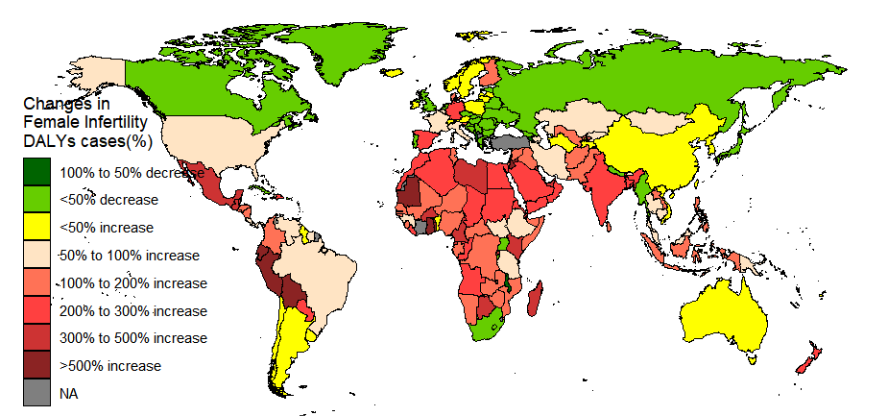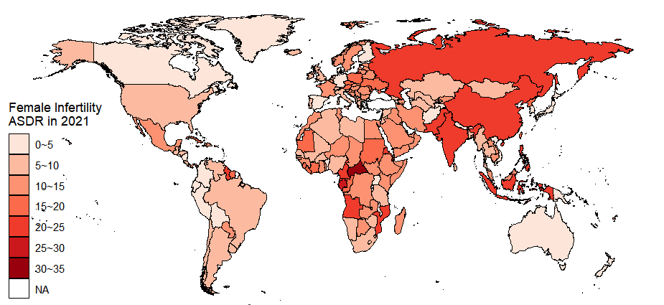

C D
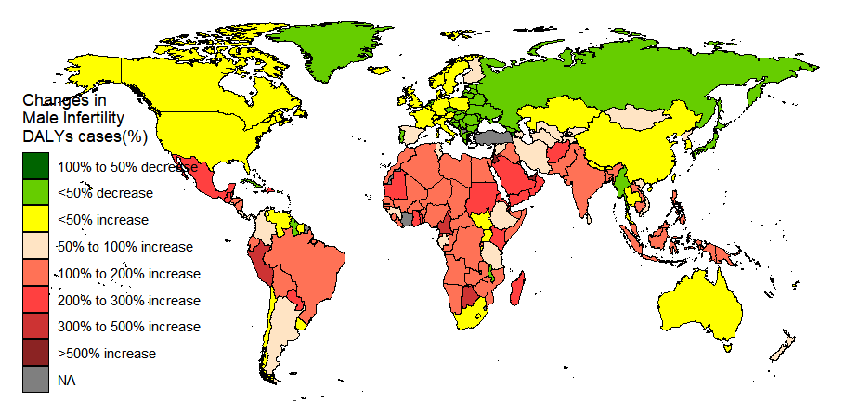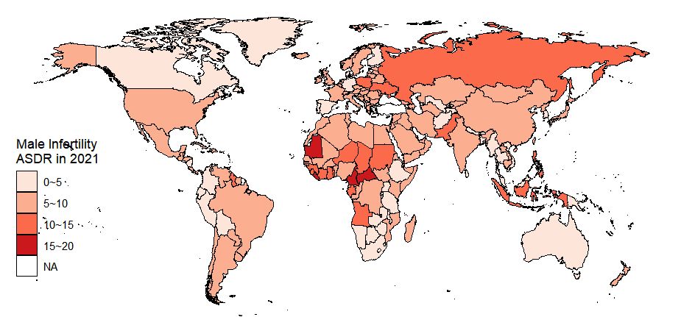

E F
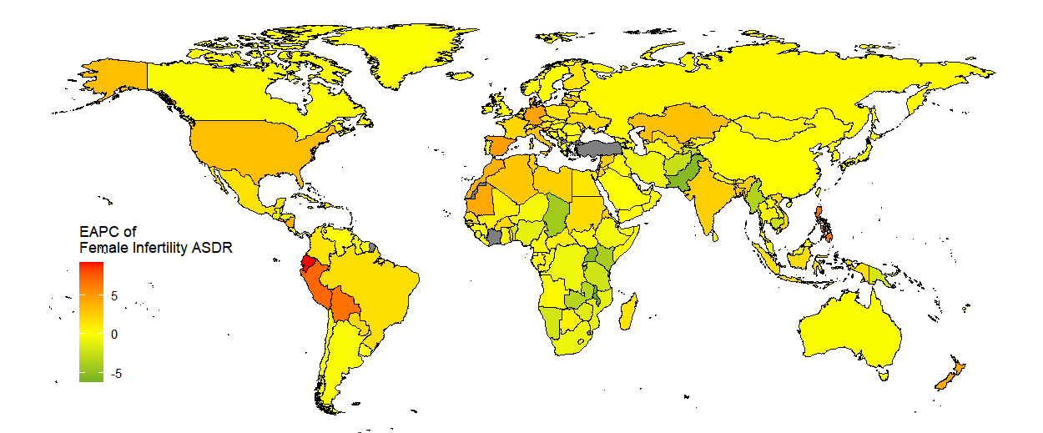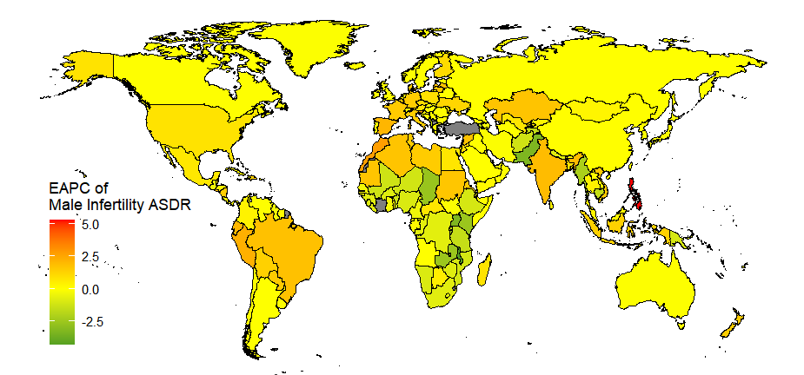

Figure S1. The ASDR of infertility across 204 countries and territories. (A) Changes in female Infertility DALYs cases;(B)Female Infertility ASDR in 2021; (C) Changes in male Infertility DALYs cases;(D) Male Infertility ASDR in 2021;(E) EAPC of female Infertility ASDR;(F)EAPC of male Infertility ASDR.ASDR, age-standardised DALYs rate;EAPC,estimated annual percentage change.
A B
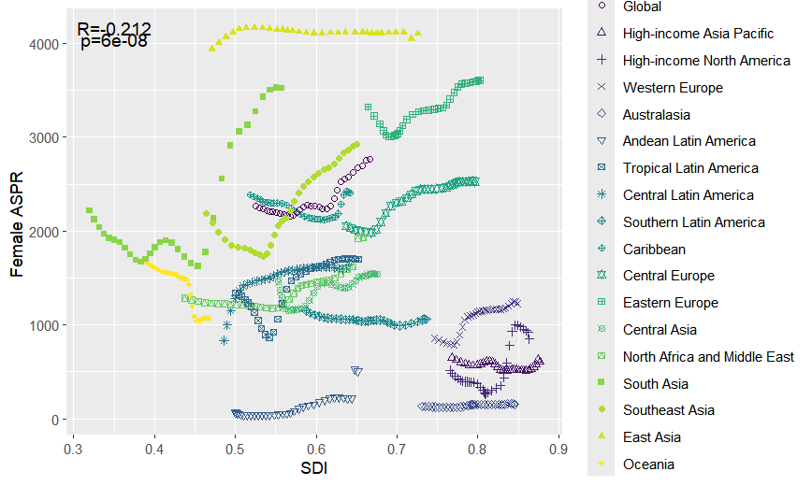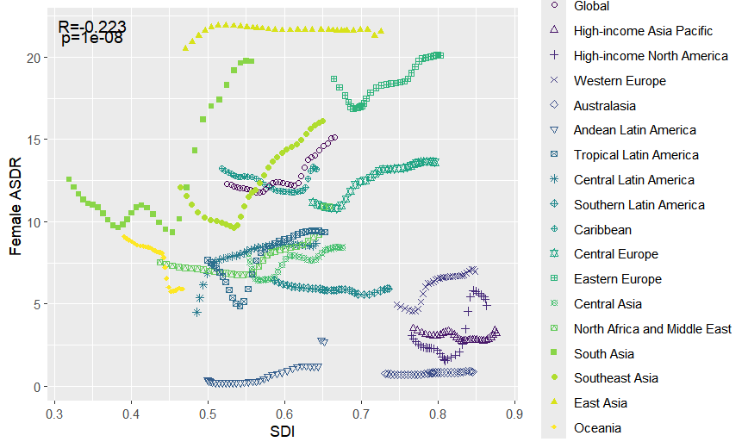
C D
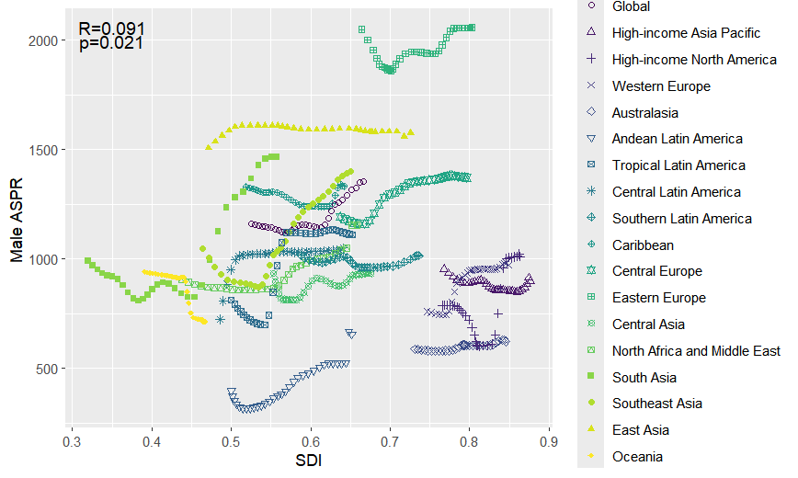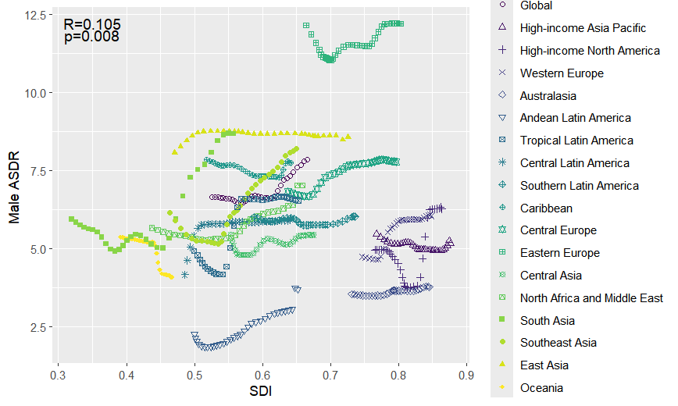
Figure S2. The association between the age-standardized prevalence rate and DALYs rate of infertility with the SDI from 1990 to 2021 year (A: ASPR of female infertility. B: ASDR of female infertility. C:ASPR of male infertility. D: ASDR of male infertility.DALYs,disability-adjusted life years;SDI,socio-demographic index;ASPR, age-standardised prevalence rate; ASDR, age-standardised DALYs rate).
Prevalence Disability-adjusted life years
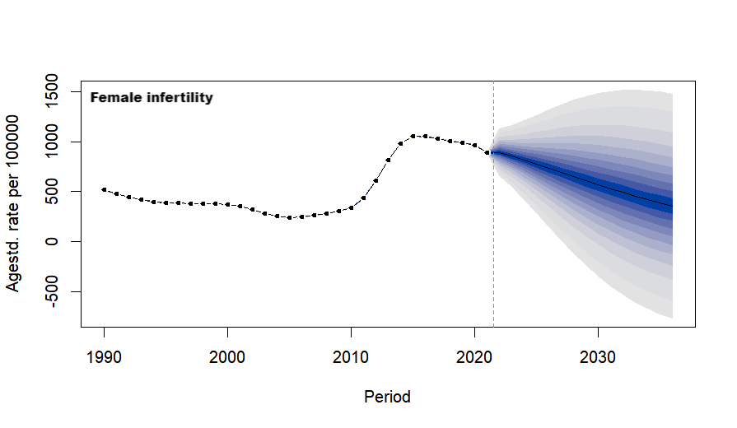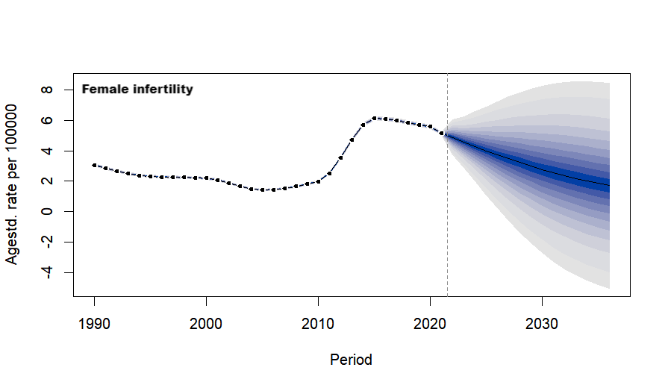
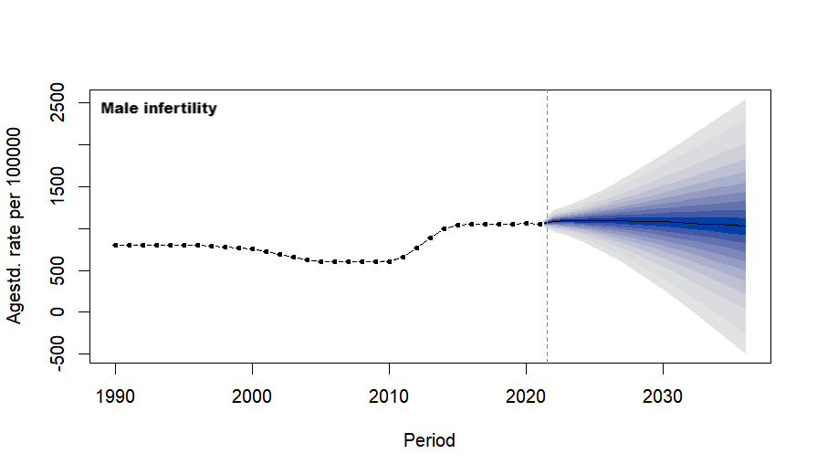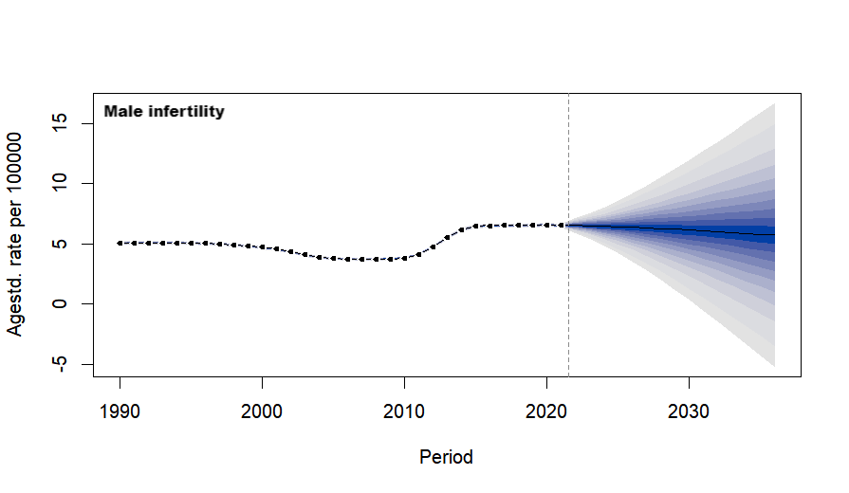
Figure S3.The ASR of infertility in the United States of America was assessed from 1990 to 2021, with forecasted ASR values projected for the period from 2022 to 2036, including the age-standardized prevalence rate and disability-adjusted life years rate.
Prevalence Disability-adjusted life years
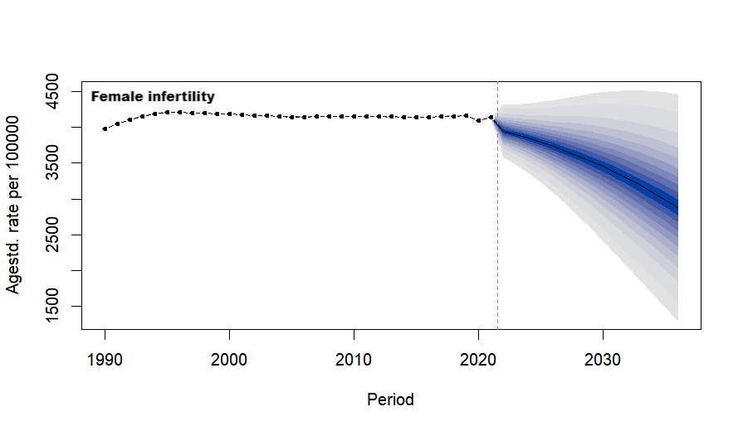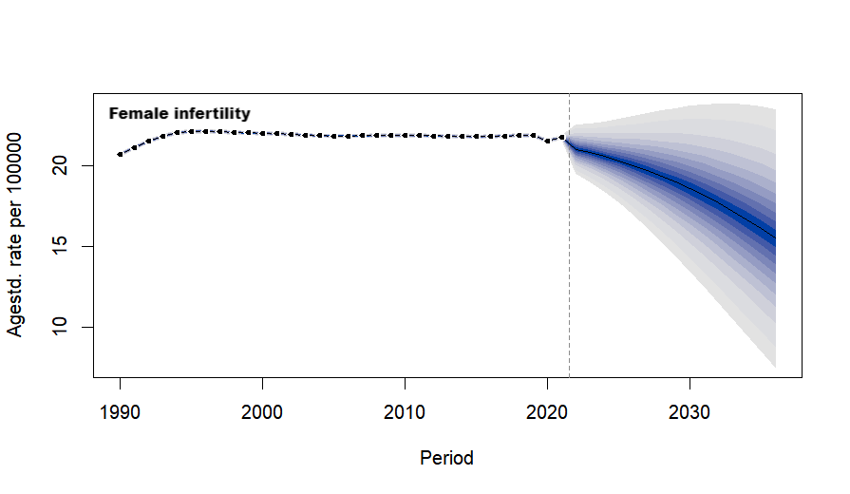
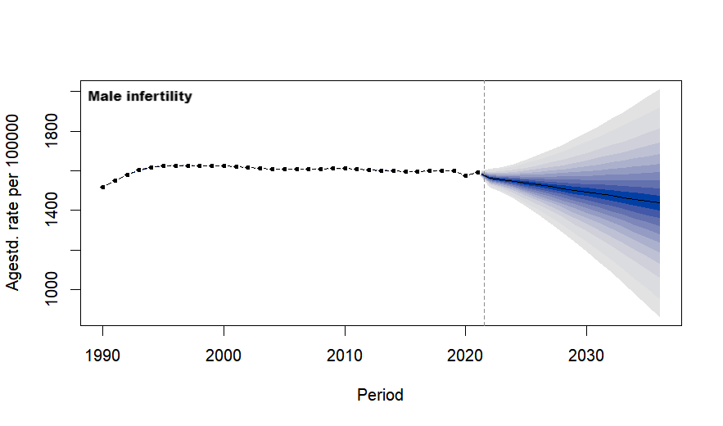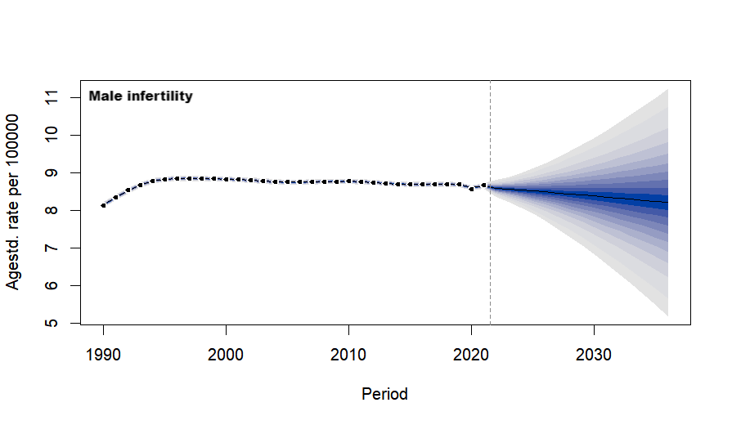
Figure S4.The ASR of infertility in China was assessed from 1990 to 2021, with forecasted ASR values projected for the period from 2022 to 2036, including the age-standardized prevalence rate and disability-adjusted life years rate.

