Table 1. Overview of the selected proteotypic peptides and their corresponding mass transitions used in targeted proteomic analysis. The amino acid residue at the C-terminus (R or K) of the stable isotope-labelled peptide is marked with an asterisk.
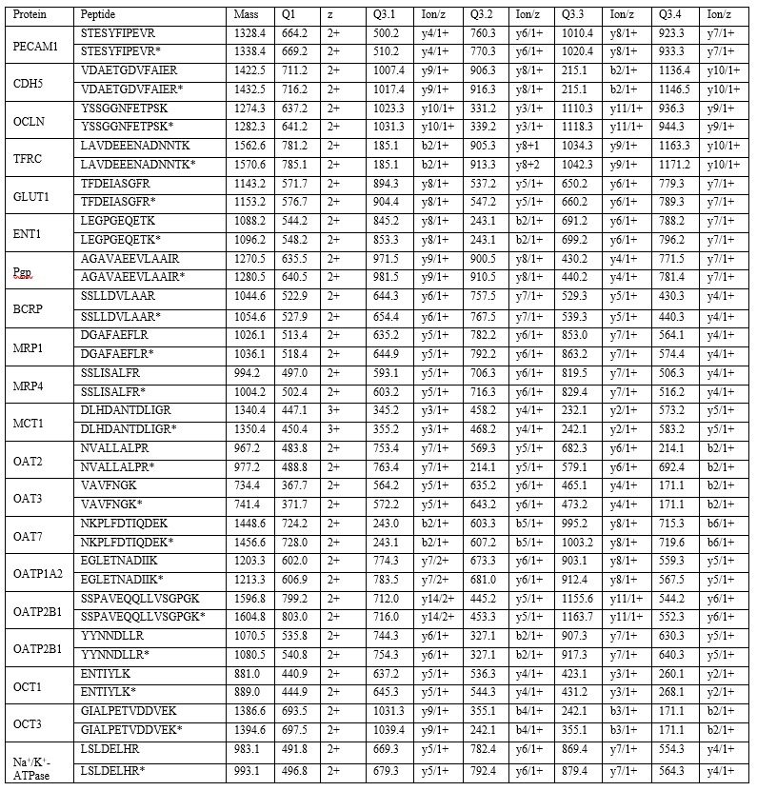

Table 2. BBB markers under limit of quantification. Absolute protein abundance below lower limit of quantification (LLOQ) of PECAM1 and CDH5 in hBMEC Ad-LacZ and hBMEC Ad-OATP2B1 and of OCLN in hCMEC/D3 Ad-LacZ and hCMEC/D3 Ad-OATP2B1. Values are expressed as pmol/ml. Results are reported as mean ± SD of n=8.
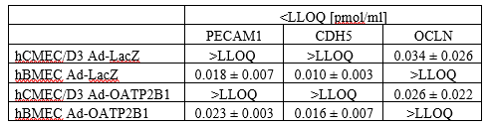

Table 3. BCRP protein expression in hCMEC/D3 Ad-LacZ and hCMEC/D3 Ad-OATP2B1. Below LLOQ absolute protein abundance of BCRP [pmol/ml] in hCMEC/D3 and hCMEC/D3 Ad-OATP2B1. Results are shown as mean ± SD of n=8.
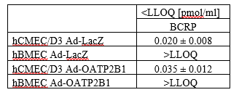

Table 4. SLC transporters below LLOQ in hCMEC/D3 Ad-LacZ, hBMEC Ad-LacZ, hCMEC/D3 Ad-OATP2B1 and hBMEC Ad-OATP2B1. Absolute protein abundance of OAT2, OAT3, OCT1, OCT3, OATP1A2, and OATP2B1 below LLOQ in hCMEC/D3 and hBMEC either infected with Ad-LacZ or Ad-OATP2B1. The data are expressed as mean ± SD in pmol/ml, with a total sample size of n=8. ND= not detected.
