Supplemental Content
eMethods. Supplementary details.
eTable 1. Main findings.
eTable 2. Serious events.
eTable 3. Severe events.
eTable 4. Discontinuation reasons.
eFigure 1. Risk of bias graph.
eFigure 2. Risk of summary.
eFigure 3. CGI-S outcomes for the whole group and KarXT subgroup.
eFigure 4. Efficacy outcomes for KarXT.
eFigure 5. Safety outcomes for KarXT.
eFigure 6. Headache for the whole group or KarXT subgroup.
eFigure 7. Weight change for the whole group or KarXT subgroup.
eFigure 8. Other adverse events for KarXT.
eMethods. Supplementary details.
The search strategy was based on the PICOS-style approach. The following search engines were probed:
Pubmed: ("Muscarinic agonists"[MeSH Terms] OR "muscarinic receptor agonist*"[Title/Abstract] OR "Cholinergic Muscarinic Agonist*"[Title/Abstract] OR "Muscarinic Cholinergic Agonist*"[Title/Abstract] OR "Muscarinic Agent*"[Title/Abstract]) AND ("Mental disorders"[MeSH Terms] OR "schizophrenia"[MeSH Terms] OR "Psychotic"[Title/Abstract] OR "Schizophrenic"[Title/Abstract] OR "SCZ"[Title/Abstract] OR "positive syndrome"[Title/Abstract] OR "negative syndrome"[Title/Abstract] OR "positive symptom*"[Title/Abstract] OR "negative symptom*"[Title/Abstract] OR "hebephrenia"[Title/Abstract] OR "psychosis"[Title/Abstract]) AND ("clinical trials"[Title/Abstract] OR "intervention*"[Title/Abstract] OR "trial*"[Title/Abstract] OR "RCT"[Title/Abstract] OR "experiment*"[Title/Abstract] OR "randomized controlled trials as topic"[MeSH Terms] OR "randomized controlled trial"[Title/Abstract] OR "controlled clinical trial"[Title/Abstract] OR "randomized"[Title/Abstract])

Embase: (‘Muscarinic agent’/exp OR ‘Muscarinic agonist*’:ab,ti OR ‘muscarinic receptor agonist*’:ab,ti OR ‘Cholinergic Muscarinic Agonist*’:ab,ti OR ‘Muscarinic Cholinergic Agonist*’:ab,ti) AND ('Schizophrenia'/exp OR 'Positive syndrome'/exp OR 'Negative syndrome'/exp OR 'Hebephrenia'/exp OR 'Psychosis'/exp OR ‘Schizophrenic’:ab,ti OR ‘Psychotic’:ab,ti OR ‘Positive symptom*’:ab,ti OR ‘Negative symptom*’:ab,ti OR ‘SCZ’:ab,ti) AND ('randomized controlled trial'/exp OR ‘clinical trials’:ab,ti OR ‘intervention*’:ab,ti OR ‘trial*’:ab,ti OR ‘RCT’:ab,ti OR ‘experiment*’:ab,ti OR ‘ randomized controlled trial ‘:ab,ti OR ‘ controlled clinical trial’:ab,ti OR ‘ randomized ‘:ab,ti)

Web of Science: ((“Muscarinic agonist*” OR “muscarinic receptor agonist*” OR “Cholinergic Muscarinic Agonist*” OR “Muscarinic Cholinergic Agonist*” OR “Muscarinic Agent*”) AND (“Schizophreni*” OR “Positive syndrome” OR “Negative syndrome” OR “Hebephrenia” OR “Psychosis” OR “Psychotic” OR “Positive symptom*” OR “Negative symptom*” OR “SCZ”) AND (“randomized controlled trial” OR “clinical trials” OR “intervention*” OR “trial*” OR “RCT” OR “experiment*” OR “ randomized controlled trial” OR “controlled clinical trial” OR “randomized”)) OR TI=((“Muscarinic agonist*” OR “muscarinic receptor agonist*” OR “Cholinergic Muscarinic Agonist*” OR “Muscarinic Cholinergic Agonist*” OR “Muscarinic Agent*”) AND (“Schizophreni*” OR “Positive syndrome” OR “Negative syndrome” OR “Hebephrenia” OR “Psychosis” OR “Psychotic” OR “Positive symptom*” OR “Negative symptom*” OR “SCZ”) AND (“randomized controlled trial” OR “clinical trials” OR “intervention*” OR “trial*” OR “RCT” OR “experiment*” OR “ randomized controlled trial” OR “controlled clinical trial” OR “randomized”))

eTable1. Main findings.
1. Demographic data.
Author | Recruiting time | Region | Groups | Age mean (SD) | Male n(male/total, (%)) | race n(%) |  |  | BMI (SD), Kg/m²
 |  |  |  |  |  | Black and African American | White | Other | BMI (SD), Kg/m²
Brannan, et al. | 2018-2019 | USA | Placebo | 41.6(10.1) | 68(74) | 70(76) | 17(18) | 5(5) | 29.6(5.4)
Brannan, et al. | 2018-2019 | USA | KarXT | 43.4(10.1) | 72(80) | 67(74) | 20(22) | 3(3) | 28.1(5.0)
Brannan, et al. | 2018-2019 | USA | Total | 43.4(10.1) | 140(77) | 137(75) | 37(20) | 8(4) | 28.9(5.2)
Krystal, et al. | 2019-2021 | USA | Placebo | 41(10) | 19(70) | 17(63) | 9(33) | 1(4) | 29.0(4.8)
Krystal, et al. | 2019-2021 | USA | Emraclidine 30mg qd | 41(8) | 23(85) | 20(74) | 7(26) | 0 | 27.6(4.5)
Krystal, et al. | 2019-2021 | USA | Emraclidine 20mg bid | 38(10) | 21(78) | 19(70) | 0 | 8(30) | 28.0(5.0)
Krystal, et al. | 2019-2021 | USA | Total | 40(9) | 63(78) | 56(69) | 16(20) | 8(10) | 28.2(4.7)
Kaul, et al. a | 2020-2022 | USA | Placebo | 46.2(10.8) | 95(75) | 92(73) | 31(25) | 3(3) | 29.1(5.4)
Kaul, et al. a | 2020-2022 | USA | KarXT | 45.6(10.4) | 95(75) | 97(77) | 26(21) | 3(3) | 30.2(5.4)
Kaul, et al. a | 2020-2022 | USA | Total | 45.9(10.6) | 190(75) | 189(75) | 57(23) | 6(2) | 29.6(5.4)
Shekhar, et al. | - | USA | Placebo | 42.1(9.2) | 8(80) | 8(80) | 2(20) | 0 | N.A.
Shekhar, et al. | - | USA | Xanomeline | 43.4(9.3) | 6(60) | 7(70) | 3(30) | 0 | N.A.
Shekhar, et al. | - | USA | Total | 42.8(9.0) | 14(70) | 15(75) | 5(25) | 0 | N.A.
Kaul, et al. b | 2021-2022 | USA & Ukraine | Placebo | 42.6(12.2) | 104(79.4) | 77(58.8) | 53(40.5) | 1(0.8) | 28.0(5.2)
Kaul, et al. b | 2021-2022 | USA & Ukraine | KarXT | 43.6(11.4) | 87(69.6) | 79(63.2) | 45(36.0) | 1(0.8) | 28.8(5.6)
Kaul, et al. b | 2021-2022 | USA & Ukraine | Total | 43.1(11.8) | 191(74.6) | 156(60.9) | 98(38.3) | 2(0.8) | 28.38(5.4)

2. Enrolled patients.
Author | Groups | Psychiatric diagnosis | Diagnostic guideline | Key inclusion criteria | PANSS |  |  | CGI-S  Positive symptom
 |  |  |  |  | Total | Positive symptom | Negative  symptom | CGI-S  Positive symptom
Brannan, et al. | Placebo | Schizophrenia, acute exacerbation or relapse within 2 months | DSM-5 | Baseline PANSS total score of 80 points or more; a score of at least 5 on one positive symptom item or at least 4 on two positive symptom items; a score on the CGI-S scale of 4 or higher; have an acute exacerbation or relapse of psychosis requiring hospitalization with an onset within 2 months before screening and had to be free of antipsychotic medication for at least 2 weeks | 96.6(8.3) | 26.3(3.2) | 22.8(4.6) | 4.9(0.6)
Brannan, et al. | KarXT | Schizophrenia, acute exacerbation or relapse within 2 months | DSM-5 |  | 97.7(9.7) | 26.4(3.4) | 22.6(4.4) | 5.0(0.6)
Brannan, et al. | Total | Schizophrenia, acute exacerbation or relapse within 2 months | DSM-5 |  | 97.1(9.0) | 26.3(3.3) | 22.7(4.5) | 4.9(0.6)
Krystal, et al. | placebo | Schizophrenia, confirmed by the Mini International Neuropsychiatric Interview | DSM-5 | CGI-S score of 4 or greater, PANSS total score of 80 or greater, a score of 4 or greater for at least two positive subscale items, history of relapse or exacerbation of symptoms when not receiving antipsychotic treatment, and current acute exacerbation or relapse of symptoms with onset within the previous 2 months | 93(8.8) | 24(2.7) | 23(3.3) | 5(0.6)
Krystal, et al. | Emraclidine 30mg qd |  | DSM-5 |  | 93(7.3) | 25(3.0) | 22(3.7) | 5(0.5)
Krystal, et al. | Emraclidine 20mg bid |  | DSM-5 |  | 97(7.9) | 26(2.6) | 24(3.8) | 5(0.7)
Krystal, et al. | Total |  | DSM-5 |  | 94(8.1) | 25(2.9) | 23(3.7) | 5(0.6)
Kaul, et al. a | Placebo | Schizophrenia, confirmed by Mini International Neuropsychiatric Interview for Schizophrenia and Psychotic Disorders version 7.0.2 | DSM-5 | An acute exacerbation or relapse of psychotic symptoms requiring hospital admission with onset less than 2 months before screening; a PANSS total score of 80–120; a score of 4 or higher on at least two of four symptoms; and a CGI-S scale score of 4 or higher | 97.9(9.7) | 26.7(4.0) | 22.9(3.8) | 5.1(0.6)
Kaul, et al. a | KarXT |  | DSM-5 |  | 98.3(8.9) | 26.8(3.7) | 22.9(4.0) | 5.1(0.6)
Kaul, et al. a | Total |  | DSM-5 |  | 98.1(9.3) | 26.7(3.9) | 22.9(3.9) | 5.1(0.6)
Shekhar, et al. | Placebo | Schizophrenia or schizoaffective disorder | DSM-4 | Total PANSS score >60, scoring at least a 4 on one positive symptom item or a 3 on two positive symptom item | 85.2(10.22) | N.A. | N.A. | N.A.
Shekhar, et al. | Xanomeline | Schizophrenia or schizoaffective disorder | DSM-4 |  | 81.3(5.1) | N.A. | N.A. | N.A.
Shekhar, et al. | Total | Schizophrenia or schizoaffective disorder | DSM-4 |  | 83.3(8.1) | N.A. | N.A. | N.A.
Kaul, et al. b | Placebo | Schizophrenia, confirmed by Mini International Neuropsychiatric Interview for Schizophrenia and Psychotic Disorders version 7.0.2 | DSM-5 | An acute exacerbation or relapse of psychotic symptoms requiring hospital admission with onset less than 2 months before screening; a PANSS total score of 80–120; a score of 4 or higher on at least two of four symptoms; and a CGI-S scale score of 4 or higher | 96.7(8.9) | 26.4(3.3) | 22.0(3.7) | 5.0(0.6)
Kaul, et al. b | KarXT |  | DSM-5 |  | 97.3(8.9) | 26.9(3.7) | 22.6(3.2) | 5.1(0.6)
Kaul, et al. b | Total |  | DSM-5 |  | 97.0(8.9) | 26.7(3.5) | 22.3(3.5) | 5.1(0.6)

3. Main results.
Author | Intervention duration | N(complete/total) | Drugs arrangement | Main findings
Brannan, et al. | 5 weeks | 73/92 | Placebo | Positive and negative symptoms were improved.
Brannan, et al. | 5 weeks | 72/90 | Xanomeline 50mg/trospium 20mg bid in Day 1-2; xanomeline 100mg/trospium 20mg bid in Day 3-7; xanomeline 125mg/trospium 30mg bid; flexible to return to xanomeline 100mg/trospium 20mg bid. | Positive and negative symptoms were improved.
Brannan, et al. | 5 weeks | 145/182 | \ | Positive and negative symptoms were improved.
Krystal, et al. | 6 weeks | 21/27 | Emraclidine 30 mg po qm, placebo po qn | Positive and negative symptoms were improved. Cognition benefit was not observed in the Brief Assessment of Cognition in Schizophrenia symbol coding test.
Krystal, et al. | 6 weeks | 21/27 | Emraclidine 20 mg po bid
Krystal, et al. | 6 weeks | 63/81 | \
Kaul, et al. a | 5 weeks | 100/126 | Placebo | Positive and negative symptoms were improved.
Kaul, et al. a | 5 weeks | 94/126 | Xanomeline 50mg/trospium 20mg bid in Day 1-2; xanomeline 100mg/trospium 20mg bid in Day 3-7; xanomeline 125mg/trospium 30mg bid; flexible to return to xanomeline 100mg/trospium 20mg bid. | Positive and negative symptoms were improved.
Kaul, et al. a | 5 weeks | 194/252 | \ | Positive and negative symptoms were improved.
Shekhar, et al. | 4 weeks | 7/10 | Placebo | Psychotic symptoms and cognition (verbal learning and short-term memory function) were improved.
Shekhar, et al. | 4 weeks | 8/10 | Xanomeline 25mg tid in Day 1-8; xanomeline 50mg tid in Day 8-10; xanomeline 75mg tid on Day 11; If the subject was unable to tolerate the increase in dosage, it was attempted again after an additional 3 days. If the subject was still unable to tolerate the dose escalation, then the subject was maintained on the previous highest tolerated dose. After 3 weeks at the highest tolerated dose, subjects were tapered off the study drug over the next 5 days.
Shekhar, et al. | 4 weeks | 15/20 | \
Kaul, et al. b | 5 weeks | 93/131 | Placebo | Psychotic symptoms were improved.
Kaul, et al. b | 5 weeks | 79/125 | Xanomeline 50mg/trospium 20mg bid in Day 1-2; xanomeline 100mg/trospium 20mg bid in Day 3-7; xanomeline 125mg/trospium 30mg bid; flexible to return to xanomeline 100mg/trospium 20mg bid. | Psychotic symptoms were improved.
Kaul, et al. b | 5 weeks | 172/256 | \ | Psychotic symptoms were improved.

eTable 2. Serious events.
Study or Subgroup | mAChRs agonists |  | Placebo
Study or Subgroup | Events | Total | Events | Total
Krystal 2022 | 3(COVID-19, n=1; accidental cocaine overdose, n=1; exacerbation of schizophrenia, n=1) | 54 | 0 | 27
Kaul 2024 b | 1(gastroesophageal reflux disease, n=1) | 125 | 0 | 128
Kaul 2024 a | 2(suicidal ideation, n=2) | 126 | 2(appendicitis, n=1; worsening of schizophrenia, n=1) | 125
Brannan 2021 | 1 | 89 | 0 | 90

eTable 3. Severe events.
Study or Subgroup | mAChRs agonists |  | Placebo
Study or Subgroup | Events | Total | Events | Total
Krystal 2022 | \ | \ | \ | \
Kaul 2024 b | \ | \ | \ | \
Kaul 2024 a | 2 | 126 | 4 | 125
Brannan 2021 | 1 | 89 | 1 | 90

eTable 4. Discontinuation reasons.
Study or Subgroup | mAChRs agonists |  | Placebo
Study or Subgroup | Events | Total | Events | Total
Krystal 2022 | 12(3 due to adverse events; 8 withdrew consent; 1 investigator discretion) | 54 | 6(2 absence of efficacy; 4 withdrew consent) | 27
Kaul 2024 b | 46(35 withdrew consent; 8 adverse events; 2 failure to adhere to protocol requirements; 1 changes to participant's condition rendering them ineligible per inclusion or exclusion criteria) | 125 | 38(22 withdrew consent; 7 adverse events; 2 failure to adhere to protocol requirements; 4 progressive disease; 2 suicidal or assaultive behavior; 1 other) | 128
Kaul 2024 a | 32( 13 withdrew consent; 10 adverse events; 9 other reason) | 126 | 25(11 withdrew consent; 6 adverse events; 6 other reason; 1 progressive disease; 1 no reason collected) | 125
Brannan 2021 | 18(3 had adverse events; 14 withdrew consent; 1 was withdrawn by investigator) | 89 | 19(2 had adverse events; 1 was lost to follow-up; 14 withdrew consent; 1 was withdrawn by investigator; 1 had other reason) | 90

eFigure 1. Risk of bias graph.
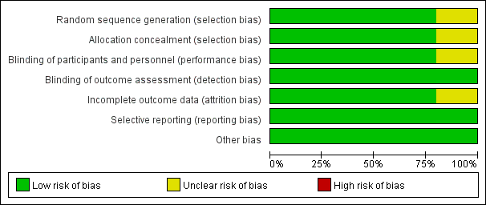
eFigure 2. Risk of bias summary.
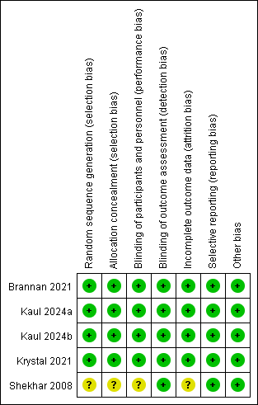
eFigure 3. CGI-S outcomes for the whole group and KarXT subgroup.
- Whole group.
- KarXT subgroup.

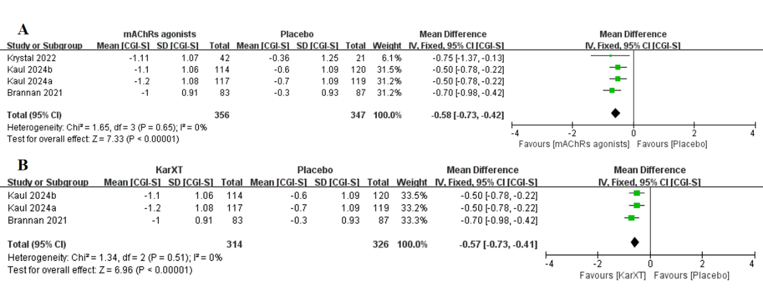
eFigure 4. Efficacy outcomes for KarXT.
- Total score changes of PANSS.
- Score changes of PANSS positive symptom subscore.
- Score changes of PANSS negative symptom subscore.
- Study-defined response rate at primary endpoint.
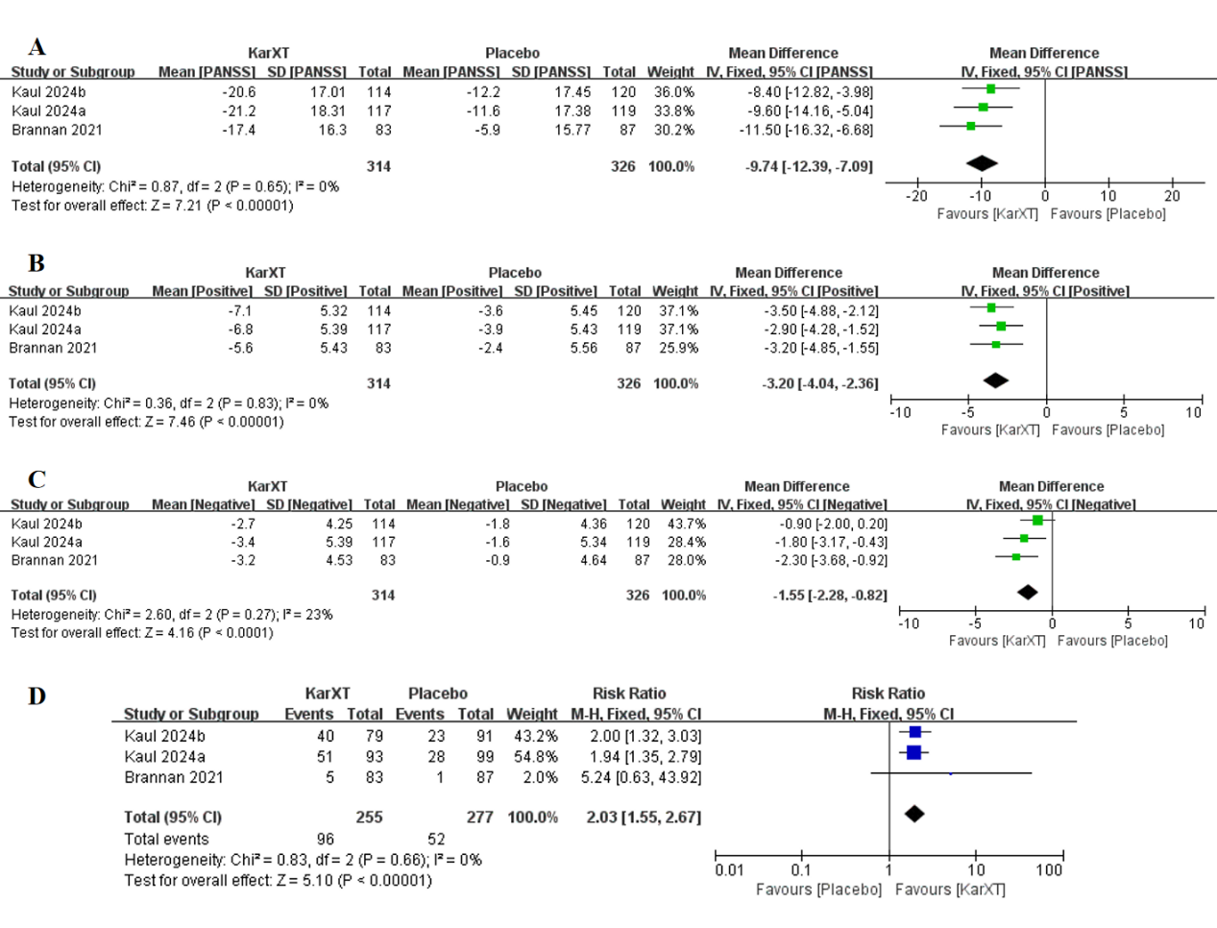
eFigure 5. Safety outcomes for KarXT.
- Discontinuation rate.
- Any adverse event rate.
- Nausea events.
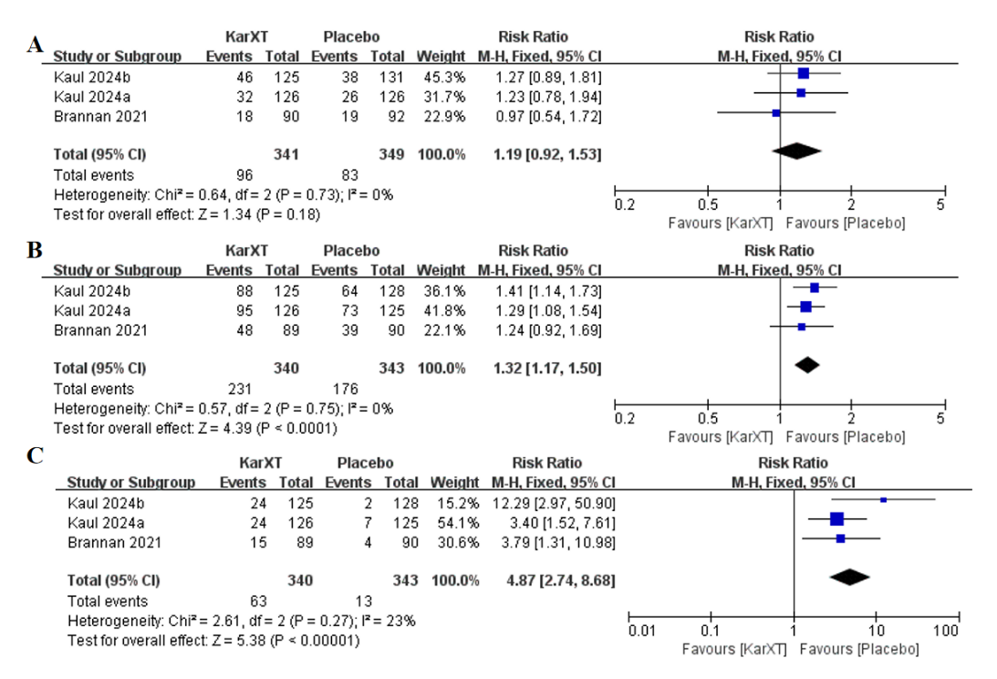

eFigure 6. Headache for the whole group or KarXT subgroup.
- Headache for the whole group.
- Headache for KarXT subgroup.
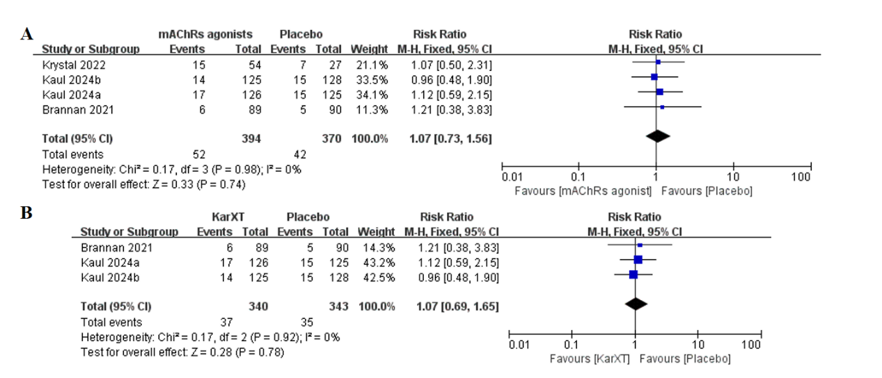

eFigure 7. Weight change for the whole group or KarXT subgroup.
- Weight change for the whole group.
- Weight change for KarXT subgroup.
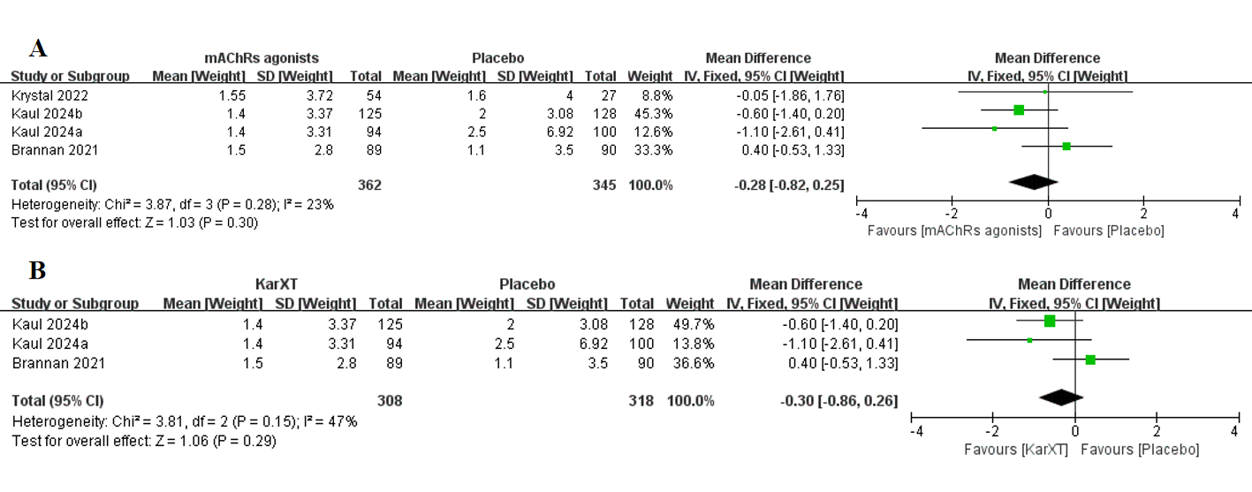

eFigure 8. Other adverse events for KarXT.
- Dyspepsia.
- Vomiting.
- Diarrhea.
- Constipation.
