Microglia aggregates define distinct immune and neurodegenerative niches in Alzheimer's disease hippocampus.

Sonja Fixemer^{1,2}*, Mónica Miranda de la Maza^{1,2,3,4}*, Gaël Paul Hammer^{2,3}, Félicia Jeannelle^{2,3}, Sophie Schreiner^{2,3}, Jean-Jacques Gérardy^{2,3}, Naguib Mechawar⁵, Michel Mittelbronn^{1,2,3,4,6,7}, David S. Bouvier^{1,2,3} .

Author affiliations:
¹ Luxembourg Centre for Systems Biomedicine (LCSB), University of Luxembourg, Belval, Luxembourg.
² Luxembourg Centre of Neuropathology (LCNP), Dudelange, Luxembourg.
³ Laboratoire national de santé (LNS), National Center of Pathology (NCP), Dudelange, Luxembourg.
⁴ Department of Cancer Research (DOCR), Luxembourg Institute of Health (LIH), Luxembourg.
⁵ Douglas Mental Health University Institute, Department of Psychiatry, McGill University, Montreal, Quebec, Canada.
⁶ Department of Life Sciences and Medicine (DLSM), University of Luxembourg, Esch-sur-Alzette, Luxembourg.
⁷ Faculty of Science, Technology and Medicine (FSTM), University of Luxembourg, Esch-sur-Alzette, Luxembourg.

* : equally contributing authors
Correspondence to: Dr. David S. Bouvier
Laboratoire national de santé (LNS)
1, Rue Louis Rech
L-3555 Dudelange
Email: david.bouvier@lns.etat.lu ;david.bouvier@ext.uni.lu

Supplementary Fig.1 Super resolution of PaM and CoM present in AD and DLB hippocampi. (A, B) STED 3D acquisitions of PFA-fixed AD hippocampal sections immunostained against Iba1 (magenta) and Aβ plaques (4G8, green) reveal the morphology of (A) PaM and (B) CoM. PaM and CoM are depicted in 3D (upper panels) and 2D images throughout the z axis (lower panels) (case #52)). (C-D) High-resolution confocal acquisitions of post-mortem hippocampal tissue from DLB patients immunostained against microglia (Iba1, magenta) and nuclei (DRAQ7TM, white). (C) PaM (case #20) and (D) CoM (case #21) are often present in DLB hippocampi. Scale bars: (A, C) 20µm; (B) 10µm; (D) 30µm.

Supplementary Fig.2 Nuclei are often encapsulated in CoM. The 3D stack allows to follow through focal plan (each 1µm) the complete encapsulation of a large dysmorphic nucleus (white arrows) within a CoM (AD case #48). Scale bars: 5 µm.

Supplementary Fig.3 Serial sections of PaM, CoM, CoM-Rod, and clumped microglia. High-resolution confocal acquisitions of immunostainings against microglia (Iba1, magenta) and nuclei (DRAQ7TM, white). Four types of microglia accumulations, shown in 3D (left) with corresponding 2D z-stack images (right). Examples of CoM-Rod, PAM from case #35 (AD), and clumped microglia from case #21 (DLB) and CoM from case #23 (AD). All scale bars: 50 µm.

Supplementary Fig.4 CoM, Tau pathology and surrounding astrocytes. (A) Low and high magnification on a CoM (Iba1, magenta), which is not engulfing any AT8+ structure (AT8, green; DRAQ7TM, cyan) in the hippocampus of an AD case #52. (B) A CoM (Iba1, magenta) is enveloping a Thiazine Red (TR, cyan) positive structure within the CA1 PL of an AD patient sample (case #34). The CoM is spatially distant from reactive astrocytes (GFAP, green). Right panel shows three confocal planes spaced by 5 µm showing the boundaries between complexity of microglial CoM and surrounding astrocytes (AD case #34). Scale bars: (A, B) 200 μm (low mag), 20 μm (high mag).

Supplementary Fig.5 Rod-shaped microglia in AD. (A) Iba1 (magenta) immunostaining revealing individual rod-shaped microglia (empty triangles) and ‘streaks of aligned rod-shaped microglia (full triangles) in the hippocampus of an AD patient (case #35). Nuclei are stained by DNA dye DRAQ7TM. (B, C) Volcano plots of DEGs in microglia AOIs of Rod vs. CoM and PaM, respectively. Thresholds of Log₂FC = 0.5, P-value = 0.05 and FDR = 0.1 are indicated in the graphs. (D, E) Heatmaps of top 30 DEGs in microglia AOIs of Rod vs. CoM and PaM respectively. Log₂FC values are indicated in brackets for each transcript. Scale bar: 100µm.

Supplementary Fig.6 Complement proteins and PCSK9 in the hippocampus and entorhinal cortex of age-matched controls and AD patients. (A) C1q is expressed in pyramidal neurons of the CA1 in CTL cases (case #14), in neurons and near plaques in the entorhinal cortex of AD patients (case#45). (B) C3 expression is very low in CTL hippocampi and found near plaques (black arrows) in the entorhinal cortex of AD patients (cases #8 and #48). (C) PCSK9 is mainly expressed by neurons in CTL hippocampus and entorhinal cortex (case #7), it is found in the plaque vicinity and associated with Astro-PaM in entorhinal cortex (EC) AD (case #44). Scale bars (A, B, C): 30 µm.

Supplementary Fig.7 Perivascular macrophages, T cells and PaM associated Tau pathology in the hippocampus and entorhinal cortex of age-matched controls and AD patients. (A) 4-plex chromogenic IHC for Iba1 (DAB, brown), CD3 (purple), 4G8 (yellow) and CD8 (teal) in the entorhinal cortices of a CTL and AD samples. T cells were rarely seen in CTL (case#15), but were found in and around blood vessels as well as in AD (case# 40), without reaching the vicinity of plaques. (B) 3-plex chromogenic IHC of CD163 (DAB, brown), Iba1 (purple) and 4G8 (teal) showed a high frequency of CD163+ cells within the PaM in AD entorhinal cortex (case #37). Scale bars (A, B): 30 µm.

Supplementary Table 1 Antibodies used in IHC fluorescent, IHC chromogenic (Dako Omnis and Ventana Discovery Ultra) and DSP.
ANTIBODIES | SOURCE | IDENTIFIER | DILUTION IHC fluorescent | DILUTION IHC chromogenic | DILUTION Ventana Discovery Ultra
PRIMARY ANTIBODIES
Mouse monoclonal anti-β-Amyloid, AA17-24 (4G8) | BioLegend | Cat# 800712, RRID: AB_2734548 | 1:200 | - | 1:500
Guinea-pig polyclonal anti-GFAP | Synaptic Systems | Cat# 173004, RRID: AB_10641162 | 1:500 | - | -
Rabbit polyclonal anti-Iba1, C-term | Wako | Cat# 019-19741, RRID: AB_839504 | 1:500 | 1:1000 | 1:1000
Goat polyclonal anti-human Iba1/AIF1 (aa 42-56) | LS-Bio | Cat# LS-B2402-50, RRID: AB_1648188 | 1:400 | - | -
Mouse monoclonal anti-pSyn, PSer129 (11A5) | Prothena Biosciences | N/A | 1:500 | - | -
Mouse monoclonal anti-pTau, Ser202, Thr205 (AT8) | Thermofisher Scientific | Cat# MN1020, RRID: AB_223647 | 1:500 | - | 1:400
Rabbit polyclonal anti-NF-𝜅B p65, phosphoS536 | Abcam | Cat# ab86299, RRID: AB_1925243 | 1:200 | - | -
Monoclonal mouse anti-pMLKL PSer358 (6F8) | Aviva Systems | Cat# OASG07777, RRID: AB_2923426 | 1:200 | - | -
Mouse monoclonal anti-CD68 (KP1) | BioLegend | Cat# 916104, RRID: AB 2616797 | - | 1:200 | -
Mouse monoclonal anti-STING (OTI4H1) | Thermo Fisher Scientific | Cat# MA5-26030, RRID: AB_2725437 | - | 1:500 | -
Rabbit monoclonal anti-C1q | Abcam | Cat# ab182451, RRID: AB_2732849 | 1:200 | 1:500 | -
Rabbit polyclonal anti-C4d | Abcam | Cat# ab36075, RRID: AB_726920 | - | - | 1:100
Rabbit polyclonal anti-C3 | Atlas Antibodies | Cat# HPA003563, RRID: AB_1847117 | 1:200 | - | 1:100
Rabbit polyclonal anti-ACADS | Sigma Aldrich | Cat# HPA022271, RRID: AB_1844472 | 1:500 | 1:750 | -
Rabbit polyclonal anti-erbB4 | Sigma Aldrich | Cat# HPA012016, RRID: AB_1846541 | 1:200 | - | -
Rabbit polyclonal anti-ITGA6 | Atlas Antibodies | Cat# HPA012696, RRID: AB_1851822 | 1:200 | 1:200 | -
Rabbit polyclonal anti-pTau (Ser 396) | Thermo Fisher Scientific | Cat# 44-752G, RRID: AB_2533745 | - | - | 1:1000
Rabbit polyclonal anti-SMURF2 | Atlas Antibodies | Cat# HPA071508, RRID: AB_2686406 | 1:100 | - | -
Mouse monoclonal anti-PCSK9 (2F1) | Thermo Fisher Scientific | Cat# MA5-32843, RRID: AB_2802490 | - | - | 1:1000
Rabbit monoclonal anti-CD3 (2GV6) | Ventana Medical Systems | Cat# 790-4341 (also 05278422001), RRID: AB_2335978 | - | - | Ready to use*
Rabbit monoclonal anti-CD8 (SP57) | Ventana Medical Systems | Cat# 790-4460 (also 05937248001), RRID: AB_2335985 | - | - | Ready to use*
Rabbit monoclonal anti-GFAP (EP672Y) | Ventana Medical Systems | Cat# 760-4345 (also 05269784001), RRID: N/A | - | - | Ready to use*
Mouse monoclonal anti-CD163 (MRQ-26) | Ventana Medical Systems | Cat# 760-4437 (also 05973929001), RRID: AB_2335969 | - | - | Ready to use*

SECONDARY ANTIBODIES
Donkey anti-rabbit Alexa Fluor 555 | Invitrogen | Cat# A-31572, RRID: AB_162543 | 1:400 | - | -
Donkey anti-mouse Alexa Fluor 488 | Jackson ImmunoResearch Labs | Cat# 715-545-150, RRID: AB_2340846 | 1:400 | - | -
Donkey anti-goat Alexa Fluor 488 | Jackson ImmunoResearch Labs | Cat# 705-545-147, RRID: AB_2336933 | 1:400 | - | -
Donkey anti-guinea pig Alexa Fluor 488 | Jackson ImmunoResearch Labs | Cat# 706-545-148, RRID: AB_2340472 | 1:400 | - | -
Donkey anti-mouse Alexa Fluor 647 | Jackson ImmunoResearch Labs | Cat# 715-605-150, RRID: AB_2340862 | 1:300 | - | -
Donkey anti-goat Alexa Fluor 647 | Jackson ImmunoResearch Labs | Cat# 705-605-003, RRID: AB_2340436 | 1:300 | - | -
Donkey anti-guinea pig Alexa Fluor 647 | Jackson ImmunoResearch Labs | Cat# 706-605-148, RRID: AB_2340476 | 1:300 | - | -
Goat anti-rabbit Atto 647N | Sigma Aldrich | Cat# 40839, RRID: AB_1137669 | 1:300 | - | -
DISCOVERY OmniMap anti-Rb HRP | Roche | Cat# 760-4311, RRID: AB_2811043 | - | - | Ready to use*
DISCOVERY OmniMap anti-Ms HRP | Roche | Cat# 760-4310, RRID: AB_2885182 | - | - | Ready to use*
DISOCVERY UltraMap anti-Ms Alk Phos | Roche | Cat# 760-4312 | - | - | Ready to use*
DISCOVERY CM DAB kit | Roche | Cat# 760-159 | - | - | Ready to use*
DISCOVERY Purple Kit | Roche | Cat# 760-229 | - | - | Ready to use*
DISCOVERY Teal HRP kit | Roche | Cat# 760-247 | - | - | Ready to use*
DISCOVERY Yellow Kit | Roche | Cat# 760-239 | - | - | Ready to use*

DSP ANTIBODIES
Rabbit monoclonal anti-Iba1/AIF1 (E4O4W) Alexa Fluor 594 conjugate** | Cell Signalling Technology | Cat# 48934, RRID: AB_2923427 | - | - | -
Mouse monoclonal anti-GFAP (GA-5) DyLight 594 conjugate** | Novus Biologicals | Cat# NBP2-33184DL594, RRID: AB_2923514 | - | - | -
Mouse monoclonal anti-Aβ (MOAB-2) Alexa Fluor 532 conjugate ** | Novus Biologicals | Cat# NBP2-13075AF532, RRID: AB_2923428 | - | - | -
*Vials ready-to-use purchased from Roche Ventana Medical Systems // ** Concentration of antibodies not provided by NanoString Techonologies
Supplementary Table 2 Materials and resources
REAGENT OR RESOURCE
Biological samples
Human post-mortem FFPE hippocampus and prefrontal cortex | GIE-Neuro-CEB biobank | See Table 1
Human post-mortem PFA-fixed hippocampus | Douglas-Bell Brain Bank and GIE-Neuro-CEB biobank | See Table 1
Chemicals, peptides, and recombinant proteins |  |  | Dilution
DRAQ7TM | Cell Signaling | Cat# 7406 | 1:100
Thiazine Red 0.2µM | Sigma Chemicals, St. Louis, MO, USA
SYTOTM 13 Green Fluorescent Nucleic Acid Stains | Invitrogen | Cat# S7575
ProLongTM Gold Antifade Mountant | Invitrogen | Cat# P36930
Deposited data
DSP proteomics and transcriptomics  raw data | This paper | Data available on request
DSP proteomics and transcriptomics DEP and DEG, ORA | This paper | Supplementary files 7 and 8
Raw images | This paper | Data available on request
Software and algorithms
Imaris (Version 9.8.0) | Bitplane | RRID: SCR_007370
GraphPad Prism (Version 9.4.1) | GraphPad Software, Inc | RRID: SCR_002798
Biorender | Biorender.com | RRID: SCR_018361
Huygens STED Deconvolution Software | Scientific Volume Imaging (SVI) | RRID: SCR_014237
R studio (Version 4.2.1.) | RStudio | RRID: SCR_001905
QuPath (Version 0.3.2) | qupath.github.io | RRID: SCR_018257
STRING | http://string.embl.de/ | RRID: SCR_005223
DSP GeoMx Analysis suite (Version 2.5.1.145) | NanoString | RRID: SCR_021660
Other
Dako Omnis Autostainers | Dako
IntelliSite Ultra Fast Scanner | Philips
Ventana Discovery Ultra Autostainer | Roche Diagnostics

Supplementary File 2- Supplementary Movie 1 CoM serial. Example from an 87-year-old male AD patient (A2B3C2) (case #35).
Supplementary File 3- Supplementary Movie 2 STED PAM serial. Example from a 66-year-old male AD patient (Braak stage IV and Thal phase 5) (case #52)
Supplementary File 4- Supplementary Movie 3 CoM pTau serial. Example from an 80-year-old male AD patient (Braak stage IV) (case #23).
Supplementary File 5- Supplementary Movie 4 CoM-TR. Example from an 87-year-old male AD patient (case #34).
Supplementary File 6- Supplementary Movie 5 CoM pSyn serial. Example from an 87-year-old male AD patient (A2B3C2) (case #35).

Supplementary File 7- Supplementary Excel 1. Spatial profiling DEPs and DEG.

Supplementary File 8- Supplementary Excel 2. ORA.

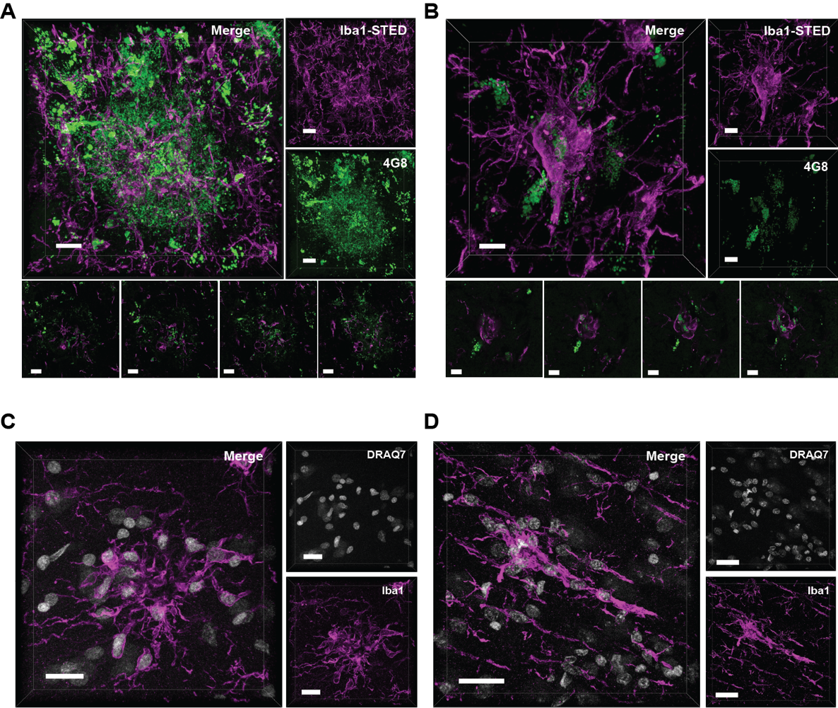

Supplementary Fig.1

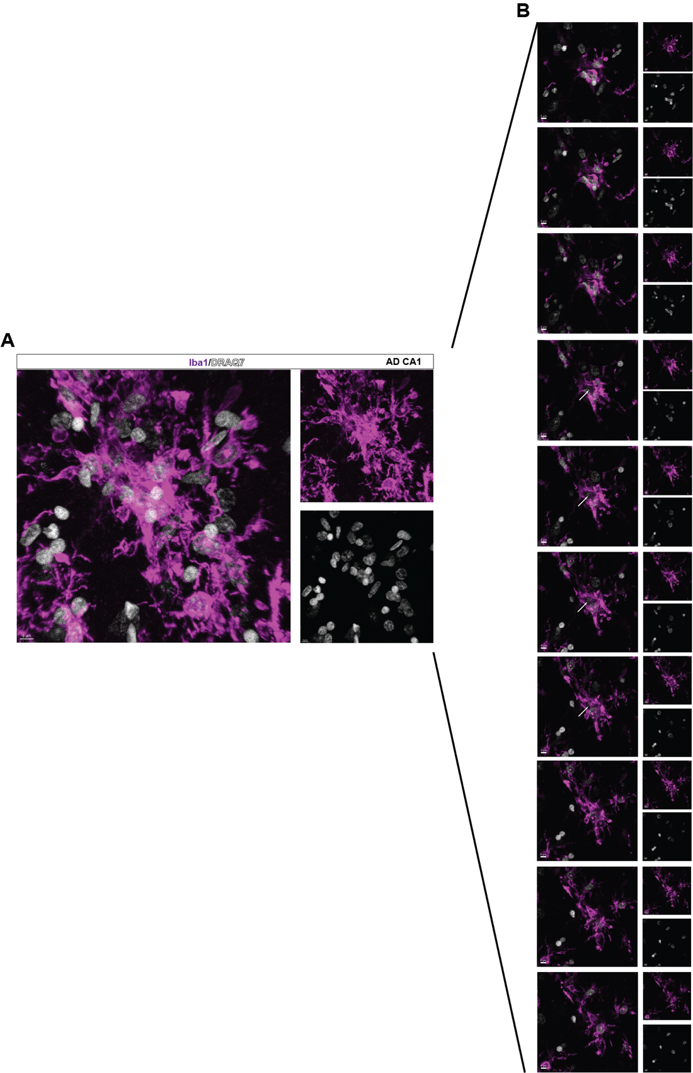

Supplementary Fig.2

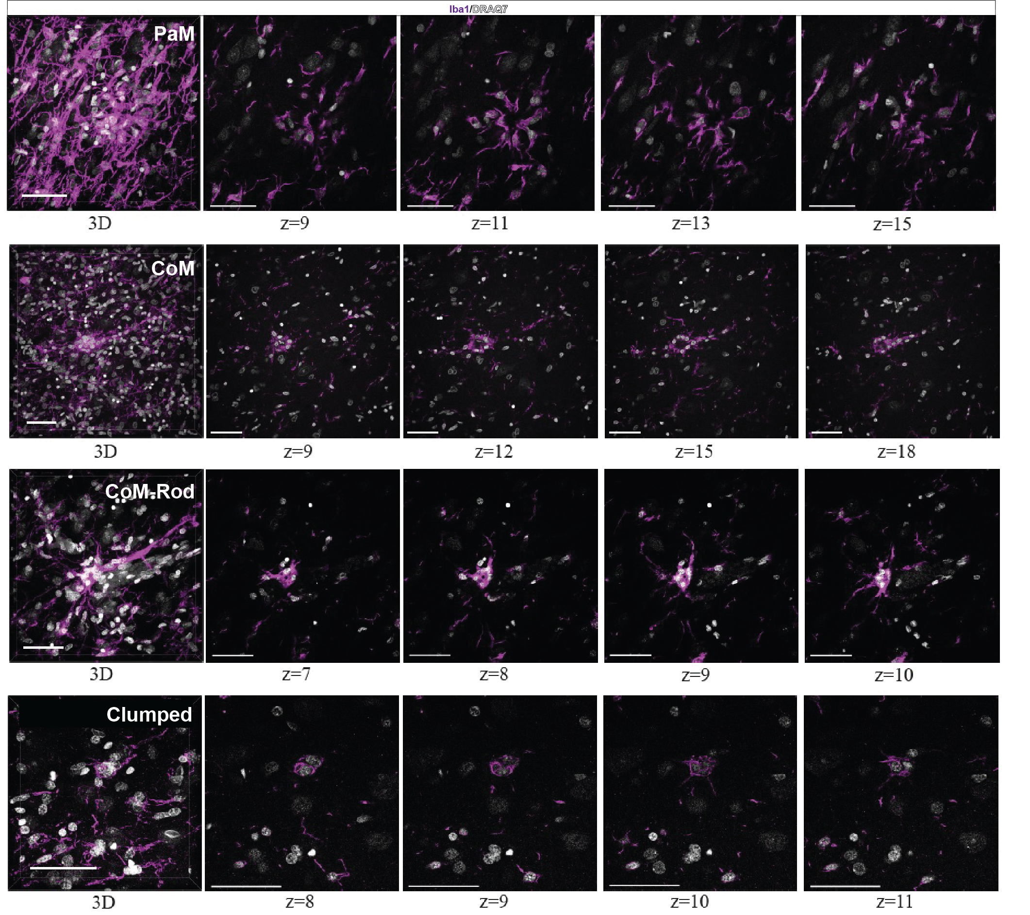

Supplementary Fig.3
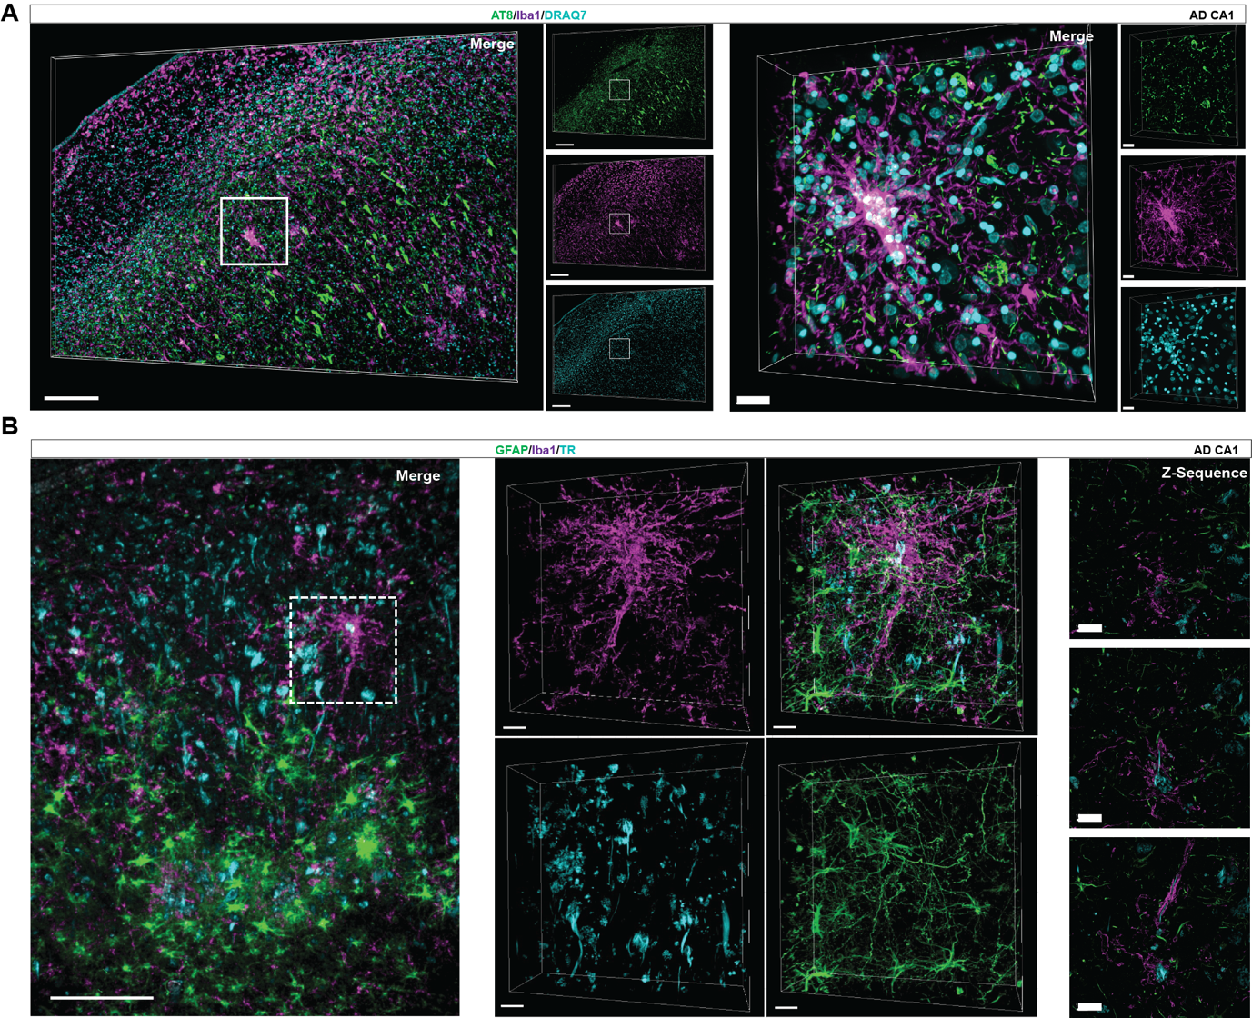

Supplementary Fig.4
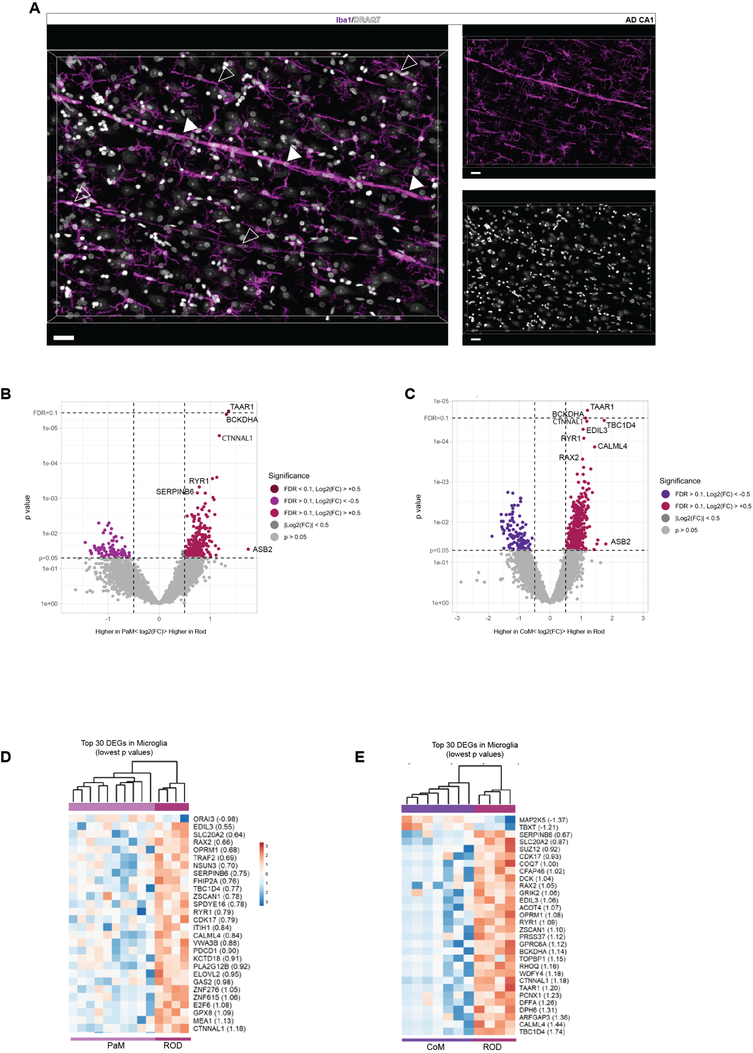

Supplementary Fig.5

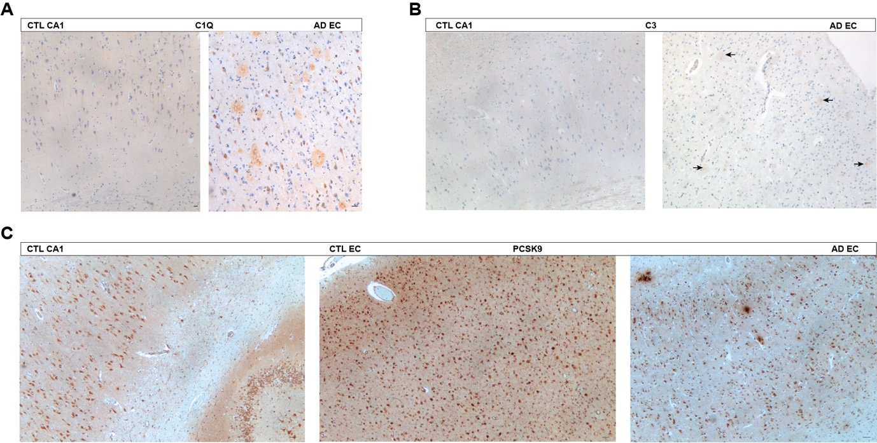

Supplementary Fig.6
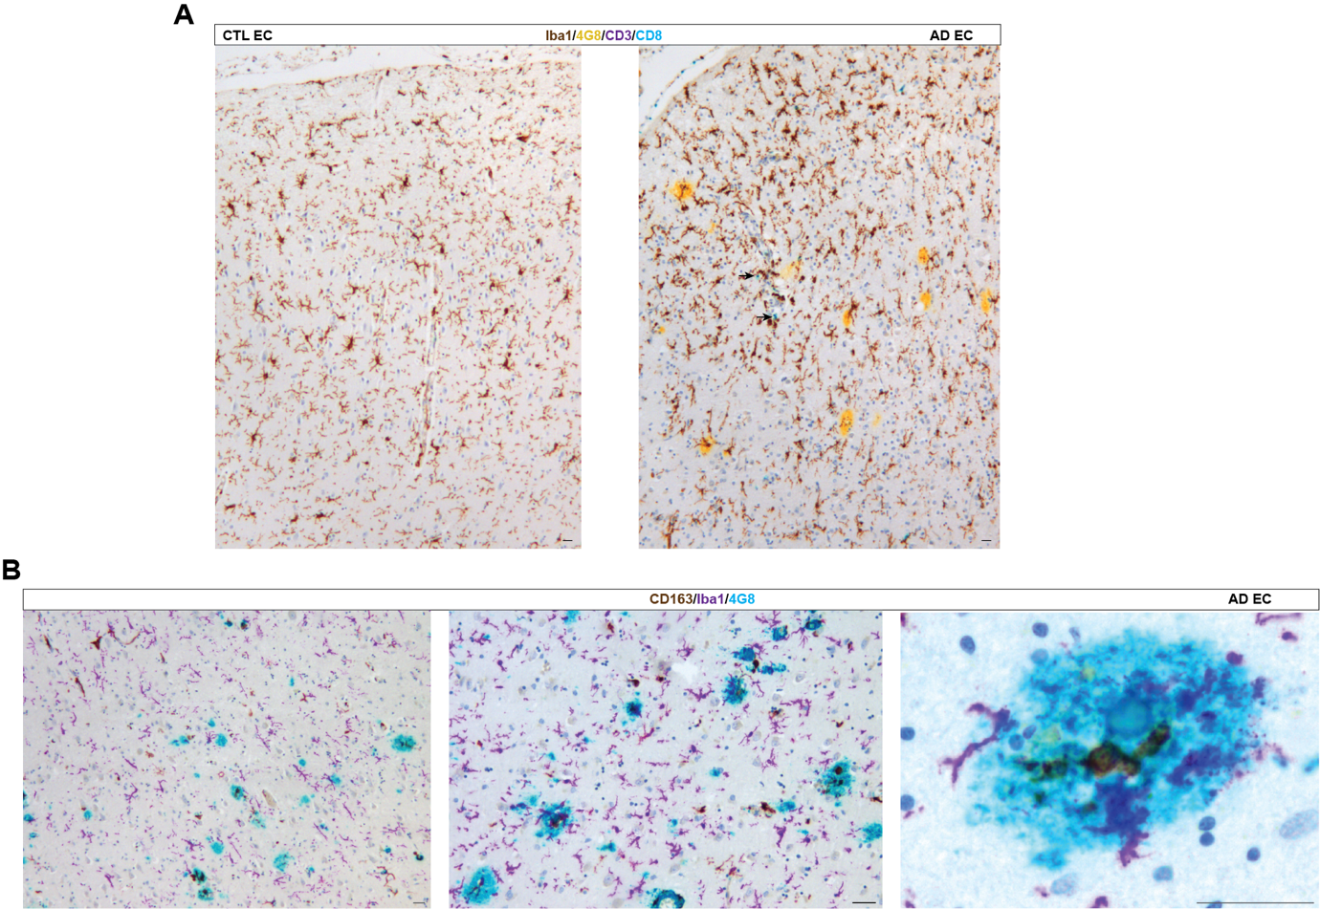

Supplementary Fig.7

