SI

Reversing sintering effect of Ni particles wetting on γ-Mo₂N support
Lili Lin^{1,2#}, Jinjia Liu^{3,4#}, Xi Liu^{5*}, Zirui Gao², Rui Ning⁶, Siyu Yao⁷, Feng Zhang⁸, Chang Liu⁹, Lili Han⁶, Feng Yang¹⁰, Sen Zhang⁹, Xiao-dong Wen^{3,4}, Sanjaya D. Senanayake⁶, Jose A. Rodriguez^{6,8*}, Ding Ma^{2*}
1. Industrial Institute of Catalysis, Department of Chemical Engineering, Zhejiang University of Technology, Hangzhou, 310014, China
2. Beijing National Laboratory for Molecular Sciences, College of Chemistry and Molecular Engineering and College of Engineering and BIC-ESAT Peking University, Beijing 100871, P. R. China
3. State Key Laboratory of Coal Conversion, Institute of Coal Chemistry, Chinese Academy of Sciences, Taiyuan, China
4. National Energy Centre for Coal to Liquids, Synfuels China Co. Ltd, Beijing, China
5. School of Chemistry and Chemical Engineering, In-situ Center for Physical Science, Shanghai Jiao Tong University, Shanghai, China
6. Chemistry Division, Brookhaven National Laboratory, Upton, New York 11973, USA
7. Key Laboratory of Biomass Chemical Engineering of Ministry of Education, College of Chemical and Biological Engineering, Zhejiang University, Hangzhou, 310027 China
8. Materials Science and Chemical Engineering Department, State University of New York, Stony Brook, New York, US
9. Department of Chemistry, University of Virginia, Charlottesville, Virginia 22904, United States
10. Department of Chemistry, Southern University of Science and Technology, Shenzhen 518055, China
Experimental Details
DFT calculation
All calculations were performed using Vienna Ab intio Simulation Package (VASP)^{[1,2]}. The electron exchange and correlation energy was treated within the Perdew-Burke-Ernzerhof (PBE)^{[3]} functional of generalized gradient approximations (GGA)^{[4]}. The election-ion interaction was described by the projector augmented wave (PAW) method^{[5]}, and the iterative solutions of Kohn-Sham equations was done using a plane-wave basis set with a cutoff energy of 400 eV. The sampling of the Brillouin zone was performed using a Monkhorst-Pack scheme with Gamma only K-points. The ab initio molecular dynamics (AIMD) simulations were performed under 590 ºC by sampling the canonical (NVT) ensemble with a time step of 1 fs during 5 ps of well-equilibrated trajectory.
In calculations, the bulk structure of Mo₂N is in accordance with previous study^{[6]}. For slab model, the Mo-terminated Mo₂N(111) surface with (6 × 6) supercell was used, there is 108 Mo, 36 N and 19 Ni atoms in Ni₁₉/Mo₂N(111) model and 108 Mo, 36 N, 19 Ni and 31 O atoms in Ni₁₉O₁₉/O-Mo₂N(111) model. In Ni₄N/Mo₂N(111) model, supported Ni₂₀N₅ cluster was truncated from bulk Ni₄N (Pmm), so there is 108 Mo, 41 N and 20 Ni atoms. In these three models, 36 Mo and 18 N atoms were fixed, while other atoms were relaxed. For CeO₂ support, an O-terminated CeO₂(111) surface with (5 × 5) supercell was used, it contains 50 Ce, 100 O and 19 Ni atoms, where 25 Ce and 25 O atoms was fixed and others was relaxed.
Catalyst preparation
Material Nickel acetylacetonate (Ni(acac)₂, 95%), oleylamine (OAm, 70%), tributylphosphine (TBP, 97%) and ammonia molybdate ((NH₄)₆Mo₇O₂₄·4H₂O) were purchased from Sigma-Aldrich and used without any further purification. Benzyl ether (BE, 99%) was bought from Acros Organics and used without any further purification. Isopropanol and hexane were purchased from Fisher (ACS Certified), distilled before use and kept with molecular sieve. All experiment was conducted under standard Schlenk line condition.
Synthesis of Ni-4nm The experiment was modified with our previous reports^{[7]}. Ni(acac)₂ (600 mg) was mixed with BE (60 ml) and OAm (8 ml) firstly. The mixture was stirred under vacuum for 5 minutes and the reaction was switched to N₂ atmosphere then. 5 ml TBP was injected to the reaction flask. The mixture was further heated under vacuum at 100 ℃ for 1 hour, generating a dark green transparent solution. The reaction flask was then filled with a N₂ blanket and the green solution was heated to 230 ℃ at a heating ramp of 5 ℃/min. The reaction was kept for 15 min at this temperature. All the product was transferred to N₂-filled glovebox to avoid exposure to air. The product was purified with extra dry isopropanol and separated by centrifugation (8000 rpm, 8 min). The purification was repeated two times and the product was then dispersed in extra dry hexane for further application.
Preparation of γ-Mo₂N The γ-Mo₂N was prepared using a literature-reported method. First, MoO₃ powders were synthesized by calcination of (NH₄)₆Mo₇O₂₄·4H₂O at 773 K for 4 h. Then, the MoO₃ powder was grounded and the fine powder of MoO₃ was transferred to a quartz tube and ammonized under the flow of pure NH₃ (150 mL/min) at 973 K for 4 h (heating rate was set as 5K/min). After cooling down to room temperature, the obtained γ-Mo₂N catalyst was passivated with CO₂ at room temperature overnight to protect the as-synthesized γ-Mo₂N material from the pyrophoric oxidation when contacted with air.
The protocol of Ni/γ-Mo₂N synthesis The Ni-4nm/γ-Mo₂N catalysts were synthesized by using incipient wet impregnation (IWI) of as-prepared homogeneous Ni-4nm hexane solution over the as-synthesized γ-Mo₂N. The slurry was then freeze-dried under stirring. The loading of Ni loading was set to ~2%. The catalyst is denoted as Ni-4nm/γ-Mo₂N.
The dispersion phenomena and mechanism of Ni-4nm/γ-Mo₂N was investigated in the flow of the N₂-H₂ mixture (1:3 v/v, 32 mL/min) at a temperature ramp of 5 ºC/min to 590 ºC.
Catalysts Characterization
QXANES and XAFS The in Situ Quick X-ray Absorption Near Edge Spectroscopy (QXANES) spectra was collected at ISS beamline of the Brookhaven National Laboratory (BNL), and X-ray Absorption Fine Structure Spectroscopy (XAFS) of the catalysts was collected at the 9-BM beamline of the Advance Photon Source (APS), Argonne National Laboratory (ANL). In the test, the powder samples were loaded in a Clausen Cell. The Ni K-edge XAFS spectra were collected in the fluorescence mode using a PIPS detector at BNL and four-channel vortex detector at APS, respectively. The activation processes for QXANES experiments is carried out in the flow of N₂/H₂ mixture (v:v=1:3) at a temperature ramp of 2 ºC/min to 590 ºC. Each scan takes 1min, and every 10 scans were merged together to get a spectrum. For the XAFS experiments, The activation processes were performed in the flow of N₂/H₂ mixture (v:v=1:3) at a temperature ramp of 10 ºC/min, but at the temperature of 400 and 590 ºC is held for 40 min before collecting spectra. Each scan will take 20 min, and every three scans are merged to be one spectrum. The data pretreatment and extended X-ray absorption fine structure (EXAFS) fitting were performed using the Ifeffit package.
Ambient Pressure X-ray Photoelectron Spectroscopy AP-XPS spectra were collected by a SPECS AP-XPS chamber equipped with a PHOIBOS 150 EP MCD-9 analyzer with an energy resolution of 0.4 eV. The C 1s photoemission line with the surface carbon feature (284.8 eV) was used for the binding energy calibration. The 2%Ni-4nm/γ-Mo₂N catalyst were pressed into a clean aluminum plate as XPS samples. Typically, the fresh sample was activated in the AP-XPS chamber by a 40 mTorr N₂/H₂ (1:3 v/v) mixture at 300, 350, 400, 500 and 520 ºC (the upper limit of the instrument) for 1 h. The spectra at the Ni2p, Mo3d/3p, O1s, N1s, and C1s XPS regions were collected at each temperature after an hour treatment.
Electron Microscopy TEM, HAADF-STEM images and EDS mappings in Figure 2 and Figure S4 were obtained using a FEI Talos F200X S/TEM microscope with a field-emission gun at 200 kV at CFN of Brookhaven National Lab.
Environmental SE-STEM
Environmental secondary electron/scanning transmission electron microscopy (Environmental SE/STEM) experiments were carried out using a probe aberration corrected Hitachi HF5000 equipped with a secondary detector, operated at 200 kV. The facility allows spontaneously record bright-field (BF), annual dark field (ADF), and secondary electron (SE) images under the STEM mode. By using the probe aberration corrector, it can get a resolution of 0.7 Å in ADF-STEM images and a resolution of below 1 Å in SE-STEM images. The sample was directly dispersed on the MEMS chip without any pretreatment. After inserting the heating holder equipped with the MEMS chip, a mixture of H₂ and N₂ with a molar ratio equal to 3:1 was introduced into the sample chamber area and a total pressure of 2 Pa was maintained during the whole experiments. The sample was directly heated to 200 ºC prior to the in-situ study. Once the sample was heated to the desired temperature, the following changes in morphology and structure of the samples were imaged.
Performance evaluation of CO₂ hydrogenation
In a typical experiment, 10 mg of Ni-4nm/γ-Mo₂N catalyst powder was mixed with 10 mg of pre-calcined SiO₂ and loaded in a fixed-bed reactor. The sample was activated in a flow of a N₂ and H₂ mixture (1:3 v/v) at 590 ºC for 2 h. After activation, the temperature of the reactor was changed to a designated temperature in the N₂-H₂ mixture and then switched to the reaction gas feed (CO₂/H₂/N₂ 1:3:1 v/v/v). For the reference catalysts. The products of the reaction were analyzed by online gas chromatography (GC, Agilent 7890) equipped with a thermal conductive detector (TCD) and a flammable ionization detector (FID). The N₂ in the flow was used as the inner standard. The response factor of each reactant and product was calibrated using standard curve methods.

Supplementary Figures, Tables and videos

Video S1. The MD simulation of Ni₁₉ on γ-Mo₂N (side view)
Video S2. The MD simulation of Ni₁₉ on γ-Mo₂N (top view)
Video S3. The MD simulation of Ni₁₉O₁₉ on γ-Mo₂N (side view)
Video S4. The MD simulation of Ni₁₉O₁₉ on γ-Mo₂N (top view)
Video S5. The MD simulation of Ni₁₉ on CeO₂ (side view)
Video S6. The MD simulation of Ni₁₉ on CeO₂ (top view)
Video S7. The record of environmental SE/STEM characterization of Ni-4nm/γ-Mo₂N catalyst in the flow of H₂/N₂ at a ratio of 3:1 at 520 ºC.
Video S8. The structure evolution of Ni4N on γ-Mo₂N(111) in AIMD calculation(side view)
Video S9. The structure evolution of Ni4N on γ-Mo₂N(111) in AIMD calculation(top view)

Table S1. The Ni K edge EXAFS fitting results of Ni-4nm/γ-Mo₂N and Ni-4nm/CeO₂ catalysts
Sample | Temp.  (ºC) | Shell | Bond length (Å) | Coordination Number | σ² (Å) | E₀ shift (eV)
Ni-4nm/γ-Mo₂N | 400 | Ni-Ni | 2.49±0.01 | 4.5±0.6 | 0.01 | -6.9
Ni-4nm/γ-Mo₂N | 400 | Ni-N | 1.9±0.02 | 1.5±0.6 | 0.003 | -6.9
Ni-4nm/γ-Mo₂N | 590 | Ni-Ni | 2.49±0.01 | 2.6±1.0 | 0.004 | -8.3
Ni-4nm/γ-Mo₂N | 590 | Ni-Mo | 2.62±0.03 | 5.4±1.1 | 0.016 | -8.3
Ni-4nm/γ-Mo₂N | 590 | Ni-N | 2.00±0.03 | 1.7±0.7 | 0.025 | -8.3
Ni-4nm/CeO₂ | 590 | Ni-Ni | 2.49±0.01 | 10.8±1.2 | 0.006 | 0.2

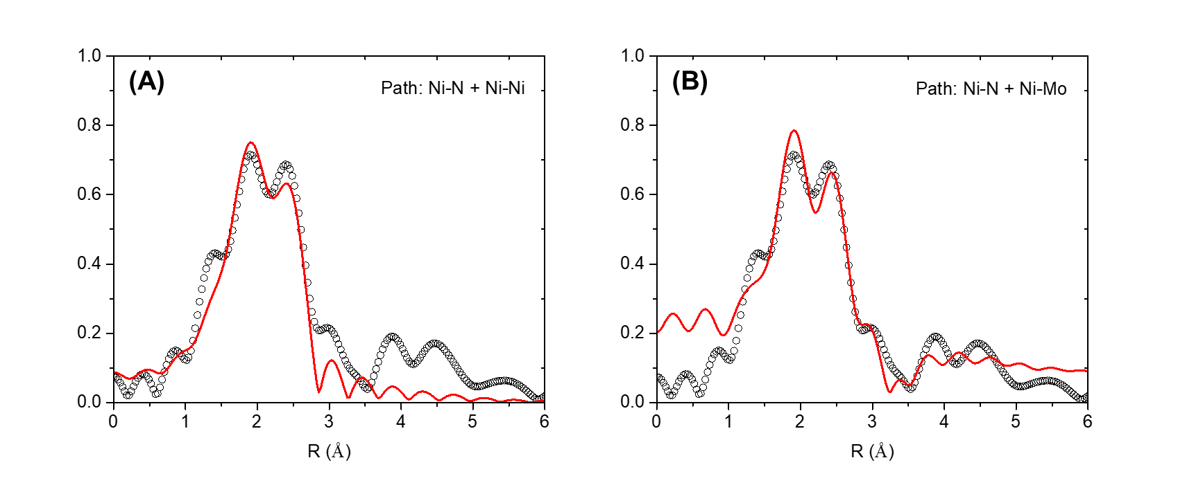
Figure S1. The detailed description of EXAFS Ni K edge fitting results. (1) Ni-Mo path only, (b) Ni-Ni path only.

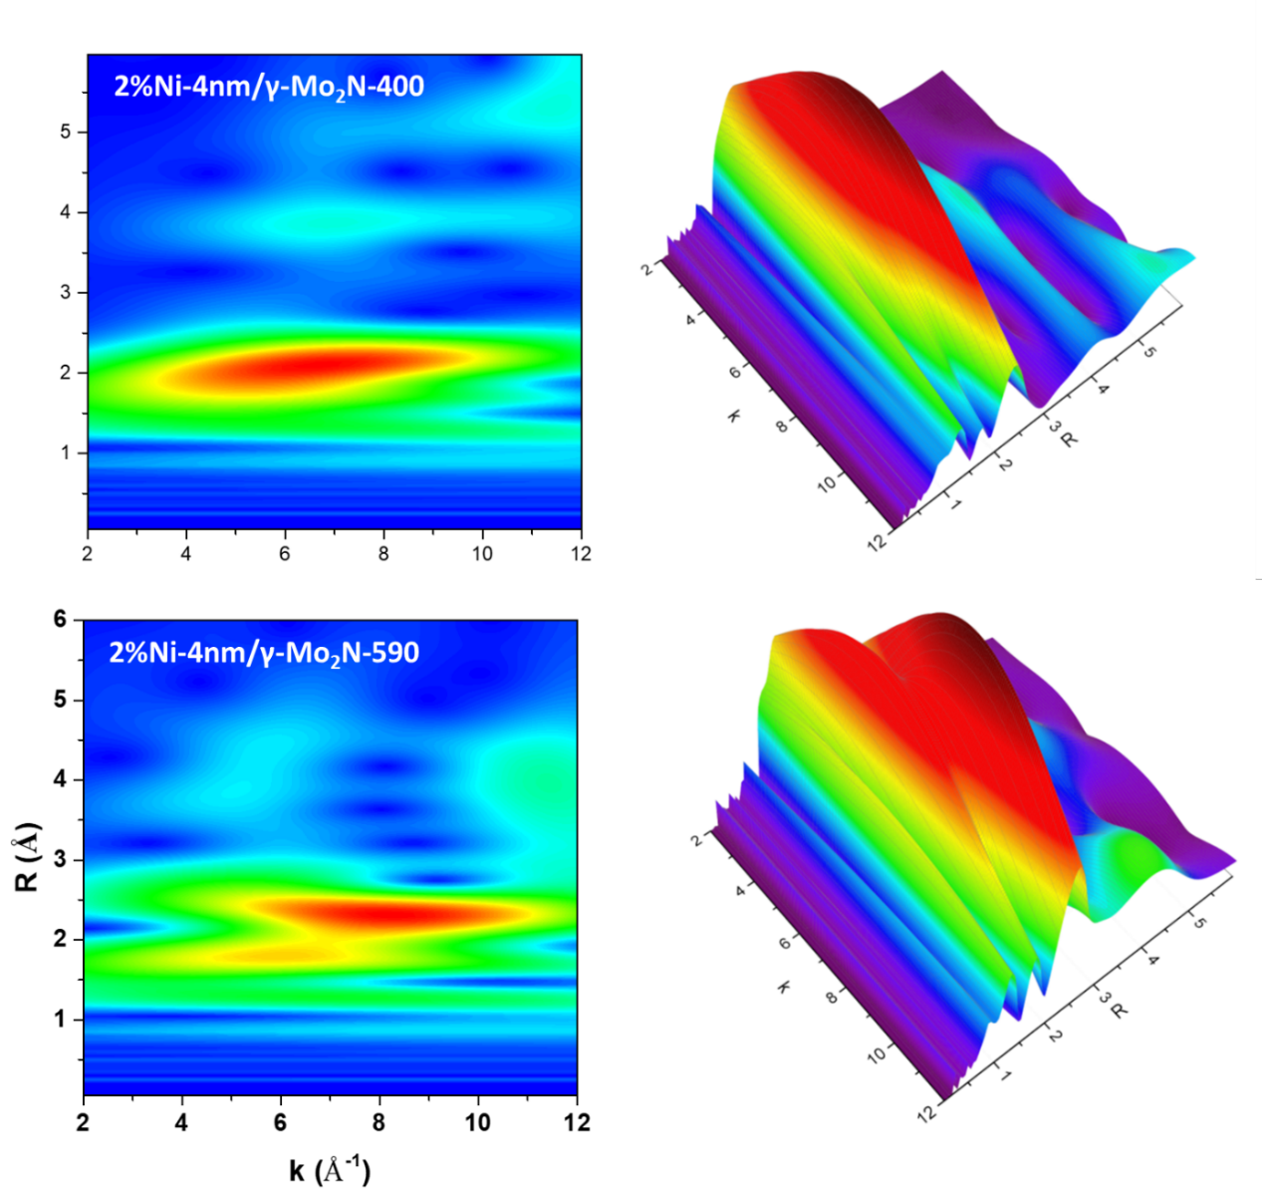
Figure S2. The wavelet transformation (WT) of the EXAFS spectra of the 2% Ni-4nm catalyst at 400 and 590 °C under reduction condition.

Figure S3. The STEM images of (a) ADF, (b) BF and (c) SE.

Figure S4. d spacing of 2.6Å analysis and comparison according to all possibile phases in Ni/γ-Mo₂N catalyst.

Figure S5. The normalized secondary electron intensity of Ni species at 400 °C, 500 °C and 520 °C. The intensity of Ni species at 520 °C sample was much weaker than those of the 400 and 500 °C samples, which is another evidence that the Ni particles has reverse sintering at high temperature.

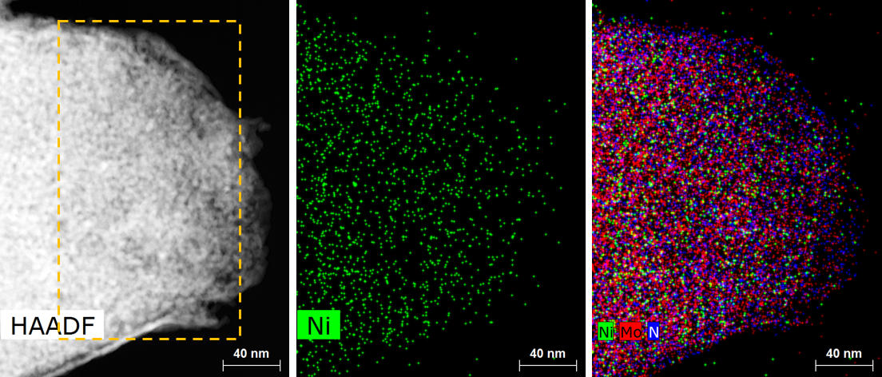
Figure S6. STEM-HAADF image and EDS mapping of ex-situ sample of Ni-4nm/γ-Mo₂N-590 catalyst.
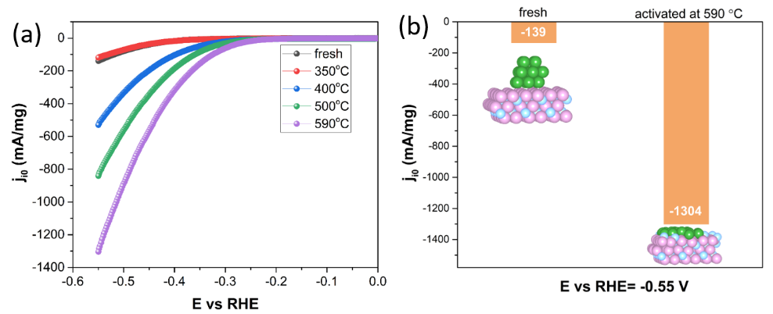
Figure S7. The performance evaluation for Ni-4nm/γ-Mo₂N treated at different temperature. (a) (b) the activity of hydrogen evaluation reaction over Ni-4nm/γ-Mo₂N catalyst at the state of fresh, activated at 350, 400, 500 and 590 ºC. The activated catalysts were passivated by CO₂ before the HER performance test.

It has also been demonstrated the reverse sintering effect in the Ni/γ-Mo₂N catalyst is able to enhance the water splitting activity by increasing the exposure of the active metal sites. Using the electrocatalytic hydrogen evolution reaction (HER) as the model reaction, we have evaluated the HER activity of the Ni-4nm/γ-Mo₂N catalysts activated at different temperature in the reductive atmosphere. Based on Figure 5f and g, it is clear that with the spread of the Ni atoms, the specific current density has been enhanced significantly. Comparing the fresh catalyst with the Ni-4nm/γ-Mo₂N-590 catalyst, the hydrogen evolution rate increased by about 10 times. Therefore, the reverse sintering effect can be used to maximize the dispersion and utilization efficiency of metals using simple treatments.

Reference
[1] Kresse, G. & Furthmüller, J. Efficient iterative schemes for ab initio total-energy calculations using a plane-wave basis set. Physical Review B (1996) 54, 11169.
[2] Kresse, G. & Furthmüller, J. Efficiency of ab-initio total energy calculations for metals and semiconductors using a plane-wave basis set. Computer Material Science (1996) 6, 15-50.
[3] Perdew, J. P., Ernzerhof, M. & Burke, K. Rationale for mixing exact exchange with density functional approximations. The Journal of chemical physics (1996) 105, 9982-9985.
[4] Perdew, J. P., Burke, K. & Ernzerhof, M. Generalized gradient approximation made simple. Physical Review Letter (1996) 77, 3865.
[5] Blöchl, P. E. Projector augmented-wave method. Phys Rev B (1994) 50, 17953.
[6] Yao, S., Lin, L., Liao, W. et al. Exploring Metal–Support Interactions To Immobilize Subnanometer Co Clusters on γ–Mo2N: A Highly Selective and Stable Catalyst for CO2 Activation. ACS Catalysis (2019) 9, 9087-9097.
[7] Zhang, S., Hao, Y., Su, D. et al. Monodisperse Core/Shell Ni/FePt Nanoparticles and Their Conversion to Ni/Pt to Catalyze Oxygen Reduction. Journal of the American Chemical Society (2014) 136, 15921-15924.

