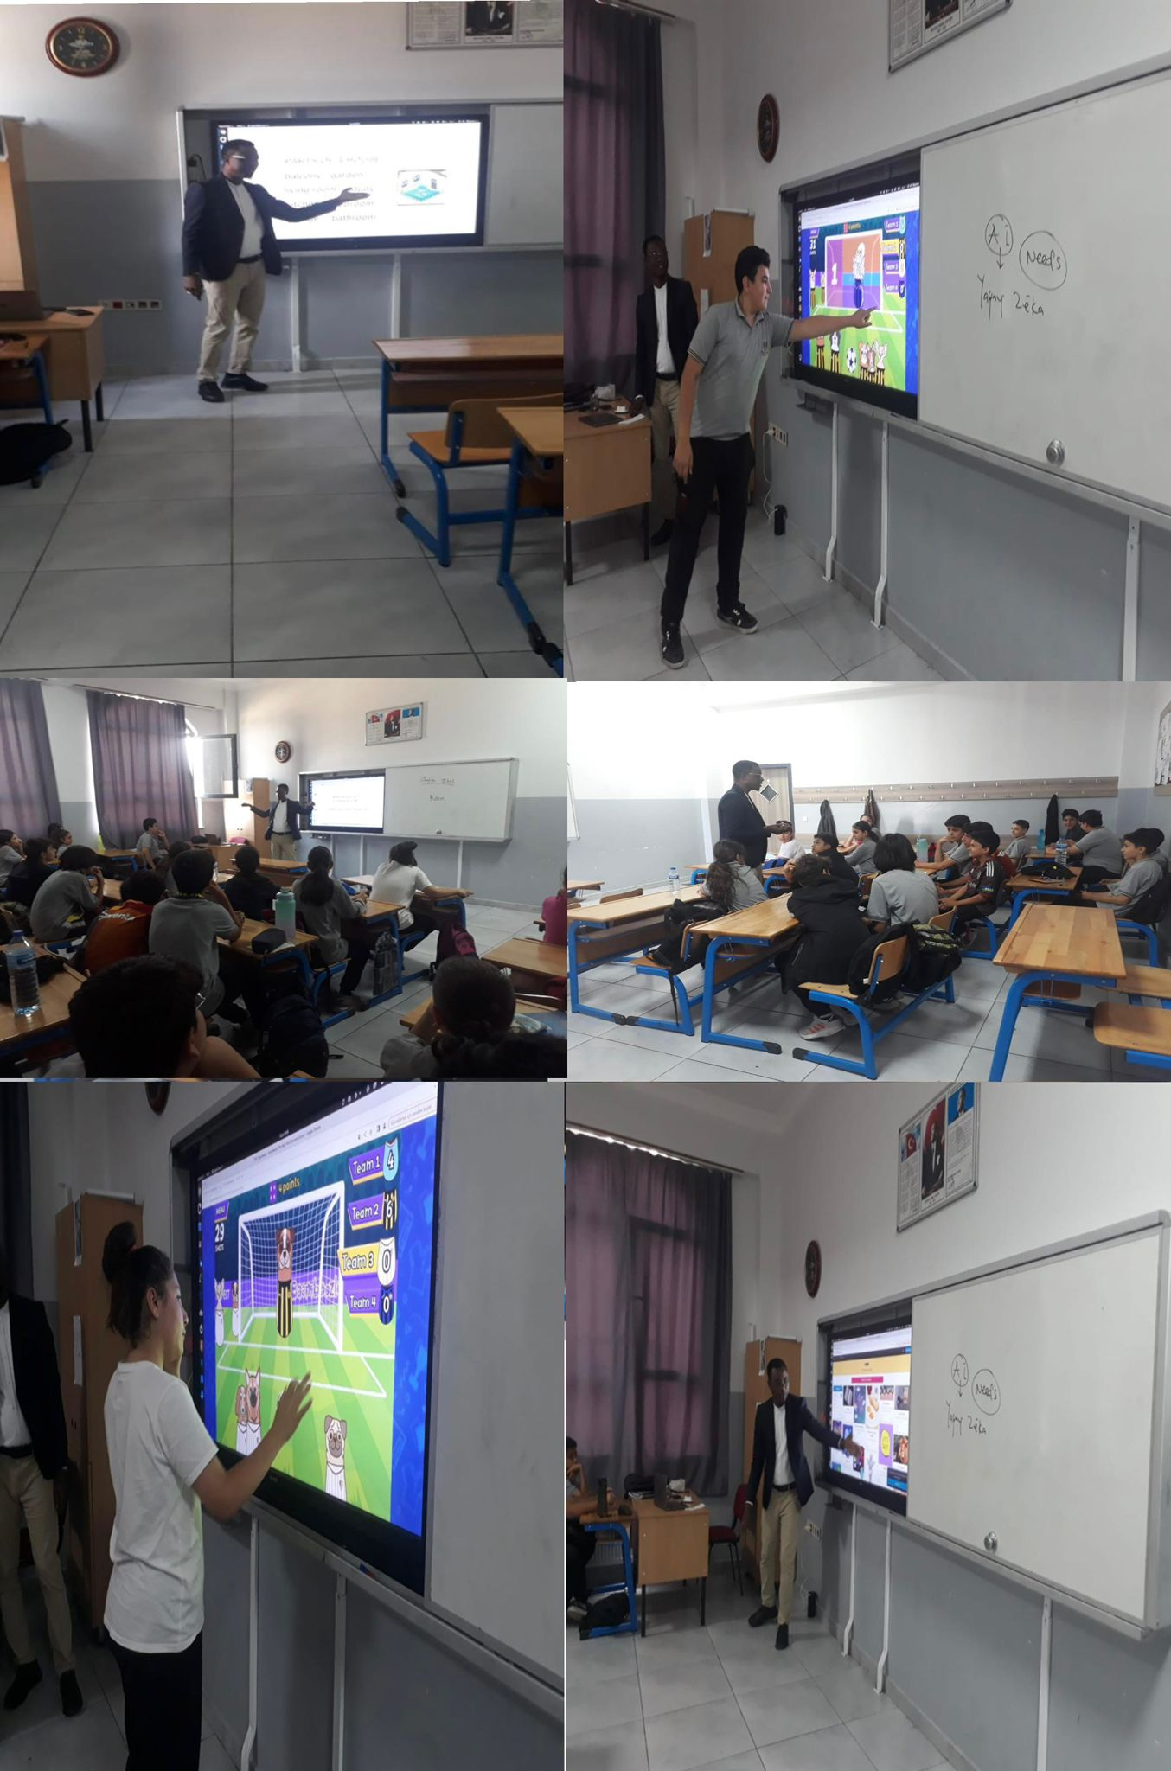
Appendix 1 Pictures Taken During Implementation

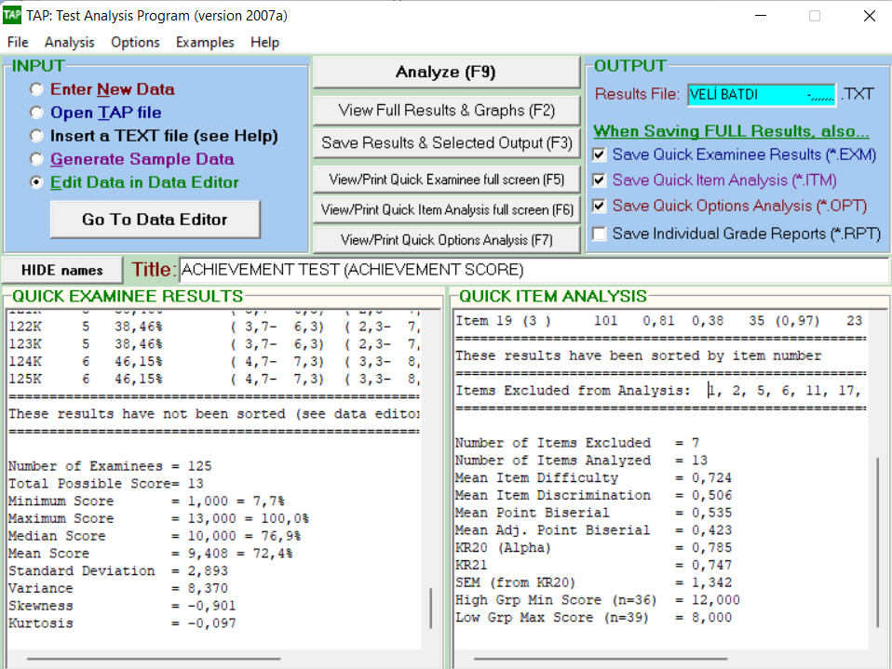
Appendix 2 Academic Achievement Test Results

