Table 1: Molecular docking score of the top 10 hits along with biological activity.
S.No. | Drugbank ID | Generic Name | Libdock Score | -CDOCKER Energy Before flexible docking | -CDOCKER Energy After flexible docking | Biological Activity
1 | DB00718 | Adefovir dipivoxil | 133.293 | 56.4289 | 59.0853 | Inhibitor of reverse transcriptase of HBV(1)
2 | DB00938 | Salmeterol | 136.5928 | 49.8625 | 52.7556 | Beta-2 adrenergic receptor agonist(2)
3 | DB13074 | Macimorelin | 147.8018 | 53.5545 | 51.3666 | Growth hormone secretagogue receptor type 1(3)
4 | DB00293 | Raltitrexed | 130.729 | 46.4396 | 48.9148 | folic acid antagonists, Thymidylate synthase(4)
5 | DB06813 | Pralatrexate | 137.8444 | 48.1235 | 48.1695 | Dihydrofolate reductase inhibitor Thymidylate synthase(5)
6 | DB08934 | Sofosbuvir | 126.3765 | 56.7153 | 48.1377 | RNA-dependent RNA-polymerase(6)
7 | DB00563 | Methotrexate | 132.3609 | 43.3586 | 43.5117 | Dihydrofolate reductase, Thymidylate synthase Bifunctional purine biosynthesis protein PURH(7)
8 | DB00775 | Tirofiban | 125.0846 | 40.0981 | 42.8513 | Integrin alpha-IIb antagonist Humans Integrin beta-3, fibrinogen binding to the GP IIb/IIIa receptor(8)
9 | DB00881 | Quinapril | 124.9284 | 43.7751 | 40.9351 | Angiotensin-converting enzyme(9)
10 | DB00542 | Benazepril | 125.6081 | 38.4797 | 39.2084 | Angiotensin-converting enzyme(10)

Table 2 Interaction between PCSK9 and EGFA in absence and in presence of ligands.
Interactions between PCSK9 and EGFA (LDLR) | Control | Sofosbuvir | Quinapril | Benazepril | Tirofiban
PCSK9:PHE379 & EGFA:CYS297 | + | - | + | + | +
PCSK9:PHE379 & EGFA:CYS308 | + | - | + | - | +
PCSK9:ASP238 & EGFA:ASN295 | + | - | - | - | -
PCSK9:THR377 & EGFA:ASP310 | + | + | - | - | +

Table 3: Non Bond interactions between PCSK9 and top 10 hit compounds after docking along with their structures
S. No. | Drugbank ID | Generic Name | Structure | Interacting Residues | Type of interaction | Distance (Å)
1. | DB00718 | Adefovir dipivoxil | 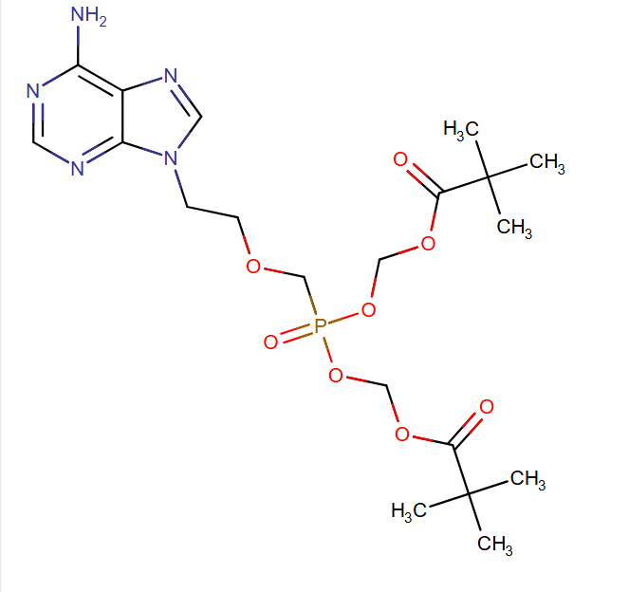 | SER383  HIS306  SER381  GLY365  VAL380  VAL307  ALA338  VAL346 | Carbon Hydrogen Bond  Carbon Hydrogen Bond  Carbon Hydrogen Bond  Carbon Hydrogen Bond  Alkyl  Alkyl  Pi-Alkyl  Pi-Alkyl | 2.57216  2.57041  2.41673  2.49816  4.25929  5.32304  5.36346  4.29095
2. | DB00938 | Salmeterol | 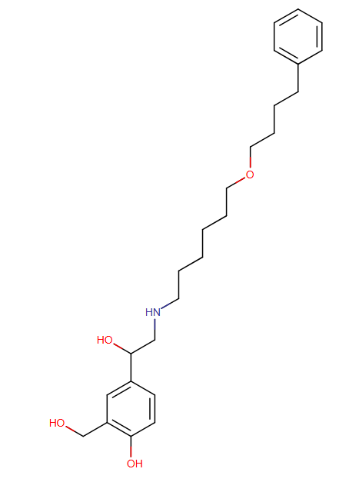 | SER373  SER383  ASP374  SER381  ASP374  LEU348  HIS306  VAL380  VAL346 | Conventional Hydrogen Bond  Conventional Hydrogen Bond  Conventional Hydrogen Bond  Carbon Hydrogen Bond  Carbon Hydrogen Bond  Alkyl  Pi-Alkyl  Pi-Alkyl  Pi-Alkyl | 2.11596  2.82477  2.43448  2.56155  2.68573  4.94803  5.03946  5.39425  4.46936
3. | DB13074 | Macimorelin | 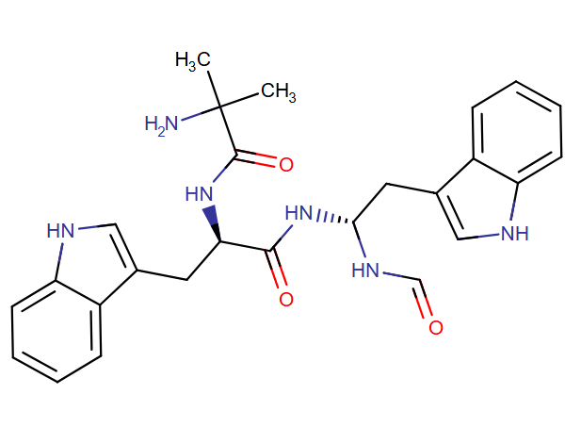 | ASN317  SER383  GLU366  HIS306  LEU351  ALA338  VAL346 | Conventional Hydrogen Bond  Conventional Hydrogen Bond  Conventional Hydrogen Bond  Pi-Pi Stacked  Pi-Alkyl  Pi-Alkyl  Pi-Alkyl | 2.97095  2.13762  2.23609  5.84068  5.12303  5.19905  4.2171
4. | DB00293 | Raltitrexed | 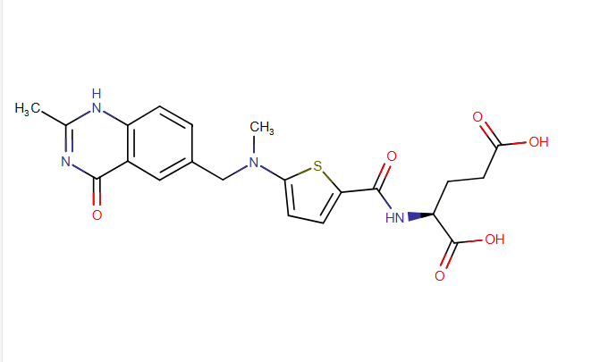 | ASN317  GLN256  GLY257  ALA151  LEU348 | Conventional Hydrogen Bond  Conventional Hydrogen Bond  Carbon Hydrogen Bond  Carbon Hydrogen Bond  Pi-Alkyl | 2.56687  2.25288  2.58613  2.50396  4.35121
5. | DB06813 | Pralatrexate | 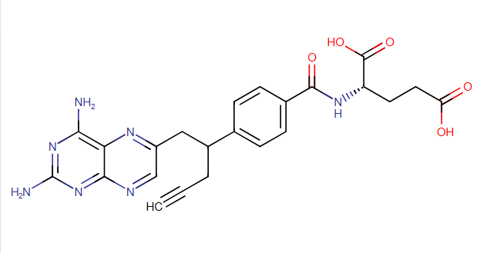 | GLN152  ASN317  VAL346  LEU348 | Carbon Hydrogen Bond  Conventional Hydrogen Bond  Alkyl  Pi-Alkyl | 2.68887  2.08275  4.3103  5.39836
6. | DB08934 | Sofosbuvir | 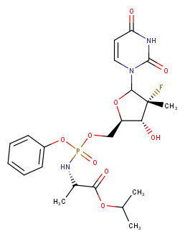
  ASN317
  ALA151
  ALA151
  ALA151
  GLN152
  VAL346
  LEU348
  Conventional Hydrogen Bond
  Conventional Hydrogen Bond
  Carbon Hydrogen Bond
  Halogen (Fluorine)
  Halogen (Fluorine)
  Alkyl
  Pi-Alkyl
  2.13927
  2.90673
  3.09951
  2.96144
  2.90032
  5.17954
  5.47585
7. | DB00563 | Methotrexate | 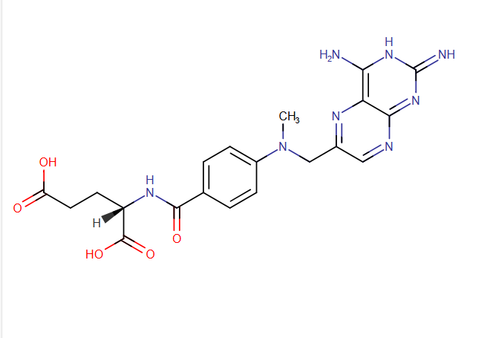 | SER381  ASP374  GLU366  LYS222  SER225  VAL380 | Conventional Hydrogen Bond Conventional Hydrogen Bond Conventional Hydrogen Bond Carbon Hydrogen Bond  Pi-Donor Hydrogen Bond  Pi-Alkyl | 2.29922  2.72239  2.78877  2.85853  2.09194  5.26248
8. | DB00775 | Tirofiban | 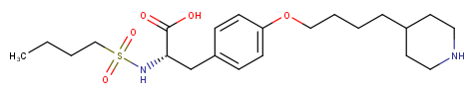
  SER383
  SER381
  GLN382
  SER383
  VAL380
  PHE318
  Conventional Hydrogen Bond
  Conventional Hydrogen Bond
  Carbon Hydrogen Bond
  Carbon Hydrogen Bond
  Alkyl
  Pi-Alkyl
  1.97656
  2.19246
  2.55921
  3.01142
  4.53612
  5.16137
9. | DB00881 | Quinapril
  HIS226
  HIS226
  ALA151
  LYS222
  LEU348
  Conventional Hydrogen Bond
  Carbon Hydrogen Bond
  Alkyl
  Pi-Alkyl
  Pi-Alkyl
  2.93106
  2.54637
  5.11551
  5.39992
  5.0596
10. |  | Benazepril
  DB00542
  SER383
  ALA151
  PHE150
  PHE318
  LEU351
  ALA151
  LYS222
  Carbon Hydrogen Bond
  Carbon Hydrogen Bond
  Pi-Donor Hydrogen Bond
  Pi-Alkyl
  Pi-Alkyl
  Pi-Alkyl
  Pi-Alkyl
  2.94055
  2.26067
  2.98709
  5.02024
  4.72753
  5.47918
  5.43922

References
- Noble S, Goa KL. Adefovir dipivoxil. Drugs. 1999 Sep;58(3):479–87; discussion 488-489.
2. Meyer JM, Wenzel CL, Kradjan WA. Salmeterol: a novel, long-acting beta 2-agonist. Ann Pharmacother. 1993 Dec;27(12):1478–87.
3. Agrawal V, Garcia JM. The macimorelin-stimulated growth hormone test for adult growth hormone deficiency diagnosis. Expert Rev Mol Diagn. 2014 Jul;14(6):647–54.
4. Liu Y, Wu W, Hong W, Sun X, Wu J, Huang Q. Raltitrexed-based chemotherapy for advanced colorectal cancer. Clin Res Hepatol Gastroenterol. 2014 Apr;38(2):219–25.
5. Jennifer C Z, Sara Mohamed J, Salma A, Francine F. Pralatrexate injection for the treatment of patients with relapsed or refractory peripheral T-cell lymphoma. Expert Rev Hematol. 2020 Jun;13(6):577–83.
6. Rubino C, Trapani S, Indolfi G. Sofosbuvir/velpatasvir for the treatment of hepatitis C in pediatric patients. Expert Rev Gastroenterol Hepatol. 2021 Oct;15(10):1097–105.
7. Puig L. Methotrexate: new therapeutic approaches. Actas Dermosifiliogr. 2014;105(6):583–9.
8. Zi W, Song J, Kong W, Huang J, Guo C, He W, et al. Tirofiban for Stroke without Large or Medium-Sized Vessel Occlusion. N Engl J Med. 2023 Jun 1;388(22):2025–36.
9. Cetnarowski-Cropp AB. Quinapril: a new second-generation ACE inhibitor. DICP Ann Pharmacother. 1991 May;25(5):499–504.
10. Gengo FM, Brady E. The pharmacokinetics of benazepril relative to other ACE inhibitors. Clin Cardiol. 1991 Aug;14(8 Suppl 4):IV44-50; discussion IV51-55.

