Supplementary material

Title: Strong impact of orally administered BCR4 defensin on aphid survival, embryo development and symbiotic cells in three Acyrthosiphon pisum parthenogenetic lines

Hugo Terrasson¹, Karen Gaget¹, Garance Lapetoule¹, Isabelle Rahioui¹, François Renoz², Sylvain Benhamou¹, Chrystèle Jouve¹, Catherine Sivignon¹, Gabrielle Duport¹, Vincent Aucagne³, Jean-Christophe Simon⁴, Mélanie Ribeiro Lopes¹, Federica Calevro^{1,#} and Pedro Da Silva^{1,#}

Affiliations :
¹: INSA Lyon, INRAE, BF2I, UMR203, 69621 Villeurbanne, France
²: UCLouvain, Biodiversity Research Centre, Earth and Life Institute, Louvain-la-Neuve, Belgium
³: Centre de Biophysique Moléculaire, CNRS UPR 4301, 45071 Orléans, France
⁴ : INRAE, UMR IGEPP, Institut Agro, Université de Rennes, Le Rheu, France
# Corresponding authors: Federica Calevro, e-mail address: federica.calevro@inrae.fr and Pedro Da Silva, e-mail address: pedro.da-silva@insa-lyon.fr

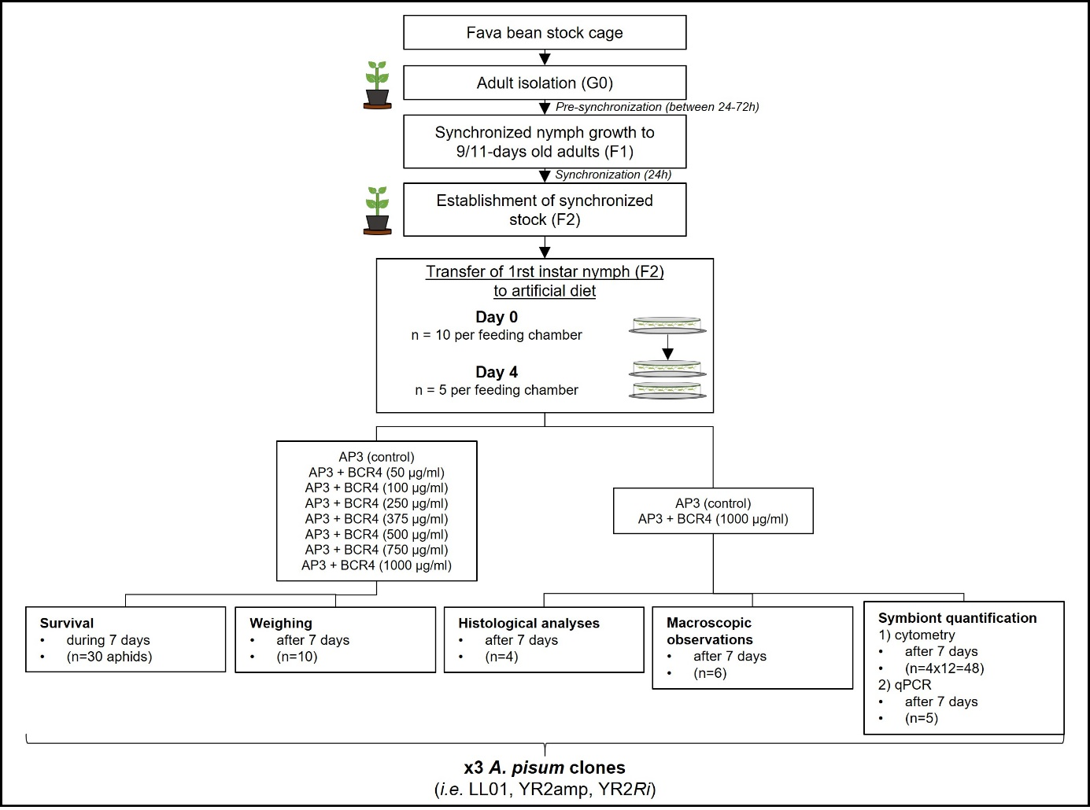
Fig. S1 Experimental design used for observations and phenotypic measurements of aphids after BCR4 ingestion

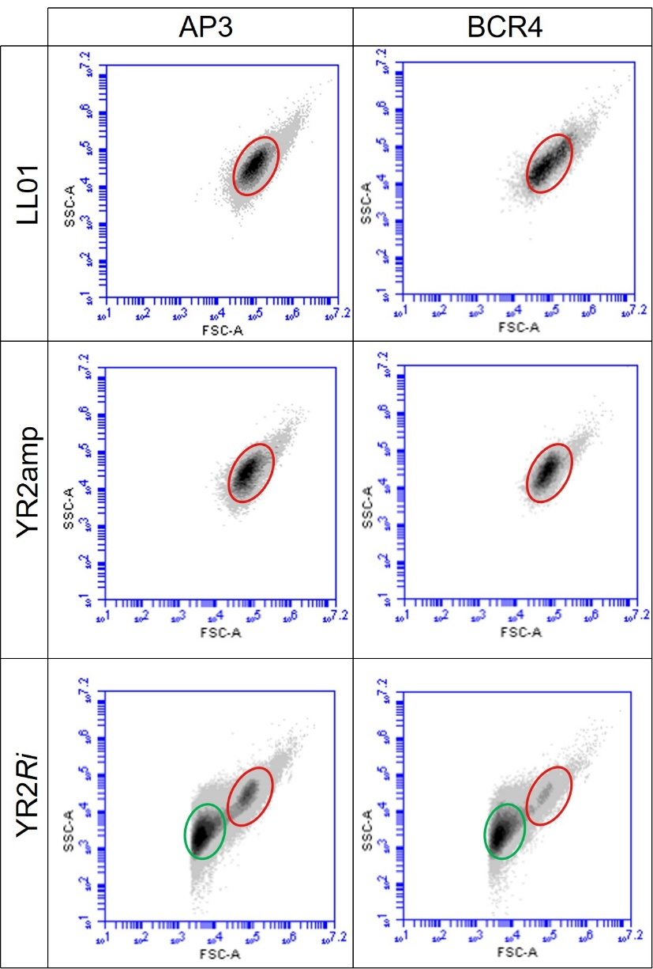
Fig. S2 Symbiont identification by flow cytometry in Acyrthosiphon pisum lines. Cells identified as symbionts were represented on density plot (FSC-A/SSC-A), the grey gradient indicating increasing density of dots. The B. aphidicola population (red circle) is defined according to the parameters described by Simonet et al. (2016), while a second population (green circle) is observed only in YR2-Ri lines and corresponds to the secondary symbiont R. insecticola
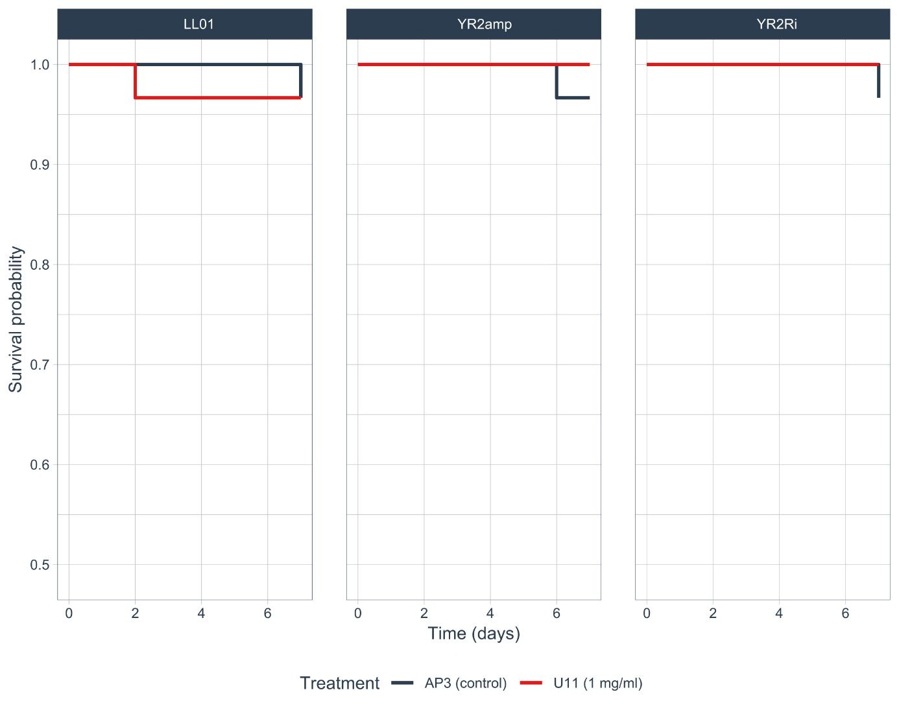
Fig. S3 Survival curves of aphid fed on AP3 only (negative control, grey lines) or on AP3 containing 1mg/ml of U11 peptide (red lines) during seven days. Left, central and right panels correspond to survival curves of LL01 line, YR2-amp line and YR2-Ri line, respectively. n=30 for each BCR4-concentration group for each line
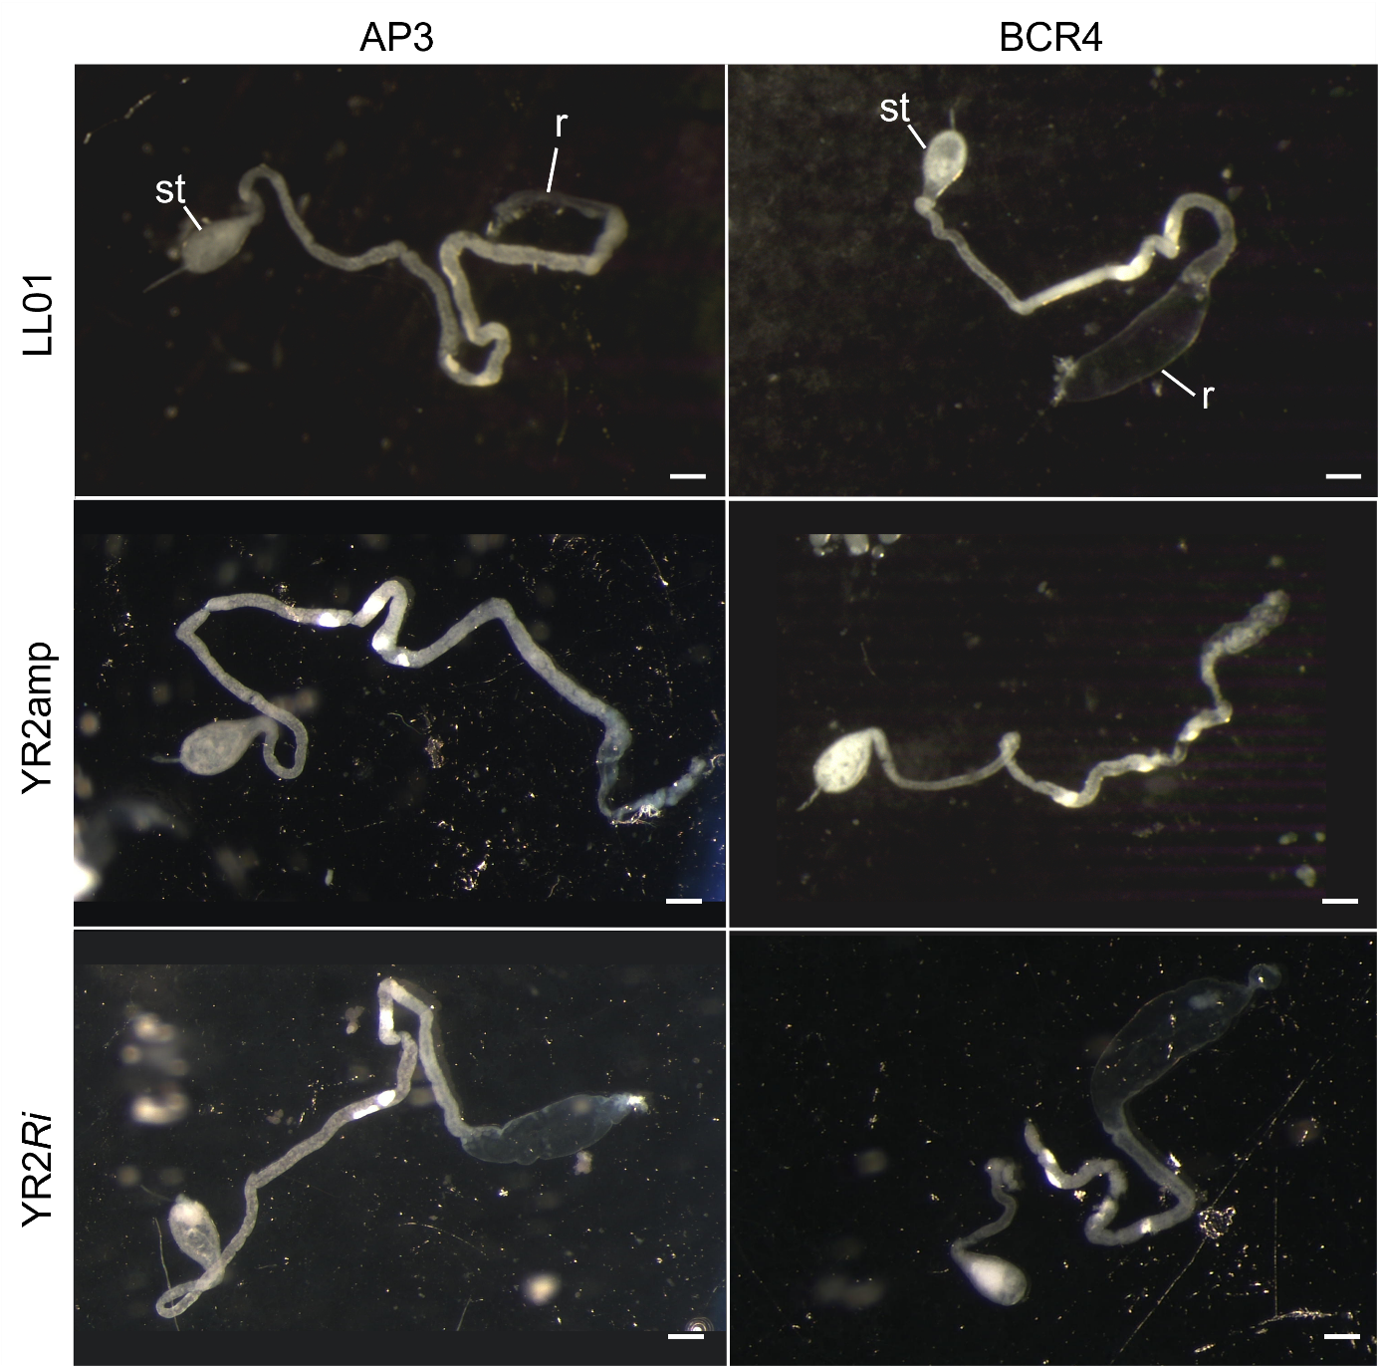
Fig. S4 Dissection of digestif tracts from three Acyrthosiphon pisum lines after ingestion of AP3 (control, left panels) or AP3 complemented with 1000 µg/ml of BCR4 peptide (right panels) for seven days. st = stomac; r = rectum. Scalebar = 200 µm

Target | Organisme | Name | Sequence, 5′–3′ | Orientation | Source
AlexaFluor-labeled probes for fluorescent in situ hybridization targeting B. aphidicola and R.insecticola 16S rRNA :
16S rRNA | B.aphidicola | Alexa488-Buch | CACCTAGAATTCTACCTCCCTCT | Antisense | This study
16S rRNA | R.insecticola | Alexa594-Reg | GTAGCAAGCTACTCCCCGAT | Antisense | This study
Table S1. Oligonucleotides used in this study

