Supplementary figures
Figure S1
Gut microbiota analysis of the control and anosmic groups. Alpha rarefaction plot of PD whole tree and ACE (A, B); Rank Abundance analysis curve (C); and Specaccum species accumulation curve (D).
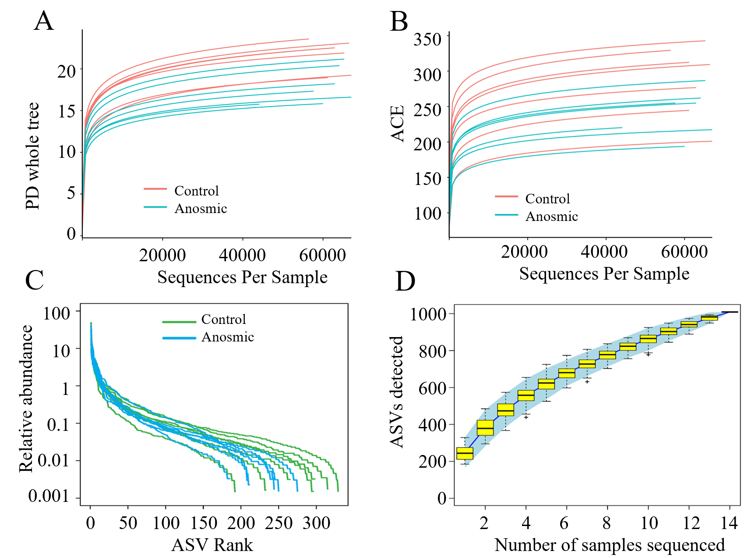

Figure S2
PCoA based on the Bray–Curtis distance matrix of the mouse gut microbiota. Control and anosmic groups (A); A-FMT and C-FMT groups (B).
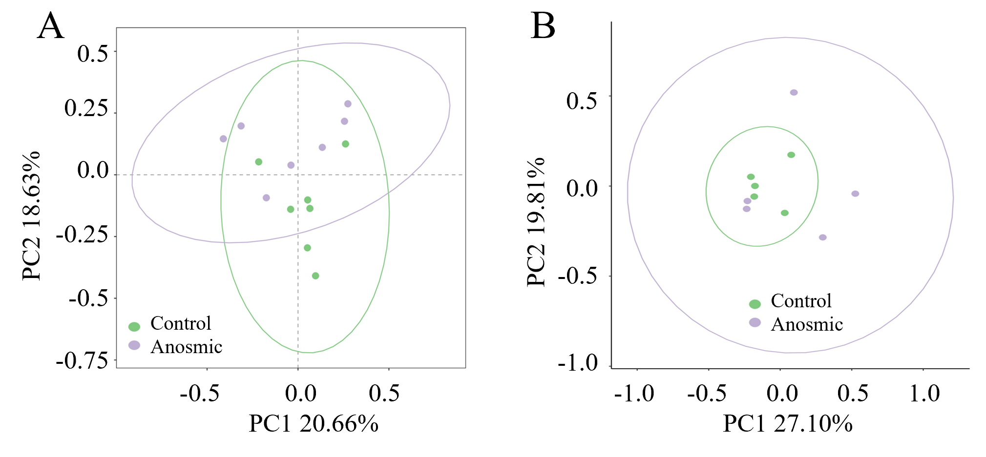

Figure S3
Pep-Quant library characteristics of olfactory bulbs. Bar graph showing distribution of identified peptides and proteins (A), molecular weight of proteins (B), protein length (C), proteome sequence coverage (D), peptide charge (E), and Pearson correlation coefficient (F).
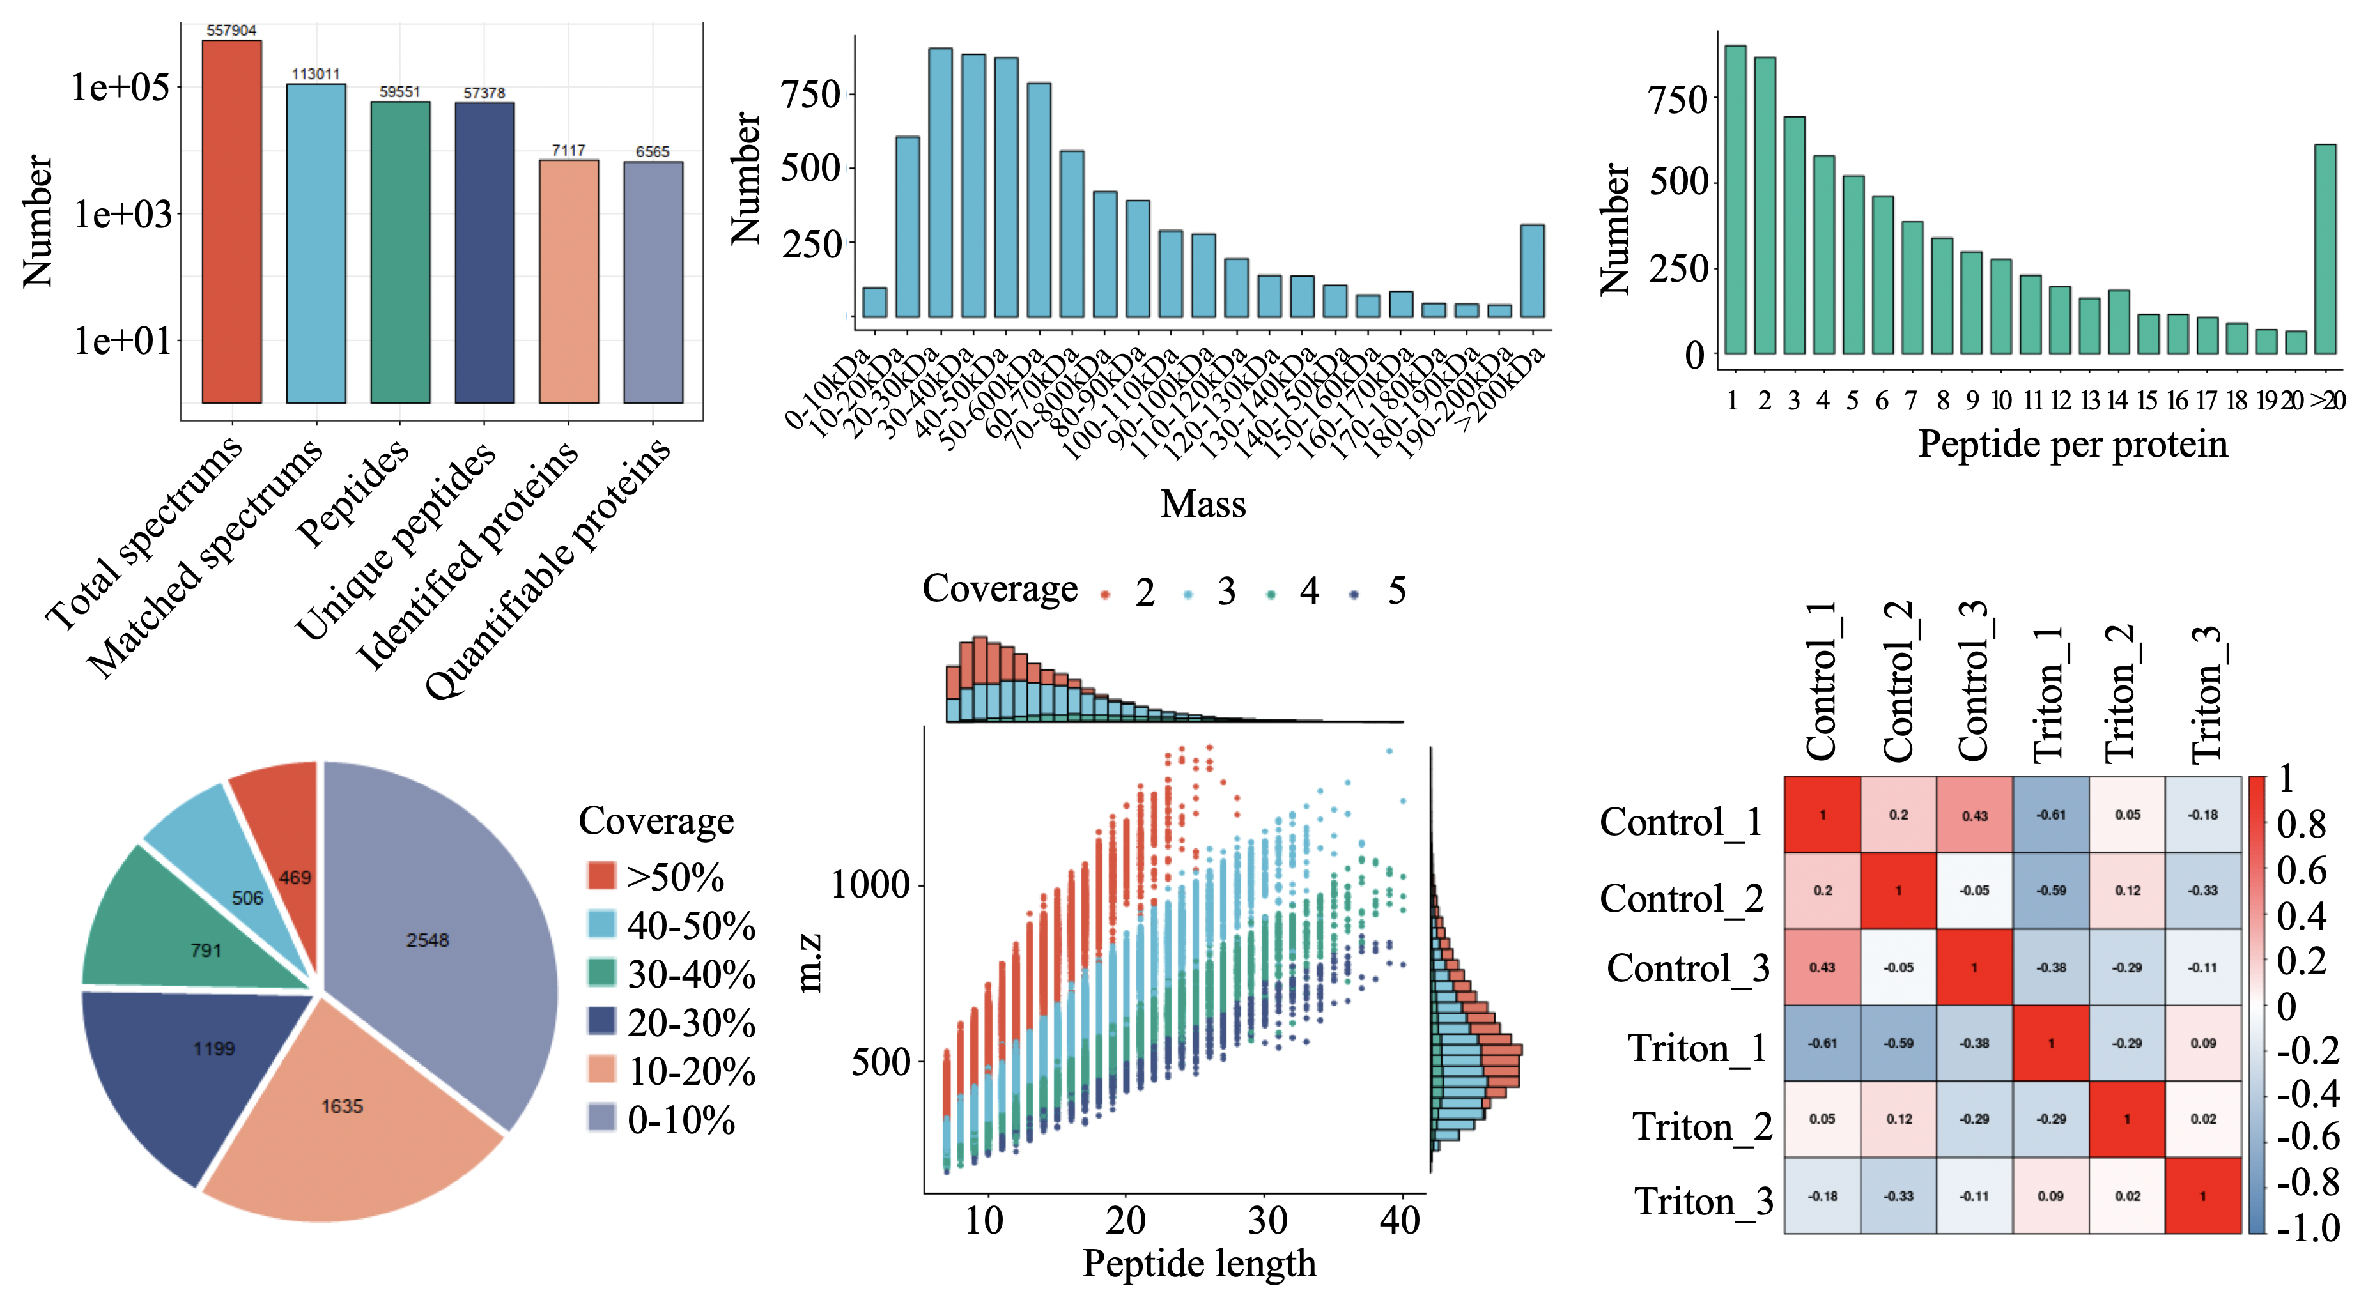
Figure S4
Pep-Quant library characteristics of mouse hippocampus. Bar graph showing distribution of identified peptides and proteins (A), molecular weight of proteins (B), protein length (C), proteome sequence coverage (D), peptide charge (E), and Pearson correlation coefficient (F).
