Supplementary materials
Table S1. Percentages of respondents with different experience in robotics (on the columns), stratified by years of experience in rehabilitation (on the rows).
 |  | Years in robotics
 |  | Less than 1 year | From 2 to 5 years | From 6 to 10 years | From 11 to 20 years | More than 20 years | No experience | Total
Years in rehabilitation | Less than 1 year | 2 (18%) | 0% | 0% | 0% | 0% | 9 (82%) | 11 (2.6%)
Years in rehabilitation | From 2 to 5 years | 16 (15%) | 19 (18%) | 0% | 0% | 0% | 71 (67%) | 106 (25.1%)
Years in rehabilitation | From 6 to 10 years | 10 (15%) | 13 (20%) | 7 (11%) | 0% | 0% | 36 (54%) | 66 (15.6%)
Years in rehabilitation | From 11 to 20 years | 16 (15%) | 12 (11%) | 15 (14%) | 5 (5%) | 0% | 58 (55%) | 106 (25.1%)
Years in rehabilitation | More than 20 years | 5 (4%) | 17 (13%) | 13 (10%) | 22 (16%) | 3 (2%) | 74 (55%) | 134 (31,7%)
 |  | 49 (11.6%) | 61 (14.4%) | 35 (8.3%) | 27 (6.4%) | 3 (0.7%) | 248 (58.6%) | 423 (100%)

Device-specific inquiries
Using/prescribing the device
For those who use/used the devices, the first question asks whether the respondent likes to use and/or to prescribe the device.
Table S2. Answers to the question “I like to use/prescribe the device”. Number and proportion of respondents stratified by the usage or knowledge of the device.
 | Use the device |  |  | Know the device but not use it
I like to use/prescribe the device | I agree | I disagree | I do not know | I agree | I disagree | I do not know
Assistive (generic) and mobile servant | 25 (92.59%) | 0 (0.0%) | 2 (7.41%) | 43 (58.9%) | 1 (1.37%) | 29 (39.73%)
Advanced treadmill | 75 (92.59%) | 3 (3.7%) | 3 (3.7%) | 37 (56.92%) | 4 (6.15%) | 24 (36.92%)
UL exoskeleton | 22 (88.0%) | 2 (8.0%) | 1 (4.0%) | 36 (45.57%) | 7 (8.86%) | 36 (45.57%)
LL exoskeleton | 28 (90.32%) | 2 (6.45%) | 1 (3.23%) | 22 (34.38%) | 5 (7.81%) | 37 (57.81%)
LL end effector | 19 (82.61%) | 3 (13.%) | 1 (4.35%) | 22 (50.0%) | 4 (9.09%) | 18 (40.91%)
Assistive UL or UL end effector | 26 (81.25%) | 2 (6.25%) | 4 (12.5%) | 10 (40.0%) | 2 (8.0%) | 13 (52.0%)
Proprioreceptive/stabilometric/balance platform | 61 (92.42%) | 1 (1.52%) | 4 (6.06%) | 30 (60.0%) | 5 (10.0%) | 15 (30.0%)
Sensor based/VR/Cognitive | 57 (95.0%) | 0 (0.0%) | 3 (5.0%) | 30 (60.0%) | 2 (4.0%) | 18 (36.0%)

Improving the practitioners’ work
The second question is related to whether the usage of these devices can improve the working capabilities of the operators.
Table S3. Answers to the question “The device can improve the capabilities of the operators”. Number and proportion of respondents stratified by the usage or knowledge of the device.
 | Use the device |  |  | Know the device but not use it
The device can improve the capabilities of the operators | I agree | I disagree | I do not know | I agree | I disagree | I do not know
Assistive (generic) and mobile servant | 24 (88.89%) | 1 (3.7%) | 2 (7.41%) | 58 (79.45%) | 3 (4.11%) | 12 (16.44%)
Advanced treadmill | 72 (88.89%) | 2 (2.47%) | 7 (8.64%) | 47 (72.31%) | 2 (3.08%) | 16 (24.62%)
UL exoskeleton | 21 (84.0%) | 1 (4.0%) | 3 (12.0%) | 53 (67.09%) | 3 (3.8%) | 23 (29.11%)
LL exoskeleton | 28 (90.32%) | 2 (6.45%) | 1 (3.23%) | 42 (65.62%) | 6 (9.38%) | 16 (25.0%)
LL end effector | 20 (86.96%) | 2 (8.7%) | 1 (4.35%) | 28 (63.64%) | 3 (6.82%) | 13 (29.55%)
Assistive UL or UL end effector | 25 (78.12%) | 3 (9.38%) | 4 (12.5%) | 13 (52.0%) | 3 (12.0%) | 9 (36.0%)
Proprioreceptive/stabilometric/balance platform | 59 (89.39%) | 0 (0.0%) | 7 (10.61%) | 40 (80.0%) | 5 (10.0%) | 5 (10.0%)
Sensor based/VR/Cognitive | 56 (93.33%) | 0 (0.0%) | 4 (6.67%) | 40 (80.0%) | 2 (4.0%) | 8 (16.0%)

Improving the patient’s health status
The third question asks whether the operators think that the use of a specific device has the potential to improve patients’ clinical outcome.

Table S4. Answers to the question “ The device has the potential to improve patients’ clinical outcome”. Number and proportion of respondents stratified by the usage or knowledge of the device.
 | Use the device |  |  | Know the device but not use it
The device has the potential to improve patients’ clinical outcome | I agree | I disagree | I do not know | I agree | I disagree | I do not know
Assistive (generic) and mobile servant | 26 (96.3%) | 0 (0.0%) | 1 (3.7%) | 65 (89.04%) | 1 (1.37%) | 7 (9.59%)
Advanced treadmill | 76 (93.83%) | 1 (1.23%) | 4 (4.94%) | 52 (80.0%) | 1 (1.54%) | 12 (18.46%)
UL exoskeleton | 23 (92.0%) | 1 (4.0%) | 1 (4.0%) | 63 (79.75%) | 2 (2.53%) | 14 (17.72%)
LL exoskeleton | 30 (96.77%) | 1 (3.23%) | 0 (0.0%) | 51 (79.69%) | 4 (6.25%) | 9 (14.06%)
LL end effector | 20 (86.96%) | 2 (8.7%) | 1 (4.35%) | 33 (75.0%) | 1 (2.27%) | 10 (22.73%)
Assistive UL or UL end effector | 30 (93.75%) | 1 (3.12%) | 1 (3.12%) | 17 (68.0%) | 2 (8.0%) | 6 (24.0%)
Proprioreceptive/stabilometric/balance platform | 62 (93.94%) | 0 (0.0%) | 4 (6.06%) | 42 (84.0%) | 4 (8.0%) | 4 (8.0%)
Sensor based/VR/Cognitive | 57 (95.0%) | 0 (0.0%) | 3 (5.0%) | 38 (76.0%) | 2 (4.0%) | 10 (20.0%)

Promote participation
The fourth question asks whether the usage of the device can augment patients and/or relatives' participation in the therapy.

Table S5. Answers to the question “the device can augment patients’ and/or relatives’ participation in the therapy”. Number and proportion of respondents stratified by the usage or knowledge of the device

 | Use the device |  |  | Know the device but not use it
the device can augment patients’ and/or relatives’ participation in the therapy | I agree | I disagree | I do not know | I agree | I disagree | I do not know
Assistive (generic) and mobile servant | 25 (92.59%) | 0 (0.0%) | 2 (7.41%) | 61 (83.56%) | 2 (2.74%) | 10 (13.7%)
Advanced treadmill | 70 (86.42%) | 6 (7.41%) | 5 (6.17%) | 46 (70.77%) | 4 (6.15%) | 15 (23.08%)
UL exoskeleton | 20 (80.0%) | 1 (4.0%) | 4 (16.0%) | 54 (68.35%) | 4 (5.06%) | 21 (26.58%)
LL exoskeleton | 26 (83.87%) | 4 (12.9%) | 1 (3.23%) | 40 (62.5%) | 5 (7.81%) | 19 (29.69%)
LL end effector | 17 (73.91%) | 2 (8.7%) | 4 (17.39%) | 29 (65.91%) | 4 (9.09%) | 11 (25.0%)
Assistive UL or UL end effector | 29 (90.62%) | 1 (3.12%) | 2 (6.25%) | 14 (56.0%) | 3 (12.0%) | 8 (32.0%)
Proprioreceptive/stabilometric/balance platform | 57 (86.36%) | 1 (1.52%) | 8 (12.12%) | 29 (58.0%) | 7 (14.0%) | 14 (28.0%)
Sensor based/VR/Cognitive | 56 (93.33%) | 1 (1.67%) | 3 (5.0%) | 35 (70.0%) | 2 (4.0%) | 13 (26.0%)

Adding value to standard rehabilitation
The fifth question is related to the perception that using a robotic device can add value in comparison with a traditional rehabilitation.

Table S6. Answers to the question “The device can add value in comparison with a traditional rehabilitation”. Number and proportion of respondents stratified by the usage or knowledge of the device.
 | Use the device |  |  | Know the device but not use it
The device can add value in comparison with a traditional rehabilitation | I agree | I disagree | I do not know | I agree | I disagree | I do not know
Assistive (generic) and mobile servant | 26 (96.3%) | 0 (0.0%) | 1 (3.7%) | 67 (91.78%) | 1 (1.37%) | 5 (6.85%)
Advanced treadmill | 70 (86.42%) | 3 (3.7%) | 8 (9.88%) | 52 (80.0%) | 1 (1.54%) | 12 (18.46%)
UL exoskeleton | 23 (92.0%) | 2 (8.0%) | 0 (0.0%) | 61 (77.22%) | 3 (3.8%) | 15 (18.99%)
LL exoskeleton | 29 (93.55%) | 2 (6.45%) | 0 (0.0%) | 49 (76.56%) | 3 (4.69%) | 12 (18.75%)
LL end effector | 20 (86.96%) | 2 (8.7%) | 1 (4.35%) | 33 (75.0%) | 1 (2.27%) | 10 (22.73%)
Assistive UL or UL end effector | 29 (90.62%) | 1 (3.12%) | 2 (6.25%) | 16 (64.0%) | 2 (8.0%) | 7 (28.0%)
Proprioreceptive/stabilometric/balance platform | 60 (90.91%) | 1 (1.52%) | 5 (7.58%) | 38 (76.0%) | 6 (12.0%) | 6 (12.0%)
Sensor based/VR/Cognitive | 57 (95.0%) | 0 (0.0%) | 3 (5.0%) | 37 (74.0%) | 3 (6.0%) | 10 (20.0%)

Appropriateness within current clinical practice
The sixth question asks whether the healthcare professionals believe that the usage of a device is appropriate within their current clinical practice.
Table S7. Answers to the question “the usage of a device is appropriate within your current clinical practice”. Number and proportion of respondents stratified by the usage or knowledge of the device.
 | Use the device |  |  | Know the device but not use it
The usage of a device is appropriate within your current clinical practice | I agree | I disagree | I do not know | I agree | I disagree | I do not know
Assistive (generic) and mobile servant | 26 (96.3%) | 1 (3.7%) | 0 (0.0%) | 58 (79.45%) | 4 (5.48%) | 11 (15.07%)
Advanced treadmill | 71 (87.65%) | 3 (3.7%) | 7 (8.64%) | 45 (69.23%) | 4 (6.15%) | 16 (24.62%)
UL exoskeleton | 22 (88.0%) | 2 (8.0%) | 1 (4.0%) | 51 (64.56%) | 7 (8.86%) | 21 (26.58%)
LL exoskeleton | 28 (90.32%) | 3 (9.68%) | 0 (0.0%) | 47 (73.44%) | 6 (9.38%) | 11 (17.19%)
LL end effector | 20 (86.96%) | 3 (13.04%) | 0 (0.0%) | 29 (65.91%) | 4 (9.09%) | 11 (25.0%)
Assistive UL or UL end effector | 27 (84.38%) | 1 (3.12%) | 4 (12.5%) | 13 (52.0%) | 3 (12.0%) | 9 (36.0%)
Proprioreceptive/stabilometric/balance platform | 63 (95.45%) | 1 (1.52%) | 2 (3.03%) | 31 (62.0%) | 9 (18.0%) | 10 (20.0%)
Sensor based/VR/Cognitive | 56 (93.33%) | 1 (1.67%) | 3 (5.0%) | 39 (78.0%) | 2 (4.0%) | 9 (18.0%)

Opinion of colleagues
The next question asks, “My trusted colleagues think that I should use these devices”.

Table S8 Answers to the question “My trusted colleagues think that I should use these devices”. Number and proportion of respondents stratified by the usage or knowledge of the device.
 | Use the device |  |  | Know the device but not use it
My trusted colleagues think that I should use these devices | I agree | I disagree | I do not know | I agree | I disagree | I do not know
Assistive (generic) and mobile servant | 14 (51.85%) | 3 (11.11%) | 10 (37.04%) | 32 (43.84%) | 12 (16.44%) | 29 (39.73%)
Advanced treadmill | 52 (64.2%) | 4 (4.94%) | 25 (30.86%) | 20 (30.77%) | 8 (12.31%) | 37 (56.92%)
UL exoskeleton | 18 (72.0%) | 2 (8.0%) | 5 (20.0%) | 31 (39.24%) | 8 (10.13%) | 40 (50.63%)
LL exoskeleton | 23 (74.19%) | 2 (6.45%) | 6 (19.35%) | 24 (37.5%) | 7 (10.94%) | 33 (51.56%)
LL end effector | 18 (78.26%) | 2 (8.7%) | 3 (13.04%) | 14 (31.82%) | 3 (6.82%) | 27 (61.36%)
Assistive UL or UL end effector | 26 (81.25%) | 1 (3.12%) | 5 (15.62%) | 8 (32.0%) | 2 (8.0%) | 15 (60.0%)
Proprioreceptive/stabilometric/balance platform | 50 (75.76%) | 1 (1.52%) | 15 (22.73%) | 15 (30.0%) | 5 (10.0%) | 30 (60.0%)
Sensor based/VR/Cognitive | 48 (80.0%) | 1 (1.67%) | 11 (18.33%) | 25 (50.0%) | 5 (10.0%) | 20 (40.0%)

Opinion of supervisor
The last question asks "My supervisors believe that I should use these devices”
Table S9. Answers to the question “My supervisors believe that I should use these devices. Number and proportion of respondents stratified by the usage or knowledge of the device.
 | Use the device |  |  | Know the device but not use it
My supervisors believe that I should use these devices | I agree | I disagree | I do not know | I agree | I disagree | I do not know
Assistive (generic) and mobile servant | 13 (48.15%) | 3 (11.11%) | 11 (40.74%) | 25 (34.25%) | 11 (15.07%) | 37 (50.68%)
Advanced treadmill | 55 (67.9%) | 3 (3.7%) | 23 (28.4%) | 14 (21.54%) | 10 (15.38%) | 41 (63.08%)
UL exoskeleton | 19 (76.0%) | 2 (8.0%) | 4 (16.0%) | 19 (24.05%) | 12 (15.19%) | 48 (60.76%)
LL exoskeleton | 20 (64.52%) | 4 (12.9%) | 7 (22.58%) | 17 (26.56%) | 8 (12.5%) | 39 (60.94%)
LL end effector | 17 (73.91%) | 1 (4.35%) | 5 (21.74%) | 13 (29.55%) | 7 (15.91%) | 24 (54.55%)
Assistive UL or UL end effector | 24 (75.0%) | 2 (6.25%) | 6 (18.75%) | 6 (24.0%) | 3 (12.0%) | 16 (64.0%)
Proprioreceptive/stabilometric/balance platform | 48 (72.73%) | 2 (3.03%) | 16 (24.24%) | 15 (30.0%) | 8 (16.0%) | 27 (54.0%)
Sensor based/VR/Cognitive | 46 (76.67%) | 2 (3.33%) | 12 (20.0%) | 21 (42.0%) | 8 (16.0%) | 21 (42.0%)

Table S10. Perception of the barriers for different types of devices for respondents that know about the device, but never used it. In black we report the percentage of operators that perceived the issues reported in the row as a barrier. In grey we report the percentage of participants that did not have a clear opinion

Lack of | Assistive mobile servant |  | Adv treadmill |  | UL exosk |  | LL end eff |  | LL exosk |  | Assistive UL or UL end eff |  | Proprioceptive / stabilometrics / balanced platform |  | Sensor-based/VR/  Cognitive
Financial resources | 68.5 | 19.1 | 72.3 | 21.5 | 60.7 | 27.8 | 68.1 | 25 | 64 | 26.5 | 60 | 36 | 70 | 20 | 56 | 30
Motivation of patients/caregivers | 20.5 | 28.7 | 16.9 | 36.9 | 13.9 | 37.9 | 22.7 | 36.3 | 12.5 | 37.5 | 24 | 52 | 20 | 30 | 14 | 34
Opportunities/participation/training | 73.9 | 15 | 61.5 | 20 | 63.2 | 18.9 | 65.9 | 20.5 | 59.3 | 18.7 | 44 | 44 | 70 | 20 | 56 | 30
Robustness | 23.2 | 46.5 | 10.7 | 44.6 | 8.8 | 56.9 | 4.5 | 59 | 7.8 | 54.6 | 16 | 60 | 20 | 42 | 10 | 52
Scientific literature | 60.2 | 19.1 | 49.2 | 23 | 41.7 | 27.8 | 50 | 22 | 48.4 | 18.7 | 48 | 36 | 42 | 24 | 50 | 28
Space | 45.2 | 30.1 | 55.3 | 27.6 | 31.6 | 35.4 | 45.4 | 36.3 | 45.3 | 32.8 | 32 | 48 | 56 | 18 | 30 | 38
Time to prepare and re-establish | 60.2 | 23.2 | 49.2 | 21.5 | 40.5 | 31.6 | 56.8 | 25 | 53.1 | 32.8 | 32 | 56 | 58 | 22 | 32 | 36
Trust | 28.7 | 17.8 | 26.1 | 29.2 | 32.9 | 27.8 | 36.3 | 25 | 35.9 | 29.6 | 36 | 36 | 24 | 20 | 22 | 40

Table S11. Results of the SUS for Lower Limb exoskeleton, Assistive Upper Limb or Upper Limb end effector, and Assistive (generic) and mobile servant
 | LL exoskeleton |  | Assistive UL or UL end effector |  | Assistive (generic) and mobile servant
 | I agree | I disagree | I agree | I disagree | I agree | I disagree
Learn a lot | 26(84%) | 2(6%) | 16(52%) | 11(35%) | 24 (89%) | 2(7%)
Need assistance | 21(68%) | 7(23%) | 8(26%) | 20(65%) | 17(63%) | 8(30%)
Learn quickly | 9(29%) | 18(58%) | 23(74%) | 2(6%) | 8(30%) | 10(37%)
Feel safe | 24(77%) | 7(23%) | 26(84%) | 2(6%) | 19(70%) | 4(15%)
Complex | 3(10%) | 23(74%) | 2(6%) | 24(77%) | 3(11%) | 19(70%)
Cumbersome to use | 11(35%) | 15(48%) | 4(13%) | 22(71%) | 4(15%) | 17(63%)
Inconsistencies | 4(13%) | 19(61%) | 2(6%) | 18(58%) | 4(15%) | 14(52%)
Well integrated | 25(81%) | 2(6%) | 22(71%) | 4(13%) | 20(74%) | 1(4%)
Would like to use it frequently | 26(84%) | 1(3%) | 20(65%) | 1(3%) | 22(81%)
Easy to use | 11(35%) | 14(45%) | 26(84%) | 3(10%) | 14(52%) | 5(19%)

Table S12. Results of the SUS for Upper Limb exoskeleton and Lower Limb end effector
 | UL exoskeleton |  | LL end effector
 | I agree | I disagree | I agree | I disagree
Learn a lot | 14(56%) | 6(24%) | 15(65%) | 7(30%)
Need assistance | 7(28%) | 14(56%) | 15(65%) | 6(26%)
Learn quickly | 18(72%) | 2(8%) | 14(61%) | 7(30%)
Feel safe | 20(80%) | 2(8%) | 16(70%) | 4(17%)
Complex | 2(8%) | 19(76%) | 2(9%) | 18(78%)
Cumbersome to use | 3(12%) | 19(76%) | 6(26%) | 14(61%)
Inconsistencies | 4(16%) | 16(64%) | 4(17%) | 10(43%)
Well integrated | 17(68%) | 3(12%) | 12(52%) | 5(22%)
Would like to use it frequently | 19(76%) | 2(8%) | 13(56%) | 6(26%)
Easy to use | 17(68%) | 4(16%) | 15(65%) | 6(26%)

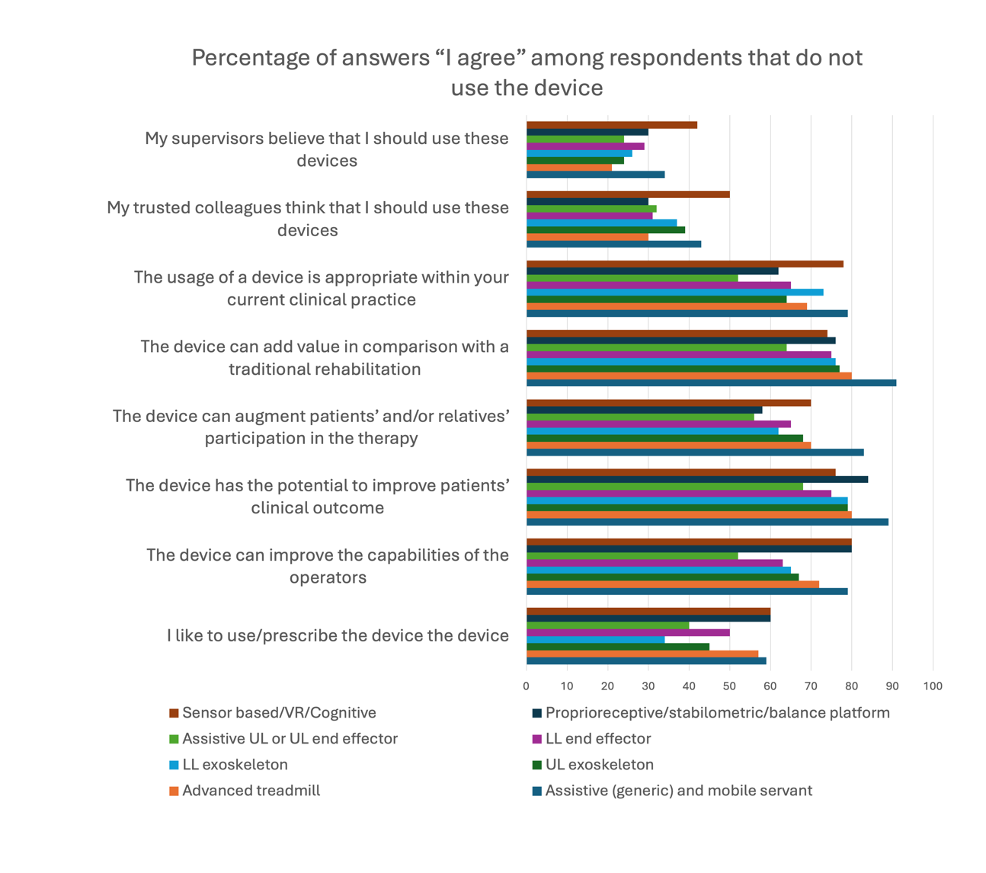
Figure S1: Histogram showing the percentage of respondents that know a specific device but do not use it, agreeing with each specific statement

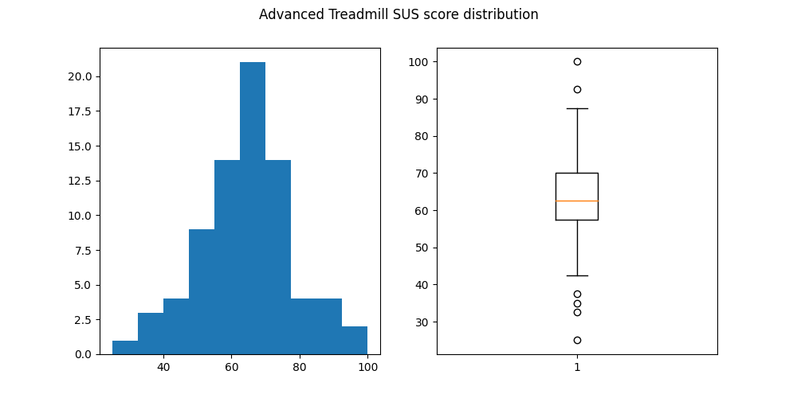
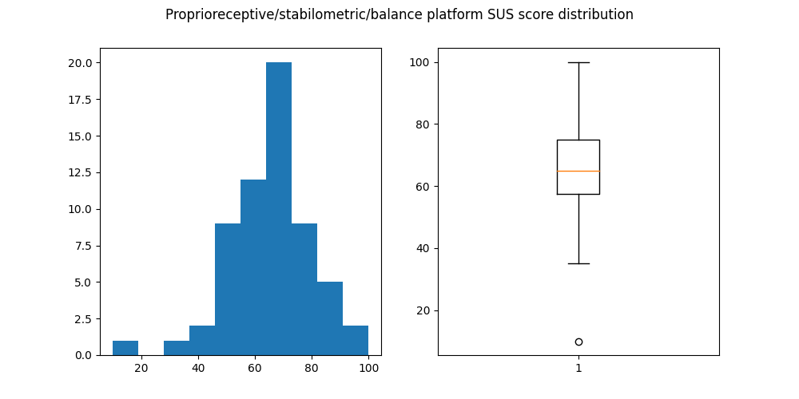
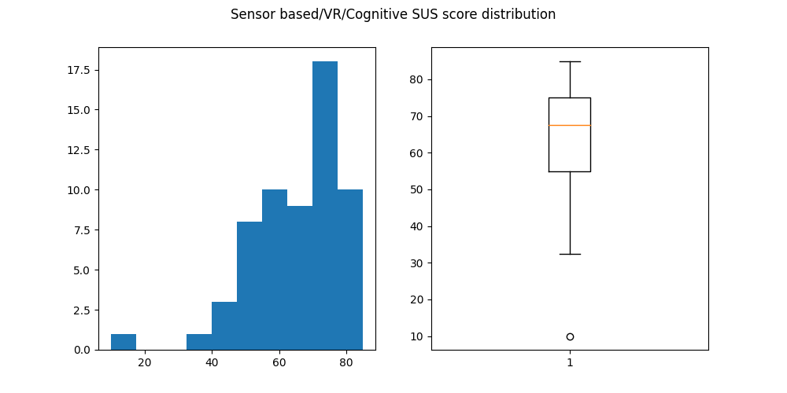
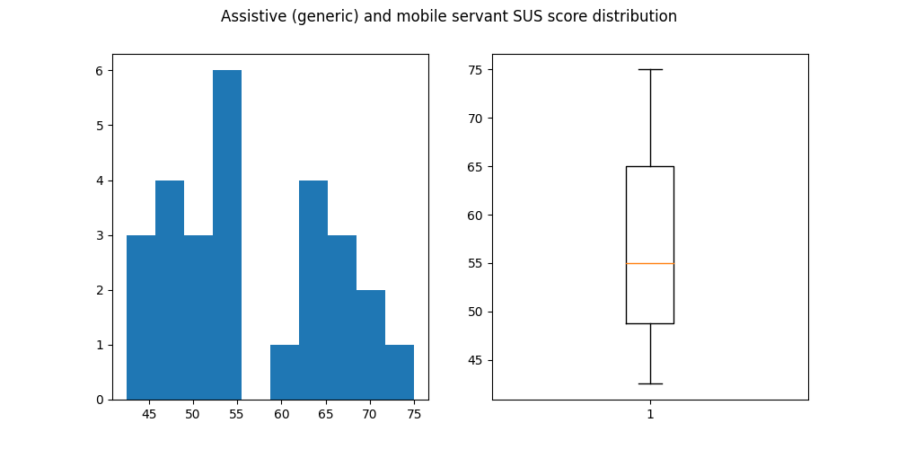
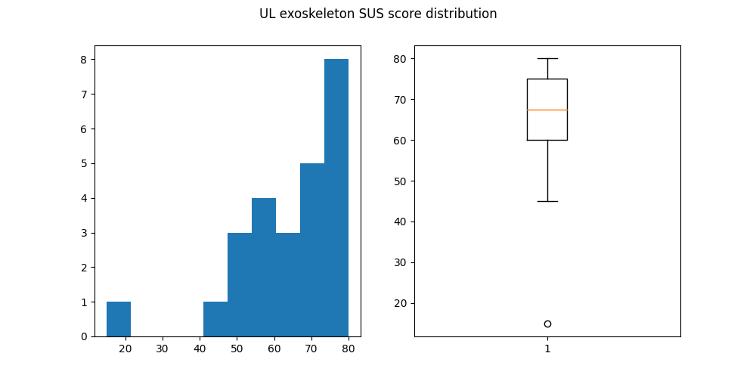
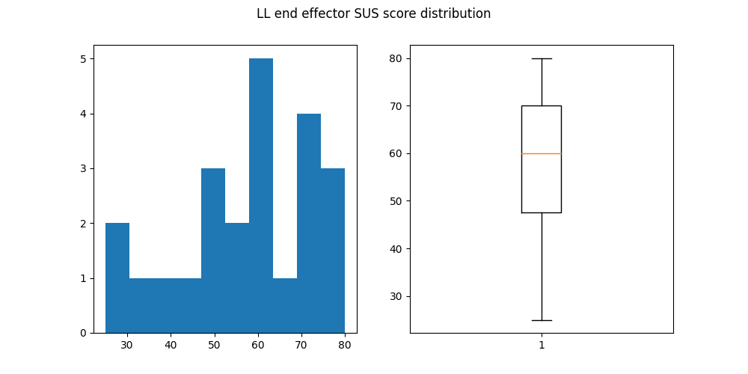
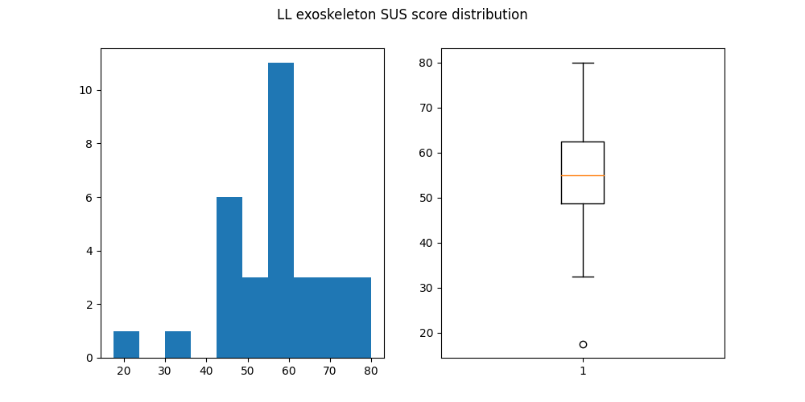
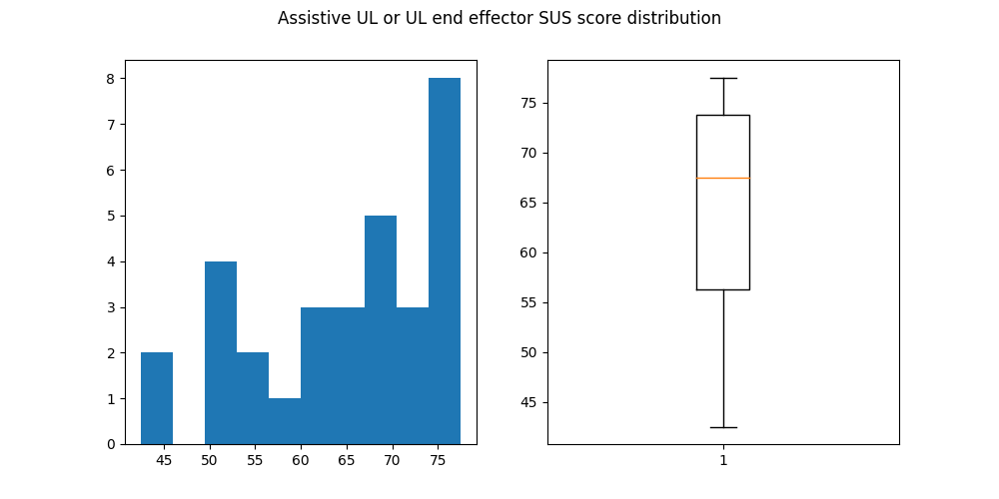
Figure S2 Histogram and boxplot of the SUS score for each respondents across the devices’ categories

