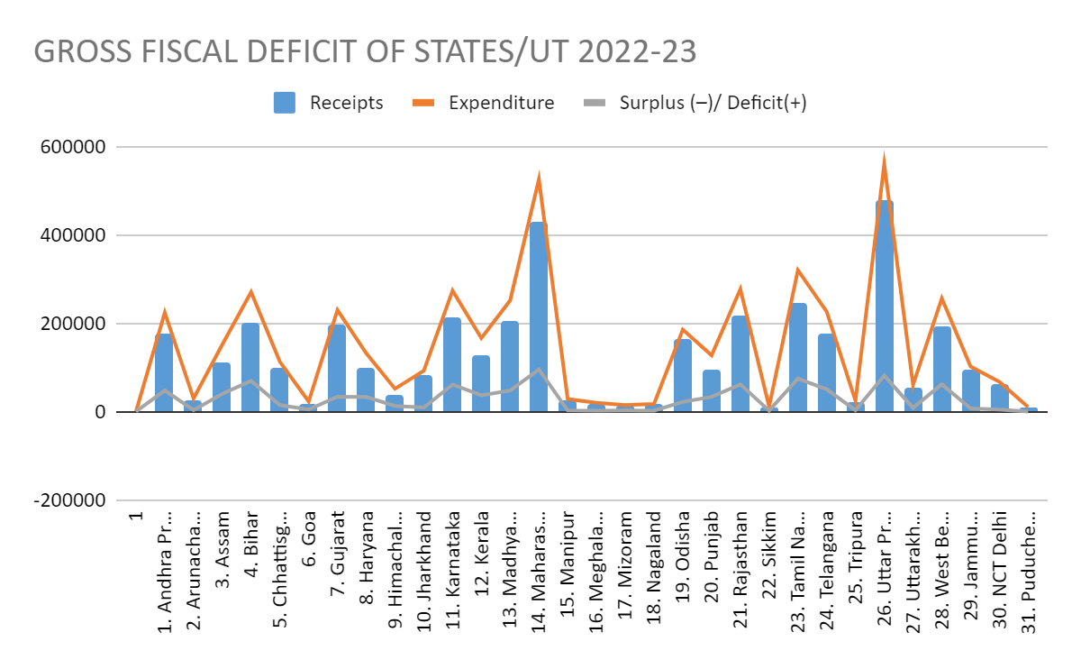
CHART 1: Source: RBI FY 2022-23 (Revised) GROSS FISCAL DEFICIT INDIAN STATES

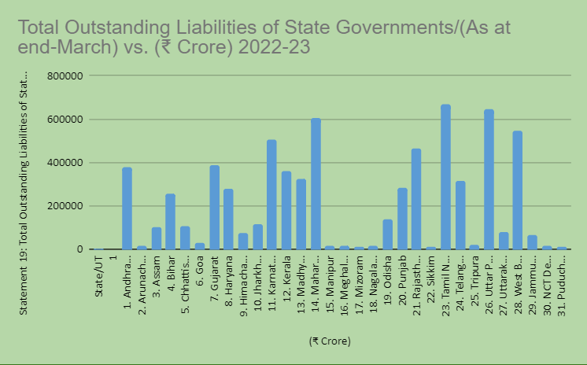
CHART 2 : Source: RBI FY 2022-23 OUTSTANDING-LIABILITIES OF STATE GOVERNMENTS

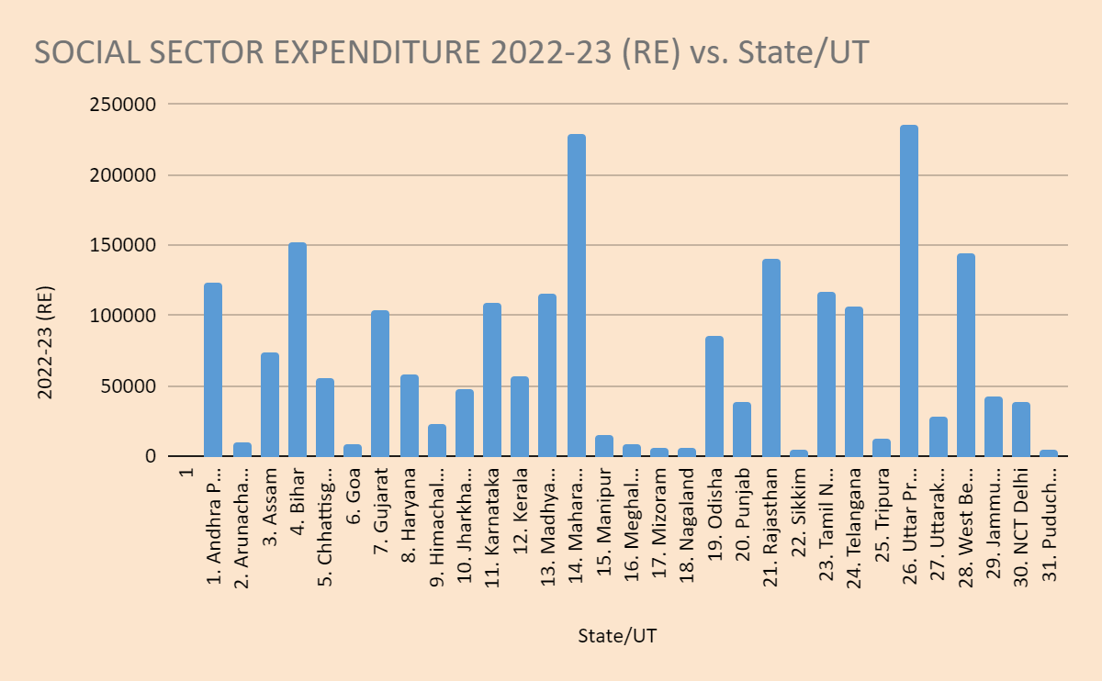
CHART 3: Source RBI State Finances AY 2022-23 SOCIAL SECTOR EXPENDITURE OF INDIAN STATES& UT

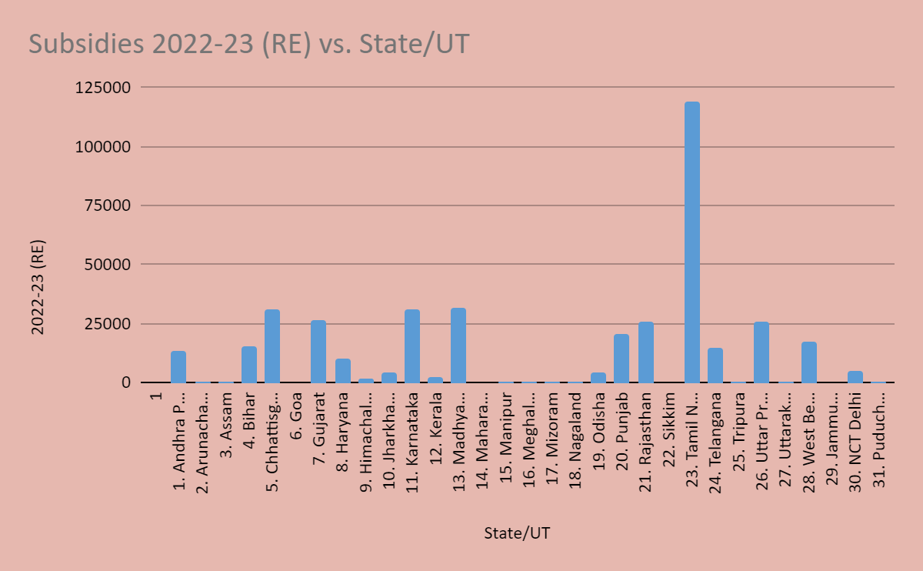
CHART 4: Source RBI State Finances AY 2022-23 SUBSIDIES OF INDIAN STATES& UT

Chart 1:
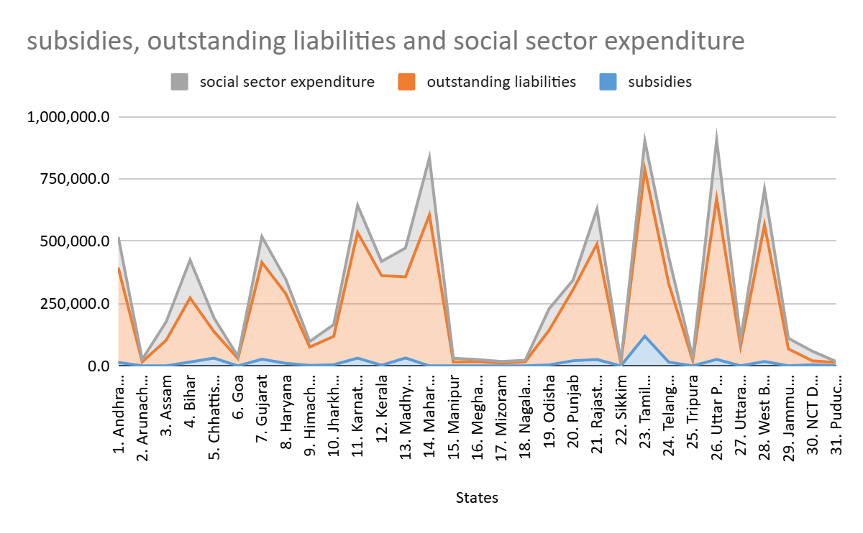
The chart 1 compares three financial metrics for various states: Social Sector Expenditure (grey), Outstanding Liabilities (orange) and Subsidies (blue).
1. Outstanding Liabilities: the chart shows consistently highest among the three metrics across almost all states, indicating the highest burden.
2. Social Sector Expenditure: Social spending is a major budget component, quite high among all states often closely trailing the outstanding liabilities.
3. Subsidies: Represented by blue line, the amounts are relatively low compared to other two financial metrics.

